1. Generate PAT (personal access token ) for gitlab account

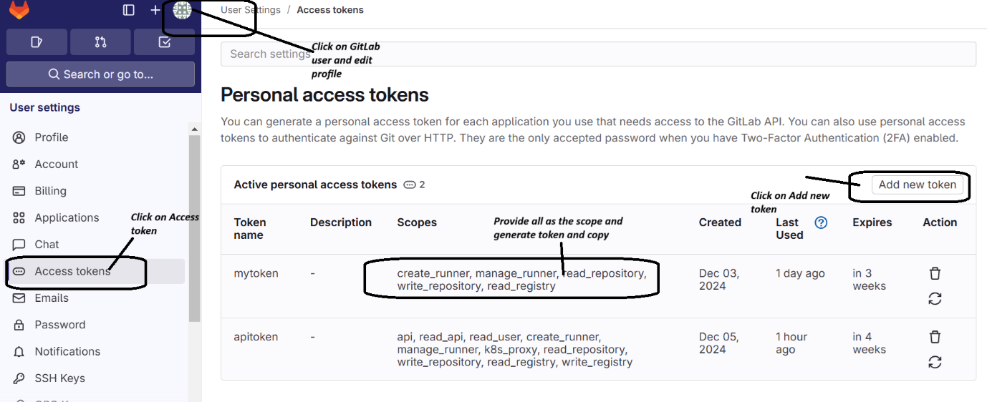

1. Open Jenkins CI dashboard

Go to Manage Jenkins-> Plugins->Available plugins->Gitlab Plugin [Install the plugin]

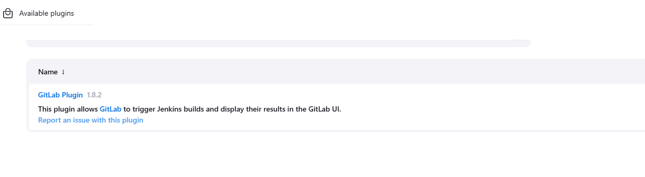

1. Go to Manage Jenkins->System Configration->System

Provide connection name: myconnection [you can provide any name]

GitLab host ur: <https://gitlab.com>

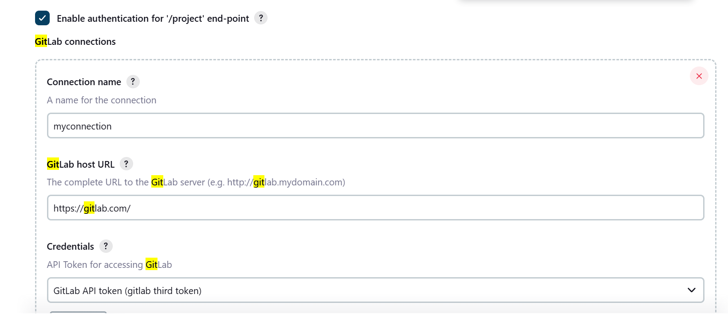

For Credential Section🡪click on add (Jenkins]

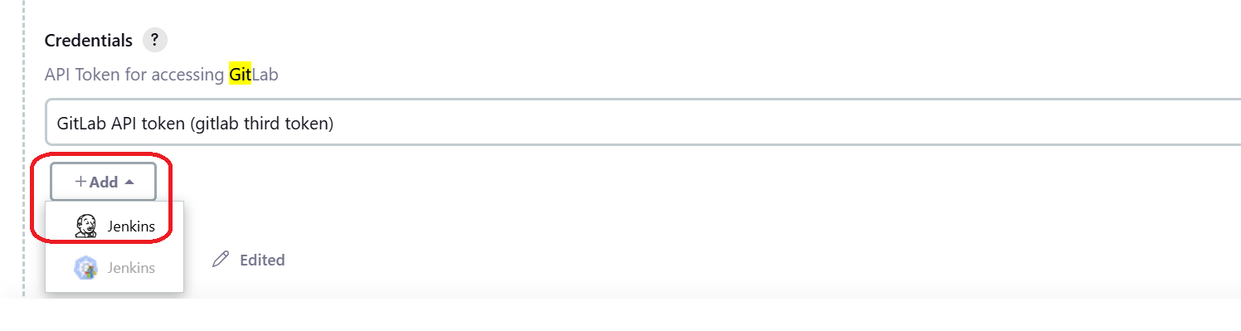

Select kind: GitLab API Token and in API token section provide the PAT of gitlab; click on Add

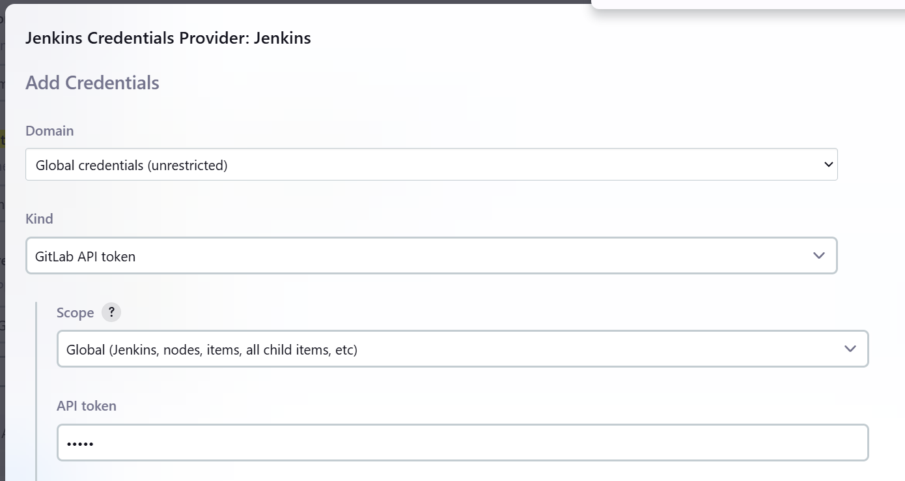

Click on Advanced🡪Checkmark ignore ssl error Rest parameters keep it default, and click on Test Connections

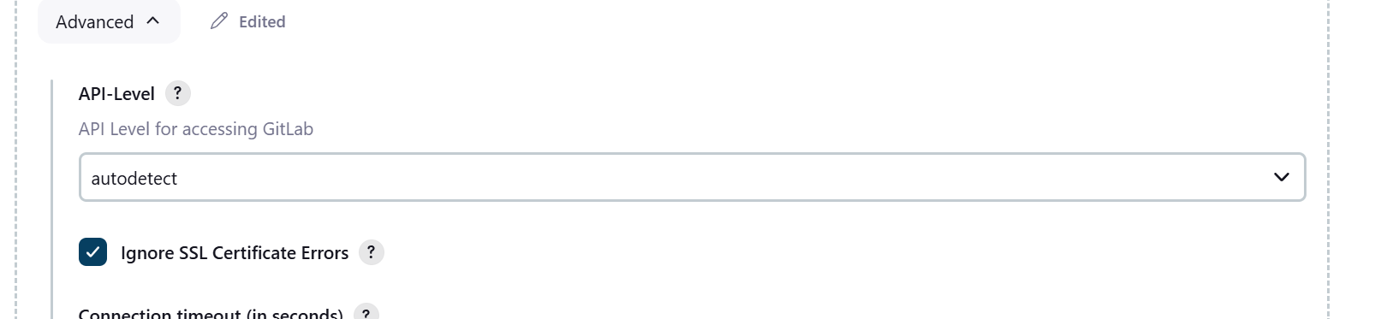

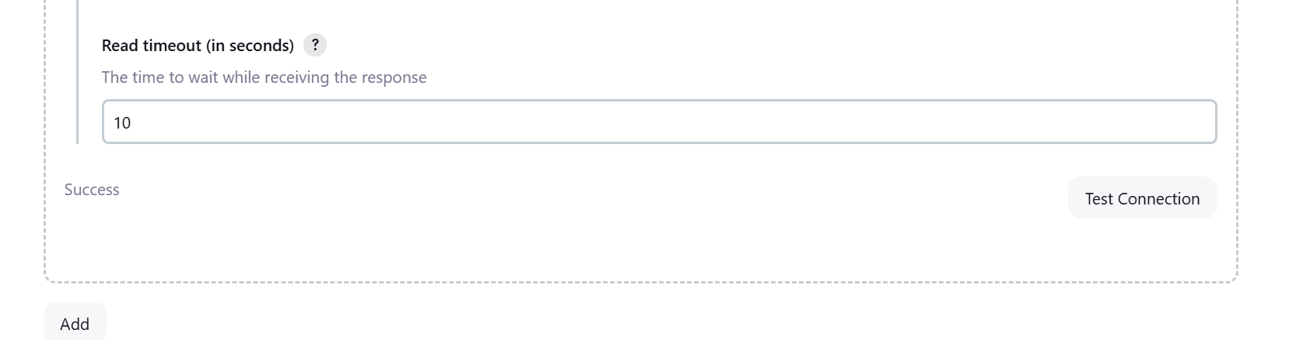

In your ansible linux box, create a directory

mkdir ansiblecicd

cd ansiblecicd

create inventory.ini file using vi editor and copy below code and save

[local]

localhost ansible_connection=local

Create a lab.yaml file using vi editor and copy below code and save

---

- hosts: all

become: true

tasks:

- name: Install apache httpd

ansible.builtin.apt:

name: apache2

state: present

update_cache: yes

- name: Copy file with owner and permissions

ansible.builtin.copy:

src: index.html

dest: /var/www/html

owner: root

group: root

mode: '0644'

Create a Jenkinsfile using vi editor and copy below code and save

pipeline {

agent any

stages {

stage('Install Ansible') {

steps {

// Install Ansible on the Jenkins agent

sh 'sudo apt-get -y install ansible'

}

}

stage('Run Ansible Playbook') {

steps {

// Run the Ansible playbook

sh 'ansible-playbook -i inventory.ini lab.yaml'

}

}

}

}

Create a index.html file using

touch index.html

Run following git command

git init

git add .

git commit -m “Add code”

git branch -M main

Create a Empty repo on Gitlab [without readme]

git remote add origin **<remote branch ssh url>**

git push origin main

Go to your gitlab page code must be visible

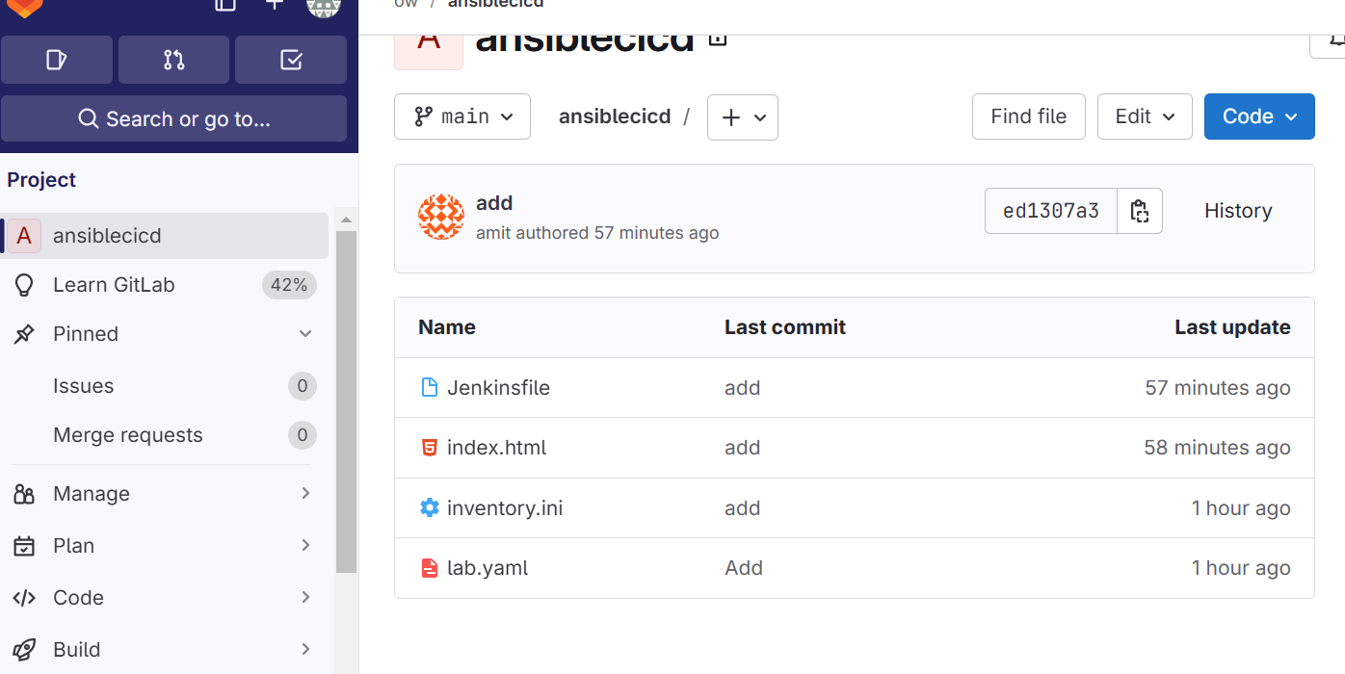

Go to Jenkins job and create a Jenkins job pipeline type , name ansibletest [you can give anything]

In Configure option select connect

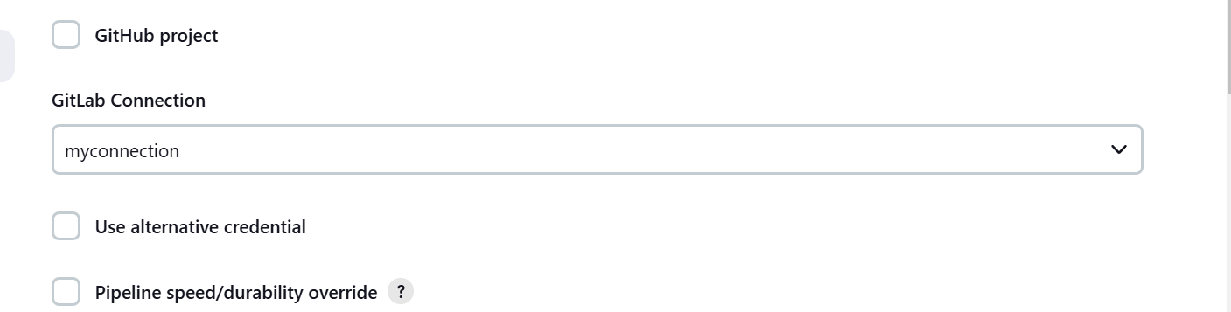

Build Trigger option select below option

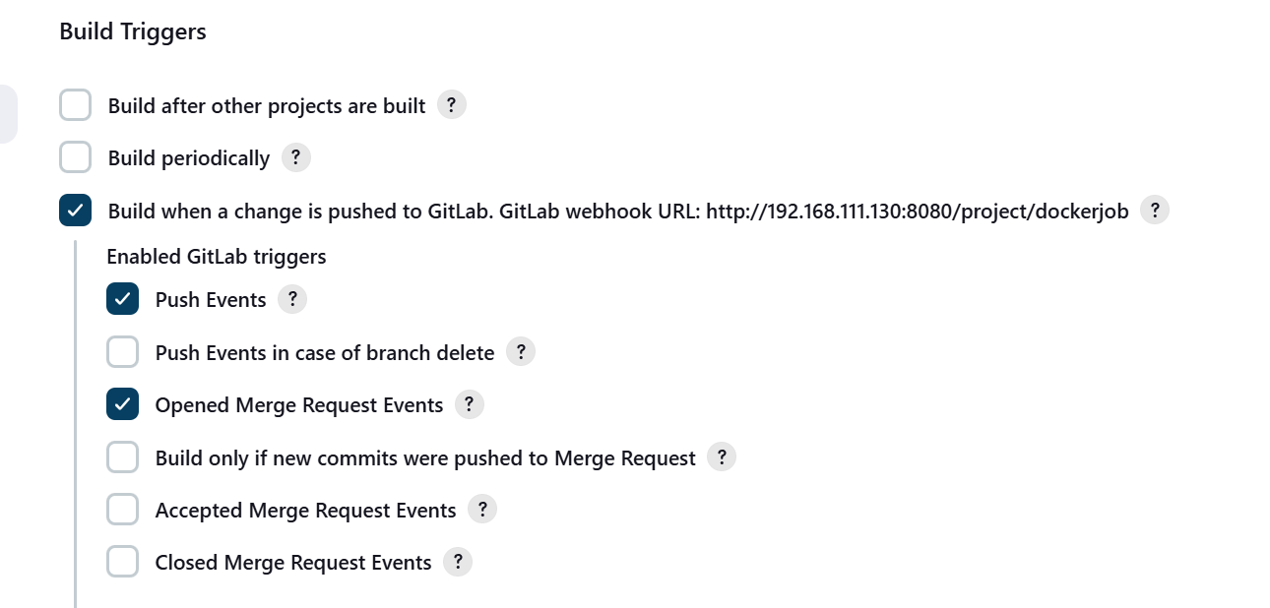

In pipeline section select following option, and provide your gitlab ssh url [where you have uploaded ansible url]

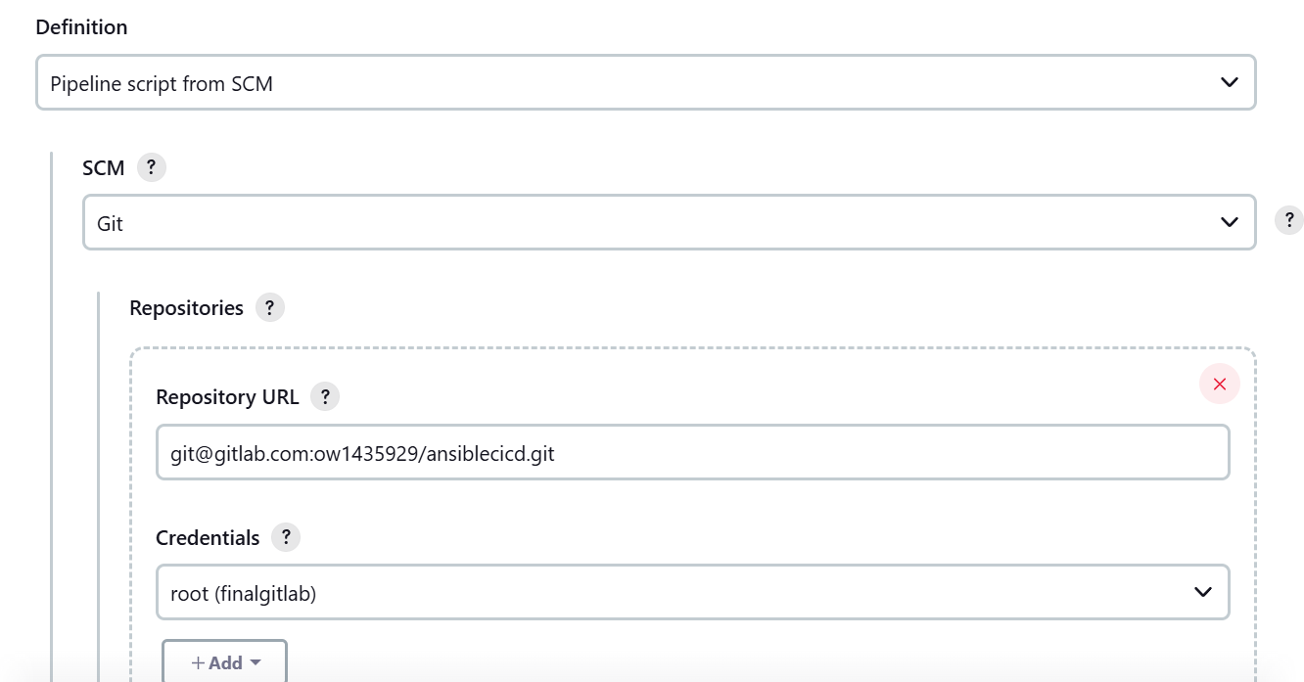

In case credentials are not configured, click on Add->Jenkins

Kind : SSH user name with private key

Username : root

Private key: cat /root/.ssh/id_rsa

**Copy the key from linxu box**

**Note: assuming you have used root user while integration from linux box**

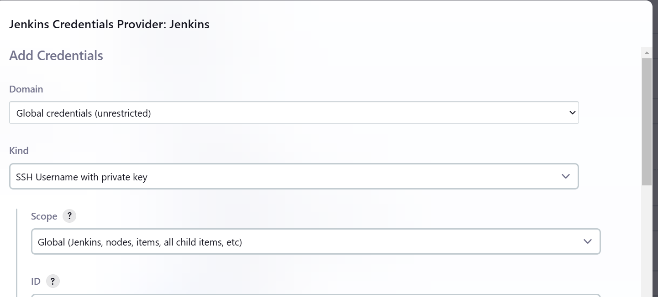

Save the jeknis job

Now go to gitlab dashboard ->Project setting

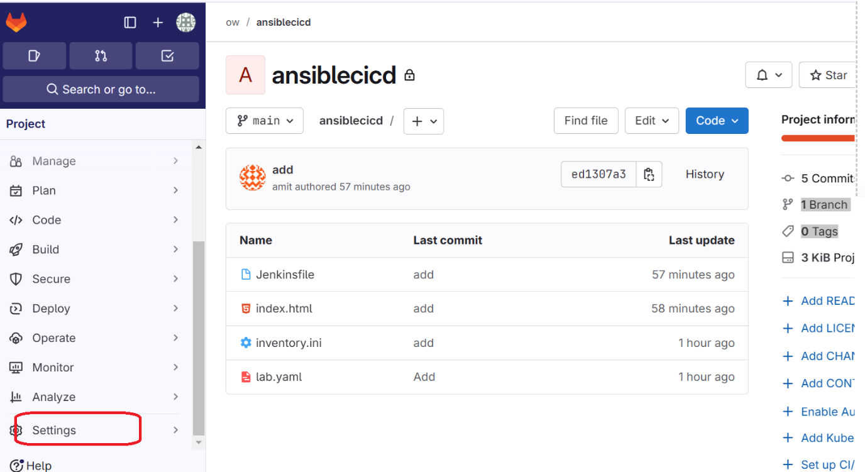

Go to integration

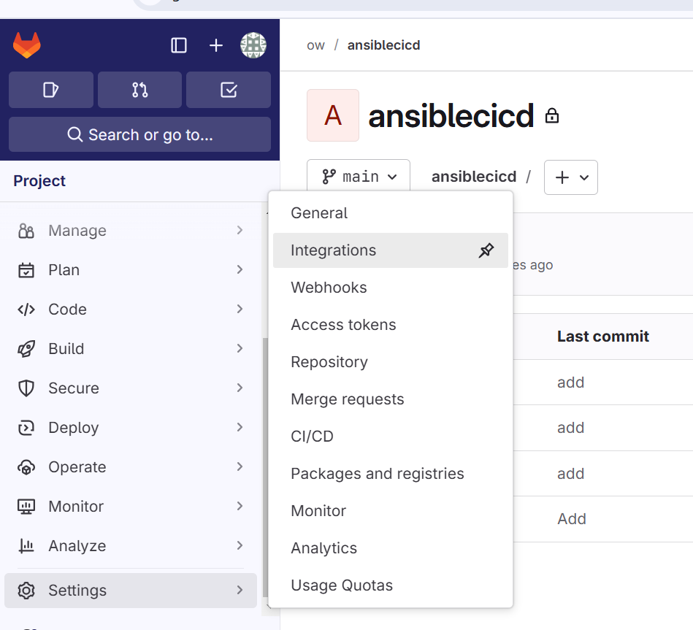

Search for Jenkins and Click on Configure

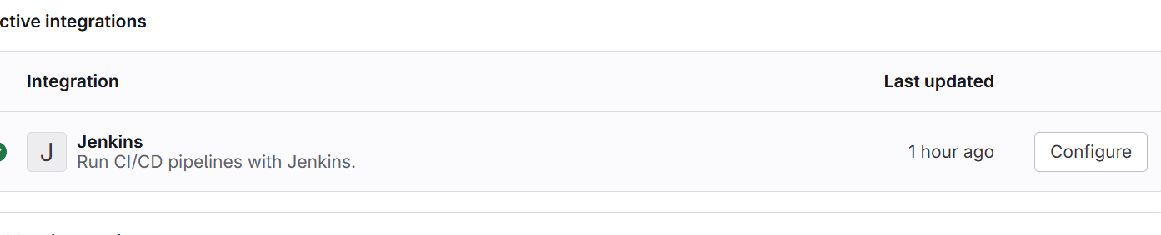

Select this option [Push]

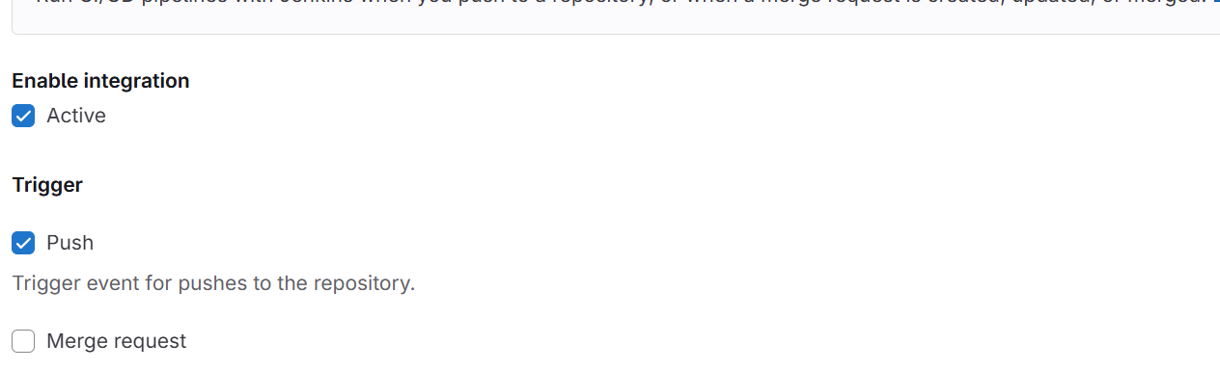

Provide your Jenkins server url, Jenkins job name [which you have created on Jenkins dashboard for this project], user name and password

Save and Test Setting

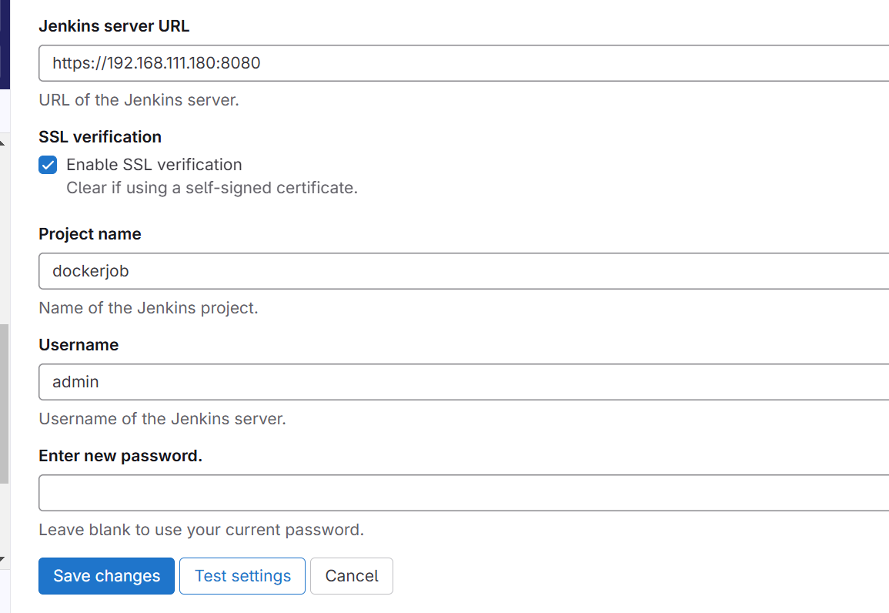

Test Setting must show connection successful

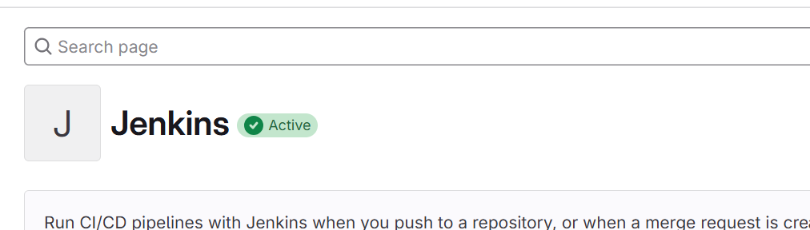

Now time to test

Go to your linux box and open index.html file using vi editor and copy and add the below code, save it

<!DOCTYPE html>

<html lang="en">

<head>

<meta charset="UTF-8">

<meta name="viewport" content="width=device-width, initial-scale=1.0">

<title>Sample Index</title>

</head>

<body>

<h1>Welcome to My Website</h1>

<p>This is a sample index.html file.</p>

</body>

</html>

Now perform git activity

git add .

git commit -m “add”

git push origin main

If everything properly configured, go to your Jenkins job, and the ansible job which you created

It must auto trigger

