Erin Stearns

EH 583 Final Project

Lymphatic filiriasis and poverty in Nigeria: a quantitative geospatial assessment at the sub-national level.

# Abstract

Neglected tropical diseases (NTDs) and poverty are commonly associated in NTD literature despite not necessarily having quantifiable evidence of an association. Quantifying the association at a sub-national level could lead to more informed, effective public health policy and disease intervention programming. **Objectives:** The objectives of this study were to spatially visualize and quantify the relationship between poverty and lymphatic filiriasis (LF) in Nigeria at the sub-national level and to perform spatial analyses of the poverty-LF association in the states of Benue and Imo. **Methods:** Poverty and LF data were visualized using ArcMAP. ArcMAP was also employed to extract data from each spatial layer to tables then exported and analyzed in SAS. Multicollinearity was assessed then multiple linear regression was performed for the association between poverty and LF. Spatial analyses included global and local tests as well as geographically weighted regression. **Results:** A sub-national, geospatial assessment of the association between poverty and LF revealed a positive estimate of association, however it was very imprecise and non-significant. The results of this analysis fail to reject the null hypothesis of no association between poverty and LF. Spatial analyses did little to explain the association further.  **Conclusions:** There were many limitations to this analysis thus it is important not to interpret the results as confirmation of a null association. Limitations arose from incomplete and non-representative small area LF data for Nigeria and highlighted the difficulties of performing spatial analysis in low-resource settings. These results also shed light on the importance of representative sub-national data for the investigation of intra-country variation in the relationship between poverty and LF prevalence. Future work should include a reevaluation of the spatial infrastructure of LF surveillance to include improved, temporally-relevant small area LFsurveillance. Improving small area LF surveillance is necessary for characterizing, monitoring and intervening on LF transmission.

# Introduction

Neglected tropical diseases (NTDs) cause tremendous suffering, decrease quality of life, and are a considerable burden upon the population of those living in endemic countries. They affect more than a billion people worldwide. NTDs are considered ‘diseases of poverty,’ alongside HIV/AIDS, tuberculosis and malaria (May, 2007), though there is a dearth of quantified evidence to support the assertion. Literature supports the conclusion that NTDs and the poor health status of citizens limits economic development in most tropical countries (Bonds, Dobson, & Keenan, 2012).The World Health Organization (WHO), among others, saw an opportunity to make great strides forward in health equity and potentially economic development by targeting nine select NTDs for elimination (Savioli & Daumerie, 2012). The WHO created a plan in January 2012 for controlling and eliminating, or at least substantially reducing the burden of, NTDs globally by 2020 (Savioli & Daumerie, 2012). The nine NTDs chosen were lymphatic filariasis, leprosy, human African trypanosomiasis, blinding trachoma, schistosomiasis, soil-transmitted helminthiasis, Chagas disease, visceral leishmaniasis and onchocerciasis.

It is possible that the relationship between poverty and poor health outcomes is bi-directional, thus determining the impact of one on the other is a persistent challenge in allocating aid and directing interventions. If health is a fundamental determinant of economic prosperity, then targeted interventions of the most burdensome diseases such as NTDs would be crucial to macroeconomic strategy for poor countries and appropriate targets for foreign financial aid (Bonds et al., 2012). Conversely, if after controlling for environmental factors, the impact of NTDs upon economic development is null, humanitarian conscience aside, then foreign aid may be better directed at bolstering economic infrastructure and institutions than targeting a reduction in NTD burden.

The first goal of the Sustainable Development Goals is to eradicate extreme poverty (subsistence on less than $1.25 per day) for all people everywhere by 2030. The WHO has goals of eliminating the nine aforementioned NTDs by 2020. Literature suggests the two global goals of eliminating poverty and NTDs are intimately intertwined although there is inadequate evidence demonstrating causal pathways highlighting the importance of epidemiological knowledge for informing future action. A sub-national, geospatial assessment of the relationship between poverty and lymphatic filariasis and using robust high-resolution gridded poverty surfaces (Tatem, Gething, Pezzulo, Weiss, & Bhatt, 2014), controlling for appropriate covariates, will be conducted for Nigeria in this paper. An investigation into the poverty-LF association will also be conducted in the states of Benue and Imo to investigate the association on a smaller scale.

## Background

LF is a mosquito vector-borne neglected tropical disease frequently referred to as elephantiasis. Like trachoma, infection usually occurs early in childhood. This initial infection causes hidden damage to the lymphatic system that manifests later in life. LF often exhibits itself as painful, disfiguring expressions that include lymphoedema, elephantiasis and scrotal swelling that lead to disability. People living with LF suffer mental, social and financial loss contributing to stigma. Over 120 million people are infected with LF, with approximately 40 million experiencing disfigurement and disability (World Health Organization, 2015).

### 1.2.1 Clinical manifestation

Two of eight species of filarial nematodes that have human hosts are responsible for LF: *Wuchereria bancrofti* (accounts for approximately 90% of cases globally) and *Brugia malayi* (distribution restricted to Southeast Asia and accounts for remainder of cases). These filarial nematodes are transmitted by mosquitoes and produce long-term, chronic infection through suppression of host immunity. Adult-worm parasitism takes place in nests (lymphangiectasia) within the lymphatic vessels, most commonly in the extremities and male genitalia (Taylor et al., 2010). Adult worms can live an average of 6-8 years and produce millions of microfilariae (immature larvae) that circulate in the blood. Mosquitoes are infected with microfilariae by ingesting blood during a blood meal of an infected host. Microfilariae mature into infective larvae within the mosquito. The infected mosquito deposits the infective larvae on the skin of the host they are feeding on, where they can then enter the body. If the larvae enter the body, they move to the lymphatic vessels where they mature into adult worms and continue the cycle of transmission (World Health Organization, 2015).

### 1.2.2 Environmental risks

LF is transmitted by different species of mosquitoes and is primarily determined by geographic area. The *Culex* species is most common in urban and semi-urban areas, the *Anopheles* mostly in rural areas and *Aedes* principally in endemic islands in the Pacific Ocean. Environmental risks for LF are consistent with risk factors for mosquito colonies which include humidity, heat and moderate to high rainfall (Sabesan, Raju, Srividya, & Das, 2006).

## 1.3 Lymphatic filiriasis (LF) and poverty

Changing the economic landscape of an area cannot be done in isolation of neighboring areas, whether that be a village or a country, nor can it be done quickly. It is a long, laborious process that the Sustainable Development Goals aim to pursue by eradicating extreme poverty (people living on less than $1.25/day) for all people everywhere by 2030 (“Sustainable Development Goals: 17 Goals to transform our world,” 2015). A study in the Philippines found LF-endemic areas had a tendency of being the poorest at the provincial level and elimination of LF in these areas presents substantial potential to reduce poverty and health inequalities (Galvez Tan, 2003). One study used country-level per capita income from 2001 and LF endemicity data from 2000 to explore the association between LF and poverty. This study found that of 175 countries with available data, 73% (47/64) of low-income countries (per capita/annum < $746), 33% (24/72) of middle income countries (per capita/annum: $746-$9205), and 5% (2/39) of high income countries (per capita/annum > $9205) were LF endemic (Durrheim, Wynd, Liese, & Gyapong, 2004).

Attaining development goals such as those set by the UN in September 2015 require critical examination of intra-country geographical disparities and inequities in health access, resource allocation, and financial capital (Tatem et al., 2014). Development indicators measured at the national level can often obscure crucial inequities at the sub-national level, particularly among the rural poor. A better understanding of the geographical variation of health, wealth and environmental factors at a subnational level will allow policy-makers to target interventions more effectively. A more thorough comprehension of the issues facing populations at varying levels within administrative boundaries will enable solutions to be tailored to address specific chasms in equity in a more efficient and effective manner.

Targeted health interventions to eliminate LF or direct, targeted economic improvement: which would have a greater impact upon the overall well-being of people most affected by both poverty and LF? This investigation aims to quantify and visualize the relationship between poverty and one NTD, LF, in Nigeria at a sub-national level, controlling for relevant environmental covariates.

# 2.1 Methods

Open source, publicly available data were exclusively used in this investigation. Lymphatic filariasis data comes from *NTDmap.org*, a mapping tool created in 2013 collaboratively between the Global Atlas of Helminth Infection at the London School of Hygiene and Tropical Medicine, Task Force for Global Health, International Trachoma Initiative, African Programme for Onchocerciasis Control, Mectizam Donation Program, and the International Coalition for Trachoma Control. The current version of the mapping tool was developed by SimSpatial GIS Consulting, LLC.

The poverty data came from the WorldPop project (<http://www.worldpop.org.uk/>). The WorldPop project began in October 2013 as a means of combining the AfriPop, AsiaPop and AmeriPop population mapping projects. The goal of the WorldPop project is to provide an open access collection of spatial demographic datasets for Central and South America, Africa and Asia to support development, disaster response and public health.

## 2.2 Data sources

Five separate data sources were used to conduct this investigation. Details regarding each spatial layer can be seen below (Table 1).

**Table 1.** Summary table of all data layers used for analysis.



### 2.2.1 Lymphatic filiriasis (LF) data

LF spatial data were acquired through structured searches of published and unpublished literature, unpublished surveys, government and international archives, and through direct contact with researchers and program managers (Cano et al., 2014). The LF spatial data measures the prevalence of LF at a particular site. Inclusion criteria for creation of the LF prevalence map were if the data provided the number of people surveyed, the number of LF positive cases, the methodological details of diagnosis and details about the specific study site (*NTD Mapping Tool Methods 2014*, 2014). The LF spatial data came as a shapefile at the local government area (LGA) administrative level with data represented as points.

### 2.2.2 Climatic and environmental data

The NTD burden in a country is unlikely the direct result of poverty alone (Durrheim et al., 2004). The poverty-LF relationship could potentially be confounded or modified by environmental factors that may determine how hospitable an area is to economic prosperity and also conducive to vector breeding and survival. With this in mind, candidate variables were included in this investigation that will be described below.

#### 2.2.2.1 Annual mean temperature and annual precipitation data

Annual mean temperature and annual precipitation data were obtained from the global climate data site, WorldClim (<http://www.worldclim.org>). Temperature data are in °C * 10, such that a value of 231 represents 23.1 °C. This allows for reduced file sizes and enables easier downloading. The unit used for the precipitation data is millimeters of rain annually. Input data were collected from various sources and restricted to the time period 1950-2000, where possible. Records were only used if they had at least 10 years of data to calculate mean values. Using an expanded time period from 1950-2000 significantly increased the number of records in certain areas (Hijmans, Cameron, Parra, Jones, & Jarvis, 2005).

#### 2.2.2.2 Aridity index

The aridity index map shows moisture availability for potential growth of reference vegetation ignoring the impact of soil condition to absorb and retain water. The aridity index value is higher for more humid environments and lower for more arid environments. Precipitation and temperature data were obtained from the WorldClim dataset and mean annual evapotranspiration (MAE) was estimated based upon modelling of evapotranspiration (PET) (Robert J. Zomer, Trabucco, Bossio, & Verchot, 2008). The aridity index was created by the Consultative Group on International Agricultural Research - Consortium for Spatial Information (CGIAR-CSI). Aridity is typically expressed as a function of precipitation, PET and temperature (R J Zomer, Trabucco, Van Straaten, & Bossio, 2006). The aridity index is used to calculate precipitation deficit over the ability of the atmosphere to remove water through evapo-transpiration processes (Robert J. Zomer et al., 2008). The equation used to calculate and map the aridity index is:

$$Aridity Index \left(AI\right)= \frac{Mean annual precipitation (MAP)}{Mean annual evapotranspiration (MAE)}$$

#### 2.2.2.3 Land cover

Land cover data was obtained from the European Space Agency (ESA) GlobCover project. The land cover map counts 22 land cover classes defined with the United Nations (UN) Land Cover Classification System (LCCS).

Aboard the ESA Environmental Satellite (ENVISAT), launched into orbit in 2002, is a wide field-of-view imaging spectrometer measuring the solar radiation reflected by the Earth in 15 spectral bands. This device is called MERIS. MERIS is able to achieve global coverage in 3 days (Defourny, Bogaert, Kalogirou, & Perez, 2011). The land cover map created by the GlobCover project uses data from MERIS to classify areas into 22 different classes. For LF, only 10 classes were present in relevant sites. The 10 different classes were grouped into 6 classes for analysis. Artificial surfaces/urban areas were used as the referent group. Rain fed croplands maintained their own group while mosaic croplands/vegetation and mosaic vegetation/croplands were merged into one group. Closed to open broadleaved evergreen and semi-deciduous forest and open broadleaved deciduous forest were merged into one group. Mosaic forest-shrub land/grassland, mosaic grassland/forest-shrub land and closed to open shrub land were merged into one group. Closed broadleaved forest permanently flooded (saline-brackish water) maintained its’ own group for analysis.

Land covers acts as a potential confounder of the poverty-LF association because land cover has been found to be an important predictor of LF distribution. Croplands and grasslands in particular have been associated with high probabilities of LF infection (Mwase et al., 2014).

## 2.3 Statistical analyses

### 2.3.1 Aspatial analyses

Appropriate spatial data was identified and obtained then brought into ArcMap for visualization and data extraction. The poverty-LF analysis project was created in ArcMap using a gridded poverty surface overlaid with disease prevalence data for LF. Covariates as identified in the literature were also brought into the project to best isolate the relationship between poverty and LF.

Analysis of the poverty-LF association began with point data of LF prevalence at a particular site. The poverty layer was then overlaid with the LF prevalence point data. Data was extracted from the poverty layer at the same locations as the LF prevalence points. The covariate data (temperature, rainfall, aridity and land cover) were layered on top of the LF prevalence point data to capture the environmental attributes of each site with LF prevalence data. LF prevalence data, poverty pertaining to each point, and environmental attributes were merged into a table and exported. This exported table was imported into SAS and analyzed.

Data exploration was conducted and cleaned accordingly in SAS. Observations that were along the Nigerian national border had missing data issues with the poverty and mean temperature data. If poverty or temperature data were missing, the observation was removed. LF points were continuous measures of prevalence. LF and values were right skewed so values were log-transformed for analysis. A basic correlation assessment was conducted to investigate the relationship between poverty and LF.

Simple linear regression as well as multiple linear regression models were run. Multicollinearity tests were run to eliminate variables that may threaten the validity of the measure of association. Multicollinearity was assessed by examining the condition indices (CNI > 30) and proportion of variance values (>0.5). Once candidate variables were selected, an all-possible subsets, backwards elimination approach was employed to evaluate whether or not variables appeared to be confounders of the poverty-LF association. Variables were considered confounders if they modified the relationship between poverty and LF by more than 10% in either direction. If variables did not appear to be confounders, they were dropped from the model as they did not have a meaningful effect upon the poverty-LF association.

### 2.3.2 Spatial analyses

Global and local analyses as well as geographically weighted regression were performed to assess the poverty-LF relationship in the Nigerian states of Benue and Imo. These two states were chosen because they appeared to have the most heterogeneity of LF burden and poverty. A 50 kilometer buffer was used for edge correction around each state.

Global analyses included using Ripley’s K-function to investigate whether or not LF prevalence points were clustered in space. A weighted K-function analysis followed to determine if the prevalence at each point were clustered, dispersed, or randomly distributed within the pattern of points. Analyses were carried out in Point Pattern Analysis (PPA), a C program that performs spatial analyses.

Local analyses included a hot spot analysis using the Getis statistic (Gi(d)) to identify the locations where clustering of LF occurred (using ArcMAP). A distance band of 17,000 meters was used for the state of Benue, and 13,500 meters was used for Imo. These bands were chosen based upon calculating the distance band from neighbor count tool in ArcMAP and designating two neighbors. A bivariate cluster analysis using a bivariate LISA (local Moran’s I) using a 1/d weighting scheme was conducted to assess the relationship between poverty at a given point with the LF prevalence values of neighboring points (using Geoda).

Ordinary least squares unadjusted and adjusted models were run (using ArcMAP) to assess the spatial structure of the model residuals. Models were based upon findings in the aspatial analysis. Geographically weighted regression was then performed on the unadjusted and adjusted models to examine whether allowing regression coefficients to vary spatially improved the fit of the model.

# 3.1 Results

## 3.2 Aspatial results

**Table 2.** Correlation analysis (Pearson correlation coefficient) between poverty and LF, controlling for annual temperature, annual rainfall, land cover and aridity.

|  |  |
| --- | --- |
| **LF & Poverty** | |
| **Corr. Coef.** | 0.05 |
| **p-value** | 0.44 |

**Table 3.** Final model and corresponding association between poverty and LF.

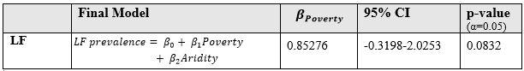

Visualization of LF and poverty shows potential clustering of LF in areas of high poverty, particularly in the south-central, north-central and eastern areas of Nigeria (Figure 1).

**Figure 1.** Lymphatic filiriasis (LF) prevalence (*NTD Mapping Tool Methods 2014*, 2014) and proportion of people living below the nationally set poverty line, Nigeria. (Tatem et al., 2014)

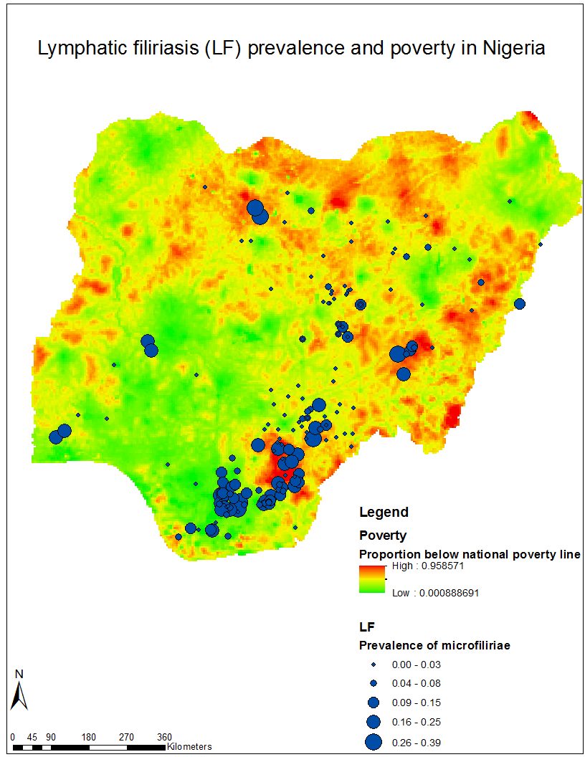

A Pearson correlation analysis controlling for all covariates did not reveal a statistically meaningful relationship between LF prevalence and poverty in Nigeria (Table 2).

A multicollinearity assessment of candidate variables revealed collinearity between annual precipitation and the aridity index. Dropping annual precipitation resolved the collinearity issue with the aridity index, however this gave rise to a collinearity issue between the intercept and mean temperature. Dropping mean temperature resolved the collinearity issue and multicollinearity problems desisted.

All possible subsets, backwards elimination was then employed to find the most unbiased estimate of the poverty-LF association. The aridity index was identified as a confounder of the poverty-LF association. As a result, the final model controlled for the confounding effect of the aridity index. This final model did not find a significant relationship between poverty and LF (β1 = 0.85, 95% CI:-0.32-2.03). These findings, though imprecise, suggest that holding aridity constant, the change in log-prevalence of LF is 0.24 for a contrast of communities at the 75th versus the 25th percentile of poverty.

## 3.3 Spatial results

Global analyses revealed little information regarding clustering of LF prevalence points in space. The K-function analyses for Benue (Figure 2) indicated that points were slightly clustered from 0 to approximately 2000 meters, however the slope of the line changed very sharply thus this may not be reliable output. The K-function for Imo did not indicate any clustering. The weighted K-function analyses for both Benue and Imo revealed that LF prevalence is not clustered based upon this data.

**Figure 2.** Global K-function analysis performed for state of Benue.

The hot-spot analyses performed on Benue (Figure 3) revealed two points of LF prevalence clustering in central Benue and on Imo revealed six points of LF prevalence clustering in northwest Imo (Figure 3).

**Figure 3.** Results of a hot-spot analysis (Getis Gi(d)) performed in Benue (left) and Imo (right).

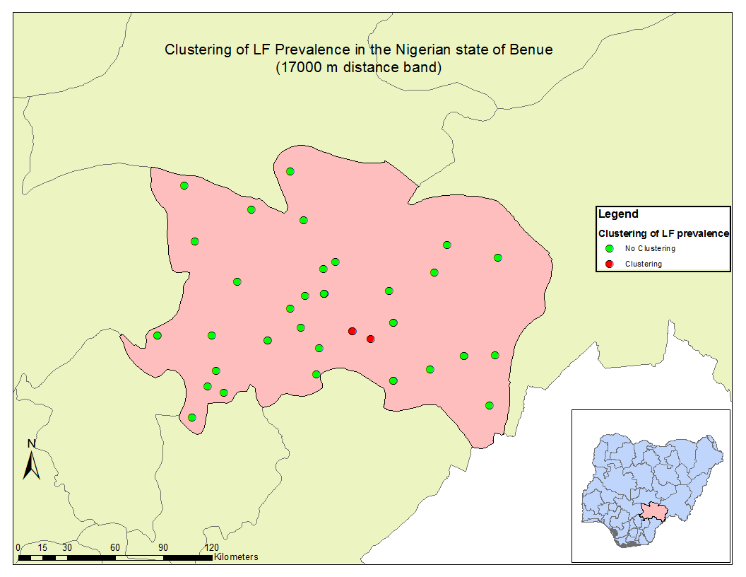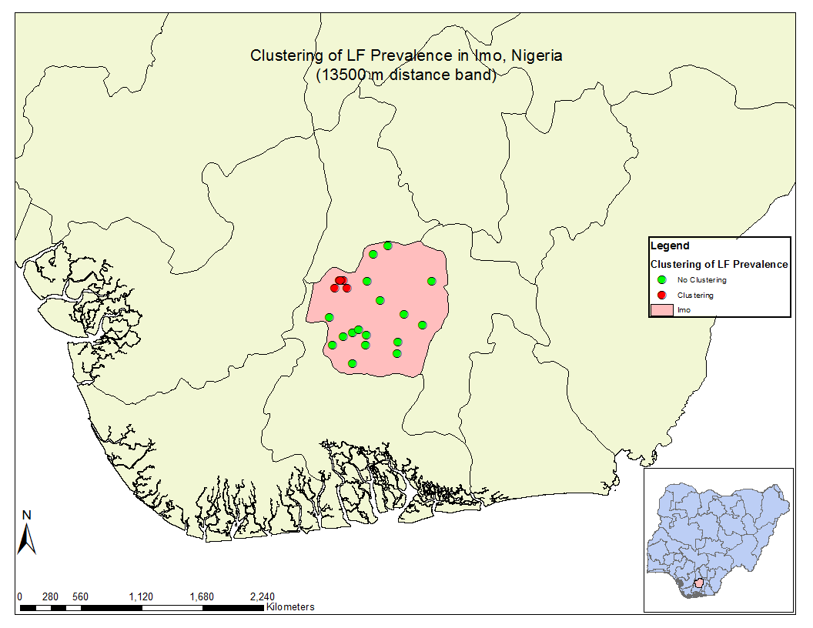

The bivariate cluster analysis using a bivariate LISA (local Moran’s I) using a 1/d weighting scheme conducted to assess the relationship between poverty at a point with the values of the neighbors of LF revealed three points of bivariate spatial association in the same direction (high-high) in Benue (Figure 5). The bivariate LISA revealed one point of bivariate spatial association in the same direction (high-high) in Imo, but six points of discordant (low-high) points of spatial association in Imo (Figure 6).

**Figure 4.** Results of a bivariate LISA analysis on poverty and LF in Benue (left) and Imo (right).

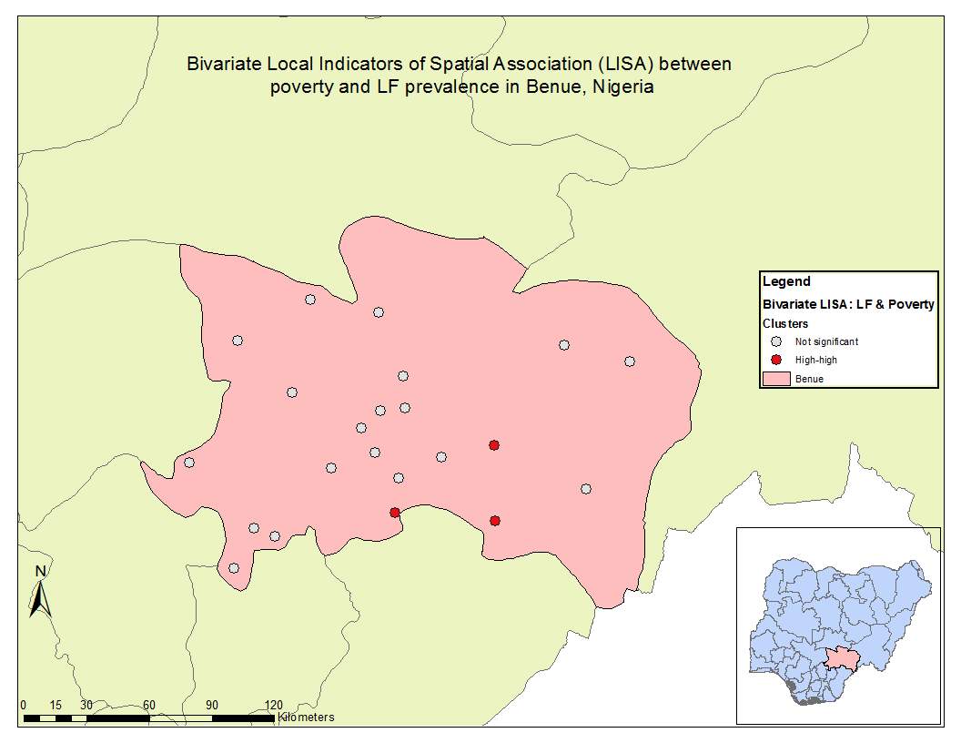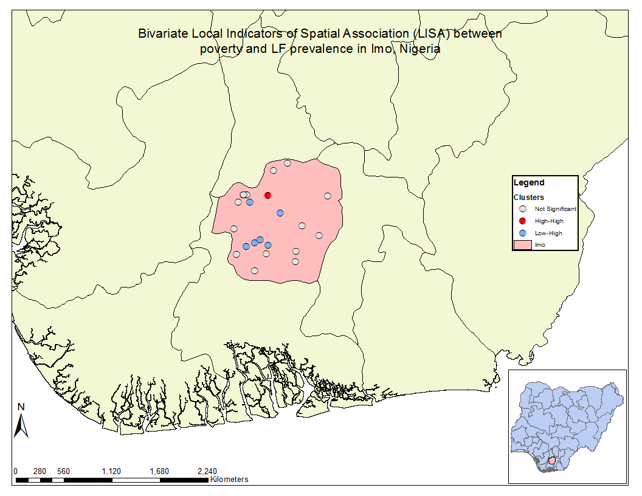

Ordinary least squares(OLS) unadjusted (Figure 5) and adjusted models (Figure 6) were run and the standardized residuals from both models were visualized and tested for global spatial autocorrelation using Moran’s I for both Benue and Imo. Results of the Moran’s I tests for the unadjusted OLS models were: -0.0043801 (*P =* 0.855738) for Benue and 0.838245 (*P=*0.362345) for Imo. Moran’s I for the adjusted OLS models were: -0.048738 (*P=*0.830180) for Benue and 0.7226 (*P=*0.431008) for Imo. None of the models revealed significant autocorrelation, thus analysis proceeded to geographically weighted regression. Geographically weighted regression was then performed on the unadjusted and adjusted models and revealed that allowing regression coefficients to vary spatially did not improve the fit of the model for this data (Table 4).

**Figure 5.** Model residuals from the unadjusted OLS models for Benue (left) and Imo (right).

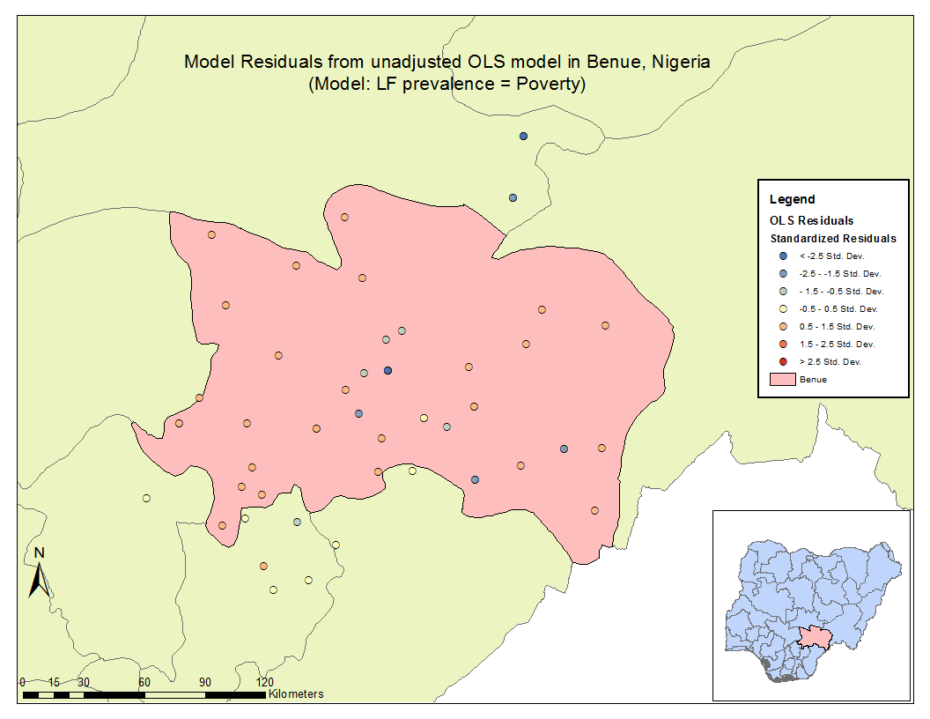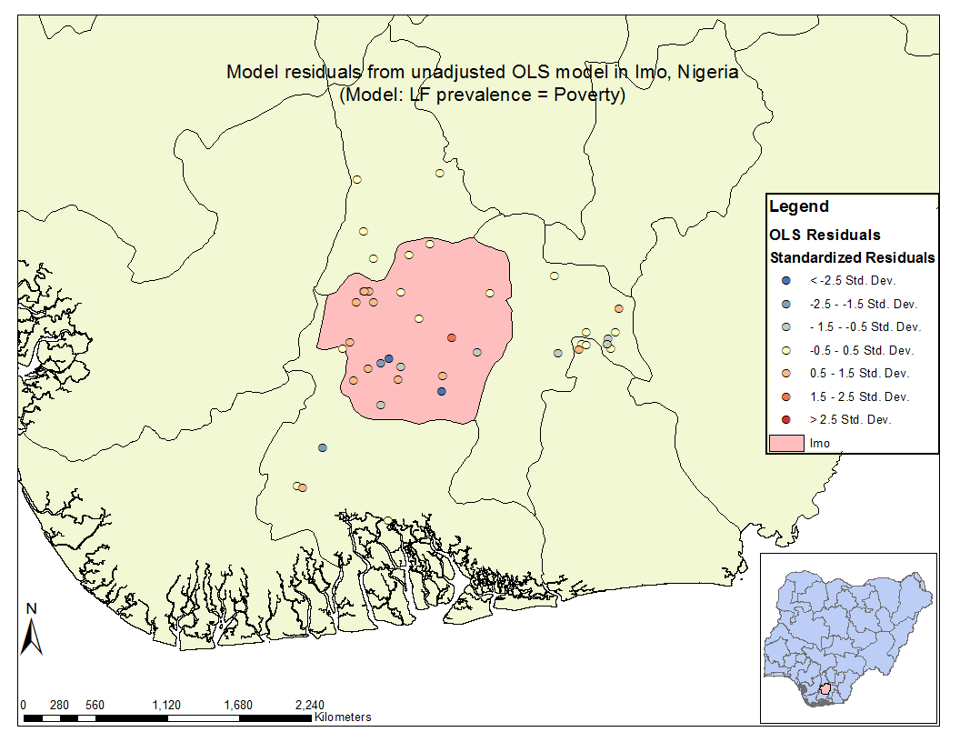

**Figure 6.** Model residuals from the adjusted OLS models for Benue (left) and Imo (right).

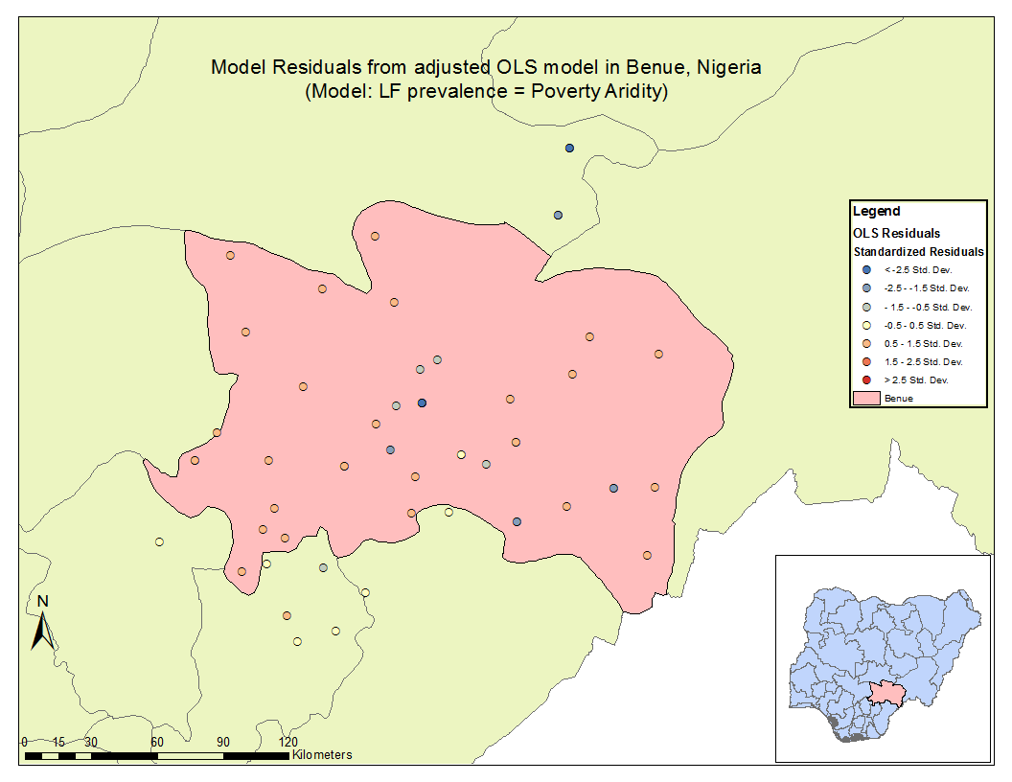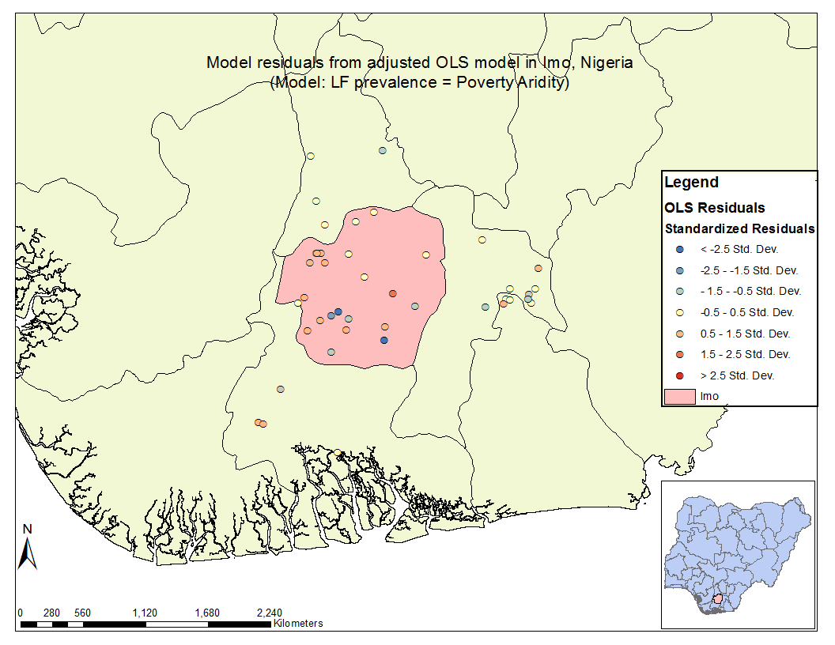

**Table 4.** Summary tables of models performed for both Benue and Imo.

Benue

|  |  |  |  |  |  |
| --- | --- | --- | --- | --- | --- |
|  | **Intercept** | **Poverty** | **Aridity** | **AICc** | **Adjusted R2** |
| **OLS unadjusted** | -1.057119 | -0.217173 |  | 253.769266 | -0.016210 |
| **OLS adjusted** | -1.308092 | -0.388812 | 0.000038 | 256.028883 | -0.032962 |
| **GWR unadjusted** | -1.057226 | -0.217458 |  | 253.772539 | -0.016255 |
| **GWR adjusted** | -1.308246 | -0.389065 | 0.000038 | 256.03637 | -0.033069 |

Imo

|  |  |  |  |  |  |
| --- | --- | --- | --- | --- | --- |
|  | **Intercept** | **Poverty** | **Aridity** | **AICc** | **Adjusted R2** |
| **OLS unadjusted** | -2.433110 | 0.466398 |  | 115.031458 | -0.022436 |
| **OLS adjusted** | -0.845455 | 0.115512 | -0.000112 | 116.359430 | -0.021568 |
| **GWR unadjusted** | -2.43322 | 0.467257 |  | 115.033371 | -0.022462 |
| **GWR adjusted** | -0.842722 | 0.115927 | -0.000112 | 116.365983 | -0.021686 |

# 4.1 Discussion

Sub-national, geospatial assessments of the relationship between poverty and lymphatic filariasis, controlling for appropriate and available covariates as prior literature informed, revealed a positive estimate of poverty-LF association. This estimate, however, was gravely imprecise and non-significant. This finding is important for the LF elimination community to consider and invest additional resources into further research and collection of LF data that is representative of within country heterogeneity. The results of this analysis fail to reject the null hypothesis of no association between poverty and LF however these results should not be misinterpreted as confirmation of a null association.

Annual rainfall, annual mean temperature, aridity and land cover were chosen as covariates for investigating the relationship between LF and poverty based upon past research and were included to better isolate the relationship between poverty and LF. Literature has found that vector-borne and parasitic diseases, including neglected tropical diseases, are influenced by both socioeconomic factors such as poverty and environmental factors (Bonds et al., 2012; Dasgupta, 1997; Deaton, 2003). Thus theoretically, controlling for environmental factors that are predictors of LF, the poverty-LF association estimate should be closer to its’ true value.

Spatial analyses did not reveal a meaningful association between poverty and LF at the state-level. Clustering of points in space were present in Benue using the K-function, however these results should raise suspicion given the sharp change in slope at 2000 meters. There was no clustering of points in Imo at the global level, nor was there clustering of prevalence in either state at the global level. There were some hot spots in each state and the bivariate LISA revealed information about the poverty-LF relationships in each state. Imo had six points of low poverty, high LF points which may have to do with geography and climate. Imo is in southern Nigeria where the climate is very tropical, thus perhaps it doesn’t matter if you are wealthy or poor, the climate is hospitable to the LF vector. The spatial structure of the OLS residuals for unadjusted and adjusted models were not spatially autocorrelated, thus geographically weighted regression(GWR) could be performed. However, GWR did little to better the understanding of the poverty-LF association (based upon examination of the AICc).

## 4.2 Limitations

As stated above, a positive estimate of association between poverty and LF was found, however this estimate was very imprecise and likely attributable to low power. Incomplete small area outcome data and potential measurement issues with exposure data as well as covariate data compromised statistical power for analyses. Data used in this analysis did not appear representative of the LF burden for the entirety of Nigeria. This is in part a result of different disease mapping strategies and also of data-sharing. LF prevalence points were not randomly distributed throughout the country. The lack of representative outcome data greatly limits the ability of spatial analysis to capture within-country heterogeneity of the outcome, exposure and covariates.

Another limitation of this analysis is that it is looking at cross-sectional data of processes that are likely longitudinal. This analysis provides a snapshot of the poverty-LF relationship, however transmission likely changes seasonally, environmental suitability may vary over time, and the covariates precipitation, temperature and aridity potentially vary on a daily basis. Accounting for temporal variability in future studies would improve estimates of the poverty-LF association.

The use of geostatistically generated raster layers for poverty and all covariates in this thesis assumed absolute spatial certainty of estimates which is unrealistic and a limitation of the findings reported here. In future analyses, incorporating the spatial uncertainty introduced by each layer would improve estimates and paint a more informative landscape of the associations being examined.

This investigation was carried out using only open-source, publicly available data. Data-sharing is valuable and vital to fostering collaborative research efforts to alleviate the world from biological and societal burdens, however, open-source data does come with unique challenges, as well. Bringing in data from multiple different sources makes analysis, particularly geospatial analysis, challenging as one has to consider various factors that may affect analysis such as spatial resolution, projection and data type.

## 4.3 Conclusions

Most find it intuitively plausible that the effects of poverty on overall health are deleterious (Deaton, 2003). However it is also plausible that the effects of poor health lead to poorer economic outcomes. Determining the impact of poverty on NTD prevalence or vice versa is an enduring challenge in aid distribution and intervention programs. A geospatial assessment of the relationship between poverty and NTD prevalence at a sub-national level, accounting for potential confounders and assuming representative data, could provide valuable insight for policy-makers and public health strategists. Areas most affected by either outcome could be appropriately targeted with interventions, funding allocation could be better informed, and surveillance could be strengthened.

The results of this study highlight the importance of representative sub-national data for the investigation of intra-country variation in the relationship between poverty and LF prevalence. Future work should include a reevaluation of the spatial infrastructure of LF surveillance to include improved, temporally-relevant small area LF surveillance. Improving small area LF surveillance is necessary for characterizing, monitoring and intervening on LF transmission.

NTDs contribute to increased morbidity and decreased quality of life. Poverty has similarly detrimental effects. NTDs and poverty affect more than a billion people worldwide and weigh heavily on the global humanitarian conscience. To alleviate the burden of one may aid in mitigating the other, however, this cannot simply be assumed. A more complete, small area understanding of the relationship between poverty and NTDs is essential for informing policy and interventions to lessen the global burden of both poverty and NTDs.

# References

Bailey, R., Downes, B., Downes, R., & Mabey, D. (1991). Trachoma and water use; a case control study in a Gambian village. *Transactions of the Royal Society of Tropical Medicine and Hygiene*, *85*(6), 824–828. Retrieved from http://ovidsp.ovid.com/ovidweb.cgi?T=JS&PAGE=reference&D=emed2&NEWS=N&AN=1992012662

Bhaumik, S., Karimkhani, C., Czaja, C. A., Williams, H. C., Rani, M., Nasser, M., … Dellavalle, R. P. (2015). Identifying gaps in research prioritization: the global burden of neglected tropical diseases as reflected in the Cochrane database of systematic reviews. *J Family Med Prim Care*, *4*(4), 507–513.

Bonds, M. H., Dobson, A. P., & Keenan, D. C. (2012). Disease Ecology, Biodiversity, and the Latitudinal Gradient in Income. *PLoS Biology*, *10*(12), e1001456. http://doi.org/10.1371/journal.pbio.1001456

Cano, J., Rebollo, M. P., Golding, N., Pullan, R. L., Crellen, T., Soler, A., … Brooker, S. J. (2014). The global distribution and transmission limits of lymphatic filariasis: past and present. *Parasites & Vectors*, *7*(1), 466. http://doi.org/10.1186/s13071-014-0466-x

Dasgupta, P. (1997). Nutritional status, the capacity for work, and poverty traps. *Journal of Econometrics*, *77*(1), 5–37. http://doi.org/10.1016/S0304-4076(96)01804-0

Deaton, A. (2003). Health, Inequality, and Economic Development. *Journal of Economic Literature*, *41*(1), 113–158. http://doi.org/10.1257/002205103321544710

Defourny, P., Bogaert, E. Van, Kalogirou, V., & Perez, J. R. (2011). GLOBCOVER 2009 Products Description and Validation Report, 53. http://doi.org/10013/epic.39884.d016

Diez-Roux, a V, Nieto, F. J., Muntaner, C., Tyroler, H. a, Comstock, G. W., Shahar, E., … Szklo, M. (1997). Neighborhood environments and coronary heart disease: a multilevel analysis. *American Journal of Epidemiology*, *146*(1), 48–63. http://doi.org/10.1093/oxfordjournals.aje.a009191

Durrheim, D. N., Wynd, S., Liese, B., & Gyapong, J. O. (2004). Editorial: Lymphatic filariasis endemicity - An indicator of poverty? *Tropical Medicine and International Health*, *9*(8), 843–845. http://doi.org/10.1111/j.1365-3156.2004.01287.x

Frick, K. D., Hanson, C. L., & Jacobson, G. A. (2003). GLOBAL BURDEN OF TRACHOMA AND ECONOMICS OF THE DISEASE. *Am. J. Trop. Med. Hyg.*, *69*(Suppl 5), 1–10.

Galvez Tan, J. Z. (2003). The Elimination of Lymphatic Filariasis: A Strategy for Poverty Alleviation and Sustainable Development - Perspectives from the Philippines. *Filaria Journal*, *2*(1), 12. http://doi.org/10.1186/1475-2883-2-12

Hijmans, R. J., Cameron, S. E., Parra, J. L., Jones, P. G., & Jarvis, A. (2005). Very high resolution interpolated climate surfaces for global land areas. *International Journal of Climatology*, *25*(15), 1965–1978. http://doi.org/10.1002/joc.1276

Khan, O. A., Davenhall, W., Ali, M., Castillo-Salgado, C., Vazquez-Prokopec, G., Kitron, U., … Clements, A. C. A. (2010). Geographical information systems and tropical medicine. *Ann Trop Med Parasitol*, *104*(4), 303–318. http://doi.org/10.1179/136485910X12743554759867

Kitron, U. (1998). Landscape Ecology and Epidemiology of Vector-Borne Diseases : Tools for Spatial Analysis, (Spielman 1994).

May, R. M. (2007). Parasites, people and policy: infectious diseases and the Millennium Development Goals. *Trends in Ecology and Evolution*, *22*(10), 497–503. http://doi.org/10.1016/j.tree.2007.08.009

Molyneux, D. H., & Nantulya, V. M. (2004). Linking disease control programmes in rural Africa: a pro-poor strategy to reach Abuja targets and millennium development goals. *BMJ : British Medical Journal*, *328*(7448), 1129–1132. http://doi.org/10.1136/bmj.328.7448.1129

Mwase, E. T., Stensgaard, A. S., Nsakashalo-Senkwe, M., Mubila, L., Mwansa, J., Songolo, P., … Simonsen, P. E. (2014). Mapping the Geographical Distribution of Lymphatic Filariasis in Zambia. *PLoS Neglected Tropical Diseases*, *8*(2). http://doi.org/10.1371/journal.pntd.0002714

*NTD Mapping Tool Methods 2014*. (2014).

Pickett, K. E., & Pearl, M. (2001). Multilevel analyses of neighbourhood socioeconomic context and health outcomes: a critical review. *emJournal of Epidemiology and Community Healthmmunity Health*, *55*(2), 111–122. http://doi.org/10.1136/jech.55.2.111

Sabesan, S., Raju, H. K. K., Srividya, A., & Das, P. K. (2006). Delimitation of lymphatic filariasis transmission risk areas: a geo-environmental approach. *Filaria Journal*, *5*, 12. http://doi.org/10.1186/1475-2883-5-12

Savioli, L., & Daumerie, D. (2012). Accelerating Work to Overcome the Global Impact of Neglected Tropical Diseases - A Roadmap for Implementation. *World Health Organization*, 42. Retrieved from http://www.who.int/neglected_diseases/NTD_RoadMap_2012_Fullversion.pdf?ua=1

Shouls, S., Congdon, P., & Curtis, S. (1996). Modelling inequality in reported long term illness in the UK: combining individual and area characteristics. *Journal of Epidemiology and Community Health*, *50*(3), 366–376. http://doi.org/10.1136/jech.50.3.366

Sustainable Development Goals: 17 Goals to transform our world. (2015). Retrieved March 7, 2016, from http://www.un.org/sustainabledevelopment/sustainable-development-goals/

Tatem, A., Gething, P., Pezzulo, C., Weiss, D., & Bhatt, S. (2014). *Final Report : Development of High-Resolution Gridded Poverty Surfaces*.

Taylor, M. J., Hoerauf, A., & Bockarie, M. (2010). Lymphatic filariasis and onchocerciasis. *Lancet*, *376*(9747), 1175–85. http://doi.org/10.1016/S0140-6736(10)60586-7

Waitzman, N. J., & Smith, K. R. (1998). Phantom of the area: Poverty-area residence and mortality in the United States. *American Journal of Public Health*, *88*(6), 973–976. http://doi.org/10.2105/AJPH.88.6.973

World Health Organization. (2015). Lymphatic filariasis. Retrieved October 17, 2015, from http://www.who.int/mediacentre/factsheets/fs102/en/

Zomer, R. J., Trabucco, a, Van Straaten, O., & Bossio, D. a. (2006). *Carbon, Land and Water:A Global Analysis of the Hydrologic Dimensions of Climate Change Mitigation through Afforestation/Reforestation*. *Water Management* (Vol. 101). http://doi.org/http://dx.doi.org/10.3910/2009.122

Zomer, R. J., Trabucco, A., Bossio, D. A., & Verchot, L. V. (2008). Climate change mitigation: A spatial analysis of global land suitability for clean development mechanism afforestation and reforestation. *Agriculture, Ecosystems and Environment*, *126*(1-2), 67–80. http://doi.org/10.1016/j.agee.2008.01.014