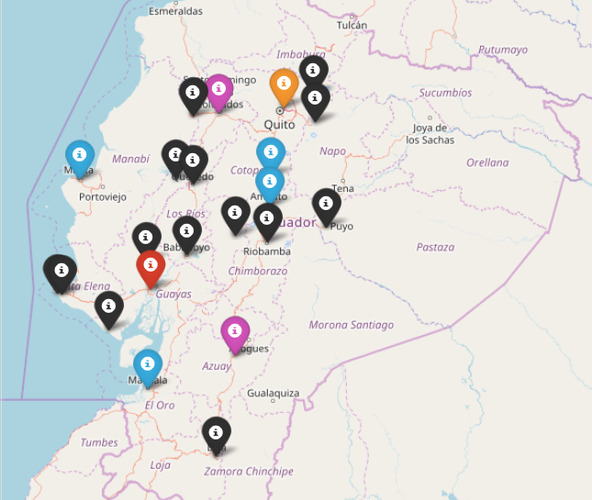

**Corporación Favorita Grocery Sales Forecasting:**

**Final Report**

Raksha Kaverappa

Emily Strong

December 15, 2017

## Overview

## Design

## Implementation

## Analysis

### Exploratory Data Analysis

|  |
| --- |
| images/FavoritaLocationMap_cropped.png  Figure 1: Density of Stores Per City. Legend: Black = 1 store, Blue = 2 stores, Purple = 3 stores, Red = >5 stores, Orange = >10 stores |

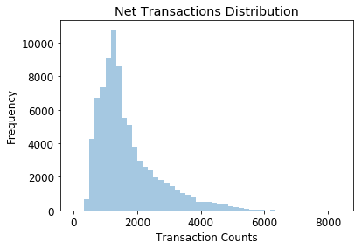

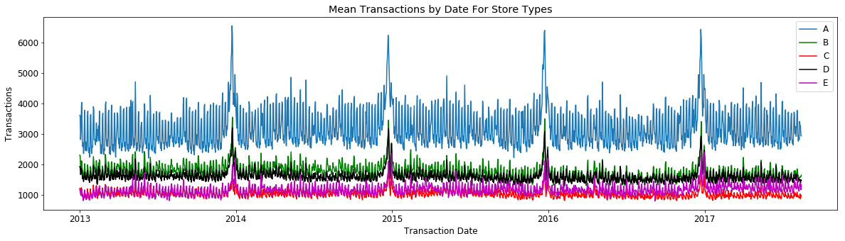

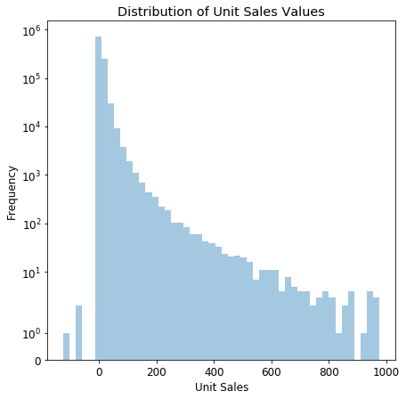

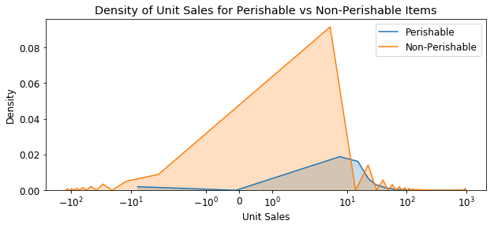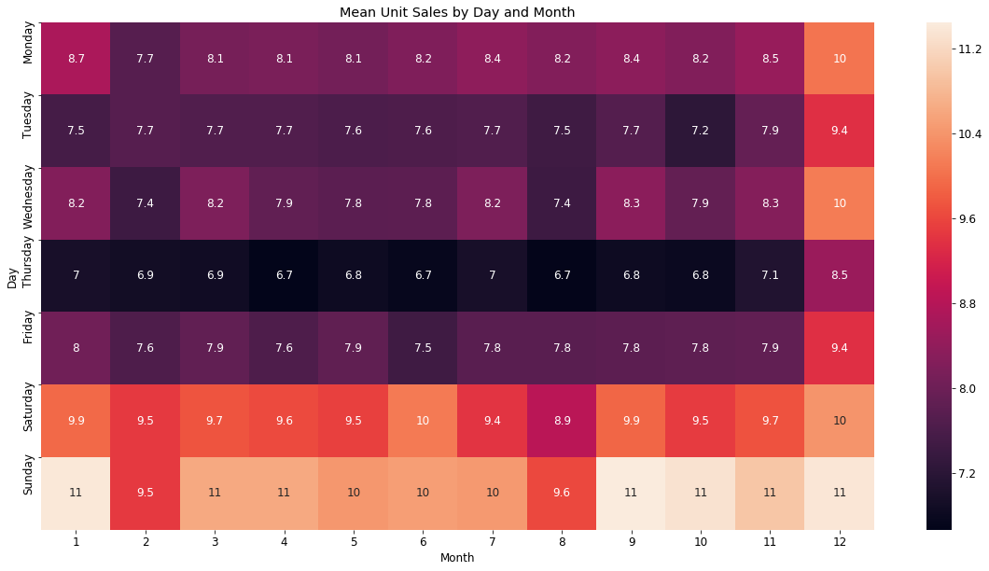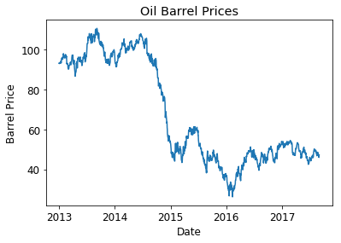

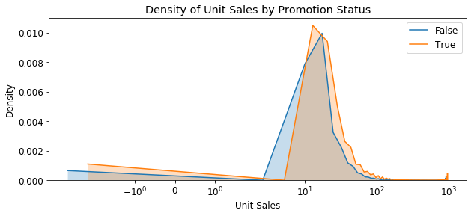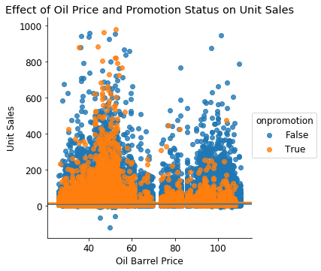

### Clustering

Unit sales:

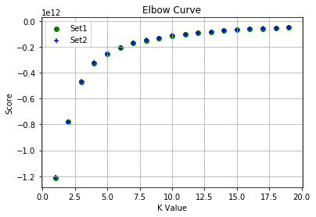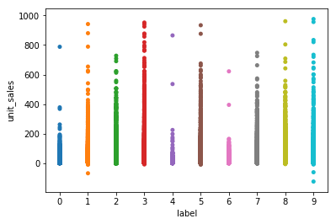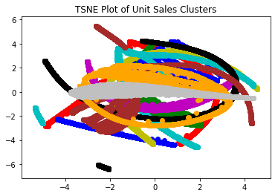

Store Transactions:

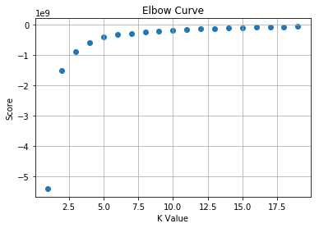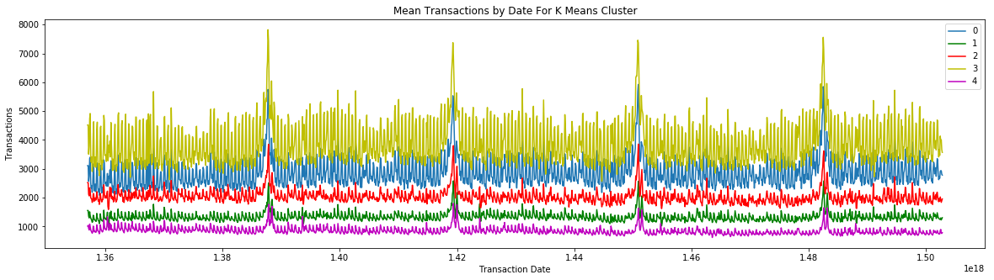

### Prediction Models

### Time Series Models

## Conclusion

## References

## Contributions

Data Wrangling:

Luigi:

Exploratory Data Analysis:

Clustering:

Prediction Models:

Time Series Models:

Azure ML:

Flask App: