Task1

For the 1st task, I added the driving variable to all the constraints, so that the driving constraint is included in the equation while the vehicle is filling or unloading.

In addition, the vehicle needs to take this variable into consideration in order to reach the battery value in the morning.

just as you want.

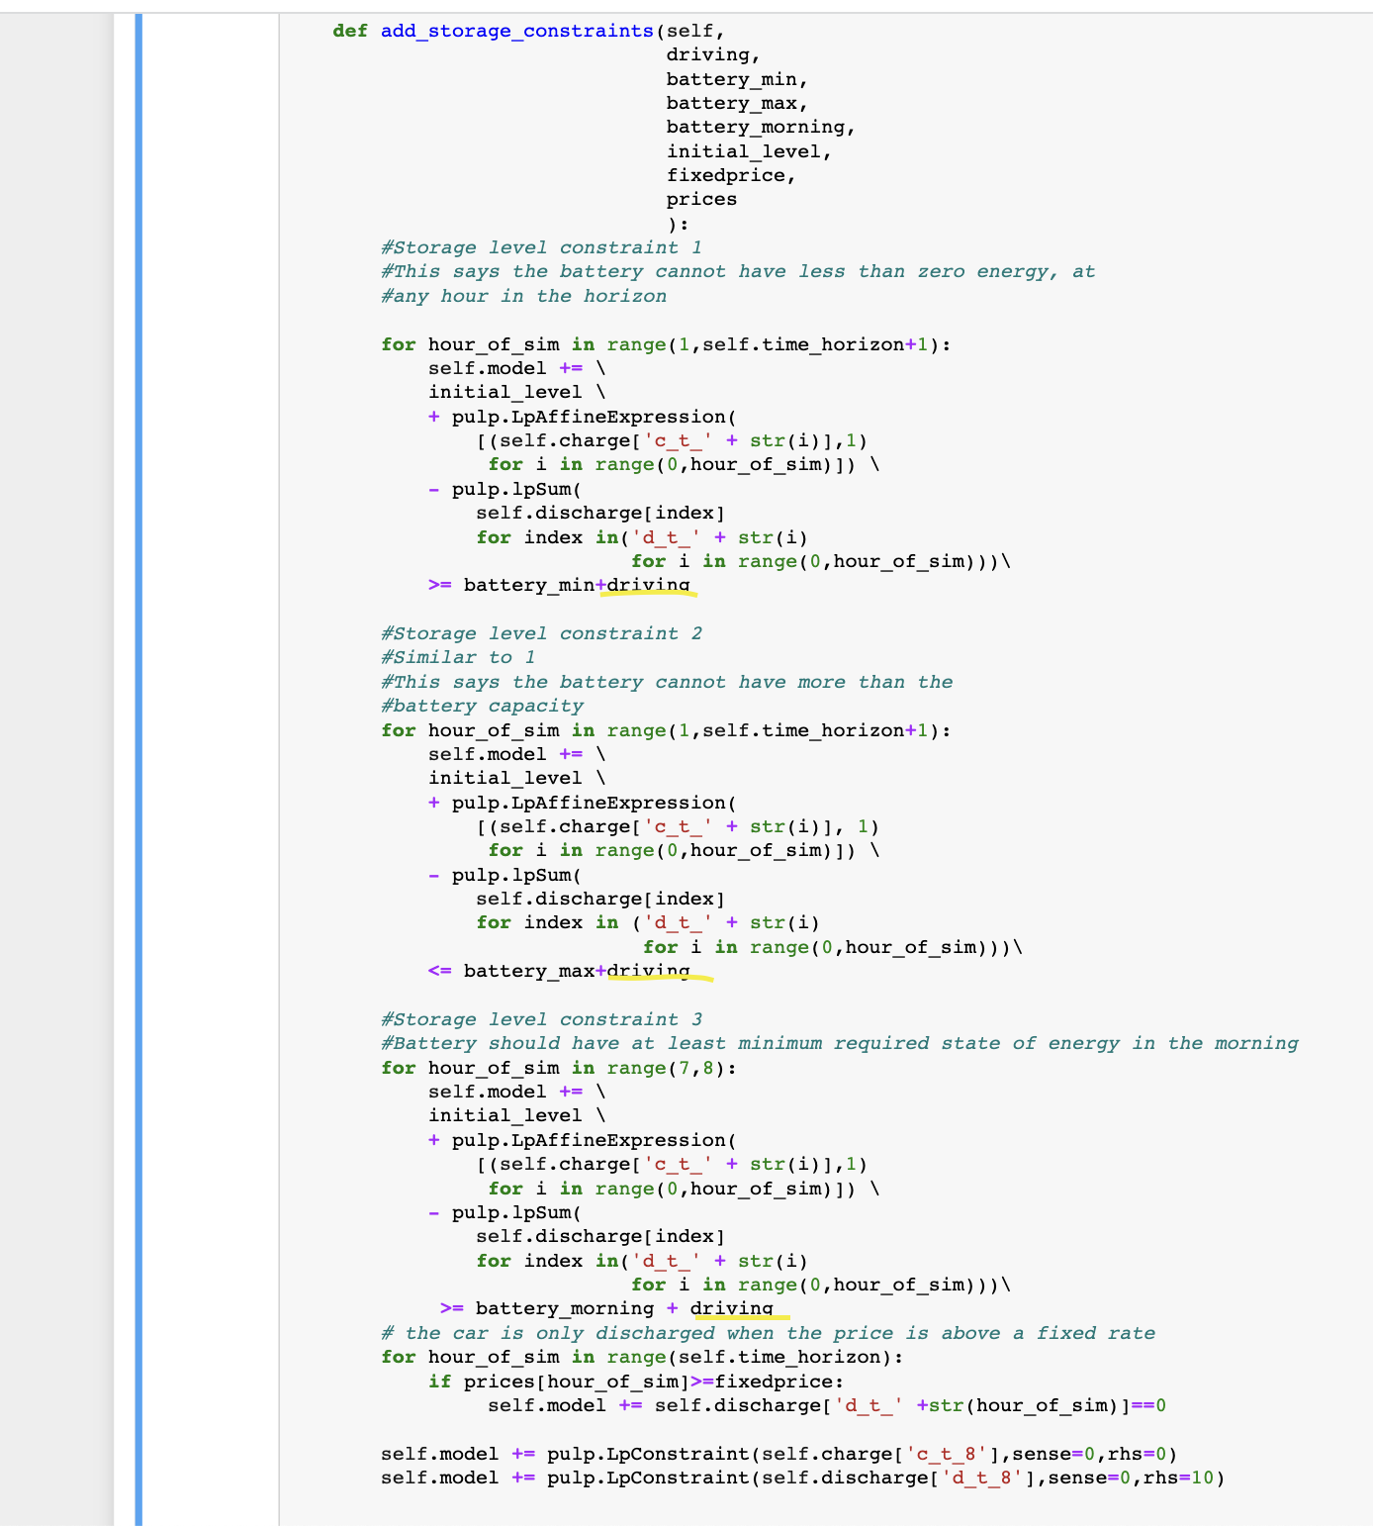

Task2

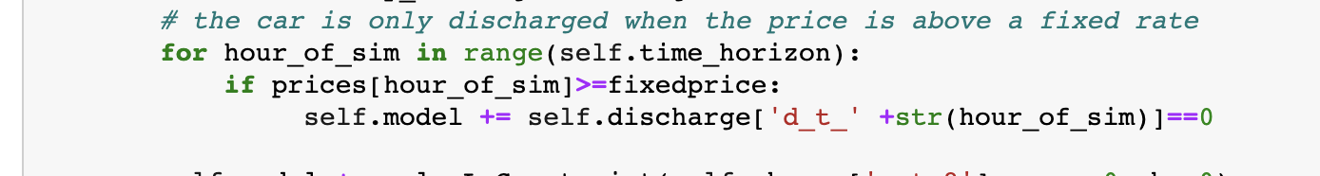

I created the fixedprice variable for the 2nd task, if the prices are higher than this price, it will not be discharged during these hours. If you want, we can add a no-charge restriction to this constraint.