Part A)

3.

Our DC link ripple frequency is equal to 150Hz, with a current which cannot be ignored magnitude of ripple will be huge. To filter that component, an LC filter is selected. Values of the filter components calculated with analyzing frequency response and optimized with Simulink simulation.

ışık içeren bir resim

Açıklama otomatik olarak oluşturuldu

Figure 1: Designed filter

Designed filter and values of the filter can be seen above. To test the filter output, output is loaded with 1ohm resistor. Ripple voltage can be seen below.

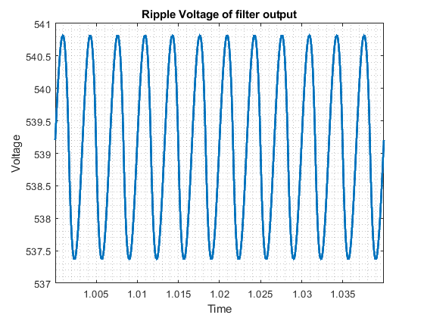

Figure 2: Voltage waveform