**Erugu Srinivasulu**

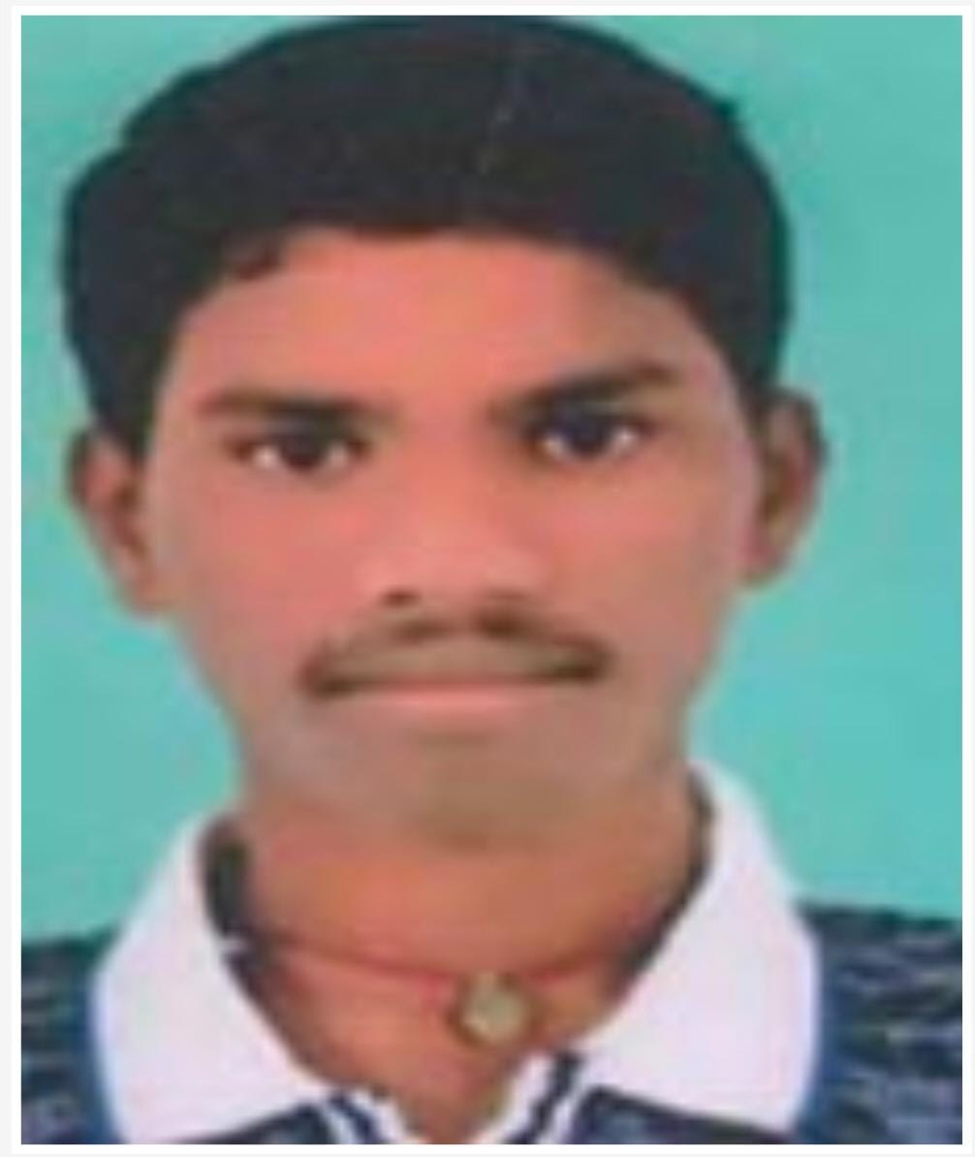

Mobile: +91 7815867946

Email ID: [srinivaserugu987@gmail.com](mailto:srinivaserugu987@gmail.com)

**Career Objective:**

To pursue my career in an organization with performance-oriented environment for achievement of personal advancement. Being ambitious and hardworking, I am looking forward to challenging my potential and be worthy of Management trust and confidence.

**Education:**

|  |  |  |  |  |
| --- | --- | --- | --- | --- |
| **Qualification** | **Institution** | **University/Board** | **Year of Passing** | **Percentage** |
| B. Tech (CSE) | Narayana Engineering College, Gudur | JNTU-A | 2023 | 68 |
| Intermediate | Vikram Junior College, Srikalastri | Board of Intermediate | 2019 | 68 |
| SSC | Audisankara English medium High School | S.S.C | 2017 | 72 |

**Skills**

Software Languages: C, Java, SQL

Utility Package: MS-office

Operating Systems: Windows, Linux, and Android

**Project Work:**

* Project Name: DDOS Attacks
* Technologies Used: Machine learning
* Project Description: In this project, The experimental results show that the proposed DDoS attack detection method based on machine learning has a good detection rate for the current popular DDoS Attack.

**Personal Details**

Date of Birth : 13-08-2000

Gender : Male

Marital status : Single

Languages Known : English, Telugu, Hindi.

Nationality : Indian

Hobbies : Playing Cricket, Watching Tv.

**Declaration**

I hereby declare that the details above are correct and true to the best of my knowledge.

**Place:** Bangalore **Signature**

**Date:** 17-09-23 **Erugu Srinivasulu**