Lab Exercise 1

Part 1. Becoming familiar with QTSPIM

We will be using QTSpim in this class as it is available on all major OS’s used today.

Step 1.

Download and install QTSPIM on your computer.

Download the latest version of QTSPIM for your operating system at the following link

<http://sourceforge.net/projects/spimsimulator/files/>

Additionally I would recommend using a good text editor when we write and edit assembly files. I am using notepad ++ which is available free at the following link.

<http://notepad-plus-plus.org/>

Step 2.

Download mipsdemo.asm and spim.pdf attached to this assignment on blackboard.

Step 3.

Open the QTSPIM application

Go to Simulator🡪settings click on the MIPS tab and make sure *Accept Pseudo Instructions* is unchecked.

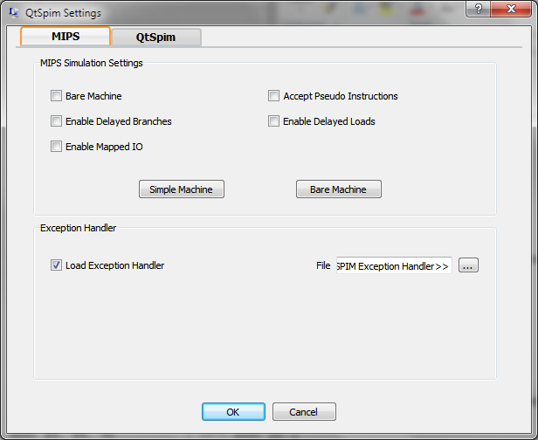

Step 4.

Go to Window and make sure the console window is checked. You should have another window opened called Console.

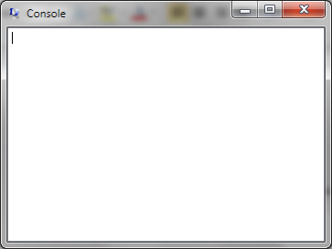

Step 5. Load the program and walk through

Go to File->Load File and load mipsdemo.asm

**NOTE: If you get error messages when you load or while executing the program go to File-> Reinitialize and Load File and start over.**

Step through the program by pressing F10. As you will see this walks through the code line by line. You should notice as instructions are being executed the registers located on the left are being updated with new values. Eventually you will hit a syscall instruction that will prompt messages on the screen. When you are prompted to enter the first integer enter the value in hex of the first letter(use capitals) in your first name and press enter. *Example I would enter 78 as my first name starts with the letter N.*

**Note: ASCII chart is located in your book on pg 122**

Again you will be prompted to enter a second integer enter the value in hex of the first letter(use capitals) in your last name and press enter. *Example I would enter 68 as my last name starts with the letter D.*

(PART OF SUBMISSION)Get a screen capture of the results.

Step 6.

(PART OF SUBMISSION)Answer the question located in the assembly file. Make sure you use spim.pdf as reference material along with your book to look up MIPS instructions.

Step 7.

(PART OF SUBMISSION)I want you to alter the program to multiply two numbers using the **mul** instruction. You should additionally change the asciiz text to printout that the program will multiply two numbers and that the output will be the product of the result no longer the sum(this will effect the syscall offsets). Finally demonstrate the result by multiplying the numbers you used in step 5 and get a screen capture of the result.

Step 8. SUBMISSION

1. Submit the screen capture of the result from step 5
2. Answer the 10 questions from step 6
3. Submit the updated assembly program
4. Get a screen capture of the multiplication program in step 7 using the same inputs as you did in step 5