

CS210 MiniProject II

*Tower of Hanoi*

By: Erum Meraj

2201CS24

**Demonstration Video:**

<https://drive.google.com/drive/folders/1KQuzqHvfm42PTPSEUrlA6q7E7umYZuqF>

**Presentation Link:**

https://docs.google.com/presentation/d/1bjU1CMZs_X97ml-_OTTU3TyNE6-rQ9TanBLCvQGq15M/edit?usp=sharing

**Code Link:**

<https://github.com/yoco-a11/Course_Projects/tree/main/FPGA%20DE1-SOC>

**Inputs Used:**

- JTAG UART: Used for user input and communication.

- Switches: Used to select source and destination rods.

- VGA Display: The game is displayed on the video interface upon the monitor.

**Gameplay:**

1. Home Screen:

- Users are presented with a home screen upon starting the game.

- They can choose to read the rules or start the game.

- Controls: Press `TAB` to read rules and `ENTER` to start.

2. Rules:

- Users can read the rules of the Tower of Hanoi game.

- The objective is to stack all disks on Rod C.

- Players must move disks from Rod A (source) to Rod C (destination), adhering to certain rules.

- Controls: Press `ESC` to return to the home screen.

3. Gameplay:

- Players interact using the JTAG UART terminal.

- They select the source and destination rods using the switches.

- Larger disks cannot be placed on top of smaller disks.

- The game tracks the number of moves made.

- The game ends when all disks are moved to Rod C.

4. Game Over:

- Upon completing the game, players are notified of their victory.

- They can choose to return to the home screen.

- The minimum number of moves required is displayed.

**Conclusion:**

The Tower of Hanoi game is successfully implemented on the DE1-SOC board, offering players an engaging and challenging experience.

**Snapshots:**

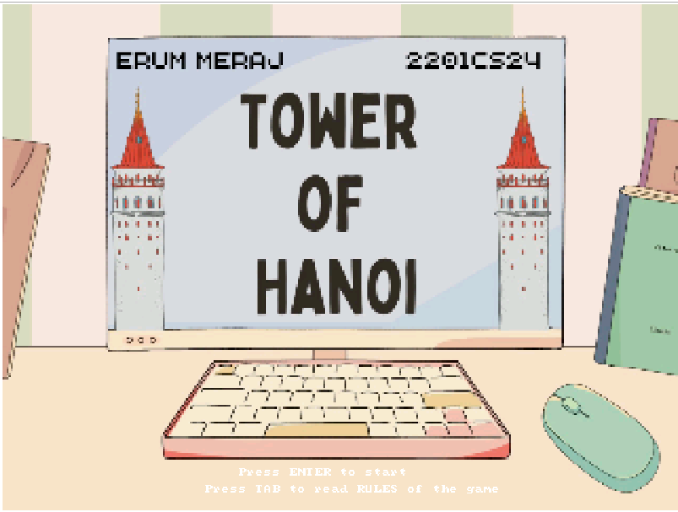

**Fig1: Homepage**

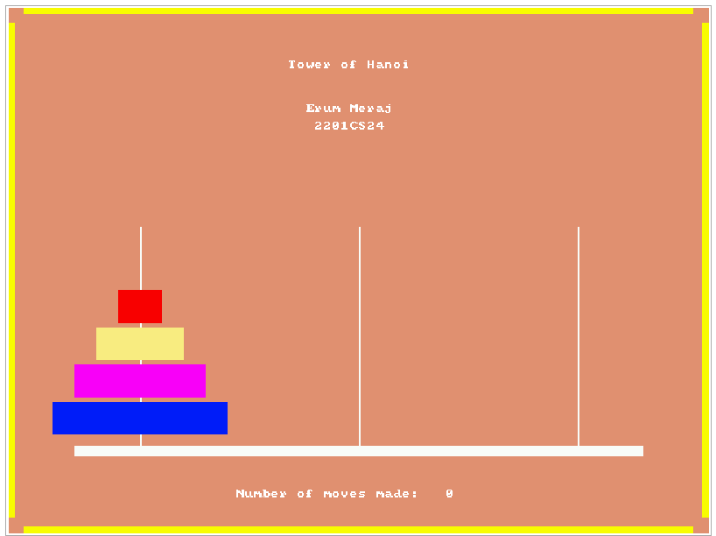

**Fig2: Game Screen**

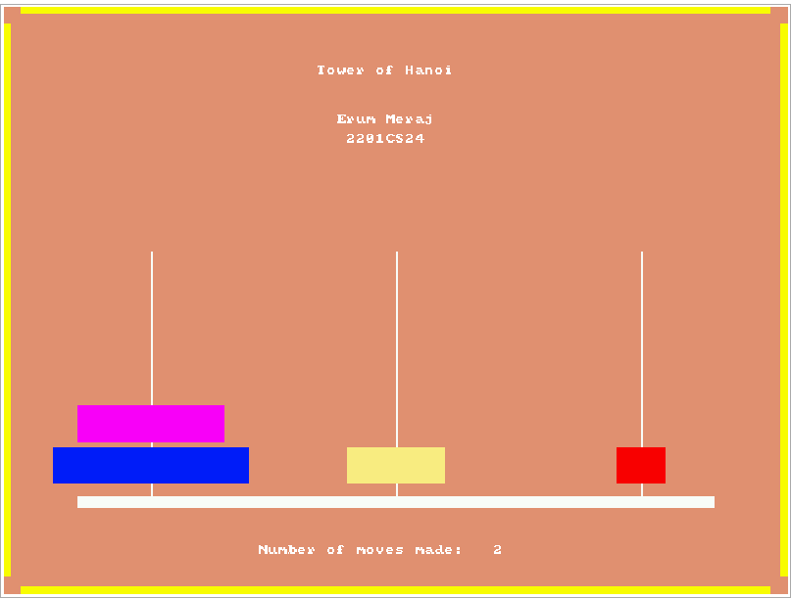

**Fig3: Game being played, moves tracked**

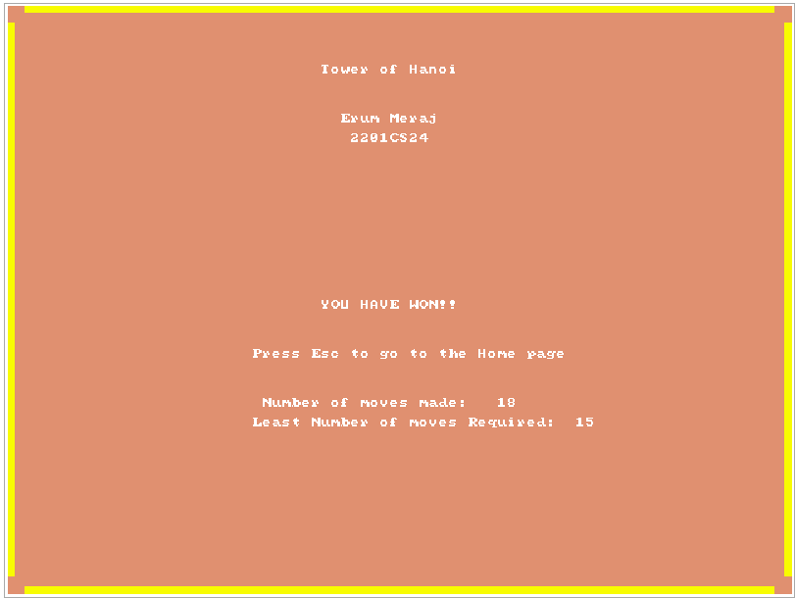

**Fig4: Winning Screen**