Lab 04: Assignment: Ping Utility Analysis

Objective:

In this assignment, you will analyze the ping utility, a fundamental network diagnostic tool. You will explore its functionality, usage, and output, and demonstrate your understanding through a series of tasks.

Tasks:

1. Ping Basics
- Explain the purpose of the ping utility and its basic syntax.
- The ping utility checks network connectivity between your computer and a target host by sending ICMP Echo Request packets. It verifies if the host is reachable and measures the round-trip time for packets to travel there and back, helping diagnose network issues like high latency or packet loss.

- Basic syntax: ping [options] destination
  - destination: The IP address or domain name of the target.
  - Common options:
  - -c count: Number of packets to send.
  - -i interval: Time between packets.
  - -t ttl: Time-to-live for packets.
- Provide examples of how to use ping to test connectivity to a website and a local host.
- Ping google.com
- ping 192.168.1.1
2. Ping Output Analysis
- Run the command ping (link unavailable) and capture the output.
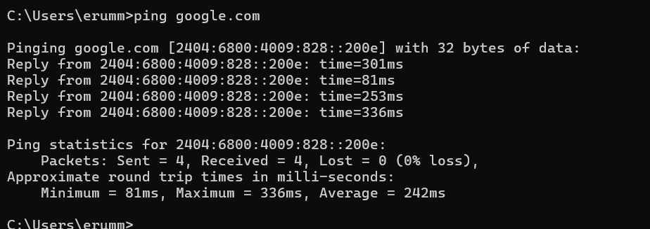
- Analyze the output, explaining each line and its significance (e.g., packet loss, round-trip time, etc.).
- Initial Line:
sh

PING www.google.com (172.217.14.196): 56 data bytes
  - PING www.google.com (172.217.14.196): Indicates that the command is pinging the domain www.google.com, which resolves to the IP address 172.217.14.196.
  - 56 data bytes: Refers to the size of the ICMP Echo Request packet payload being sent (56 bytes by default).
- Response Lines:
sh

64 bytes from 172.217.14.196: icmp_seq=0 ttl=53 time=14.5 ms
Each line represents a response from the target host.
  - 64 bytes from 172.217.14.196: Indicates that 64 bytes of data were received from the IP address 172.217.14.196.
  - icmp_seq=0: Shows the sequence number of the ICMP packet (starting at 0 and incrementing with each packet sent).
  - ttl=53: Stands for Time-To-Live, indicating the maximum number of hops (routers) the packet can pass through before being discarded. A higher TTL suggests fewer hops between the source and destination.
  - time=14.5 ms: Shows the round-trip time it took for the packet to reach the destination and return, measured in milliseconds (ms). This value reflects network latency.
- Statistics Summary:
sh

--- www.google.com ping statistics ---
4 packets transmitted, 4 packets received, 0.0% packet loss
round-trip min/avg/max/stddev = 13.9/14.1/14.5/0.2 ms
  - 4 packets transmitted, 4 packets received: Indicates that 4 ICMP Echo Request packets were sent and 4 were successfully received back.
  - 0.0% packet loss: Shows the percentage of packets that were lost during transmission. A 0% packet loss indicates that all packets were successfully delivered and returned.
  - round-trip min/avg/max/stddev = 13.9/14.1/14.5/0.2 ms: Summarizes the round-trip time statistics:
    - min: The minimum round-trip time observed.
    - avg: The average round-trip time.
    - max: The maximum round-trip time.
    - stddev: The standard deviation, showing the variability in round-trip times.
Significance:
- Packet Loss: Indicates potential network issues if there’s any significant packet loss.
- Round-Trip Time (RTT): Reflects network latency; lower RTT values indicate faster communication between the source and destination.
- TTL: Provides insight into the number of hops the packet took, which can help in diagnosing routing issues.
- Repeat the process for a local host (e.g., ping 127.0.0.1).
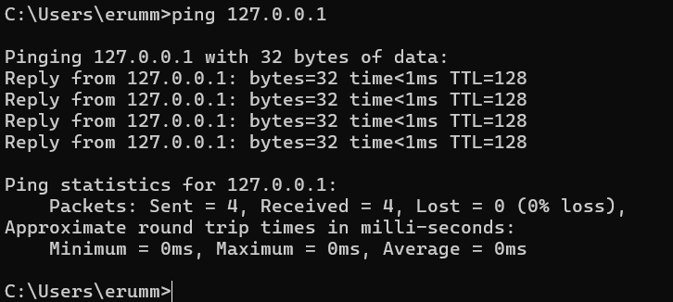
- Initial Line:
sh

ping 192.168.1.1
  - This command initiates a ping to the IP address 192.168.1.1, which is typically a local network address, often associated with a router or another device on your local network.
- Pinging with Data:
sh

Pinging 192.168.1.1 with 32 bytes of data:
  - This line indicates that the ping command is sending ICMP Echo Request packets with a payload of 32 bytes to the target IP address 192.168.1.1.
- Request Timed Out:
sh

Request timed out.
  - This message means that no response was received from the target IP address within the expected time frame. The target host did not reply to the ICMP Echo Request packet, which might indicate that the host is offline, unreachable, or that the network connection is down.
- Destination Net Unreachable:
sh

Reply from 122.187.157.165: Destination net unreachable.
  - This message indicates that the router or gateway at IP address 122.187.157.165 reported that the destination network for 192.168.1.1 is unreachable. This suggests a routing issue, possibly due to misconfiguration, a disconnected device, or network failure between the source and destination.
- Ping Statistics:
sh

Ping statistics for 192.168.1.1:
Packets: Sent = 4, Received = 2, Lost = 2 (50% loss),
  - Packets Sent = 4: Four ICMP Echo Request packets were sent to the target IP address.
  - Received = 2: Two packets were received back, but these were "Destination net unreachable" messages, not proper ICMP Echo Replies from 192.168.1.1.
  - Lost = 2 (50% loss): Two packets were lost, resulting in a 50% packet loss. This indicates that half of the requests sent did not receive any response.
Significance:
- Request Timed Out: Indicates a failure to receive any response from the target, which might suggest the target device is down, the network is misconfigured, or there are connectivity issues.
- Destination Net Unreachable: Suggests that the target network is unreachable, likely due to a routing issue or the target being disconnected from the network.
- Packet Loss: A 50% packet loss is significant and indicates poor connectivity or a network issue, which requires further investigation.
This output suggests that there is a problem with the network connectivity to 192.168.1.1, possibly due to routing issues or the target device being offline or unreachable.

3. Ping Options
- Research and explain the following ping options:
- -c (count)
- -s (size)
- -t (ttl)
- -W (deadline)
- Provide examples of how to use each option.
1. -c (count):
- Description: This option specifies the number of ICMP Echo Request packets to send. By default, ping continues sending packets until you manually stop it (using Ctrl+C). With the -c option, you can limit the number of packets.
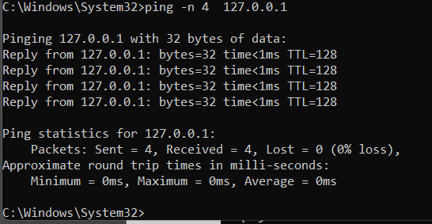
2. -s (size):
- Description: This option sets the size of the payload in the ICMP Echo Request packet, in bytes. The default size is 56 bytes (resulting in 64 bytes when combined with the ICMP header). You can increase or decrease the size depending on your testing needs.
- Usage:
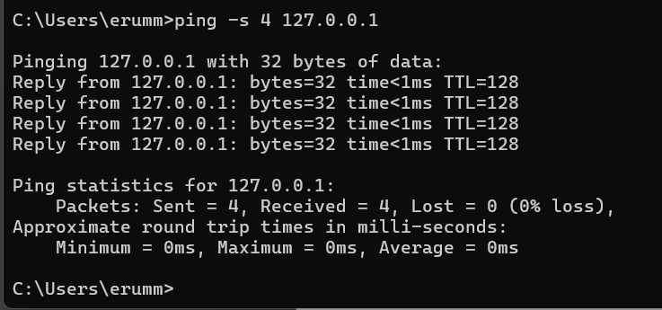3. -t (ttl):
- Description: The -t option sets the Time-To-Live (TTL) value for packets. TTL is the maximum number of hops (routers) that the packet can pass through before being discarded. It is used to prevent packets from circulating endlessly in the network. Each router that forwards the packet decrements the TTL by 1. When the TTL reaches zero, the packet is dropped, and an ICMP "Time Exceeded" message is sent back.
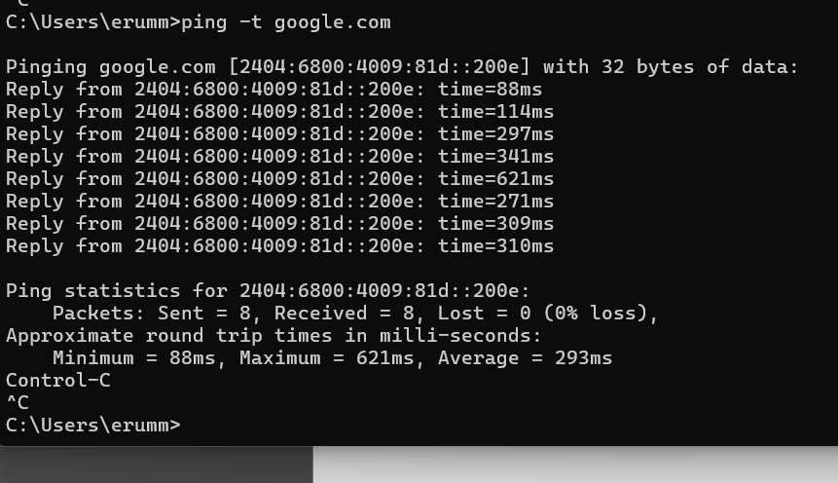
4. -W (deadline):
- Description: The -W option sets a time limit, in seconds, for how long the ping command should run. This is different from -c, which limits the number of packets; -W limits the duration of the ping command.
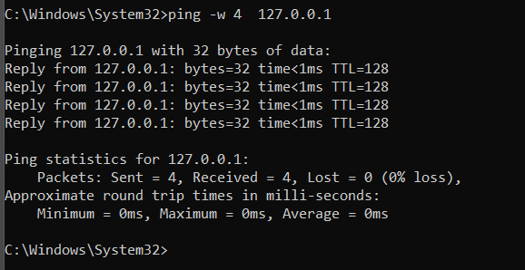

4. Troubleshooting with Ping
- Describe a scenario where ping would be used for network troubleshooting (e.g., connectivity issues, slow network speeds).
Context: Imagine you are working in an office where multiple devices (computers, printers, etc.) are connected to a local network, and you notice that your computer is unable to access a shared printer on the network. Additionally, some websites are not loading, and you're experiencing slow network speeds. You need to determine whether the issue is with your computer, the local network, or the external internet connection.
Steps to Troubleshoot Using ping:
- Ping the Local Printer (Testing Local Network Connectivity):
  - Command: ping 192.168.1.50
  - Purpose: Check if your computer can communicate with the printer's IP address on the local network.
  - Expected Outcome: If you receive replies from the printer, it indicates that the printer is online and your computer can reach it. If you see "Request timed out," the printer may be offline, or there could be a network issue.
- Ping the Default Gateway (Testing Connectivity to the Router):
  - Command: ping 192.168.1.1
  - Purpose: Verify whether your computer can communicate with the router, which serves as the gateway to other networks, including the internet.
  - Expected Outcome: Receiving replies from the gateway indicates that your local network is functioning properly up to the router. If you experience packet loss or no response, the problem could be with your connection to the router.
- Ping an External Website (Testing Internet Connectivity):
  - Command: ping www.google.com
  - Purpose: Determine if you can reach a reliable external server, indicating that your internet connection is working.
  - Expected Outcome: If you get a response, your internet connection is likely functioning, and the issue may be specific to certain websites. If you don't get a response, it suggests an issue with your internet connection.
- Analyze the Ping Results:
  - Packet Loss: If you observe significant packet loss when pinging any of the targets, it indicates network instability, which could be the cause of the connectivity issues.
  - High Latency: High round-trip times (RTT) when pinging external websites might explain slow network speeds, potentially due to congestion or an ISP issue.
  - No Response: If you get no response from the printer or the gateway, focus your troubleshooting on the local network (e.g., checking cables, restarting the router).
Conclusion: Using ping in this scenario helps isolate the problem. If the issue is with the local network (e.g., no response from the printer or gateway), you can focus on troubleshooting that segment. If the issue is with external connectivity (e.g., no response from www.google.com), the problem might be with your internet connection or ISP.

- Explain how to use ping to diagnose the issue, including which options to use and why.
To diagnose network issues with `ping`, start by checking basic connectivity using `ping -c 4 [IP address]`, which sends 4 packets to see if the device responds. Next, assess performance with `ping -s 128 [IP address]` to test larger packet sizes, which can reveal issues like congestion or faulty equipment. Use `ping -t 64 [URL]` to check if packets are being dropped before reaching their destination, helping to identify routing problems. Finally, test stability over time with `ping -W 10 [URL]`, which runs for 10 seconds to detect intermittent network issues.
5. Develop a ping type utility using Scapy. It should have the following points.
- 1. Basic Functionality
- Ensure the provided code works correctly.
- Test with different destination IPs and counts.

2. Additional Features
- Implement the following features:
- Option to specify TTL (Time-To-Live)
- Option to specify packet size
- Option to specify timeout
- Use Scapy's built-in functions to implement these features.
3. Error Handling
- Add error handling for cases like:
- Invalid destination IP
- Invalid count or TTL values
- Timeout errors
- Use try-except blocks to catch and handle exceptions.
4. Output Formatting
- Improve the output formatting to include:
- Packet loss percentage
- Average RTT (Round-Trip Time)
- Maximum and minimum RTT values
- Use Python's built-in formatting options to create a clean output.
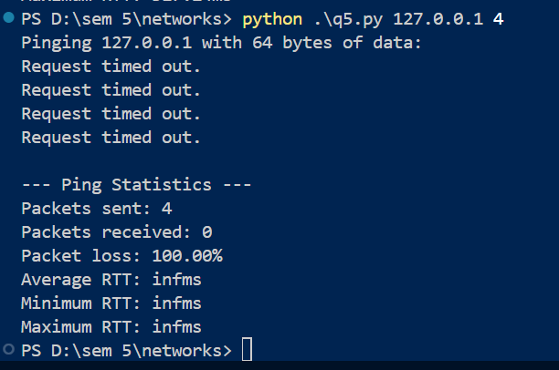
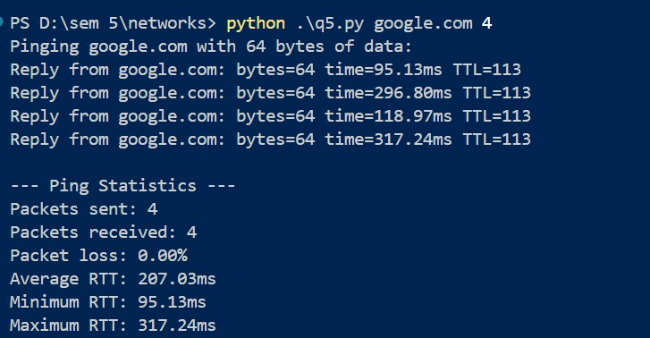

Submission:

Please submit a written report (PDF or Word document) containing your answers to the tasks above. Include screenshots or output captures where relevant.
For programming you need to create a github page (instruction to be given later)

