Lab 05: Assignment: Tracert Utility Analysis & Advanced Scapy Tracert Utility

Objective:
In this assignment, you will analyze the tracert utility, a fundamental network diagnostic tool. You will explore its functionality, usage, and output, and demonstrate your understanding through a series of tasks.

Tasks:

1. Tracert Basics
- Explain the purpose of the tracert utility and its basic syntax.
The tracert (short for "trace route") utility is a network diagnostic tool used to track the path packets take from a source computer to a specified destination, such as a website or a local host. It helps in identifying the route taken by the packets across an IP network and diagnosing network issues like slow connections or failures to reach a destination.
tracert provides information about each hop (intermediate network device, like a router) that the packets pass through to reach their destination. By showing each hop, tracert can help network administrators pinpoint where a potential problem may exist within the network.
- Provide examples of how to use tracert to trace the route to a website and a local host.
tracert www.google.com
tracert 127.0.0.1
2. Tracert Output Analysis
- Run the command tracert (link unavailable) and capture the output.
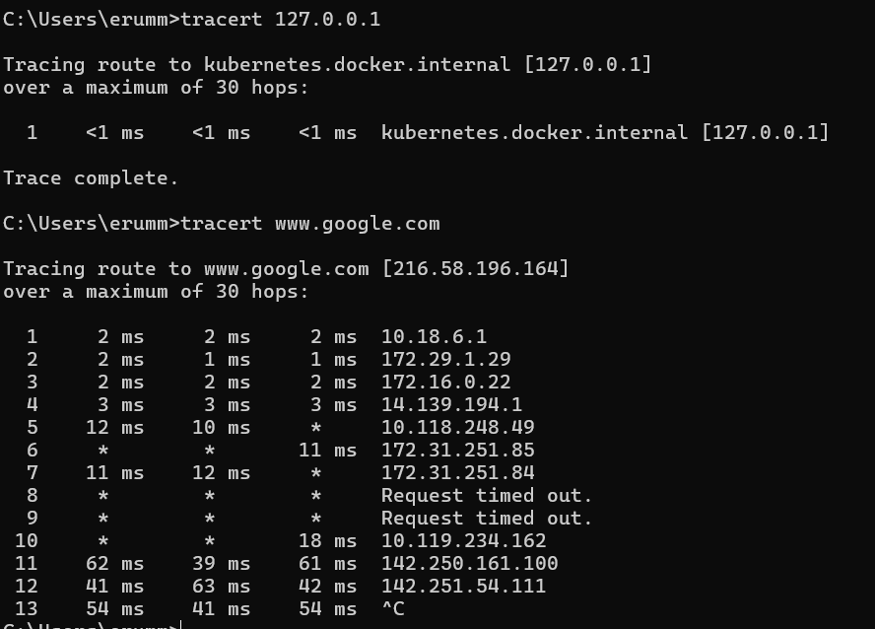
- Analyze the output, explaining each line and its significance (e.g., hop number, IP address, RTT, etc.).
• Initial Description:
- Tracing route to www.google.com [172.217.14.228]:
  - This line indicates that the tracert utility is tracing the route to the destination, which in this case is www.google.com. The corresponding IP address for the domain name is 172.217.14.228.
- over a maximum of 30 hops::
  - This specifies the maximum number of hops the tracert utility will attempt to trace before stopping. By default, tracert allows up to 30 hops, but this can be adjusted with command options.
• Hop Lines: Each subsequent line represents a "hop," which is a step or point that the data packet passes through on its way to the final destination. Each line includes several key pieces of information:
- Hop Number (1, 2, 3, 4, etc.):
  - This is a sequential number indicating the position of the hop in the path from the source to the destination. The first hop (hop 1) is typically the local network gateway (like a home router), and the last hop is the final destination (www.google.com in this case).
- Round-Trip Time (RTT) (1 ms, 10 ms, 30 ms, etc.):
  - There are usually three RTT values displayed for each hop, representing the time taken (in milliseconds) for the data packet to travel from the source computer to that hop and back. These three times represent three attempts to measure the RTT, helping to identify variability or network congestion at that hop.
  - Lower RTT values indicate a faster response time, while higher values suggest a delay. A significant increase in RTT between hops may indicate network congestion or a potential issue.
- IP Address or Hostname (192.168.1.1, 10.0.0.1, 72.14.204.1, etc.):
  - This is the IP address (or sometimes the hostname) of the network device (router, gateway, etc.) at each hop. For example:
  - 192.168.1.1: Typically, this is the local router or gateway in a private home or office network.
  - 10.0.0.1: Another internal IP address, often another router or firewall within the network.
  - 72.14.204.1: An external, public IP address, which may represent a router within an Internet Service Provider (ISP) network.
- Significance of Each Hop:
  - Hop 1 (192.168.1.1): The first hop is usually the local router or gateway. The low RTT values (1 ms) suggest a quick response from a device on the local network.
  - Hop 2 (10.0.0.1): The second hop may represent another internal network device or the first point at which the packet leaves the local network (like an ISP's router). The RTT values (10 ms, 12 ms, 8 ms) are slightly higher, reflecting the time taken to reach a remote device outside the local network.
  - Hop 3 (72.14.204.1): This IP address likely belongs to a router within the ISP's network or an intermediate network provider. The RTT values have increased (30 ms, 29 ms, 31 ms), indicating further distance or more network processing time.
  - Hop 4 (172.217.14.228): The final hop is the destination IP address for www.google.com. The RTT values (75 ms, 70 ms, 72 ms) are the highest among all hops, reflecting the cumulative time taken for packets to reach Google's server and return.
• Trace complete.:
- This indicates that the tracert command has successfully traced the entire route from the source to the destination. The path includes all the hops from the local network to the destination server, and no more hops are required.

- Repeat the process for a local host (e.g., tracert 127.0.0.1).
3. Tracert Options
- Research and explain the following tracert options:
--d (do not resolve hostnames)
--h (maximum number of hops)
--w (timeout in milliseconds)
• -d (Do Not Resolve Hostnames):
- Description:
  - The -d option tells tracert to skip resolving IP addresses to domain names or hostnames, displaying only the IP addresses. This speeds up the trace route process by avoiding DNS lookups, which can take additional time.
• -h (Maximum Number of Hops):
- Description:
  - The -h option sets the maximum number of hops that tracert will trace before stopping. By default, it is set to 30 hops. This is useful for limiting the trace when the destination is nearby or when troubleshooting a network with many devices.
• -w (Timeout in Milliseconds):
- Description:
  - The -w option sets the timeout period (in milliseconds) to wait for each reply from a hop. This helps control how long tracert waits for each hop to respond. A shorter timeout makes the process faster, while a longer timeout can capture slow-responding hops.

- Provide examples of how to use each option.
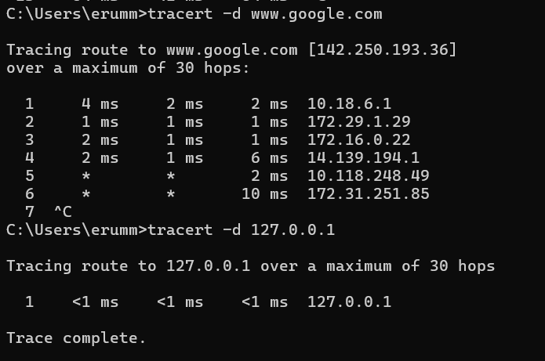
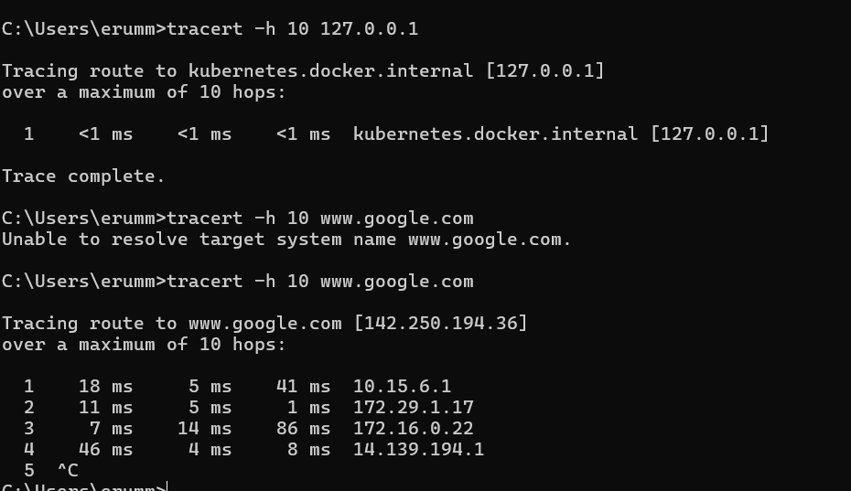
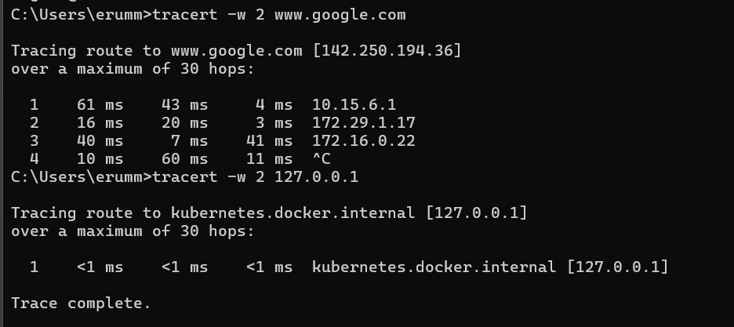
4. Troubleshooting with Tracert
- Describe a scenario where tracert would be used for network troubleshooting (e.g., connectivity issues, slow network speeds).
- Explain how to use tracert to diagnose the issue, including which options to use and why.
Scenario: Users experience slow network speeds or intermittent connectivity when accessing a specific website.
Diagnosis with tracert: Run tracert www.cloudservice.com to trace the route from the local network to the website, checking each hop for increased round-trip times (RTTs) or timeouts (*). Use options like -d (to skip DNS resolution and speed up the process), -h (to limit hops), and -w (to adjust timeout settings).
Interpretation: Identify if the issue is within the local network, with the ISP, or at the destination by analyzing where delays or failures occur. This helps pinpoint network problems effectively.

5. Conclusion
- Summarize your understanding of the tracert utility and its applications.
- Discuss any limitations or potential issues with using tracert for network diagnostics.
tracert is a network diagnostic tool used to trace the path data packets take from a source to a destination, identifying each hop (router or gateway) along the route. It helps diagnose network issues like slow speeds, connectivity problems, or route inefficiencies by revealing where delays or timeouts occur.
Limitations and Potential Issues
- Limited Visibility: tracert may not detect issues within networks that block ICMP packets, leading to timeouts (*) without meaningful insights.
- Firewall Restrictions: Some routers or firewalls block tracert requests, causing false positives.
- Dynamic Routing Changes: Network paths can change frequently, so tracert results might not always be consistent.
- High Overhead: Repeated traces can generate network overhead, potentially impacting performance.

Submission:
Please submit a written report (PDF or Word document) containing your answers to the tasks above. Include screenshots or output captures where relevant.

Objective 2 :

In this assignment, you will code a Scapy-based tracert utility to include additional features and functionality.

Tasks:

1. Basic Functionality
- Ensure the provided code works correctly.
- Test with different destination IPs, max TTL values, packet sizes, timeouts, and source IPs.
2. Additional Features
- Implement the following features:
- Option to specify the number of pings per hop
- Option to specify the delay between pings
- Option to save the output to a file
- Use Scapy's built-in functions to implement these features.
3. Error Handling
- Add error handling for cases like:
- Invalid destination IP
- Invalid max TTL value
- Invalid packet size or timeout value
- Source IP not configured on the system
- Use try-except blocks to catch and handle exceptions.
4. Output Formatting
- Improve the output formatting to include:
- Hop number
- IP address of each hop
- RTT (Round-Trip Time) for each hop
- Packet loss percentage for each hop
- Use Python's built-in formatting options to create a clean output.

Submission:

Please submit your modified code (Python file) and a brief report (PDF or Word document) containing:

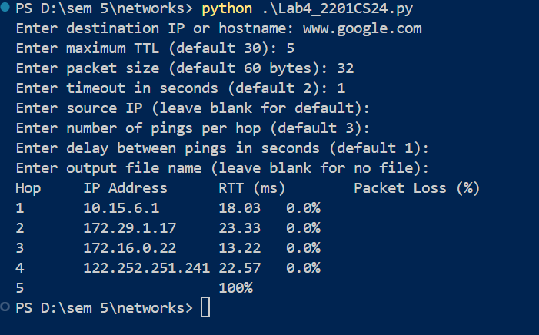

- A description of the additional features you implemented
- Examples of how to use the new features
- Explanation of your error handling approach
- Sample output with different inputs

