Assignment-2

|  |
| --- |
| Cloud SERVER PROJECT- ict 171 |

|  |  |
| --- | --- |
| Name: | Laibah Erum |
| Student ID: | 35569772 |
| Public IP Adress: | 13.53.130.168 |
| DNS Link: | https://laibah.net/ |
| video link: |  |

Table of contents

A. SETTING UP WEB SERVER ………………………………………..3

-CREATING AWS EC2 INSTANCE 3

-ACCESSING EC2 INSTANCE VIA SSH 5

-INSTALLING LAMP STACK 6

-ACQUIRING DNS NAME 8

B. WORDPRESS INSTALLATION…………………………………….10

C. SSL/TSL FUCNTIONALITY………………………………. ……….14

-ACQUIRING CERTIFICATE FROM CERTBOT 14

D. SCRIPTING …………………………………………...…………..16

- SCRIPT CODE 16

- SCRIPT EXECUTION: 18

- SCRIPT OUTPUT GENERATION 19

E. REFERENCES

A.SETTING UP WEB SERVER

1.Creating an AWS EC2 instance

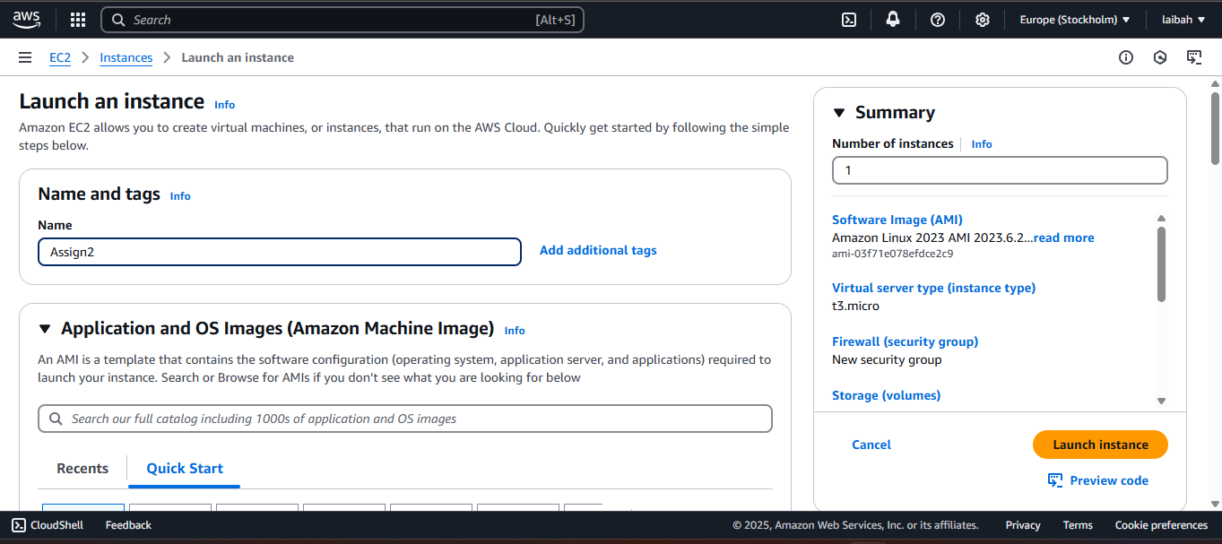

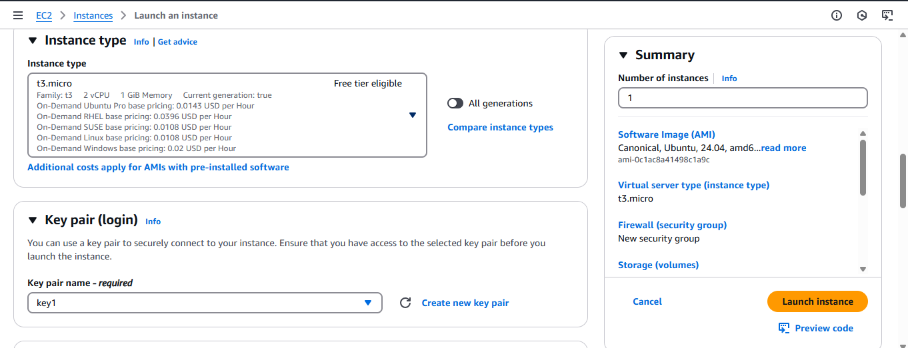

2.Connecting to EC2 instance

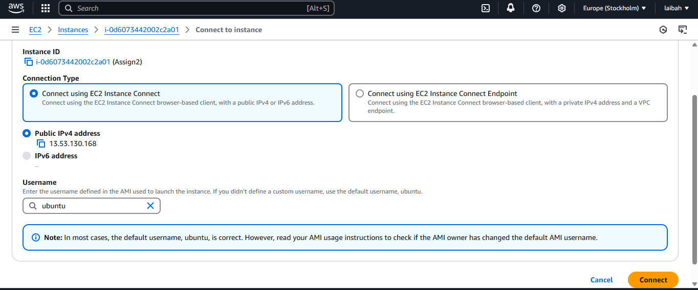

2. Install LAMP Stack

1.Update and Upgrade Package lists

2. Install Apache Web Server



3. Install MySQL Database Server



4. Secure MySQL

5. Install PHP & Required Extensions

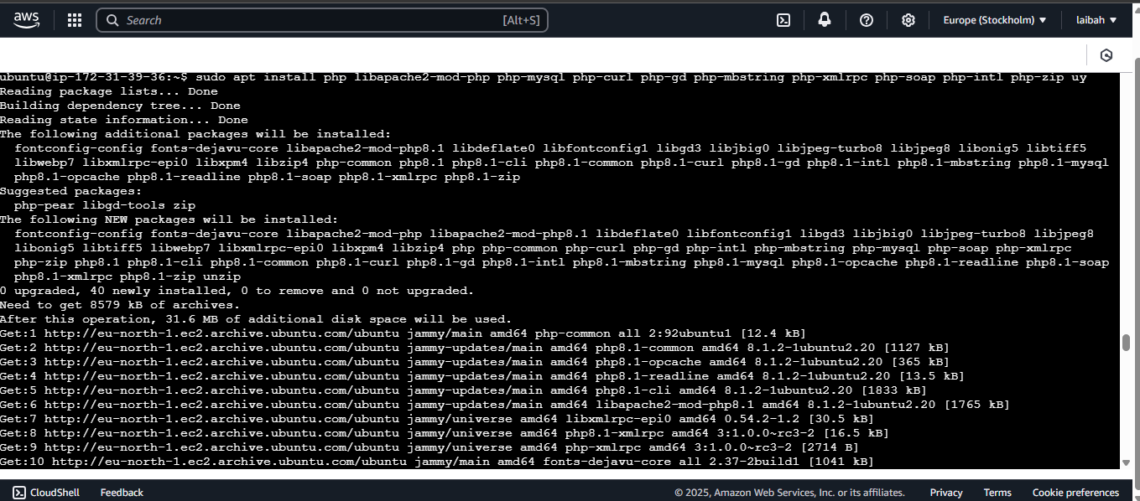

6. Verify & Restart Apache



3. Link Domain (laibah.net) with AWS EC2

>Check for availability of domain names of your choice and purchase

Go to route 53 > Hosted zones

Create A record for domain

B.WORDPRESS INSTALLATION

1.Download & Set Up WordPress



sudo unzip latest.zip

sudo mv wordpress/* .

sudo rm -rf wordpress latest.zip

2.Set Permissions



Create a WordPress Database

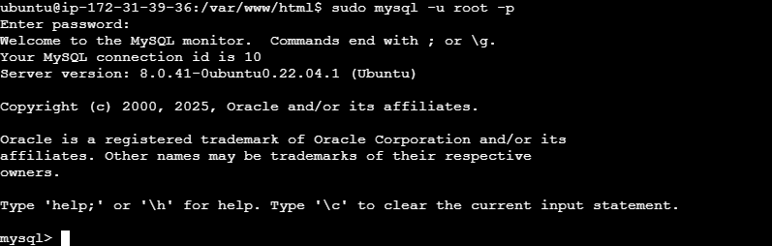

Create password for database

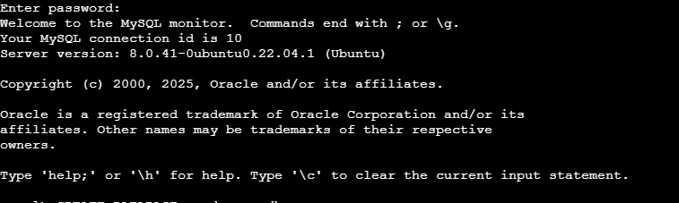

Create database



Create User



Grant privileges



Flush and exit

Configure WordPress



Replace default values with actual database name,user name,password

Restart Apache & Open WordPress



C. SSL/TSL FUCNTIONALITY

1. Install certbot and encrypt

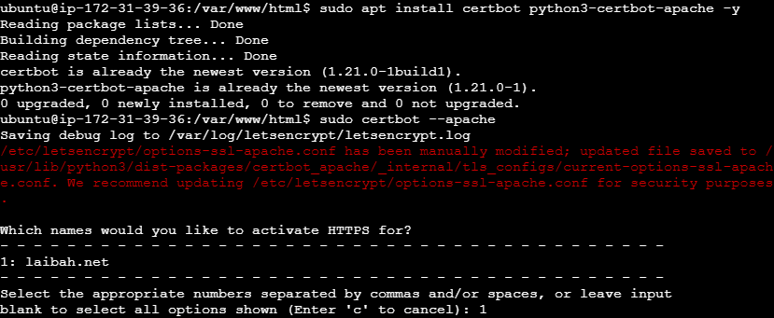

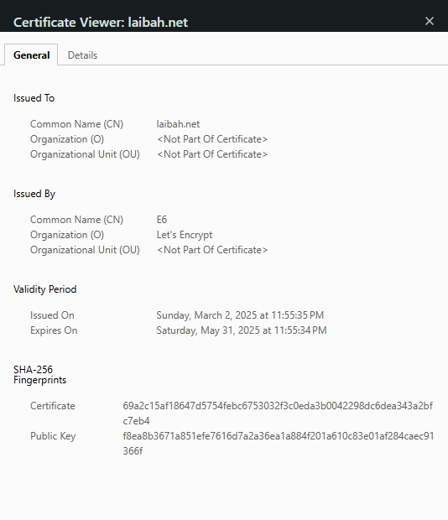

D. SCRIPTING

1.Script Code





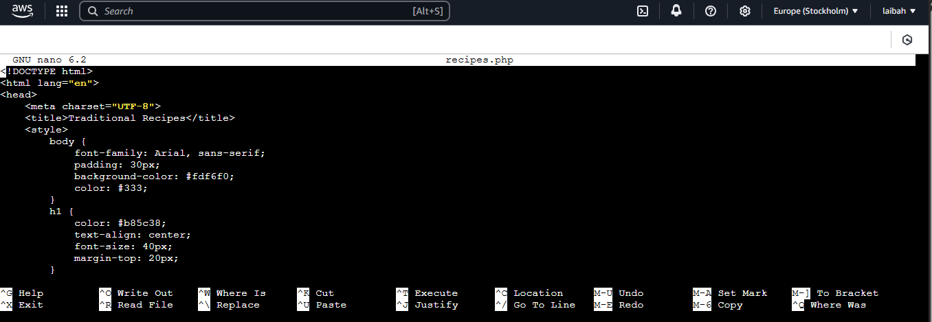

Creating a drop down menu and button

Add script for recipes and link for images

Adding a scrolling function

Ctrl+0 to save and press enter

Ctrl + x to exit

-Script Output Generation

E. REFERENCES

Kate, C. a. *Margherita pizza recipe.* <https://cookieandkate.com/margherita-pizza-recipe/>

AllRecipes. *Perfect sushi* <https://www.allrecipes.com/recipe/99211/perfect-sushi-rice/>

DamnDelicious. (2019, April 18). *Mexcican street tacos*. <https://damndelicious.net/2019/04/18/mexican-street-tacos/>

Recipes., I. H. *Chicken Biryani recipe*. <https://www.indianhealthyrecipes.com/chicken-biryani-recipe/>

Kitchn., T. *One-pot recipe: Easy French ratatouille.* <https://www.thekitchn.com/one-pot-recipe-easy-french-ratatouille-recipes-from-the-kitchn-106669>

Life., T. W. o. *Kung Pao chicken. The Woks of Life.* <https://thewoksoflife.com/kung-pao-chicken/>