Integrate Jenkins and Github

Required Plugins:
This can be installed in Jenkins
- Git Plugin -> basic Git support
- Github Plugin -> adds GitHub integration features
- GitHub Branch Source plugin (optional) -> for multibranch pipelines
- HTML Publisher -> display the Robot Framework HTML report directly in the job view

Install Plugins
1.Open Jenkins in local machine
URL: Dashboard - Jenkins
2. Check if the plugins are already available.
Click Manage Jenkins (Settings icon) -> Plugins -> Installed plugins
NOTE:
Some plugins are already installed by default when you install Jenkins
If the plugin is already installed, check if it is enabled. If it is disabled, just tick the Enabled button beside the plugin
Some plugins cannot be disabled
To uninstall the plugin, click the X button beside the plugin
Plugins will be helpful to integrate other applications to Jenkins
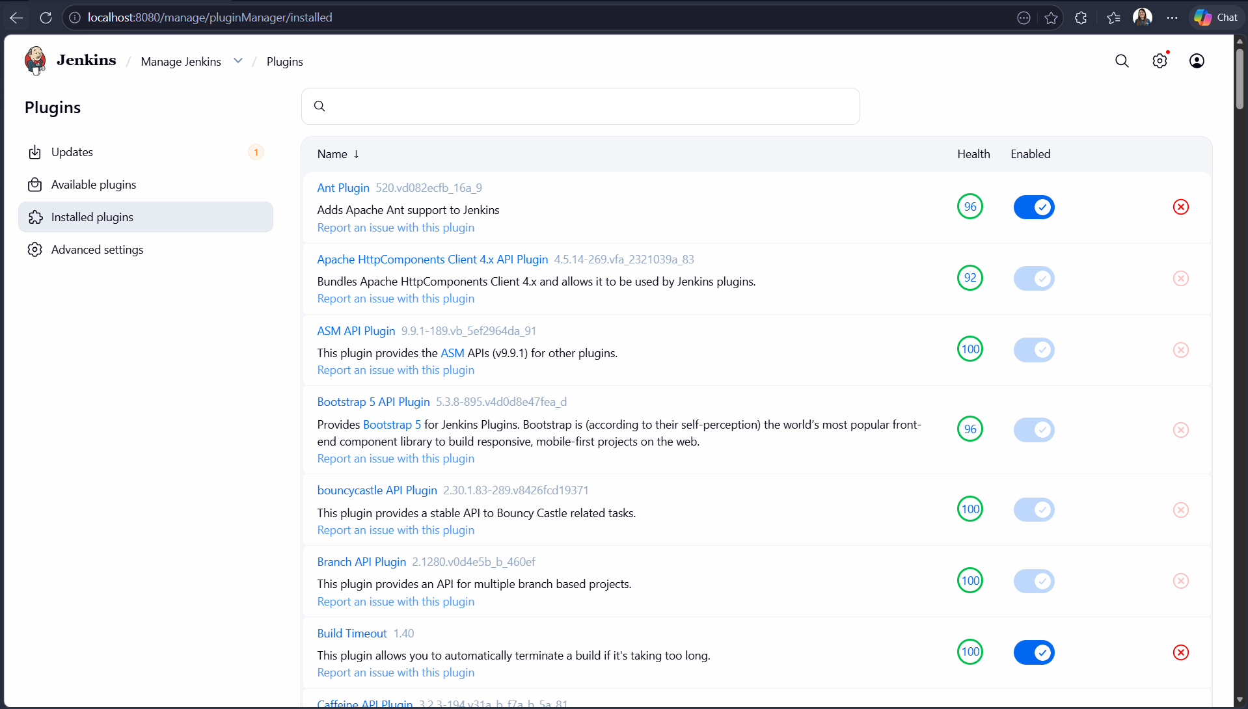
3. If the plugins are not installed, use Available plugins to install them. Click the plugin then click Install button
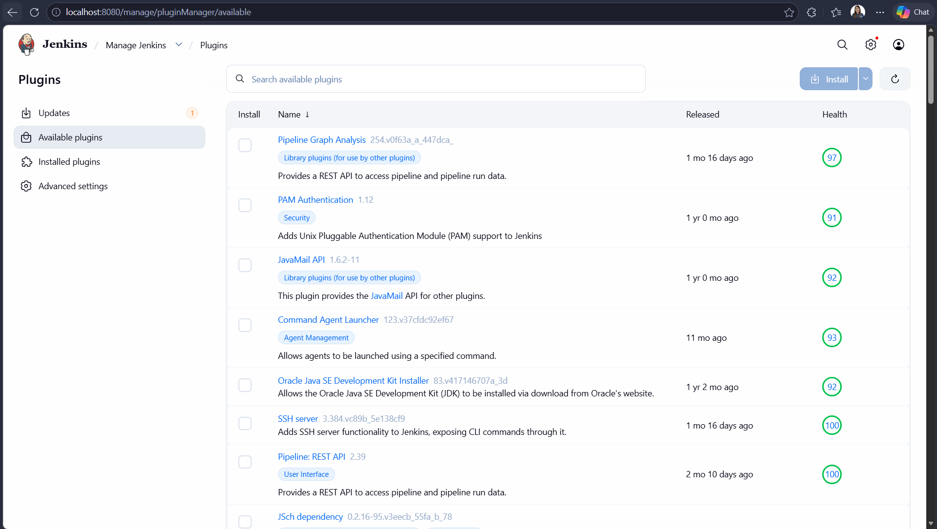
4. Download is in progress
You can either restart Jenkins or not
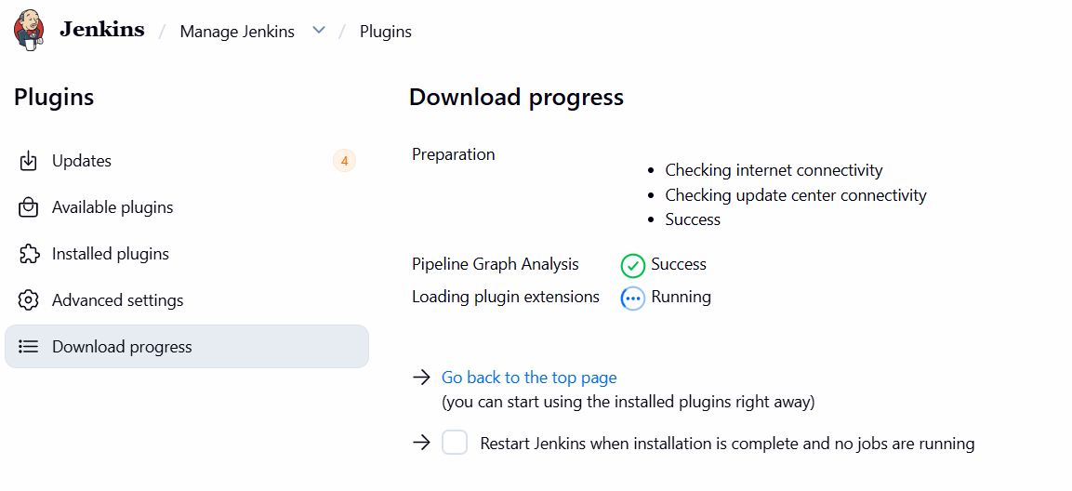

Generate Personal Access Token in Github
Access Token will be used to integrate Github and Jenkins
A token has the same capabilities to access resources and perform actions on those resources that the owner of the token has and is further limited by any scopes or permissions granted to the token. A token cannot grant additional access capabilities to a user
1.Open Github
URL: https://github.com/
2. Go to Settings -> Developer settings -> Personal access tokens -> Tokens (classic)
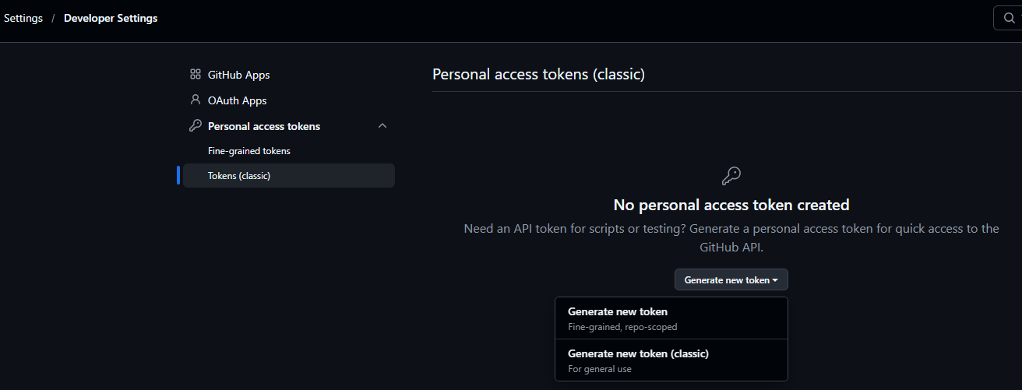
3. Click Generate new token button
4. Click Verify via email button
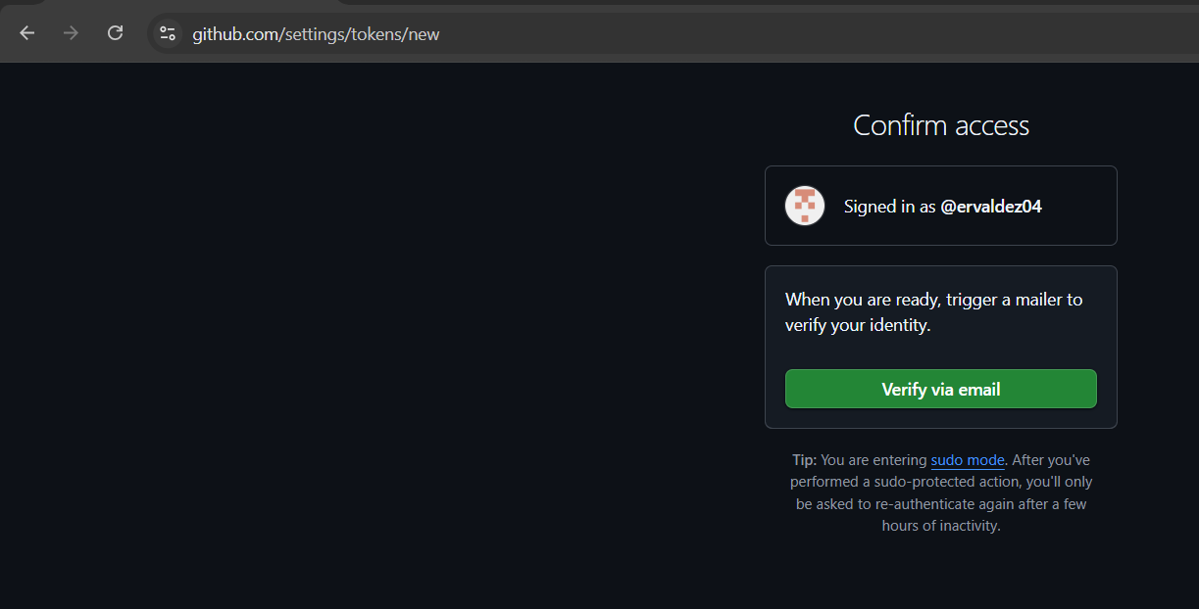
5. Enter code sent in mail then click Verify button
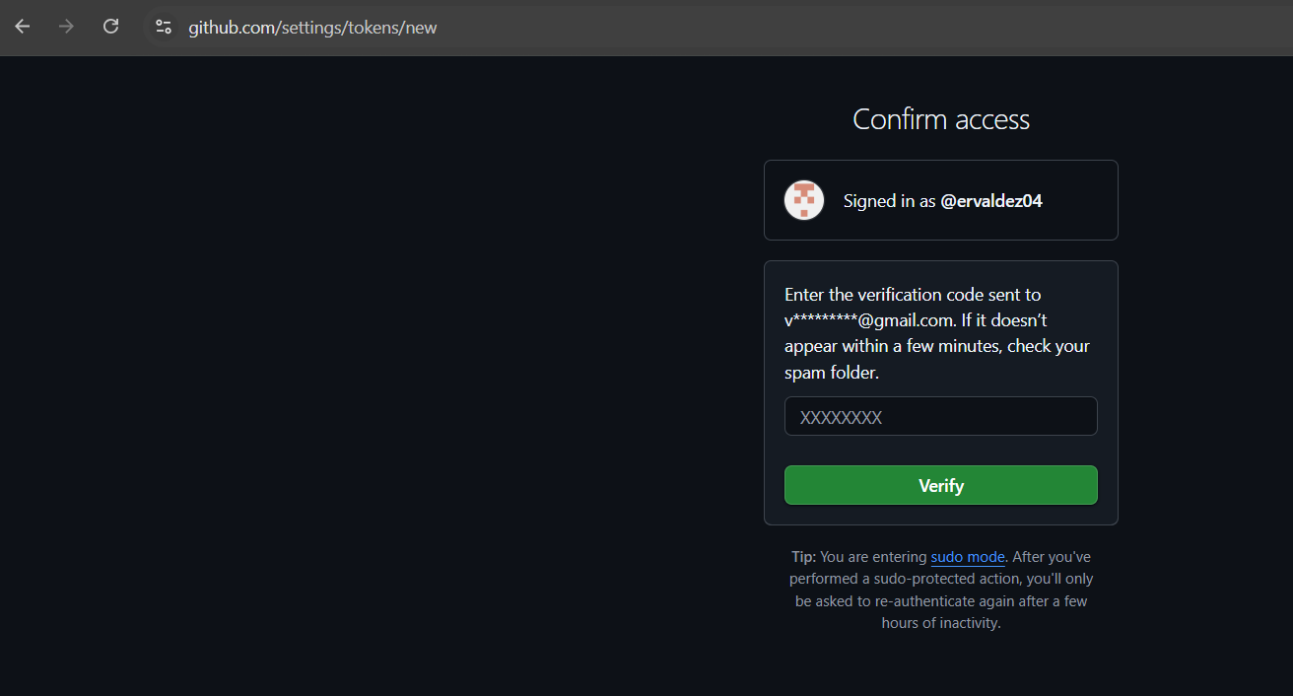
6. Enter Note and expiration
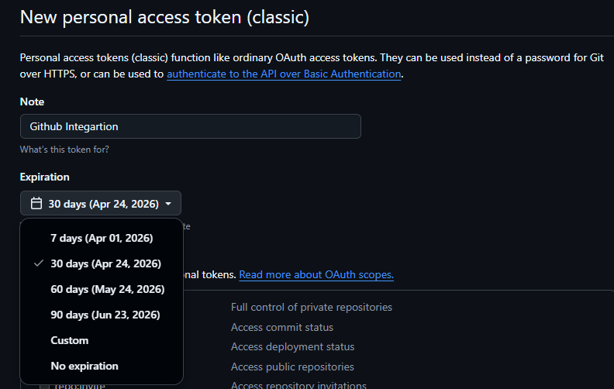
7. Under Select Scopes check the following scopes:
- repo
- admin: repo_hook
NOTE: It will also automatically enable the children scopes
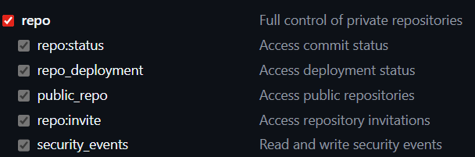

7. Click Generate token button
8. Copy token generated

Connect Jenkins to Github
1.Open Jenkins in local machine
URL: http://localhost:8080/
2. Go to Manage Jenkins (Settings icon) -> Credentials -> System -> Global
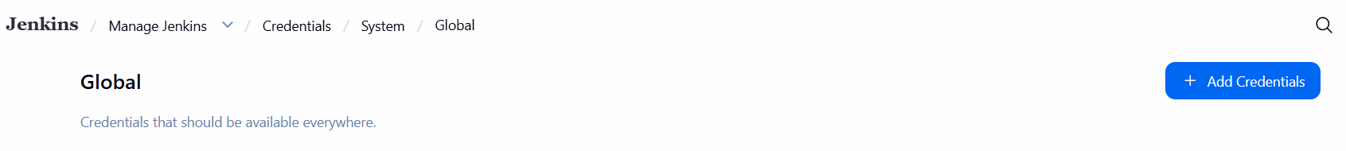
3. Click Add Credentials button
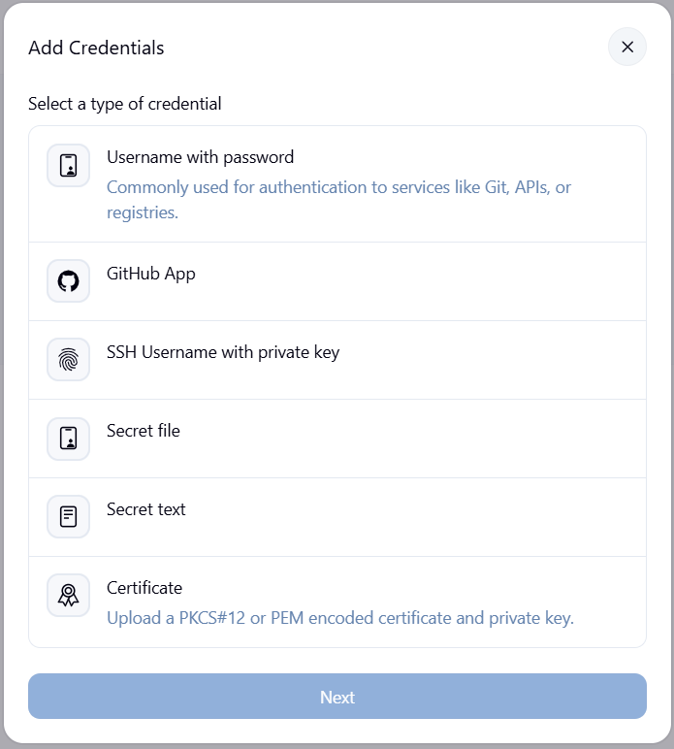
4. Click Github App then click Next button
5. Enter details in the following field: ID and Description then click Add button and paste the token generated in Github in Key field, then click Create button
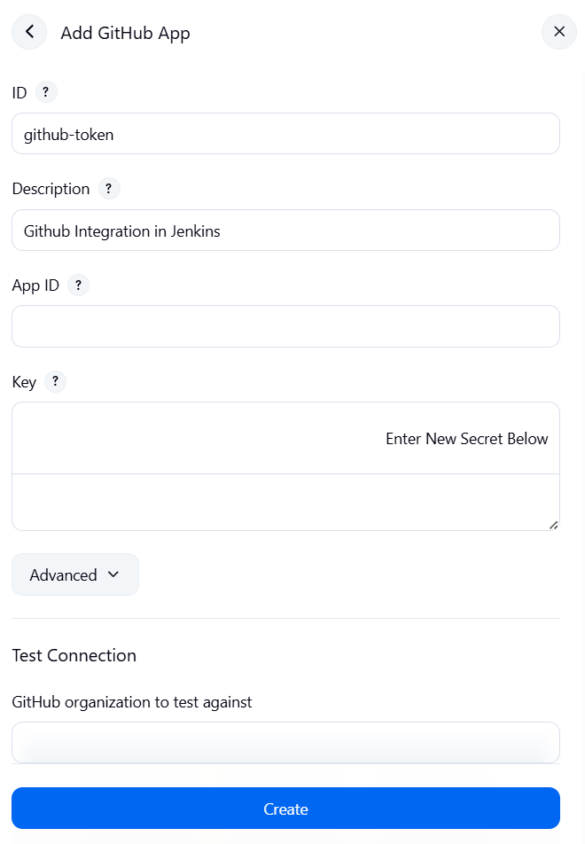
7. Credential is created
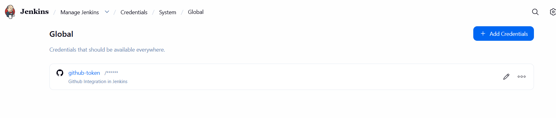

Create Jenkins Job
1.Open Jenkins in local machine
URL: http://localhost:8080/
2. Click Create a job
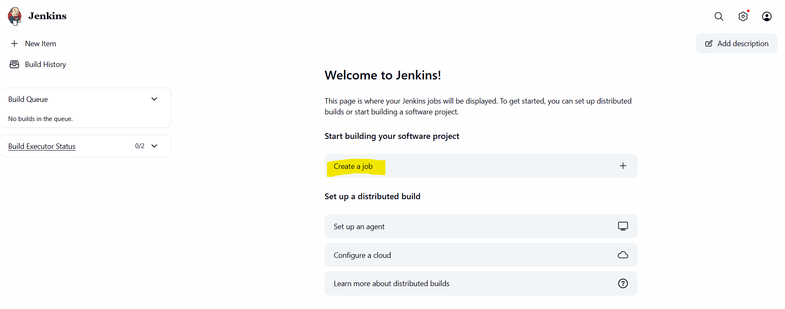
Note:
- Dashboard will display all the job created
- You can update the created job
- You can have multiple jobs in Jenkins
3. Enter Item Name then select either Pipeline or Freestyle project then click OK button
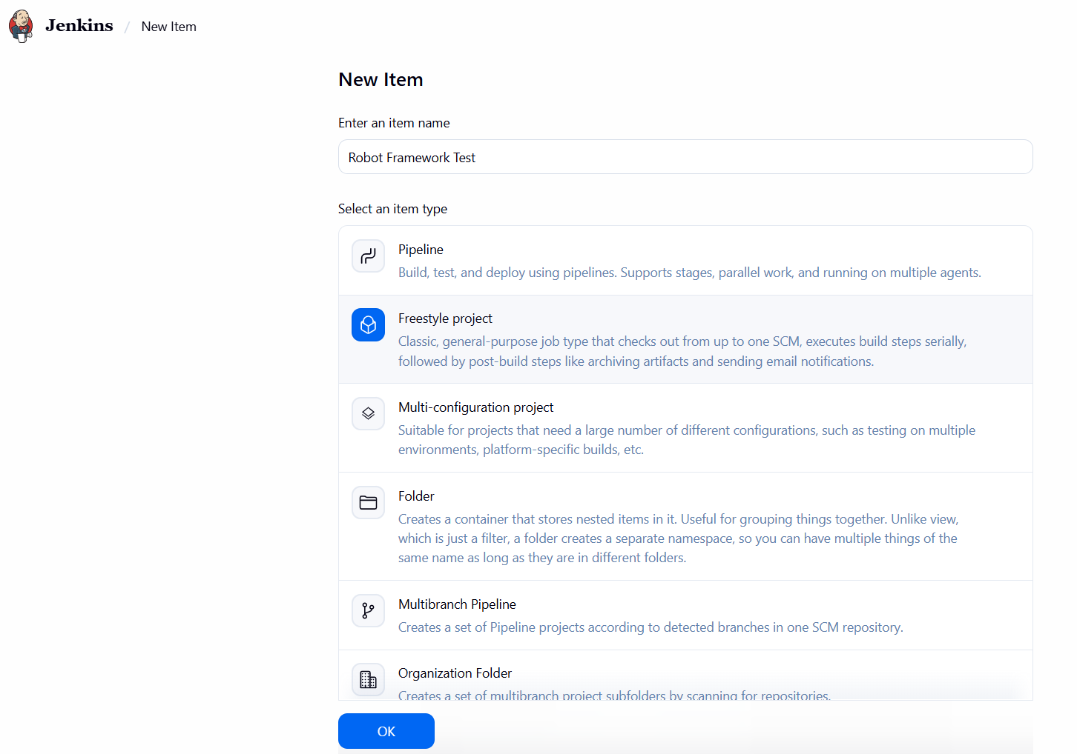
4. Click Source Code Management
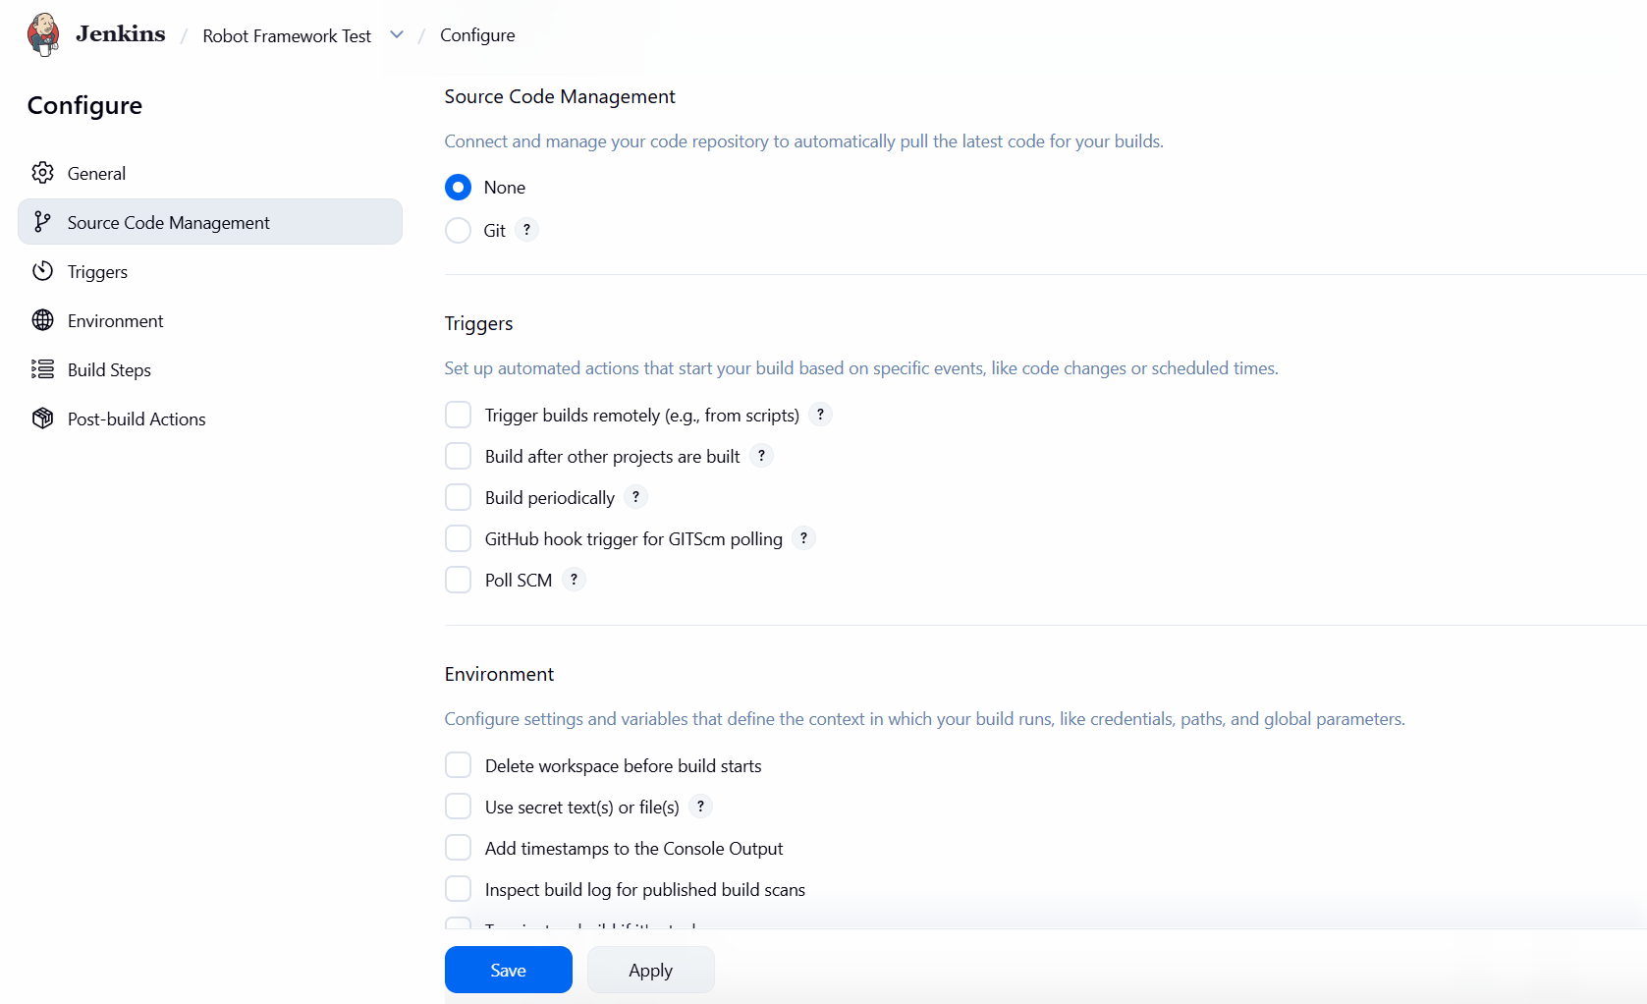
5. Click Git then paste github repository then add credentials if repository is private then click Apply button, then click Save button
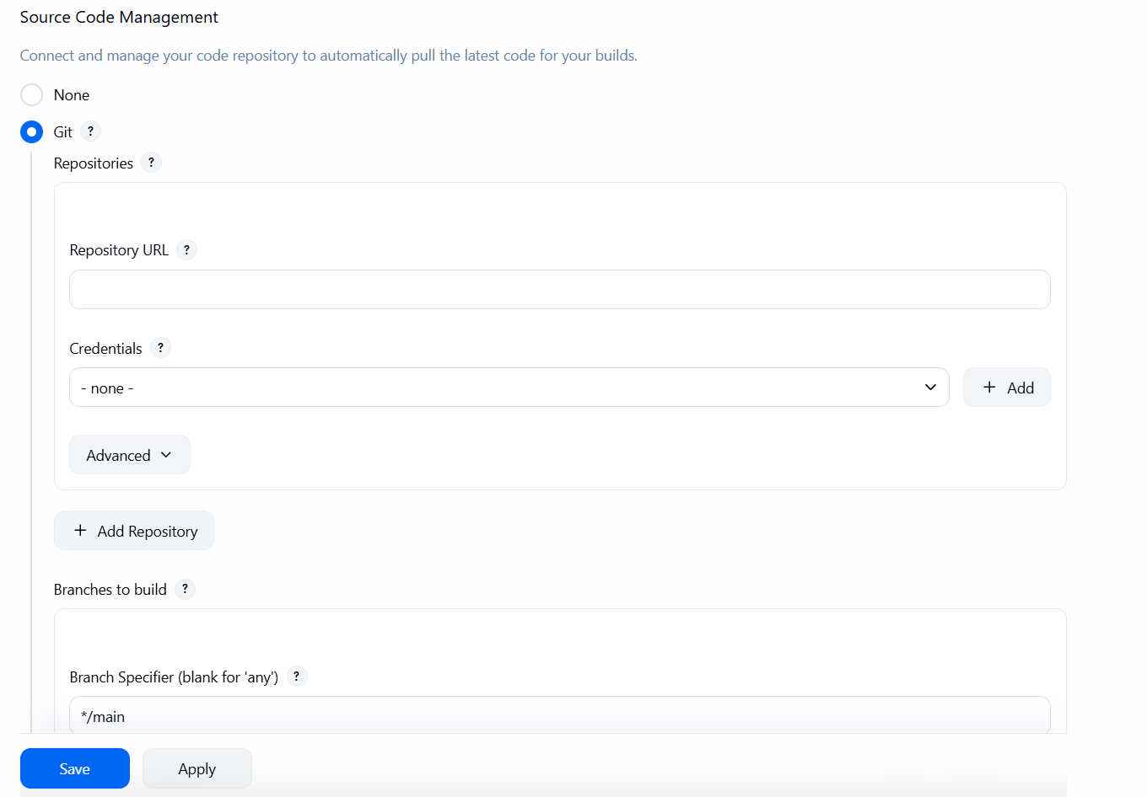
6. Check the new job created if integrated successfully in Git by clicking Build Now
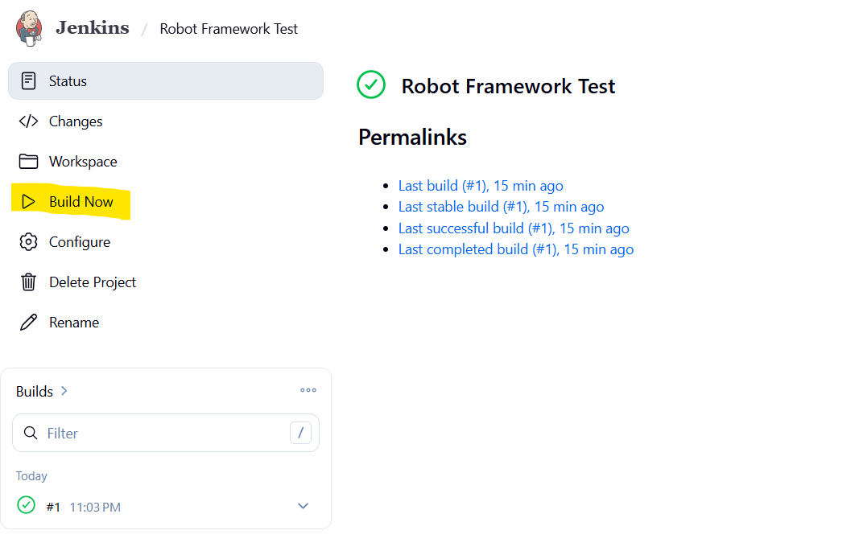

Make local Jenkins Publicly Accessible
1. Go to ngrok site and create account
URL: https://ngrok.com/
2. Click Your Authtoken then copy the token by clicking Copy button
ex: 2M3xXyzAbCdEfGhIjKlMnOpQrStUvWxYz...
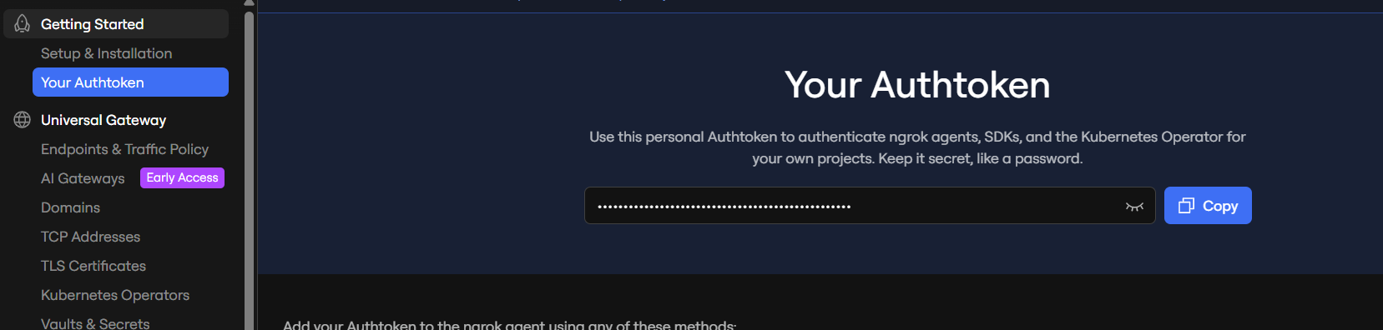
3. Download ngrok then unzipping the file
URL: https://ngrok.com/download
4. Verify the application in the zip file

5. Open Environment Variables then paste the location path under System variable -> Path
NOTE: You can select which location to unzip the file
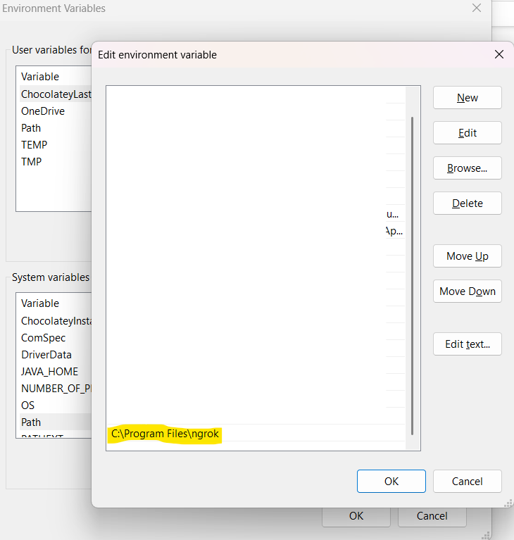
6. Open CMD then enter command
command: ngrok config add-authtoken <authtoken>
authtoken = token in the ngrok site
7. Validate if configured correctly
command: ngrok http 8080
NOTE: Copy value of forwarding as it will be used for the Webhook
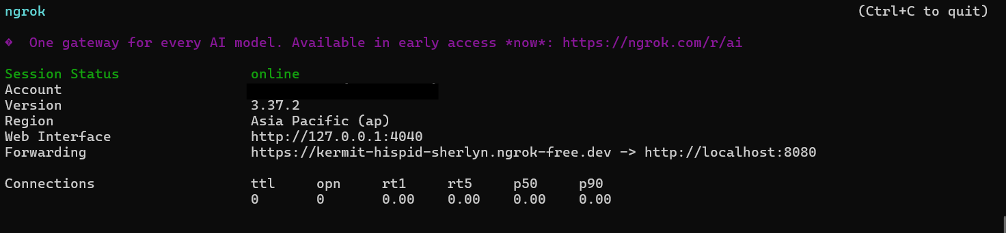
IMPORTANT:
Free accounts work fine for Jenkins webhooks, but the public URL changes every time you restart ngrok

Configure Github Webhook
1.Open Github then navigate to repository
2. Go to Settings -> Webhooks
3. Click Add webhook button
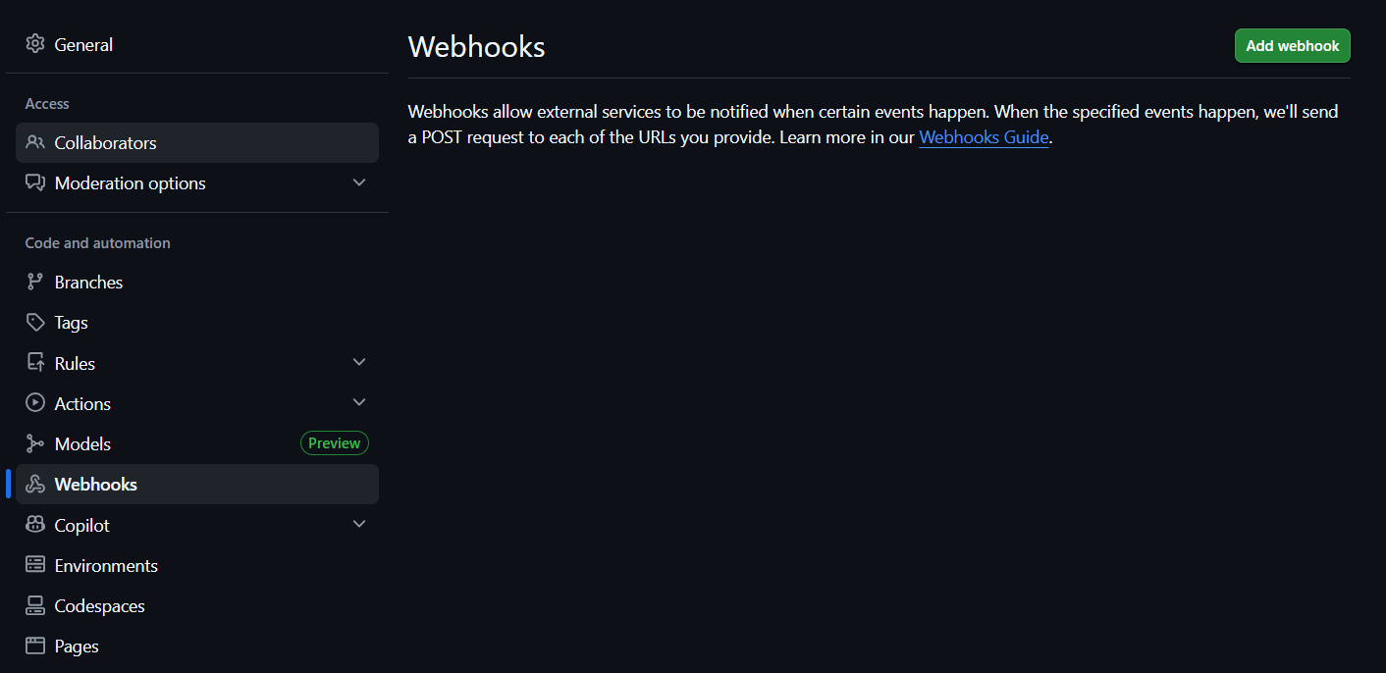
4. Enter Jenkins server URL followed by /github-webhook/ in Payload URL
NOTE: Use the URL generated via ngrok
Ex: http://localhost:8080/github-webhook/

5. Select application/json in Content type
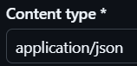
6. Select Just the push event or Let me select individual events then select events you want to include
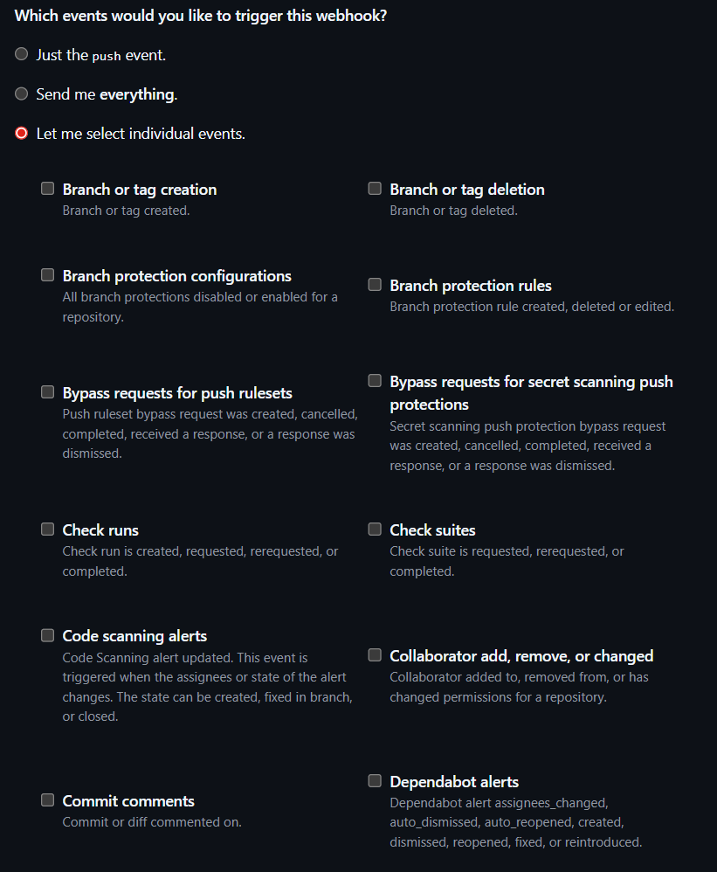
7. Click Add webhook button
8. Webhook is created
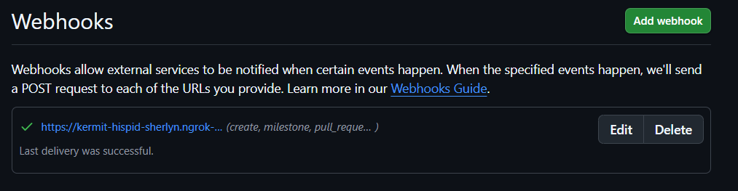

Test the Integration
- Update repository and merge to main branch
- Jenkins job will run
- You’ll see build status updates in Jenkins, and if configured, Jenkins can also report build results back to GitHub via the commit status API (green check or red X on commits).

Other option to install plugins in Jenkins:
Can download the file
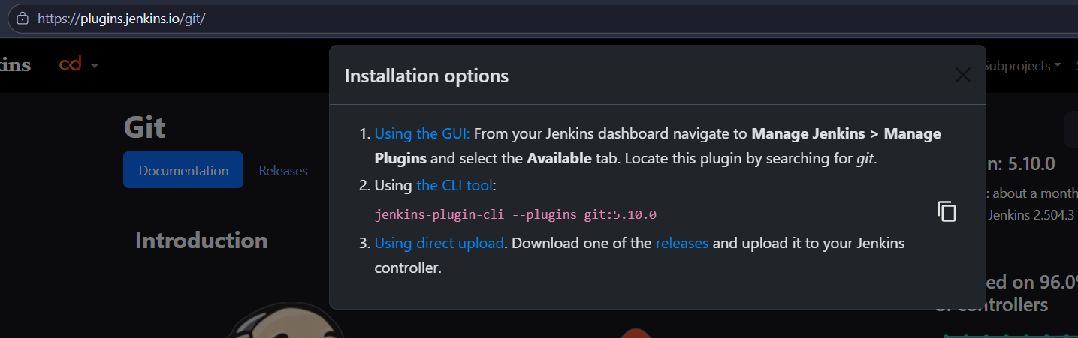
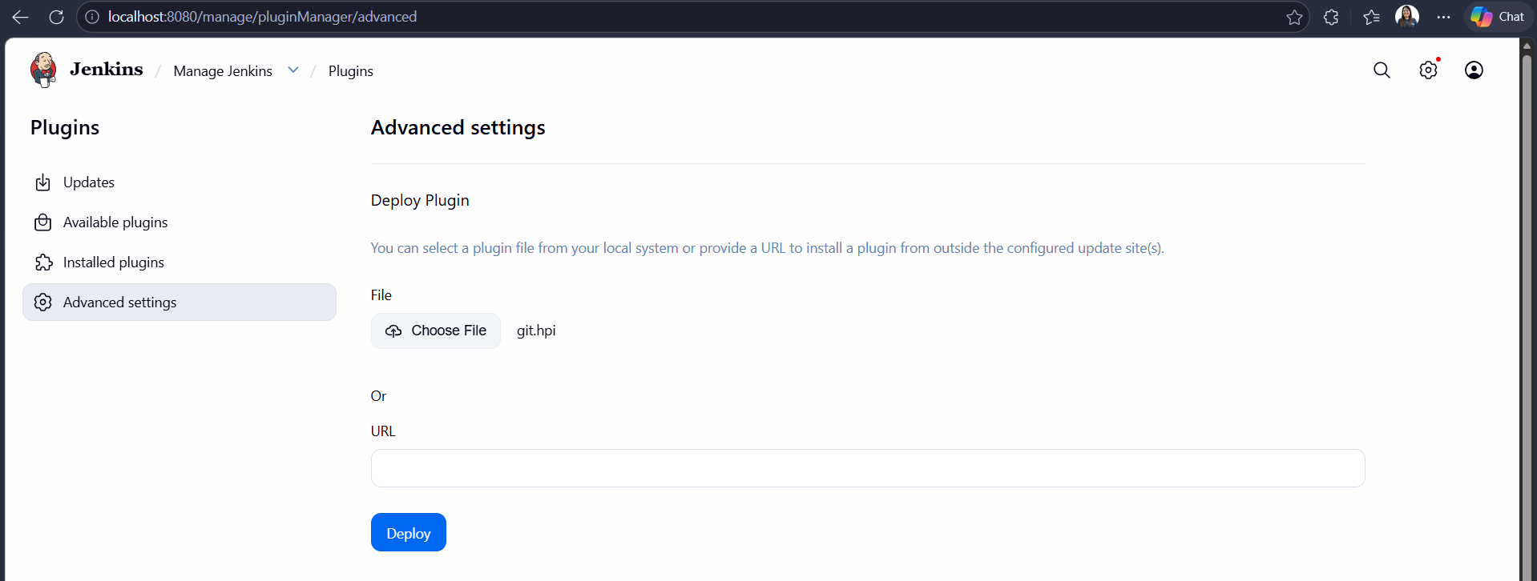
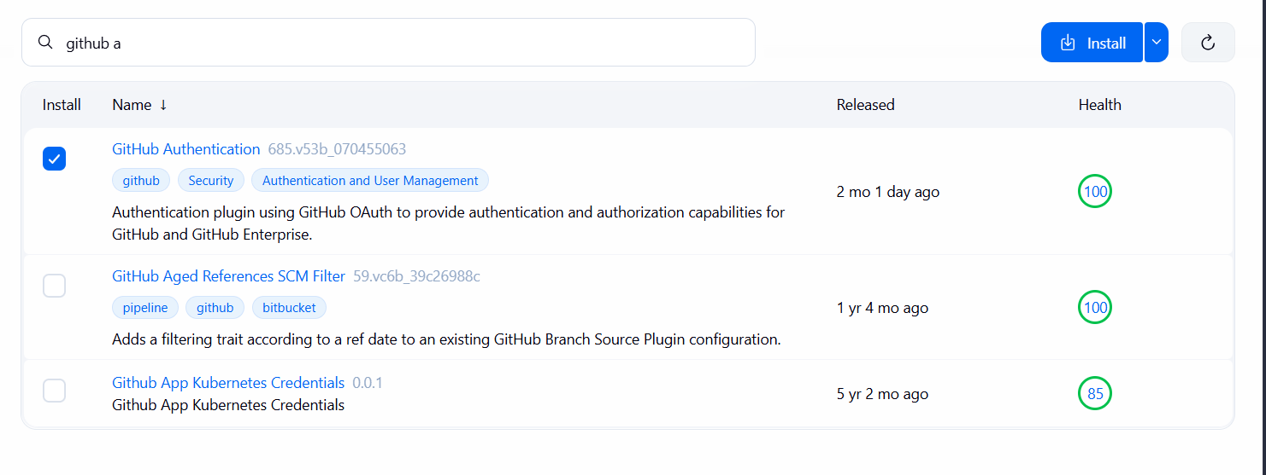
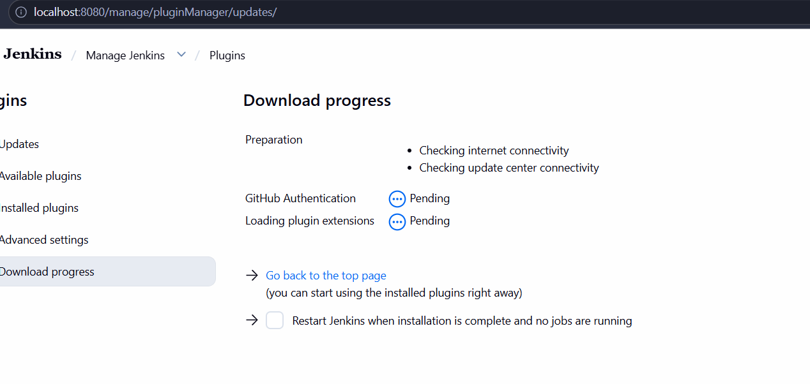
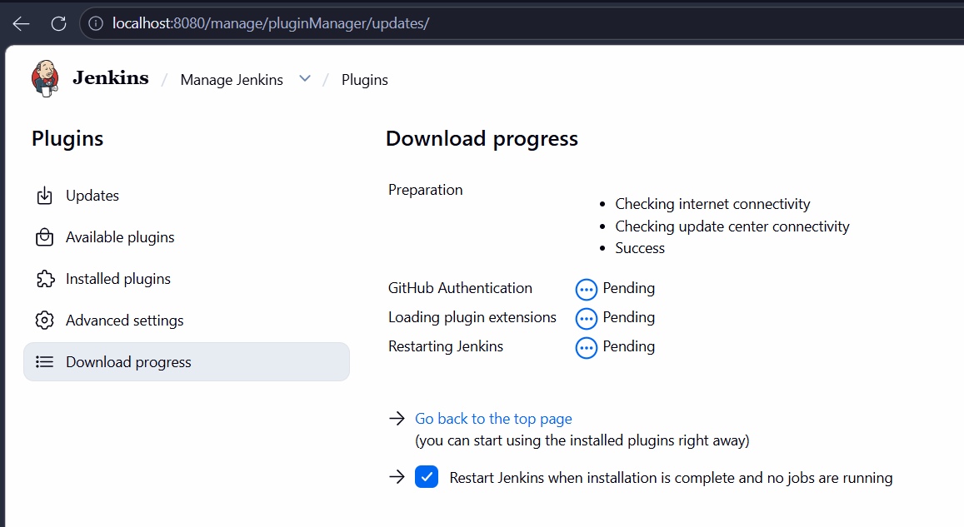
There will also be a time that you need to update the plugin, click Updates then update the plugin you wish to update

