Jenkins Installation

Note
Only Java 17, 21, and 25 are supported by Jenkins
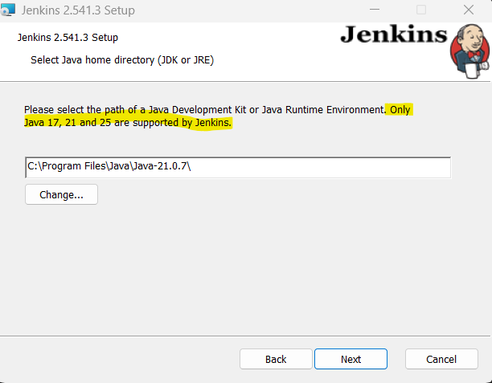

Install Pre-requisite: Java
1. Check Java version installed in local via CMD
Command: java -version
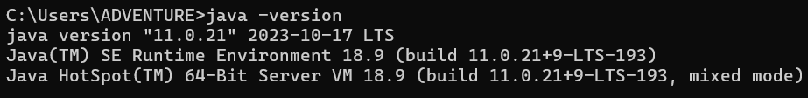
2. If version is 17 or higher, no need to update java version. If version is lower, update java version. If no java is installed, install
Installation URL: https://www.oracle.com/java/technologies/downloads
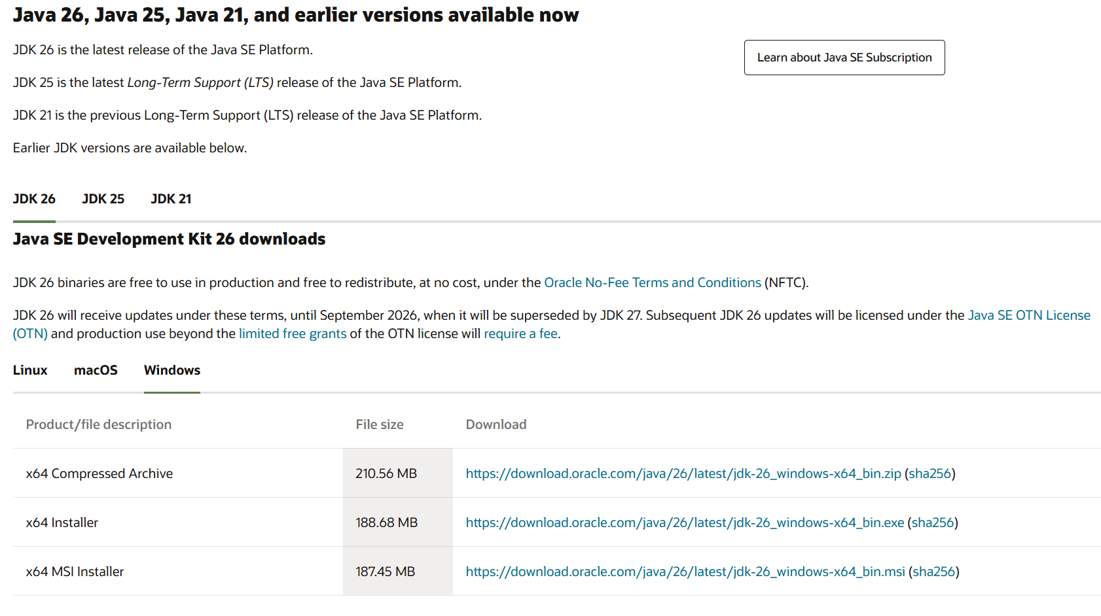
Check if Java is installed
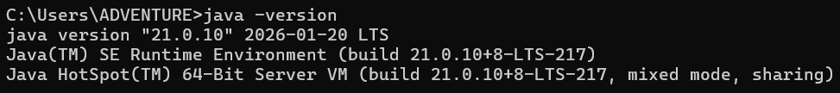

Install Jenkins
1. Install Jenkins - https://www.jenkins.io/download/
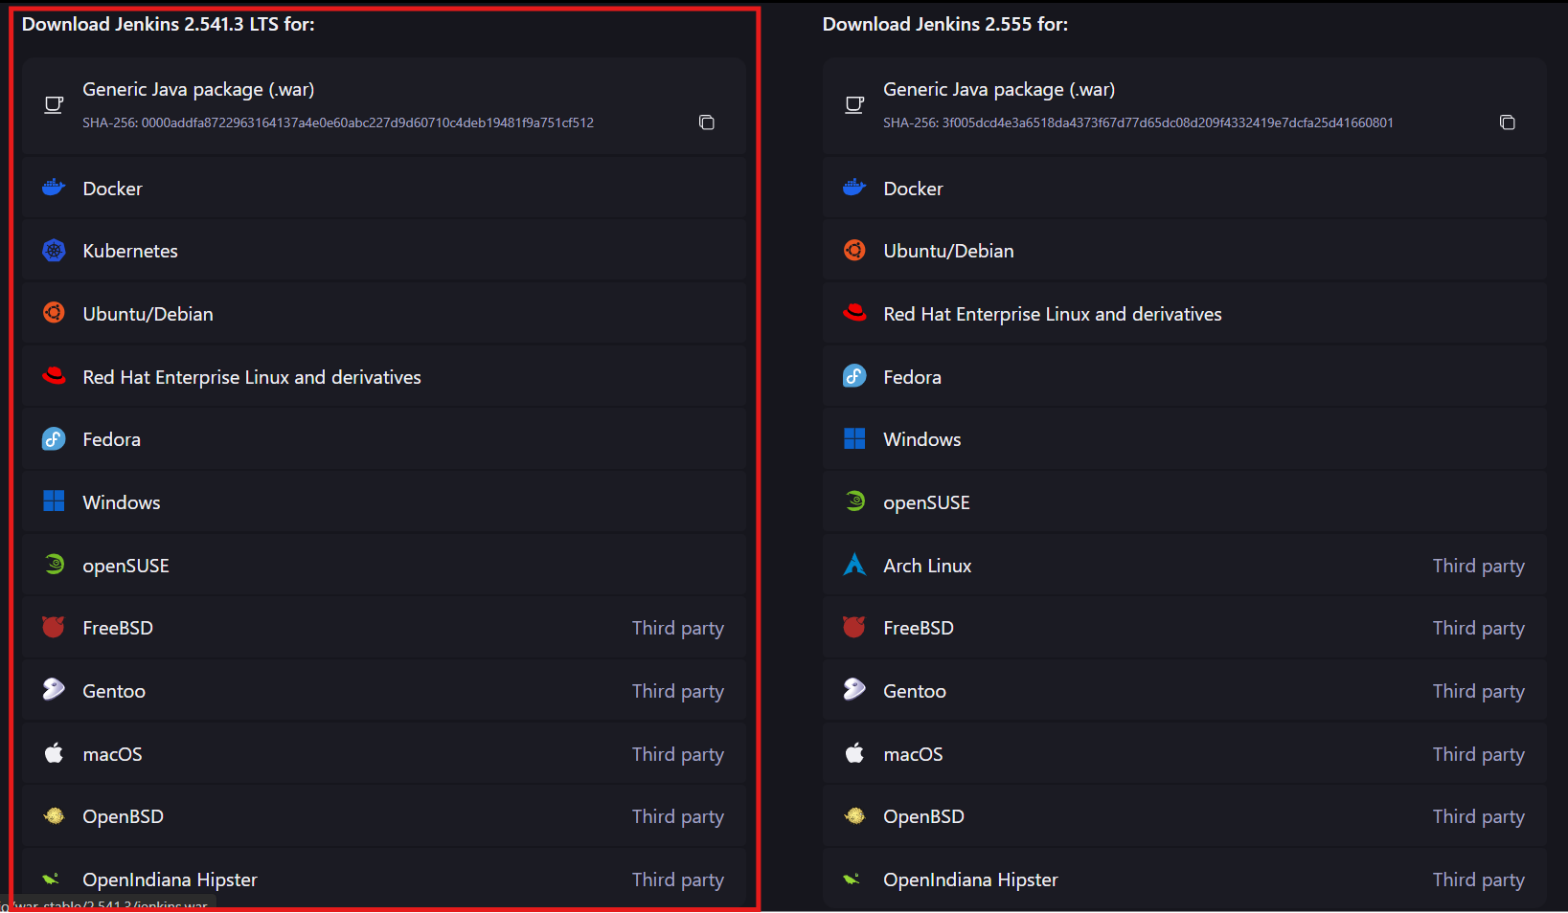
2. Validate Jenkins is installed
NOTE: Default location path: C:\Program Files (x86)\Jenkins
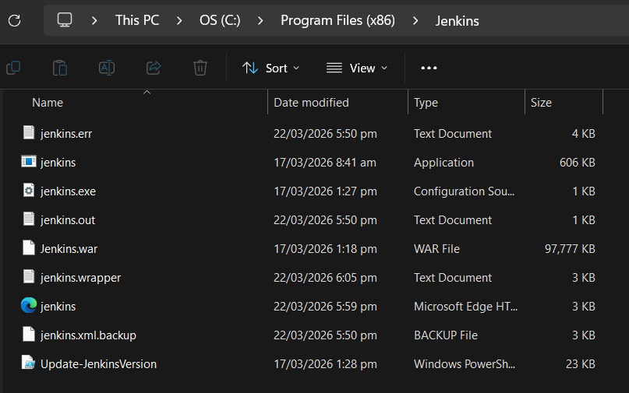
3. Open Jenkins URL via browser (after installation, the service is running)
If in case the service is not running, open power shell in ADMIN mode
command: net start Jenkins
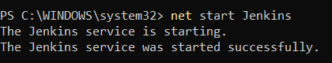
Other command:
stop service: net stop Jenkins
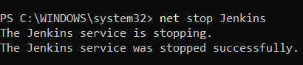
Default URL: http://localhost:8080/
Note: URL depends on the port number define during installation
4. Unlock Jenkins by pasting the password
Note: Password can be found on the path displayed in the server
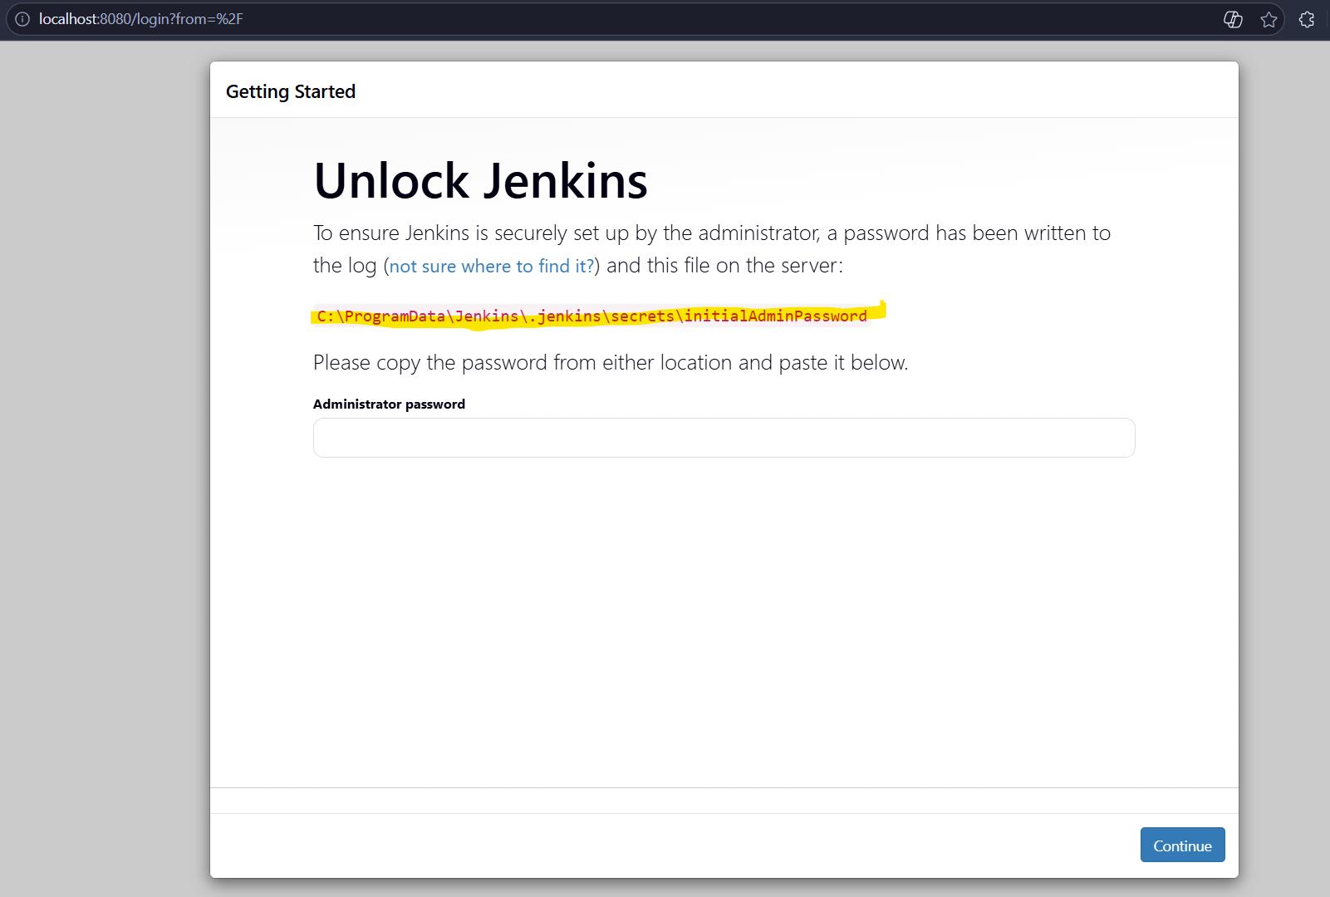
5. Once password is verified, install plugins (can choose if selected plugins or all plugins will be installed)
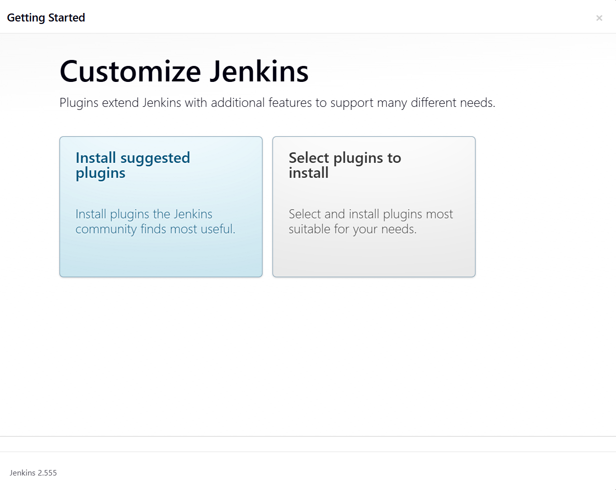
6. Wait until all plugins are loaded. It will install the plugins and may take time for it to finish
NOTE: The screenshot below will be displayed if Install suggested plugins is selected
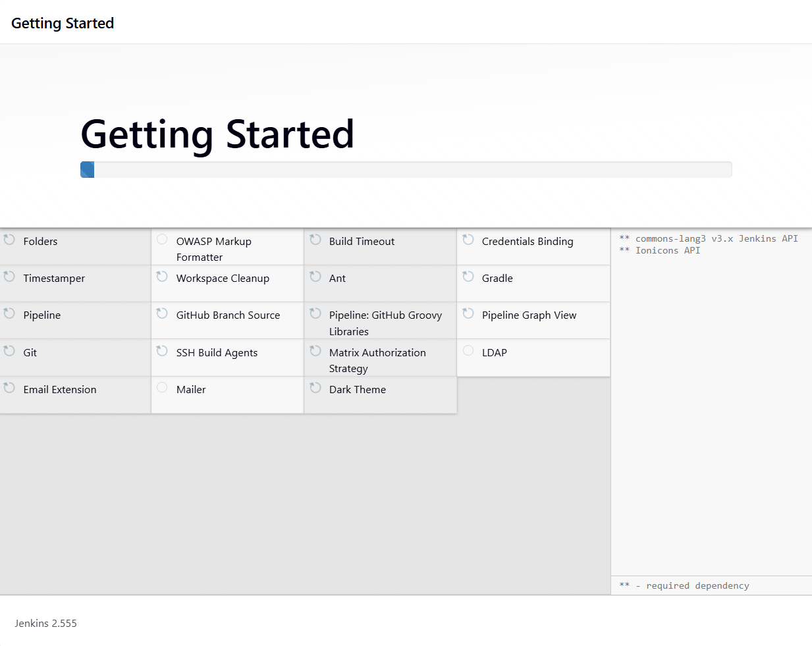
7. If in case, not all applications are installed properly, just click Retry button
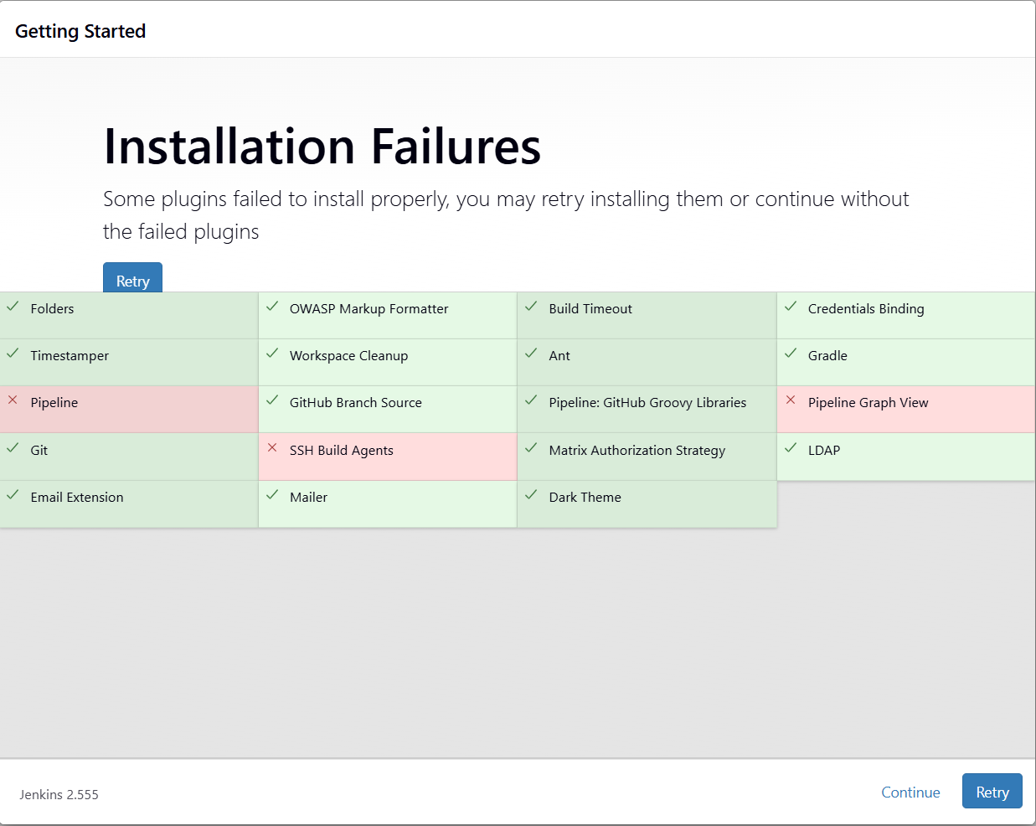
8. Once all applications are installed properly, site will ask to create Admin User. Click Save and Continue button once all fields are populated
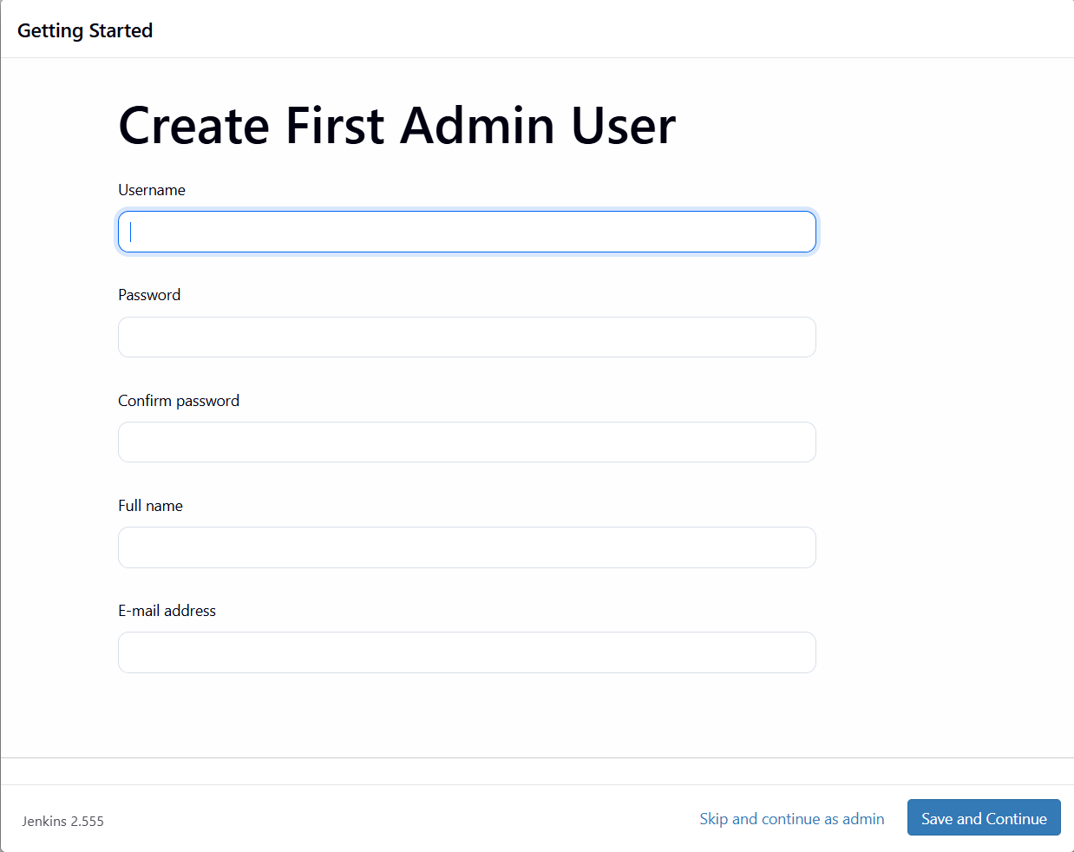
9. Redirected to successful configuration then click Save and Finish button
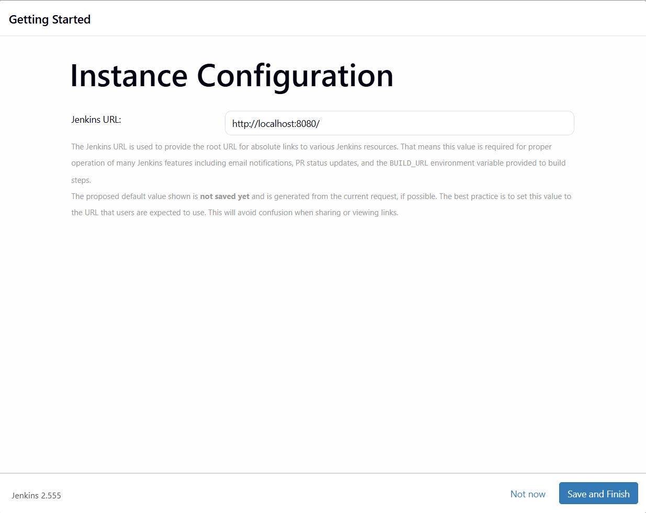
10. Redirected to Setup Complete then click Start using Jenkins button
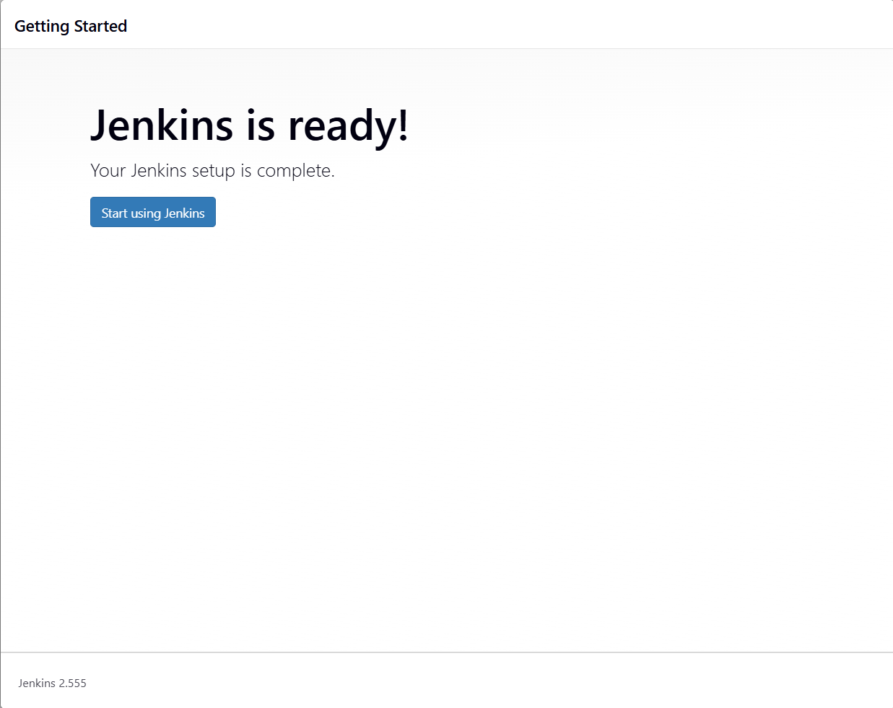
11. Dashboard page of Jenkins
