GIT Tutorial
Pre-condition:
1. Install GIT - https://git-scm.com/install/
2. Copy SSH or HTTPS
GIT Commands:
git clone <repository>
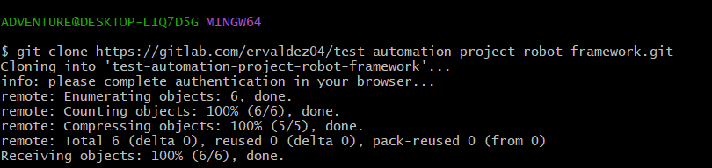

ls -> list all repository

cd <repositoryName> -> go to selected repository

git status -> identify all added, updated, removed file and/or folder
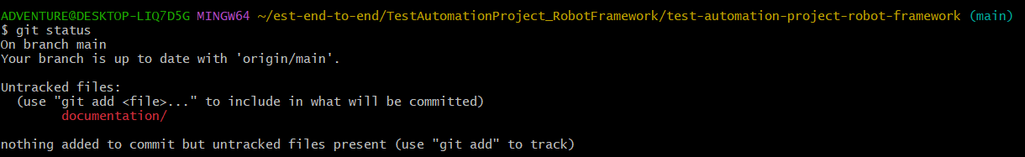

git add <fileName> or git add <folderName> -> add selected file or folder
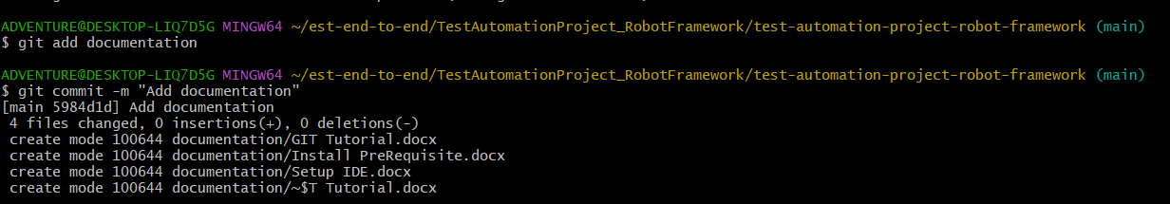

git push origin <branch> -> push changes to repository
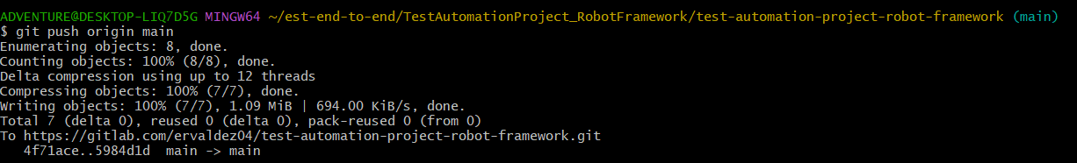

git checkout -b <branchName> -> creates new branch and switch to new branch

git branch -> list all branch in local

