Install Pre-requisite

1. Go to https://www.python.org/downloads/ to download python .exe file
2. Install .exe file
3. Check that python is installed by checking if a folder is created
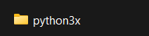
4. In Environment Variables, add the following under System Variables
Variable Name: PYTHONPATH
Variable Value: C:\python3x\Scripts -> Location path of Scripts folder in Python folder
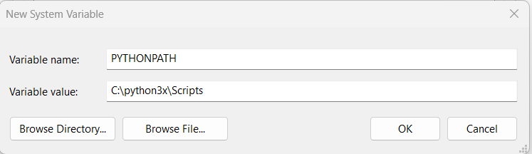
5. Update Path variable under System Variables by adding %PYTHONPATH%
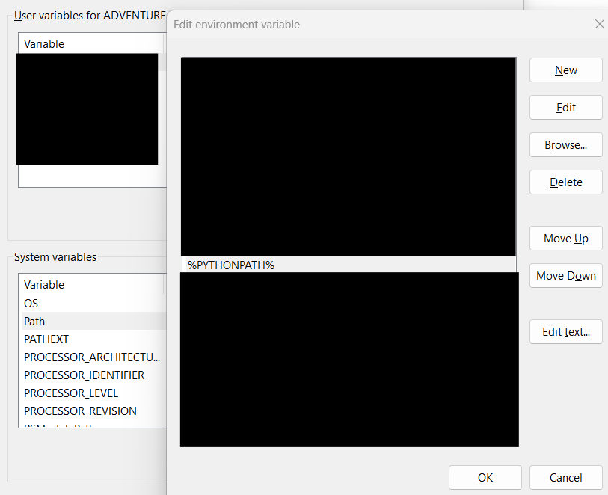
6. Open CMD and check the version of python
command: python –-version
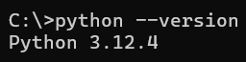
7. in CMD, check pip version
command: pip –-version
NOTE: pip is installed along with Python
Other Command:
update python version: python.exe -m pip install –-upgrade pip
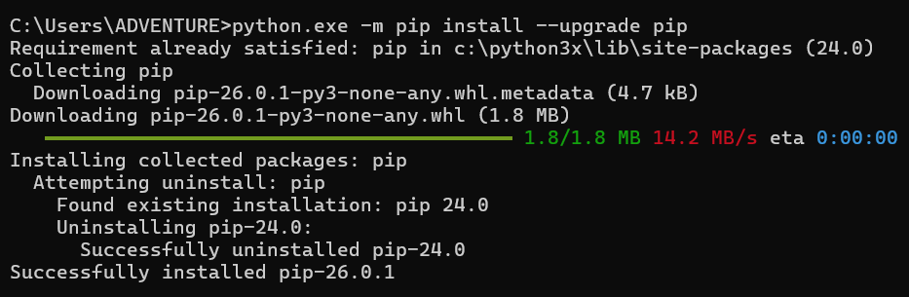
8. Install Selenium via CMD
command: pip install selenium
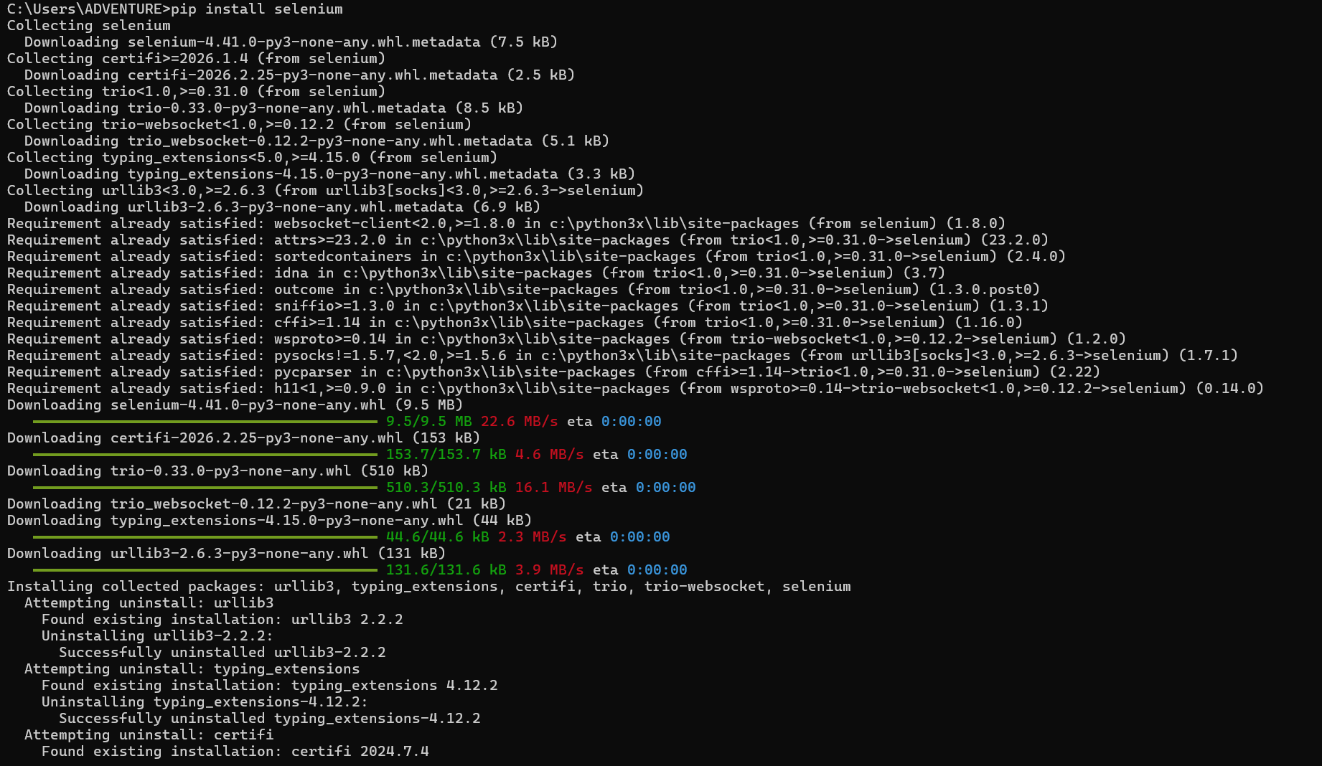
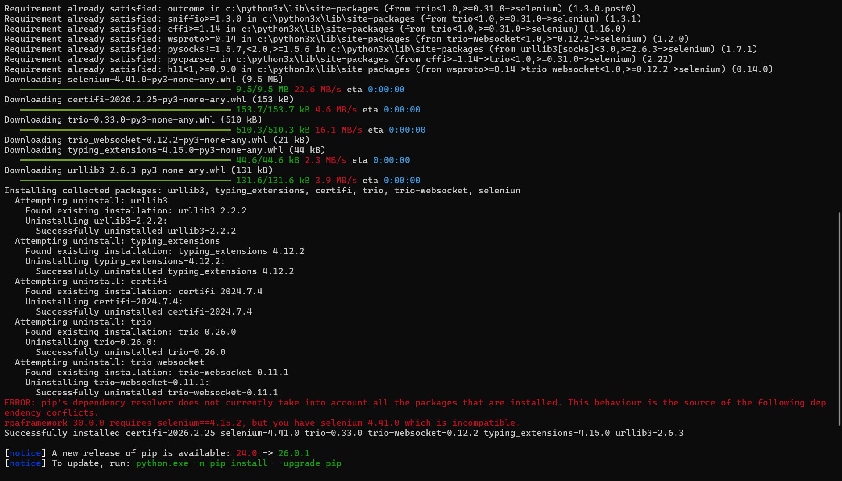
Note: It will download the latest version based on the python version
Other Commands:
uninstall: pip uninstall selenium
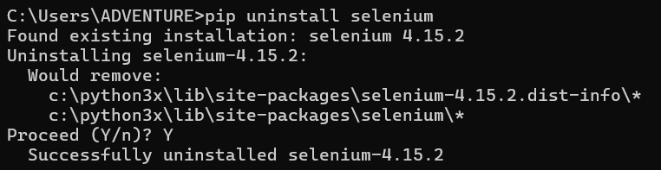
check version: pip show selenium
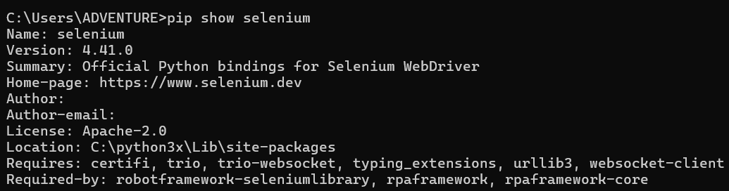
9. Install Robot Framework via CMD
command: pip install robotframework
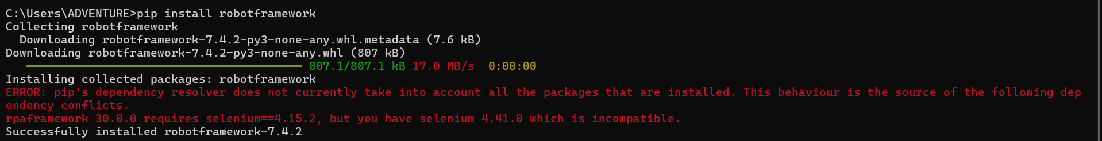
Other Commands:
check version: pip show robotframework
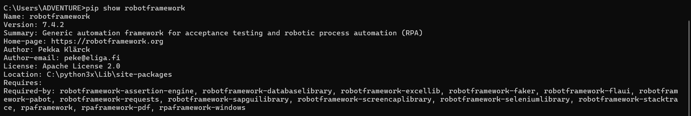
upgrade: pip install –-upgrade robotframework
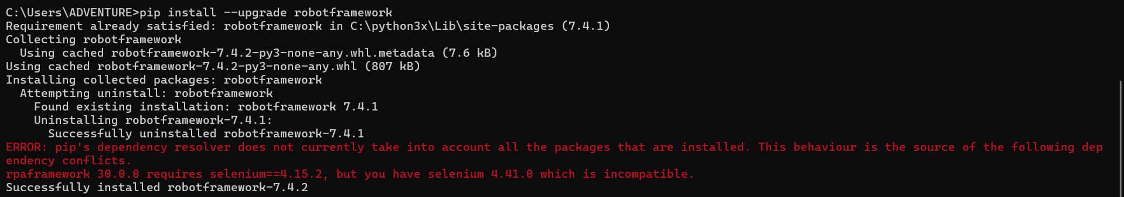
install specific version: pip install robotframework--<version>
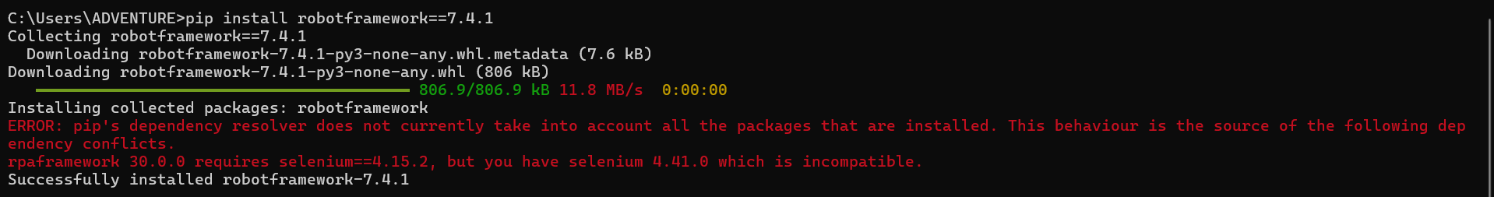
ex: pip install robotframework--7.4.1
uninstall: pip uninstall robotframework
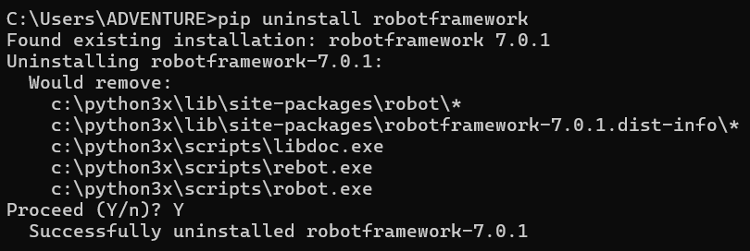
show all package installed and their version: pip list
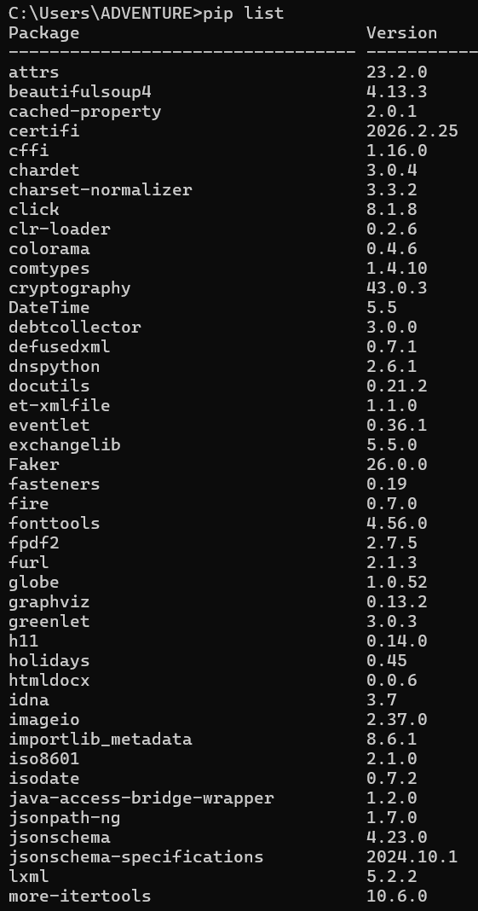

extra: pip check robot framework
10. Install Robot Framework Library via CMD
command: pip install robotframework-seleniumlibrary
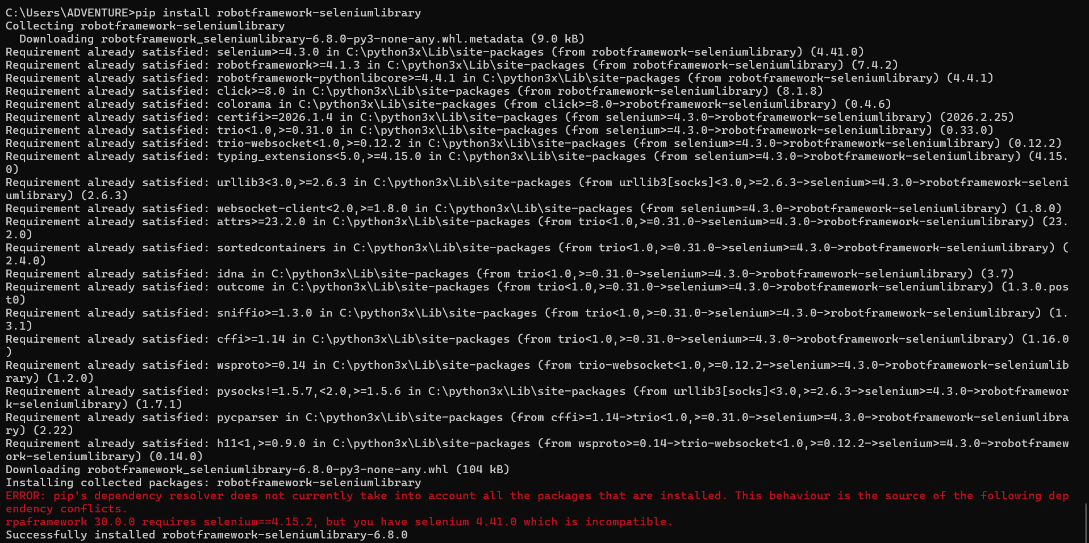
Other Command:
uninstall: pip uninstall robotframework-seleniumlibrary
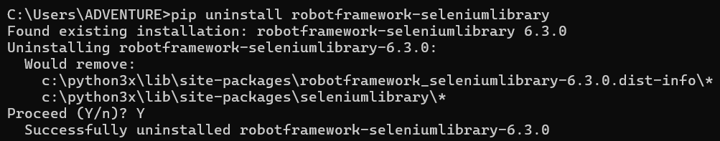
11. Install IDE
- PyCharm
- Visual Studio Code
- RED (Robot Editor)
- Any IDE that can accommodate Robot Framework

OPTIONAL: Install npx
command: rfbrowser init
NOTE: This is needed when using robotframework-browser library
