Integrating Repository with Jenkins

Add new file
1.Create new file named Jenkinsfile
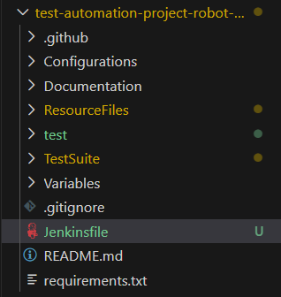
2. Paste sample code in the new file created
pipeline {
agent any

stages {
stage('Checkout') {
steps {
git branch: 'main', url: 'https://github.com/your-org/your-repo.git'
}
}

stage('Install Dependencies') {
steps {
sh 'pip install -r requirements.txt'
}
}

stage('Run Robot Tests') {
steps {
sh 'robot tests/'
}
}
}

post {
always {
archiveArtifacts artifacts: '**/output.xml', fingerprint: true
publishHTML(target: [
reportDir: '.',
reportFiles: 'report.html, log.html',
keepAll: true,
reportName: 'Robot Framework Report'
])
}
}
}

Create Pipeline
1.Open Jenkins in local machine
URL: Dashboard - Jenkins
2. Create new pipeline job with Pipeline as Item Type
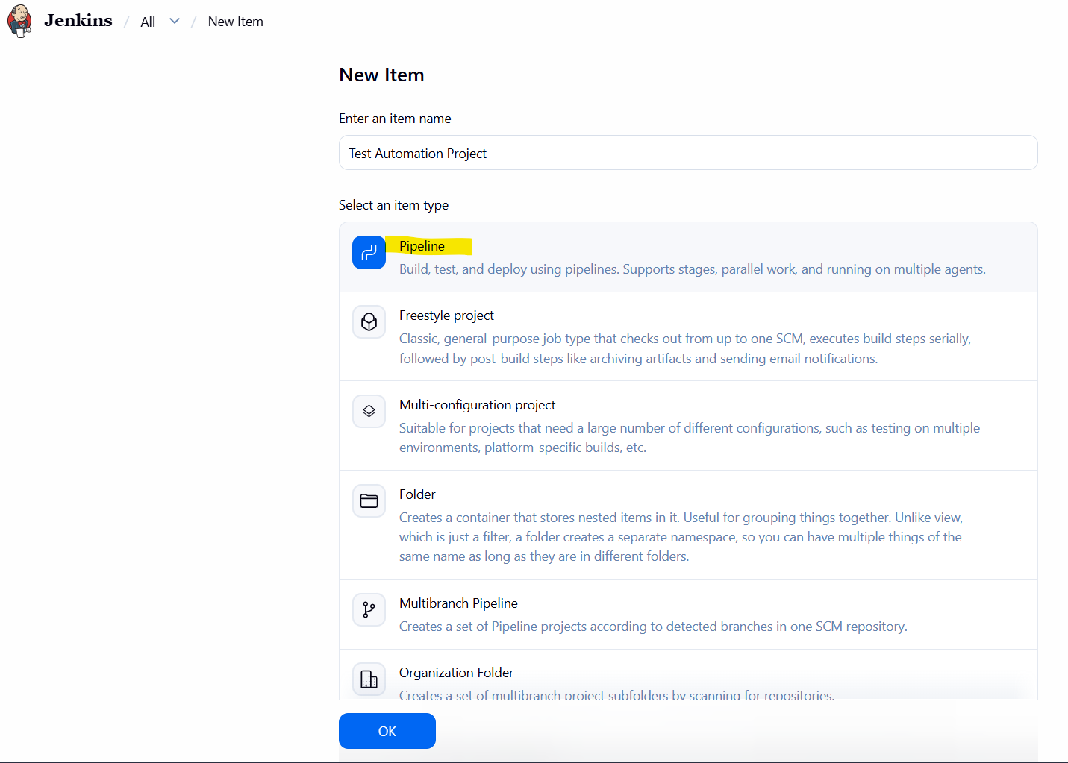
3. Click Pipeline then select Pipeline script from SCM under Definition then select GIT under SCM
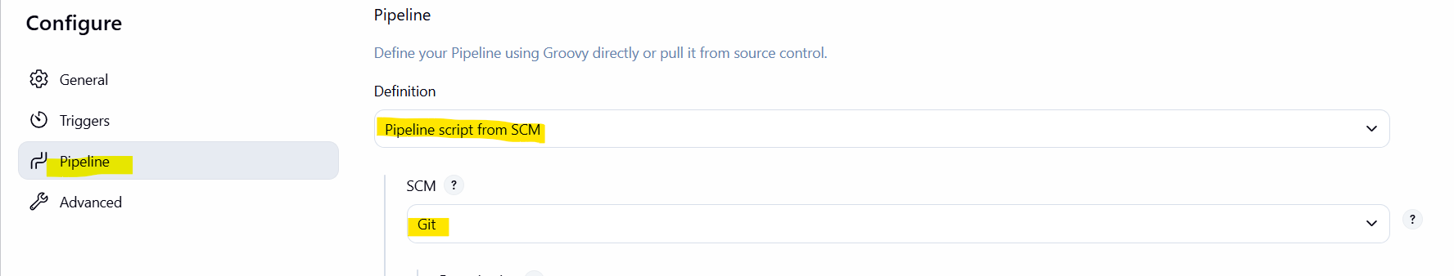
4. Paste github repository URL under Repository URL then add credentials if repository is private then click Apply button then update Branch Specifier, then click Save button
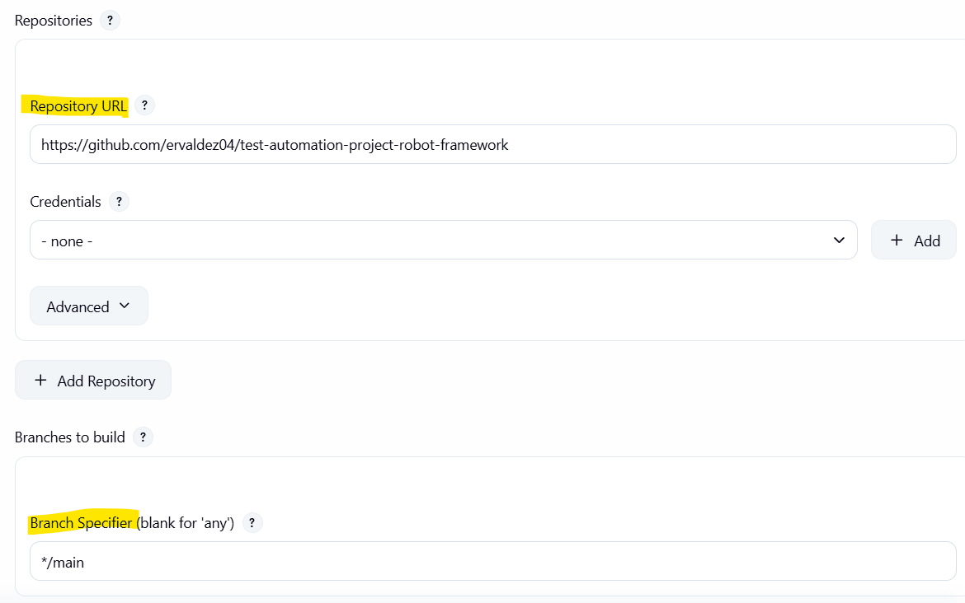
5. Click Save button

Expose Jenkins if using Local Server
1. Go to ngrok site and create or login to account
URL: ngrok: AI & API Gateway | Secure Tunnels & Traffic
2. Click Your Authtoken then copy the token by clicking Copy button
ex: 2M3xXyzAbCdEfGhIjKlMnOpQrStUvWxYz...
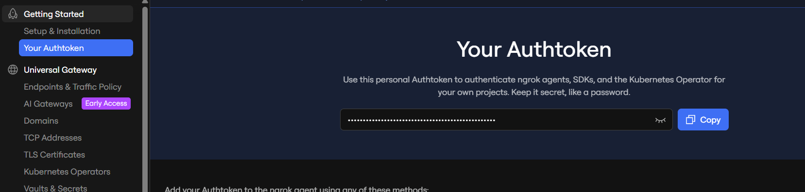
3. Download ngrok then unzipping the file
URL: Download ngrok for Windows
4. Verify the application in the zip file
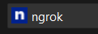
5. Open Environment Variables then paste the location path under System variable -> Path
Folder
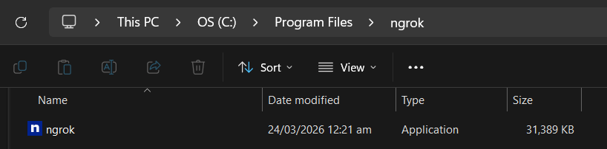
Environment Variable
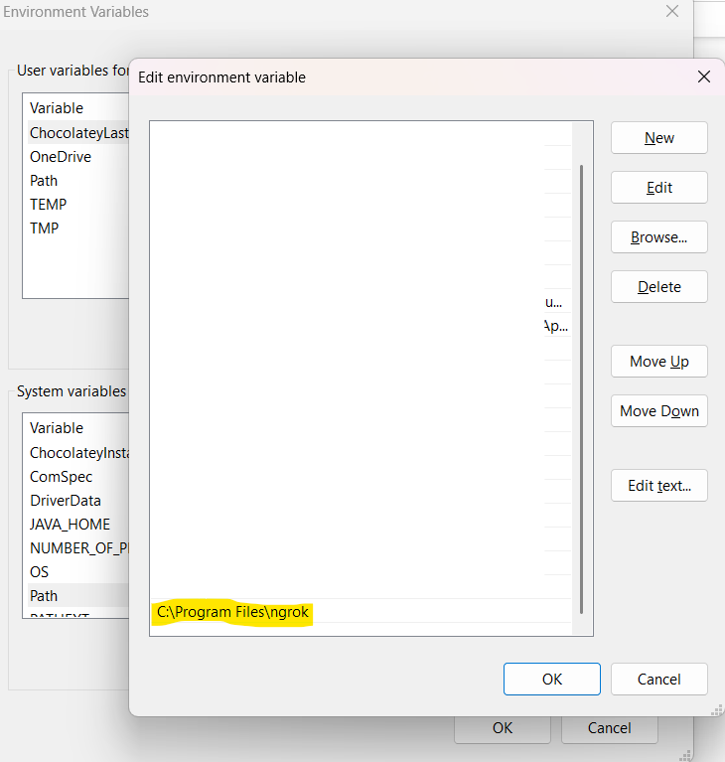
6. Open CMD then enter command
command: ngrok config add-authtoken <authtoken>
7. Validate if configured correctly
command: ngrok http 8080
NOTE: Copy value of forwarding as it will be used for the Webhook
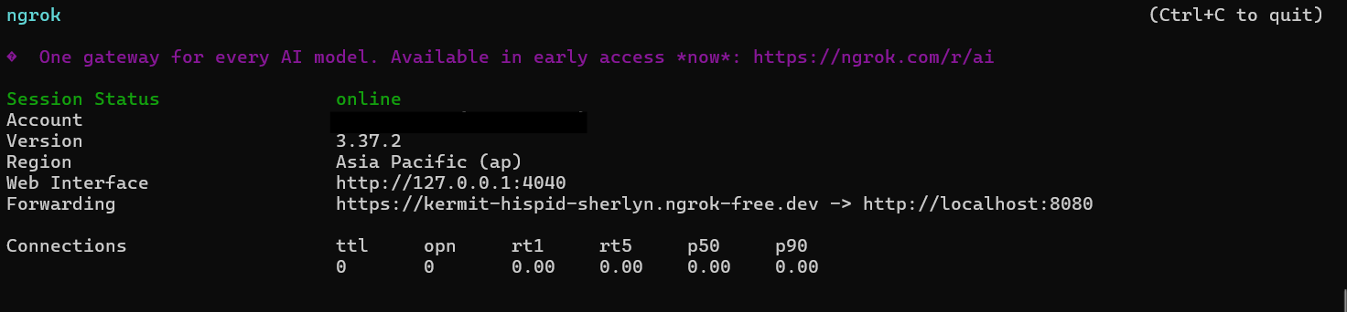

Connect Github Webhook
1. Generate new URL generated by ngrok by entering the command in CMD
Reason: Everytime local machine restarts or started, new URL is created
command: ngrok http 8080
Use the value generated in Forwarding

2. Open Github then navigate to repository
3. Go to Settings -> Webhooks
4. Click Add webhook button
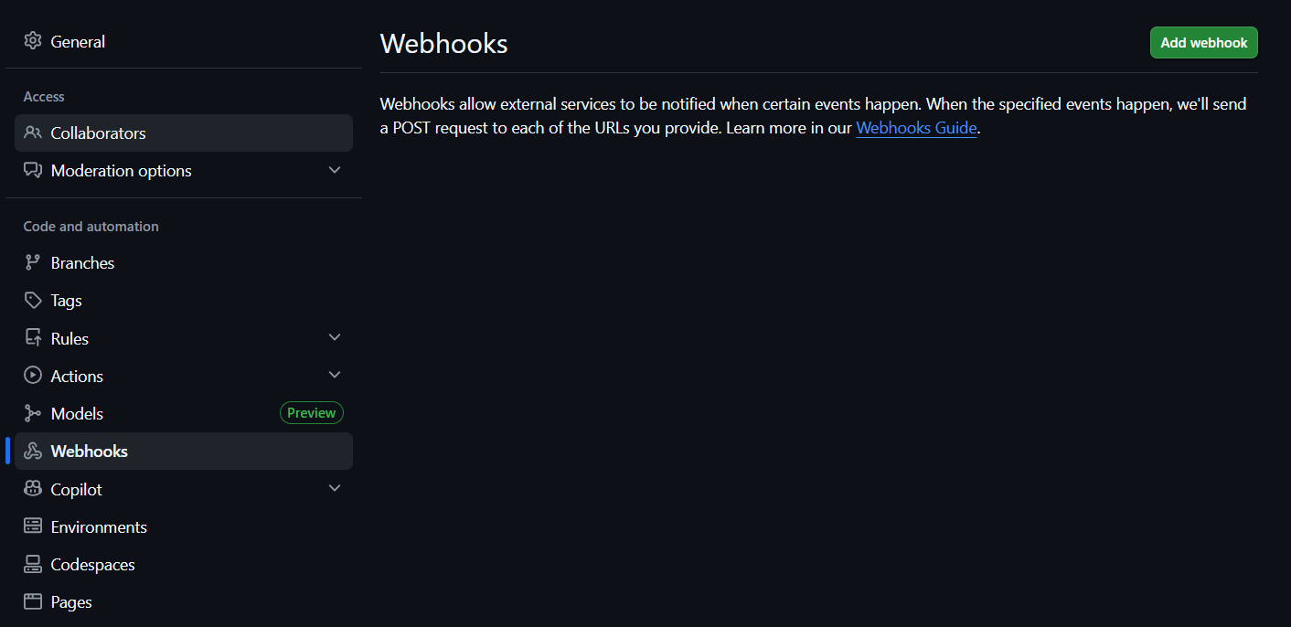
5. Enter server URL copied from ngrok followed by /github-webhook/ under Payload URL
NOTE:
Use the URL generated via ngrok
If not using local server, no need to use ngrok
Ex: http://localhost:8080/github-webhook/
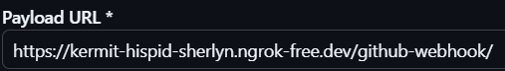
6. Select application/json in Content type
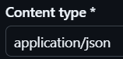
6. Select Just the push event or Let me select individual events then select events you want to include
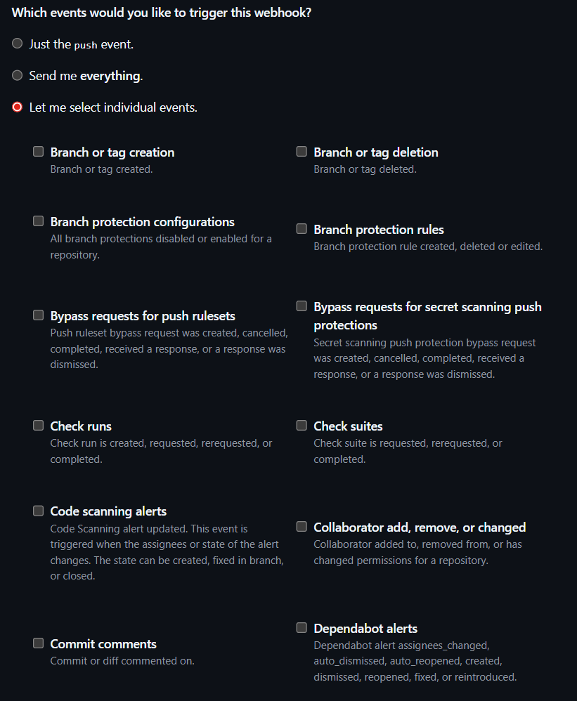
7. Click Add webhook button
8. Webhook is created
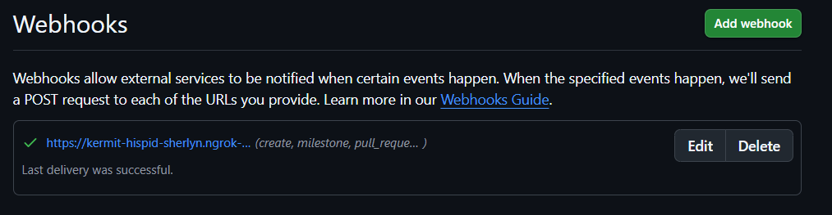

Add Branch Condition in Jenkins File
Job will only run after merging to specific branch
pipeline {
agent any

stages {
stage('Checkout') {
steps {
git branch: 'main', url: 'https://github.com/your-org/your-repo.git'
}
}

stage('Install Dependencies') {
when {
branch 'main'
}
steps {
sh 'pip install -r requirements.txt'
}
}

stage('Run Robot Tests') {
when {
branch 'main'
}
steps {
sh 'robot tests/'
}
}
}

post {
always {
archiveArtifacts artifacts: '**/output.xml', fingerprint: true
publishHTML(target: [
reportDir: '.',
reportFiles: 'report.html, log.html',
keepAll: true,
reportName: 'Robot Framework Report'
])
}
}
}
After a pull request is merged into branch specified, the webhook triggers Jenkins, and the Robot Framework tests run automatically.

Best Practice:
- Keep the Checkout stage unconditional so Jenkins always pulls the repo.
- Multiple Branch
when {
anyOf {
branch 'main'
branch 'develop'
}
}

Add Parameter
1.Open Jenkins in local machine
URL: Dashboard - Jenkins
2. Select existing job or create a new job
3. Click Configure -> General
4. Click This project is parameterized
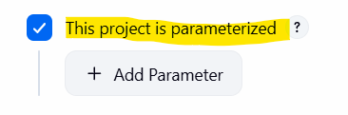
5. Click Add Parameter button then select desired parameter
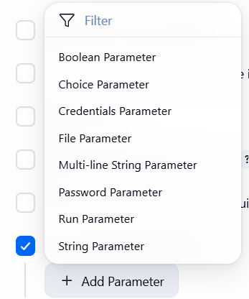
6. Populate the fields
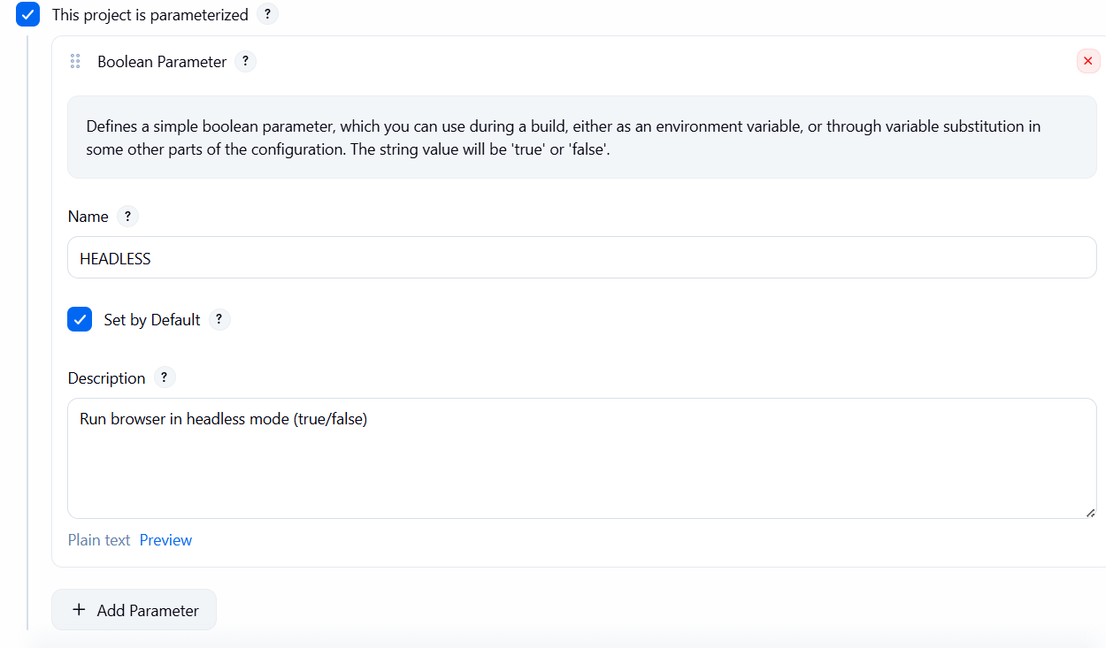
NOTE: Can create multiple parameters in a single job
7. Click Apply button then Save button
8. Update Jenkins file to use the parameter/s
parameters {
booleanParam(name: 'HEADLESS', defaultValue: true, description: 'Run browser in headless mode')
}

Build with Parameter Sample
