ALP Cyber Security
Sistem Otorisasi
Nama: Ervandy Rangganata
NIM: 0706012414015
Universitas Ciputra Online Learning
Surabaya
2026

Daftar access policy
Berikut daftar access policy yang diterapkan pada aplikasi alp-cybersecurity, menjelaskan aturan akses berdasarkan peran (RBAC) dan atribut (ABAC). Setiap endpoint dilindungi oleh middleware guard yang melakukan dua pengecekan berurutan: (1) verifikasi JWT (Firebase ID token, RS256) dan (2) evaluasi policy engine terpusat (src/lib/auth/policies.ts).

Endpoint | Aksi | Pengecekan | Aturan Akses
/api/auth/me | GET | JWT | Siapa pun yang punya ID token valid. Tanpa token → 401.
/api/hospitals | GET | RBAC | Semua user terautentikasi dapat melihat daftar rumah sakit (data publik).
/api/hospitals | POST | RBAC | Hanya admin yang dapat membuat rumah sakit baru.
/api/doctors | GET | RBAC | Admin dan hospital_staff. Doctor & donor → 403.
/api/doctors | POST | RBAC | Hanya admin yang dapat menambah dokter.
/api/donors | GET | RBAC+ABAC | admin: semua · doctor: semua · hospital_staff: donor yang donor.assignedHospitalId == user.linkedId · donor: hanya donor.userId == uid.
/api/donors | POST | RBAC+ABAC | admin/hospital_staff/donor dapat membuat. Donor di-paksa userId = uid sendiri (tidak dapat membuat atas nama orang lain).
/api/donors/{id} | GET | RBAC+ABAC | admin · doctor · hospital_staff (jika donor.assignedHospitalId == user.linkedId) · donor (jika donor.userId == uid).
/api/donors/{id} | PATCH | RBAC+ABAC | admin · donor diri sendiri · hospital_staff rumah sakitnya.
/api/donors/{id} | DELETE | RBAC | Hanya admin.
/api/medical-records | GET | RBAC+ABAC | admin: semua · doctor: semua · hospital_staff: record.hospitalId == user.linkedId · donor: record.donorId == user.linkedId.
/api/medical-records | POST | RBAC+ABAC | admin/doctor/hospital_staff. hospital_staff di-paksa hospitalId = linkedId.

Semua policy diimplementasikan sebagai pure function di src/lib/auth/policies.ts dan dipanggil oleh API route guard (src/lib/auth/api-guard.ts). Hasil evaluasi memuat field "matched" (RBAC / ABAC / RBAC+ABAC / DENY) untuk auditing.

Diagram arsitektur sistem
Alur autentikasi dan otorisasi aplikasi ditunjukkan pada diagram di bawah. User login via email/password atau Google OAuth ke Firebase Auth, kemudian menerima Firebase ID token (JWT RS256). Client (Next.js) melampirkan token pada setiap request API sebagai header Authorization: Bearer. Setiap API route melewati api-guard yang (1) memverifikasi tanda tangan JWT via firebase-admin SDK, (2) mengambil atribut user (role, linkedId) dari Realtime Database, (3) memanggil policy engine, dan (4) mengembalikan 200/403 beserta alasan dan kategori kecocokan.

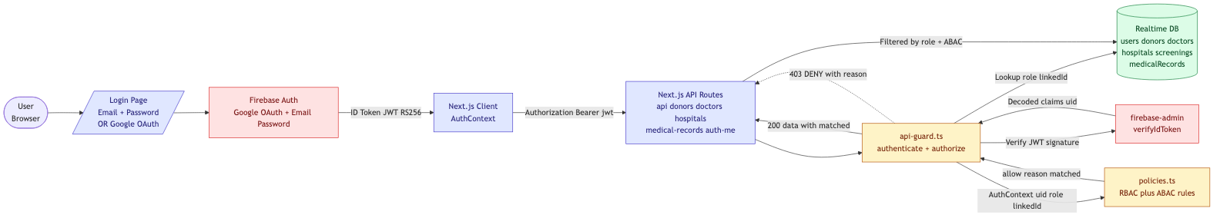
Diagram arsitektur: alur JWT + policy engine di alp-cybersecurity.

#1 Access Token
Aplikasi menggunakan dua mekanisme access token:
- JWT via email + password — Firebase Auth menerbitkan ID token RS256 saat signInWithEmailAndPassword. Token dilampirkan pada header Authorization Bearer.
- OAuth 2.0 Google Login — tombol "Masuk dengan Google" pada halaman /login memakai GoogleAuthProvider via signInWithPopup. Pada login Google pertama, user otomatis dibuat sebagai donor.

Endpoint /api/auth/me melakukan verifikasi tanda tangan JWT dan mengembalikan isi token (header + payload). Percobaan tanpa token akan ditolak dengan 401.

Tampilan login (email + password + Google OAuth)
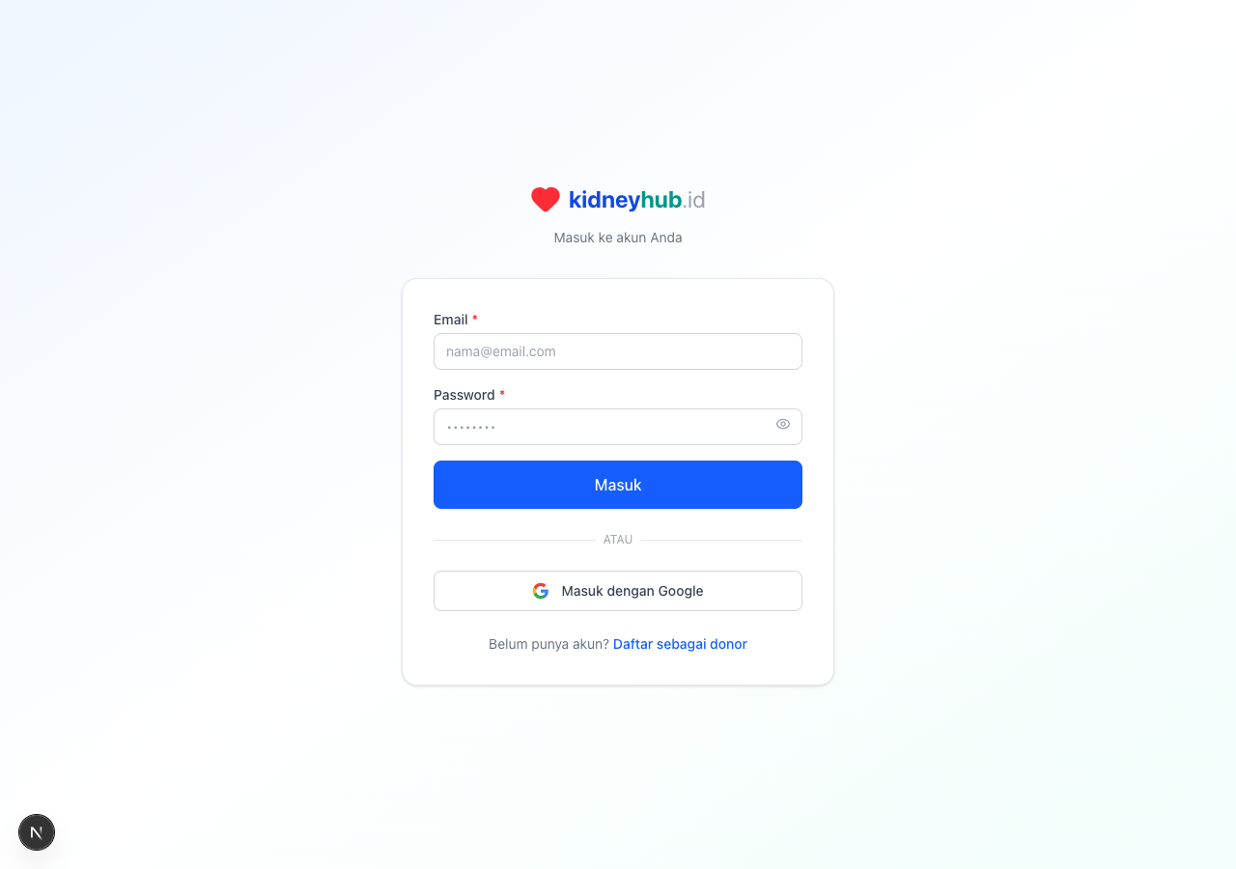
/login — tombol "Masuk dengan Google" dan form email/password.

Decoded JWT untuk akun admin@demo.test
=== JWT /api/auth/me sebagai admin ===
REQUEST: GET /api/auth/me
STATUS: HTTP 200
RESPONSE:
{
"success": true,
"context": {
"uid": "edE7O5iV8Few7FKVhddGrS5sqkf1",
"email": "admin@demo.test",
"role": "admin"
},
"jwt": {
"header": {
"alg": "RS256",
"kid": "3b095747bf8331ea4ad53f370c63260179b0d23a",
"typ": "JWT"
},
"payload": {
"iss": "https://securetoken.google.com/alp-cybersecurity-b38b3",
"aud": "alp-cybersecurity-b38b3",
"auth_time": 1776966175,
"user_id": "edE7O5iV8Few7FKVhddGrS5sqkf1",
"sub": "edE7O5iV8Few7FKVhddGrS5sqkf1",
"iat": 1776966175,
"exp": 1776969775,
"email": "admin@demo.test",
"email_verified": false,
"firebase": {
"identities": {
"email": [
"admin@demo.test"
]
},
"sign_in_provider": "password"
},
"uid": "edE7O5iV8Few7FKVhddGrS5sqkf1"
},
"signature": "[RS256 verified by firebase-admin SDK]"
}
}

Percobaan tanpa token → HTTP 401
=== JWT /api/auth/me TANPA token ===
REQUEST: GET /api/auth/me
STATUS: HTTP 401
RESPONSE:
{
"success": false,
"error": "Missing Authorization Bearer token",
"code": "NO_TOKEN"
}

#2 Role-Based Access Control (RBAC)
Aplikasi mendefinisikan 4 peran dengan hak akses berbeda (file: src/types/index.ts → UserRole):
- admin — akses penuh ke seluruh data sistem (donor, dokter, rumah sakit, skrining, rekam medis).
- doctor — dapat melihat & mengubah skrining donor yang ditugaskan ke dirinya.
- hospital_staff — dapat melihat donor & rekam medis rumah sakitnya, dan menginput rekam medis baru.
- donor — hanya dapat mengakses & mengubah data miliknya sendiri.

Berikut contoh penerapan RBAC pada endpoint /api/doctors: hanya admin dan hospital_staff yang diizinkan. Akun doctor & donor akan mendapat 403.

admin → /api/doctors (200 ALLOWED)
=== RBAC admin GET /api/doctors (ALLOWED) ===
REQUEST: GET /api/doctors
STATUS: HTTP 200
RESPONSE:
{
"success": true,
"data": [
{
"id": "doctor-1",
"createdAt": "2026-04-23T17:37:53.362Z",
"email": "doctor1@demo.test",
"hospital": "RS Demo Utama",
"isActive": true,
"licenseNumber": "DEMO-DR-001",
"name": "dr. Demo Satu, SpPD-KGH",
"phone": "08111000001",
"specialization": "SpPD-KGH",
"userId": "urhdGLugWATWYCIpxFzY0v0j6p92"
},
{
"id": "doctor-2",
"createdAt": "2026-04-23T17:37:53.362Z",
"email": "doctor2@demo.test",
"hospital": "RS Demo Kedua",
"isActive": true,
"licenseNumber": "DEMO-DR-002",
"name": "dr. Demo Dua, SpPD-KGH",
"phone": "08111000002",
"specialization": "SpPD-KGH",
"userId": "74S1sQENq5MOakaUEQ4DOFXjBH42"
}
],
"matched": "RBAC"
}

hospital_staff → /api/doctors (200 ALLOWED)
=== RBAC staffA GET /api/doctors (ALLOWED) ===
REQUEST: GET /api/doctors
STATUS: HTTP 200
RESPONSE:
{
"success": true,
"data": [
{
"id": "doctor-1",
"createdAt": "2026-04-23T17:37:53.362Z",
"email": "doctor1@demo.test",
"hospital": "RS Demo Utama",
"isActive": true,
"licenseNumber": "DEMO-DR-001",
"name": "dr. Demo Satu, SpPD-KGH",
"phone": "08111000001",
"specialization": "SpPD-KGH",
"userId": "urhdGLugWATWYCIpxFzY0v0j6p92"
},
{
"id": "doctor-2",
"createdAt": "2026-04-23T17:37:53.362Z",
"email": "doctor2@demo.test",
"hospital": "RS Demo Kedua",
"isActive": true,
"licenseNumber": "DEMO-DR-002",
"name": "dr. Demo Dua, SpPD-KGH",
"phone": "08111000002",
"specialization": "SpPD-KGH",
"userId": "74S1sQENq5MOakaUEQ4DOFXjBH42"
}
],
"matched": "RBAC"
}

doctor → /api/doctors (403 DENIED)
=== RBAC doctor1 GET /api/doctors (DENIED) ===
REQUEST: GET /api/doctors
STATUS: HTTP 403
RESPONSE:
{
"success": false,
"error": "hanya admin & hospital_staff yang dapat melihat daftar dokter",
"code": "FORBIDDEN",
"matched": "DENY"
}

donor → /api/doctors (403 DENIED)
=== RBAC donor GET /api/doctors (DENIED) ===
REQUEST: GET /api/doctors
STATUS: HTTP 403
RESPONSE:
{
"success": false,
"error": "hanya admin & hospital_staff yang dapat melihat daftar dokter",
"code": "FORBIDDEN",
"matched": "DENY"
}

Halaman /demo/authz sebagai admin — semua RBAC lulus
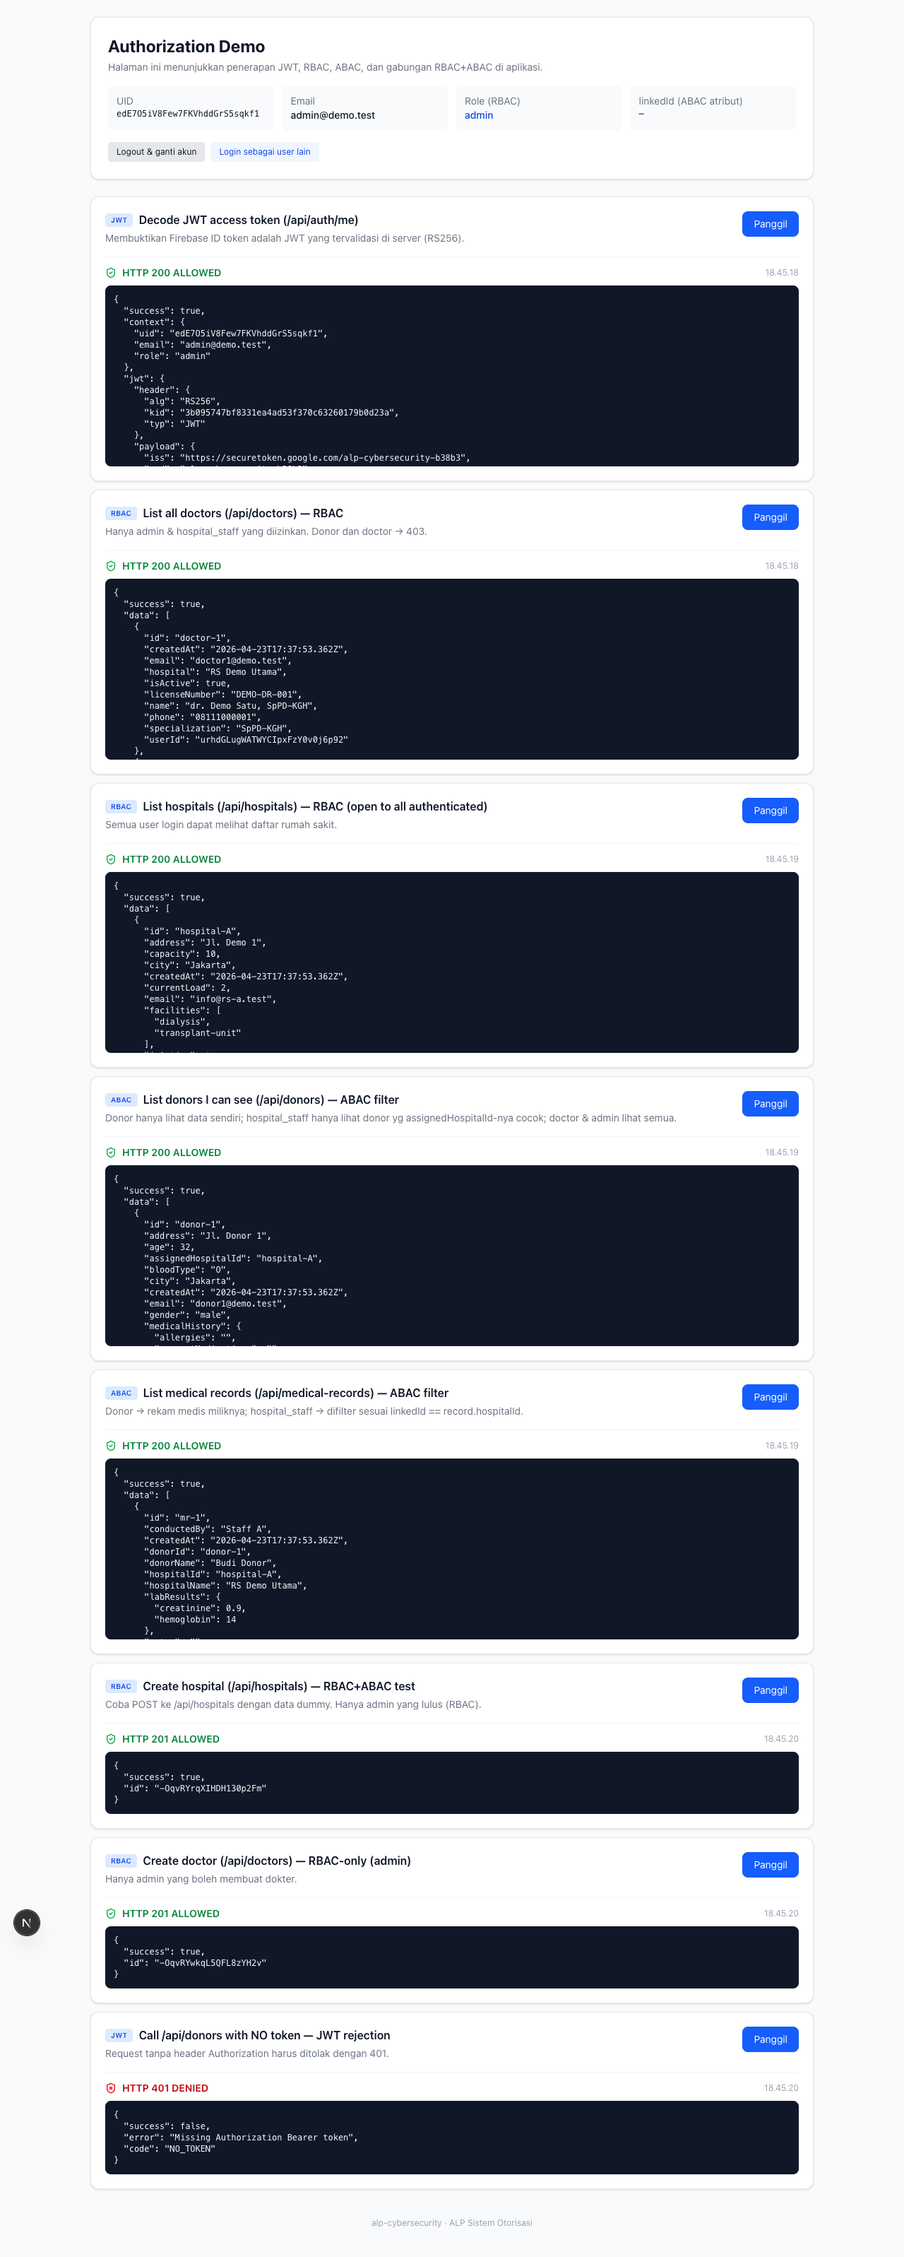
/demo/authz — admin melihat 200 di semua scenario (RBAC bypass).

#3 Attribute-Based Access Control (ABAC)
Selain peran, aplikasi mengontrol akses berdasarkan atribut:
- Donor — atribut donor.userId harus cocok dengan uid pengguna.
- Medical record — atribut record.donorId atau record.hospitalId harus cocok dengan user.linkedId.
- Screening — atribut screening.doctorId harus cocok dengan doctor.linkedId.

Contoh 1: endpoint /api/donors memfilter berdasarkan atribut. staffA (linkedId=hospital-A) hanya melihat donor yang assignedHospitalId=hospital-A.

staffA → /api/donors (hanya donor-1, matched=RBAC+ABAC)
=== ABAC staffA GET /api/donors (filter hospital A) ===
REQUEST: GET /api/donors
STATUS: HTTP 200
RESPONSE:
{
"success": true,
"data": [
{
"id": "donor-1",
"address": "Jl. Donor 1",
"age": 32,
"assignedHospitalId": "hospital-A",
"bloodType": "O",
"city": "Jakarta",
"createdAt": "2026-04-23T17:37:53.362Z",
"email": "donor1@demo.test",
"gender": "male",
"medicalHistory": {
"allergies": "",
"currentMedications": "",
"familyMedicalHistory": "",
"hasCancer": false,
"hasDiabetes": false,
"hasHIV": false,
"hasHeartDisease": false,
"hasHepatitis": false,
"hasHypertension": false,
"hasKidneyDisease": false,
"notes": "",
"previousSurgeries": ""
},
"name": "Budi Donor",
"phone": "085100000001",
"rhesus": "+",
"status": "screening",
"updatedAt": "2026-04-23T17:37:53.362Z",
"userId": "AXZ6q3vuvmho9v0Z3UI0QwIJwSB3"
}
],
"matched": "RBAC+ABAC"
}

staffB → /api/donors (hanya donor-2, matched=RBAC+ABAC)
=== ABAC staffB GET /api/donors (filter hospital B) ===
REQUEST: GET /api/donors
STATUS: HTTP 200
RESPONSE:
{
"success": true,
"data": [
{
"id": "donor-2",
"address": "Jl. Donor 2",
"age": 29,
"assignedHospitalId": "hospital-B",
"bloodType": "A",
"city": "Surabaya",
"createdAt": "2026-04-23T17:37:53.362Z",
"email": "donor2@demo.test",
"gender": "female",
"medicalHistory": {
"allergies": "",
"currentMedications": "",
"familyMedicalHistory": "",
"hasCancer": false,
"hasDiabetes": false,
"hasHIV": false,
"hasHeartDisease": false,
"hasHepatitis": false,
"hasHypertension": false,
"hasKidneyDisease": false,
"notes": "",
"previousSurgeries": ""
},
"name": "Siti Donor",
"phone": "085100000002",
"rhesus": "+",
"status": "eligible",
"updatedAt": "2026-04-23T17:37:53.362Z",
"userId": "orphan-donor"
}
],
"matched": "RBAC+ABAC"
}

donor1 → /api/donors (hanya data sendiri, matched=ABAC)
=== ABAC donor GET /api/donors (only self) ===
REQUEST: GET /api/donors
STATUS: HTTP 200
RESPONSE:
{
"success": true,
"data": [
{
"id": "donor-1",
"address": "Jl. Donor 1",
"age": 32,
"assignedHospitalId": "hospital-A",
"bloodType": "O",
"city": "Jakarta",
"createdAt": "2026-04-23T17:37:53.362Z",
"email": "donor1@demo.test",
"gender": "male",
"medicalHistory": {
"allergies": "",
"currentMedications": "",
"familyMedicalHistory": "",
"hasCancer": false,
"hasDiabetes": false,
"hasHIV": false,
"hasHeartDisease": false,
"hasHepatitis": false,
"hasHypertension": false,
"hasKidneyDisease": false,
"notes": "",
"previousSurgeries": ""
},
"name": "Budi Donor",
"phone": "085100000001",
"rhesus": "+",
"status": "screening",
"updatedAt": "2026-04-23T17:37:53.362Z",
"userId": "AXZ6q3vuvmho9v0Z3UI0QwIJwSB3"
}
],
"matched": "ABAC"
}

Halaman /demo/authz sebagai donor — ABAC mengizinkan data sendiri saja
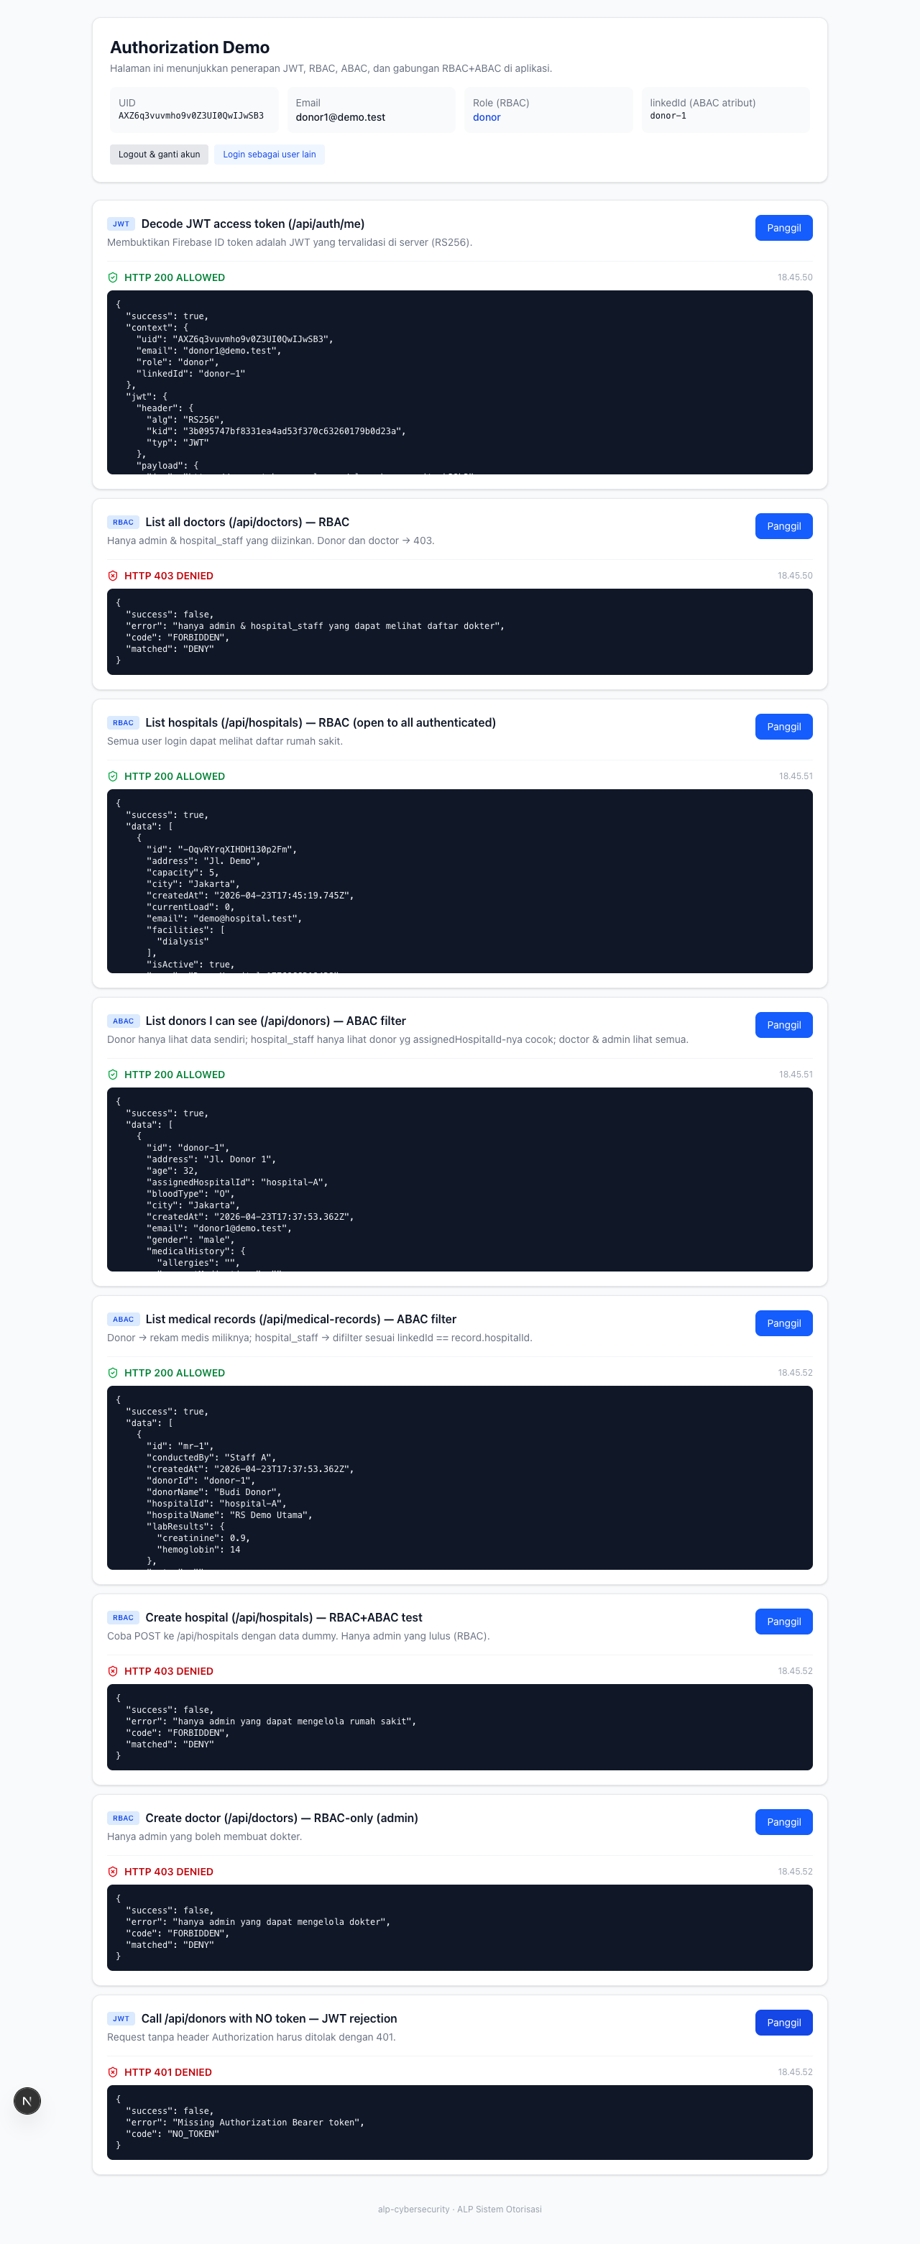
/demo/authz — donor1 hanya dapat melihat data miliknya. List doctors/create = 403.

#4 Gabungan RBAC dan ABAC
Kasus penggunaan gabungan: endpoint /api/donors/{id} mengevaluasi keduanya. Untuk hospital_staff, akses hanya diizinkan jika (role==hospital_staff) DAN (donor.assignedHospitalId==user.linkedId). Untuk penghapusan rekam medis, hanya (admin) atau (hospital_staff AND record.hospitalId==linkedId) yang diizinkan.

staffA → /api/donors/donor-1 (rumah sakit sama) → 200 RBAC+ABAC
=== RBAC+ABAC staffA GET /api/donors/donor-1 (ALLOWED same hospital) ===
REQUEST: GET /api/donors/donor-1
STATUS: HTTP 200
RESPONSE:
{
"success": true,
"data": {
"id": "donor-1",
"address": "Jl. Donor 1",
"age": 32,
"assignedHospitalId": "hospital-A",
"bloodType": "O",
"city": "Jakarta",
"createdAt": "2026-04-23T17:37:53.362Z",
"email": "donor1@demo.test",
"gender": "male",
"medicalHistory": {
"allergies": "",
"currentMedications": "",
"familyMedicalHistory": "",
"hasCancer": false,
"hasDiabetes": false,
"hasHIV": false,
"hasHeartDisease": false,
"hasHepatitis": false,
"hasHypertension": false,
"hasKidneyDisease": false,
"notes": "",
"previousSurgeries": ""
},
"name": "Budi Donor",
"phone": "085100000001",
"rhesus": "+",
"status": "screening",
"updatedAt": "2026-04-23T17:37:53.362Z",
"userId": "AXZ6q3vuvmho9v0Z3UI0QwIJwSB3"
},
"matched": "RBAC+ABAC"
}

staffB → /api/donors/donor-1 (rumah sakit beda) → 403 DENY
=== RBAC+ABAC staffB GET /api/donors/donor-1 (DENIED diff hospital) ===
REQUEST: GET /api/donors/donor-1
STATUS: HTTP 403
RESPONSE:
{
"success": false,
"error": "hospital_staff hanya dapat melihat donor yang ditugaskan ke rumah sakitnya (linkedId=hospital-B, donor.assignedHospitalId=hospital-A)",
"code": "FORBIDDEN",
"matched": "DENY"
}

donor → /api/donors/donor-1 (dirinya sendiri) → 200 ABAC
=== ABAC donor GET /api/donors/donor-1 (ALLOWED self) ===
REQUEST: GET /api/donors/donor-1
STATUS: HTTP 200
RESPONSE:
{
"success": true,
"data": {
"id": "donor-1",
"address": "Jl. Donor 1",
"age": 32,
"assignedHospitalId": "hospital-A",
"bloodType": "O",
"city": "Jakarta",
"createdAt": "2026-04-23T17:37:53.362Z",
"email": "donor1@demo.test",
"gender": "male",
"medicalHistory": {
"allergies": "",
"currentMedications": "",
"familyMedicalHistory": "",
"hasCancer": false,
"hasDiabetes": false,
"hasHIV": false,
"hasHeartDisease": false,
"hasHepatitis": false,
"hasHypertension": false,
"hasKidneyDisease": false,
"notes": "",
"previousSurgeries": ""
},
"name": "Budi Donor",
"phone": "085100000001",
"rhesus": "+",
"status": "screening",
"updatedAt": "2026-04-23T17:37:53.362Z",
"userId": "AXZ6q3vuvmho9v0Z3UI0QwIJwSB3"
},
"matched": "ABAC"
}

admin → /api/donors/donor-1 → 200 RBAC (bypass)
=== RBAC admin GET /api/donors/donor-1 (ALLOWED role bypass) ===
REQUEST: GET /api/donors/donor-1
STATUS: HTTP 200
RESPONSE:
{
"success": true,
"data": {
"id": "donor-1",
"address": "Jl. Donor 1",
"age": 32,
"assignedHospitalId": "hospital-A",
"bloodType": "O",
"city": "Jakarta",
"createdAt": "2026-04-23T17:37:53.362Z",
"email": "donor1@demo.test",
"gender": "male",
"medicalHistory": {
"allergies": "",
"currentMedications": "",
"familyMedicalHistory": "",
"hasCancer": false,
"hasDiabetes": false,
"hasHIV": false,
"hasHeartDisease": false,
"hasHepatitis": false,
"hasHypertension": false,
"hasKidneyDisease": false,
"notes": "",
"previousSurgeries": ""
},
"name": "Budi Donor",
"phone": "085100000001",
"rhesus": "+",
"status": "screening",
"updatedAt": "2026-04-23T17:37:53.362Z",
"userId": "AXZ6q3vuvmho9v0Z3UI0QwIJwSB3"
},
"matched": "RBAC"
}

Perbandingan staffA vs staffB pada halaman /demo/authz
staffA: dapat melihat donor-1 (rumah sakit yang sama). staffB: tidak dapat melihat donor-1, hanya dapat melihat donor-2.
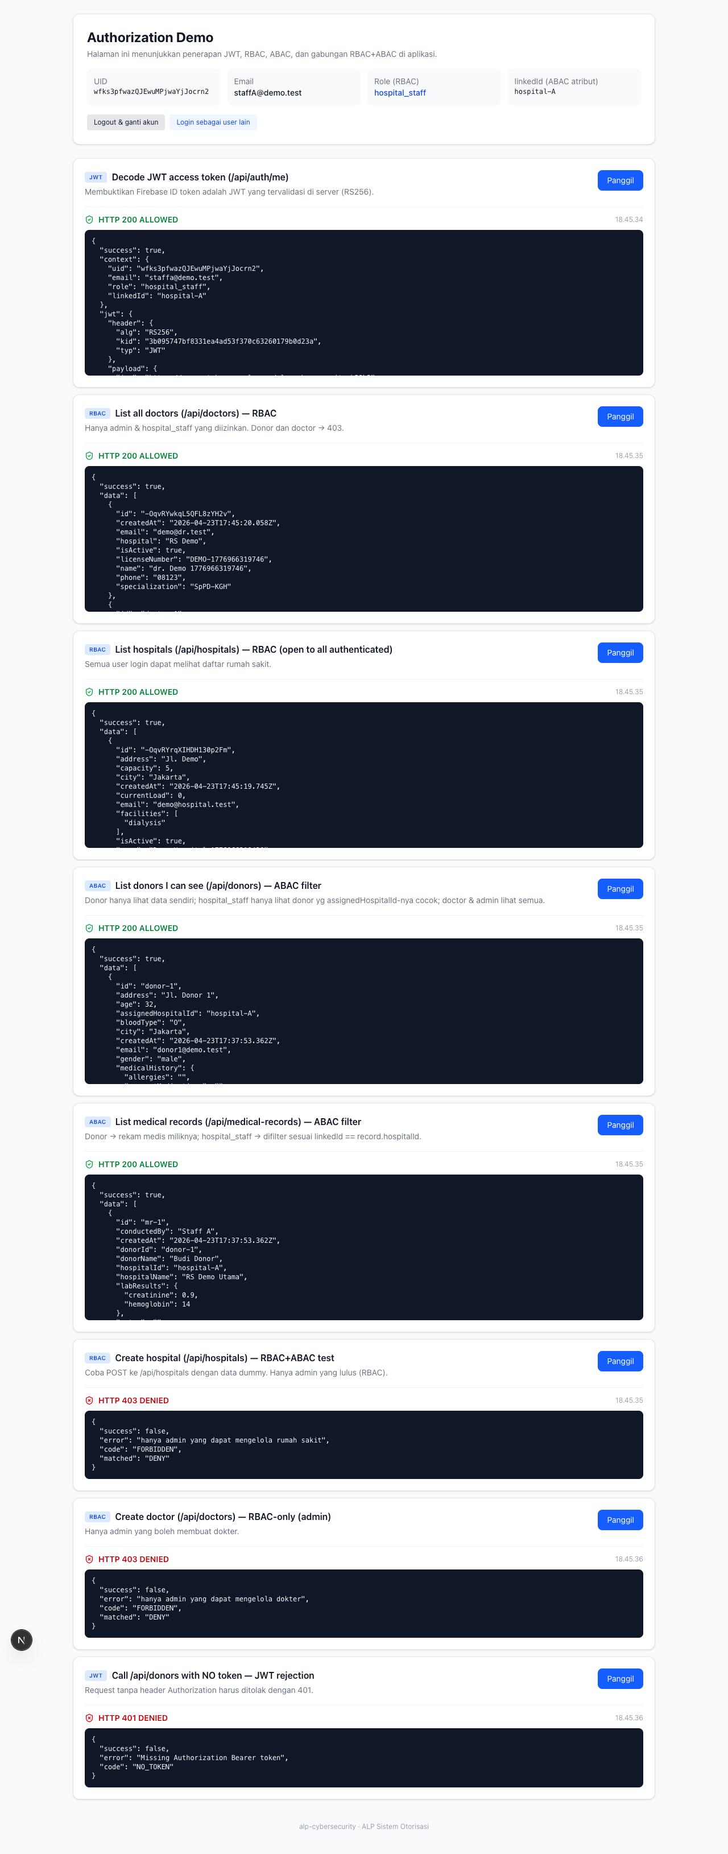
staffA (linkedId=hospital-A) hanya melihat data donor/rekam milik RS Utama.

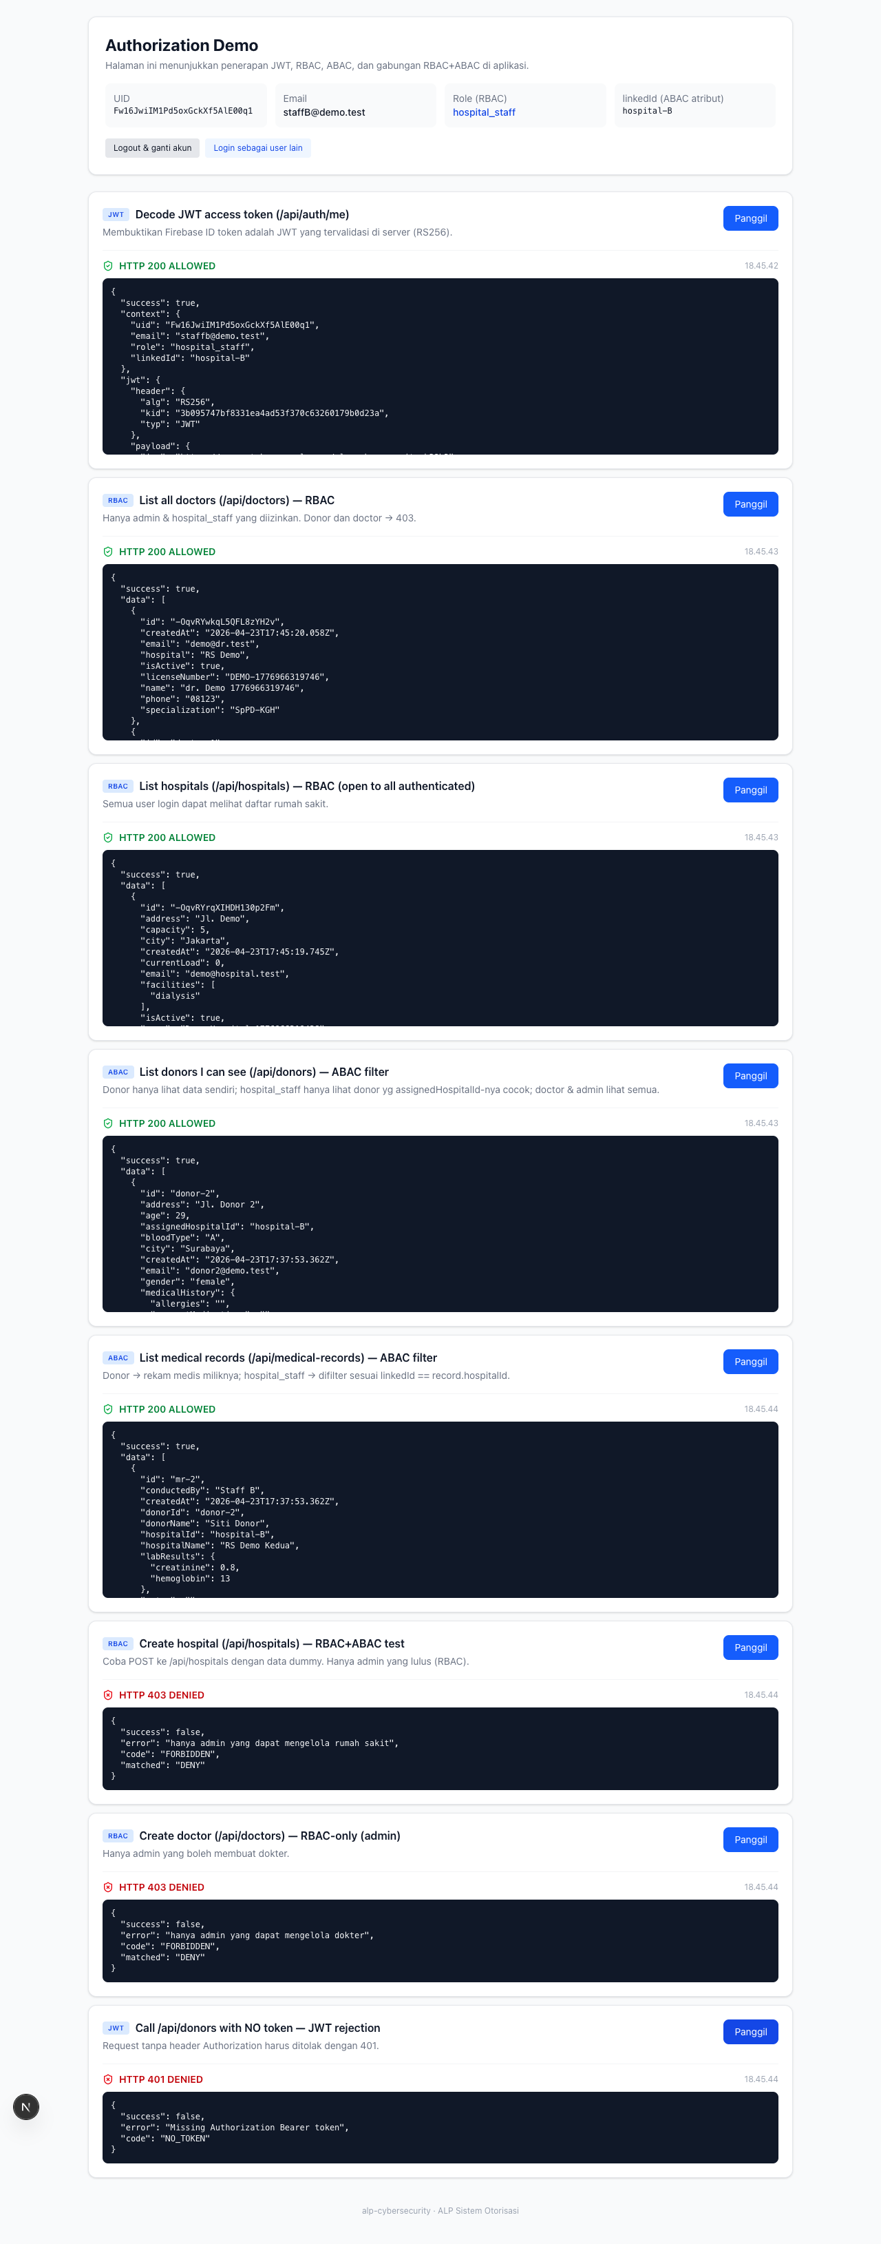
staffB (linkedId=hospital-B) hanya melihat data donor/rekam milik RS Kedua. Struktur sama, data beda → bukti ABAC bekerja.

Link repository GitHub
https://github.com/ervandyr2512/alp-cybersecurity

Aplikasi live di:
https://alp-cybersecurity.vercel.app

Demo halaman otorisasi interaktif:
https://alp-cybersecurity.vercel.app/demo/authz

Link video demo aplikasi
(akan diisi setelah rekaman video diunggah ke YouTube, maksimal 15 menit)

