|  |  |
| --- | --- |
| **Project Case** |  |
| COMP6144  Web Programming |
| **Computer Science** | **O182-COMP6144-LL04-00** |
| ***Valid on*** *Odd Semester Year 2017/2018* | **Revision 00** |

1. Seluruh kelompok tidak diperkenankan untuk:

*The whole group is not allowed to:*

* + - Melihat sebagian atau seluruh proyek kelompok lain,

*Seeing a part or the whole project from other groups*

* + - Menyadur sebagian maupun seluruh proyek dari buku,

*Adapted a part or the whole project from the book*

* + - Mendownload sebagian maupun seluruh proyek dari internet,

*Downloading a part or the whole project from the internet,*

* + - Mengerjakan soal yang tidak sesuai dengan tema yang ada di soal proyek,

*Working with another theme which is not in accordance with the existing theme in the matter of the project,*

* + - Melakukan tindakan kecurangan lainnya,

*Committing other dishonest actions,*

* + - Secara sengaja maupun tidak sengaja melakukan segala tindakan kelalaian yang menyebabkan hasil karyanya berhasil dicontek oleh orang lain / kelompok lain.

*Accidentally or intentionally conduct any failure action that cause the results of the project was copied by someone else / other groups.*

1. Jika kelompok terbukti melakukan tindakan seperti yang dijelaskan butir 1 di atas, maka **nilai kelompok** yang melakukan kecurangan (menyontek maupun dicontek) akan di – **NOL** – kan.

*If the group is proved to the actions described in point 1 above, the score of the group which committed dishonest acts (cheating or being cheated) will be “Zero”*

1. Perhatikan jadwal pengumpulan proyek, segala jenis pengumpulan proyek di luar jadwal tidak dilayani.

*Pay attention to the submission schedule for the project, all kinds of submission outside the project schedule will not be accepted*

1. Jangan lupa untuk melihat kriteria penilaian proyek yang ditempel di papan pengumuman, atau tanya asisten anda.

*Don’t forget to look at the project assessment criteria that posted on the announcement board, or ask your teaching assistant.*

1. Persentase penilaiaan untuk matakuliah ini adalah sebagai berikut:

*Marking percentage for this subject is described as follows:*

|  |  |  |
| --- | --- | --- |
| **Tugas Mandiri**  *Assignment* | **Proyek**  *Project* | **UAP**  *Final Exam* |
| 40% | 60% | - |

1. Software yang digunakan pada matakuliah ini adalah sebagai berikut:

*Software will be used in this subject are described as follows:*

|  |
| --- |
| **Software**  *Software* |
| PHP Composer  PHP Storm 2017.1  XAMPP 3.22 (PHP >= 5.6, MySQL)  IE / Firefox / Chrome |

## Ekstensi file yang harus disertakan dalam pengumpulan tugas mandiri dan proyek untuk matakuliah ini adalah sebagai berikut:

*File extensions should be included in assignment and project collection for this subject are described as follows:*

|  |  |
| --- | --- |
| **Tugas Mandiri**  *Assignment* | **Proyek**  *Project* |
| Folder Project (PHP, SQL, image files (JPG/PNG/GIF), CSS, ENV, JSON, LOCK, XML, JS, CSS, SCSS, VUE, HTACCESS, TXT, ICO, CONFIG, ARTISAN, MD) | Folder Project (PHP, SQL, image files (JPG/PNG/GIF), CSS, ENV, JSON, LOCK, XML, JS, CSS, SCSS, VUE, HTACCESS, TXT, ICO, CONFIG, ARTISAN, MD) |

## Soal

*Case*

General Provisions:

* Use **MySQL** asdatabase.
* **Regular Expression (Regex)** will not be marked.
* Use PHP Framework **Laravel 5.2** to build the project.
* Use Laravel **MVC** concept (**Model, View, Controller**) to build the project.
* Use **Eloquent Query / Query Builder** to work with database.
* You are free to design your own database table **based on given requirements**.
* Print screen given below is only an example. You are free to create your own user interfaces.
* It is **prohibited** to install any kind of Laravel packages. You must use fresh installation of **Laravel 5.2**.
* Only **validation** in the **backend** (using Laravel) will be graded.

**SneakeLLs**

**SneakeLLs** is a largest online sneakers store in the world, which allows the customer to buy sneakers. To expand its business, **sneakeLLs** wants to create a website for their store. In that website, people can find information and buy desired sneakers. This website also allows admin to manage sneakers, user, brand, and all transaction made by users.

As a web developer, you are asked to create a website using PHP Framework **Laravel 5.2** for sneakeLLs. There are three types of user’s role in this website: **Admin**, **Member**, and **Guest** (**non-logged-in member**).

Minimum pages you need to create for each role are:

* + - **Admin**
* Home
* Sneakers
* Brand
* User
* Transaction
* Logout
  + - **Member**
* Home
* Profile
* Shoes
* Cart
* Transaction History
* Logout
  + - **Guest**
* Home
* Login
* Register

If you logged in as **member**, show **current date** and **member’s name** on the navigation bar. The descriptions for each page are:

* + - 1. **Home**

This page tells about **sneakeLLs** in general.

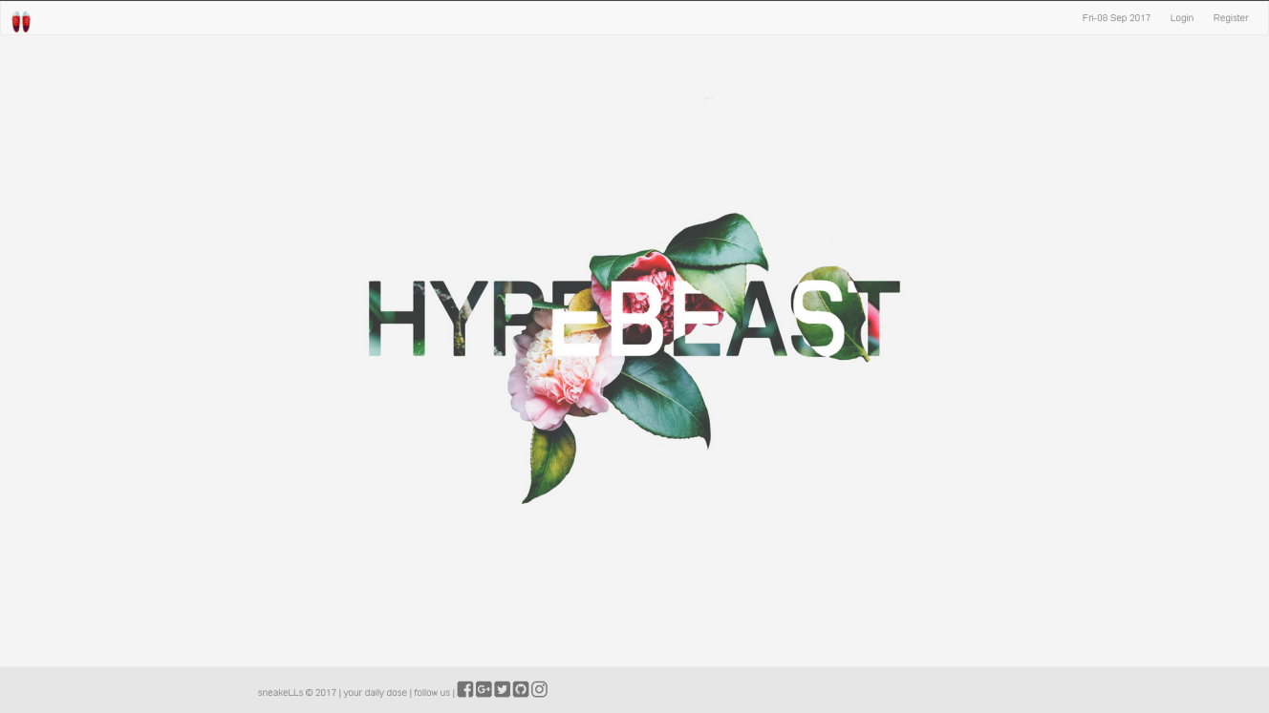

Figure 1. Home Page (for Guest)

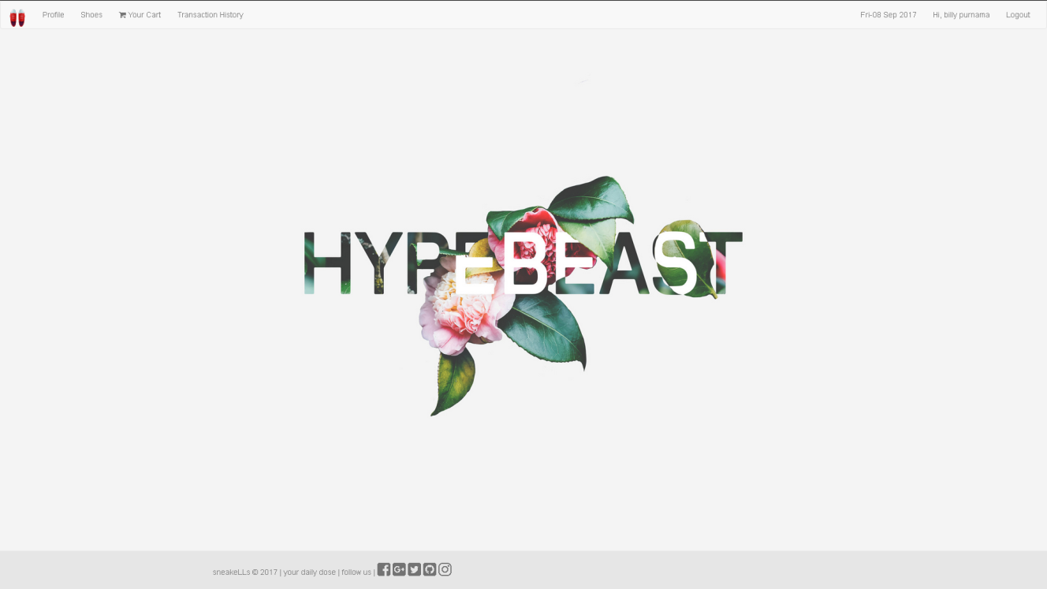

Figure 2. Home Page (for Member)

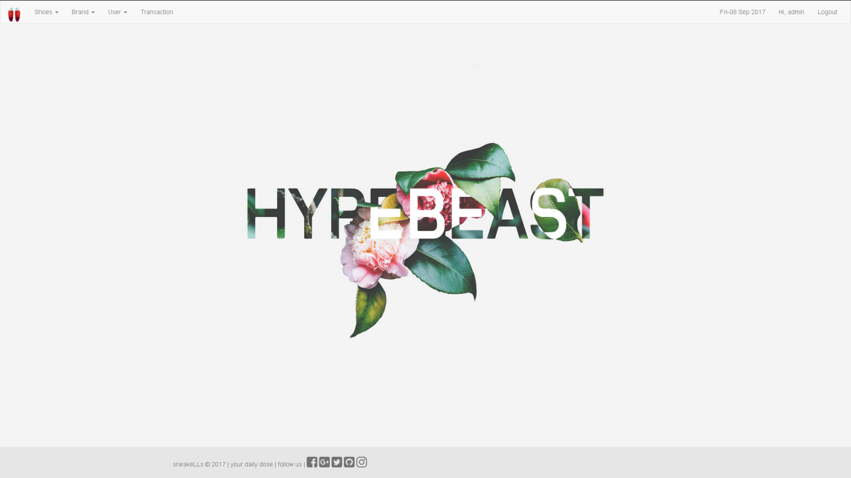

Figure 3. Home Page (for Admin)

1. **Login**

This page allows user to log in to the website. Validate this page is accessible only to **guest**. Display an **error message** on the login page if user enters wrong combination of **Email** and **Password**. The following table shows the existing fields in this page and validations for each field:

|  |  |
| --- | --- |
| **Field** | **Information** |
| **Email** | Must be filled and appropriate with the data in the database |
| **Password** | Must be filled and appropriate with the data in the database |

If user has entered correct **Email** and **Password**, the page will be redirected to the **Home Page** **for member** or **admin** based on the user role menu and if user checks the “**Remember Me**” checkbox, the website will save the **Email** and **Password** using cookies that will expire within **1hour**.

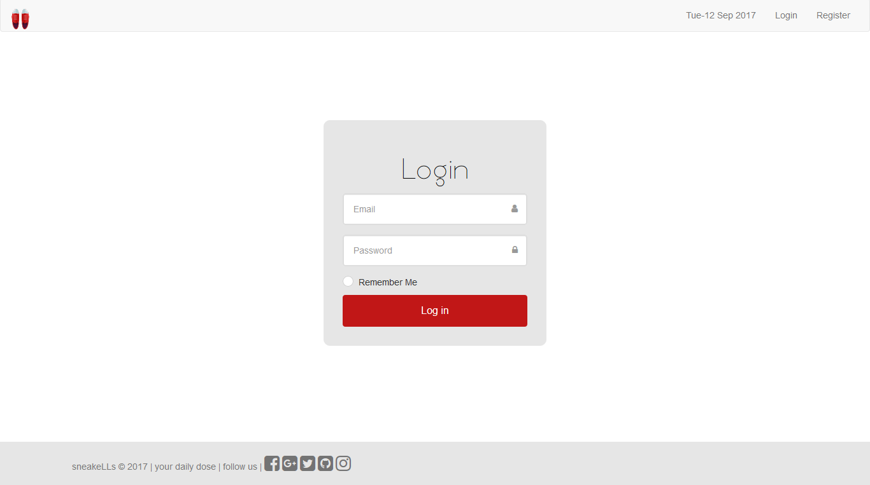

Figure 4. Login Page

1. **Register**

This page allows guests to **register** themselves as **sneakeLLs** member. Validate this page is accessible to **guest** only. Display an **error message** if user input incorrect personal data. The following table shows the existing fields on this page and the validation for each field:

|  |  |
| --- | --- |
| **Field** | **Information** |
| **Name** | * Must be **filled** * Minimum **3 characters length** |
| **Email** | * Must be filled with **email** format * Must be **unique** |
| **Password** | * Must be **alphanumeric** * Minimum **5 characters length** |
| **Confirm Password** | Must be filled and **same with password** |
| **Profile Picture** | Must be selected and an image. |
| **Gender** | Must be selected |
| **Date of Birth** | * + - Must be filled in **yyyy-MM-dd** format     - Older than 10 years |
| **Address** | * Must be filled * Minimum **10 characters length** |

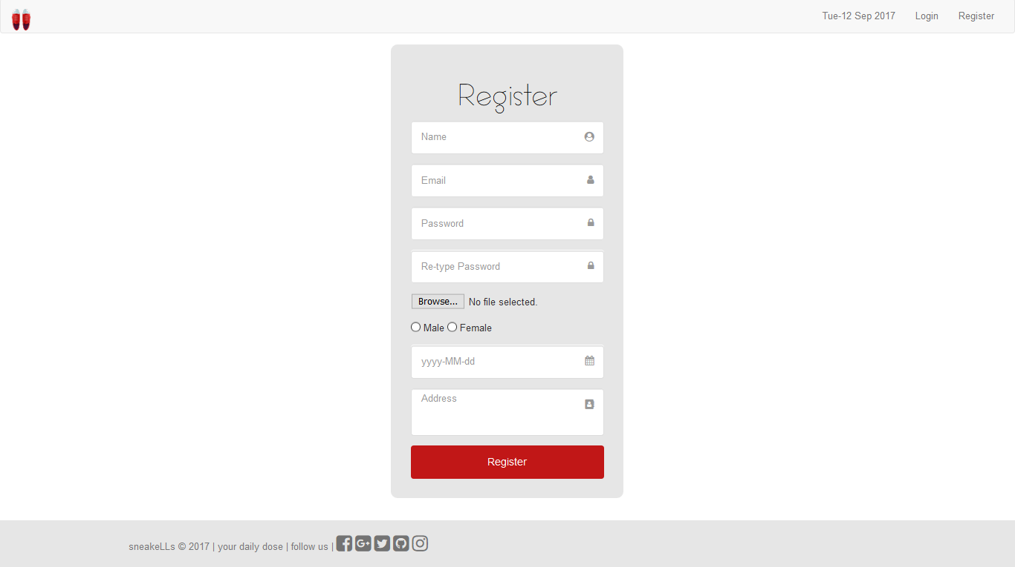

Figure 5. Register Page

1. **Profile**

This page allows user to see their **own personal information** and also **change** their own data. This page is accessible for **member** only. User’s personal information page is displaying user’s **email**, **profile picture**, **gender**, **date of birth**,and **address**. Display an **error message** if user input incorrect personal data. The following table shows the existing fields on this page and the validation for each field:

|  |  |
| --- | --- |
| **Field** | **Information** |
| **Name** | * Must be filled * Minimum **3 characters length** |
| **Email** | * Must be filled with **email** format * Must be **unique** |
| **Profile Picture** | Must be an image file |
| **Gender** | Must be filled |
| **Date of Birth** | * + - Must be filled in **yyyy-MM-dd** format     - Older than 10 years |
| **Address** | * Must be filled * Minimum **10 characters length** |

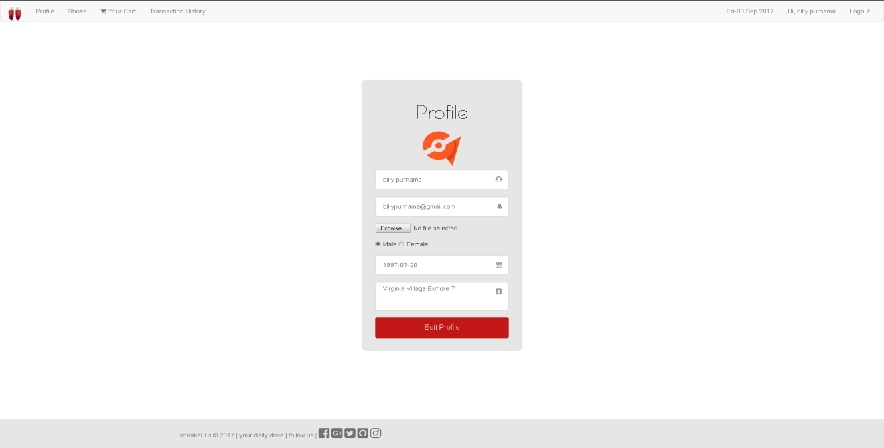

Figure 5. Profile Page

1. **Shoes**

This page allows user to see all **sneakeLLs’s** **shoes information** and **search** the product by **name** or **brand**. This page is accessible for **member** only. Shoes information is displayed using **paging** with **8** products for each page.

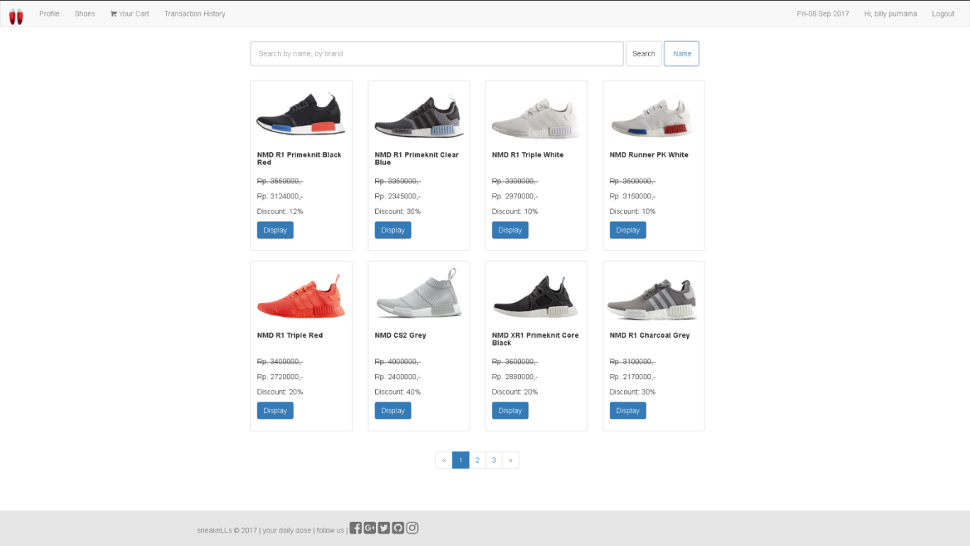

Figure 6. Shoes Page

**User** can click **Display** button from each of the sneakers in the list, then redirect to **Shoes Detail Page**.

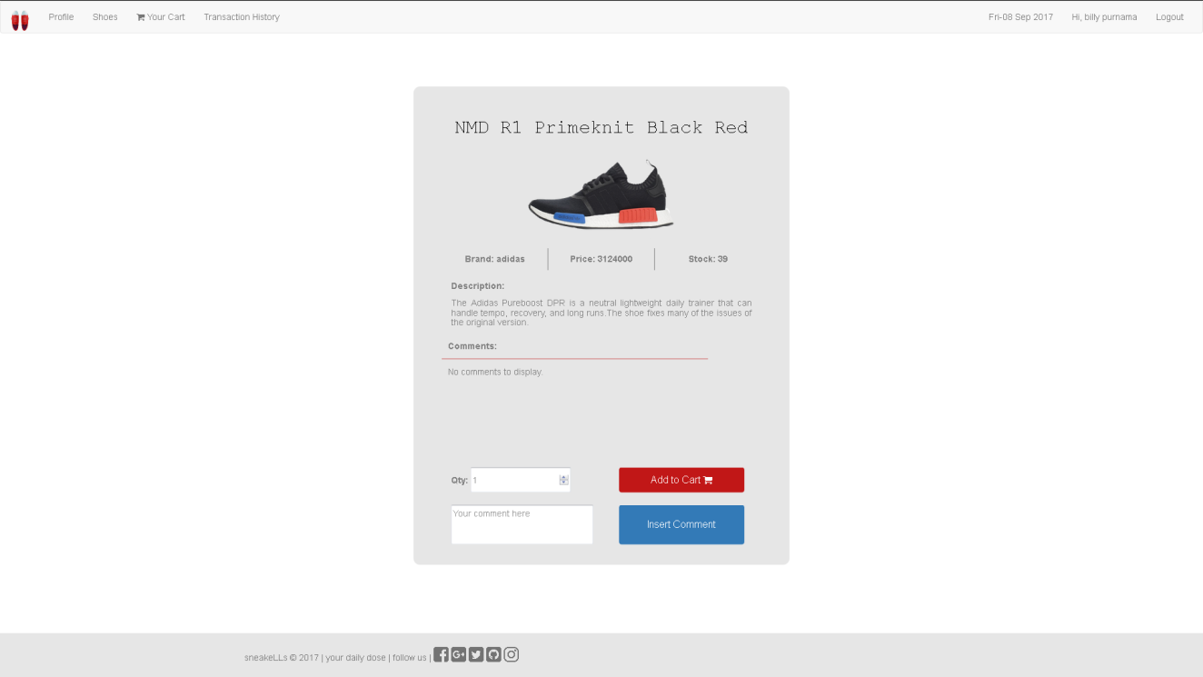

Figure 7. Sneakers Detail Page

This page shows **name**, **image**, **price (calculate the price with shoe’s discount)**, **brand**, **stock**, **description** and **all** **comments** of selected shoes. This page also allow user to **insert** their own **comment**. To add a new comment, user can click **Insert Comment** button. Validate the comment must minimum 1 character length.

To add selected shoes to the cart, user can click ‘**Add to Cart**’ button. After that, validate **the quantity** **cannot** exceed the shoes’s stock.

1. **Cart**

This page is only accessible by member. This page **shows all shoes** that have been added into **member’s shopping cart**. Display cart information such as **Name, Qty, Price (after calculated with shoe’s discount), SubTotal Price, Total Quantity** and **Grand Total.**

There are 2 buttons in the page, **Delete** button **and Complete the Payment** button.

- If user click ‘**Delete**’ button, then remove shoes from the current member’s active cart.

- If user click ‘**Complete the Payment**’ button, then redirect user to product page and the shopping cart data will be **inserted** to **Transaction** with ‘**Success**’ status, then **all shopping cart data** will be **deleted**.

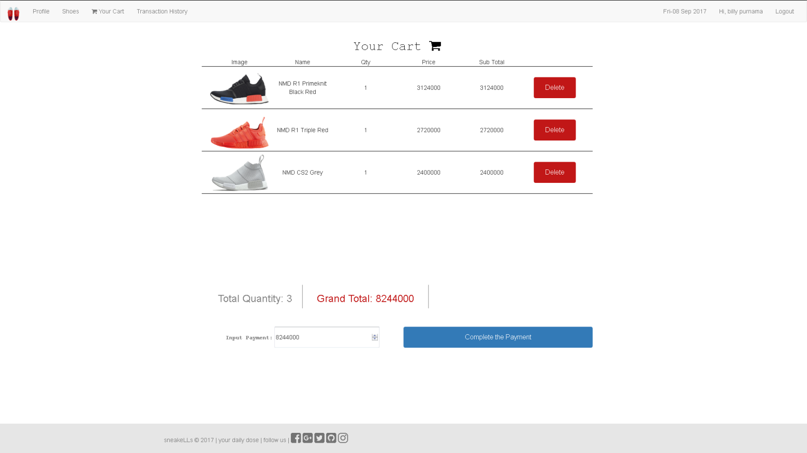**Figure 8. Cart Page**

Add to Cart Page

1. **Transaction History**

This section could only be accessed by **user** to see the transaction history made by the user itself. This section will be shown if **user** select **Transaction History** tab in **Navigation Bar**. Display transaction history information such as **ID**, **Email**, **Transaction Date**, **and Transaction Status.**

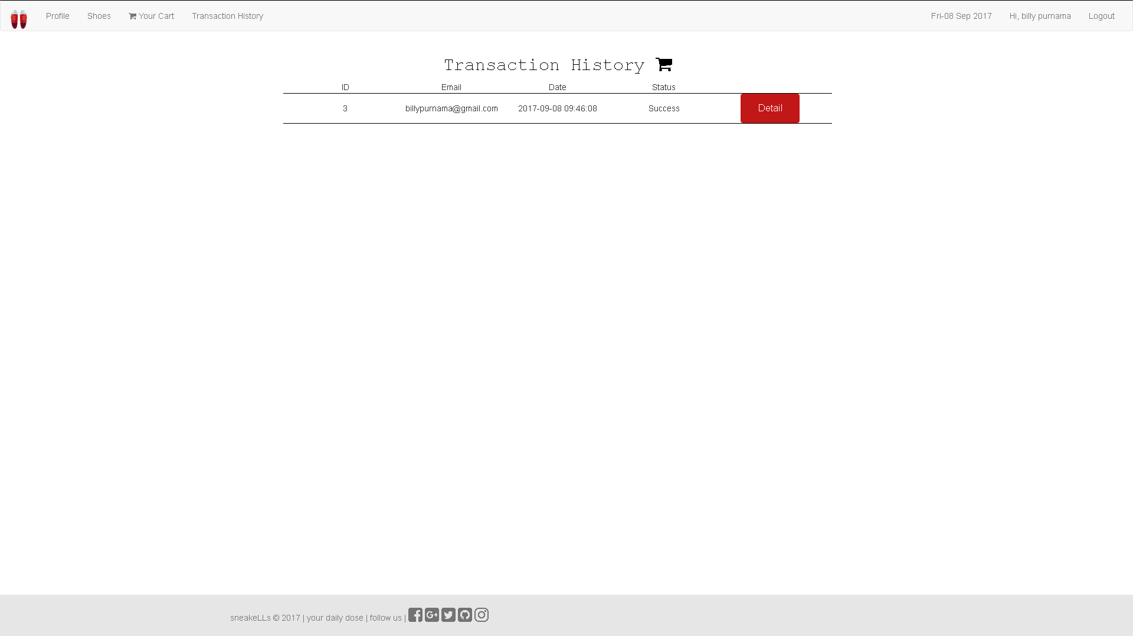

Figure 9. Transaction History Page

**User** can click **Display** button from each of the transaction in the list, then redirect to **Transaction History Detail Page**.

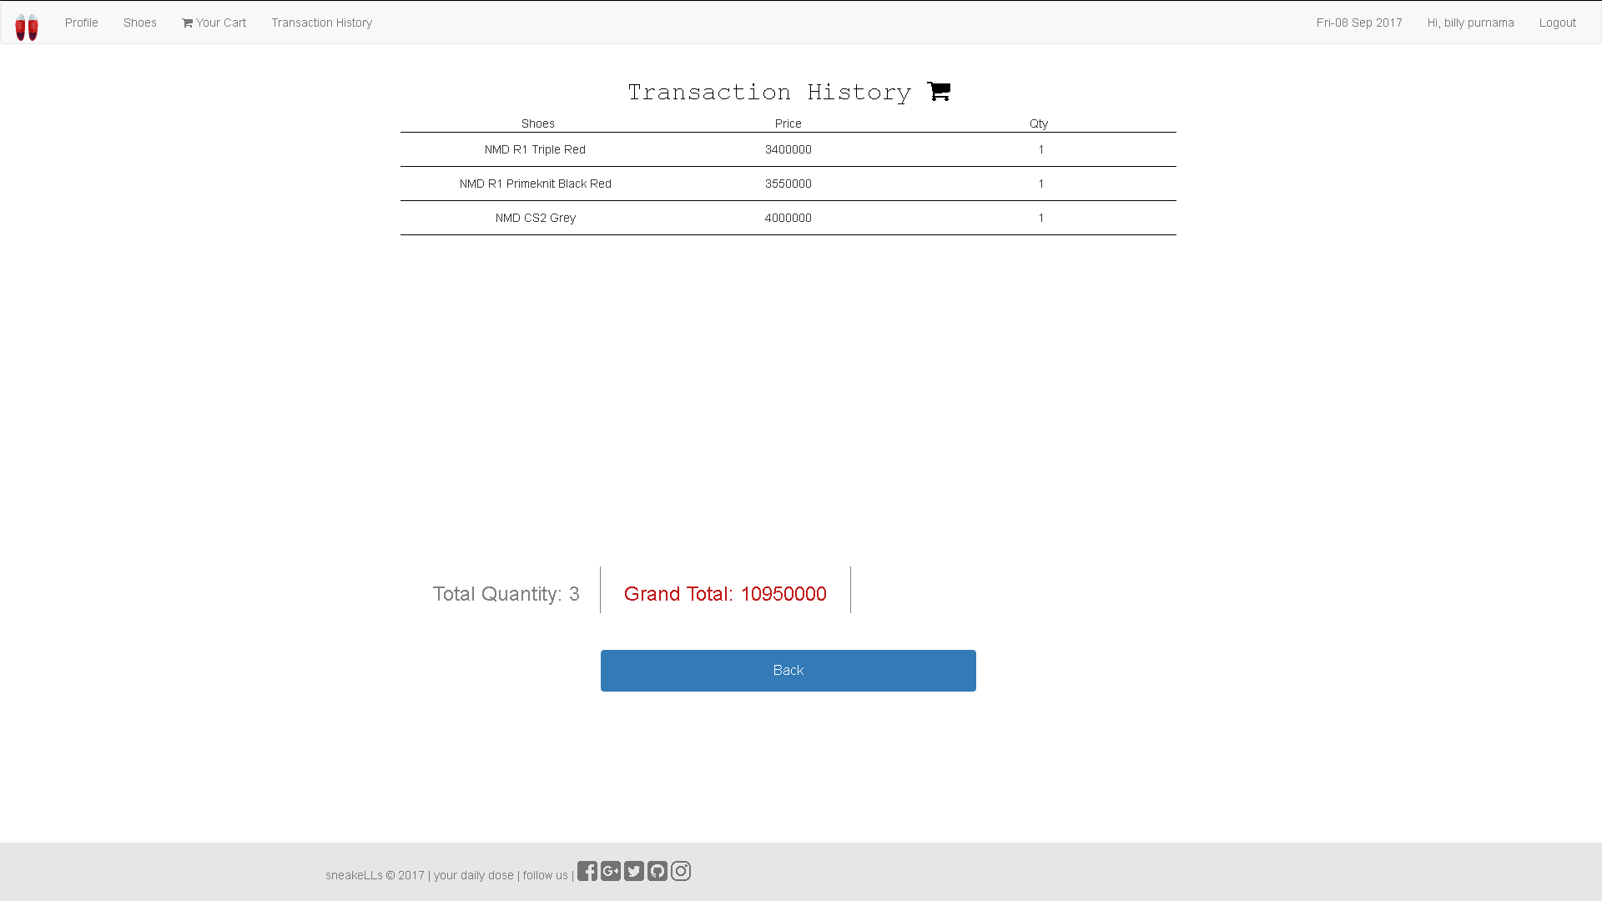

Figure 10. Transaction History Detail Page

1. **Insert Shoes**

This page is only accessible by **admin**. This page will be shown if admin select Insert Shoes tab in Navigation bar. Display **error message** if **admin** input incorrect shoes data. The following table shows existing fields in this page and the validation for each field:

|  |  |
| --- | --- |
| **Field** | **Information** |
| **Name** | * Must be filled * Minimum **3 characters length** * Must be **unique** |
| **Brand** | Must be selected |
| **Image** | * Must be selected * Must be an **image** file |
| **Description** | Must be filled |
| **Price** | * Must be filled with **numbers** * Minimum **price is 1000**. |
| **Discount** | * Must be filled * Minimum **discount is 0** * Maximum **discount is 100** |
| **Stock** | * Must be filled * Minimum **stock is 0** * Maximum **stock is 100** |

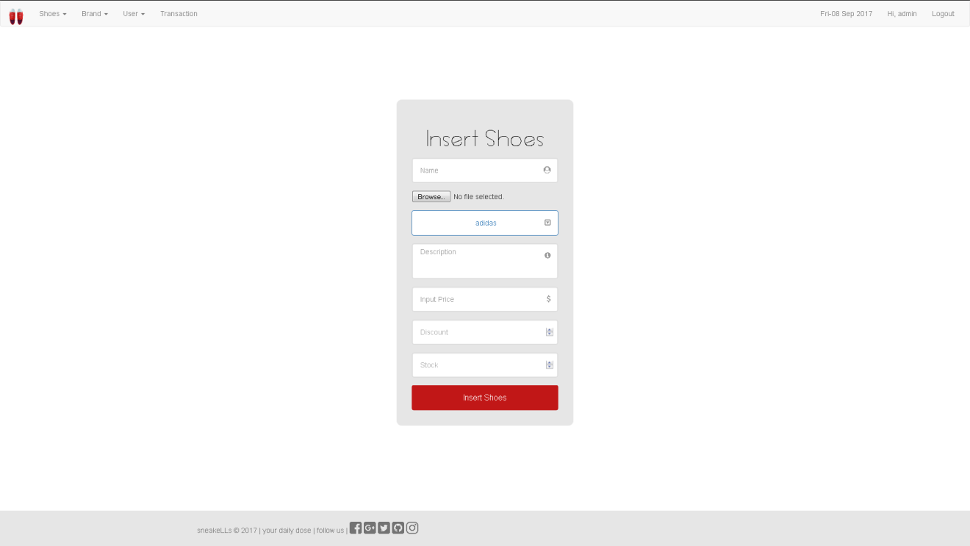

Figure 11. Insert Shoes Page

1. **Update Shoes**

This page allows **admin** to update an existing shoes and also delete an existing shoes. This page will be shown if **admin** select **Update Shoes** tab in **Navigation Bar**. Display **error message** if **admin** input incorrect shoes data. The following table shows existing fields in the page and the validation for each field:

|  |  |
| --- | --- |
| **Field** | **Information** |
| **Name** | * Must be filled * Minimum **3 characters length** * Must be **unique** |
| **Brand** | Must be filled |
| **Image** | * Must be selected * Must be an **image** file |
| **Description** | Must be filled |
| **Price** | * Must be filled with **numbers** * Minimum **price is 1000** |
| **Discount** | * Must be filled * Minimum **discount is 0** * Maximum **discount is 100** |
| **Stock** | * Must be filled * Minimum **stock is 0** * Maximum **stock is 100** |

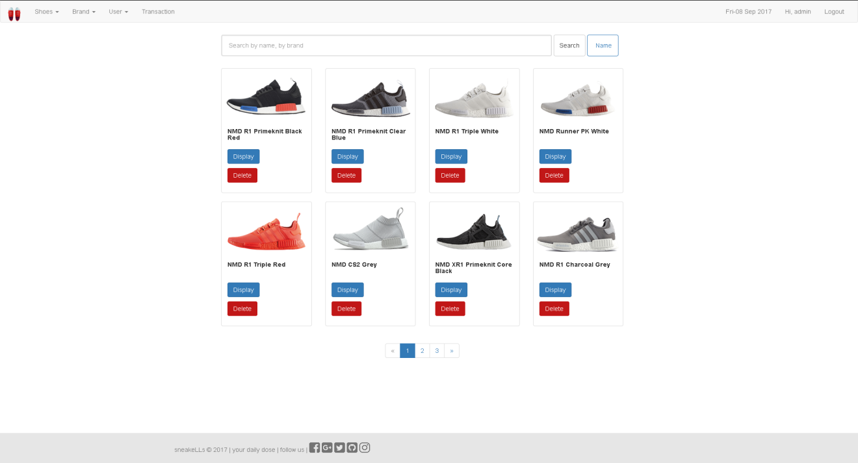

Figure 12. Update Shoes Page

This page provides ‘**Display**’ button and ‘**Delete’** button for each shoes lists. If user click ‘**Display**’ button, then redirect user to **Shoes Detail page**. If user click ‘**Delete’** button, then delete the selected existing shoes.

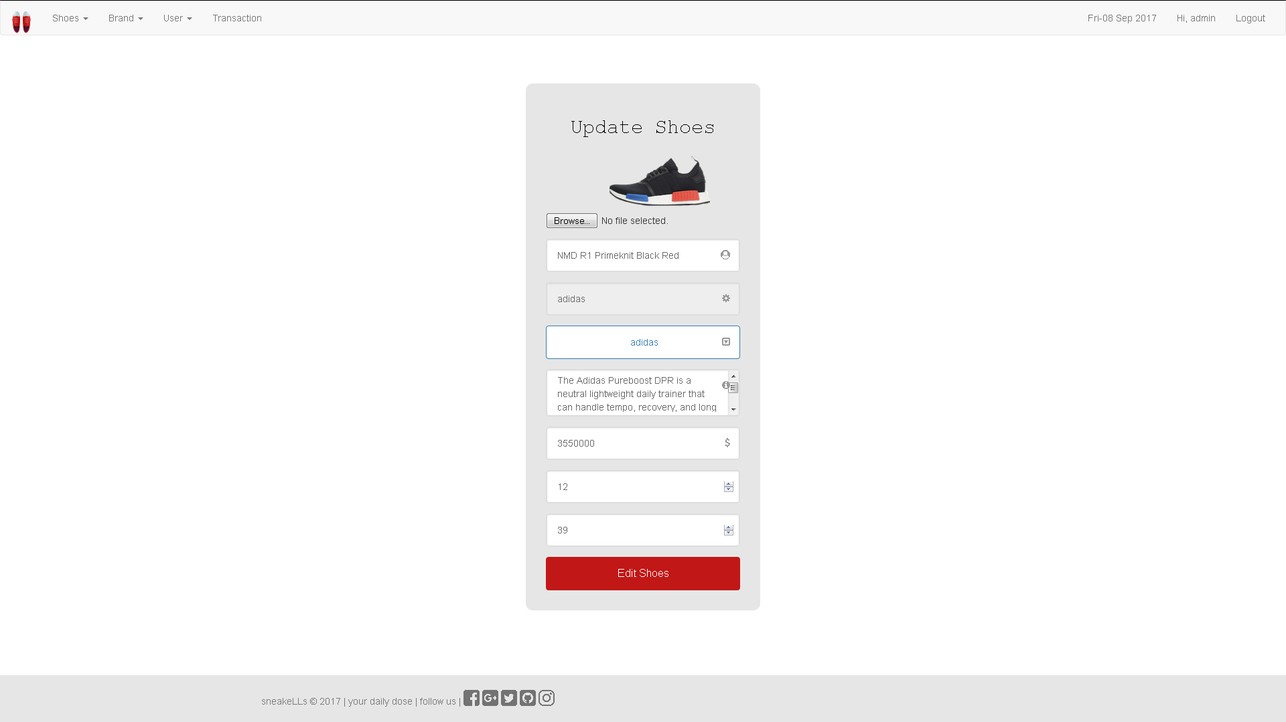

Figure 13. Update Shoes Page

1. **Insert Brand**

This page could only be accessed by **admin** to insert new brand. This page will be shown if **admin** select **Insert Brand** tab in **Navigation Bar**. Display **error message** if **admin** input incorrect brand data. The following table shows existing fields in this page and the validation for each field:

|  |  |
| --- | --- |
| **Field** | **Information** |
| **Brand Name** | * + - Must be filled     - Must be unique in the database’s **table** |

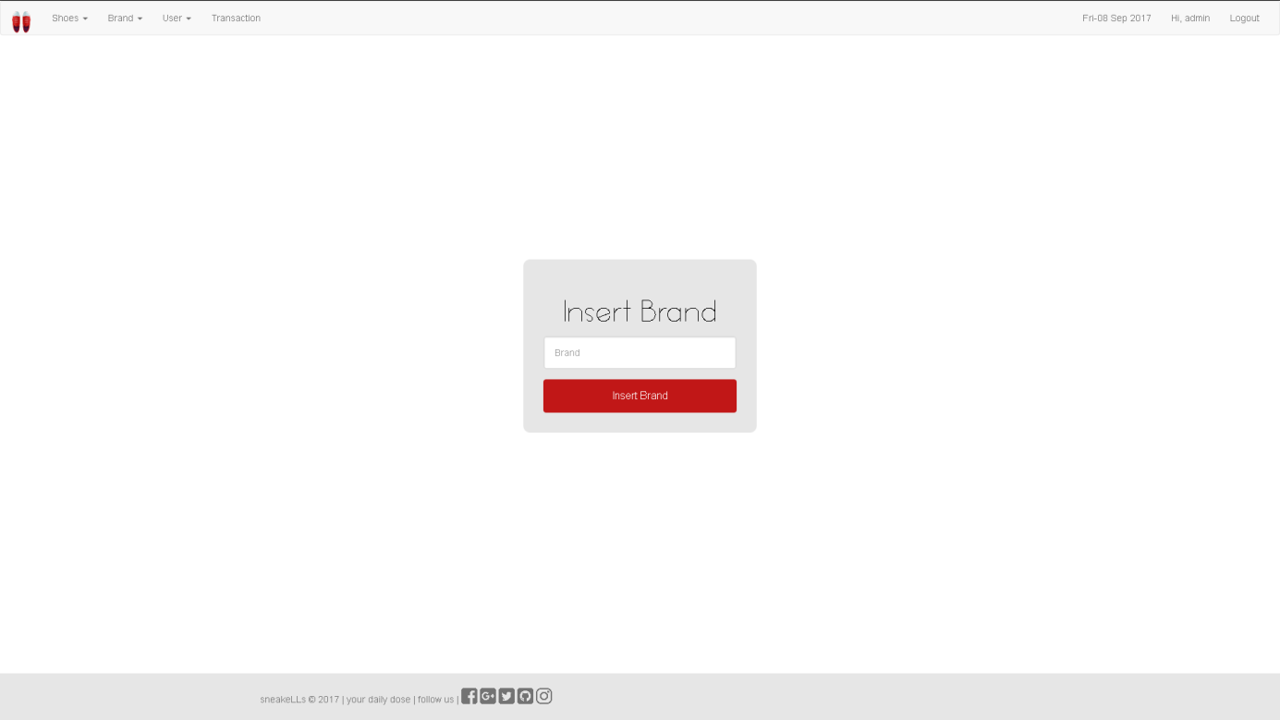

Figure 14. Insert Brand page

1. **Update Brand**

This section could only be accessed by **admin** to update an existing brand and also delete an existing brand. This section will be shown if **admin** select **Update Brand** tab in **Navigation Bar**. Display **error message** if **admin** input incorrect brand data. The following table shows existing fields in this page and the validation for each field:

|  |  |
| --- | --- |
| **Field** | **Information** |
| **Brand Name** | * + - Must be filled     - Must be unique in the database’s **table** |

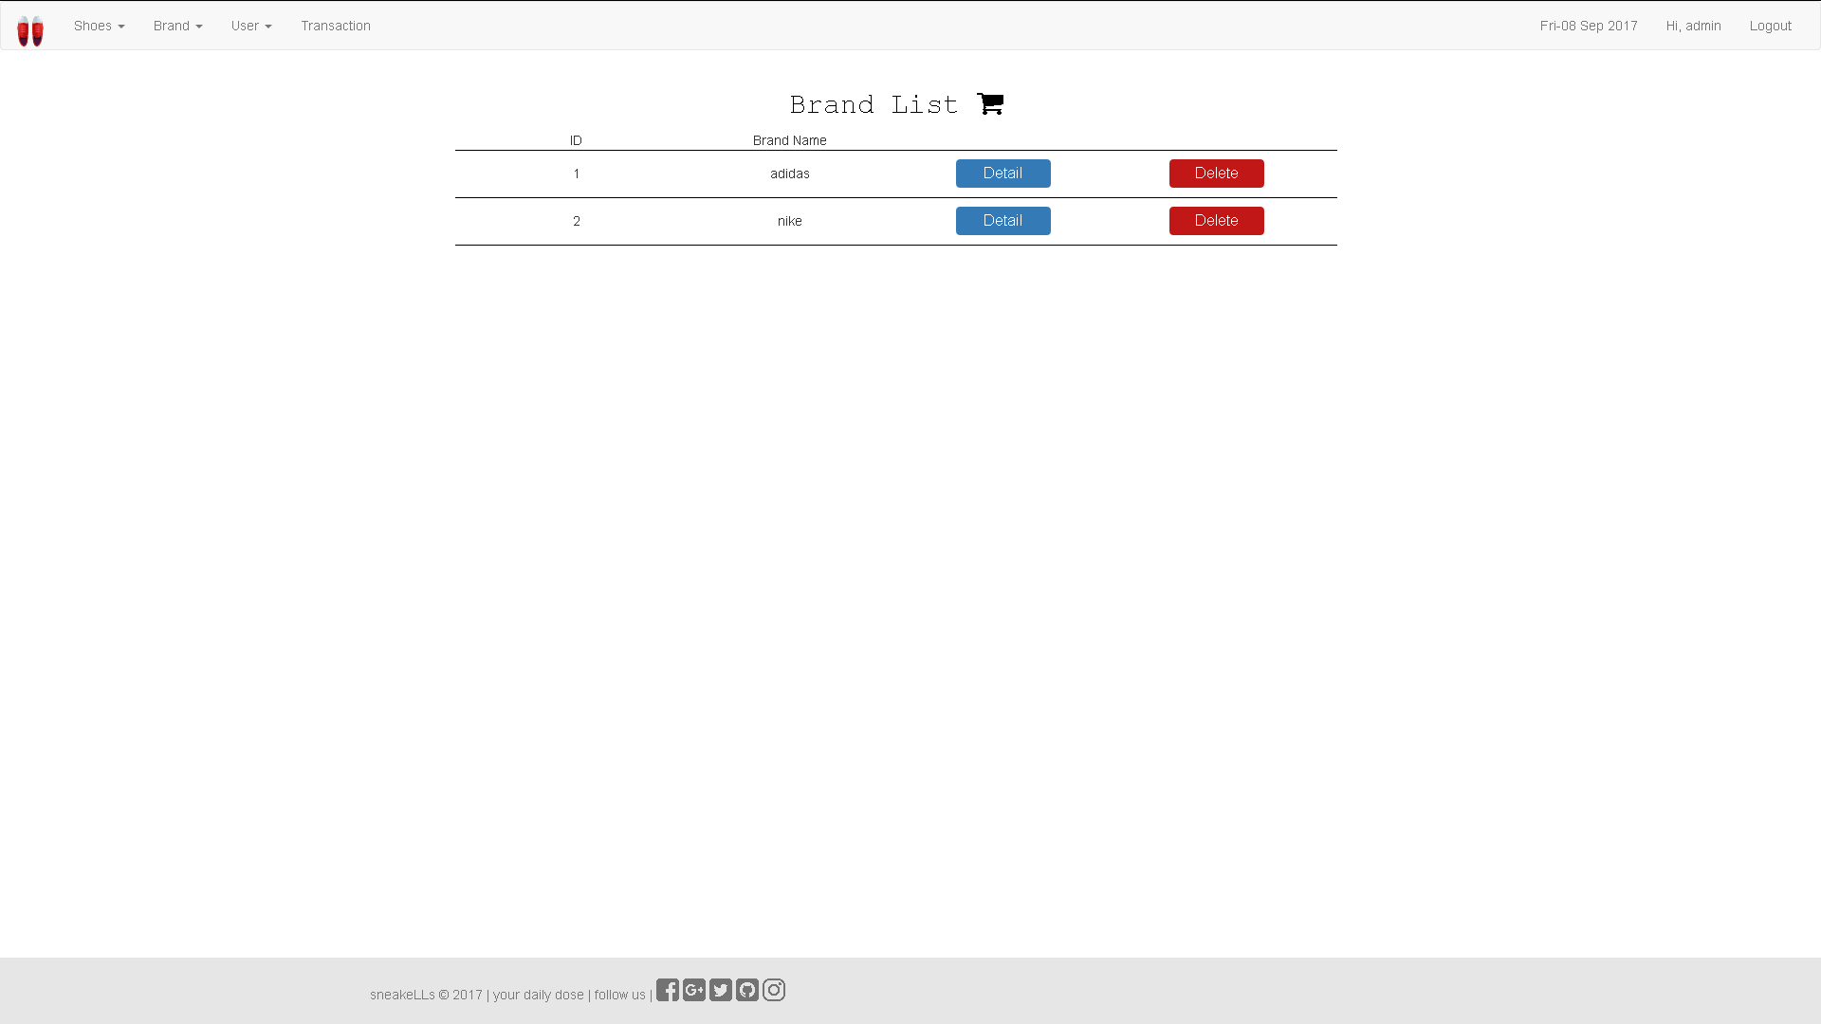

Figure 15. Update Brand Page

If **user** click ‘**Detail**’button, then redirect to **Update Brand Detail Page**. If **user** click ‘**Delete’** button, then delete the existing brand.

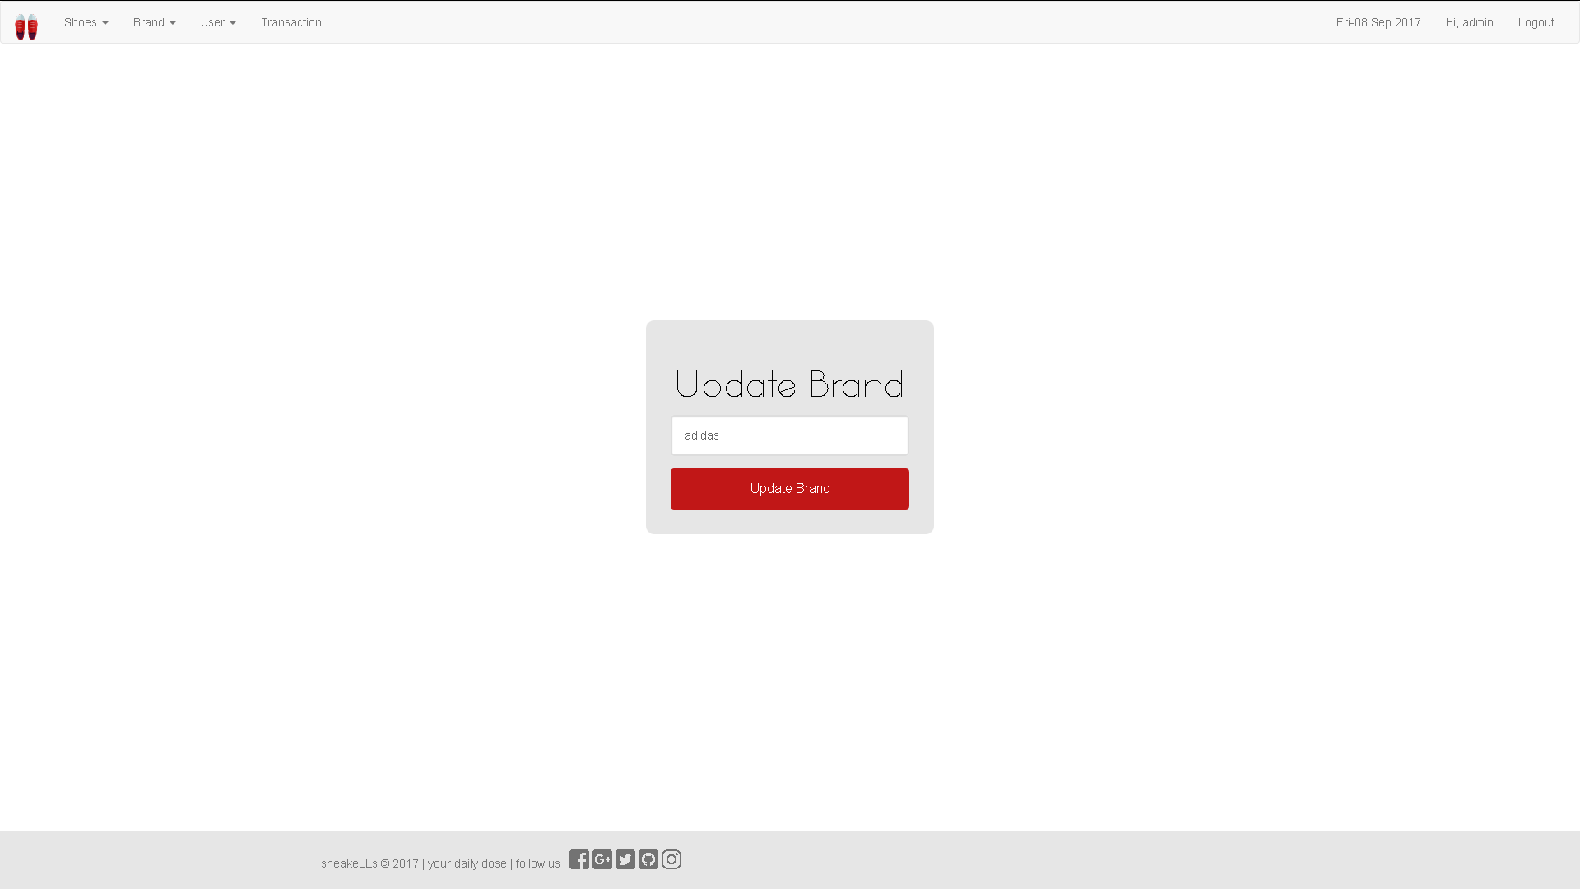

Figure 16. Update Brand Detail Page

1. **Insert User**

This section could only be accessed by **admin** to insert new user. This section will be shown if **admin** select **Insert User** tab in **Navigation Bar**. Display **error message** if **admin** input incorrect user data. The following table shows existing fields in this page and the validation for each field:

|  |  |
| --- | --- |
| **Field** | **Information** |
| **Name** | * + - Must be filled and minimum 3 characters length |
| **Email** | * + - Must be filled with **email** format and **must be unique** |
| **Password** | * + - Must be **alphanumeric** and minimum 5 characters length |
| **Confirm Password** | * + - Must be filled and **same with password** |
| **Profile Picture** | * + - Must be selected and an image. |
| **Gender** | * + - Must be selected |
| **Date of Birth** | * + - Must be filled in **yyyy-MM-dd** format     - Older than 10 years |
| **Address** | * + - Must be filled and minimum 10 characters length |

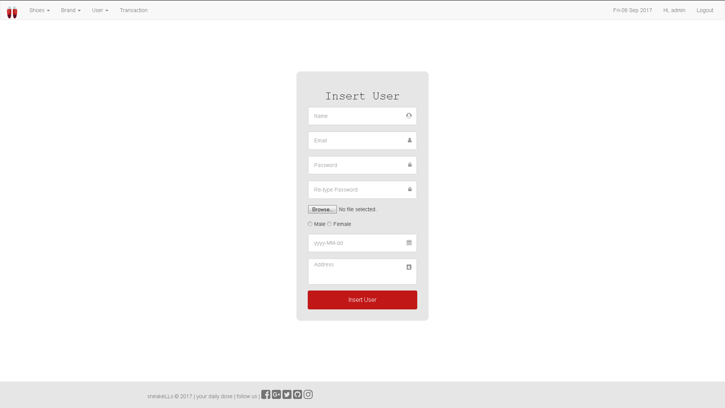

**Figure 17. Insert User page**

1. **Update User**

This section could only be accessed by **admin** to update an existing user and also delete an existing user. This section will be shown if **admin** select **Update User** tab in **Navigation Bar**. Display **error message** if **admin** input incorrect user data. The following table shows existing fields in this page and the validation for each field:

|  |  |
| --- | --- |
| **Field** | **Information** |
| **Name** | * + - Must be filled     - Minimum 3 characters length |
| **Email** | * Must be filled with **email** format * Must be **unique** |
| **Profile Picture** | Must be an image file |
| **Gender** | Must be filled |
| **Date of Birth** | * Must be filled in **yyyy-MM-dd** format * Older than **10** years |

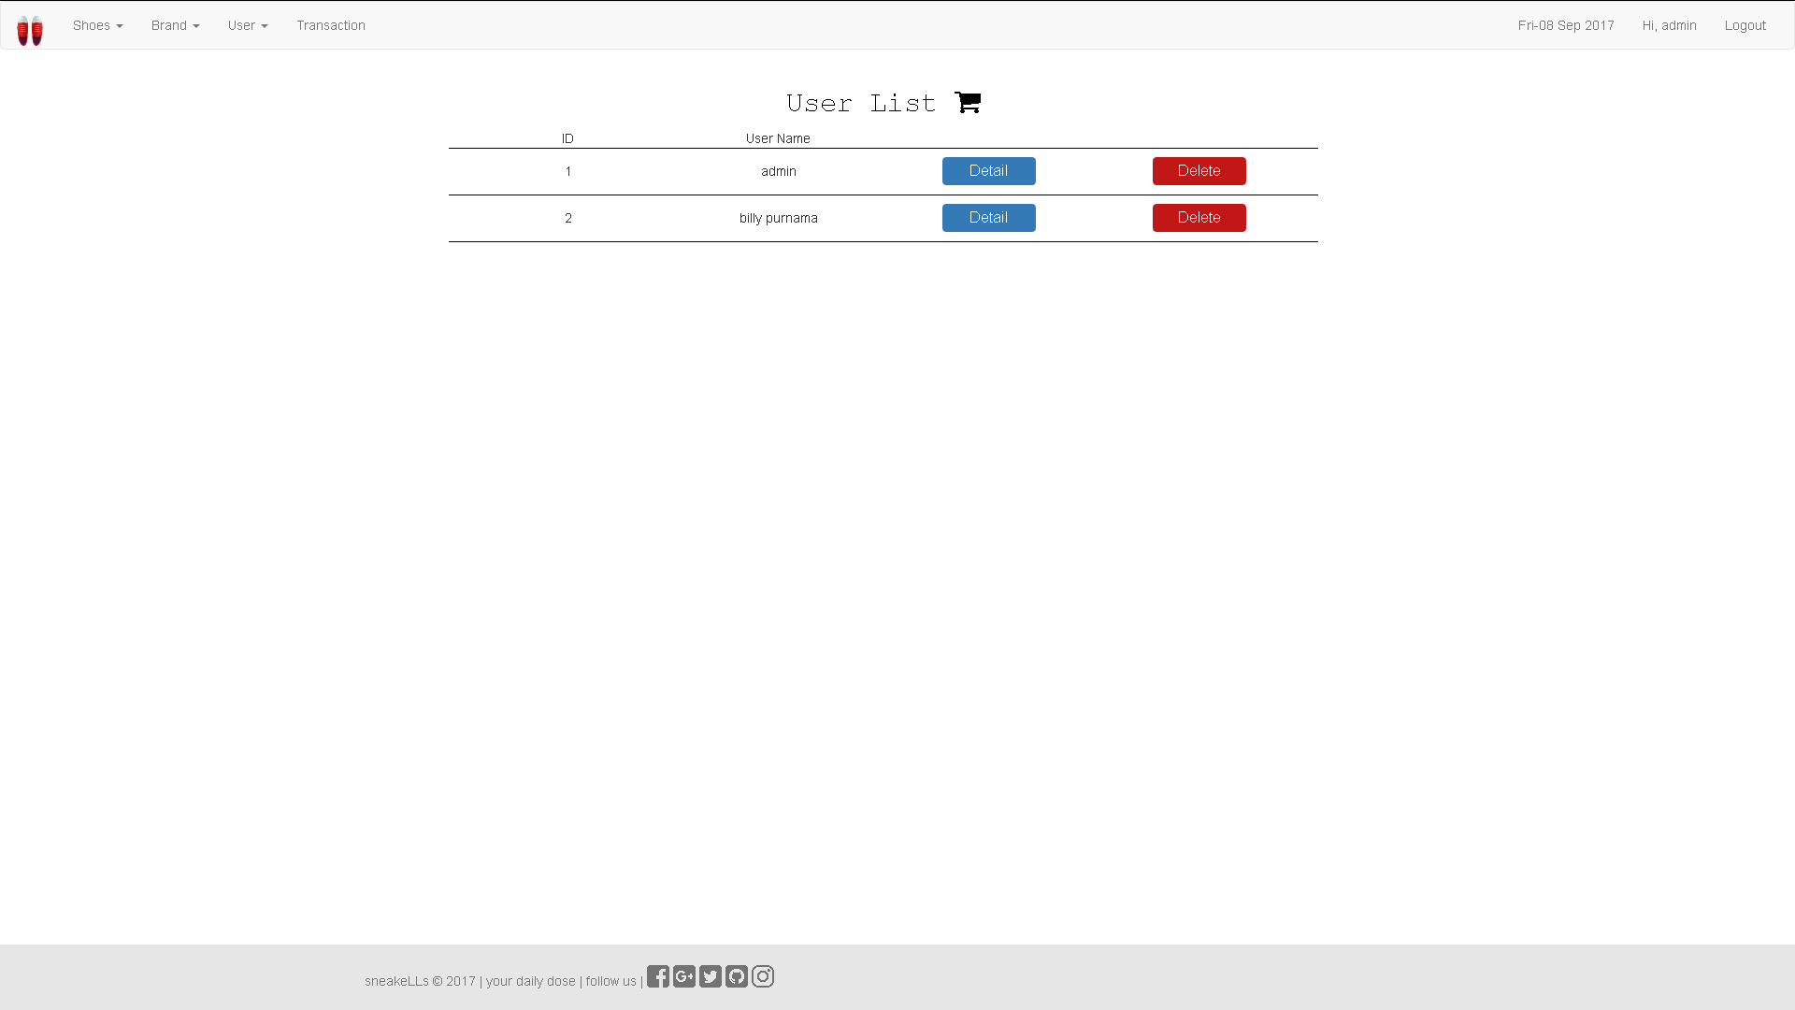

Update User Page

Figure 18. Update User Page

**User** can click **Edit User** button from each of the user in the list, then redirect to **Update User Detail Page**.

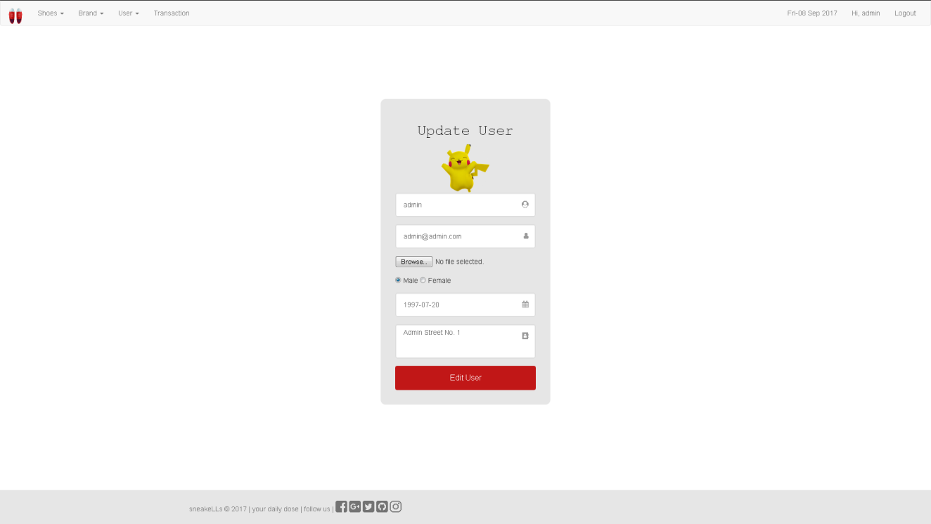

*Figure 19. Update User Detail Page*

1. **Admin Transaction**

This section allows **admin** to see the transaction’s detail and also delete an existing transaction. This section will be shown if **admin** select **Transaction** tab in **Navigation Bar**. Delete the existing transaction when **admin** click the **Delete Button.**

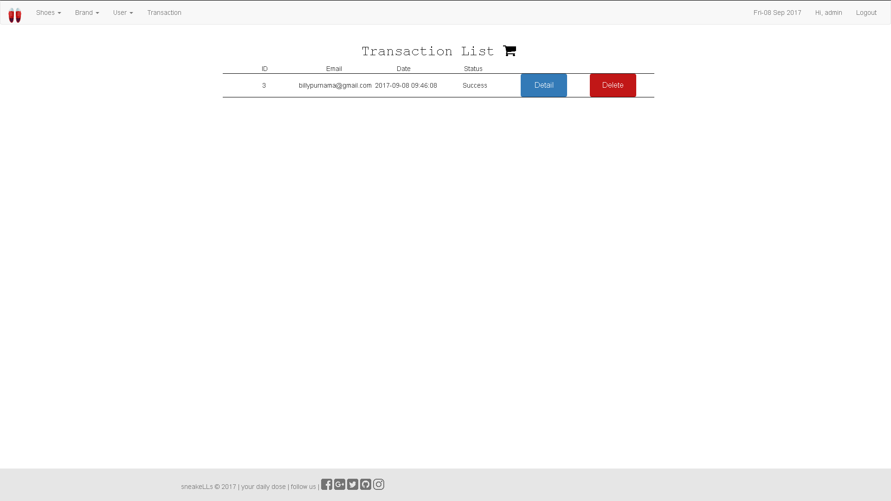

Figure 20. Delete Transaction Page

If **admin** click ‘**Detail**’button, then redirect to **Transaction Detail Page**. If **admin** click ‘**Delete’** button, then delete the existing transaction.

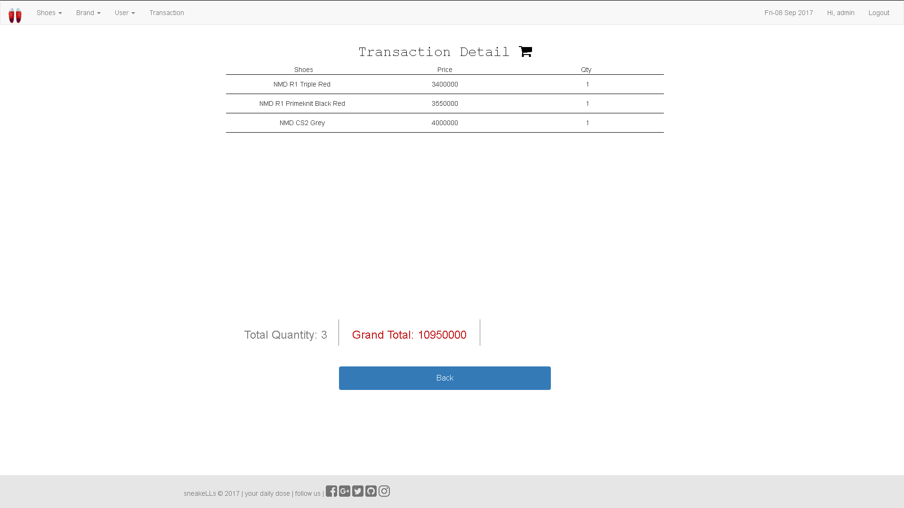

Figure 21. Transaction Detail Page

Here are the rules that you must follow to create your project:

1. Use appropriate software for this subject based on **Sistem Praktikum** that can be downloaded from Binusmaya.
2. Collect appropriate files for this subject based on **Sistem Praktikum** that can be downloaded from Binusmaya.
3. Include the other files that can support your project, such as:
   * All files in your project
   * Other files (image, audio, video, etc.) used in your project
   * *.DOC file (documentation of your project) that contains all pages in your project, reference links of additional files (image, audio, video, etc.) used in your project, the description about how to use your application, etc

**References Link:**

https://www.flaticon.com/free-icon/sneakers_188287#term=sneakers&page=1&position=28 --logo

https://www.flaticon.com/free-icon/sneaker_413475#term=sneakers&page=1&position=30 --favicon

https://static.esea.net/global/images/teams/154935.1486362580.jpg --background

https://thesolesupplier.co.uk/wp-content/ --adidas shoes

https://thesolesupplier.co.uk/wp-content/uploads/2015/12/adidas-nmd.png https://thesolesupplier.co.uk/wp-content/uploads/2016/03/Adidas-NMD_R1-Black-White-Clear-Blue.png https://thesolesupplier.co.uk/wp-content/uploads/2016/03/Adidas-NMD_R1-Triple-White.png https://thesolesupplier.co.uk/wp-content/uploads/2016/05/Adidas-NMD-R1-White-Primeknit-OG.png https://thesolesupplier.co.uk/wp-content/uploads/2016/08/Adidas-NMD-R1-Triple-Red.png http://dropinsidercom.none1459677421.netdna-cdn.com/wp-content/uploads/2016/11/adidas-consortium-x-packer-nmd-runner-pk-single-lateral-external-whitebackground.png https://thesolesupplier.co.uk/wp-content/uploads/2016/07/adidas-NMD-City-Sock-Grey-White.png http://dropinsidercom.none1459677421.netdna-cdn.com/wp-content/uploads/thumbs_dir/adidas-NMD-XR1-Beige-Grey1-n0bbiqjyoxi5fz6ybu3yqbjdmsqbqrbe0k1c50i1gs.png https://thesolesupplier.co.uk/wp-content/uploads/2016/10/Bape-NMD-Black.png https://2.kixify.com/sites/default/files/imagecache/product_full/product/2017/01/25/p_12729031_72242096_6263836.png

https://thesolesupplier.co.uk/wp-content/uploads/2016/10/Bape-Camo-NMD.png https://www.kicksonfire.com/adidas-nmd-xr1-triple-white-release-reminder/

https://thesolesupplier.co.uk/wp-content/uploads/2016/10/adidas-NMD-R1-Green.png https://thesolesupplier.co.uk/wp-content/uploads/2016/06/Adidas-NMD-R1-Charcoal-Grey-1.png