### **Study Information**

1. **Title (required)**

The relationship between visual confidence and post-decisional evidence accumulation

1. **Authors (required)**

Pascal Mamassian

Tarryn Balsdon

Erva Nihan Kandemir

1. **Description (optional)**

Our perceptual decision is accompanied by confidence, which refers to the observers' estimation of their perceptual accuracy. Therefore, the process of decision making is divided into two types of judgments: Type-I decisions quantify the perceptual evidence itself, and type-II decisions estimate the accuracy of the Type-I decision (Mamassian,2016). Previous findings suggest that Type-II evidence accumulation continues even after Type-I evidence accumulation reaches its bounds (see Pleskac & Busemeyer, 2010).

The relationship between Type-I and Type-II judgments was recently investigated by Baldson et al.'s (2020) study suggesting that observers commit to their decisions early whilst continuing to monitor additional evidence for evaluating confidence. In this previous study, the post-decision evidence was not specifically manipulated. In the current study, the limits will be pushed by providing observers with either a lot of supportive evidence in favor of the correct choice or a lot of evidence against the correct choice of the Type-I responses.

1. **Hypotheses (required)**

Our main hypothesis is that in a visual decision-making task, post-decision evidence will affect confidence but not alter the initial decision. When the post-evidence is in favor of the initial decision confidence will increase, and when evidence is against the initial decision, confidence will decrease.

So, our null hypothesis implies that post-decisional evidence has no effect on confidence and no effect on performance.

A second alternative hypothesis is that this post-decisional evidence has an effect on both confidence and performance (the observer will change their initial decision when provided with sufficient counter-evidence).

### **Design Plan**

1. **Study type (required)**

Experiment - A researcher randomly assigns treatments to study subjects, including field or lab experiments. This is also known as an intervention experiment and includes randomized controlled trials.

1. **Blinding (required)**

The participant will not know what condition they are performing.

1. **Is there any additional blinding in this study?**

No

1. **Study design (required)**

We will use a within-subject design.

The stimulus will be Global Drifted Gabor Stimulus based on Amano et al.'s (2009) original study. The task will be the motion direction discrimination task. On each trial, the participant must decide if the global motion is to the left or right. There will be two versions of this task: In the Free Task observers can enter their response as soon as they feel ready; in the Replay Task, ¾ of the trials will have a fixed duration and the participant will be cued to enter their final response after that duration.

**Free Task (Figure-1):** We will run the first block to estimate each observers' default decision time for a particular pre-generated trial. Each unique pre-generated trial will be presented multiple times, and the median reaction time of the responses given to the same trial will be calculated for each participant. Then the decision time will be estimated by subtracting the estimated non-decision time (~200 ms) from each of the unique trials’ median reaction times. So we will end up with each participants' default decision time for each unique pre-generated trial. These unique decision times will determine the stimulus duration for each condition in the Second Part of the experiment, where we will actually test our hypothesis.

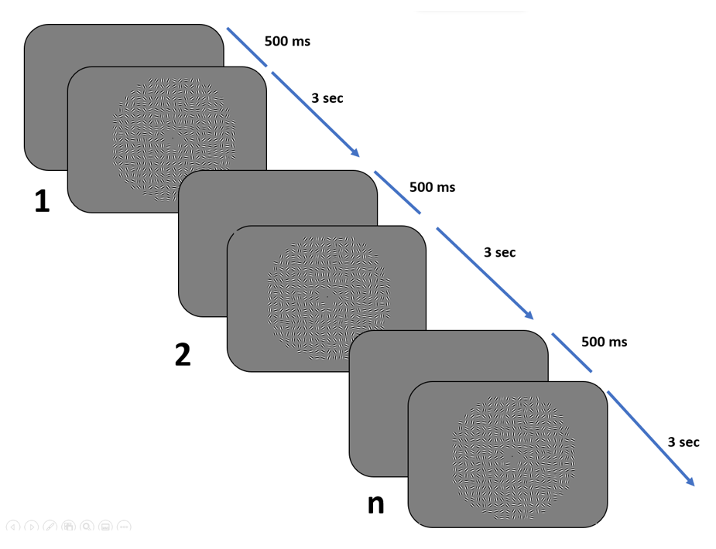

Figure-1 Free Task

**Replay Task (Figure-2):** Task will be the same as the Free Task, but the stimulus duration will differ depending on the default decision time for each trial calculated based on the data coming from the Free Task. In Replay Task, five conditions (Less, Free in Replay, More Contrary, More Neutre, and More Supportive Conditions) will be presented in a mixed form and in random order.

In the Replay Task, all answers will be followed by a confidence rating concerning the last responses given. Confidence rating will be on a scale of 1-4 (1 indicating the minimum confidence level and 4 indicating the maximum confidence level).

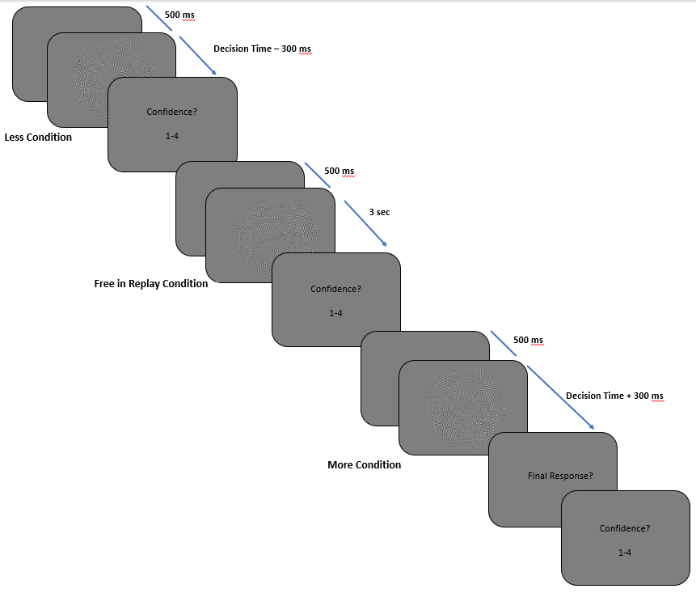

Figure-2 Replay Task

1. **Randomization (optional)**

The trial order in both the Free and Replay tasks will be randomized. All participants will be presented with the same pre-generated stimulus set, but the order of presentation of these pre-generated trials will be randomized between subjects.

### **Sampling Plan**

1. **Existing data (required)**
   * 1. Registration prior to creation of data: As of the date of submission of this research plan for preregistration, the data have not yet been collected, created, or realized.
2. **Explanation of existing data (optional)**

We collected pilot data from 2 participants and analyzed it to see the approximate time required for the task completion and set the parameters appropriately. We will run one final pilot and analyze it to see the parameters change we did after the two previous pilots run smoothly.

1. **Data collection procedures (required)**

20 participants who have normal or corrected to normal vision will be recruited by mailing lists and word of mouth. They will be required to speak English to understand the full explanation of the task. Written consent will be requested after explaining the task and before beginning the experiment.

1. **Sample size (required)**

We will use a similar procedure that is used in Balsdon et al.'s (2020) study. Therefore, we will include a total of 20 participants by referencing the moderate effect size aimed in this study (d= 0.68) with a power of 0.8 (alpha = 0.05). Participants who have below chance level (50% correct) performance will be excluded and replaced by another participant to preserve the total number of data included in the full analysis.

1. **Stopping rule (optional)**

No more than 20 participants' data will be included in the final analysis.

### **Variables**

1. **Manipulated variables (optional)**

In the Replay Task, we will manipulate the strength of the presented evidence, by predicting that increasing the proportion of Gabors moving in a coherent direction will increase performance and decrease reaction times. We will also manipulate the duration of stimulus presentation in the Replay task: Less, Free response, and More Conditions. In the More conditions of the Replay Task, we will manipulate the post-decision evidence which will either confirm, contradict, or have no change on the information presented up to the decision point. This manipulation will allow us to test our main hypothesis, where this post-decision evidence is expected to have an influence on confidence but not on the final perceptual decision.

1. **Measured variables (required)**

The outcome variable will be the choice on each trial, the reaction time of each choice, and the confidence rating in the Replay Task.

**Indices (optional)**

### Analysis Plan

1. **Statistical models (required)**

The main analysis will be to test our hypothesis to examine the effect of extra post-decisional information that contradicts the pre-decision information on the performance and confidence ratings. This effect will be examined by non-parametric within-subject statistics on the d’ and confidence ratings between five conditions. Specifically, to test our hypothesis, we will investigate whether the observers are more likely to change their initial response in the More Contrary Condition than in the More Supportive Condition.

We will further examine the data by using Drift Diffusion Models to explain the decision-making quantitatively and to see whether the Type-I and Type-II decisions have the same or different boundaries. We will first fit parameters of different versions of models to describe behavior in the Free trials, and then compare how well this model predicts responses in the More conditions across accumulating all evidence and accumulating evidence only to the bound.

1. **Transformations (optional)**
2. **Inference criteria (optional)**

The null hypothesis will be rejected at the alpha level of 0.05 (p<0.05 to reject the null hypothesis). Our hypothesis also includes the performance, so the difference in the performance level across conditions will also be assessed against an alpha level of 0.05.

1. Data exclusion (optional)

Participants who have below chance level performance (50% correct) on the first block and participants who wait more than enough time to respond both in the Free Task (more than 1.5 seconds for 80% of trials) and Replay task ( waiting in the majority of trials until the end of the stimulus presentation in the Free in Replay condition) will be excluded. Additionally, participants who will show biases consistently (80% of trials) choosing a certain confidence level in the confidence task may also be excluded. All the excluded participants' data will be replaced by another participant to preserve the total number of data included in the full analysis.

Even if participants only give a very late response (response given after 3 sec) in a small number of trials, that is not enough to exclude the whole data (not correspond to 80% of the trials); these trials with very late responses will not be included in the analysis.

1. Missing data (optional)

Only complete data sets will be included in the analysis.

1. Exploratory analysis (optional)

We have no current exploratory analysis planned.

References

Amano, K., Edwards, M., Badcock, D. R., & Nishida, S. Y. (2009). Adaptive pooling of visual motion signals by the human visual system revealed with a novel multi-element stimulus. Journal of vision, 9(3), 4-4.

Balsdon, T., Wyart, V., & Mamassian, P. (2020). Confidence controls perceptual evidence accumulation. *Nature communications*, *11*(1), 1-11.

Mamassian, P. (2016). Visual confidence. *Annual Review of Vision Science*, *2*, 459-481.

Pleskac, T. J., & Busemeyer, J. R. (2010). Two-stage dynamic signal detection: a theory of choice, decision time, and confidence. Psychological review, 117(3), 864.