Specification
Specification of running script
bash version:4.3.46(1)
chmod 555 scriptname
(gives everyone read/execute permission) [14]
or
chmod +rx scriptname
(gives everyone read/execute permission)
chmod u+rx scriptname
(gives only the script owner read/execute permission)
Installing the script
Open Applications -> Accessories -> Terminal.
- Find where the .sh file. Use the ls and cd commands. ls will list the files and folders in the current folder. Give it a try: type "ls" and press Enter. ...
- Run the .sh file. Once you can see for example script1.sh with ls run this: .watch -n 2 ./script1.sh |tee >script1.log

Design consideration
Ps -
displays information about a selection of the active processes. If you want a repetitive update of the selection and the displayed information.
-f Do full-format listing. This option can be combined with many other UNIX-style options to add additional columns. It also causes the command arguments to be printed.
w
displays information about the users currently on the machine, and their processes. The header shows, in this order, the current
time, how long the system has been running, how many users are currently logged on, and the system load averages for the past 1, 5, and 15 minutes.
Dmesg
is used to examine or control the kernel ring buffer. The default action is to display all messages from the kernel ring buffer.
Tail -
output the last part of files
Usage: tail [OPTION]... [FILE]...
Print the last 10 lines of each FILE to standard output.
With more than one FILE, precede each with a header giving the file name.

With no FILE, or when FILE is -, read standard input.

Mandatory arguments to long options are mandatory for short options too.
-c, --bytes=[+]NUM output the last NUM bytes; or use -c +NUM to
output starting with byte NUM of each file
-f, --follow[={name|descriptor}]
output appended data as the file grows;
an absent option argument means 'descriptor'
-F same as --follow=name --retry
-n, --lines=[+]NUM output the last NUM lines, instead of the last 10;
or use -n +NUM to output starting with line NUM
--max-unchanged-stats=N
with --follow=name, reopen a FILE which has not
changed size after N (default 5) iterations
to see if it has been unlinked or renamed
(this is the usual case of rotated log files);
with inotify, this option is rarely useful
--pid=PID with -f, terminate after process ID, PID dies
-q, --quiet, --silent never output headers giving file names
--retry keep trying to open a file if it is inaccessible
-s, --sleep-interval=N with -f, sleep for approximately N seconds
(default 1.0) between iterations;
with inotify and --pid=P, check process P at
least once every N seconds
-v, --verbose always output headers giving file names
-z, --zero-terminated line delimiter is NUL, not newline
--help display this help and exit
--version output version information and exit
df
displays the amount of disk space available on the file system containing each
file name argument. If no file name is given, the space available on all currently mounted file systems is shown. Disk space is shown in 1K blocks by default, unless the environment variable POSIXLY_CORRECT is set, in which case 512-byte blocks are used.
Usage: df [OPTION]... [FILE]...
Show information about the file system on which each FILE resides,
or all file systems by default.

Mandatory arguments to long options are mandatory for short options too.
-a, --all include pseudo, duplicate, inaccessible file systems
-B, --block-size=SIZE scale sizes by SIZE before printing them; e.g.,
'-BM' prints sizes in units of 1,048,576 bytes;
see SIZE format below
-h, --human-readable print sizes in powers of 1024 (e.g., 1023M)
-H, --si print sizes in powers of 1000 (e.g., 1.1G)
-i, --inodes list inode information instead of block usage
-k like --block-size=1K
-l, --local limit listing to local file systems
--no-sync do not invoke sync before getting usage info (default)
--output[=FIELD_LIST] use the output format defined by FIELD_LIST,
or print all fields if FIELD_LIST is omitted.
-P, --portability use the POSIX output format
--sync invoke sync before getting usage info
--total elide all entries insignificant to available space,
and produce a grand total
-t, --type=TYPE limit listing to file systems of type TYPE
-T, --print-type print file system type
-x, --exclude-type=TYPE limit listing to file systems not of type TYPE
-v (ignored)
--help display this help and exit
--version output version information and exit
du -du - estimate file space usage

SYNOPSIS
du [OPTION]... [FILE]...
du [OPTION]... --files0-from=F

DESCRIPTION
Summarize disk usage of the set of FILEs, recursively for directories.
--time
show time of the last modification of any file in the directory, or any of its subdirectories

ip - ip - show / manipulate routing, devices, policy routing and tunnels
OBJECT
address
- protocol (IP or IPv6) address on a device.

addrlabel
- label configuration for protocol address selection.

l2tp - tunnel ethernet over IP (L2TPv3).

link - network device.

maddress
- multicast address.

monitor
- watch for netlink messages.

mroute - multicast routing cache entry.

mrule - rule in multicast routing policy database.

neighbour
- manage ARP or NDISC cache entries.

netns - manage network namespaces.

ntable - manage the neighbor cache's operation.

route - routing table entry.

rule - rule in routing policy database.

tcp_metrics/tcpmetrics
- manage TCP Metrics

tunnel - tunnel over IP.

tuntap - manage TUN/TAP devices.

xfrm - manage IPSec policies.
Pkill
pkill will send the specified signal (by default SIGTERM) to each process instead of listing them on stdout.

Usage:
pkill [options] <pattern>

Options:
-<sig>, --signal <sig> signal to send (either number or name)
-e, --echo display what is killed
-c, --count count of matching processes
-f, --full use full process name to match
-g, --pgroup <PGID,...> match listed process group IDs
-G, --group <GID,...> match real group IDs
-i, --ignore-case match case insensitively
-n, --newest select most recently started
-o, --oldest select least recently started
-P, --parent <PPID,...> match only child processes of the given parent
-s, --session <SID,...> match session IDs
-t, --terminal <tty,...> match by controlling terminal
-u, --euid <ID,...> match by effective IDs
-U, --uid <ID,...> match by real IDs
-x, --exact match exactly with the command name
-F, --pidfile <file> read PIDs from file
-L, --logpidfile fail if PID file is not locked
--ns <PID> match the processes that belong to the same
namespace as <pid>
--nslist <ns,...> list which namespaces will be considered for
the --ns option.
Available namespaces: ipc, mnt, net, pid, user, uts

-h, --help display this help and exit
-V, --version output version information and exit

Script as follow:
a=tty
ps ;
w;
dmesg|tail -n 8 ;
df -h;
ip -c -t link show;
du -chd 1 /home;
du -chd 2 /var;
pkill -9 -t $a

Exemplary log and screen output

step 0. Change the permission of file
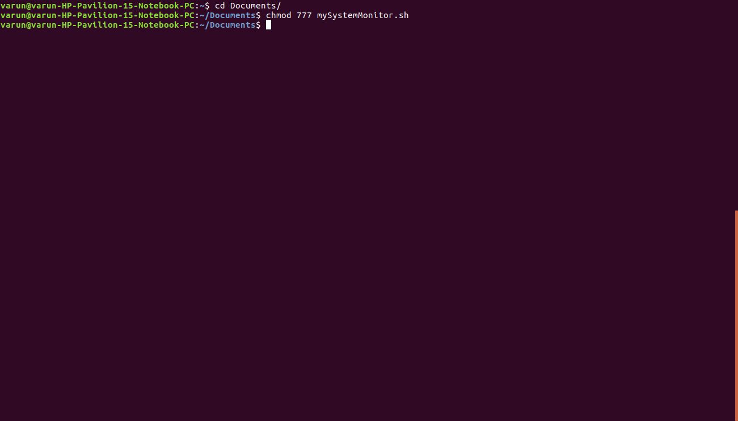



Step1 .moving to destination folder where script is placed
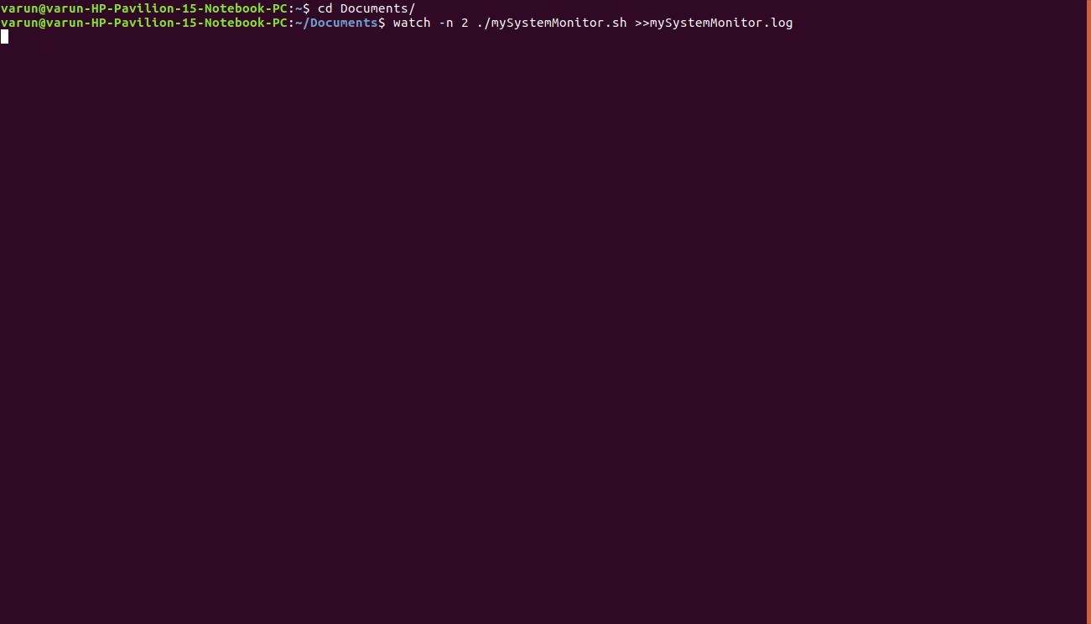
step 2.run the command :watch -n 2 ./mySystemMonitor.sh >>mySystemMonitor.log
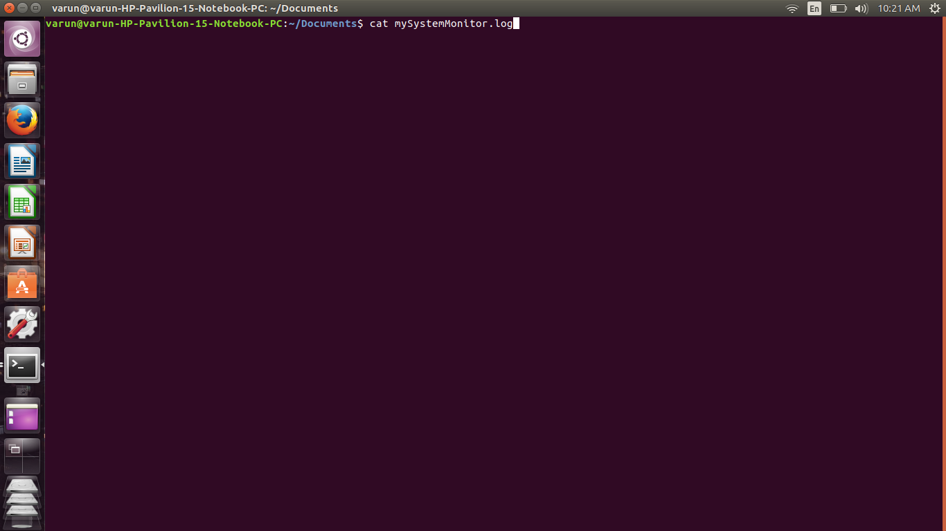
step 3: run the command in new terminal :cat mySystemMonitor.log
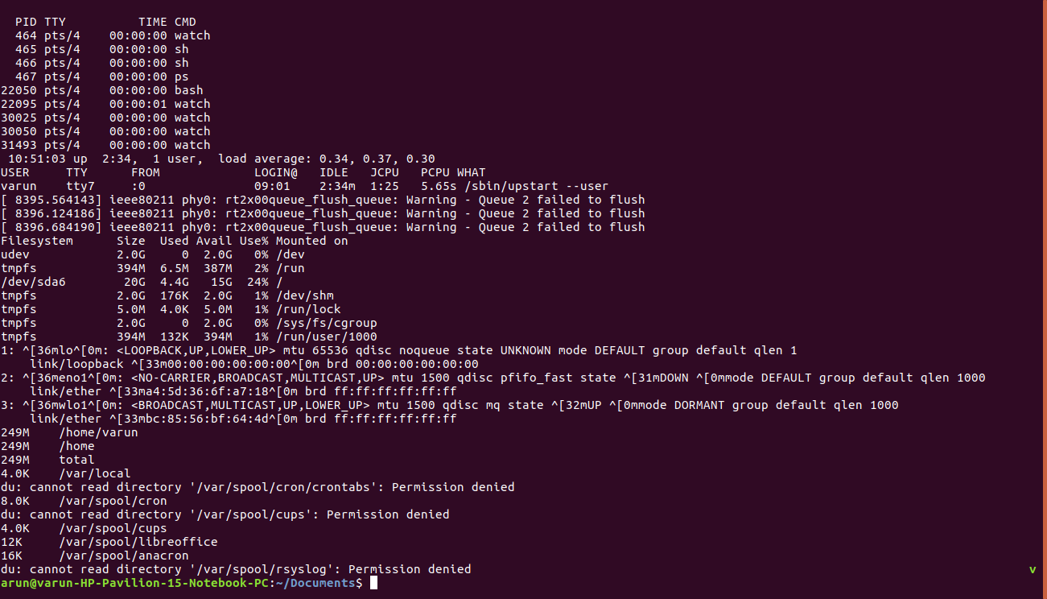
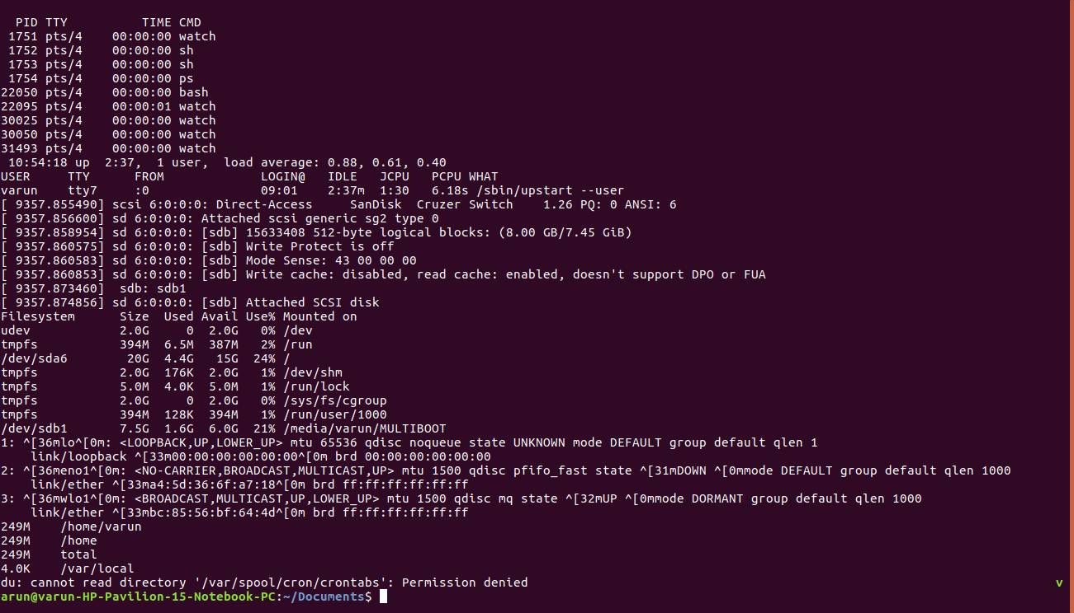
step 3:see the log file
step 4:do changes like usb plug in
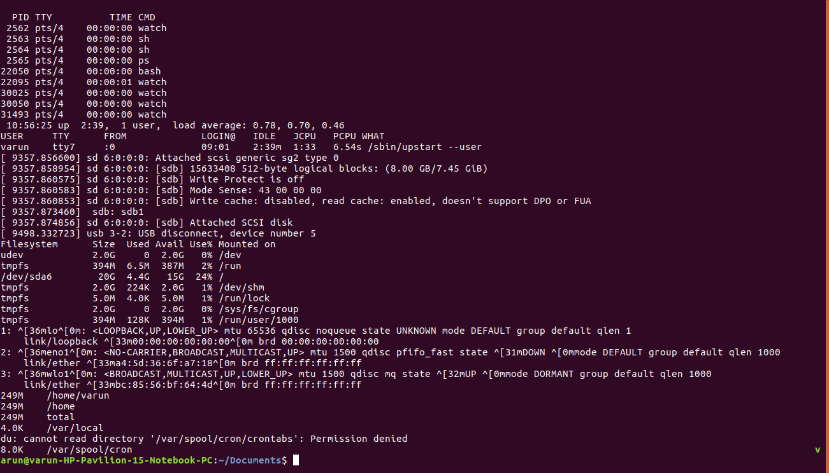
step 5:note the changes in log file

Conclusion

Pros:
1)monitoring the system in every 2 seconds
2)automatically kill the pervious process after 1 cycle
3)check network link state and usb devices

Cons:
1)very length log file
2)data is lengthy in log file

Bibilography

https://www.ibm.com/developerworks/community/forums/html
https://www.unixmen.com
http://unix.stackexchange.com/questions
http://superuser.com/questions
http://www.digitalinternals.com/unix
https://www.autoitscript.com/forum
http://linux.101hacks.com/unix

