

**Linux Basic Commands Assignment**

***Assignment Part-3*** Playing with files

1. Create a file like **nano file1.txt**

o Edit some data and then save the file

Ans- CTRL + O saves a Nano file. CTRL + X exits Nano

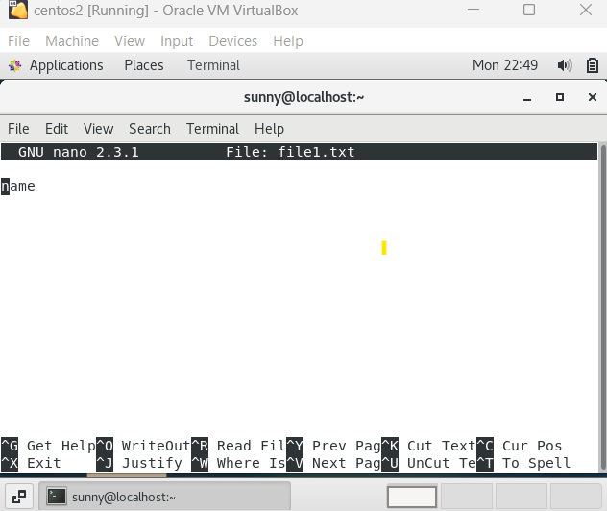

1. Now we will copy date from file1 to new file2

**cp file1.txt file2.txt**

Given screenshot



**o**

o

Then see the output of file2.txt,

**cat file2.txt**

o

Give screenshot

3.

Now we will move the file2.txt to new folder

**/home**

o

**mv file2.txt /home**

o

Then go to

**home**

directory and check

**ls,**

file exits

or not?

o

Ans of 2 and 3-

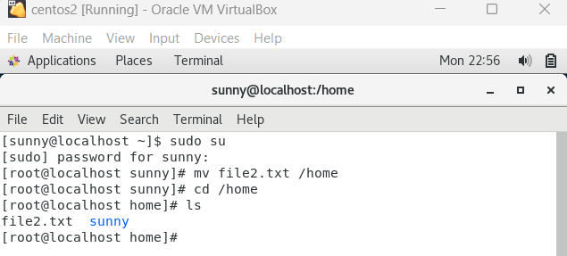

1. Then we create a new **file3.txt and file4.txt** in **home directory** and add content in it.
   * Now do **echo “Hello I am newline” > file3.txt** and provide the output of file3.txt
   * Now do **echo “Hello I am newline” >> file4.txt** and provide the output of file4.txt
   * Tell the different between both step you follow and the reason behind it

Ans 4-

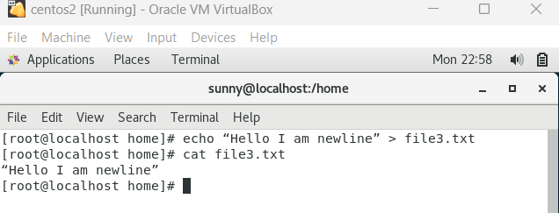

echo “Hello I am newline” > file3.txt (note the >> replaced by >), everything already present in file3.txt would be replaced by “Hello I am newline.

echo “Hello I am newline” >> file4.txt will append “Hello I am newline” and not replace everything already present to the end of the file4.xt file.

1. For remove a file or directory you can use the below two commands **o** To delete a file – **rm <any_filename>**

* To delete a directory - **rmdir <any_directoryname>**

Ans 5-

