1 Initialisation
This document explains detection, automatic cropping and automatic initialisation in version 2.14.4, including the performance and reliability updates supplied with this distribution. It is written for colleagues who already know holography, HoloPy and the guesses used in the original program. The aim is to explain what the code does, in what order and why. The important code excerpts are shown next to the figures they relate to.
The guide has three main parts. Initialisation prepares the image and finds the particle centre. Automatic cropping chooses which pixels to keep. Searching for guesses compares starting values, runs the fits and selects the result.

Prepare the image and follow the calculation
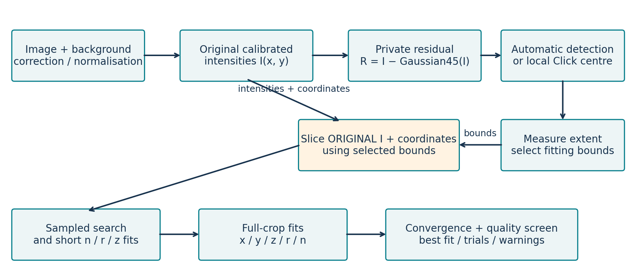
Figure 1. General order of the calculation. The program first finds the centre and the rectangle. It then uses the original normalised intensities, with their actual coordinates, to search for starting values and run the full fits.
How to read Figure 1
The top row prepares the image. The program corrects and normalises it, removes slow background changes, proposes centres and checks how far the fringes remain visible. This part answers two questions: where is the particle? and which pixels should be kept?
The middle row chooses the crop. The orange outline shows the whole area measured around the particle. If the bright and dark fringes are clear enough, the program tries to keep a smaller cyan rectangle. This rectangle must still keep enough pixels in each bright peak and dark trough of the profile. These peaks and troughs are called lobes in the rest of the document.
The bottom row shows Automatic mode. The program prepares several n/r/z starts, compares them quickly on some of the original pixels, then runs the full fits. In Manual mode, it uses the combinations supplied by the user directly.
The key point is that the filtered image is only used to choose the centre and rectangle. HoloPy does not use it as the experimental image. The fit receives the corrected, normalised intensities before this filtering, together with their physical coordinates and the optical information stored with the image.
Step | Main file | What this step returns
Preparation and detection | hologram_analysis/preparation.py | normalised image, residual, activity and candidate centres
Centre correction after a click | hologram_analysis/click_centering.py | local centre and confidence flag
Automatic cropping | hologram_analysis/cropping.py | rectangle bounds and information about the fringes found
Starting-value search | hologram_analysis/initialization.py | list of different n/r/z starts
Fitting and selection | hologram_analysis/fitting.py | best acceptable trial and warnings

Find possible centres automatically
Figure 2 shows the four steps of the standard detector. The example contains two sets of rings, a slowly changing background, noise and a small bright speck added on purpose. This speck shows an important limit: the detector proposes positions to check. It does not prove that every position contains a particle.
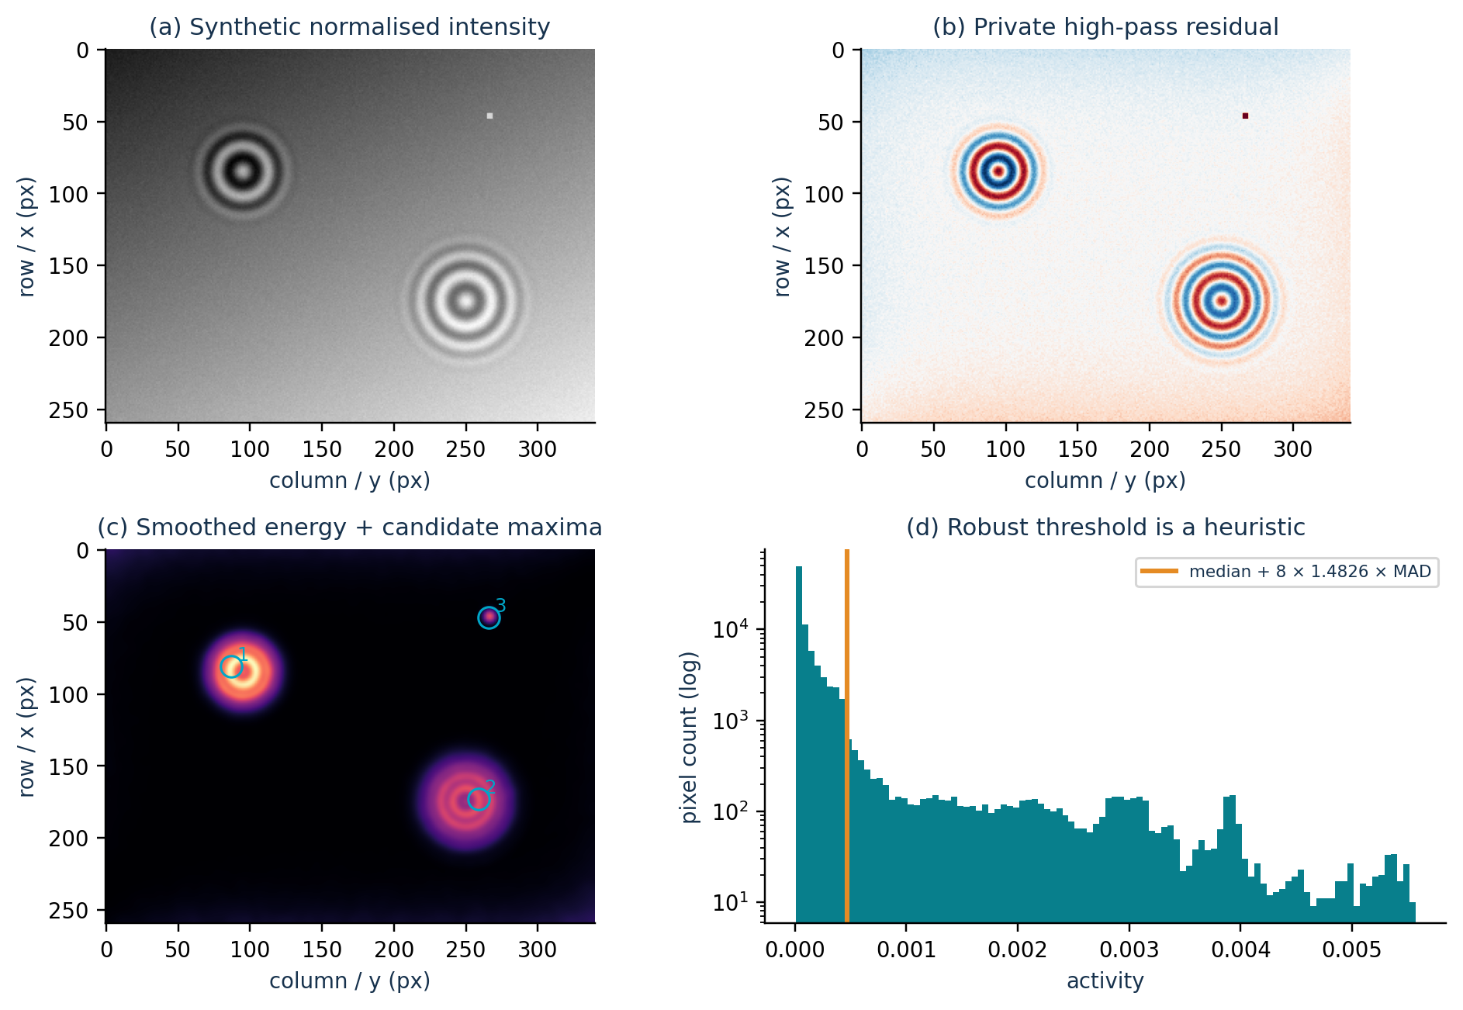
Figure 2. Steps of the standard detector. (a) normalised synthetic image; (b) image after removing the slow background; (c) activity map and proposed positions; (d) activity values and the threshold used.
Figure 2(a) — Starting image
Panel (a) shows the image given to the program. The two fringe patterns were created at (x=85, y=95) and (x=175, y=250). The background changes slowly from one side to the other, as it might with uneven illumination or imperfect background correction. The small bright point near (x=47, y=267) is the speck added for the test.
In every figure, x means rows and runs vertically. y means columns and runs horizontally. A centre stored as (x, y) must therefore be plotted as (y, x) with Matplotlib.
Figure 2(b) — Image after removing the slow background
The program subtracts a heavily smoothed copy of the image:
Code 1 — Remove the slow background and start detection. hologram_analysis/preparation.py.
# Subtract the local background to remove slow variations; squaring reveals
# bright and dark fringes. Smoothing combines the energy of the rings.
residual = image - gaussian_filter(image, sigma=45)
activity, candidates = _detect_residual(residual, sigma, min_distance,
border, limit, min_diameter_px,
max_diameter_px)

The subtraction calculates R = I − G₄₅(I). G₄₅(I) is a very blurred copy of the image, made with sigma=45 pixels. This copy mainly contains slow background changes. Subtracting it makes faster changes, such as fringes, easier to see. The result R is called the residual. In panel (b), white is close to zero. Red and blue show the two signs of the residual.
The speck remains visible because it also changes sharply compared with the background. This filter cannot yet separate a fringe pattern from a small defect. The residual is only used to find the crop position and size. The final fit does not use this red and blue image.
Figure 2(c) — Activity map and proposed positions
The detector squares the residual, then smooths the result. Squaring makes both the red and blue fringes contribute positive values. Smoothing combines nearby values. An area with several rings then becomes a bright area in the activity map.
Code 2 — Calculate the activity map, threshold and possible positions. hologram_analysis/preparation.py.
activity = gaussian_filter(residual**2, sigma=sigma)
mid = np.median(activity)
mad = np.median(np.abs(activity - mid))
threshold = mid + 8 * 1.4826 * mad
maxima = (activity == maximum_filter(activity, size=2 * min_distance + 1))
maxima &= activity > threshold
if candidate_mask is not None:
maxima &= candidate_mask

The first statement calculates A = Gσ(R²), where σ is detect_sigma. The maxima and threshold checks keep points that are stronger than their neighbours and above the threshold. The cyan circles in panel (c) show the three proposed positions: the two expected patterns and the speck. Their numbers give their order, from the strongest activity to the weakest.
At this stage, the proposed centre is simply the strongest point in the area. It can be slightly shifted by a stronger background on one side, a neighbour, a strong fringe or a defect. The program must therefore still check or correct this centre.
Figure 2(d) — How the threshold is chosen
Panel (d) groups all the activity-map values. The horizontal axis shows activity. The vertical axis gives the number of pixels with that value. It uses a logarithmic scale so that both common and rare values can be seen. The orange line is the threshold calculated from the median and MAD:
Formula corresponding to the median/MAD threshold calculation.
mid = median(activity)
mad = median(abs(activity - mid))
threshold = mid + 8 * 1.4826 * mad

The median gives the usual level of the map. The MAD measures how far the values are from this level. A few very large values have little effect on it, which is useful here. The factor 1.4826 puts the MAD on a scale close to a standard deviation for Gaussian noise. The factor 8 deliberately sets a high threshold.
This threshold is a practical rule. It does not give the probability that a particle is present. A strong defect can exceed it, as candidate 3 does. A weak pattern can stay below it. The code then removes points too close to the border, enforces detect_min_distance between positions and keeps at most max_particles positions.
If this step needs to be changed
Detection only answers the question: “where is the local signal stronger than usual?” It does not say whether a fit will be good or whether the point really corresponds to a particle. If the factor 8, detect_sigma or the background filter is changed, test weak patterns, small defects, nearby particles and particles near the image edge. Diameter-guided detection is in detection.py. It tries several sizes and also checks the visible fringe diameter.

Find the centre after a click
Click mode does not rerun detection over the whole image. The code tries several centres around the click. For each centre, it checks whether the rings are well arranged around that position. No HoloPy fit is run at this stage.
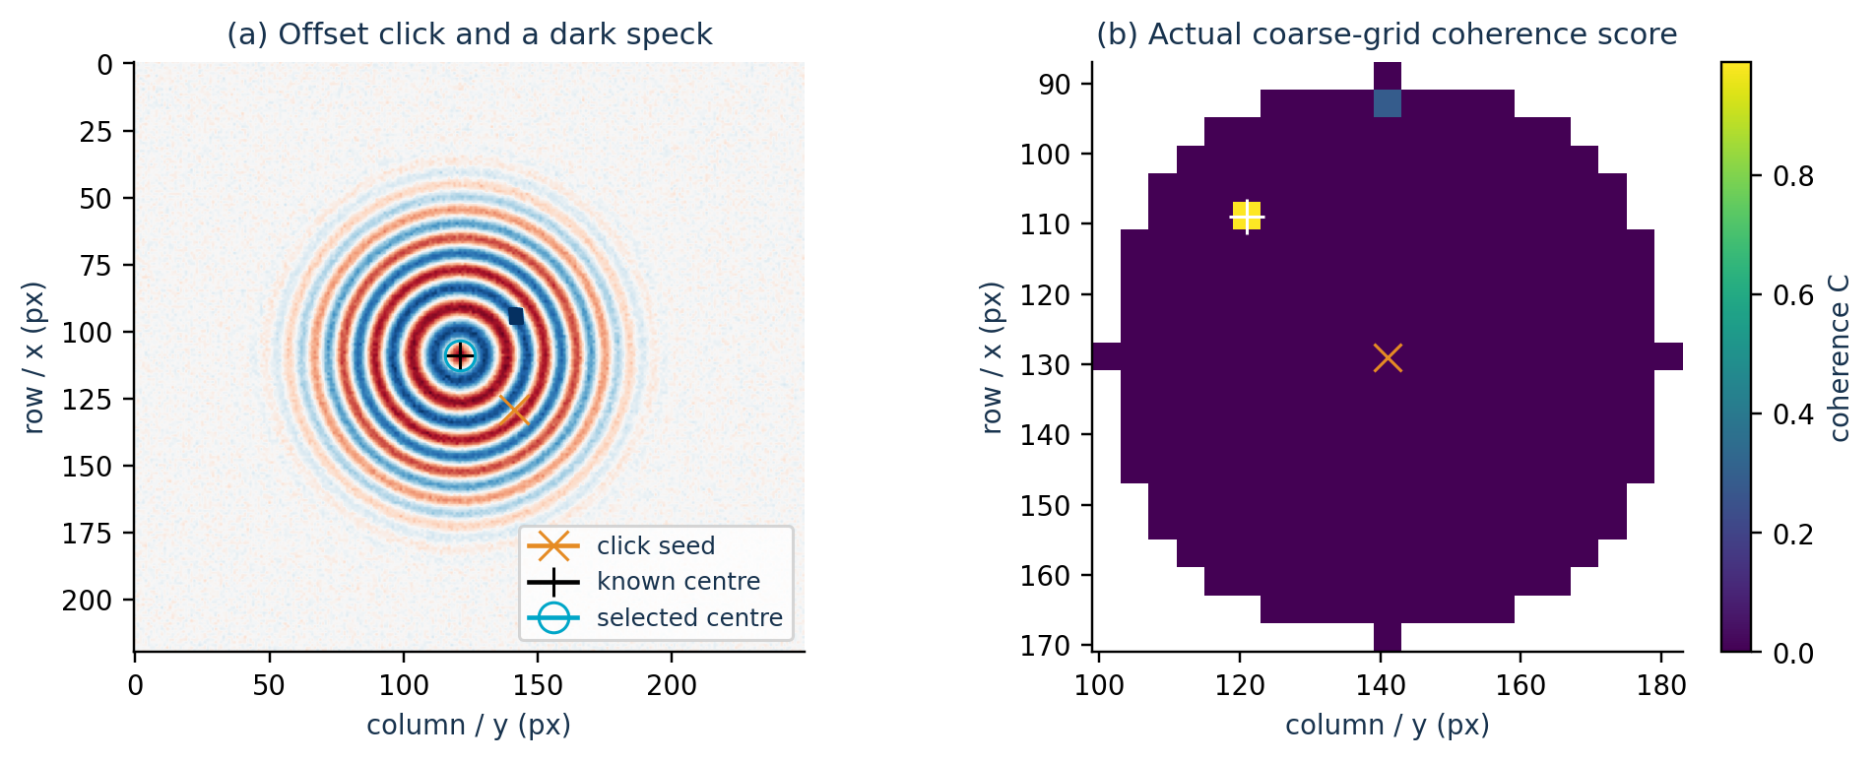
Figure 3. (a) synthetic example with an offset click and a dark speck; (b) map of the actual scores calculated on the first local grid.
Figure 3(a) — What the left image shows
The orange cross is the initial click at (129, 141). The black cross marks the centre used to create the pattern, (109, 121). The cyan circle is the centre chosen by the algorithm, which overlaps the black cross here. The dark speck was added to check that one isolated defect does not control the centre position.
The program does not simply search for the brightest or darkest pixel. For each possible centre, it groups pixels by their distance from that centre. It then checks two things: how the signal changes as the distance increases, and whether pixels on the same circle have similar values.
Code 3 — Calculate the score used to compare centres. hologram_analysis/click_centering.py.
weights = counts * mask
total = np.maximum(weights.sum(axis=1), 1)
offset = (means * weights).sum(axis=1) / total
radial_variance = (((means - offset[:, None])**2 * weights).sum(
axis=1) / total)
disagreement = (angular_variance * weights).sum(axis=1) / total
coherence = radial_variance / np.maximum(
radial_variance + disagreement + noise**2, 1e-20)

The code removes the average level, then measures how the signal changes with distance. It also measures differences between directions on the same circle. These terms then build this score:
Meaning of the score calculated by the code.
coherence = radial_variation / (
radial_variation + angular_disagreement + noise**2)

A good centre produces two effects. First, the signal changes clearly from one ring to the next. Second, pixels at the same distance from the centre have similar values. The score increases when both conditions are present. It decreases if the image depends mainly on direction or noise. Before this calculation, the code limits the effect of unusually bright or dark pixels.
Figure 3(b) — How to read the map on the right
Each coloured cell corresponds to a centre tested on the first grid, with a 4-pixel step. Yellow marks the best scores. Purple marks a low or zero score. The white areas were not tested because they lie outside the search area around the click. They therefore represent neither a good nor a bad score.
The program checks 64 directions and requires at least 24 sample points inside the image for each ring. It looks at several maximum distances from the centre: 32, 56 and 80 pixels, depending on the available space. It keeps at most eight good starts that are spread apart, then tests them more precisely with whole-pixel shifts of ±4 pixels.
The score alone is not enough. The profile must also show a series of peaks and troughs, or a clear core followed by a ring of the opposite sign. If several good positions have similar scores, the program prefers the one closest to the click. This avoids jumping to a more visible neighbouring particle.
The search distance is min(40, max(24, maximum // 4)) pixels. If the result remains uncertain or reaches the edge of this area, the code keeps the original click and returns confident=False. The interface then rejects the uncertain new selection. Keep this behaviour if _ring_scores() or the search distance is changed.

2 Automatic cropping
Once the centre has been found, the program chooses which pixels to keep around the particle for the fit.

Choose the area to keep
select_adaptive_crop() makes two decisions. First, it finds how far the fringes remain visible and adds a safety margin. If the bright and dark fringes alternate clearly enough, it then looks for a smaller rectangle that keeps enough pixels in each lobe.
The function returns values such as bounds_px, extent_bounds_px, extent_radius_px, extent_confidence and warning. The preview shows the same rectangles used by the calculation: orange shows the full measured area and cyan shows the pixels sent to the fit.
Setting | What it changes
adaptive_crop | Enables this method. Its library default is False.
adaptive_crop_rectangle | Allows the search for a smaller band after measuring the orange area. Its default is True.
adaptive_crop_min_px / adaptive_crop_max_px | Set the minimum and maximum size; the defaults are 32 and 256 pixels. The maximum also limits the search distance.
adaptive_crop_margin_px | Adds a margin beyond the last fringe found; the default is 6 pixels.
xy_fit_margin_um | Limits x/y movement during fitting. It must not enlarge the measured crop.

bounded_window() provides the area available around the centre. The window keeps an even size, stays inside the image and respects the minimum safety size MIN_CROP_PX. adaptive_crop_min_px is also applied when the program builds the orange area and the possible rectangles.
The automatic measurement does not depend on crop_height_px or crop_width_px. If the program cannot clearly recognise the fringes, it does not return to these fixed dimensions. It keeps an area based on the activity or the available space, then adds a warning explaining the situation.
Turning off only adaptive_crop_rectangle keeps the automatic measurement of the orange area but removes the search for a smaller cyan rectangle. This test helps identify which of the two steps changes the result.

Take neighbouring particles into account
A neighbouring particle's fringes must not make the target's crop larger by mistake. owned is therefore a map of True/False values. True means that a pixel can be used to measure the target's area.
Code 4 — Assign pixels to the target rather than known neighbours. hologram_analysis/cropping.py.
owned = np.ones(local.shape, dtype=bool)
for neighbor in neighbors:
other_distance = (rows - neighbor['x'])**2 + (cols - neighbor['y'])**2
owned &= distance**2 <= other_distance
owned &= other_distance >= (cfg.detect_min_distance / 2)**2

The distance comparison assigns each pixel to the nearest centre. A pixel remains owned if it is at least as close to the target as to the neighbour. The next statement also removes a small disc around the neighbour, with radius detect_min_distance / 2. The radial curves, noise calculation and area measurement all use this same map.
In Click mode, find_local_neighbors() can create an internal list of possible neighbours, used only for this calculation. It first removes the target's profile, looks for other centres and requires a credible sequence of bright and dark fringes. These possible centres do not create new particles in the interface or launch separate fits.
If a possible neighbour is not certain enough, it is not used as an exclusion centre. The program sets isolation_uncertain=True, displays a warning and requires better contrast before accepting the rectangle. This avoids removing good pixels because of a false neighbour.
What the owned mask changes
owned only helps choose the rectangle. It does not remove the neighbour's light signal from the fitting data. Once the rectangle has been chosen, extract_window() sends HoloPy all the original pixels inside it, even those that were not owned during the size calculation.

Measure how far the fringes remain visible
Turn the image into curves
_radial_profiles() groups pixels by their distance from the centre and their direction. Distances are divided into groups 1 pixel wide. The circle is also split into several parts, called sectors. The function uses the actual pixels directly and does not invent values between them.
Code 5 — Group pixels by radius and sector. hologram_analysis/cropping.py.
radial = np.minimum(np.floor(distance / step).astype(int), bins - 1)
sector = np.minimum((angles * sectors / (2 * np.pi)).astype(int),
sectors - 1)
valid = owned & (distance <= limit)
labels = (sector * bins + radial)[valid]
counts = np.bincount(labels,
minlength=sectors * bins).reshape(sectors, bins)
total = np.bincount(labels,
weights=values[valid],
minlength=sectors * bins).reshape(sectors, bins)
signed = total / np.maximum(counts, 1)

The first statements give each pixel a distance-group number and a sector number, then keep only owned pixels inside the search area. The bincount operations count the pixels and add their residual values. The final statement calculates the mean while keeping the positive or negative sign.
The sign matters: a positive peak or negative trough in the curve corresponds to a bright or dark fringe. The code calls each one a lobe. If all values became positive, the program could no longer check the bright/dark alternation. counts is also needed: it records how many pixels were used to calculate each point on the curve.
The code starts with 16 sectors. If that estimate already qualifies as high confidence, the unused 8-, 4- and 1-sector profiles are skipped. Otherwise it continues with 8, 4 and 1 sector. The curves are lightly smoothed with σ=0.45. The mean level far from the centre is calculated in the outer 20% of the allowed radius, using groups that contain enough pixels.
Number of sectors | Minimum number of directions where fringes are recognised
16 sectors | 6 directions
8 sectors | 3 directions
4 sectors | 2 directions
1 sector | 1 full-circle profile

With 16 sectors, the program can better identify the direction of a neighbour or image edge. With fewer sectors, more pixels are grouped together and the last faint fringes can become easier to see. The program prefers the finest division that works. A result obtained by grouping more directions can extend a weak result by no more than 8 pixels. This prevents a small change far from the centre from greatly enlarging the crop.
Estimate the noise before choosing the size
Figure 4 shows the image used to choose the size, followed by the mean curve around the centre. It explains why the final radius cannot be read from this curve alone.
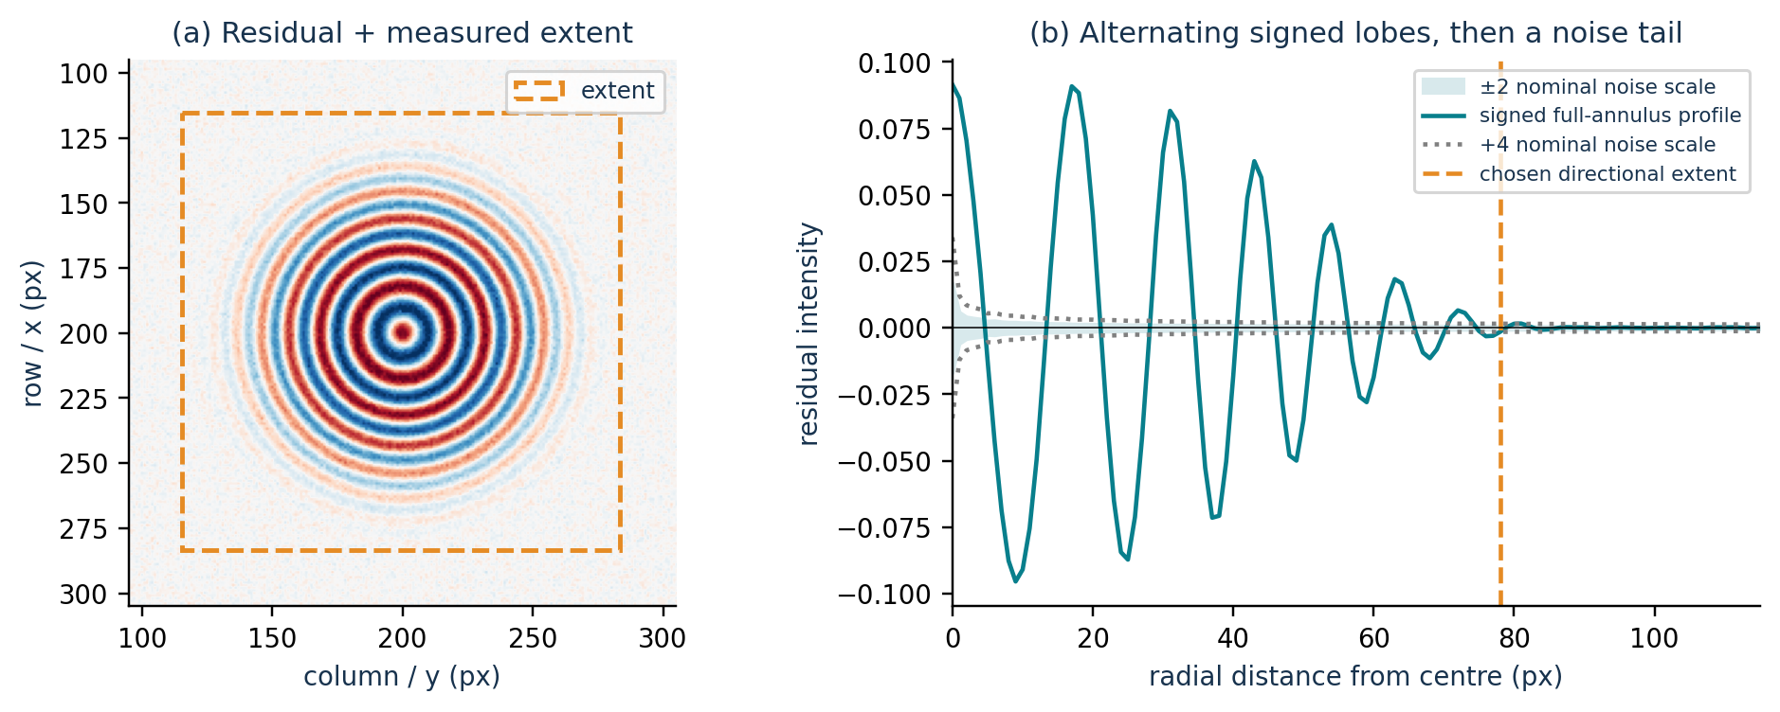
Figure 4. (a) Synthetic residual and selected orange area; (b) mean curve retaining positive and negative values, levels calculated from the noise, and selected radius.
Figure 4(a) — The orange square
The left panel shows the residual. The orange square is the selected area after adding the margin. By comparing several directions around the centre, the code found a useful radius of 78 pixels. With a 6-pixel margin, the square's side is 2 × (78 + 6) = 168 pixels. The circle of radius 78 is not drawn on the left; this radius is shown by the orange line on the right. The square is not a physical parameter supplied to HoloPy.
Figure 4(b) — The mean curve and the noise
The right panel shows the mean over a complete ring, keeping positive and negative signs. The peaks and troughs correspond to bright and dark fringes. The coloured band shows ±2 times the noise level used for this curve. The dotted lines show ±4 times this level. The vertical orange line marks the radius chosen using the different directions.
This mean curve does not decide the orange line's position on its own. One direction may retain fringes farther out than another. A fringe visible over only part of a circle may also become less visible in the mean. The code sorts the last distances found in each direction, then takes the 90th percentile: 90% of the distances are less than or equal to this value. This retains distant fringes without letting one unusual direction decide the whole size.
Code 6 — Smooth the residual and measure the noise used to choose the size. hologram_analysis/cropping.py.
smooth = gaussian_filter(local, .8)
highpass = local - gaussian_filter(local, 1.0)
noise_values = highpass[owned] if owned.any() else highpass.ravel()
camera_noise = max(
float(1.4826 *
np.median(np.abs(noise_values - np.median(noise_values)))) /
.87, 1e-8)

The first statement lightly smooths the residual used for the curves. The next creates a second image, local − G₁(local), containing mainly small, rapid changes. The following statements measure their usual level with the MAD, multiply the result by 1.4826, divide it by 0.87 and set a minimum value of 10⁻⁸.
For a group containing N pixels, the noise level used by the curve is s = 1.5 × camera_noise / √N. It is used only to decide whether a fringe remains visible. It differs from the noise_sd given to HoloPy during fitting. The ±2 and ±4 levels do not mean, for example, “95% confidence”.
Follow several fringes without being misled by an isolated point
Here, a lobe is simply a positive peak or a negative trough in the curve. _hysteresis_extent() uses two levels. A strong enough peak or trough must start the sequence. Weaker fringes can then extend it. Once this sequence stops, a distant signal cannot restart it.
Code 7 — Define the weak points the program can still use. hologram_analysis/cropping.py.
amplitude = np.abs(values)
snr = amplitude / np.maximum(sigma, 1e-12)
near = (np.arange(len(values)) * step <= seed_radius) & (counts >= 8)
peak = float(amplitude[near].max()) if near.any() else 0.0
# Pooling many pixels can make an almost invisible tail nominally
# significant. Follow useful lobes, not arbitrarily small averaged texture.
weak = (snr >= 2.0) & (amplitude >= .02 * peak) & (counts >= 8)
weak[:int(np.ceil(4 / step))] = False

A weak point on the curve can still be used if it meets three conditions. Its amplitude must reach at least 2 times the noise level and 2% of the peak near the centre. The calculation must also use at least 8 pixels. The first four pixels around the centre are ignored. To start the sequence, one lobe must reach 4 times the noise level. Overall, the program requires at least three consecutive lobes, including two strong ones.
The code also checks that peaks and troughs alternate correctly, are not too far apart and have a reasonable width. Neighbouring pieces with the same sign can be joined. However, a long area that stays positive or negative cannot count as several fringes. As soon as the sequence is no longer regular, the program stops.
The label high is used only when the 16-sector analysis gives a strong enough signal, with a median strength of at least 6. Other results where fringes are recognised are labelled weak. These are simple program labels. They do not give a probability of success.
If the fringes are not clear enough
_activity_extent() then looks for an activity area connected to the centre. It keeps a region containing 99.5% of the useful activity above the background level. It also adds a larger margin: max(1.5 × margin, 3 × detect_sigma).
If this method still does not give a reliable size, the program keeps the available local area. It respects the image edges, maximum size and neighbour positions. It does not automatically return to crop_height_px × crop_width_px. In this case, it does not search for a narrower band either.
Three warnings must remain separate: the fringes are not recognised, the fringes reach the search limit, or the area is cut off by the image edge. These three cases can produce a large crop, but for different reasons.

Look for a smaller rectangle
When fringes have been recognised, _optimize_fringe_rectangle() tries several horizontal and vertical bands. Their size changes in 2-pixel steps. The program also tries small shifts to avoid a neighbour. It starts with the smallest rectangles and always uses the same order. The first rectangle that passes every check is kept.
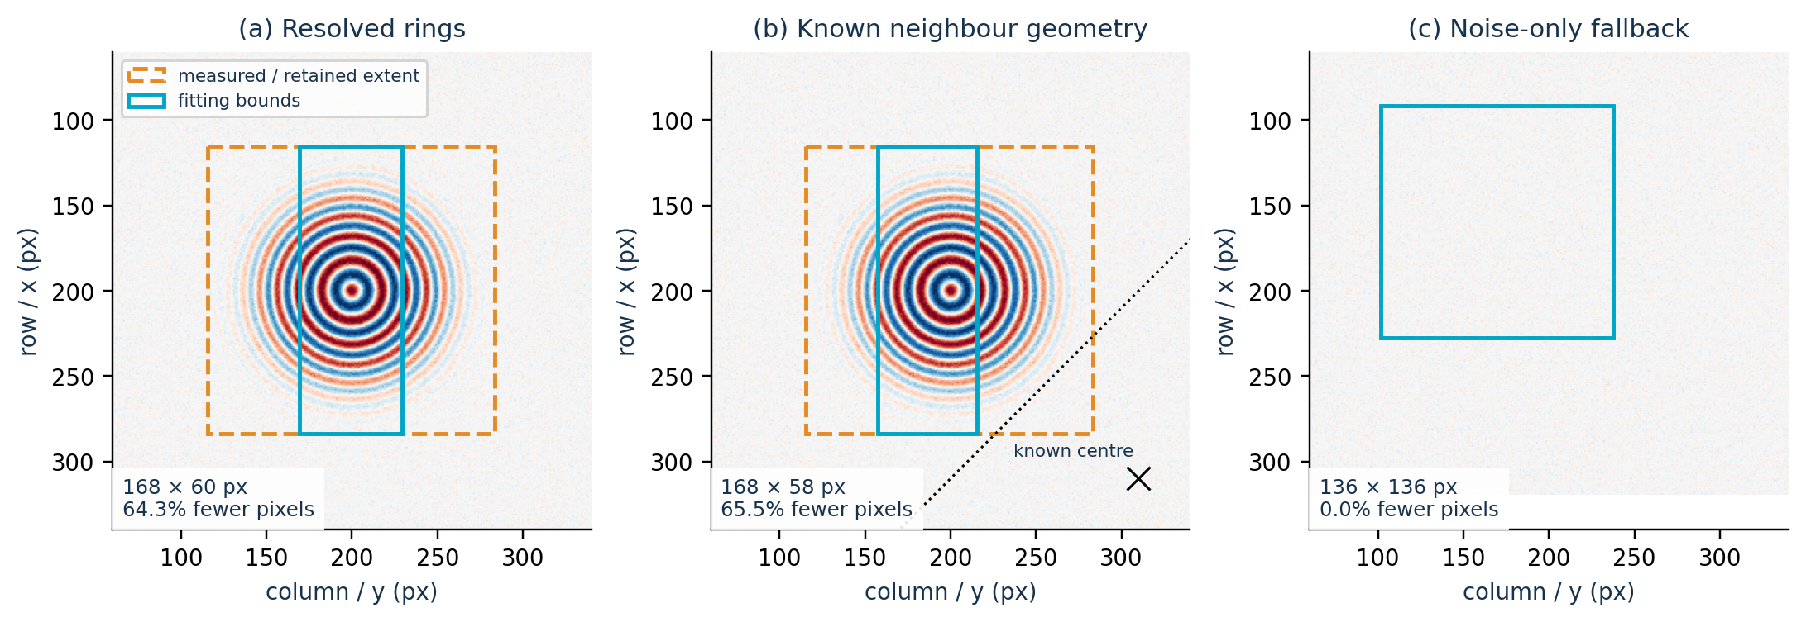
Figure 5. Three possible results: isolated pattern, known diagonal neighbour and noise alone. Orange shows the full measured area. Cyan shows the rectangle actually sent to the fit.
Figure 5(a) — Isolated pattern
On the left, the orange area measures 168 × 168 pixels. The program finds that a 168 × 60-pixel band keeps enough pixels in each bright peak and dark trough. It also keeps pixels on both sides of the centre and in opposite directions. The band is therefore accepted. It does not keep complete rings, but it passes through the pattern.
Figure 5(b) — Known diagonal neighbour
In the middle, we supplied only a neighbour's position. No second hologram was added. The owned mask removes pixels considered closer to the neighbour from the analysis. A slightly shifted 168 × 58-pixel band still passes the checks. The rectangle can therefore be offset from the centre if the fringes remain well enough represented.
Figure 5(c) — Noise alone
On the right, the program does not recognise any clear fringe sequence. It keeps a 136 × 136-pixel square and does not look for a smaller band. This size comes from a fallback rule based on activity and the available area. It does not measure a hologram's physical size and will not always equal 136 pixels.
Code 8 — Check each lobe before accepting a band. hologram_analysis/cropping.py.
selected_counts = np.bincount(lobe_labels[inside], minlength=len(peaks))
values = np.bincount(lobe_labels[inside],
weights=local[inside],
minlength=len(peaks))
means = values / np.maximum(selected_counts, 1)
fractions = selected_counts / np.maximum(reference_counts, 1)
contrast = np.abs(means) / np.maximum(np.abs(reference_means), 1e-12)
if (np.any(selected_counts < 12) or np.any(fractions < .25)
or np.any(contrast < (.9 if isolation_uncertain else .8))
or np.any(np.sign(means) != np.sign(reference_means))):
continue

The code calculates four values for each peak or trough: the number of pixels kept, their mean value with its sign, the fraction of pixels kept and the remaining contrast compared with the orange area. The conditional rejects the rectangle in four cases: fewer than 12 pixels in a lobe, less than 25% of its pixels kept, contrast too weak, or a change from bright to dark or the reverse. The minimum contrast is normally 80%, or 90% if a neighbour’s presence is uncertain.
If a rectangle fails, the program tries another one, larger or slightly shifted. It keeps the whole orange area only if no rectangle passes, reduction is disabled or the fringes are not recognised.
optimization_pixel_reduction calculates 1 − area(fit)/area(orange region). The 64.3% in this example shows only the reduction in pixel count. It guarantees neither 64.3% less time nor unchanged accuracy.
Checks before accepting a band
The first test is not enough. Before accepting a band, the program also checks that it represents each fringe, both sides of the centre and opposite directions properly.
What the program checks | Condition
Enough pixels in each lobe | At least 12 pixels and 25% of the available pixels.
Same type of fringe | A bright area must remain bright and a dark area must remain dark. Contrast must stay above 80%, or 90% if a neighbour is uncertain.
Pixels on both sides of the centre | At least 6 pixels from each lobe in each half of the band.
Contrast in each half | Each side must retain at least 60%, or 80% if a neighbour is uncertain, allowing for noise. A clear sign reversal is rejected.
Opposite directions | For a lobe cut by the band, at least two opposite sectors must each contain 3 pixels. This test is not needed if the whole lobe is kept.
Distance from neighbours | The rectangle must remain acceptable relative to neighbouring centres. A bad corner of the large square does not necessarily rule out a band that avoids it.

The program allows a small difference due to noise. This allowance is 3 × camera_noise / √Nhalf. Take a dark reference fringe at −0.10. If one half of the band has a value of −0.05 and the allowance is 0.02, the code obtains a useful value of 0.07 in the expected direction. This exceeds the normal minimum of 0.06. If the mean clearly changes to the opposite sign, the band is rejected. The overall 80% contrast check still applies.
Each check avoids a different problem. The minimum pixel count prevents decisions based on only a few points. Contrast avoids nearly flat areas. Checking both halves prevents keeping only one side of the pattern. Opposite sectors check that the band really passes through the fringes.
The program does not run a second fit on the orange square to compare it directly with the cyan band. crop_validation.py records the selected rectangle and fits only that rectangle. After changing the thresholds, compare residuals, fitted parameters and calculation time on the same images.

Cut out the rectangle without moving its coordinates
Once the rectangle has been chosen, extract_window() returns to the original corrected, normalised intensities and cuts out these data. The filtered residual is no longer used. This is when the selected area is prepared for HoloPy.
Code 9 — Cut out the original data and keep their information. hologram_analysis/cropping.py.
def extract_window(data, bounds, info):
"""Slice the original normalized data without moving physical coordinates."""
x0, x1, y0, y1 = bounds
h = data.isel(x=slice(x0, x1), y=slice(y0, y1)).copy(deep=False)
h.attrs = dict(h.attrs, crop_selection=dict(info, bounds_px=bounds))
return h

The isel() statement selects pixels and keeps their existing coordinates rather than creating new ones. The next statement adds information about the selected crop to the result.
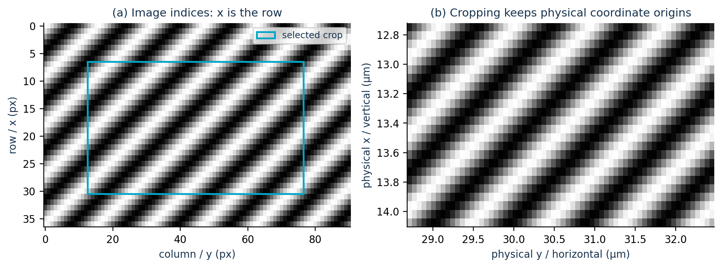
Figure 6. (a) Image indices and selected rectangle; (b) the same rectangle after extraction, displayed with its original physical coordinates.
Figure 6(a) — The selected rows and columns
On the left, the bands simply make the cut easy to see; this is not a particle model. bounds_px = (7, 31, 13, 77) means that the program takes rows 7 to 30 and columns 13 to 76. As in a Python slice, the final value is excluded. The crop therefore contains 24 × 64 pixels.
Figure 6(b) — The coordinates used by HoloPy
On the right, the first pixel keeps x=12.721296295 µm and y=28.682407405 µm. The program does not move this pixel to (0, 0). Intensities, pixel spacing and optical settings remain those of the original image.
Rule to keep | Convention
Axes | x = vertical row; y = horizontal column; display a centre with plot(y, x).
bounds_px | (row_start, row_stop, column_start, column_stop), with the stop indices excluded.
Initial physical centre | Read it from the full image's coordinates at the selected point, not from the middle of a possibly shifted crop.
Fitting data | Keep the values, type, dimensions, coordinates and optical information. All trials for one particle use the same rectangle.
Lateral bounds | Intersect the observed coordinates with initial centre ± xy_fit_margin_um; do not enlarge the crop to reach this margin.

The rectangle may look correct on screen while the fit is wrong if the code resets coordinates to zero or forgets that a centre came from a manual click. After a change, inspect the returned HoloPy/xarray object as well as the drawn rectangle.

3 Searching for guesses
The crop is now ready. This part explains how the program prepares n/r/z starts, compares them quickly and chooses which ones will launch the full fits. It also explains how good starts found earlier can be reused for the next particles.

Create the lists of n/r/z values to try
search_axes() first spreads values between the bounds, then adds the user's hints. The image does not determine the spacing. These rules are written in the code.
Code 10 — Build the radius, refractive-index and depth values. hologram_analysis/initialization.py.
radii = _axis_values(cfg.r_bounds,
np.geomspace(rlow + rinset, rhigh - rinset, 8),
cfg.r_guesses)
contrasts = tuple(cfg.medium_index + sign * delta
for delta in (.002, .01, .05) for sign in (-1, 1))
indices = _axis_values(cfg.n_bounds,
(*np.linspace(nlow + ninset, nhigh - ninset, 5),
*contrasts), (cfg.n_guess,))
depths = _axis_values(cfg.z_bounds,
np.linspace(zlow + zinset, zhigh - zinset, 12),
z_values)

For radius, the program creates eight values with roughly equal ratios between neighbours, rather than equal differences in micrometres. This covers a wide size range with few points. For refractive index, it combines five evenly spaced values with medium_index ±0.002, ±0.010 and ±0.050, then adds n_guess. For z, it creates twelve evenly spaced values and adds z_values. It uses only the sides of focus allowed by z_bounds.
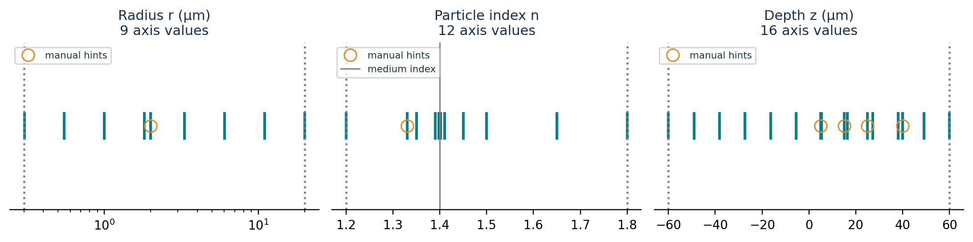
Figure 7. Values actually produced by search_axes() in this example: 9 radii, 12 refractive indices and 16 depths. Orange circles mark the hints added by the user.
How to read the three panels in Figure 7
On the left, the radius axis is logarithmic. The orange point is r_guess = 2 µm and the bounds are 0.3 and 20 µm. Equal distances on this axis represent similar size ratios.
In the middle, the grey line is the medium index, here 1.4. The orange point is n_guess = 1.33. The program adds more values near the medium index to examine small index differences more closely.
On the right, the orange points are the depth hints 5, 15, 25 and 40 µm. The bounds [−60, 60] µm were chosen only for this figure. They are not the notebook defaults. The height of the markers has no meaning. Only their horizontal position matters.
Automatically created values sit just inside the bounds, at a distance of 10⁻⁴ of the interval width. _axis_values() then removes invalid, out-of-bounds or repeated values and sorts the list.
The figure gives 9 × 12 × 16 = 1,728 combinations. A hint simply adds an interesting value to test. It does not change the bounds or lock the fit to that value. The program keeps at most four hints per axis so that the total number of combinations does not grow too quickly.

Use the hints and compare the starts
Manual or Automatic mode
In Manual mode, the program tries every combination of r_guesses and z_values with the single n_guess. In Automatic mode, these values are added to the general grid. In both modes, hints must stay inside the bounds. If a bound is narrowed, an old saved hint may therefore need to be changed.
staged_grid() begins by creating every possible combination of r, n and z. If there are at least 100 combinations, adaptive_fit_budget is enabled and the mode is not Thorough, it splits the list into two groups. The first group is spread across the whole search range. The second is kept in reserve.
Code 11 — Split the grid between the first stage and the remaining group. hologram_analysis/initialization.py.
for ir, radius in enumerate(radii):
for ni, index in enumerate(indices):
for zi, depth in enumerate(depths):
hinted = (index == cfg.n_guess and radius in hint_radii
and depth in hint_depths)
target = first if (ir + ni + zi) % 2 == 0 or hinted else remaining
target.append((radius, index, depth))
return first, remaining

The odd/even index check splits the combinations between the groups. Combinations that directly contain one of r_guesses, one of z_values and n_guess always enter the first group. Together, both groups cover the full grid shown in Figure 7. If the grid is small, the mode is Thorough or adaptation is disabled, the program tries the whole grid straight away.
After the first quick tests, _escalation_reason() checks whether there is enough evidence to skip the second group. Every condition in the table must be met.
What must be checked | Rule before skipping the second group
Good agreement on the tested pixels | Best error ≤ 0.30 times the error of a constant image.
Result away from the bounds | Best candidate at least 1% of each bound width from either end.
No other solution that is almost as good | No candidate at separation ≥1 with a score below best + 0.02 × reference error.
Same region found from several starts | At least three normally converged short fits, close in score and parameters, from original starts separated by at least 1.
Enough starts and no errors | Enough different starts for initial_search_trials and no errors during the quick calculations.

If even one condition fails, the program also tries the second group. It keeps the results already calculated. This decision only reduces the amount of calculation. It does not prove that the final fit is physically correct.
Use fewer pixels for the first calculations
sampled_detector() reduces the cost of the first calculations without resizing the image. It selects real rows and columns, then keeps the pixels at their intersections. Every n/r/z combination is compared on the same pixels.
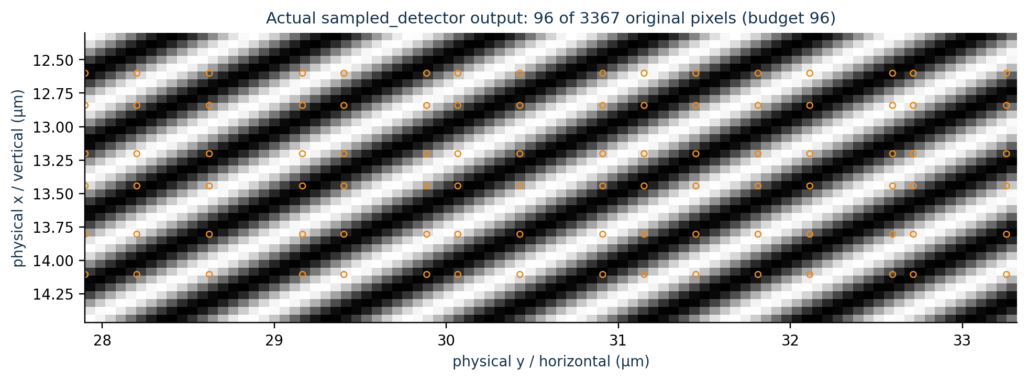
Figure 8. The 96 orange markers are the pixels actually selected: 6 rows × 16 columns from a 37 × 91 detector. The striped background only makes their positions easier to see.
How to read Figure 8
The full image contains 3,367 pixels. The program does not draw 96 pixels separately. It chooses 6 rows and 16 columns, then keeps their 6 × 16 = 96 intersections. To spread these rows and columns across the image, each axis is divided into several regions and one position is chosen in each region. The random seed is fixed at 0, so the program selects the same pixels again for the same data.
The background is a simple demonstration image calculated with 1 + 0.1 cos(0.7 row + 0.4 col). It is not a MieLens hologram. Its only role is to make the orange pixels easy to see.
Code 12 — Select rows and columns from the original detector. hologram_analysis/initialization.py.
rng = np.random.default_rng(0)

def positions(length, count):
edges = np.linspace(0, length, count + 1).astype(int)
return np.array([rng.integers(a, b)
for a, b in zip(edges[:-1], edges[1:])])

return h.isel(x=positions(height, nx), y=positions(width, ny))

If the crop contains no more than initial_search_max_pixels, it is kept in full. Otherwise the code chooses a number of rows and columns that fits the limit. In the excerpt above, the random seed is fixed and positions are chosen across each axis. The final statement extracts those positions directly with isel(). The pixels therefore keep their original intensities and coordinates.
The first score is the mean of (I − H)². The program does not adjust the contrast separately for each candidate. Resizing the image, making up values between real pixels or resetting the coordinates to zero would change the comparison between simulations. The 96 pixels in this figure only explain how the selection works. This number is not a recommendation for experimental data.

Run a few short fits and keep different starts
After the first simulations, exploratory_seed_pool() gathers several types of starts. It takes the best scores, some combinations near the limits and cases with deliberately different radii, contrast signs and sides of focus. This gives a start that looks poor at first a chance to improve during a short fit.
These short fits use NmpfitStrategy(maxiter=15). They change n, r and z on the small group of selected pixels. During this step, x and y stay fixed. The first stage can try up to 12 starts. If the search is expanded, it can try up to 16 in total. A search that uses the whole grid straight away can also try 16.
A short fit can reach its limit of 15 iterations before fully converging. Its last result can still be used as a start for the full fit if the values are valid and inside the bounds. However, this result cannot justify skipping the second half of the grid and can never be chosen directly as the final result.
distinct_starts() avoids spending all the available work on almost identical starts.
Code 13 — Rank candidates while keeping them separated. hologram_analysis/initialization.py.
def distinct_starts(scored, cfg):
"""Avoid spending every local fit on nearly identical coarse candidates."""
selected = []
for candidate in sorted(scored, key=lambda item: item['initial_score']):
if all(_candidate_separation(candidate, kept, cfg) >= 1.
for kept in selected):
selected.append(candidate)
if len(selected) >= cfg.initial_search_trials:
break
return selected

Candidates are ranked by initial_score. The code then keeps a candidate only if its distance from every start already kept is at least 1. This distance combines three parts:
Distance used to keep different starts. Explanatory example.
dr = log(r1 / r2) / log(1.5)
dz = (z1 - z2) / max(5, 0.1 * z_bound_width)
dn = asinh((n1 - medium_index) / 0.002) - asinh((n2 - medium_index) / 0.002)
distance = sqrt(dr**2 + dz**2 + dn**2)

A radius ratio of 1.5 is therefore enough to give a distance of 1. The asinh function only changes the scale used to compare refractive indices. It makes small differences near the medium index more visible and reduces the weight of large differences. This distance keeps the starts varied. It does not measure parameter uncertainty.
Why keep several starts?
Figure 9 shows an error map actually calculated with HoloPy. It helps explain why the best-scoring point on a simple grid is not always enough to launch the final fit.
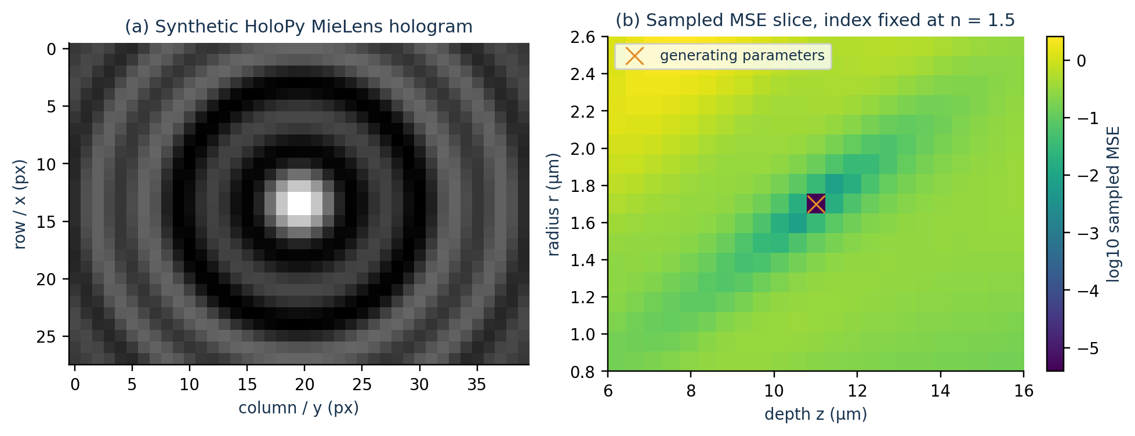
Figure 9. (a) synthetic MieLens hologram; (b) mean squared error on the selected pixels for different r and z values, with n fixed.
Figure 9(a) — The hologram used
The left panel was calculated with HoloPy 3.5.0 and MieLens. The image contains 28 × 40 pixels spaced by 0.24 µm. It was created with n=1.5, r=1.7 µm and z=11 µm, in a medium with index 1.33. Small Gaussian noise with standard deviation 0.002 was then added using a fixed random seed. This image only shows how the calculation behaves.
Figure 9(b) — The error map
The right panel contains 17 radii × 23 depths, giving 391 simulations. Each simulation is compared on the same 187 original pixels, selected with a requested limit of 192 pixels. The index stays fixed at 1.5. Only r and z change. The horizontal axis is z, the vertical axis is r and the colour shows log10(MSE). Dark colours mean smaller errors. A difference of 1 on the colour scale means the error is multiplied or divided by 10. The cross marks the values used to create the image: r=1.7 µm and z=11 µm.
The dark region runs diagonally. This means that a change in radius can be partly offset by a change in depth. Several combinations can therefore give similar errors. Depending on its start, the fit can reach different regions. This is why the program keeps several starts that are separated from one another.
This figure does not show the path followed by a fit or a result from an experimental image. It shows 391 calculations on a grid created for this demonstration in generate_figures.py. This grid differs from the one in Figure 7. Because n stays fixed, the figure does not prove that there is only one possible solution across all n/r/z values.

Run the full fits and choose the result
The final fits use every original pixel in the cyan rectangle. ExactModel calculates a Sphere with MieLens(arcsin(NA/noil)). During the fit, x, y, z, r and n can change, but they must stay inside their bounds. Before calculating the error, the program checks that the simulated image has exactly the same shape and coordinates as the data.
The saved chisq value is the mean squared difference between the image and the simulation, pixel by pixel. The program compares it with a simple reference obtained by replacing the image with its mean intensity. If E is the fit error and B is the reference error, then Q = 1 − E/B. For a trial to be selected, its values must be valid, meaning neither NaN nor infinite. The fit must also have converged and Q must be at least 0.10. Here, 'converged' means that MPFIT stopped with a status confirming a stable result under its own rules.
Code 14 — Apply the minimum selection conditions. hologram_analysis/fitting.py.
acceptable = (trial['converged'] is True
and quality['relative_improvement'] is not None
and quality['relative_improvement'] >= MIN_RELATIVE_IMPROVEMENT)

A trial with 0.10 ≤ Q < 0.50 can still be selected, but it receives the weak_fit warning. MPFIT statuses 1 to 4 and 6 to 8 indicate convergence. Statuses 6 to 8 also add a numerical-precision warning. A trial with status 5, or with unknown convergence, cannot win. The program reports parameters too close to a bound separately.
Code 15 — Keep the best acceptable trial. hologram_analysis/fitting.py.
if acceptable and (best_trial is None
or chisq < best_trial['chisq']):
best_result, best_trial = fit_result, trial

Among trials that pass these basic checks, the program keeps the one with the lowest error. A trial that has not converged or contains invalid values cannot win, even if its error looks low.
diagnostics.solution_ambiguity() then compares the other converged trials. Some may have an error within 5% of the winner while giving clearly different parameters. In that case, the program warns that several solutions give almost the same agreement. This warning does not change the selected result or launch extra calculations.
The program can stop the full fits early, but only when the results agree closely. At least three trials must have converged normally. They must have Q ≥0.70, no parameter close to a bound and errors within 5% of the best result. They must also agree within 0.2 µm for x/y, 0.001 for n, 2% for r and max(0.25 µm, 2% of |z|) for z. Every planned contrast sign and side of focus must have been tried. Thorough mode disables this early stopping.

Reuse good starts found earlier
For the same experiment, the program can save good n/r/z combinations found during broad searches. learned_candidates() creates new starts close to these saved values. It keeps only the allowed contrast signs and sides of focus. It then tests these starts on the current image using at most min(1600, initial_search_max_pixels) original pixels.
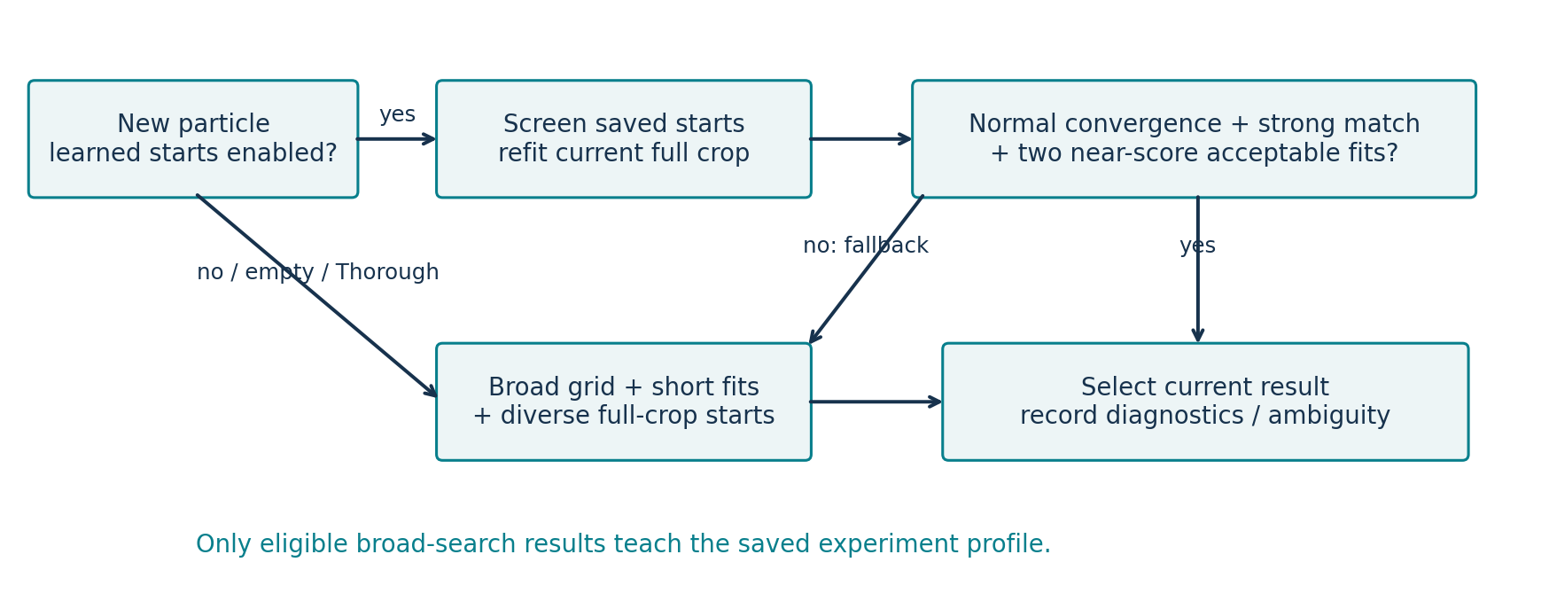
Figure 10. Automatic mode with saved starts: test them on the new particle, run full fits, check reliability, then run a broad search if the checks fail.
Read Figure 10 from left to right
The 'saved starts' block contains starts saved from previous particles in the same experiment. The program removes values outside the bounds or with a contrast sign or side of focus that is not allowed. It then compares the remaining starts with the new image. The best are used to launch new full fits. The parameters of the new particle remain free. The program does not simply copy an old result.
The decision box at the top right checks whether the result is reliable enough to skip the broad search. reusable_fit_is_reliable() requires an accepted result, normal MPFIT convergence, a valid error that is positive or zero, no parameter close to a bound and a high enough Q. Its threshold is max(0.70, min(0.90, median of saved Q values − 0.15)). It therefore stays between 0.70 and 0.90. If no earlier Q values are available, the threshold is 0.70.
Code 16 — Confirm saved starts using similar scores and matching physical parameters. hologram_analysis/learned_initialization.py; diagnostics.same_final_solution().
near = [t for t in trials if t.get('converged') is True
and t.get('optimizer_status') in (1, 2, 3, 4)
and not t.get('boundary_parameters') and t.get('fit_acceptable') is True
and t.get('chisq') is not None
and t['chisq'] <= selected['chisq']*1.05 + 1e-15]
if len(near) < 2:
return False, 'independent learned starts have not confirmed the current fit'
if any(not same_final_solution(selected, trial) for trial in near):
return False, 'learned starts found competing parameter solutions'
return True, ''

This check requires at least two accepted trials. They must have converged normally, stay away from the bounds and have an error no greater than 1.05 × selected error + 10⁻¹⁵. Every such near-best trial must also agree with the selected result in finite radius, refractive index and x/y/z position. The tolerances are the same as the general early-stopping comparison: 2% in radius, 0.001 in index, 0.2 µm in x/y and max(0.25 µm, 2% of |z|) in z. Similar errors with competing parameters trigger the broad search. The general early stop still requires three trials.
If all checks pass, the program can keep the result without launching the broad search. If they fail, Automatic mode runs the broad grid. The best accepted result from either stage can ultimately be selected. Only good results from the broad search can be added to the list of saved starts.
This diagram describes Automatic mode. It does not cover Manual mode or the exact cache, which can directly return an identical calculation that has already finished. Thorough mode forces a broad search. If this part of the program changes, check the saved starts and the cache of identical calculations separately.

Performance and reuse in this distribution
During exploratory forward simulations, optical_cache.with_mie_matrix_cache() retains Mie scattering matrices that do not depend on z. The numerical field calculation, calibration, tested parameter combinations and precision remain unchanged. Exact keys include the index ratio, size parameter and actual quadrature nodes. Each temporary theory is limited to 128 entries and 4 MiB; unsupported or custom theories keep their ordinary HoloPy implementation. Short exploratory fits and final full-crop fits retain ordinary MieLens.
The exact completed-fit cache retains up to 32 results within an estimated 128 MiB retention budget. Its keys cover detector intensities, coordinates, metadata, centre guesses and numerical settings. Returned results are independent copies. This helps repeated unchanged analyses and does not remove the first fit of a new particle.
The analysis worker can reuse detached, read-only image and crop preparations already checked in the preview. File path, modification time, size, detection settings, effective crop settings, centres and neighbour geometry determine whether reuse is allowed. Changed or missing inputs follow the ordinary per-image preparation path; worker diagnostics do not modify the preview.
Strong 16-sector crop estimates skip the coarser profiles that would not affect their result. Weak and unresolved cases retain the full pooling sequence. Local-neighbour support is not evaluated twice when centre refinement leaves the coordinates unchanged. Runtime gains depend on the image, search settings and how much calculation is reused; no whole-analysis speed factor is guaranteed.

Change the program and check the results
Choose where to make a change
Start by identifying the visible problem. If fringes are cut off too early, adaptive_crop_max_px may be too small, the measured radius may be too short or the margin may be too small. The radius measurement is in cropping._hysteresis_extent(). The rules that accept or reject a band are in _optimize_fringe_rectangle(). Temporarily disabling band reduction helps show which step causes the problem.
If the search misses an interesting n/r/z region, start by adding a few values based on experience. Adding many values to search_axes() quickly increases the amount of calculation, because each new value is combined with every value on the other two axes.
Example settings in Python
This example uses the same calculation limits as the interface's Balanced setting. It also enables automatic cropping and allows negative and positive z values. The bounds shown here are examples and must be adapted to the experiment.
Usage example written for this guide.
from dataclasses import replace
from hologram_analysis.config import AnalysisConfig

cfg = replace(
AnalysisConfig(),
adaptive_crop=True,
auto_initial_guess=True,
search_effort='balanced',
initial_search_trials=5,
initial_search_max_pixels=3600,
adaptive_fit_budget=True,
z_bounds=(-60., 60.),
z_values=(-20., 20.))
cfg = cfg.validate()

In the interface, Balanced sets five final starts, 3,600 search pixels and automatic adjustment of the amount of calculation. In a Python configuration, writing only search_effort='balanced' does not set these three values automatically. By default, the library uses Manual initialisation, Custom effort and automatic cropping disabled.
When adding a new setting, declare and validate it in AnalysisConfig. Update its label and help in the interface, then the saved profiles. The cache rules must recognise whether an old result can still be used. Keep the check_cancelled() cancellation points and the original coordinates. The preview and fit must use the same rectangle. Keep the confidence flag for click-based centring as well.
Check the changes
For a recipient check, open check installation/check_environment.ipynb from the supplied Erwan_code folder and use the same HoloPy kernel as analyse_hologrammes.ipynb. Then analyse one representative image with known acquisition settings and inspect the crop and experimental/fit comparison.
Maintainer checks for the supplied optimisations
The development project has a separate regression suite; it is not included in this recipient folder.
It checks optical predictions, crop geometry, cache bounds and invalidation.
It also checks competing learned solutions and the broad-search fallback.
A full HoloPy fit verifies that preview reuse preserves the fitted parameters.
Use the environment checker and one representative image for the recipient smoke test.
First run check installation/check_environment.ipynb with your HoloPy kernel, then open analyse_hologrammes.ipynb using the same kernel. For HoloPy setup, follow your laboratory or supervisor's instructions.

Automated checks do not replace scientific inspection. Compare versions on exactly the same images and with the same optical settings. Compare centres, crops and fit residuals. Also inspect failed trials, parameters near bounds, warnings about multiple solutions and the total number of calculations.
Where do the figures and code excerpts come from?
All ten figures were created specifically for this project using Python and Matplotlib. They were not taken from the internet or produced with an AI image generator. Figures 1 and 10 are diagrams drawn from the program's steps. Figures 2 to 5 use artificial ring patterns and noise, then run the project's actual detection, centring and cropping functions. Figures 6 and 8 use simple stripes to show how the actual code extracts or selects pixels. Figure 7 plots the lists actually returned by search_axes(). Figure 9 uses physical simulations calculated with HoloPy 3.5.0 and MieLens.
Maintainers retain generate_figures.py and the associated figure sources in the development project. They can recreate the PNG and SVG images. The PNG files are saved at 220 dpi. Fixed random seeds make the noise and pixel selection repeatable. figure_provenance.json records the settings, software versions and source fingerprints used for the illustrations.
The editable narrative and Word-building scripts are maintainer assets and are not required to run the recipient folder. File-based code references above refer to the supplied hologram_analysis package; line numbers are intentionally omitted because they change between revisions. Review explanations and affected figures when changing the algorithms.

