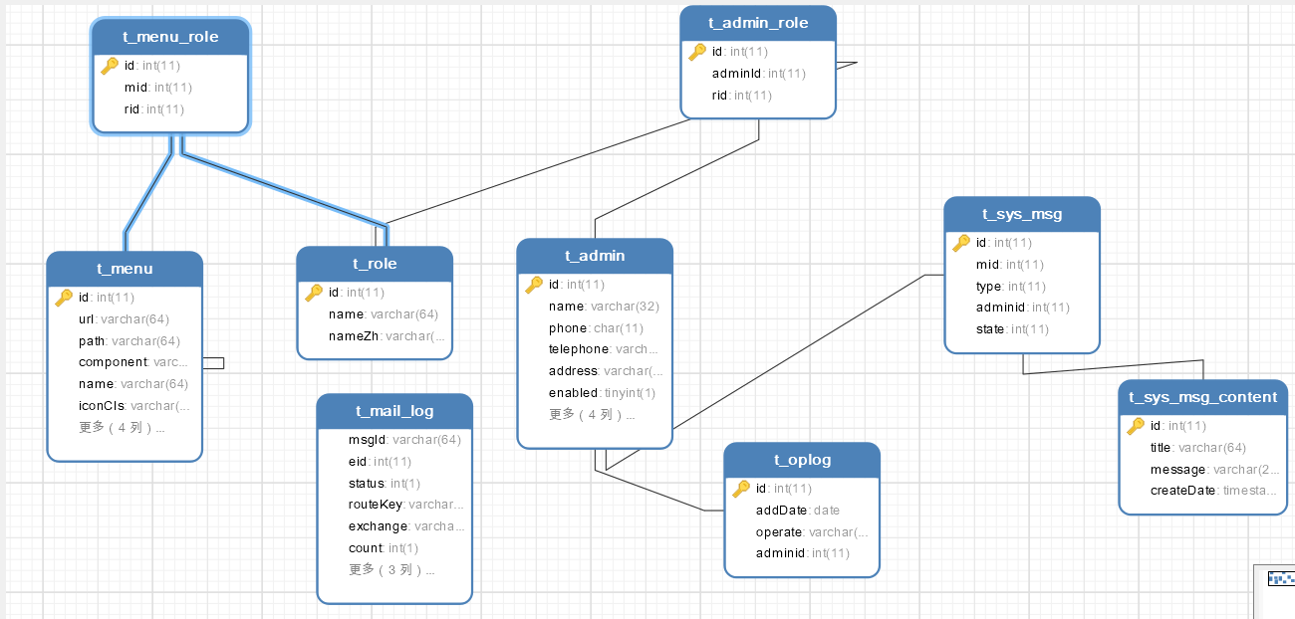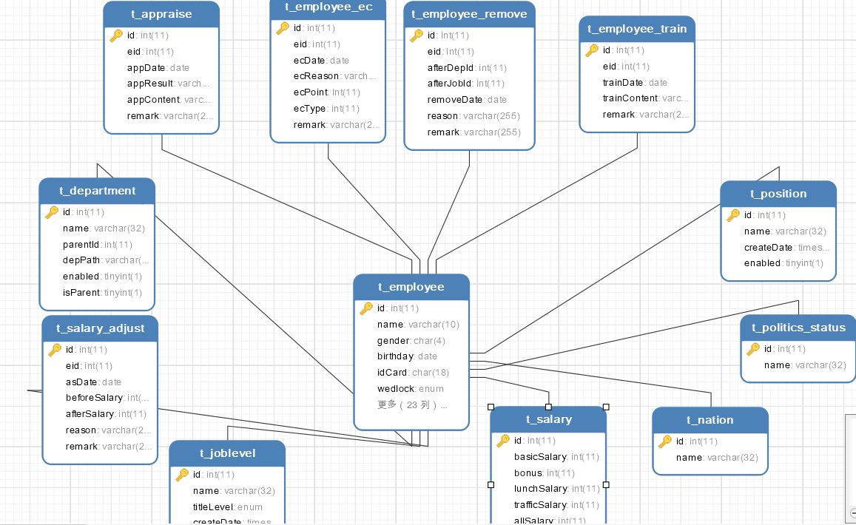

单表结构

t_admin表

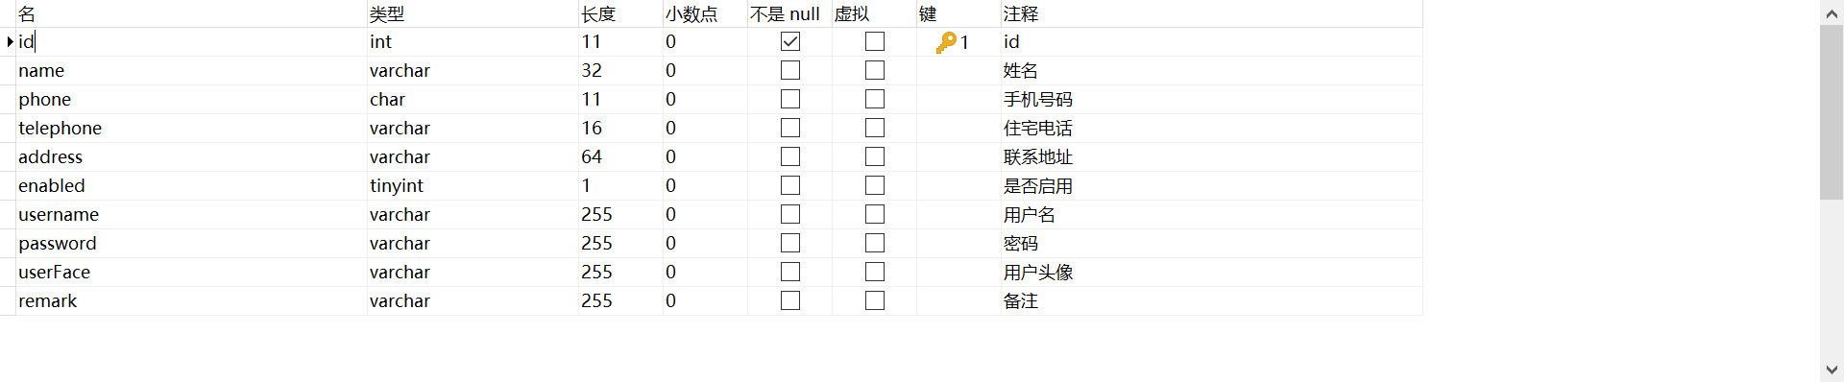

t_menu_role

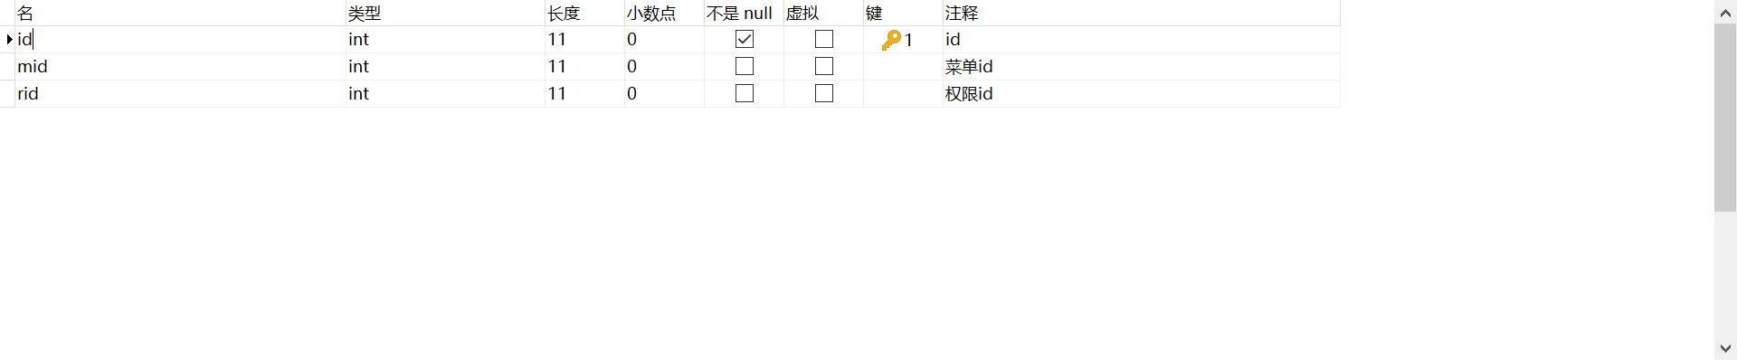

t_menu

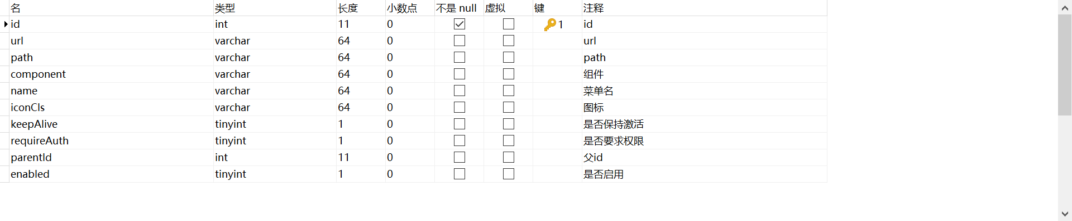

T_role

t_main_log

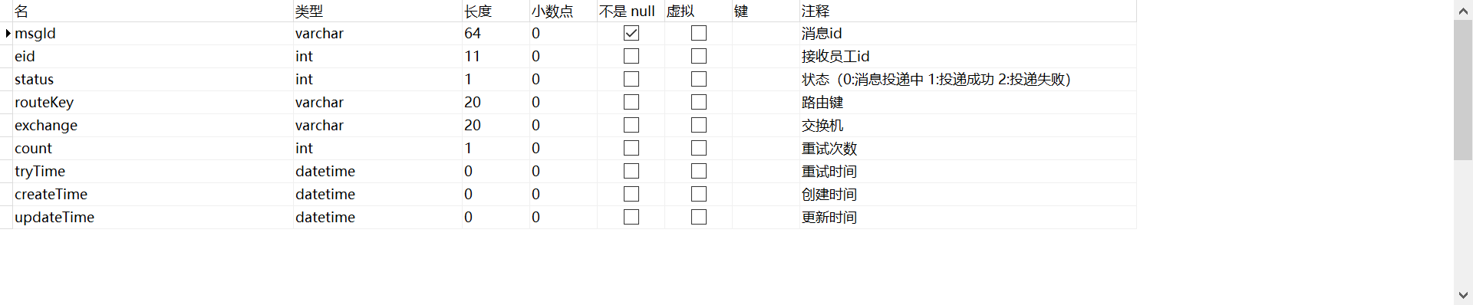

t_admin_role

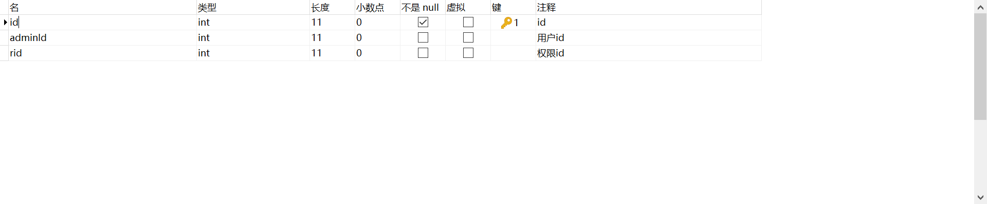

t_sys_msg

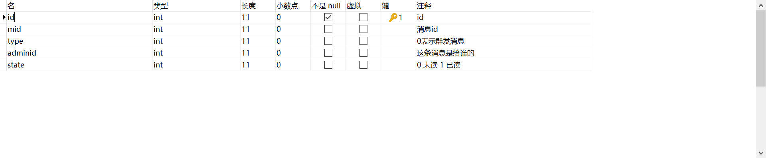

t_sys_msg_content

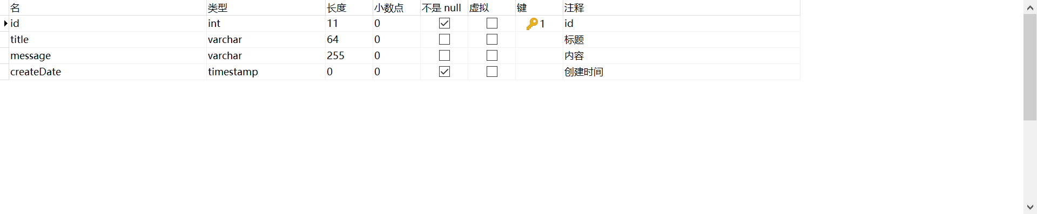

t_employee

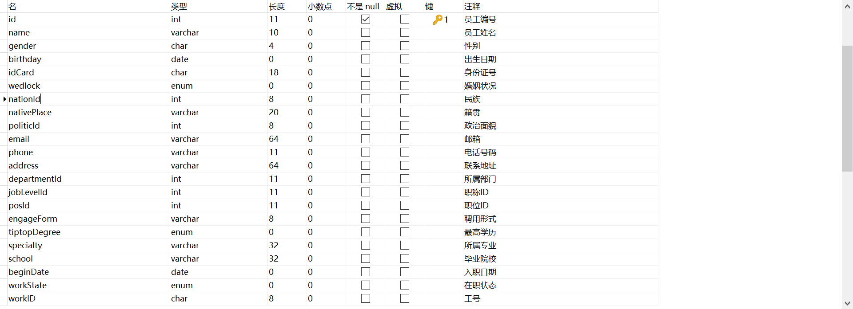

t_appraise

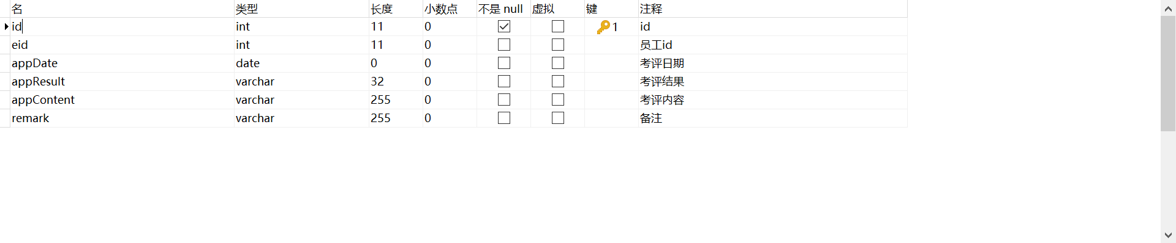

t_employee_ec

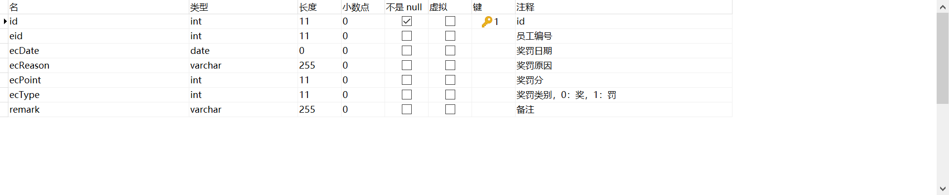

t_employee_remove

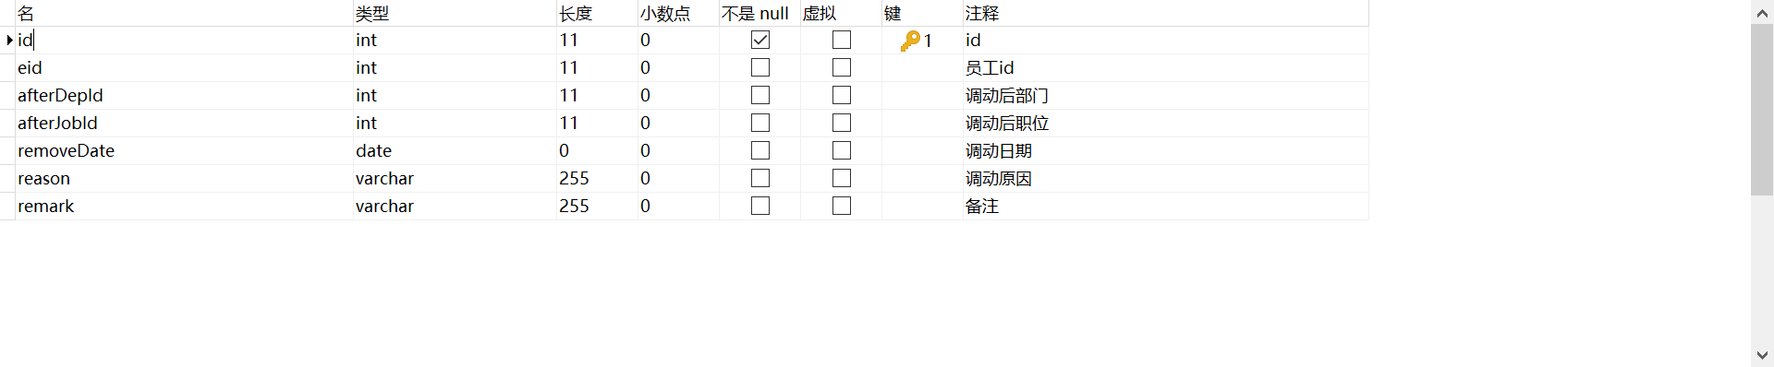

t_employee_train

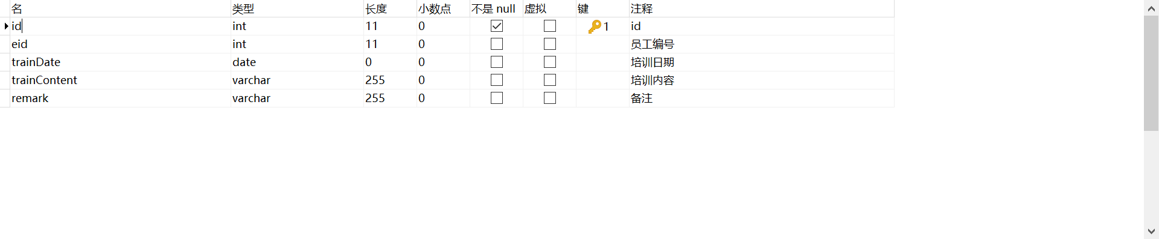

t_position

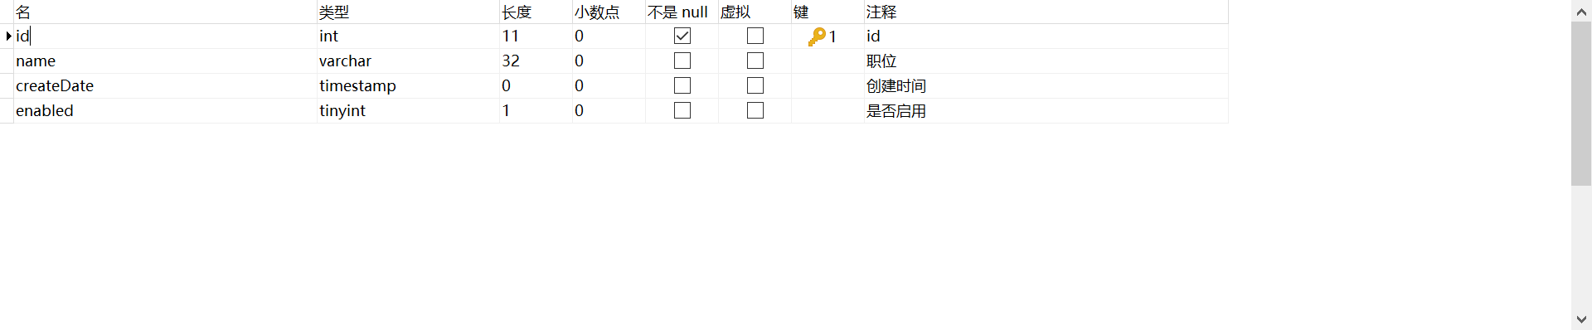 t_politics_status

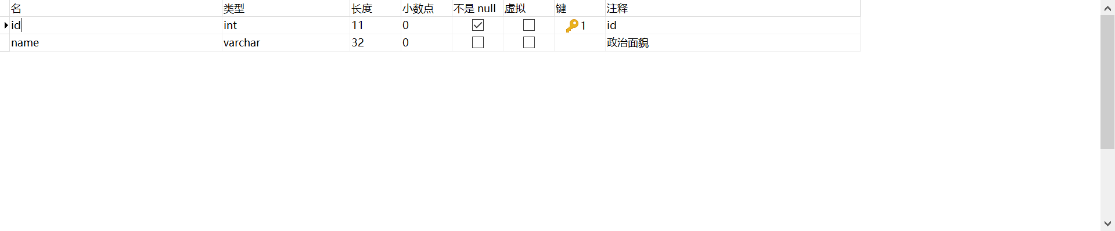

t_nation



t_salary

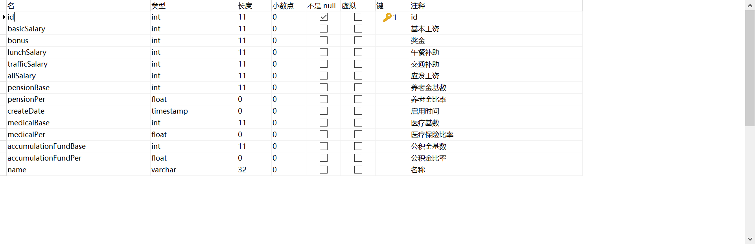t_joblevel

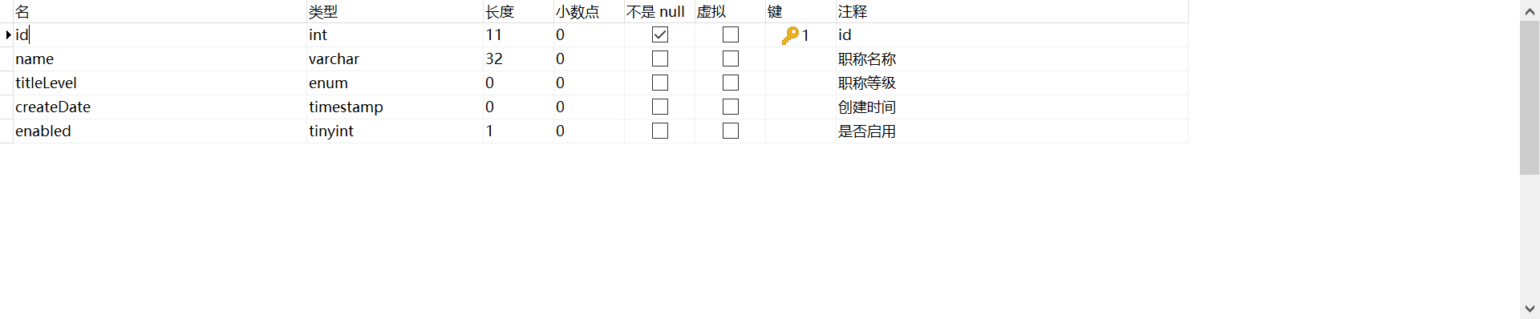

t_salary_adjust

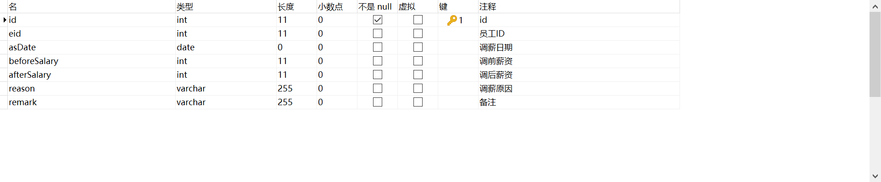

t_department

