ACADEMIC YEAR | 2026-2027
NAME OF INTERN | MARTIN, JEFFERSON D.
NAME OF COMPANY | FLIGHT CHARLIE
DEPARTMENT | B.S CRIMINOLOGY
DATE | SEPTEMBER 16,17 2026 | NUMBER OF HOURS | - HOURS
OBJECTIVES (Identify objectives for the week)
- Assisst with student dismissal and dismissal security protocols at Leisure Coast Resort for UDD Basic Education students to ensure safe handover to parents/guardians.
- Enforce gate access control and ID verification policies at Building E to prevent unauthorized entry and maintain campus safety.
- Develop professional communication skills and learn effective crowd management strategies when handling student dismissal rushes and entrance monitoring.

REFLECTION FROM THE OBJECTIVES
- Ensuring Student Safety During Dismissal: Assisting basic education students at Leisure Coast Resort showed me that security work goes beyond watching doors—it is directly about child safety. Managing the pickup system made me realize how important it is to strictly verify parents and guardians before letting young students leave.
- Maintaining Consistency in Access Control: Returning to Building E guard duty on Thursday reinforced the value of doing daily routines with high attention to detail. I applied what I learned previously to check IDs faster and manage logbook entries smoothly.
- Improving Communication and Efficiency: Communicating clearly with parents, students, and campus visitors over both days helped me build confidence. I learned how to handle crowded pickup areas and busy gate lines calmly without causing confusion.
- Connecting Classroom Concepts to Real Duty: These tasks helped me see the bigger picture of physical security and risk prevention. Applying basic criminology rules during both student dismissal and building access control showed me how discipline prevents safety risks before they happen.

ACCOMPLISHMENT FOR THE WEEK (actual tasks accomplished)
Wednesday, Sep 16 (Student Dismissal & Pickup Security at Leisure Coast Resort - UDD Basic Education): Assisted basic education students during dismissal, managed traffic and crowd flow at the pickup area, and guided students safely to their parents or authorized fetching persons (sundo) to ensure no child left unaccompanied.
Thursday, Sep 17 (Building E Security Facilitator): Maintained security post at the main entrance of Building E, checked student IDs, recorded guest details in the official logbook, assisted with corridor monitoring, and enforced building entry rules.

REALIZATION ABOUT THE TASK/S

Working during the basic education dismissal at Leisure Coast Resort made me realize that security officers carry a heavy responsibility when it comes to student safety. Nowadays, allowing young students to leave campus grounds unassisted poses serious safety risks. Ensuring that every child is safely handed over to their verified parents or guardians requires patience, high vigilance, and strict enforcement of pickup rules. This experience taught me that security is not just about keeping unwanted people out, but also about actively protecting vulnerable students until they are safely in the care of their families.
Transitioning back to Building E duty on Thursday highlighted the importance of adaptability and operational consistency in criminological work. Whether managing a high-energy dismissal area at the resort or maintaining strict gate checks at a university building, doing routine safety procedures correctly every time is essential. Handling both roles helped me improve my communication skills, stay calm under pressure, and work better with fellow interns. Ultimately, these tasks proved that systematic security controls directly protect the community and keep educational operations running smoothly.

PREPARED BY:

________________________________________
Signature over Printed Name of the Student Intern

PHOTO DOCUMENTATION
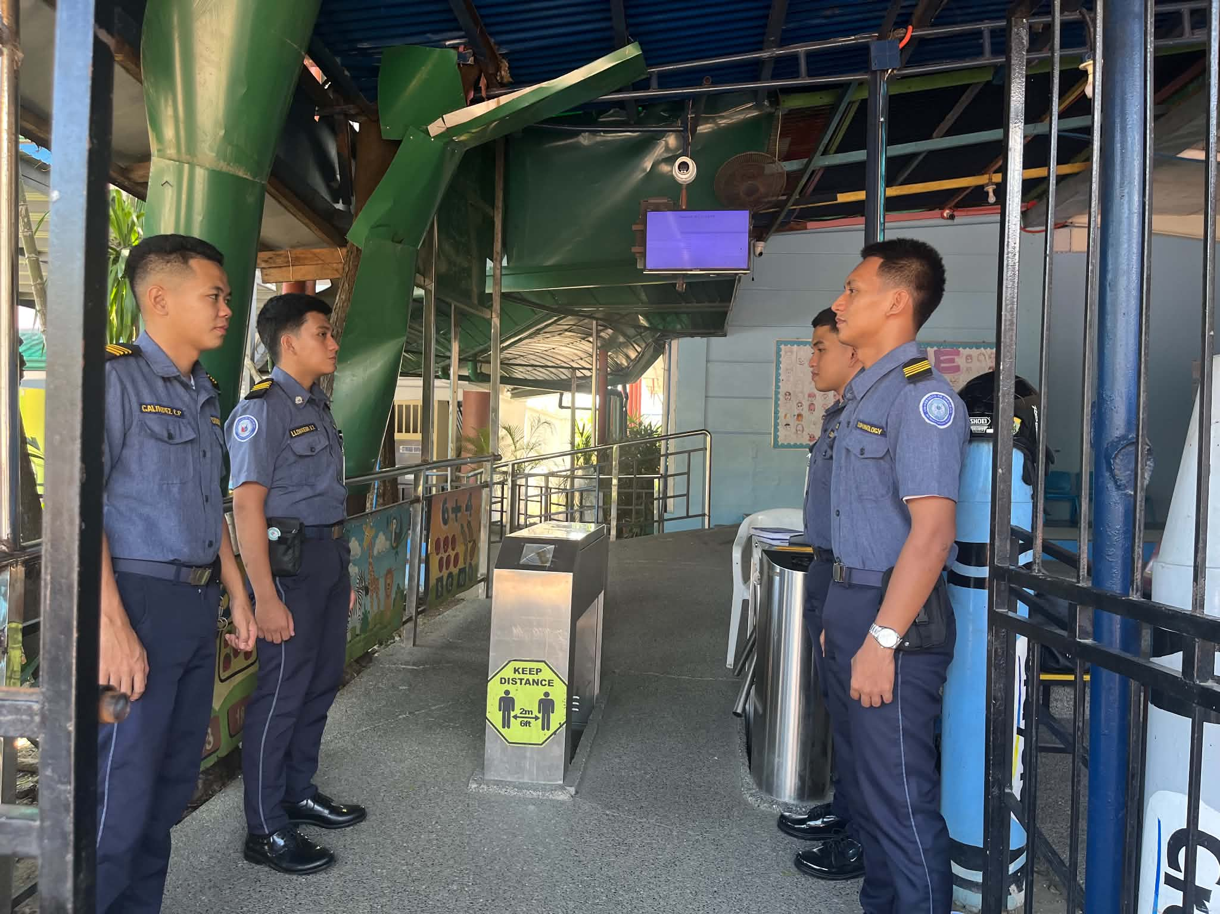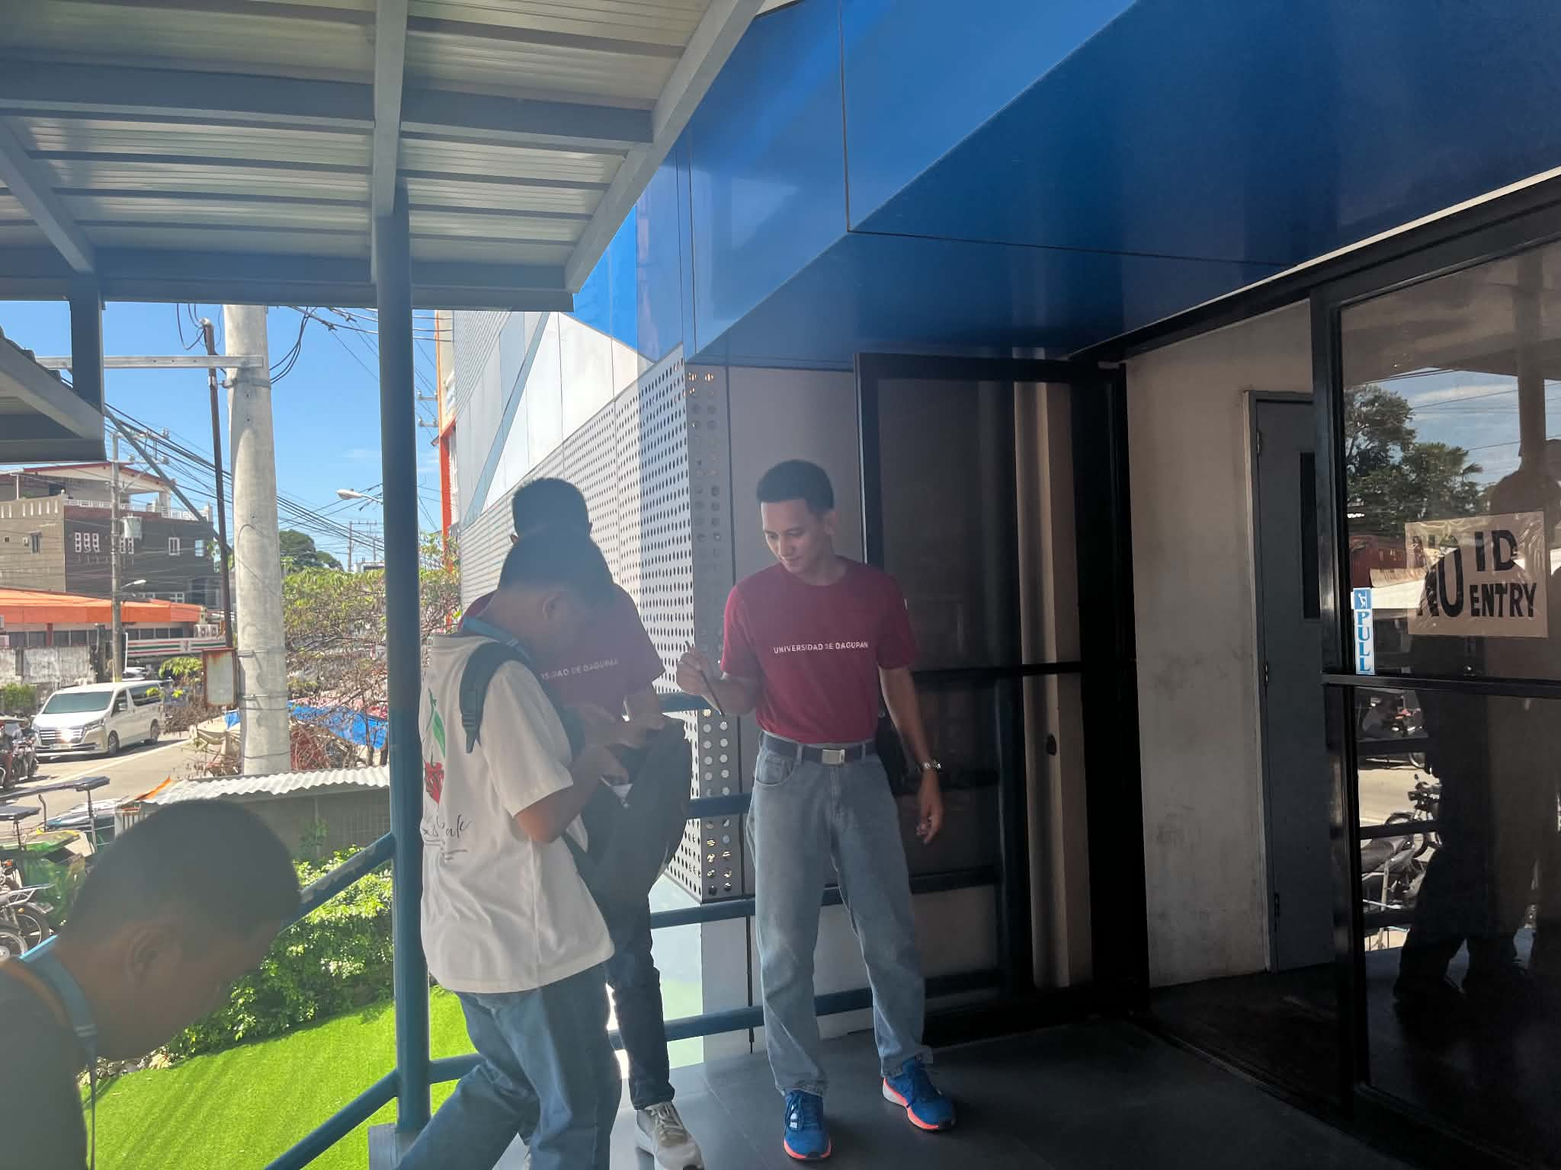

PHOTO DOCUMENTATION

