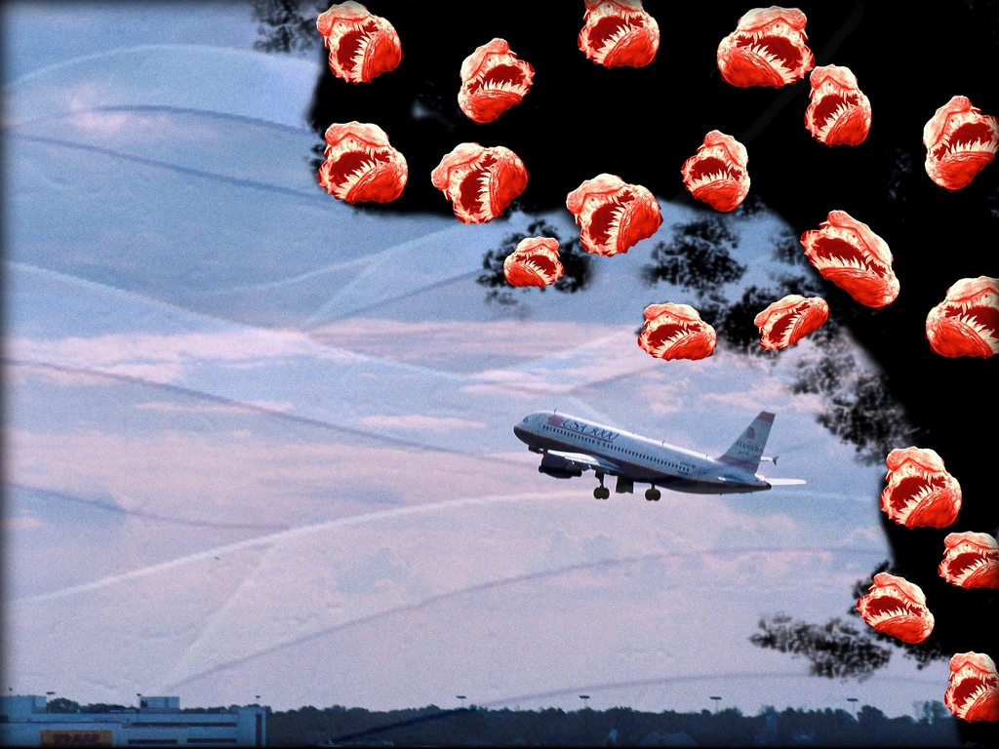



Escape!

Travel by foot , bus & plane tot escape langoliers

Sidescroller upgrade your travelspeed

Stay in front and evade all eating monsters