Student Engagement Analysis: Assessment Participation and Chronic Absenteeism
  - Multi-Year Trends for Data Quality and Accountability

What is the current state of assessment participation and chronic absenteeism across California districts?
This analysis examines student engagement patterns across 892 California districts serving 2,700,158 students during the 2018-2023 period. Current statewide performance shows median district participation rates of 97.52% (ELA) and 98.16% (Math), while chronic absenteeism has reached median levels of 17.94%.
Assessment participation directly impacts the validity of accountability determinations and federal compliance status. The statewide landscape shows considerable variation, with district participation rates ranging from 83.71% (Klamath-Trinity Joint Unified) to 100% (Alexander Valley Union Elementary), demonstrating a 16.29 percentage point range across districts.
Notably, 11.66% of districts fall below the federal 95% participation threshold, and 41.03% exceed the 20% chronic absenteeism benchmark. Current data shows district absenteeism rates ranging from 0% (Gratton Elementary) to 67.8% (Twin Ridges Elementary), representing a 67.8 percentage point range across the state.

How have participation and absenteeism patterns changed over time?

Multi-Year Participation Trends
District Assessment Participation Trends by Subject and Year
Year | ELA Median % | Math Median % | ELA % Below 95% | Math % Below 95%
2018 | 98.06 | 98.34 | 8.96 | 8.50
2020 | 46.40 | 45.33 | 83.29 | 83.29
2021 | 97.19 | 97.44 | 20.71 | 21.38
2022 | 97.80 | 98.10 | 10.20 | 10.43
2023 | 97.52 | 98.16 | 11.66 | 9.87
The trend data reveals that participation rates experienced their most significant disruption in 2020, with median participation dropping to unprecedented levels before beginning recovery in subsequent years. The federal compliance picture shows 11.66% of districts currently failing to meet the 95% threshold in ELA, compared to 8.96% in 2018.

Multi-Year Absenteeism Trends
District Chronic Absenteeism Trends by Subject and Year
Year | ELA Median % | Math Median % | ELA % Above 20% | Math % Above 20%
2018 | 9.93 | 9.93 | 7.14 | 7.14
2020 | 11.80 | 11.80 | 24.48 | 24.36
2021 | 28.02 | 28.02 | 71.60 | 71.60
2022 | 23.32 | 23.32 | 62.44 | 62.44
2023 | 17.94 | 17.94 | 41.03 | 41.03
Chronic absenteeism patterns show dramatic increases during the 2020-2021 period, with median district rates reaching peak levels before beginning to moderate in recent years. The proportion of districts exceeding the 20% threshold increased substantially during this period, with 41.03% currently above this benchmark compared to 7.14% in 2018.

Are engagement challenges concentrated in specific schools within districts or distributed system-wide?

School-Level Participation Drivers
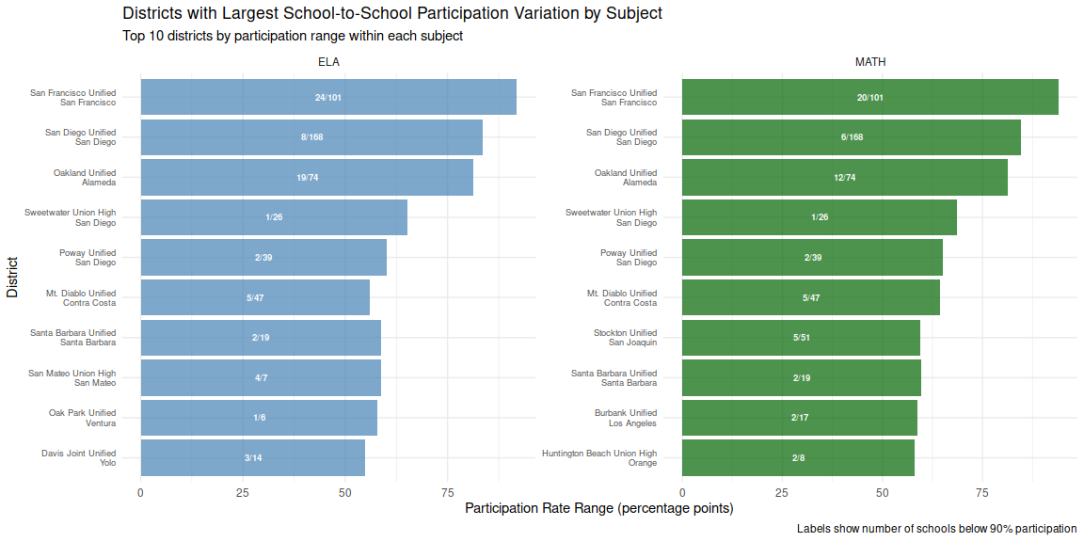
This analysis identifies districts where participation challenges are concentrated in specific schools rather than distributed system-wide. Among districts with at least 5 schools, 154 show ELA participation problems driven by one-third or fewer of their schools, while 148 show similar patterns in MATH, suggesting that targeted interventions at the school level could significantly improve district-wide compliance rates.

School-Level Absenteeism Drivers
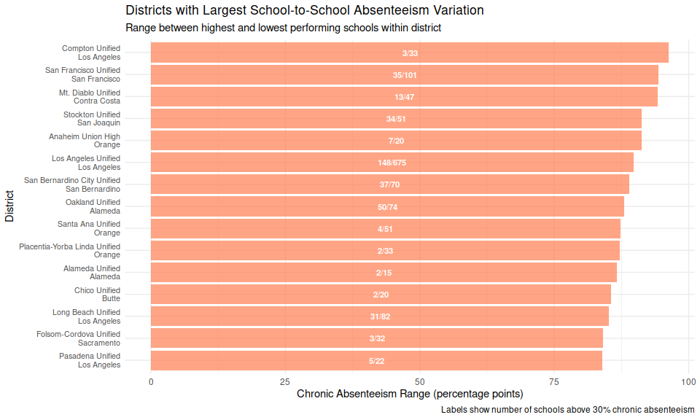
Similar to participation patterns, chronic absenteeism challenges are often concentrated within specific schools rather than being district-wide phenomena. Analysis reveals that 179 districts have absenteeism concerns driven by one-third or fewer of their schools, indicating that school-specific factors—such as leadership, climate, or targeted populations—may be primary drivers of attendance challenges.
A critical finding is that participation and absenteeism challenges are often concentrated in a small number of schools within districts—154 districts have ELA participation issues driven by one-third or fewer of their schools, 148 districts show similar patterns for MATH participation, while 179 districts show concentration patterns for chronic absenteeism. This concentration suggests that targeted school-level interventions may be more effective than district-wide approaches in many cases.

Which student groups show the largest engagement gaps compared to their district averages?
Disaggregated data analysis reveals substantial variation in engagement patterns across student groups, with some populations experiencing significantly lower participation rates and higher absenteeism than their district averages. The largest recorded participation gap shows Disability students in Madera County Superintendent of Schools participating at 42.22%, compared to a district average of 84.66%—a difference of 42.44 percentage points.
For chronic absenteeism, the most substantial gap appears among Black students in San Francisco Unified, with an absenteeism rate of 54.34% compared to the district average of 23.04%—representing a 31.3 percentage point difference.
Across all districts and student groups, 27 instances show participation gaps of 15 percentage points or more, while 96 instances demonstrate similar magnitude gaps in chronic absenteeism. These patterns suggest that engagement challenges disproportionately affect specific student populations, with implications for both educational equity and data quality in accountability systems.

What are the implications for data quality and intervention strategies?
The concentration of engagement challenges within specific schools and student groups has important implications for data interpretation and intervention planning. When participation or absenteeism problems are driven by a small number of schools within a district, district-wide averages may mask the severity of issues at particular sites while simultaneously understating the performance of schools that are functioning effectively.
The school-level concentration patterns identified in this analysis suggest that 481 district-metric combinations could benefit from targeted, school-specific interventions rather than broad district-wide approaches. This finding is particularly relevant for states developing technical assistance and support strategies, as resources may be more effectively deployed when focused on the specific schools driving district-level challenges.
Student group disparities further compound these data quality concerns, as substantial gaps in participation and attendance may result in certain populations being under-represented in accountability measures. The 123 instances of large engagement gaps identified in this analysis represent student groups whose academic performance may not be accurately reflected in state accountability systems due to low assessment participation or chronic absence patterns.
This analysis encompasses data from 2018 through 2023 across 892 districts meeting minimum enrollment criteria. District-level calculations exclude County Offices of Education and require minimum enrollment of 30 students for statistical reliability.

