Chronic Absenteeism Analysis
  - Multi-Level Trends and Patterns

Current State Overview
Analysis of 11,695,581 students across 930 districts and 8643 schools for the 2018-2023 period shows a statewide chronic absenteeism rate of 34.5% for 2023.
District rates range from 27.47% (SBE - Watsonville Prep) to 43.7% (Mountain Valley Unified), with a median of 34.47%. 930 districts (100%) exceed the 20% threshold, while 913 districts (98.2%) exceed 30%.
School-level rates range from 23.56% to 49.68%, with 8643 schools (100%) above 20% and 7941 schools (91.9%) above 30%.

State-Level Trends by Student Group
State-Level Chronic Absenteeism Rates by Student Group (%)
 | Subgroup | Y2018 | Y2020 | Y2021 | Y2022 | Y2023
1 | ALL | 26.93 | 29.03 | 42.08 | 37.26 | 34.50
2 | HISPANIC | 39.00 | 41.01 | 54.02 | 48.97 | 46.06
6 | ELL | 42.64 | 44.64 | 57.63 | 52.72 | 49.80
7 | DISADVANTAGE | 37.36 | 39.45 | 52.51 | 47.60 | 44.76
8 | DISABILITY | 44.54 | 46.63 | 59.63 | 54.83 | 52.01
The table shows state-level chronic absenteeism rates for ALL students and the four highest-rate subgroups across the most recent 5 years. DISABILITY students show the highest current rate at 52.01%, while ALL students show a rate of 34.50%. The range between the highest and lowest subgroup rates in 2023 is 17.51 percentage points.

Year-to-Year Changes
Year-to-Year Point Changes in Chronic Absenteeism (percentage points)
 | Subgroup | 2018-2020 | 2020-2021 | 2021-2022 | 2022-2023
4 | DISABILITY | 2.09 | 13.00 | -4.80 | -2.82
5 | DISADVANTAGE | 2.09 | 13.06 | -4.91 | -2.84
6 | ELL | 2.00 | 12.99 | -4.91 | -2.92
8 | HISPANIC | 2.01 | 13.01 | -5.05 | -2.91
The table presents year-to-year point changes in chronic absenteeism for the four highest-rate subgroups across the most recent year-to-year transitions. The largest single-year increase was 13.06 percentage points for DISADVANTAGE students from 2020 to 2021. The largest single-year decrease was 5.05 percentage points for HISPANIC students from 2021 to 2022.

Pre-Pandemic Comparison
Pre-Pandemic to Current Comparison (2018 vs 2023)
 | Subgroup | 2018 Rate (%) | 2023 Rate (%) | Point Change | Percent Change (%)
3 | BLACK | 34.19 | 41.39 | 7.20 | 21.06
4 | DISABILITY | 44.54 | 52.01 | 7.47 | 16.77
5 | DISADVANTAGE | 37.36 | 44.76 | 7.40 | 19.81
6 | ELL | 42.64 | 49.80 | 7.16 | 16.79
8 | HISPANIC | 39.00 | 46.06 | 7.06 | 18.10
The pre-pandemic comparison shows changes from 2018 to 2023 for the five highest-rate subgroups. All subgroups show increases from pre-pandemic levels, with the largest point increase of 7.47 percentage points for DISABILITY students. The smallest increase was 7.06 percentage points for HISPANIC students. In relative terms, the largest percent increase was 21.06% for BLACK students.

District-Level Patterns
Extreme District Chronic Absenteeism Rates - 2023
Category | District | County | Rate (%) | Students
Highest | Mountain Valley Unified | Trinity | 43.70 | 238
Highest | McCabe Union Elementary | Imperial | 42.79 | 222
Lowest | SBE - Watsonville Prep | Santa Cruz | 27.47 | 233
Lowest | Pollock Pines Elementary | El Dorado | 28.08 | 381
The table identifies the two highest and two lowest performing districts by chronic absenteeism rate for 2023. The highest rate of 43.70% occurs in Mountain Valley Unified in Trinity County, serving 238 students. The lowest rate of 27.47% occurs in SBE - Watsonville Prep in Santa Cruz County, serving 233 students. The difference between the highest and lowest performing districts represents a 16.23 percentage point range.

Demographic Composition Analysis
School Chronic Absenteeism by Demographic Terciles - 2023
Hispanic % | Disadvantaged % | Absenteeism (%) | Avg Enrollment
High | High | 35.82 | 241
Medium | High | 35.07 | 253
High | Medium | 34.96 | 246
Low | High | 34.59 | 234
Medium | Medium | 34.45 | 266
Schools with High Disability x High Disadvantaged show the highest chronic absenteeism at 35.87 %, while Low ELL x Low Disadvantaged show the lowest at 33.21 %, representing a 2.66 percentage point difference.

School-Level Pandemic Recovery
Pre-Pandemic Recovery Example: Oak Meadow Elementary - Buckeye Union Elementary
Subgroup | 2018 Rate (%) | 2023 Rate (%) | Point Change | Percent Change (%)
DISABILITY | 51.35 | 52.17 | 0.82 | 1.60
ELL | 42.24 | 44.00 | 1.76 | 4.17
DISADVANTAGE | 31.19 | 39.85 | 8.66 | 27.77
HISPANIC | 36.59 | 39.42 | 2.83 | 7.73
BLACK | 30.77 | 39.29 | 8.52 | 27.69
The table shows pre-pandemic to current chronic absenteeism changes for Oak Meadow Elementary in Buckeye Union Elementary district, displaying the five highest-rate subgroups. The highest current rate of 52.17% occurs among DISABILITY students, representing a 0.82 percentage point change from 2018. The largest point increase was 8.66 percentage points for DISADVANTAGE students, while the smallest increase was 0.82 percentage points for DISABILITY students.

State-Level Trends Visualization
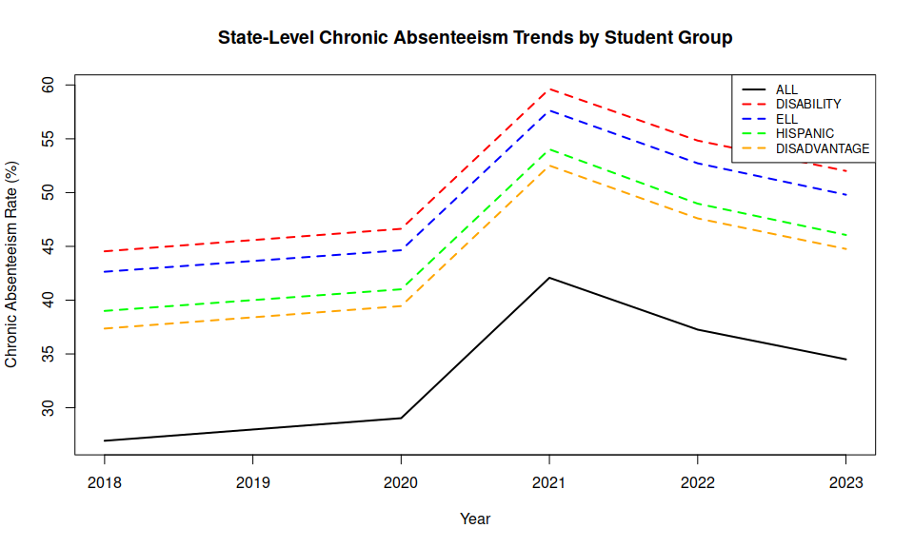

School Distribution Example
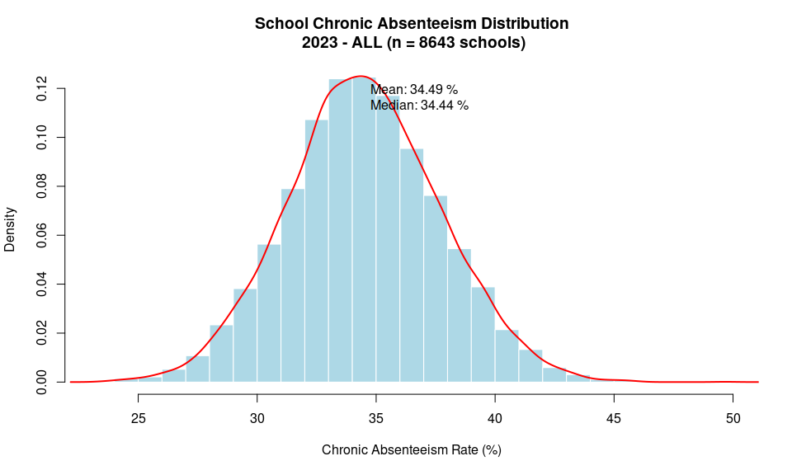

Summary
This analysis covers 5 years of chronic absenteeism data across 930 districts and 8643 schools. Current statewide rates of 34.5% represent a decrease from the previous year.
Compared to pre-pandemic levels, the ALL students group shows a 7.57 percentage point change from 2018 to 2023.
Analysis includes students from 2018 through 2023. Geographic calculations use student-level aggregations across county, district, and school levels.

