Saturday, 11 October 2025

**Stage 1 – Verify file name and type (Quick file check)**

The result shows that the file is a gzip-compressed disk image (disko-1.d.gz)

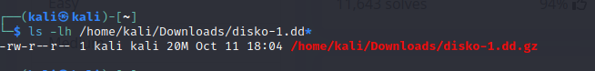

**Stage 2 – Fast search (no permanent decompression)**

Pipe the gzip content with strings and grep for the flag

(the flag is stored as plain text inside the image.)

The reason using zcat | strings | grep worked here, the image was gzip-compressed but the flag itself is plain text inside the image. So streaming the decompressed bytes through strings and grep is fastest and avoids mounting or extracting the whole image.

**The answer is:** picoCTF{1t5_ju5t_4_5tr1n9_c63b02ef}