Fengnan Wang fwang40

**My Code:**

**HW2.py**

#!/usr/bin/python

import os, struct

from array import array as pyarray

from numpy import append, array, int8, uint8, zeros

import numpy as np

from pylab import *

import random

import matplotlib.pyplot as plt

def load_mnist(dataset="training", digits=np.arange(10)):

if dataset == "training":

fname_img = os.path.join('/Users/ou/Dropbox/course/559 neural networks/HW/hw2/train-images-idx3-ubyte')

fname_lbl = os.path.join('/Users/ou/Dropbox/course/559 neural networks/HW/hw2/train-labels-idx1-ubyte')

elif dataset == "testing":

fname_img = os.path.join('/Users/ou/Dropbox/course/559 neural networks/HW/hw2/t10k-images-idx3-ubyte')

fname_lbl = os.path.join('/Users/ou/Dropbox/course/559 neural networks/HW/hw2/t10k-labels-idx1-ubyte')

else:

raise ValueError("dataset must be 'testing' or 'training'")

flbl = open(fname_lbl, 'rb')

magic_nr, size = struct.unpack(">II", flbl.read(8))

lbl = pyarray("b", flbl.read())

flbl.close()

fimg = open(fname_img, 'rb')

magic_nr, size, rows, cols = struct.unpack(">IIII", fimg.read(16))

img = pyarray("B", fimg.read())

fimg.close()

ind = [ k for k in range(size) if lbl[k] in digits ]

N = len(ind)

images = zeros((N, rows, cols), dtype=uint8)

labels = zeros((N, 1), dtype=int8)

for i in range(len(ind)):

images[i] = array(img[ ind[i]*rows*cols : (ind[i]+1)*rows*cols ]).reshape((rows, cols))

labels[i] = lbl[ind[i]]

return images, labels

#imshow(images.mean(axis=0), cmap=cm.gray)

#show()

#print images[1]

#images /= 255.0

def get_weights(m,n):

list_x=[0]*784

list_w=[[ 0 for i in range(10)] for j in range(784)]

for i in range(1,784):

for j in range(1,10):

list_w[i][j]=random.uniform(m,n)

return list_w

def get_x(image):

list_x=[]

for i in range(28):

for j in range(28):

list_x.append(image[i][j])

return list_x

###################### initalize all global variable ########################

vout=[]

x=[]

####################### all functions ###########################

def sample(condition):

images=[]

labels=[]

if condition=='training':

for n in range(10):

image,label =load_mnist('training',digits=[n])#the label n

images.append(image)

labels.append(label)

elif condition=='testing':

for n in range(10):

image,label =load_mnist('testing',digits=[n])#the label n

images.append(image)

labels.append(label)

else:

print'the condition is wrong'

return images,labels

def equals(i,j,w):

dout=[0]*10

x=get_x(images[i][j])

v = np.dot(x,w)

v = v.tolist()

max_index=v.index(max(v))

#desired_output

dout[i]=1

if max_index==i:

return 1,x,v,dout

else:

return 0,x,v,dout

# current_output

def current_output(vout):

cout=[]

for i in range(len(vout)):

cout.append(1 if vout[i] >= 0 else 0)

return cout

def pta(u,dout,cout,x,w):

for i in range(784):

for j in range(10):

w[i][j]=w[i][j]+u*(dout[j]-cout[j])*x[i]

return w

def train(w,u,n,minmum):

error_epoch=[]

epoch = 0

while True:

# step 1 count errors

error = 0

for j in range(n/10):

for i in range(10):

(m,x,v,d)=equals(i,j,w)

#print m

c=current_output(v)

if (m==0):

error = error + 1

elif (m==1):

error = error + 0

error_epoch.append(error)

print "@epoch", epoch, "# errors = ", error

# step 2 add epoch

epoch = epoch + 1

# step 3 update W

for j in range(n/10):

for i in range(10):

(m,x,v,d)=equals(i,j,w)

c=current_output(v)

w=pta(u,d,c,x,w)

# step 4 check if continue

# 0 should work

if (error_epoch[epoch-1])<= minmum*n:

break

return w

def test(w,u,n):

# step 1 count errors

error = 0

for j in range(n/10):

for i in range(10):

(m,x,v,d)=equals(i,j,w)

#print m

c=current_output(v)

if (m==0):

error = error + 1

elif (m==1):

error = error + 0

return error

print'##################### u=1 min=0 ################################'

print'############ Q(f) 50 d ##################'

images,labels=sample('training')

w=get_weights(-1,1)

w_f=train(w,1,50,0)

print'########### Q(f) 10000 e ################'

images,labels=sample('testing')

#IndexError: index 892 is out of bounds for axis 0 with size 892

error=test(w_f,1,8920)+test(w_f,1,1080)

print "# errors of 50 = ", error

print'########### Q(g) 1000 d #################'

images,labels=sample('training')

w=get_weights(-1,1)

w_g=train(w,1,1000,0)

print'########### Q(g) 10000 e ################'

images,labels=sample('testing')

#IndexError: index 892 is out of bounds for axis 0 with size 892

error=test(w_g,1,8920)+test(w_g,1,1080)

print "# errors of 1000 = ", error

print'########### Q(h) 60000 d ################'

images,labels=sample('training')

w=get_weights(-1,1)

#IndexError: index 5421 is out of bounds for axis 0 with size 5421

w_n=train(w,1,54210,0)

w_h=train(w_n,1,5790,0)

print'########### Q(h) 10000 e ################'

images,labels=sample('testing')

#IndexError: index 892 is out of bounds for axis 0 with size 892

error=test(w_h,1,8920)+test(w_h,1,1080)

print "# errors of 60000= ", error

print '########### Repeat the following two subitems three times ##########'

print'########### first time u=10 minimum=0.01 ################'

images,labels=sample('training')

w=get_weights(-1,1)

#IndexError: index 5421 is out of bounds for axis 0 with size 5421

w_n=train(w,10,54210,0.01)

w_h=train(w_n,10,5790,0.01)

images,labels=sample('testing')

#IndexError: index 892 is out of bounds for axis 0 with size 892

error=test(w_h,10,8920)+test(w_h,10,1080)

print "# errors of 60000= ", error

print'########### second time u=0.1 minimum=0.01 ################'

images,labels=sample('training')

w=get_weights(-1,1)

#IndexError: index 5421 is out of bounds for axis 0 with size 5421

w_n=train(w,0.1,54210,0.01)

w_h=train(w_n,0.1,5790,0.01)

images,labels=sample('testing')

#IndexError: index 892 is out of bounds for axis 0 with size 892

error=test(w_h,0.1,8920)+test(w_h,0.1,1080)

print "# errors of 60000= ", error

print'########### third time u=10 minimum=0.1 ################'

images,labels=sample('training')

w=get_weights(-1,1)

#IndexError: index 5421 is out of bounds for axis 0 with size 5421

w_n=train(w,10,54210,0.1)

w_h=train(w_n,10,5790,0.1)

images,labels=sample('testing')

#IndexError: index 892 is out of bounds for axis 0 with size 892

error=test(w_h,10,8920)+test(w_h,10,1080)

print "# errors of 60000= ", error

**Results:**

eryao:eryao ou$ ./hw2.py

**(f) Run Steps (d) and (e) for n=50, $η$ =1,**

##################### u=1 min=0 ################################

############ Q(f) 50 d ##################

@epoch 0 # errors = 41

@epoch 1 # errors = 6

@epoch 2 # errors = 3

@epoch 3 # errors = 0

########### Q(f) 10000 e ################

**# errors of 50 = 4298/10000= 42.98%**

the percentages of errors obtained through the training and test samples are different ( epoch=0 82% vs 42.98% and finally 0% vs 42.98%), the weights obtained after training present a better result, which means the algorithm works.

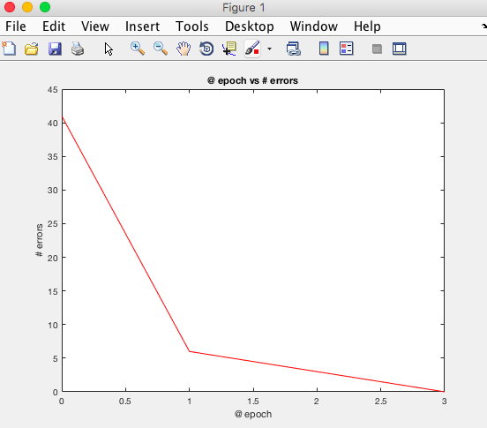

**(g) Run Steps (d) and (e) for n=1000, $η$ =1,**

########### Q(g) 1000 d #################

@epoch 0 # errors = 911

@epoch 1 # errors = 127

@epoch 2 # errors = 140

@epoch 3 # errors = 120

@epoch 4 # errors = 69

@epoch 5 # errors = 59

@epoch 6 # errors = 62

@epoch 7 # errors = 59

@epoch 8 # errors = 33

@epoch 9 # errors = 54

@epoch 10 # errors = 48

@epoch 11 # errors = 30

@epoch 12 # errors = 41

@epoch 13 # errors = 16

@epoch 14 # errors = 46

@epoch 15 # errors = 22

@epoch 16 # errors = 15

@epoch 17 # errors = 19

@epoch 18 # errors = 26

@epoch 19 # errors = 9

@epoch 20 # errors = 14

@epoch 21 # errors = 14

@epoch 22 # errors = 

@epoch 23 # errors = 10

@epoch 24 # errors = 11

@epoch 25 # errors = 5

@epoch 26 # errors = 1

@epoch 27 # errors = 7

@epoch 28 # errors = 6

@epoch 29 # errors = 2

@epoch 30 # errors = 4

@epoch 31 # errors = 4

@epoch 32 # errors = 3

@epoch 33 # errors = 1

@epoch 34 # errors = 1

@epoch 35 # errors = 2

@epoch 36 # errors = 1

@epoch 37 # errors = 0

########### Q(g) 10000 e ################

**# errors of 1000 = 1787/10000= 17.87%**

the percentages of errors obtained through the training and test samples are different (epoch=0 91.1% vs 17.87% and finally 0% vs 17.87%) and after comparing the weights obtained in 50 samples training and in 1000 samples, I found more samples could train a better and more idealized weight.

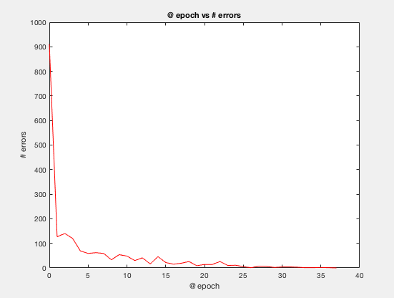

**(h) Run Steps (d) and (e) for n=60000, $η$ =1,**

the number of epoch is too big; I will just show pictures below.

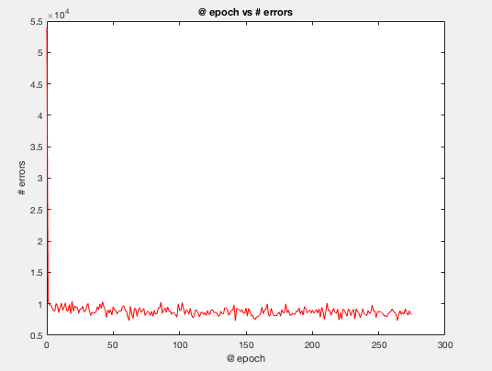

the algorithm does not converge because the training samples are not linearly separable. The error number begins to oscillate.

**(I)Repeat the following two sub items three times with different initial weights and comment on the results:**

$η$**=1, $ε=0.14$**

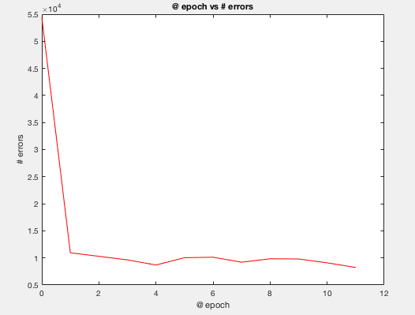

The percentage of errors number is 1630/10000 = 16.30%

$η$**=10, $ε=0.14$**

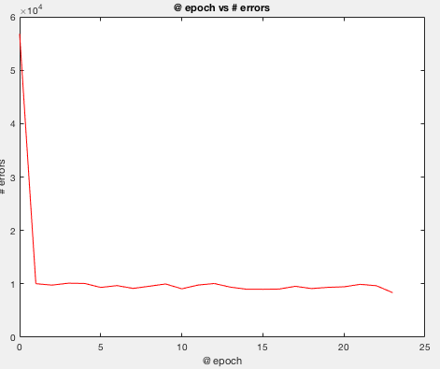

The percentage of errors number is 1580/10000 = 15.80%

$η$**=1, $ε=0.15$**

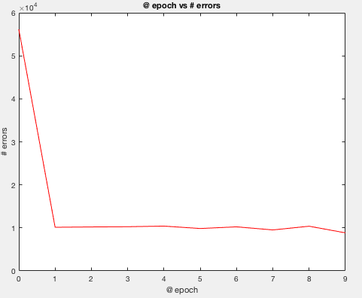

The percentage of errors number is 1918/10000 = 19.18%

After three experiences, the most obvious conclusion I can draw is that when $ε$ becomes bigger, the epoch for convergence decrease significantly. And the final error percentage is nearly 10%. However, after training 1000 samples, we can also get the similar result. Moreover, no matter how much $η$ is, there is no obvious difference in final result, maybe epoch becomes bigger or maybe it will be smaller than prior one. Therefore, I need more experiences to verify these uncertain aspects.