Eric Wang/Xuhui Wang CSC361 P2 documentation
ARP packets:
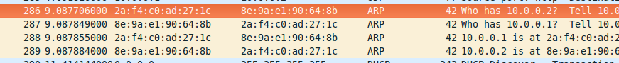

UDP packets:
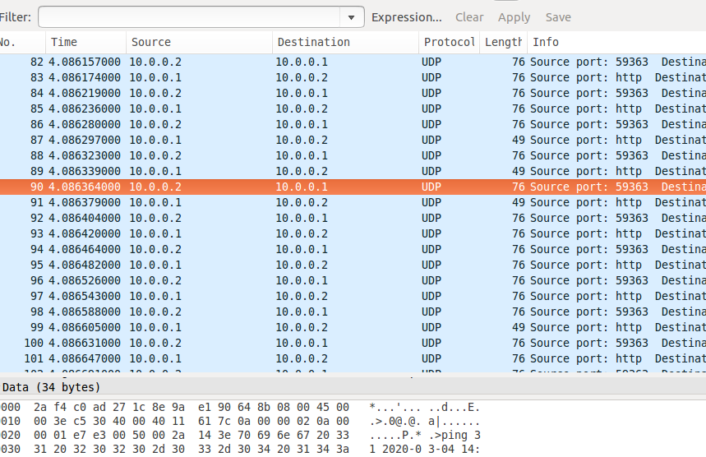

Client terminal:
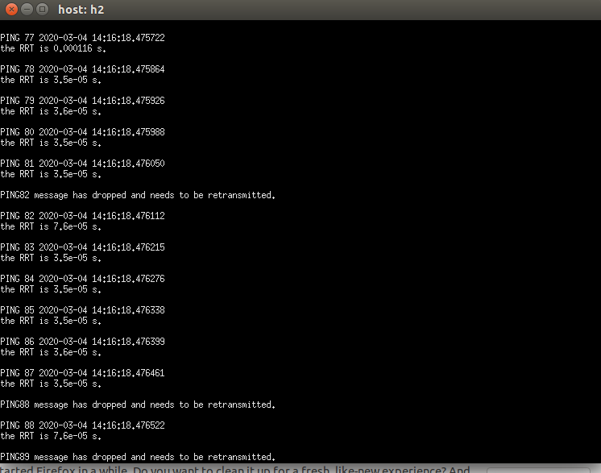

Retransmission:
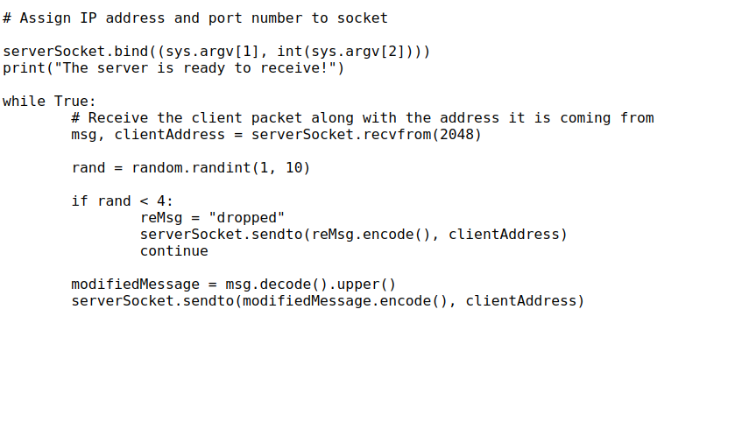
I implemented retransmission on the server side as indicated in the code above:
If the server decides to drop the packet, it sends a string ”dropped” to indicate the client that the packet last sent by the client was dropped.

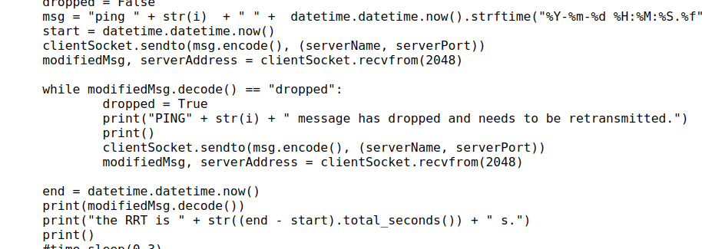
I implemented retransmission on the client side as indicated in the code above:
If the client receives the packet replied by the server containing the string “dropped”, it resends the same packet to the server until it gets the right replied packet.

RRT:
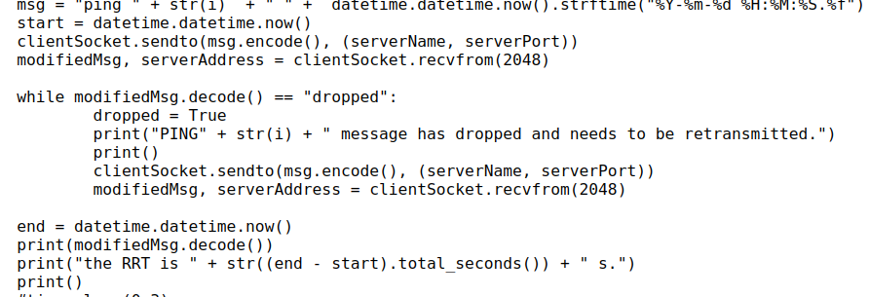
I implemented the RRT calculation as indicated in the code above:
Before I send the packet to the server, I get the start timestamp.
I get the end timestamp after I have received the replied packet correctly (including the retransmission time if need).
Then I get the time difference between start and end, which is the RRT.

