**Created by**:

**Names**: Eray Gül, Alp Buğra Toker

**Student Numbers**: 20190808005, 20200808611

**Software Requirement:**

**Features:**

-This web application allows our users to login our home automation system software

a. If user has no account, user can sign up.

b. Our web application verify username and password. If values are correct, it allows to log in.

c. If values are not correct, it returns error massage.

d. If user has forgetten their password, user can reset his/her password.

-This web application allows to add other rooms and floors, if home has more than one floor.

-This web application allows to add or remove different devices to control via app.

-This web application allows to turn on or off devices.

-This web application allows to change some specific features, if device has (like adjusting heat of air conditioner or changing channels on TV)

**Supported Devices and Properties:**

-TV:

*Turning on and off TV.

*Changing channels

*Playing music via supported apps(Spotify, Apple Music, Youtube Music.. )

-Ceiling fan

*Turning on and off

*Adjusting speed

-Air conditioner

*Turning on and off

*Changing mods

*Adjusting temperature

*Changing fan speed

-Window

*Turning on and off

*Position of window(half open, fully open)

-Door

*Turning on and off

*Position of door(half open, fully open)

-Ligths

*Turning on and off

*Changing colors

-Washing machine

*Switching between mods(cotton, silk)

*Adjusting temperature

*Start/Pause

-Fridge

*Turning on and off

*Adjusting temperature

**Possible Use Cases:**

-User logs in his/her account:

-Adding TV as a device:

-Opening TV and changing channel to 25:

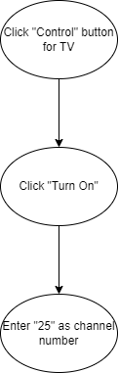

**Wireframe:**

