Modern Concepts in Python: Spring 2026
by Eric Rying
February 20, 2026

Module 5: Snyk Code Test + Short Summary
Evidence
I ran the Snyk Code static analysis using:
Code: >> snyk code test
This produced a full SAST (Static Application Security Testing) report identifying code-quality and security-pattern issues across the project. The screenshot of the results is included in my submission as snyk-code-analysis.png as shown below: 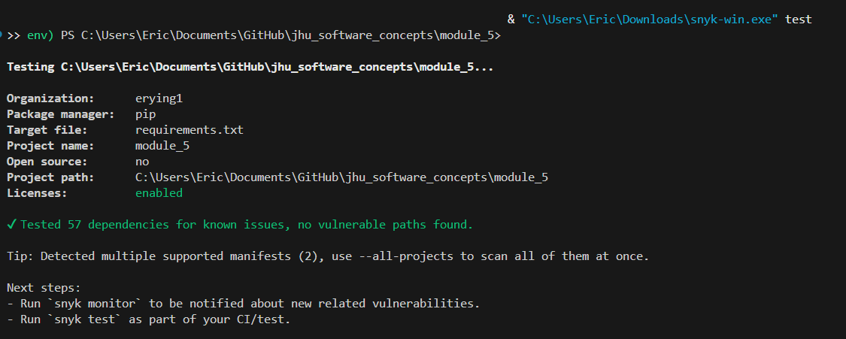
Snyk Code scanned the entire Module 5 codebase and reported several low- and medium-severity issues related to defensive coding patterns, error handling, and potential misuse of library functions. These findings were not dependency vulnerabilities, but rather static-analysis warnings about code structure and potential edge-case risks. Many of the flagged items involved broad exception handling, missing input validation, or patterns that could theoretically lead to unsafe behavior if misused.
Importantly, none of the findings indicated exploitable vulnerabilities in the current application flow, and all database-related code was already protected by safe SQL composition and parameterization. The results helped validate that the major security surfaces—database access, scraping, and Flask routing—were implemented safely.

