Latent Chemical Recognition Diversity in an Evolved Periplasmic Binding Protein Biosensor Family
Eryney Marrogi1,2, Anand Muthusamy2, Aaron Nichols2, Henry Lester2
1 Larner Medical College, Burlington, VT
2 Division of Biology and Biological Engineering, Caltech, Pasadena, CA

Abstract
Genetically encoded fluorescent biosensors collapse binding, conformational switching, signal generation, and calibration into a single molecular machine, but each new ligand still usually requires a fresh engineering campaign. Here we asked whether existing sensors in an evolved OpuBC/cpGFP family already contain useful latent recognition scope outside their engineered targets. We screened 18 related biosensors, originally built around nicotine, nicotinic agonists, SSRIs, opioids, and related drug-like ligands, against 63 structurally diverse compounds. The panel detected 24 ligands above ΔF/F0 > 0.3, a threshold that can seed practical engineering, and 8 ligands above ΔF/F0 > 1.0. Non-native hits included DEHP, ergothioneine, ciprofloxacin, thiamine, betahistine, L-carnitine, and L-thyroxine. Ciprofloxacin was the strongest immediate application lead: 4 sensors produced dose-dependent responses, with visible signal from the single-digit to low-tens micromolar range and fitted EC50 values of 22.4 to 53.7 µM after excluding a bad high-concentration well. The screen also exposed sequence-function cliffs. Tap1.0 and V7 differ by a single W436A aromatic-cage mutation yet their response fingerprints were essentially uncorrelated (r = 0.007). Across the scaffold set, mutation distance correlated with functional similarity, but weakly enough that close sequence neighbors often carried different chemical scope. These results support broad empirical screening as a fast front end for biosensor engineering: a small family of related PBP/cpGFP scaffolds can reveal starting points for ligands well outside the selection history of the family.

Introduction
Periplasmic binding protein (PBP) biosensors are useful because they turn small-molecule binding into a fluorescent readout. A PBP closes around a ligand, and a circularly permuted fluorescent protein (cpGFP) inserted into the scaffold converts that motion into a change in fluorescence (Figure 1A,B).¹ The result is a genetically encoded sensor that can be purified for analytical assays, immobilized in a device, or expressed inside cells.²⁻⁴
The hard part is building the first working sensor for a new ligand. A typical campaign starts with a binding protein, searches insertion sites and linkers, then mutates the binding pocket until binding and fluorescence coupling land in the right range. That is a lot of experimental work for each target, especially when the desired molecule has no obvious natural binding protein.
Protein design and structure prediction are improving quickly,^{5,6} but allosteric biosensors remain a difficult class. They need ligand binding, conformational switching, fluorescence coupling, and expression behavior to work together. For this reason, an experimentally detected weak hit can be valuable. A ΔF/F0 response around 0.3 is already a foothold: the scaffold binds something in a geometry that can move the reporter, even if affinity, dynamic range, and selectivity still need tuning.
We tested whether such footholds already exist inside an evolved OpuBC/cpGFP biosensor family. OpuBC is a choline-binding PBP⁷ that has been repurposed into sensors for nicotine, nicotinic agonists, SSRIs, opioids, and related drug-like ligands.^{4,8-10} Many constructs in this family are intermediates rather than final published sensors, which makes them useful for asking a broader question: how much chemical recognition was created, retained, or exposed during those engineering paths?
We screened 18 sensors against 63 compounds spanning metabolites, drugs, hormones, neurotransmitters, environmental compounds, and other analytes. We use three terms throughout. Latent recognition scope means ligands detected outside the scaffold's natural and engineered targets. Ligand hit breadth means the number of sensors activated by a ligand. Sensor hit breadth means the number of ligands detected by a sensor. This vocabulary keeps the central result plain: the family contains more chemical recognition than its published target names imply.
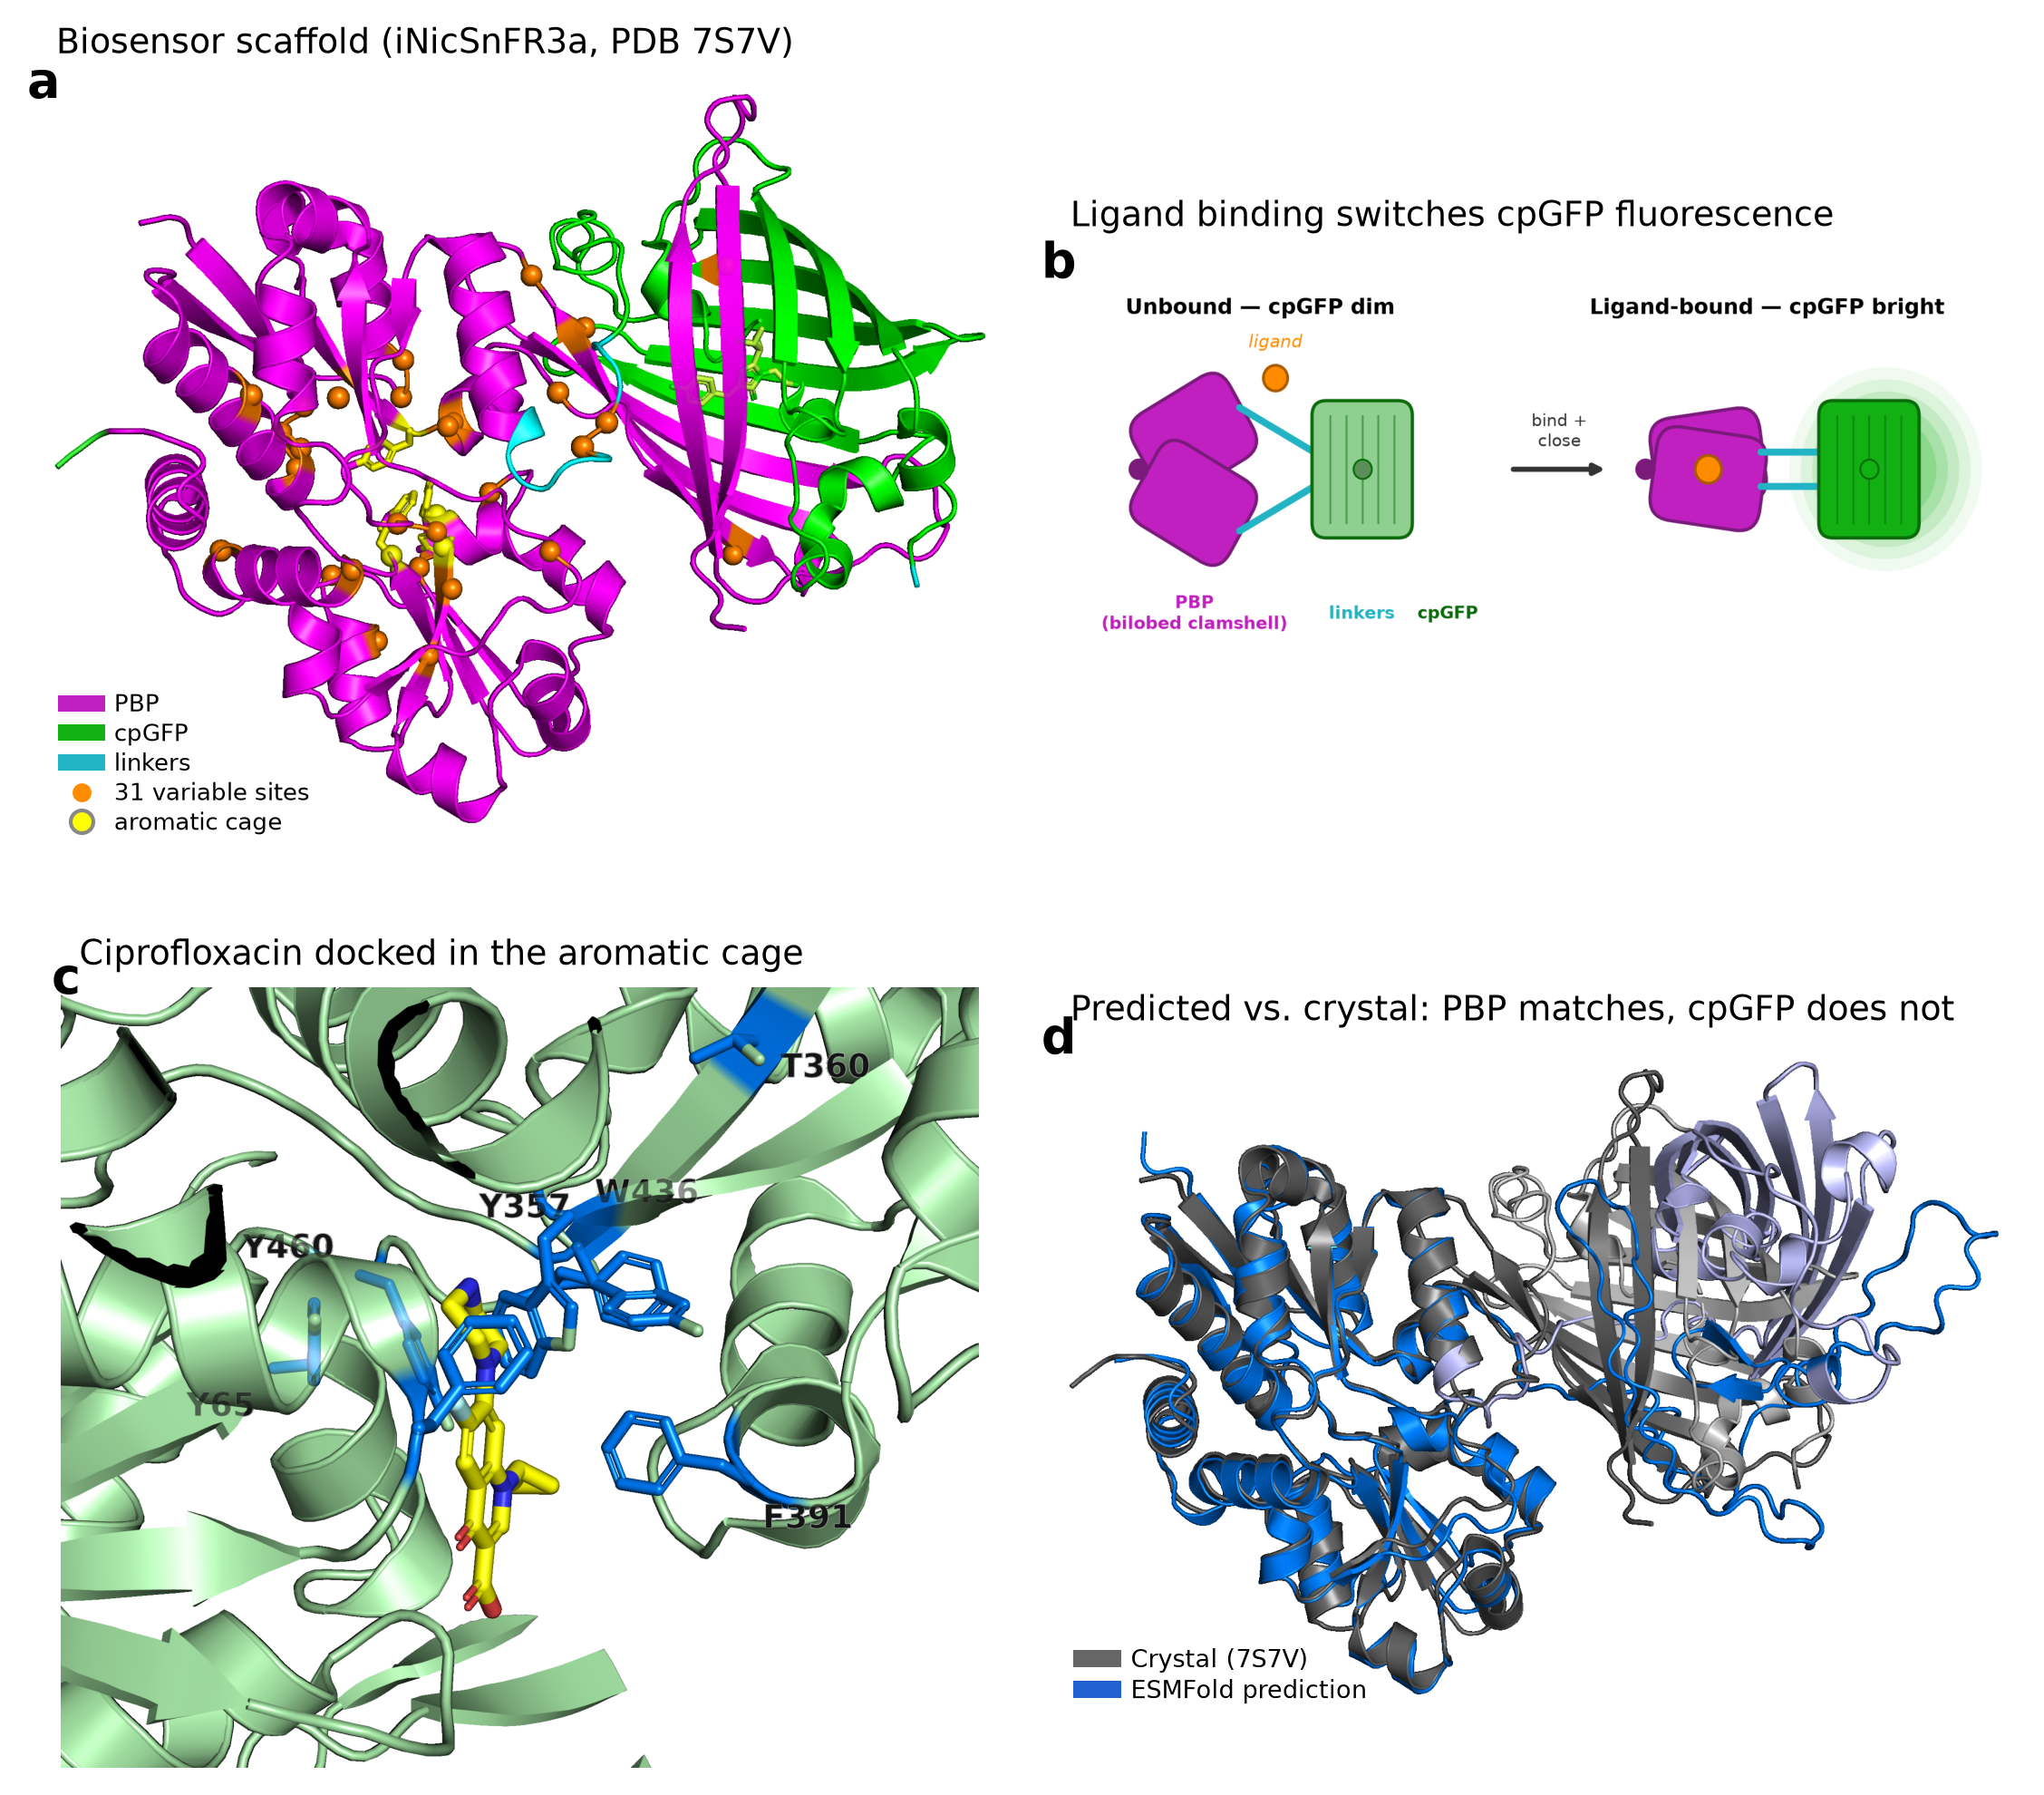
Figure 1. The OpuBC/cpGFP biosensor scaffold and its ligand-binding pocket. In all structural panels the PBP recognition domain is at left and the cpGFP reporter at right, matching the PBP-cpGFP domain order. (A) Crystal structure of iNicSnFR3a (cc93; PDB 7S7V⁴), the full-length nicotine sensor, colored by module: the periplasmic binding protein (PBP) recognition domain (magenta), the circularly permuted GFP reporter (cpGFP, green), and the connecting linkers (cyan). Orange spheres mark the 31 positions that vary across the 17-member scaffold family (Cα shown); the four aromatic-cage residues Y65, Y357, F391, and W436 are drawn as yellow sticks and the GFP chromophore is shown in limon. (B) Sensing mechanism: the bilobed PBP closes around a ligand in a Venus-flytrap motion, and this conformational change is transmitted through the connecting linkers to switch the inserted cpGFP from a dim to a bright state. (C) Close-up of the binding pocket with ciprofloxacin (yellow sticks) placed by blind diffusion docking (DiffDock-L).¹¹ Aromatic-cage and pocket residues are shown as marine sticks (Y65, Y357, T360, F391, W436, Y460). The pose is illustrative of a plausible binding geometry in the cage; the 7S7V structure has no drug ligand resolved in the pocket, and the geometry has not been experimentally determined. Residue 457 is phenylalanine (F457) in this family. (D) Full-length structure prediction (ESMFold⁶; mean pLDDT ≈ 70) superposed on the 7S7V crystal over the PBP domain. The entire crystal is shown in grey and the entire prediction in blue (darker shades, PBP lobes; lighter shades, linker and cpGFP). The predicted PBP lobes overlay the crystal closely (Cα RMSD 1.7 Å across the folded core), whereas the predicted linker and cpGFP module are displaced by ≈ 21 Å in the same frame. Current end-to-end predictors reproduce the PBP fold but not the placement of the inserted reporter, so structure-guided design in this family is presently anchored on the experimental PBP scaffold.

Results

Broad screening reveals structured latent recognition
The screened panel contains 17 OpuBC/cpGFP scaffold sensors plus 1 outgroup control, Fent2 436L. The main lineage runs from early nicotine-responsive constructs through iNicSnFR3a (cc93), iNicSnFR3b (V7), later acetylcholine intermediates, and iAChSnFR (V9). Branches include serotonin-, escitalopram-, cytisine-, fluoxetine-, tapentadol-, and levorphanol-facing constructs or intermediates.
This family is useful because the sensors are close in sequence but far enough apart functionally to probe latent scope. Across the 17 scaffold sensors, pairwise identity ranges from 95.0 to 99.8%. Only 31 of 521 aligned positions vary, and several changes fall near residues already implicated in selectivity, including Y357 and W436. W436 sits in the aromatic cage that helps recognize cationic ligands in this family,¹² so mutations at this position are plausible switches for substrate scope (Figure 1C,D).
We screened 18 sensors against 63 ligands at a single concentration and computed ΔF/F0 relative to no-ligand controls. Responses ranged from -0.90 to 12.14. Using ΔF/F0 > 0.3 as a permissive engineering-hit threshold, 24 of 63 ligands activated at least 1 sensor. That threshold is deliberately practical: it marks a weak but engineerable fluorescence change, not a finished sensor. Using ΔF/F0 > 1.0 as a strong-response threshold, 8 ligands remained: nicotine, thiamine, DEHP, ergothioneine, betahistine, ciprofloxacin, L-carnitine, and L-thyroxine.
The pair-level screen was sparse, but the hits were not random. Across 1134 sensor-ligand combinations, 124 exceeded ΔF/F0 > 0.3 and 50 exceeded ΔF/F0 > 1.0. Nicotine produced the largest native-class signal, with a maximum ΔF/F0 of 12.14 and 10 sensors above the strong-response threshold. Several non-native ligands also produced large responses: thiamine reached 4.66, DEHP 3.25, ergothioneine 3.04, betahistine 2.70, and ciprofloxacin 2.50.
Grouping ligands by pre-specified chemical scope made the pattern easier to read than an unsupervised mode count. Alkaloid-like ligands, non-alkaloid charged ligands, and non-alkaloid uncharged ligands all contained hits. The charged non-alkaloid group was small, but 3 of 6 compounds produced strong responses. The uncharged non-alkaloid group was much larger and contained DEHP, ciprofloxacin, and L-thyroxine as strong hits. Representative structures in Figure 2C show how widely these classes differ in charge, size, and shape. That matters because OpuBC began as a choline-binding PBP, yet the family now detects compounds with very different charge and shape.
DEHP was the broadest non-native ligand hit, activating 13 sensors above ΔF/F0 > 0.3 and 10 sensors above ΔF/F0 > 1.0. Ciprofloxacin activated 11 sensors above ΔF/F0 > 0.3 and 8 above ΔF/F0 > 1.0. Ergothioneine and thiamine activated 9 and 7 sensors above the strong-response threshold, respectively. MEHP, which differs from DEHP by replacing one ethylhexyl ester with a carboxylate, activated no sensors above ΔF/F0 > 1.0. That contrast points to a hydrophobic DEHP recognition mode rather than a generic phthalate response.
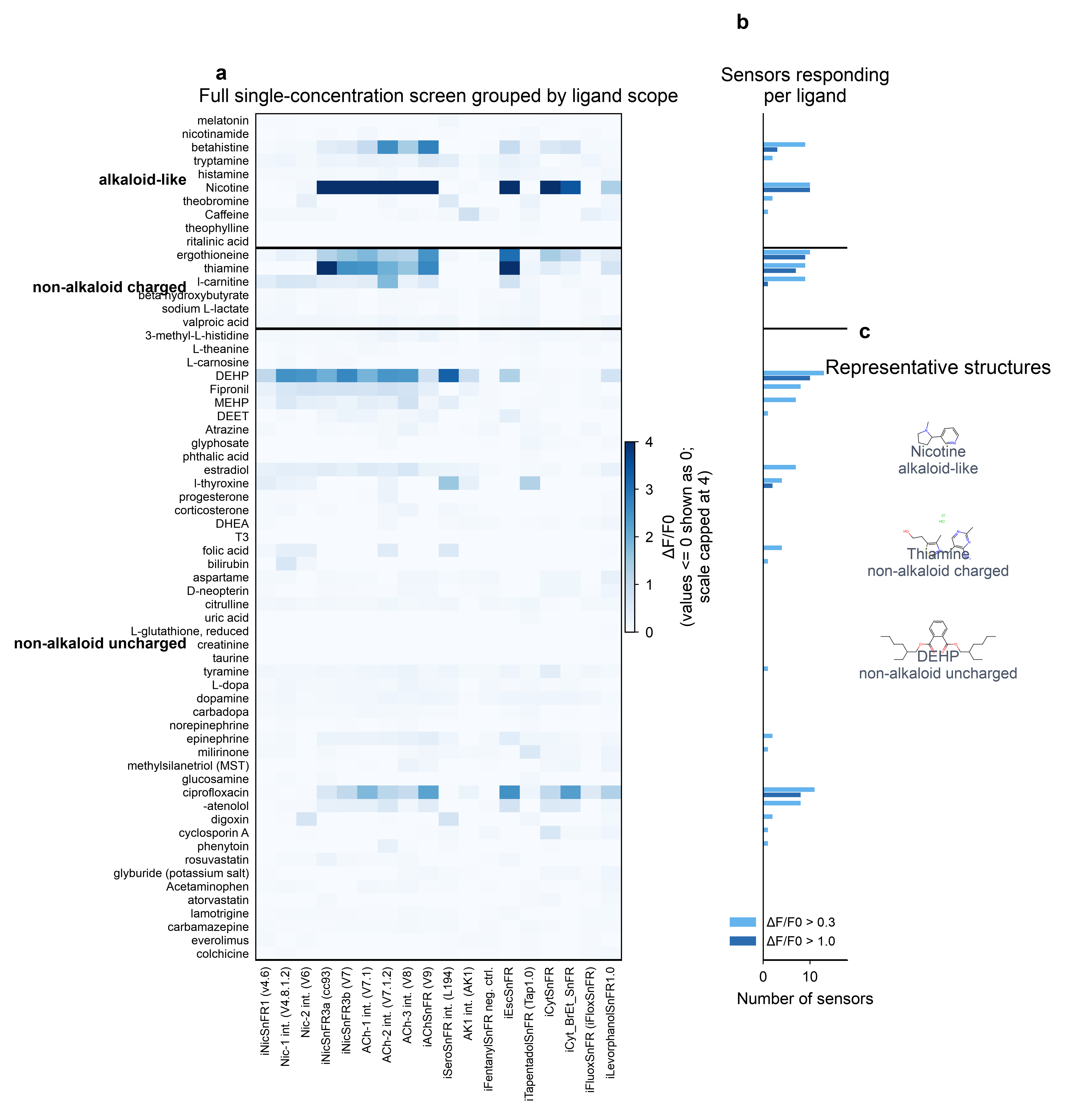
Figure 2. Compound screen grouped by ligand scope. (A) Full 63 ligand x 18 sensor response matrix, grouped into alkaloid-like, non-alkaloid charged, and non-alkaloid uncharged ligands. Values at or below zero are displayed as zero, and the color scale is capped at ΔF/F0 = 4 so weak and moderate hits remain visible; the largest nicotine response is 12.14. (B) Number of sensors producing a meaningful response to each ligand at ΔF/F0 > 0.3 and ΔF/F0 > 1.0. (C) Representative structures from the 3 ligand scope classes: nicotine, thiamine, and DEHP.

Sequence-function cliffs reshape ligand fingerprints
Sequence similarity carried some information about function, but it was not enough to predict response fingerprints reliably. Across the 17 scaffold sensors, pairwise mutation events correlated negatively with response-profile correlation (r = -0.363, p = 1.4 x 10^-5). That broad trend makes sense: more divergent sensors usually behave less similarly. The useful result is hiding in the spread around that trend.
Many close neighbors had different ligand fingerprints. Across parent-child steps separated by 1 to 3 mutations, as many as 12 of 63 ligands crossed the meaningful-response threshold (Figure 3B). Tap1.0 and V7 differed by only 1 internal mutation, W436A, yet 12 ligand-response states changed: Tap1.0 gained 2 hits and lost 10 relative to V7. Their response-profile correlation was 0.007. Tap1.0 and V8 differed by 3 internal mutations and had a correlation of -0.004. iEscSnFR and Tap1.0 differed by 2 mutations and had a correlation of 0.032. These are sequence-function cliffs: a small sequence change creates a large functional jump.
The Tap1.0 versus V7 comparison is the cleanest example because it lands on a residue with an obvious mechanistic interpretation. V7 retains W436. Tap1.0 carries W436A, which removes an aromatic side chain from the cage. V7 responds strongly to nicotine, DEHP, thiamine, ergothioneine, ciprofloxacin, and several other ligands. Tap1.0 loses most of that breadth and gains a different response profile. For ML-guided design, this is the hard case: a model that treats nearby sequences as nearby functions will miss the most useful switches.
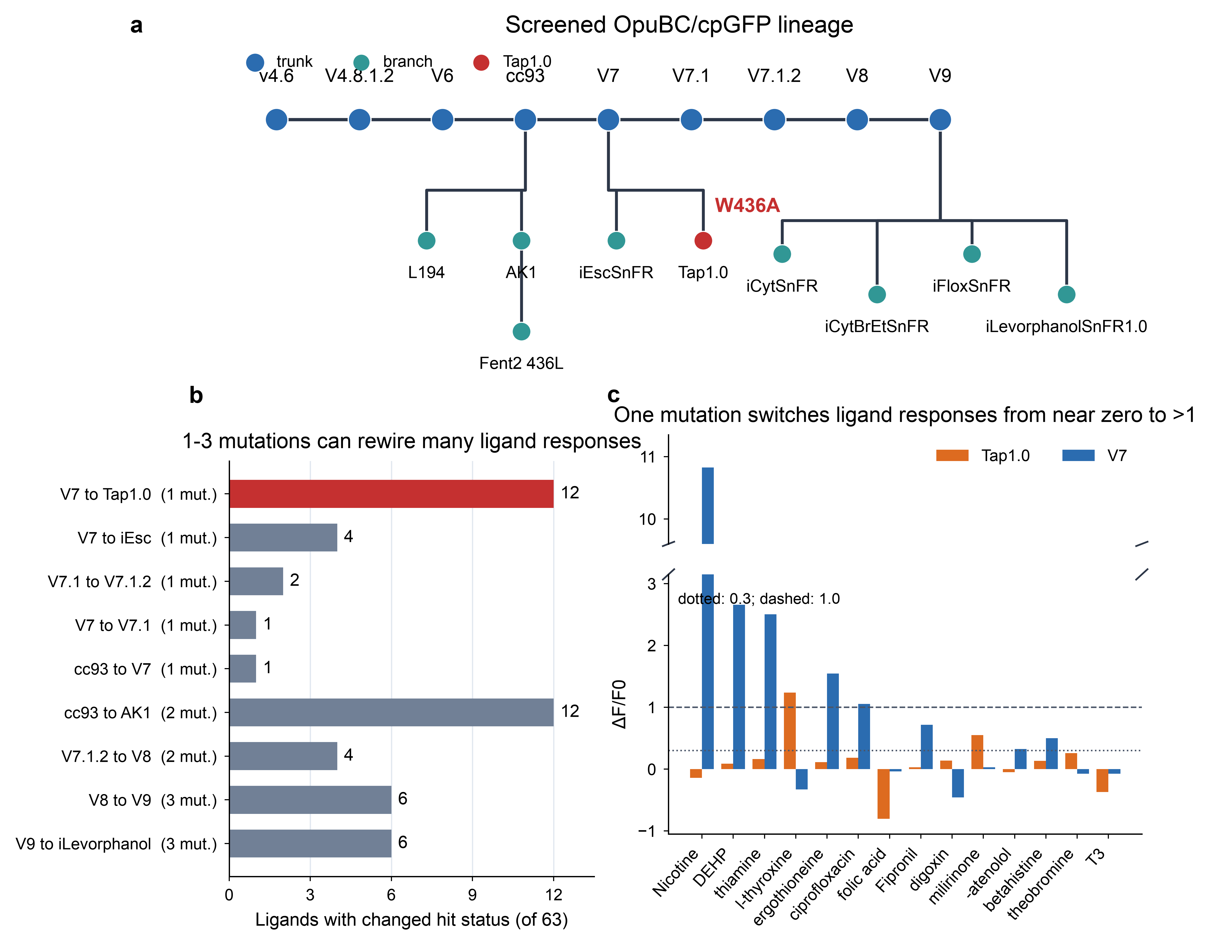
Figure 3. A few mutations can redirect ligand recognition across the OpuBC/cpGFP family. (A) Screened sensor lineage using the simplified paper-facing taxonomy. Tap1.0 is highlighted because it differs from V7 by W436A. Fent2 436L is shown as the sequence-outgroup negative control but is excluded from scaffold-only sequence analyses. (B) Number of ligands that changed hit status across each parent-child step separated by 1 to 3 mutations. A status change means that a ligand crossed the ΔF/F0 = 0.3 meaningful-response threshold in either direction. V7 to Tap1.0 and cc93 to AK1 each changed 12 of 63 ligand-response states after 1 and 2 mutations, respectively. (C) Tap1.0 and V7 responses for the 14 ligands with the largest absolute differences. The broken y-axis isolates the nicotine response (ΔF/F0 = 10.83 in V7) while preserving the scale of the remaining ligands. Dotted and dashed lines mark ΔF/F0 thresholds of 0.3 and 1.0, respectively.

Ciprofloxacin sensors are already near an application-relevant range
We next fit dose-response curves for selected hits. Ciprofloxacin stood out because 4 sensors gave clear dose-dependent responses with high fit quality after removing a known bad well at the highest concentration. In the cipro plates, well H2 was anomalously low across sensors; we excluded that single well and computed the 200 µM point from the remaining 2 replicates. iEscSnFR, V7.1, V9, and V7 gave EC50 values of 22.4, 35.9, 45.3, and 53.7 µM, respectively, with R^2 values from 0.990 to 0.999.
Those fitted EC50 values sit above standard plasma exposure, but the curves still produce measurable fluorescence changes in the clinically relevant range. The ciprofloxacin prescribing label reports a steady-state Cmax of 2.97 µg/mL for 500 mg oral ciprofloxacin every 12 hours, which is about 9 µM given a molecular weight of 331.4 g/mol.¹³ At 6.3 to 20 µM ciprofloxacin, the 4 sensors already produce ΔF/F0 responses of roughly 0.45 to 1.67. The best sensors are not yet optimized clinical tools, but they start close enough to standard exposure to make ciprofloxacin the strongest immediate lead from the screen.
The corrected cipro curves also change the interpretation of sensitivity. The 200 µM points now rise above the 63 µM points, so the curves should be treated as first-pass dose responses rather than final saturation measurements. A focused evolution campaign should be able to improve both apparent affinity and slope, especially because the starting constructs already respond around the concentration range relevant for dosing and monitoring.
Other ligands showed useful but less mature behavior. DEHP gave a strong and well-fit response in V4.8.1.2, with EC50 = 34.5 µM and dFmax = 2.8. L194 and V7 also responded to DEHP, but their fits were lower-bound cases in the measured concentration range. Thiamine, ergothioneine, and L-carnitine produced high top-end responses but generally required concentrations above physiological plasma ranges. These are starting points for evolution rather than finished sensors.
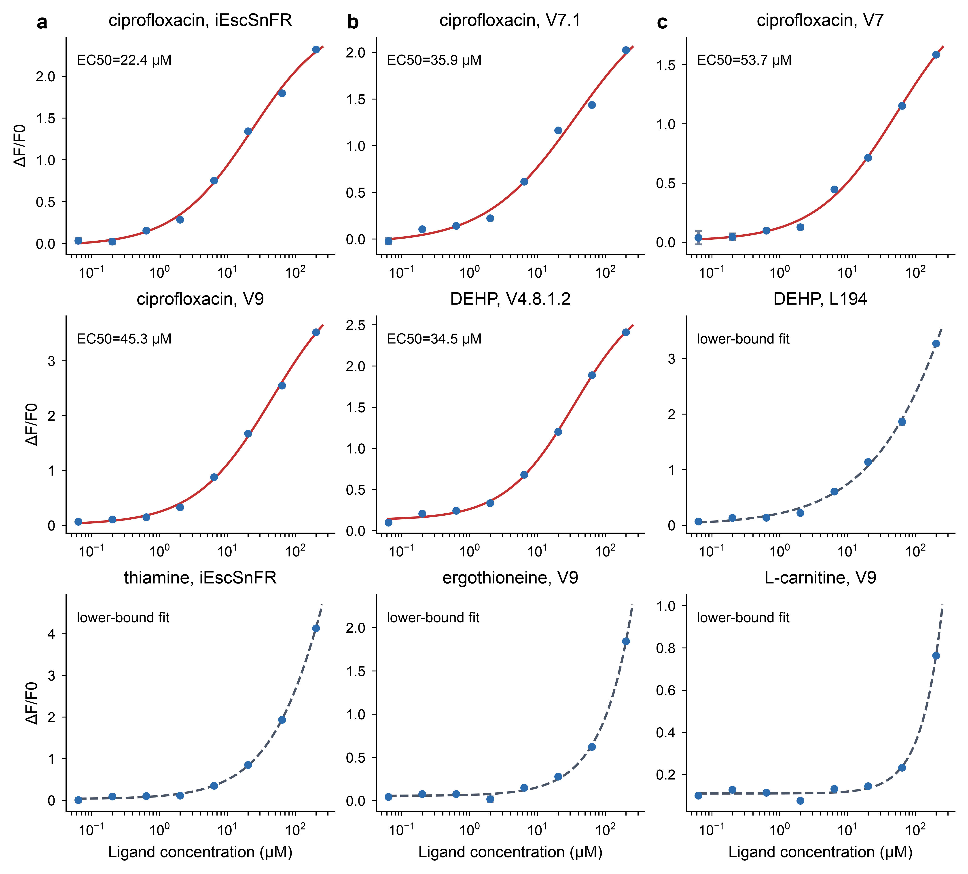
Figure 4. Dose responses for the strongest latent-recognition leads. Points show mean ΔF/F0 from 3 technical replicates, with error bars showing propagated SEM. Ciprofloxacin responses in iEscSnFR, V7.1, V7, and V9 produce fitted EC50 values from 22.4 to 53.7 µM after excluding the known bad H2 well at the 200 µM point and recomputing that point from the remaining 2 replicates. Solid red curves indicate within-range fits. Dashed gray curves indicate lower-bound behavior. DEHP responses include a within-range fit for V4.8.1.2 and lower-bound behavior in L194. Thiamine, ergothioneine, and L-carnitine show large top-end responses but need affinity improvement for most physiological applications.

Discussion
The main result is practical: evolved PBP/cpGFP biosensor families can be screened as reusable recognition libraries. These sensors were built for nicotine-related ligands, SSRIs, opioids, and nearby drug-like classes, yet the same family exposed starting points for ciprofloxacin, DEHP, ergothioneine, thiamine, betahistine, L-carnitine, and L-thyroxine. A broad screen can therefore shorten the first step of biosensor design by finding scaffolds that already couple a new ligand to fluorescence.
This is especially useful for intermediate constructs. Labs often keep only the final named sensor, but intermediates may carry the weirdest and most useful recognition states. In this panel, broad response capacity was distributed across the lineage rather than confined to one odd construct. V7.1.2, V9, iEscSnFR, V7.1, V8, and V7 were among the broadest responders by sensor hit breadth.
Ciprofloxacin is the cleanest application lead. It is detected by multiple sensors, gives µM-scale dose responses, and produces measurable signal near standard serum exposure after oral dosing. To our knowledge, these are the first genetically encoded protein biosensor starting points for ciprofloxacin. The current sensors still need improved affinity and slope, but they start close enough that a focused directed-evolution campaign could plausibly improve sensitivity and selectivity. That expectation is realistic for this sensor class: computationally guided engineering of iNicSnFR3a produced iNicSnFR12, a nicotine sensor with a 6.1-fold higher delta-slope than its parent.¹⁰
DEHP is interesting for a different reason. It has no nitrogen and no obvious relationship to the cationic ligands that shaped the family. The screen detects DEHP broadly, while MEHP, a closely related monoester, produces no strong activation. This suggests a hydrophobic pocket-fitting mode rather than a generic response to phthalate chemistry. It also warns against over-reading simple ligand descriptors. Charge helps in some cases, especially permanent cations, but shape and fit still matter.
The existing lineage provides an empirical scale for whether these application-facing engineering gaps are plausible (Figure 5).
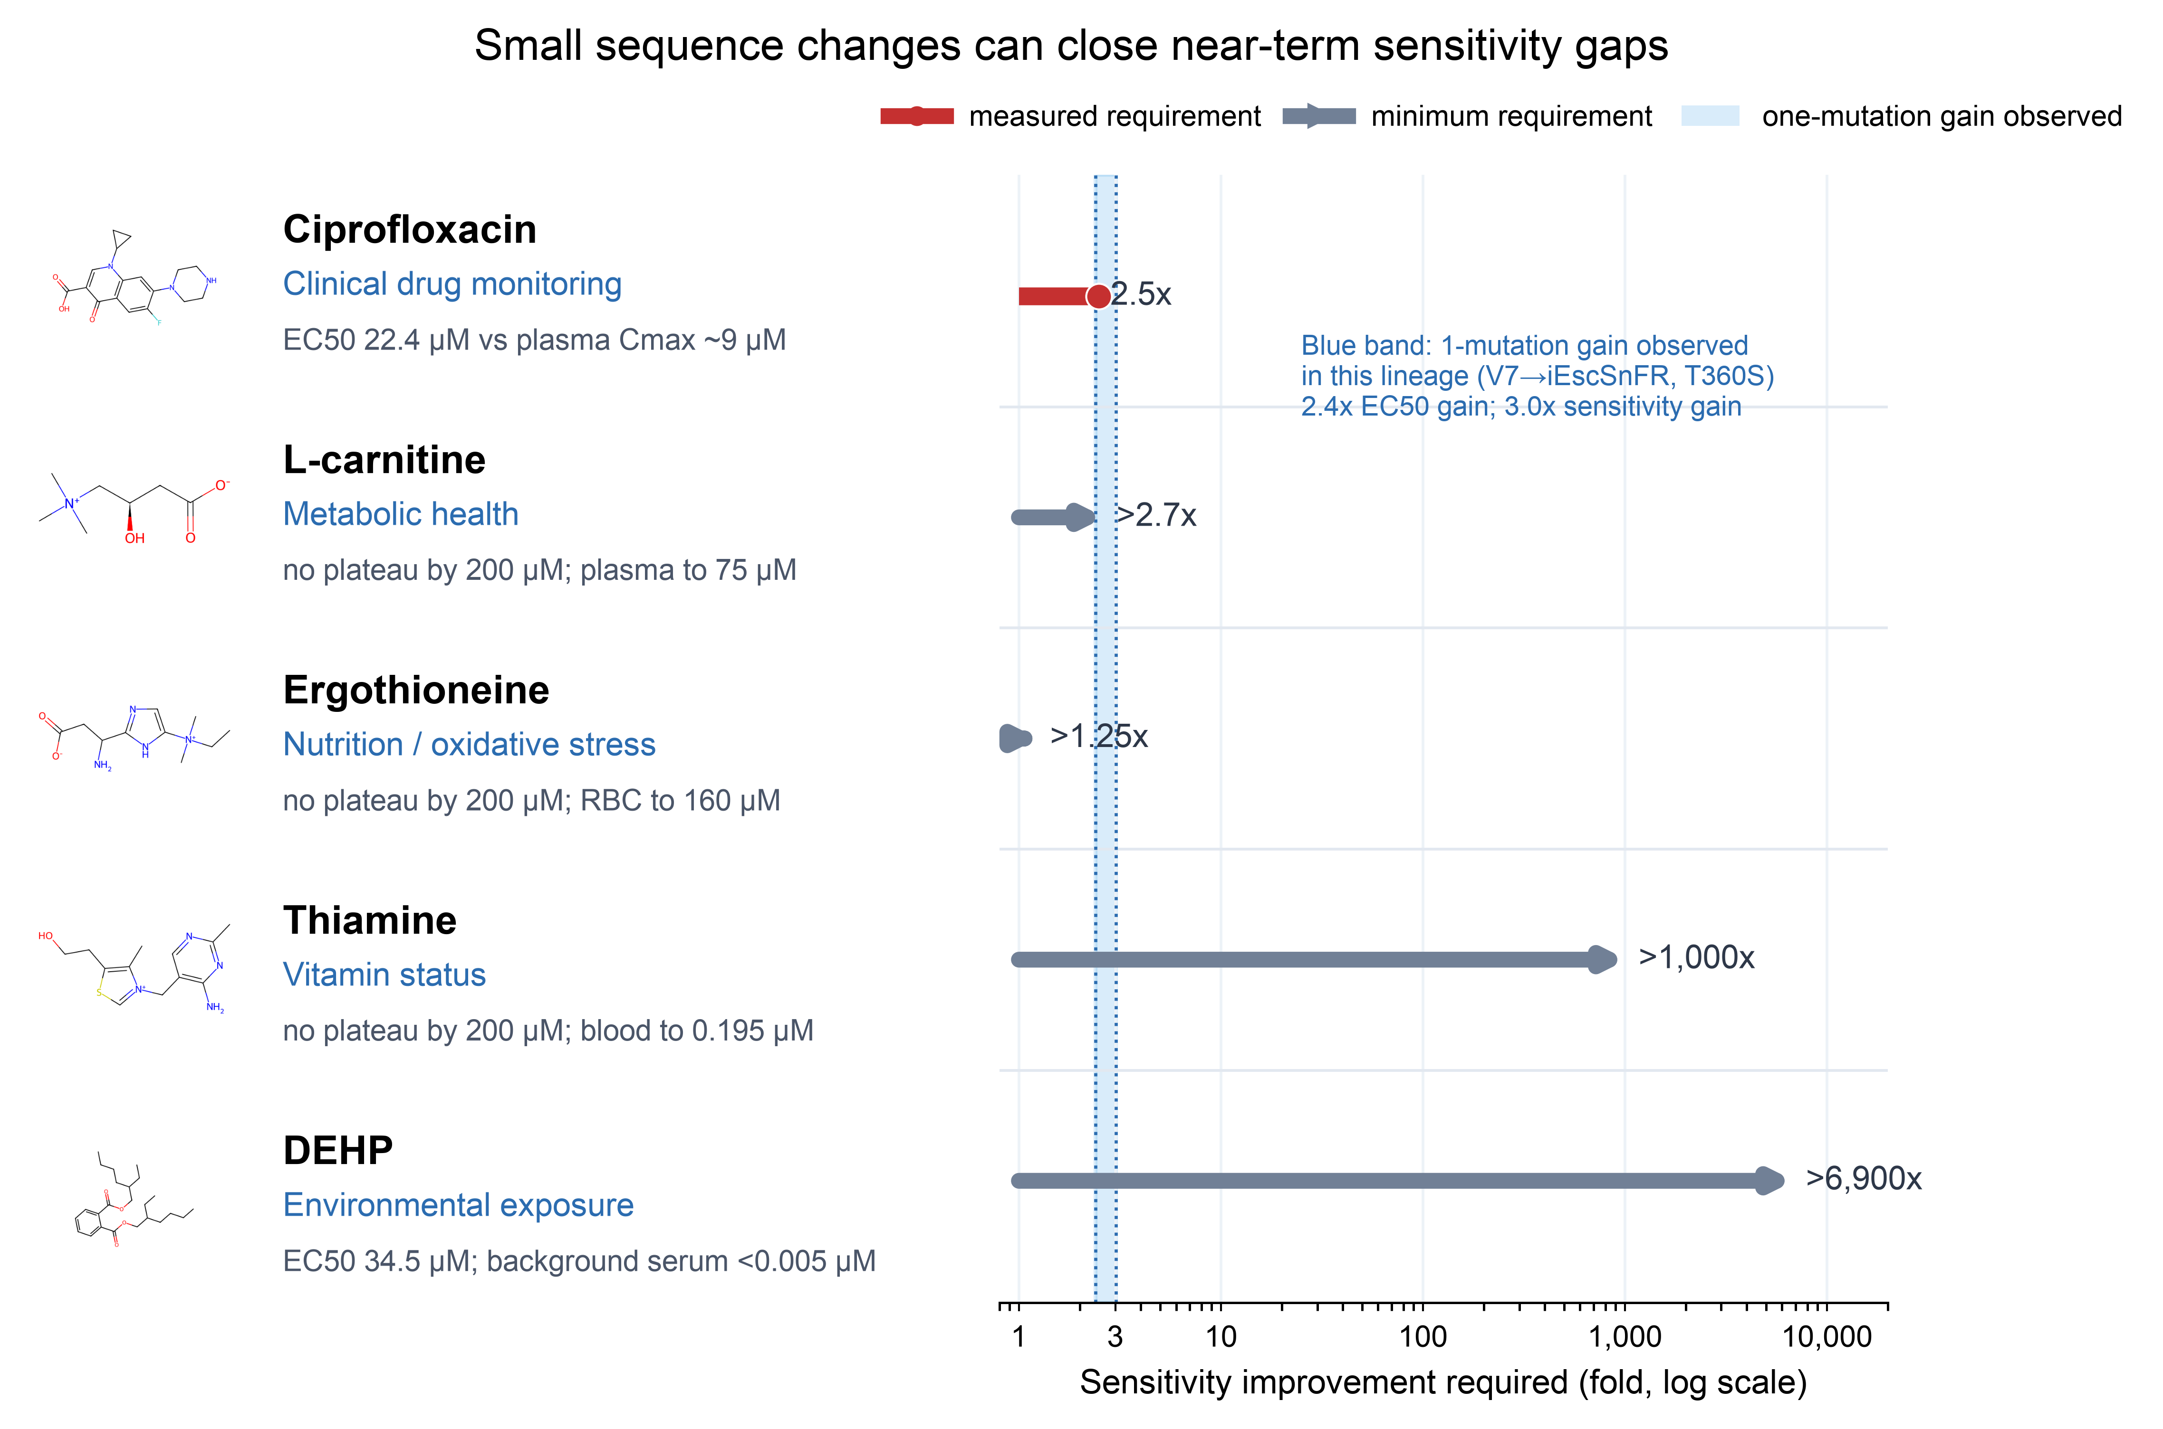
Figure 5. Small sequence changes can close near-term sensitivity gaps. Two-dimensional structures are shown beside potential clinical, physiological, or environmental use cases. The x-axis reports the fold improvement needed to bring current apparent sensor sensitivity to the upper end of an application-relevant concentration range. The red ciprofloxacin bar uses the measured best EC50 of 22.4 µM and a steady-state plasma Cmax of approximately 9 µM. Gray arrowheads mark minimum requirements where dose-response curves did not plateau by 200 µM or where the contextual exposure is an upper bound. Ergothioneine is benchmarked against the upper erythrocyte range of 160 µM; its plasma gap would exceed 65-fold. The blue band marks the gain already observed after the single T360S change from V7 to iEscSnFR: ciprofloxacin EC50 improves 2.4-fold, from 53.7 to 22.4 µM, while ΔFmax/EC50 improves 3.0-fold, from 0.041 to 0.123 µM^-1. Concentration ranges are literature context values and require final source verification before submission.
V7 and iEscSnFR differ only by T360S. For ciprofloxacin, that substitution lowers the fitted EC50 from 53.7 to 22.4 µM, a 2.4-fold improvement, and raises ΔFmax/EC50 from 0.041 to 0.123 µM^-1, a 3.0-fold improvement in apparent sensitivity. The best ciprofloxacin sensor requires an approximately 2.5-fold shift to reach the approximately 9 µM steady-state plasma Cmax, placing its engineering gap inside the range already produced by one mutation in this family. L-carnitine and erythrocyte ergothioneine also have minimum gaps near that scale, although their unsaturated curves make the true requirements uncertain. Thiamine and DEHP remain longer-term engineering targets.
The sequence-function cliff result is the piece most relevant to ML-guided protein design. Protein language model embeddings and raw mutation distance mostly track sequence divergence in this family. They do not automatically reveal that W436A can nearly erase correlation between close neighbors. That kind of cliff is exactly the regime where experimental screens are valuable training data. The screen gives models adversarial examples: close sequences with different functions, and distant chemical structures detected by nearby scaffolds.
There are also ordinary assay caveats. Fluorescent protein sensors can respond to pH, solvent, aggregation, or direct fluorescence effects. Ritalinic acid produced global suppression across all 18 sensors, which we do not interpret as productive binding-pocket closure without follow-up. Full dose responses, Hill coefficients near 1, and orthogonal validation are the right filters for converting screen hits into mechanistic claims.
This study should be read as a map of starting points, not as a finished sensor catalog. The most immediate next step is focused evolution from the ciprofloxacin-responsive scaffolds. A second useful step is to expand this workflow across other published PBP/cpGFP families, including intermediate mutants that are usually left out of final papers. Smart scaffold selection, broad empirical screening, and ML-guided mutagenesis should work best when each part does the thing it is actually good at: screens find footholds, models propose mutations, and directed evolution tests the coupled allosteric machine.

Methods

Sensor panel and ligand screen
The dataset contains 18 genetically encoded fluorescent biosensors screened against 63 ligands plus a no-ligand control. Sensor names, protein sequences, ligand names, SMILES strings, and single-concentration ΔF/F0 responses were parsed from the per-sensor raw and analyzed screening workbooks in `data_codex/v2/raw/20240724_GFP_assay`, following the published plate-screening workflow used for related CNS drug biosensor screens.¹⁴ The analyzed workbooks store matched ligand and baseline fluorescence values; full-precision ΔF/F0 values were rebuilt from those workbooks rather than from the rounded combined heatmap. The no-ligand control row was excluded from ligand counts and downstream response summaries.
Responses were analyzed as ΔF/F0 relative to matched no-ligand or solvent baselines. Screening SEM values were propagated from the ligand and matched baseline SEM values and are reported in the supplement. We used ΔF/F0 > 0.3 as a permissive engineering-hit threshold and ΔF/F0 > 1.0 as a strong-response threshold. Ligand hit breadth was computed as the number of sensors exceeding a threshold for each ligand. Sensor hit breadth was computed as the number of ligands exceeding a threshold for each sensor.

Ligand-scope classification
Ligands were assigned to 3 pre-specified scope classes for Figure 2: alkaloid-like, non-alkaloid charged, and non-alkaloid uncharged. Alkaloid-like ligands included nicotine and related nitrogen-containing bioactive compounds in the screen. Charged compounds were identified from formal charges in RDKit-parsed SMILES,¹⁵ including zwitterions and permanent cations. The remaining ligands were assigned to the non-alkaloid uncharged class.

Dose-response fitting
Dose-response files were rebuilt from the raw Excel workbooks in `data_codex/v2/raw/20240730_doseresponses`. Each dose-response sheet contained 3 replicate rows, a baseline column, and 8 ligand concentrations beginning at 200 µM followed by serial dilution by sqrt(10). ΔF/F0 was computed from the mean ligand fluorescence and mean baseline fluorescence. SEM was propagated from ligand and baseline standard deviations and divided by the square root of the number of finite replicate wells. Four weak or negative extra curves were excluded from the processed dose-response set: MEHP_cc93, aspartame_iLevaSnFR, bilirubin_V4.8.1.2, and theobromine_Tap1.0. In the ciprofloxacin dose-response plates, the H2 well was a known bad well at the highest ciprofloxacin concentration. For cipro curves, H2 was excluded and the 200 µM point was recomputed from the remaining 2 replicates. SEM values were converted to absolute values. Curves were fit with a 4-parameter Hill model:
F(x) = baseline + dFmax / (1 + (EC50 / x)^n)
Fits used SciPy's `curve_fit`¹⁶ with multiple starting EC50 and Hill-coefficient guesses, lower bounds of dFmax >= 0, EC50 >= 1e-4 µM, and Hill coefficient >= 0.1, and upper bounds of EC50 <= 1e6 µM and Hill coefficient <= 10. Curves with response range below 0.12 ΔF/F0 were flagged as noise. Curves with a near-flat body followed by a single high-concentration jump were flagged as step-like. Fits with EC50 < 400 µM and dFmax < 20 were treated as within-range reliable; the others were treated as lower-bound or out-of-range for interpretation. For Figure 4, ciprofloxacin curves were treated as the primary application-relevant dose-response result because 4 sensors gave monotonic dose-dependent responses with measurable signal from the single-digit to low-tens micromolar range and R^2 > 0.99.

Sequence-function analysis
Protein sequences were parsed from the sensor sequence row in `CaltechData.xlsx` and are reported in Supplementary Table S7. Pairwise mutation events were counted across the 17 OpuBC/cpGFP scaffold sensors after excluding Fent2 436L, which is a deliberate negative-control outgroup. A terminal one-residue length difference was ignored for the Tap1.0/V7 comparison because the internal sequence comparison identifies a single W436A difference. Functional similarity was computed as the Pearson correlation between full ligand-response profiles. For Figure 3B, parent-child steps were taken from the simplified lineage in Figure 3A and restricted to pairs separated by 1 to 3 mutations. Each ligand was classified as a meaningful hit or non-hit at ΔF/F0 > 0.3 in the parent and child. Ligands crossing that threshold in either direction were counted as changed response states.

Structural figures
Figure 1 was prepared from the full-length crystal structure of iNicSnFR3a (PDB 7S7V⁴). Chain A was retained, waters and alternate conformers were removed, and the single most-occupied conformer was kept at each position. Modules were assigned from the cc93 sequence as PBP N-lobe (residues 1-175), cpGFP (176-320, including the GFP chromophore CRO), and PBP C-lobe (321-522), with the two connecting linkers at ~168-175 and ~321-330. The 31 family-variable positions were mapped from a multiple-sequence alignment of the 17 scaffold sensors (crystal residue numbering matches the cc93 sequence position directly) and rendered as Cα spheres. All structural panels are oriented with the PBP domain at left and cpGFP at right to match the PBP-cpGFP domain order.
For panel C, ciprofloxacin was drawn from the screen SMILES, converted to the neutral free base, and given a 3D conformer with RDKit.¹⁵ Blind diffusion docking was run with DiffDock-L¹¹ against the crystal receptors; the top-ranked pose that placed the ligand inside the aromatic cage was retained as an illustrative binding geometry and superposed into the 7S7V frame by least-squares alignment of the cage Cα atoms. The pose is not an experimentally determined structure. For panel D, the full-length cc93 sequence (522 residues) was folded with ESMFold⁶ (mean pLDDT ≈ 70) and superposed onto the 7S7V crystal over the PBP domain Cα atoms in PyMOL; the reported RMSD values are for the PBP core (1.7 Å) and for the cpGFP module in that same superposition frame (≈ 21 Å). All molecular images were rendered in PyMOL.

Data and Code Availability
All processed data, analysis code, and figures are publicly available at https://github.com/eryney/biosensor-latent-recognition. The repository contains the processed single-concentration response and propagated SEM matrices, the 49 processed dose-response curves and their Hill fits, ligand SMILES and scope classifications, sensor sequences, the supplementary tables workbook, and the final figures. The analysis pipeline is included: `analysis/rebuild_v3_processed_from_raw.py` rebuilds the processed tables from the raw plate-reader workbooks, `analysis/make_v3_figures.py` regenerates all figures from the processed data, and `analysis/build_v3_supplement_tables.py` rebuilds the supplement. The raw plate-reader workbooks are available from the authors on request. Code is released under the MIT License and data under CC BY 4.0.

References
1. Marvin, J. S.; Borghuis, B. G.; Tian, L.; Cichon, J.; Harnett, M. T.; Akerboom, J.; Gordus, A.; Renninger, S. L.; Chen, T.-W.; Bargmann, C. I.; Orger, M. B.; Schreiter, E. R.; Demb, J. B.; Gan, W.-B.; Hires, S. A.; Looger, L. L. An Optimized Fluorescent Probe for Visualizing Glutamate Neurotransmission. Nat. Methods 2013, 10 (2), 162–170. DOI: 10.1038/nmeth.2333.
2. Bera, K.; Kamajaya, A.; Shivange, A. V.; Muthusamy, A. K.; Nichols, A. L.; Borden, P. M.; Grant, S.; Jeon, J.; Lin, E.; Bishara, I.; Chin, T. M.; Cohen, B. N.; Kim, C. H.; Unger, E. K.; Tian, L.; Marvin, J. S.; Looger, L. L.; Lester, H. A. Biosensors Show the Pharmacokinetics of S-Ketamine in the Endoplasmic Reticulum. Front. Cell. Neurosci. 2019, 13, 499. DOI: 10.3389/fncel.2019.00499.
3. Unger, E. K.; Keller, J. P.; Altermatt, M.; Liang, R.; Matsui, A.; Dong, C.; Hon, O. J.; Yao, Z.; Sun, J.; Banala, S.; et al. Directed Evolution of a Selective and Sensitive Serotonin Sensor via Machine Learning. Cell 2020, 183 (7), 1986–2002.e26. DOI: 10.1016/j.cell.2020.11.040.
4. Nichols, A. L.; Blumenfeld, Z.; Luebbert, L.; Knox, H. J.; Muthusamy, A. K.; Marvin, J. S.; Kim, C. H.; Grant, S. N.; Walker, A. S.; Cohen, B. N.; et al. Fluorescence Activation Mechanism and Imaging of Drug Permeation with New Sensors for Smoking-Cessation Ligands. eLife 2022, 11, e74648. DOI: 10.7554/eLife.74648.
5. Jumper, J.; Evans, R.; Pritzel, A.; Green, T.; Figurnov, M.; Ronneberger, O.; Tunyasuvunakool, K.; Bates, R.; Žídek, A.; Potapenko, A.; et al. Highly Accurate Protein Structure Prediction with AlphaFold. Nature 2021, 596 (7873), 583–589. DOI: 10.1038/s41586-021-03819-2.
6. Lin, Z.; Akin, H.; Rao, R.; Hie, B.; Zhu, Z.; Lu, W.; Smetanin, N.; Verkuil, R.; Kabeli, O.; Shmueli, Y.; et al. Evolutionary-Scale Prediction of Atomic-Level Protein Structure with a Language Model. Science 2023, 379 (6637), 1123–1130. DOI: 10.1126/science.ade2574.
7. Kappes, R. M.; Kempf, B.; Kneip, S.; Boch, J.; Gade, J.; Meier-Wagner, J.; Bremer, E. Two Evolutionarily Closely Related ABC Transporters Mediate the Uptake of Choline for Synthesis of the Osmoprotectant Glycine Betaine in Bacillus subtilis. Mol. Microbiol. 1999, 32 (1), 203–216. DOI: 10.1046/j.1365-2958.1999.01354.x.
8. Shivange, A. V.; Borden, P. M.; Muthusamy, A. K.; Nichols, A. L.; Bera, K.; Bao, H.; Bishara, I.; Jeon, J.; Mulcahy, M. J.; Cohen, B.; O'Riordan, S. L.; Kim, C.; Dougherty, D. A.; Chapman, E. R.; Marvin, J. S.; Looger, L. L.; Lester, H. A. Determining the Pharmacokinetics of Nicotinic Drugs in the Endoplasmic Reticulum Using Biosensors. J. Gen. Physiol. 2019, 151 (6), 738–757. DOI: 10.1085/jgp.201812201.
9. Muthusamy, A. K.; Kim, C. H.; Virgil, S. C.; Knox, H. J.; Marvin, J. S.; Nichols, A. L.; Cohen, B. N.; Dougherty, D. A.; Looger, L. L.; Lester, H. A. Three Mutations Convert the Selectivity of a Protein Sensor from Nicotinic Agonists to S-Methadone for Use in Cells, Organelles, and Biofluids. J. Am. Chem. Soc. 2022, 144 (19), 8480–8486. DOI: 10.1021/jacs.2c02323.
10. Haloi, N.; Huang, S.; Nichols, A. L.; Fan, E. Y.; Zhao, Y.; Aryal, S. P.; Lester, H. A.; Lindahl, E.; Dougherty, D. A. Interactive Computational and Experimental Approaches Improve the Sensitivity of Periplasmic Binding Protein-Based Nicotine Biosensors for Measurements in Biofluids. Protein Eng. Des. Sel. 2024, 37, gzae003. DOI: 10.1093/protein/gzae003.
11. Corso, G.; Stärk, H.; Jing, B.; Barzilay, R.; Jaakkola, T. DiffDock: Diffusion Steps, Twists, and Turns for Molecular Docking. In International Conference on Learning Representations (ICLR) 2023. DOI: 10.48550/arXiv.2210.01776.
12. Dougherty, D. A. The Cation-π Interaction. Acc. Chem. Res. 2013, 46 (4), 885–893. DOI: 10.1021/ar300265y.
13. Ciprofloxacin Tablet Prescribing Information. DailyMed, National Library of Medicine. https://dailymed.nlm.nih.gov (accessed 2025).
14. Beatty, E. J.; Nichols, A. L.; Bera, K.; Muthusamy, A. K.; Marvin, J. S.; Kim, C. H.; Baltanás, F. C.; Lester, H. A. Fluorescence Screens for Identifying Central Nervous System-Acting Drug-Biosensor Pairs for Subcellular and Supracellular Pharmacokinetics. Bio-protocol 2022, 12 (22), e4551. DOI: 10.21769/BioProtoc.4551.
15. RDKit: Open-Source Cheminformatics. https://www.rdkit.org (accessed 2025).
16. Virtanen, P.; Gommers, R.; Oliphant, T. E.; Haberland, M.; Reddy, T.; Cournapeau, D.; Burovski, E.; Peterson, P.; Weckesser, W.; Bright, J.; et al. SciPy 1.0: Fundamental Algorithms for Scientific Computing in Python. Nat. Methods 2020, 17 (3), 261–272. DOI: 10.1038/s41592-019-0686-2.

