Marble Mart CRM Suite

Marble Mart CRM System
Smart Sales, Inventory & Billing Solution
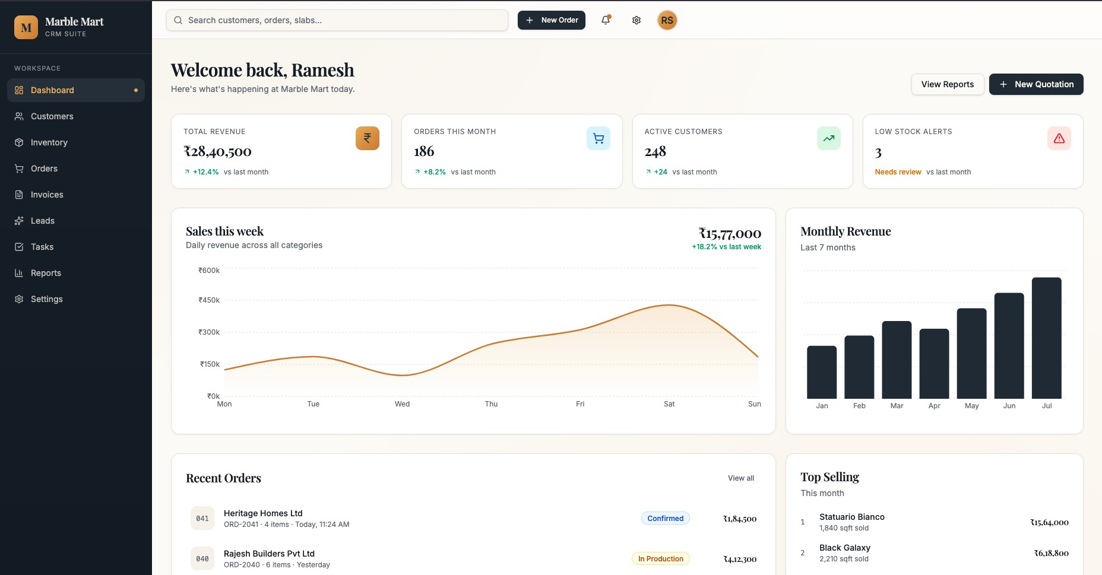
April 2026

✉ [YOUR EMAIL] ☎ [YOUR PHONE] ■ [YOUR WEBSITE] ■ [YOUR CITY]

OVERVIEW

What is Marble Mart CRM?

Marble Mart CRM is a purpose-built business management system designed exclusively for marble, granite, and tile dealers. It brings together customer management, inventory tracking, order processing, GST invoicing, and sales analytics — all in one clean, easy-to-use platform.
- Built for Marble Businesses

Designed around the real workflows of slab dealers, contractors, and retail showrooms.
- One Platform, Everything

Replaces spreadsheets, WhatsApp chats, and manual registers with a single system.
- Real-Time Visibility

Know your stock, payments, and leads at any moment — from any device.

CHALLENGES & SOLUTION

Why Marble Businesses Need a CRM
■■ Common Pain Points

- Manual order tracking leads to costly errors
- Payment follow-ups done over WhatsApp
— prone to confusion
- Inventory mismanagement causes stockouts & over-ordering
- No visibility into which products or customers drive revenue
- GST calculations and invoice generation done manually
- How CRM Solves It

- Centralised customer & order records, always up to date
- Payment status (Paid / Partial / Unpaid) tracked automatically
- Live inventory with low-stock alerts and reorder triggers
- Reports & dashboards show top products, revenue by region
- One-click GST invoice generation with auto calculations

UI SHOWCASE — DASHBOARD

Business Dashboard


- At-a-glance view of Total Revenue, Active Orders, Customers, and Low-Stock Alerts
- Weekly sales trend line with daily revenue breakdown across all product categories
- Recent orders list with status tags (Confirmed, In Production, Delivered)
- Top-selling products and Monthly Revenue bar chart for quick performance review

UI SHOWCASE — DASHBOARD

Dashboard — Activity & Low Stock

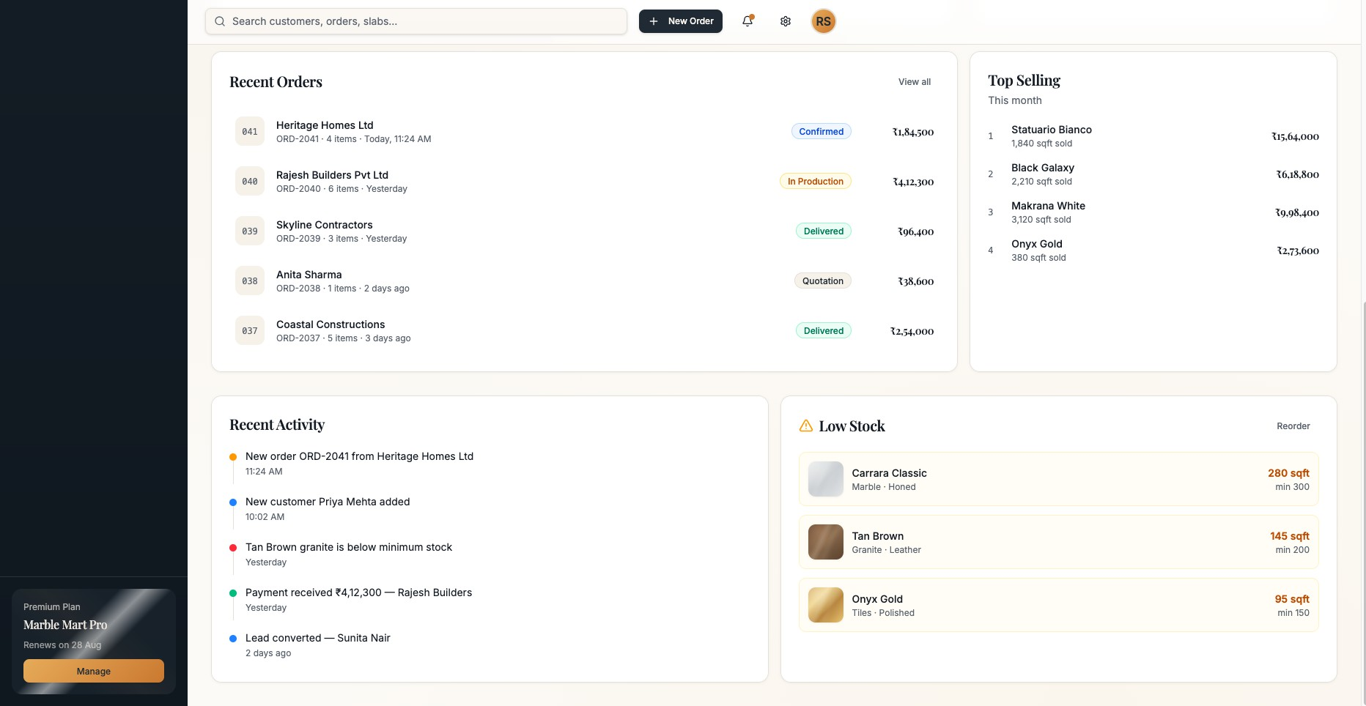 | 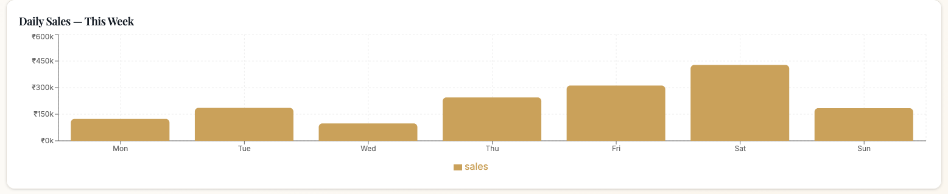
- Recent activity feed keeps the whole team in sync without extra calls
- Low-stock panel highlights items below minimum threshold with a one-click Reorder link
- Daily Sales bar chart shows peak days — helping plan staffing and promotions

UI SHOWCASE — CUSTOMERS

Customer Management
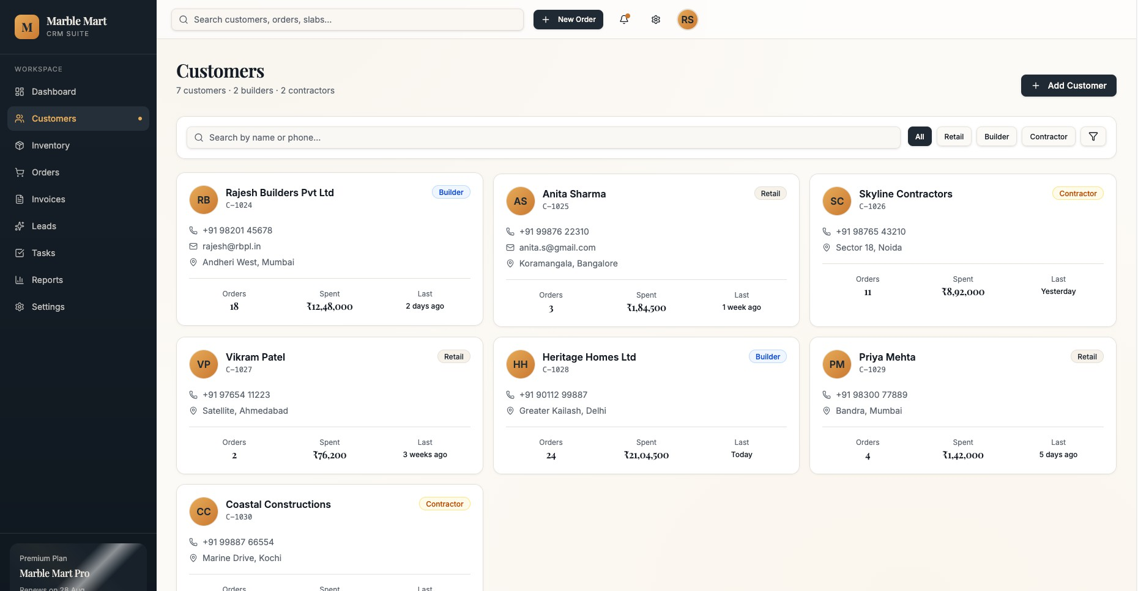

- Customer cards display type (Retail / Builder / Contractor) with contact details and location
- Quick-glance stats: total orders placed, total spend, and last order date per customer
- Filter customers by category (All / Retail / Builder / Contractor) in one click
- Add new customers instantly and link them to orders, invoices, and leads

UI SHOWCASE — INVENTORY

Inventory Management
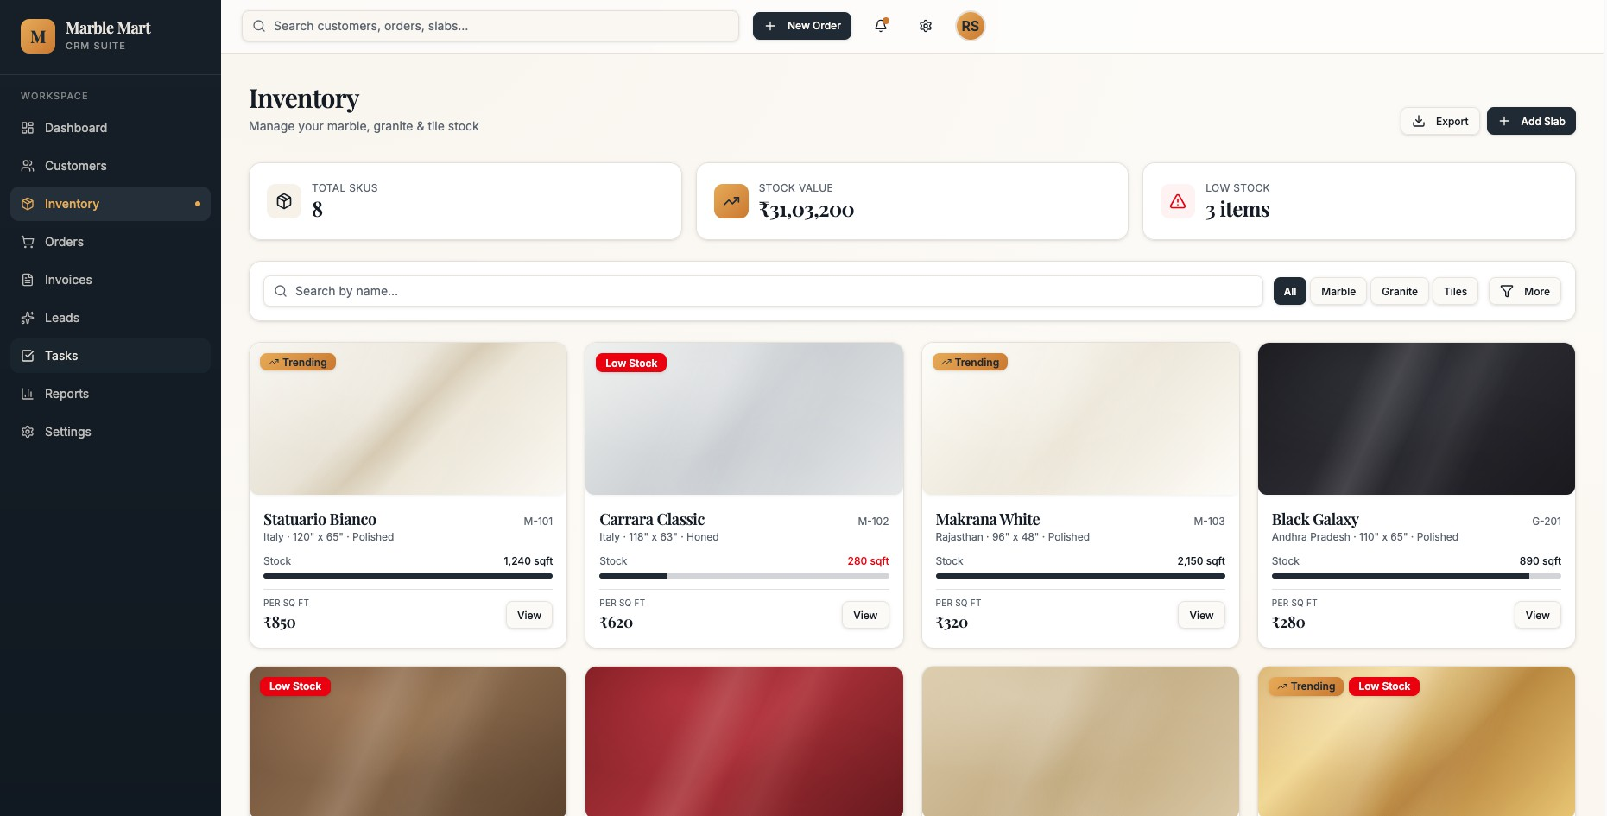

- Visual slab gallery with Trending and Low Stock badges for instant awareness
- Real-time stock levels (in sq ft) with progress bars — critical items highlighted in red
- Filter by material type: All / Marble / Granite / Tiles with search by name
- Total SKUs count and aggregate stock value visible at the top of every session

UI SHOWCASE — ORDERS

Order Management
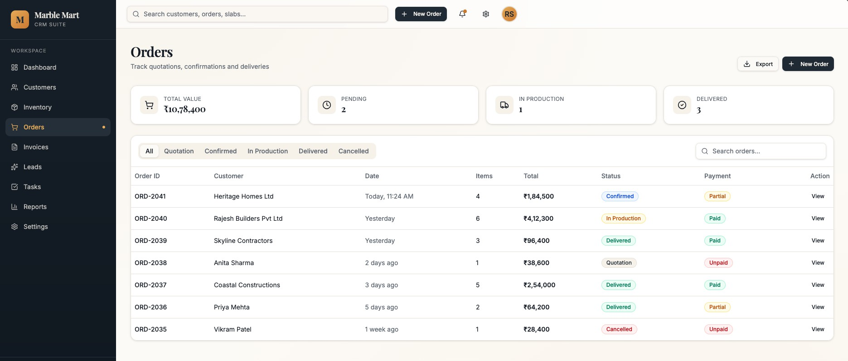

- Full order list with status pipeline: Quotation → Confirmed → In Production → Delivered
- Payment column shows Paid / Partial / Unpaid at a glance for faster collections
- Filter by status tab; export order data for accounting or logistics teams
- Quick-view summary cards: Total Value, Pending, In Production, and Delivered counts

UI SHOWCASE — INVOICES

GST Invoicing
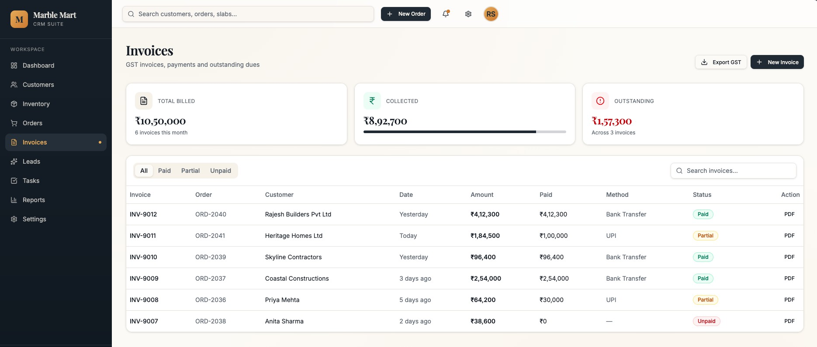

- Auto-generated GST invoices linked to each order — download as PDF instantly
- Three billing stats at the top: Total Billed, Collected, and Outstanding amounts
- Invoice list shows payment method (UPI / Bank Transfer) and status badge
- Filter by Paid, Partial, or Unpaid; export all GST data with one click

UI SHOWCASE — LEADS

Lead Tracking
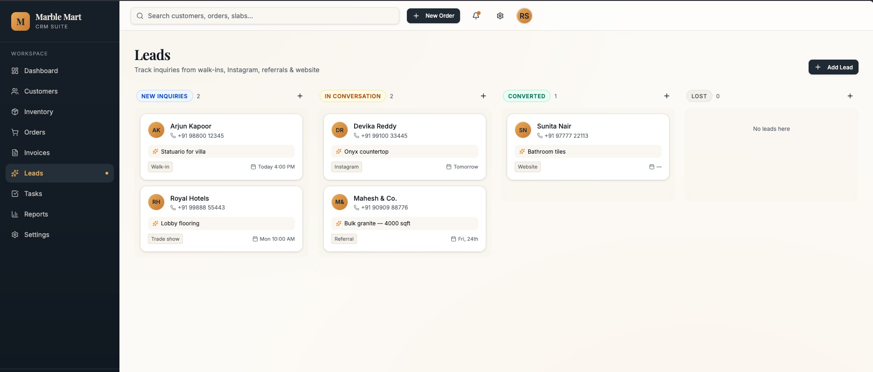

- Kanban board tracks every enquiry: New Inquiry → In Conversation → Converted → Lost
- Lead source tags (Walk-in, Instagram, Referral, Trade Show, Website) for marketing insights
- Scheduled follow-up date and time visible on every lead card
- Convert a lead to customer with a single action — no data re-entry required

UI SHOWCASE — TASKS

Daily Task Management
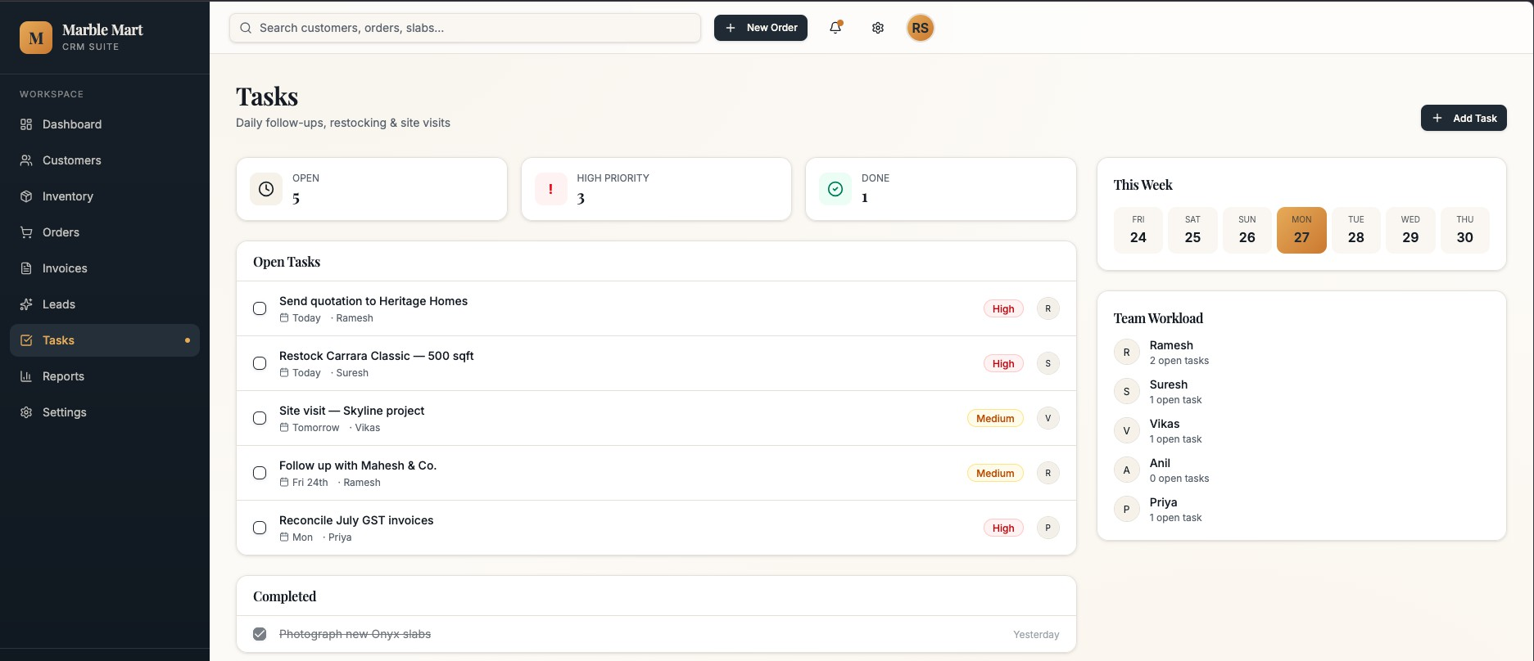

- Centralised task board for the whole team — open, high-priority, and done counts at a glance
- Each task shows due date, assigned team member, and priority level (High / Medium)
- Team Workload panel shows open task count per person for balanced assignment
- Weekly calendar view helps plan site visits, restocking, and client follow-ups

UI SHOWCASE — REPORTS

Reports & Analytics
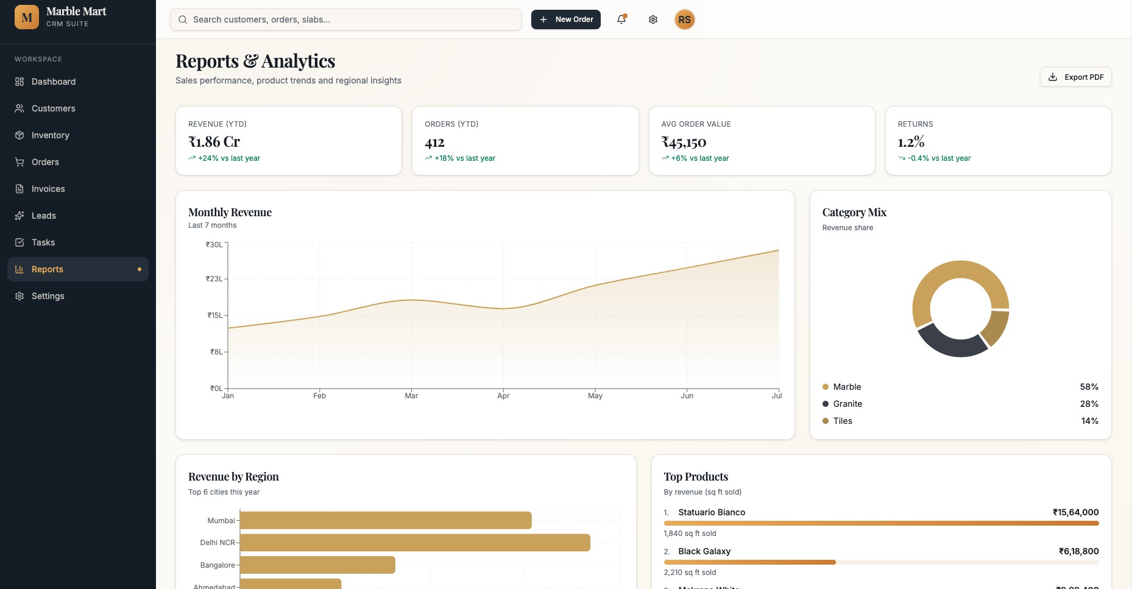

- YTD Revenue, Orders, Average Order Value, and Returns in one consolidated view
- Monthly Revenue area chart shows growth trend over the last 7 months
- Revenue by Region (top cities) and Category Mix (Marble / Granite / Tiles) donut chart
- Top Products ranked by revenue with sq ft sold — export entire report as PDF

UI SHOWCASE — SETTINGS

Business Settings
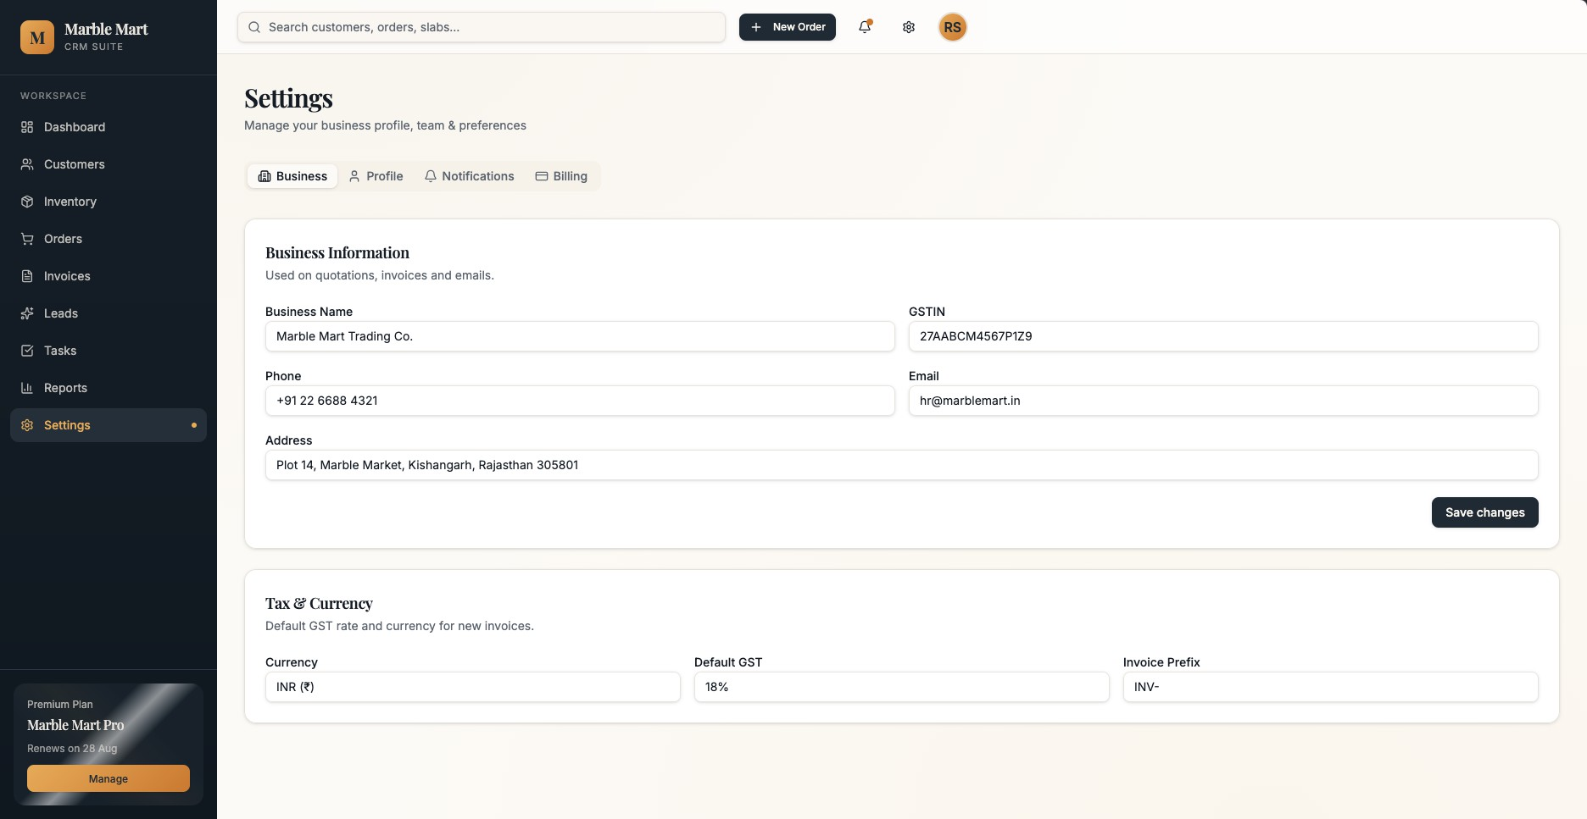

- Business profile (name, GSTIN, phone, email, address) used auto-filled on all invoices
- Tax & Currency settings: default GST rate, currency, and invoice prefix in one place
- Profile, Notifications, and Billing tabs keep all configuration organised
- Premium plan details and renewal date visible in the sidebar for easy management

KEY FEATURES

Everything Your Business Needs
- GST Invoice Generation

Auto-calculated invoices with GSTIN, ready to send or print as PDF.
- Payment Tracking

Track Paid, Partial & Unpaid status across all orders in real time.
- Lead Management

Kanban pipeline from first enquiry to converted customer.
- Inventory Control

Live stock levels, low-stock alerts, and trending product tags.
- Reports & Analytics

Revenue trends, regional insights, and top-product rankings.
- Role-Based Access

Control who sees what — separate access for sales, accounts & admin.

BUSINESS IMPACT

Benefits, Security & Roadmap
- Save Time

- Invoices generated in seconds

- Orders logged in one place

- No manual data re-entry
- Reduce Errors

- Auto GST calculations

- Real-time inventory sync

- Payment status always current
- Grow Revenue

- Never lose a lead again

- Spot top products fast

- Act on regional trends

- Security & Reliability

- Secure login with role-based access control
- Data protection — no unauthorised access to pricing or customer info
- Regular automated backups and audit trail
- SSL-encrypted data transmission at all times
- Future Enhancements

- WhatsApp integration — send quotations and invoices directly
- Native mobile app for Android & iOS
- Advanced AI-powered analytics and demand forecasting
- Multi-branch support for larger dealership networks

Ready to Transform
Your Marble Business?
One platform. Total control.
Next Step: Schedule a Live Demo and see Marble Mart CRM in action.

✉ [YOUR EMAIL] | ☎ [YOUR PHONE] | ■ [YOUR WEBSITE]
[YOUR COMPANY NAME] · [YOUR CITY] · April 2026

