PREMIUM TRAINING GUIDE
VictoriaMetrics
as an LLM Observability Backend

Concrete setup, MetricsQL, dashboards, alerts and sovereign architecture

Samuel Desseaux
Erythix
VictoriaMetrics Training Partner - France / Benelux / Germany

Table of Contents

Module 1 : Why VictoriaMetrics for LLM workloads | 3
Module 2 : Complete architecture VM + OTel | 5
Diagram 1 : Full architecture overview | 6
Module 3 : Single Node vs Cluster - choosing your deployment mode | 8
Diagram 2 : Single vs Cluster comparison | 9
Module 4 : Step-by-step installation and configuration | 11
Module 5 : LLM metrics taxonomy | 16
Diagram 3 : Complete LLM metrics taxonomy | 17
Module 6 : Python instrumentation - pushing metrics | 20
Module 7 : MetricsQL - essential queries for LLM observability | 25
Diagram 4 : MetricsQL vs PromQL - key features | 26
Module 8 : Grafana dashboards - structure and panels | 31
Diagram 5 : Recommended Grafana LLM dashboard layout | 32
Module 9 : VMAlert - production alert rules | 36
Module 10 : Recording rules - pre-aggregating cost metrics | 40
Module 11 : Optimization, retention and tuning | 43
Module 12 : Security, air-gap and compliance | 46
Module 13 : Practical labs | 48
Module 14 : References and resources | 51

MODULE 1

1. Why VictoriaMetrics for LLM Workloads

1.1 The specific challenge of LLM metrics
LLM workloads in production generate an atypical metrics profile that pushes classic monitoring backends to their limits:

LLM Characteristic | Impact on the metrics backend
High cardinality | model * provider * tenant * pipeline = thousands of timeseries. Prometheus saturates quickly.
Token histograms | Wide distributions (10 to 100k tokens/request). Very spread-out buckets.
USD cost metrics | Financial metrics requiring float precision. Aggregations by accounting period.
Long retention | Cost audits, contractual SLAs: 1-3 year retention is often required.
Ingestion bursts | A completion batch can generate 10x the normal write rate in seconds.
RAG quality metrics | Floats, distributions, scores: write-intensive, frequently read for alerting.

1.2 VictoriaMetrics vs Prometheus - head-to-head
Criteria | Prometheus | VictoriaMetrics
Cardinality | Degrades above 500k active series | Stable up to 10M+ active series
Compression | ~4:1 ratio | ~10:1 ratio (20:1 with long retention)
Write throughput | ~200k samples/s per instance | >1M samples/s on a standard instance
Long retention | Degrades after 90 days | Performant over 2+ years without manual compaction
Query language | PromQL | MetricsQL (superset: anomaly_score, median_over_time...)
Native OTLP | Via Collector only | Direct OTLP endpoint in Single mode (port 4318)
Deployment | Multiple recommended components | Single binary in Single mode
RAM footprint | 4 GB RAM / 500k series | 1 GB RAM / 500k series (4x less)
Migration | N/A | 100% Prometheus-compatible API: zero dashboard migration

1.3 Learning objectives
By the end of this guide, you will be able to:
Deploy VictoriaMetrics in Single mode in 15 minutes for an LLM development environment
Choose between Single and Cluster mode based on your actual LLM workload
Configure the OTel Collector -> VictoriaMetrics pipeline for LLM metrics collection
Instrument a Python/FastAPI application to emit the right LLM metrics
Write MetricsQL queries for 8 essential use cases (cost, quality, latency, GPU)
Build a Grafana LLM dashboard with 4 functional rows and real-time alerts
Configure VMAlert with production-grade alert rules for LLM degradations
Optimize retention, storage and recording rules to minimize infra costs

MODULE 2

2. Complete Architecture VM + OTel for LLM

2.1 Overview
The architecture below covers the full metrics collection path from LLM sources to dashboards and alerts. It is deployable in full air-gap mode.

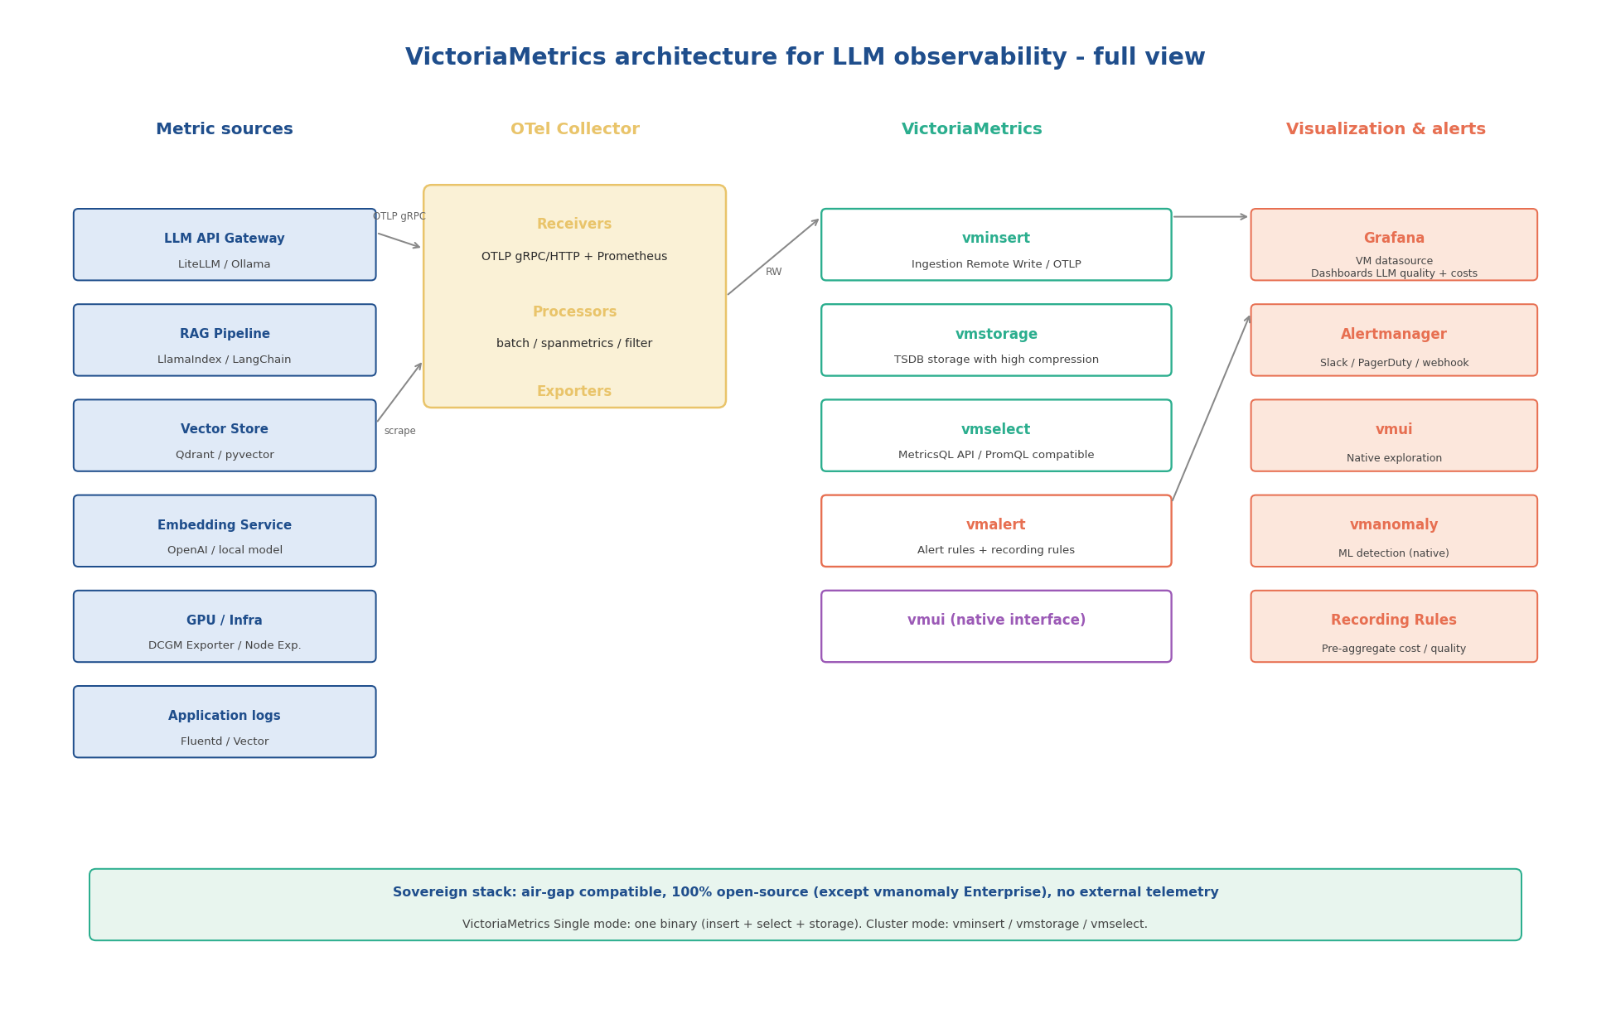
Diagram 1 : Complete VictoriaMetrics architecture for LLM observability - air-gap compatible

Key architectural points
All sources emit to the OTel Collector via OTLP (gRPC port 4317 or HTTP port 4318)
The Collector filters, enriches (k8s labels), derives metrics from traces (spanmetrics), and exports
VictoriaMetrics receives via Remote Write. In Single mode, it also accepts OTLP directly.
VMAlert evaluates MetricsQL rules and sends alerts to Alertmanager
Grafana uses VictoriaMetrics as a datasource (Prometheus-compatible, zero reconfiguration)
vmanomaly (Enterprise) adds ML-based anomaly detection on LLM metrics

2.2 Components and roles
Component | Port(s) | Role for LLM observability
OTel Collector | 4317 (gRPC), 4318 (HTTP) | Normalises and routes all metrics. spanmetrics derives metrics from RAG traces.
VictoriaMetrics Single | 8428 | TSDB storage, MetricsQL API, Remote Write, direct OTLP, built-in vmui
vmagent | 8429 | Distributed Prometheus scraping. Ideal for DCGM Exporter, vLLM /metrics, Ollama
vmalert | 8880 | Evaluation of MetricsQL alert rules. Talks to Alertmanager.
Alertmanager | 9093 | Alert routing: Slack, PagerDuty, email, webhook. Deduplication and silencing.
Grafana | 3000 | Dashboards. Uses the VictoriaMetrics plugin or standard Prometheus datasource.
vmanomaly (Enterprise) | 9090 | ML anomaly detection (ARIMA, Prophet) on LLM metrics. Optional.

MODULE 3

3. Single Node vs Cluster - Choosing Your Mode

3.1 Comparison diagram
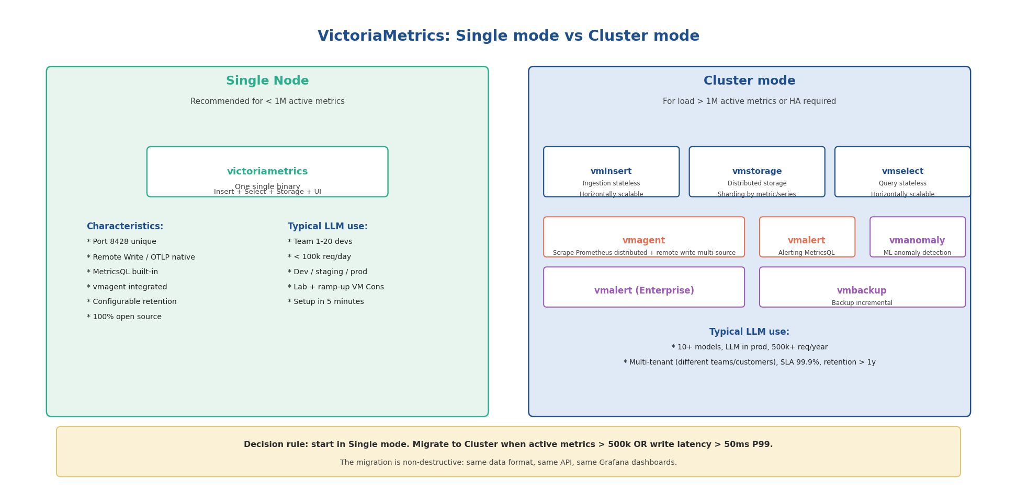
Diagram 2 : Single mode (one binary) vs Cluster mode (3 separate components) - LLM decision criteria

3.2 Decision criteria for an LLM context
Criteria | Single mode | Cluster mode
Active metrics | < 1M (recommended < 500k) | > 500k, theoretically unlimited
LLM requests/s | < 500 rps | > 500 rps or intensive multi-tenant
High availability | Not native (external solutions) | Native: replicas per component
LLM models in prod | 1 to 10 models | > 10 models or > 50 tenants
Deployment | 1 container / 1 binary | 3 Kubernetes deployments minimum
Retention | Configurable, identical | Configurable per tier (hot/warm/cold)
Ops complexity | Very low | Moderate to high
RAM required | 1-4 GB depending on load | 4 GB+ per component
License | Open source (Apache 2.0) | Open source (vminsert/vmstorage/vmselect)

Migration rule: Single to Cluster
Migrate when: active metrics > 500k OR P99 write latency > 50ms OR HA SLA required.
Migration is non-destructive: same data format, same API, same Grafana dashboards.
Procedure: vmstorage snapshot -> restore on new cluster. Zero downtime possible with vmagent.

MODULE 4

4. Installation and Configuration Step by Step

4.1 Docker Compose - full stack in 5 minutes
Development or lightweight production stack: VictoriaMetrics Single + OTel Collector + Grafana + VMAlert.

# docker-compose.yml
version: '3.8'
services:
victoriametrics:
image: victoriametrics/victoria-metrics:v1.99.0
command:
- '--storageDataPath=/var/lib/victoria-metrics-data'
- '--retentionPeriod=12' # 12 months retention
- '--httpListenAddr=:8428'
- '--search.maxQueryLen=16384' # Long MetricsQL queries
ports: ['8428:8428']
volumes:
- vm-data:/var/lib/victoria-metrics-data
otel-collector:
image: otel/opentelemetry-collector-contrib:0.99.0
command: ['--config=/etc/otel-collector-config.yaml']
volumes:
- ./otel-collector-config.yaml:/etc/otel-collector-config.yaml
ports:
- '4317:4317' # OTLP gRPC
- '4318:4318' # OTLP HTTP
depends_on: [victoriametrics]
vmagent:
image: victoriametrics/vmagent:v1.99.0
command:
- '--promscrape.config=/etc/prometheus.yml'
- '--remoteWrite.url=http://victoriametrics:8428/api/v1/write'
volumes:
- ./prometheus.yml:/etc/prometheus.yml
vmalert:
image: victoriametrics/vmalert:v1.99.0
command:
- '--datasource.url=http://victoriametrics:8428'
- '--remoteWrite.url=http://victoriametrics:8428/api/v1/write'
- '--notifier.url=http://alertmanager:9093'
- '--rule=/etc/alerts/*.yml'
volumes:
- ./alerts:/etc/alerts
alertmanager:
image: prom/alertmanager:v0.27.0
volumes: ['./alertmanager.yml:/etc/alertmanager/alertmanager.yml']
ports: ['9093:9093']
grafana:
image: grafana/grafana:10.4.0
environment:
- GF_SECURITY_ADMIN_PASSWORD=admin
- GF_INSTALL_PLUGINS=victoriametrics-metrics-datasource
ports: ['3000:3000']
volumes:
vm-data: {}

4.2 OTel Collector configuration for LLM metrics
# otel-collector-config.yaml
receivers:
otlp:
protocols:
grpc: { endpoint: 0.0.0.0:4317 }
http: { endpoint: 0.0.0.0:4318 }
prometheus:
config:
scrape_configs:
- job_name: vllm
scrape_interval: 15s
static_configs: [{ targets: ['vllm-service:8000'] }]
- job_name: ollama
scrape_interval: 15s
static_configs: [{ targets: ['ollama:11434'] }]
processors:
batch: { timeout: 5s, send_batch_size: 512 }
k8sattributes:
extract:
metadata: [k8s.pod.name, k8s.namespace.name, k8s.deployment.name]
spanmetrics:
metrics_exporter: prometheusremotewrite
latency_histogram_buckets: [50, 100, 200, 500, 1000, 2000, 5000, 10000]
dimensions:
- name: gen_ai.request.model
- name: gen_ai.system
- name: rag.index.id
- name: rag.pipeline.id
- name: rag.tenant.id
exporters:
prometheusremotewrite:
endpoint: http://victoriametrics:8428/api/v1/write
timeout: 30s
retry_on_failure: { enabled: true, initial_interval: 5s }
service:
pipelines:
metrics:
receivers: [otlp, prometheus]
processors: [k8sattributes, batch]
exporters: [prometheusremotewrite]
traces/metrics:
receivers: [otlp]
processors: [spanmetrics, batch]
exporters: [prometheusremotewrite]

4.3 vmagent - scraping DCGM and LLM endpoints
# prometheus.yml (used by vmagent)
global:
scrape_interval: 15s
external_labels:
cluster: 'prod-llm'
environment: 'production'
scrape_configs:
# DCGM Exporter - NVIDIA GPU metrics
- job_name: 'dcgm-exporter'
scrape_interval: 5s
kubernetes_sd_configs: [{ role: pod }]
relabel_configs:
- source_labels: [__meta_kubernetes_pod_label_app]
regex: dcgm-exporter
action: keep
# vLLM inference server
- job_name: 'vllm'
static_configs:
- targets: ['vllm-llama:8000', 'vllm-mistral:8001']
# Ollama (local models)
- job_name: 'ollama'
static_configs: [{ targets: ['ollama:11434'] }]
# LiteLLM proxy
- job_name: 'litellm'
static_configs: [{ targets: ['litellm-proxy:4000'] }]

MODULE 5

5. LLM Metrics Taxonomy
The taxonomy below covers the four dimensions of LLM observability: response quality, performance and latency, costs and tokens, and GPU/CPU infrastructure.

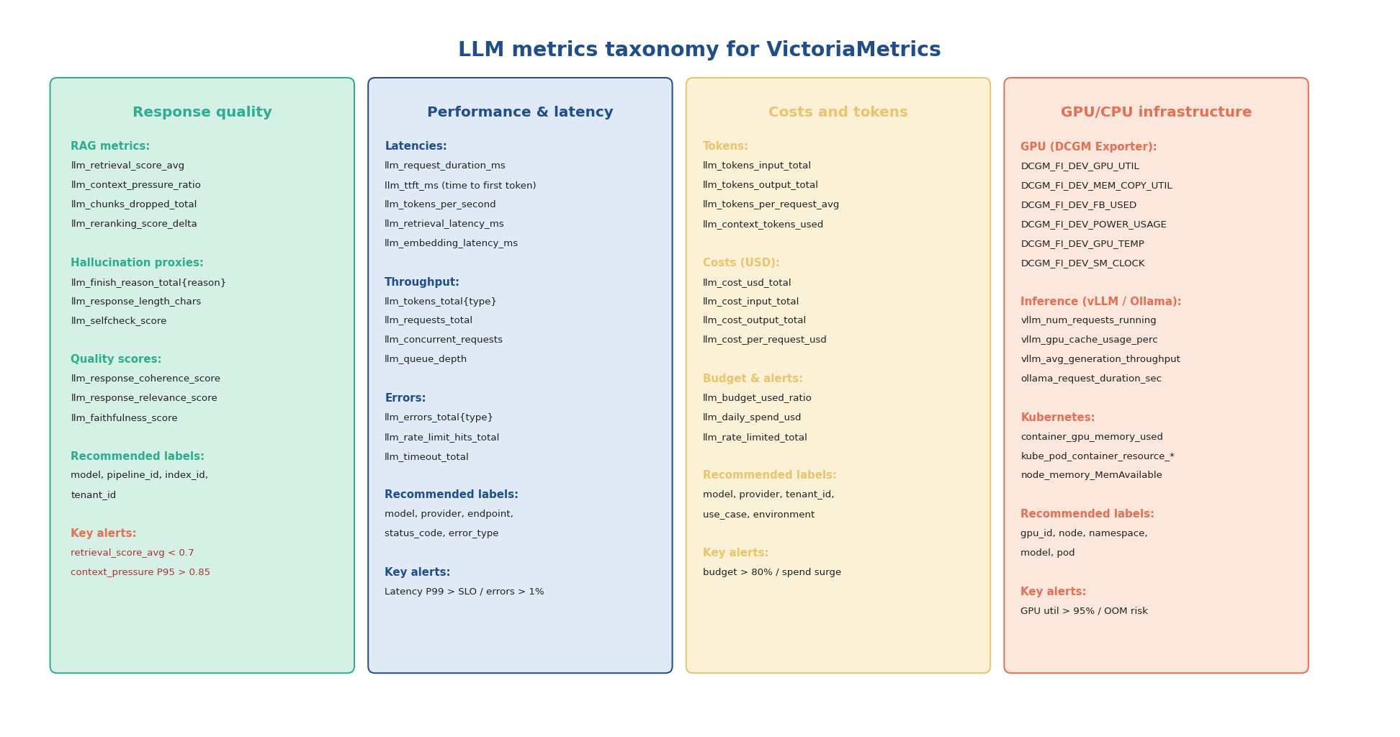
Diagram 3 : Complete LLM metrics taxonomy for VictoriaMetrics - 4 dimensions, recommended labels, alert thresholds

5.1 Recommended naming conventions
- Prefix llm_ for all LLM-specific metrics
- Prefix rag_ for retrieval-specific metrics
- Use DCGM standard names for GPU metrics (DCGM_FI_*)
- Standard suffixes: _total (counter), _seconds/_ms (latency histogram), _ratio (0-1 gauge), _bytes (gauge)

Metric | Prometheus Type | Cardinality | Essential Labels
llm_request_duration_ms | Histogram | Medium | model, provider, pipeline_id, status
llm_tokens_total{type} | Counter | Low | model, provider, type=input|output
llm_cost_usd_total | Counter | Low | model, provider, tenant_id, use_case
llm_errors_total | Counter | Medium | model, provider, error_type, status_code
llm_ttft_ms | Histogram | Medium | model, provider, stream=true|false
rag_retrieval_score_avg | Gauge | Low | index_id, pipeline_id, strategy
rag_context_pressure_ratio | Histogram | Low | pipeline_id, model, tenant_id
rag_chunks_dropped_total | Counter | Low | pipeline_id, reason
DCGM_FI_DEV_GPU_UTIL | Gauge | Low | gpu, UUID, pod, namespace, node
vllm:num_requests_running | Gauge | Low | model_name, instance

Cardinality warning: tenant_id label
If you have more than 1000 tenants, the tenant_id label can cause a cardinality explosion.
Solution: use a tenant_tier label (free/pro/enterprise) for high-frequency metrics,
and keep tenant_id only for cost metrics (llm_cost_usd_total) which have low write frequency.

MODULE 6

6. Python Instrumentation - Pushing Metrics

6.1 Setup: two complementary approaches
- Prometheus client library: /metrics endpoint exposed + scraping by vmagent. Simple, battle-tested.
- OTLP via OTel SDK: metrics AND traces in the same pipeline. Recommended for new applications.

# Option 1: prometheus_client
pip install prometheus-client
# Option 2: OTel SDK (unified metrics + traces)
pip install opentelemetry-sdk opentelemetry-exporter-otlp-proto-grpc

6.2 Prometheus client: core LLM metrics
from prometheus_client import Counter, Histogram, Gauge, start_http_server
import time
LLM_REQUESTS = Counter(
'llm_requests_total', 'Total LLM requests',
['model', 'provider', 'pipeline_id', 'status']
)
LLM_DURATION = Histogram(
'llm_request_duration_ms', 'LLM request duration in ms',
['model', 'provider', 'pipeline_id'],
buckets=[50, 100, 200, 500, 1000, 2000, 5000, 10000, 30000]
)
LLM_TOKENS = Counter(
'llm_tokens_total', 'Total tokens processed',
['model', 'provider', 'type'] # type: input|output
)
LLM_COST = Counter(
'llm_cost_usd_total', 'Total cost in USD',
['model', 'provider', 'tenant_id', 'use_case']
)
LLM_TTFT = Histogram(
'llm_ttft_ms', 'Time to first token in ms',
['model', 'provider'],
buckets=[50, 100, 200, 500, 1000, 2000, 5000]
)
RAG_RETRIEVAL_SCORE = Gauge(
'rag_retrieval_score_avg', 'Average retrieval similarity score',
['index_id', 'pipeline_id', 'strategy']
)
RAG_CONTEXT_PRESSURE = Histogram(
'rag_context_pressure_ratio', 'Context window pressure ratio (0-1)',
['pipeline_id', 'model'],
buckets=[0.1, 0.3, 0.5, 0.7, 0.8, 0.85, 0.9, 0.95, 1.0]
)
# Expose /metrics on port 9090
start_http_server(9090)

6.3 Instrumentation decorator - automatic cost tracking
import functools
TOKEN_PRICES = {
'gpt-4o': {'input': 5.0e-6, 'output': 15.0e-6},
'gpt-4o-mini': {'input': 0.15e-6, 'output': 0.6e-6},
'claude-3-5-sonnet':{'input': 3.0e-6, 'output': 15.0e-6},
'mistral-large': {'input': 4.0e-6, 'output': 12.0e-6},
}
def track_llm_call(model, provider, pipeline_id, tenant_id='default', use_case='chat'):
def decorator(func):
@functools.wraps(func)
async def wrapper(*args, **kwargs):
labels = {'model': model, 'provider': provider, 'pipeline_id': pipeline_id}
t0 = time.monotonic()
status = 'success'
try:
result = await func(*args, **kwargs)
if hasattr(result, 'usage'):
in_tok = result.usage.prompt_tokens
out_tok = result.usage.completion_tokens
LLM_TOKENS.labels(model=model, provider=provider, type='input').inc(in_tok)
LLM_TOKENS.labels(model=model, provider=provider, type='output').inc(out_tok)
if model in TOKEN_PRICES:
p = TOKEN_PRICES[model]
cost = in_tok * p['input'] + out_tok * p['output']
LLM_COST.labels(model=model, provider=provider,
tenant_id=tenant_id, use_case=use_case).inc(cost)
return result
except Exception as e:
status = type(e).__name__
raise
finally:
LLM_DURATION.labels(**labels).observe((time.monotonic()-t0)*1000)
LLM_REQUESTS.labels(**labels, status=status).inc()
return wrapper
return decorator
@track_llm_call(model='gpt-4o', provider='openai', pipeline_id='support-rag', tenant_id='acme')
async def call_llm(messages: list) -> dict:
return await openai_client.chat.completions.create(model='gpt-4o', messages=messages)

MODULE 7

7. MetricsQL - Essential Queries

7.1 MetricsQL features for LLM observability
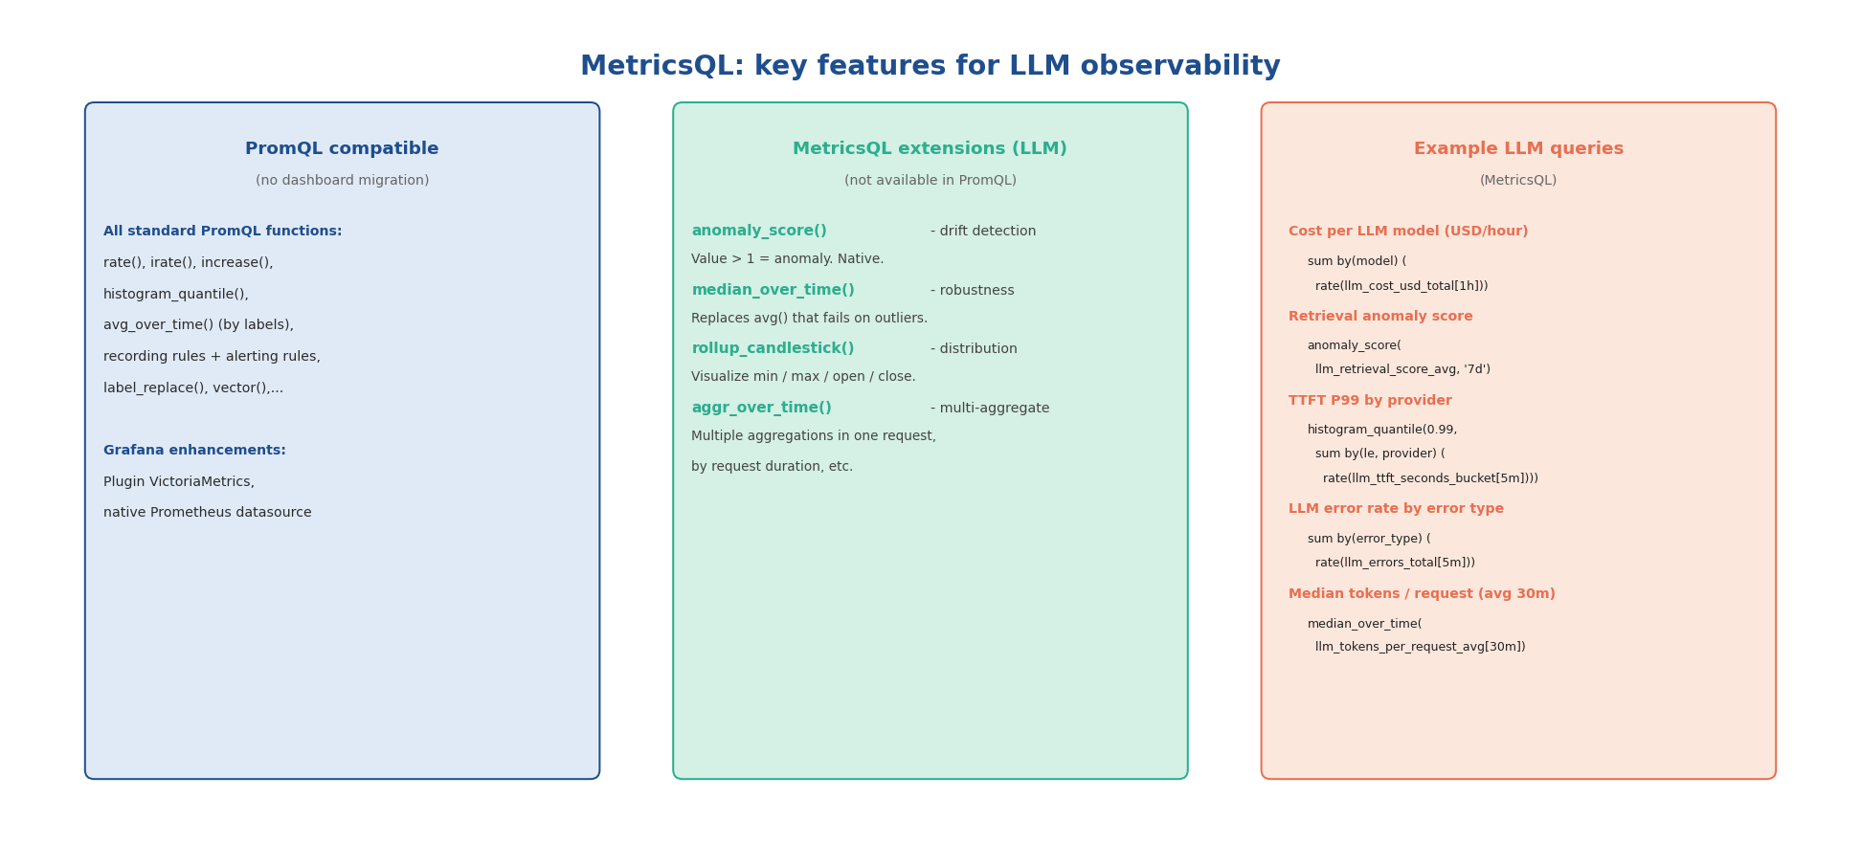
Diagram 4 : MetricsQL vs PromQL - key features for LLM workloads

7.2 Cost and token queries

Hourly LLM cost by model (USD)
sum by (model, provider) (increase(llm_cost_usd_total[1h]))

Daily cost projection (extrapolated from last 30 minutes)
sum by (model) (rate(llm_cost_usd_total[30m])) * 86400

Top 10 tenants by cost (last 24h)
topk(10, sum by (tenant_id) (increase(llm_cost_usd_total[24h])))

Input/output token ratio (detect outlier requests)
sum(rate(llm_tokens_total{type='output'}[5m])) / sum(rate(llm_tokens_total{type='input'}[5m]))

7.3 RAG quality queries

Retrieval score anomaly - index drift detection
# anomaly_score: value > 1 = significant deviation vs 7-day baseline
anomaly_score(
avg by (index_id) (rag_retrieval_score_avg),
'7d'
)

Context pressure P95 by pipeline
histogram_quantile(0.95,
sum by (le, pipeline_id) (
rate(rag_context_pressure_ratio_bucket[10m])
)
)

Requests with dropped chunks (%)
sum by (pipeline_id) (rate(rag_chunks_dropped_total[5m]))
/
sum by (pipeline_id) (rate(llm_requests_total[5m]))
* 100

7.4 Performance and latency queries

End-to-end P99 latency by model
histogram_quantile(0.99,
sum by (le, model, provider) (
rate(llm_request_duration_ms_bucket[5m])
)
)

TTFT P95 - time to first token (critical for streaming)
histogram_quantile(0.95,
sum by (le, model) (rate(llm_ttft_ms_bucket[5m]))
)

GPU energy efficiency - tokens per watt
sum by (model) (rate(llm_tokens_total{type='output'}[5m]))
/
avg by (model) (DCGM_FI_DEV_POWER_USAGE)

MODULE 8

8. Grafana Dashboards - Structure and Panels
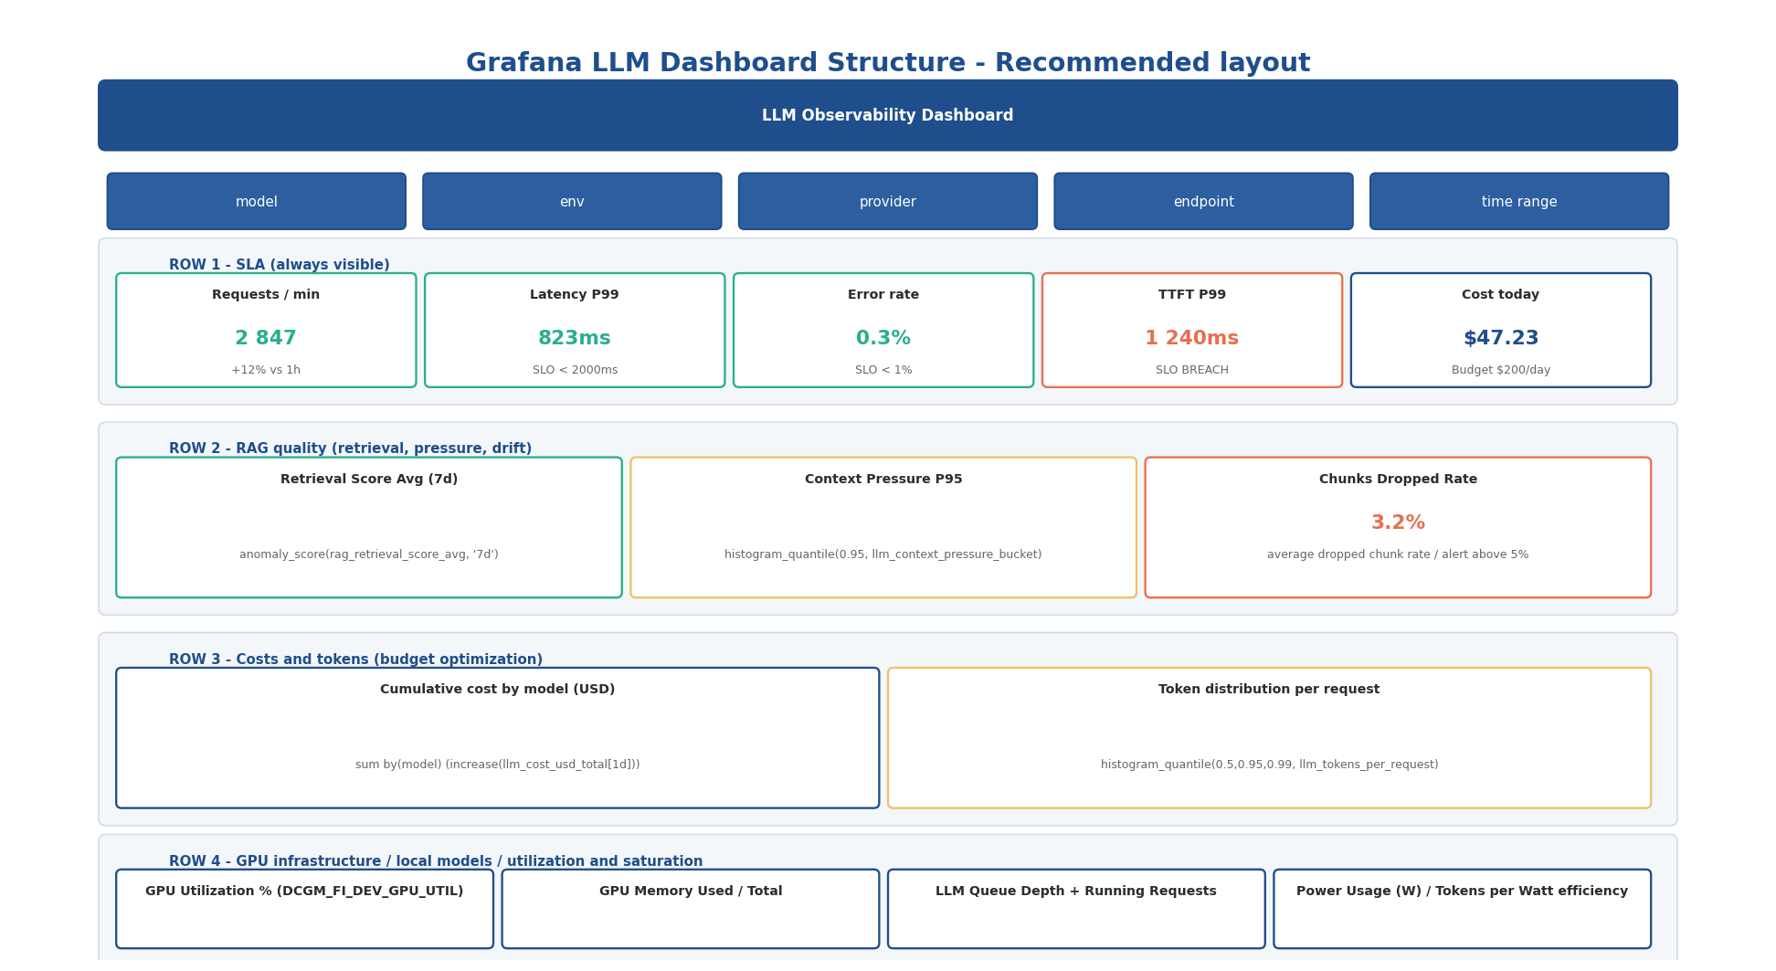
Diagram 5 : Grafana LLM dashboard layout - 4 functional rows with MetricsQL queries

8.1 Datasource configuration
# Auto-provision datasource (grafana/provisioning/datasources/vm.yaml)
apiVersion: 1
datasources:
- name: VictoriaMetrics
type: victoriametrics-metrics-datasource
url: http://victoriametrics:8428
access: proxy
isDefault: true
jsonData:
timeInterval: '15s'

8.2 Template variables
# Variable 'model': list of active models
label_values(llm_requests_total, model)
# Variable 'provider'
label_values(llm_requests_total{model=~'$model'}, provider)
# Variable 'pipeline_id'
label_values(rag_retrieval_score_avg, pipeline_id)

8.3 Recommended panel types per metric
Metric | Panel type | Key options
Requests/min (SLA) | Stat + sparkline | Thresholds: green >0, orange if drift >20%
P99 latency | Stat + threshold | Absolute thresholds per contractual SLO
Error rate | Stat + threshold | Red >1%, orange >0.5%
Retrieval score 7 days | Time series | anomaly_score line + 0.70 threshold
Context pressure P95 | Time series + threshold | Red zone above 0.85
Cumulative cost by model | Stacked area time series | Color per model, USD unit
Token distribution | Heatmap or Histogram | Visualise outliers (abnormally long requests)
GPU utilisation | Gauge + threshold | Orange threshold at 80%, red at 95%
vLLM queue depth | Time series | Alert if >10 requests waiting
Anomaly score | Time series | Threshold at 1.0 (significant deviation)

MODULE 9

9. VMAlert - Production Alert Rules

9.1 Complete production ruleset
# alerts/llm-quality.yml
groups:
- name: llm_quality
interval: 1m
rules:
# RAG index drift
- alert: RAGIndexDrift
expr: |
avg by (index_id, pipeline_id) (
avg_over_time(rag_retrieval_score_avg[1h])
) < 0.70
for: 15m
labels: { severity: warning, team: ai-platform }
annotations:
summary: 'RAG index drift on {{ $labels.index_id }}'
description: |
Mean retrieval score = {{ $value | printf "%.2f" }} < threshold 0.70
for 15m on pipeline {{ $labels.pipeline_id }}.
Action: check for document updates without re-indexing.
runbook_url: 'https://wiki.internal/runbooks/rag-index-drift'
# Context pressure critical
- alert: RAGContextPressureHigh
expr: |
histogram_quantile(0.95,
sum by (le, pipeline_id) (
rate(rag_context_pressure_ratio_bucket[10m])
)
) > 0.85
for: 5m
labels: { severity: warning, team: ai-platform }
annotations:
summary: 'High context pressure P95: {{ $labels.pipeline_id }}'
description: 'P95 = {{ $value | printf "%.2f" }}. Reduce system prompt or increase context window.'
# High LLM error rate
- alert: LLMHighErrorRate
expr: |
sum by (model, provider) (rate(llm_errors_total[5m]))
/
sum by (model, provider) (rate(llm_requests_total[5m]))
> 0.01
for: 3m
labels: { severity: critical, team: ai-platform }
annotations:
summary: 'Error rate > 1% on {{ $labels.model }} / {{ $labels.provider }}'
description: 'Current rate: {{ $value | printf "%.1f" }}%. Check provider availability.'
# Latency SLO breach
- alert: LLMLatencySLOBreach
expr: |
histogram_quantile(0.99,
sum by (le, model, pipeline_id) (
rate(llm_request_duration_ms_bucket[5m])
)
) > 5000
for: 5m
labels: { severity: critical, team: ai-platform }
annotations:
summary: 'P99 latency SLO breach on {{ $labels.model }}'
description: 'P99 = {{ $value | printf "%.0f" }}ms > SLO 5000ms. Pipeline {{ $labels.pipeline_id }}'
# GPU memory saturation
- alert: GPUMemorySaturation
expr: DCGM_FI_DEV_FB_USED / DCGM_FI_DEV_FB_TOTAL * 100 > 90
for: 2m
labels: { severity: warning, team: mlops }
annotations:
summary: 'GPU {{ $labels.gpu }} memory saturated ({{ $value | printf "%.0f" }}%)'
description: 'OOM risk. Reduce batch size or model context window.'
# Daily LLM budget
- alert: LLMDailyBudgetWarning
expr: |
sum by (tenant_id) (
increase(llm_cost_usd_total[24h])
) > 80
labels: { severity: warning, team: billing }
annotations:
summary: 'LLM budget at 80% for tenant {{ $labels.tenant_id }}'
description: '24h cost = ${{ $value | printf "%.2f" }}. Threshold: $100/day.'

9.2 Alertmanager routing by team
# alertmanager.yml
route:
group_by: ['alertname', 'model', 'pipeline_id']
group_wait: 30s
repeat_interval: 12h
receiver: 'default'
routes:
- matchers: [severity='critical']
receiver: pagerduty
- matchers: [team='ai-platform']
receiver: slack-ai-platform
- matchers: [team='billing']
receiver: slack-billing
receivers:
- name: 'default'
slack_configs:
- channel: '#llm-ops-alerts'
title: '{{ .CommonAnnotations.summary }}'
text: '{{ .CommonAnnotations.description }}'
- name: 'pagerduty'
pagerduty_configs:
- routing_key: 'YOUR_PAGERDUTY_KEY'

MODULE 10

10. Recording Rules - Pre-aggregating Cost Metrics
Cost metrics are queried very frequently in dashboards. Recalculating increase(llm_cost_usd_total[24h]) on every refresh is CPU-intensive. Recording rules pre-compute these aggregations in the background, yielding a 10-100x performance improvement.

# alerts/recording-rules.yml
groups:
- name: llm_recording_rules
interval: 1m
rules:
- record: llm:cost_usd:rate1h
expr: |
sum by (model, provider, tenant_id) (
increase(llm_cost_usd_total[1h])
)
- record: llm:cost_usd:rate24h
expr: |
sum by (model, provider, tenant_id) (
increase(llm_cost_usd_total[24h])
)
- record: llm:error_rate:ratio5m
expr: |
sum by (model, provider) (rate(llm_errors_total[5m]))
/
sum by (model, provider) (rate(llm_requests_total[5m]))
- record: llm:request_duration_ms:p99_5m
expr: |
histogram_quantile(0.99,
sum by (le, model, pipeline_id) (
rate(llm_request_duration_ms_bucket[5m])
)
)
- record: llm:ttft_ms:p95_5m
expr: |
histogram_quantile(0.95,
sum by (le, model) (rate(llm_ttft_ms_bucket[5m]))
)
- record: rag:retrieval_score:avg30m
expr: |
avg by (index_id, pipeline_id) (
avg_over_time(rag_retrieval_score_avg[30m])
)
- record: rag:context_pressure:p95_10m
expr: |
histogram_quantile(0.95,
sum by (le, pipeline_id) (
rate(rag_context_pressure_ratio_bucket[10m])
)
)
- record: gpu:memory_utilization:ratio
expr: DCGM_FI_DEV_FB_USED / DCGM_FI_DEV_FB_TOTAL

Using recording rules in alerts and dashboards
Once defined, use recording rules in alerts and dashboards instead of the full query:
Instead of: histogram_quantile(0.99, sum by(le,model)(rate(llm_request_duration_ms_bucket[5m])))
Use: llm:request_duration_ms:p99_5m
The query is 50x faster and the result is identical.

MODULE 11

11. Optimization, Retention and Tuning

11.1 Retention policy by metric type
Metric type | Recommended retention | Justification | VM flag
USD cost metrics | 2-3 years | Accounting audit, contractual SLAs | --retentionPeriod=24m
RAG quality scores | 6-12 months | Long-term drift detection | --retentionPeriod=12m
Latency and throughput | 3-6 months | Performance trending | --retentionPeriod=6m
GPU metrics | 1-3 months | Capacity planning | --retentionPeriod=3m
OTel traces (Jaeger) | 7-30 days | Debug, no long-term audit | Jaeger TTL config

11.2 Cardinality optimisation
- Never label by trace_id, request_id or session_id - infinite cardinality.
- Restrict tenant_id to cost metrics only (not for latency or token metrics).
- Group similar models under a model_family label if more than 20 active versions.
- Use adapted histogram buckets for tokens: [10, 100, 500, 1000, 4096, 16384, 65536].

# Monitor cardinality in VictoriaMetrics
# Via API: http://victoriametrics:8428/api/v1/status/tsdb
# Top 10 metrics by cardinality (MetricsQL)
topk(10, count by (__name__) ({__name__!=""}))

11.3 VictoriaMetrics tuning flags for LLM production
victoriametrics \
--storageDataPath=/var/lib/vm-data \
--retentionPeriod=12 \
--httpListenAddr=:8428 \
--maxInsertRequestSize=32MB \ # Batch LLM writes
--search.maxQueryLen=16384 \ # Long MetricsQL queries
--search.maxSamplesPerQuery=1e9 \ # Large time windows for cost audit
--memory.allowedPercent=60 \ # Leave 40% for the kernel
--loggerLevel=INFO \
--loggerFormat=json

MODULE 12

12. Security, Air-Gap and Compliance

12.1 Authentication and access control
- VictoriaMetrics has no native authentication. Use vmauth (open-source) or an Nginx reverse proxy.
- vmauth supports role-based routing: read-only for Grafana, write-only for OTel Collector, admin for ops.
- Kubernetes NetworkPolicy: restrict access to VM ports to authorised components only.

# vmauth config
users:
- username: grafana
password: '${GRAFANA_PASSWORD}'
url_prefix:
- 'http://victoriametrics:8428/api/v1/query'
- 'http://victoriametrics:8428/api/v1/query_range'
- username: otel-collector
password: '${OTEL_PASSWORD}'
url_prefix:
- 'http://victoriametrics:8428/api/v1/write'

12.2 Compliance checklist for LLM metrics
Compliance point | Recommended implementation
PII in metrics | Never label with user query content. Use opaque IDs only.
Cost audit (GDPR/NIS2) | 3-year retention on llm_cost_usd_total. Monthly CSV export.
Encryption in transit | TLS on all VM endpoints in production (vmauth or reverse proxy).
Multi-tenant isolation | vmauth for per-tenant access segmentation. Grafana Teams + RBAC.
Backup | vmbackup incremental to S3-compatible storage (MinIO for air-gap).
Dashboard access | Grafana with SSO (LDAP, OIDC). Viewer-only for business teams.

MODULE 13

13. Practical Labs

Lab 1 - Deploy the stack and ingest first metrics
Goal
Deploy the complete Docker Compose stack (VM + OTel Collector + Grafana + VMAlert).
Ingest metrics from the provided LLM simulator script. Verify in vmui and Grafana.
Estimated time: 30 minutes | Level: beginner

- Clone the repo and start the stack
git clone https://github.com/erythix4/aiobs-lab
cd aiobs-lab/labs/victoriametrics-llm
docker compose up -d
docker compose ps # verify all services are UP

- Run the LLM simulator
python simulate_llm_metrics.py --rps 10 --models 3 --duration 300

- Check in vmui (http://localhost:8428/vmui)
Query: sum by (model) (rate(llm_requests_total[1m])) * 60

- Import the Grafana dashboard
Import from: aiobs-lab/labs/victoriametrics-llm/grafana/dashboard-llm-prod.json

Lab 2 - Write 5 MetricsQL queries
Goal
Using metrics generated by the simulator, write the 5 core production queries.
Validate them in vmui, then add them to a Grafana dashboard.
Estimated time: 40 minutes | Level: intermediate

- Total cost by model over the last 24 hours
- TTFT P95 by provider (histogram_quantile)
- RAG retrieval score anomaly (anomaly_score)
- Top 5 tenants by cost (topk + increase)
- GPU efficiency: tokens per watt (metric division)

Lab 3 - Configure a production alert
Goal
Configure the RAGIndexDrift alert in VMAlert. Test it by injecting a score degradation.
Verify the notification in the test Slack channel.
Estimated time: 25 minutes | Level: intermediate

- Copy and adapt alerts/llm-quality.yml with your test Slack webhook
- Reload VMAlert: docker compose restart vmalert
- Inject a score degradation: python simulate_llm_metrics.py --score-drift 0.5
- Verify in VMAlert UI (http://localhost:8880) that the alert fires after 15 min
- Confirm receipt in Slack

Lab 4 - Recording rules and performance
Goal
Add the 5 essential recording rules. Compare query response times with and without
recording rules via the VictoriaMetrics API.
Estimated time: 20 minutes | Level: advanced

Lab 5 - Backup, vmauth and air-gap (bonus, Module 12 hands-on)
Goal Add MinIO (S3-compatible storage), vmbackup runner and vmauth multi-role reverse proxy. Run a full restore drill from the backup.
Estimated time: 35 minutes | Level: advanced

- Start the air-gap overlay:
make lab5-airgap
# Or directly:
docker compose -f docker-compose.yml -f airgap/docker-compose.airgap.yml up -d

- Verify backups land in MinIO -- open http://localhost:9001 (admin / admin12345). Bucket vm-backups/auto fills within 5-6 minutes.
- Verify vmauth multi-role authentication:
# Read-only role (Grafana)
curl -u grafana:grafana-password 'http://localhost:8427/api/v1/query?query=up'

# Write-only role (OTel collector)
echo 'demo_metric 1' | curl -u otel-collector:otel-password \
--data-binary @- 'http://localhost:8427/api/v1/write'

# Admin role -- everything
curl -u admin:admin-password 'http://localhost:8427/-/healthy'

- Run the disaster-recovery drill (wipe VM data and restore from MinIO). See solutions/lab5-backup-airgap.md for the exact vmrestore command.

Lab 6 - MetricsQL functions PromQL cannot do (VM-differentiator)
Goal Demonstrate six MetricsQL functions that have no PromQL equivalent. Each one solves a real LLM observability problem.
Estimated time: 30 minutes | Level: intermediate

Open vmui (http://localhost:8428/vmui) and try the six queries below. Reference solutions in solutions/lab6-metricsql-exclusive.md.
# | Function | What it solves
1 | anomaly_score (vmanomaly Enterprise) / manual z-score in OSS | Drift detection without static thresholds
2 | outliers_iqr(q) | Light up only the model whose latency just broke -- empty when nothing is abnormal
3 | share_le_over_time(m[d], threshold) | Direct answer to '% time below SLO'
4 | quantiles_over_time("phi", 0.5, 0.95, 0.99, m[d]) | P50/P95/P99 from a gauge in ONE query
5 | histogram_avg(rate(m_bucket[5m])) | Mean from a histogram, label-mismatch tolerant
6 | keep_last_value(m) | Carry last value forward across scrape gaps

Bonus -- range_normalize(...) lets you overlay metrics on different scales on a single chart.

Lab 7 - Cardinality observation and remediation (VM-differentiator)
Goal Use VictoriaMetrics' native /api/v1/status/tsdb endpoint to detect cardinality issues. Inject high cardinality on purpose, observe, then remediate via vmagent relabeling.
Estimated time: 30 minutes | Level: advanced

- Inject 5000 high-cardinality demo series:
make lab7-explode # or: bash scripts/cardinality_explosion.sh

- Observe via VM-native endpoints (no exporter needed):
# Top 10 labels by cardinality
curl -s 'http://localhost:8428/api/v1/status/tsdb?topN=10' | jq '.data.seriesCountByLabelName'

# Open vmui Cardinality tab:
# http://localhost:8428/vmui/#/?tab=cardinality

- Remediate (3 strategies, see solutions/lab7-cardinality.md):
- A. labeldrop the offending label at scrape time (trace_id, request_id, session_id)
- B. Group fine-grained values into a coarse model_family label
- C. Restrict tenant_id to cost metrics only
- Cleanup: make lab7-cleanup

Lab 8 - vmagent stream aggregation (VM-differentiator)
Goal Pre-roll cost metrics AT INGESTION (not at query time). Reduce cardinality 10x before the data lands in VM. Pattern impossible in plain Prometheus.
Estimated time: 25 minutes | Level: advanced

IMPORTANT flag-name correction -- in vmagent v1.99 the flag is -remoteWrite.streamAggr.config (per remoteWrite), not -streamAggr.config. The latter does not exist and will cause vmagent to crash-loop with 'flag provided but not defined'.
- Enable stream aggregation:
make lab8-streamaggr # uncomments the flag in docker-compose.yml and restarts vmagent

- After 1 minute (lab interval shortened to 1m for visibility), query the rolled metric:
# In vmui:
llm:cost_usd:agg1h
llm:requests:agg1m
llm:tokens:agg1m

- Compare cardinality before vs after:
curl -s 'http://localhost:8428/api/v1/series/count?match[]=llm_cost_usd_total'
curl -s 'http://localhost:8428/api/v1/series/count?match[]={__name__="llm:cost_usd:agg1h"}'

Production retention strategy: keep raw llm_cost_usd_total for 7-day debug, keep llm:cost_usd:agg1h for 36-month cost audit. Same metric, two retentions, impossible in plain Prometheus.

MODULE 13B

13B. Lab evolution notes (v1.6+)

13B.1 Three ingestion paths run side by side
The lab now demonstrates THREE distinct ways to land the same metric names in VictoriaMetrics, so trainees can compare patterns directly. Row 3 of the VM Differentiators dashboard plots all three P99 latencies next to each other.
Path | Source | Distinguishing label
Path A -- Prometheus client | llm-simulator (prometheus_client) -> vmagent scrape -> VM remote_write | job=llm-simulator
Path B -- OTLP metric push | llm-app (OTel SDK) -> OTLP gRPC -> OTel collector -> VM remote_write | service_name=llm-demo-app, suffix _milliseconds
Path C -- OTLP traces -> spanmetrics | llm-app traces -> spanmetrics CONNECTOR -> RED metrics -> VM | metric duration_milliseconds, dims gen_ai_*, rag_*

13B.2 OTel Collector spanmetrics is now a connector
In OTel Collector >= 0.96, spanmetrics moved from being a processor to a connector. The lab uses the 0.99 image, so the configuration in the guide (spanmetrics under processors:) needs to be moved under connectors: with a separate metrics/spanmetrics pipeline. The corrected snippet:
connectors:
spanmetrics:
histogram:
explicit:
buckets: [50ms, 100ms, 200ms, 500ms, 1s, 2s, 5s, 10s]
dimensions:
- name: gen_ai.request.model
- name: gen_ai.system
- name: rag.index.id
- name: rag.pipeline.id
- name: rag.tenant.id

service:
pipelines:
traces:
receivers: [otlp]
exporters: [spanmetrics]
metrics/spanmetrics:
receivers: [spanmetrics]
exporters: [prometheusremotewrite]

13B.3 Demo loaders -- make every panel show its value
Many VM Differentiators panels are flat in nominal regime, by design (outliers_iqr returns empty, share_le_over_time stays at 0%). The lab ships with demo loader scripts that create exactly the right signal so each row visualizes its feature within 30-60 seconds.
Command | Triggers | Time to visible
make demo-row1 | MetricsQL row -- RAG drift + latency outlier on gpt-4o | 30 s
make demo-row2 | Stream aggregation row -- enables --remoteWrite.streamAggr.config | 60 s
make demo-row3 | OTel histograms row -- verifies llm-app + bursts traffic | 30 s
make demo-row4 | Cardinality row -- pushes 5000 demo series | 5 s
make demo-all | All four in sequence (full live POC demo) | 60 s
make demo-clean | Reverts everything | 30 s

13B.4 Diagnostic and verification commands
Command | What it does
make diagnose | 5-step end-to-end health check
make inspect | Tests every panel query and reports [EMPTY]
make diag-vmagent | vmagent status + logs + targets + reachability
make diag-otel | llm-app health + OTel labels actually present + collector logs
make diag-simulator | Which simulator container is actually producing metrics

13B.5 Four Grafana dashboards (Home + 3 audiences)
Grafana now ships with FOUR dashboards (Home + 3 audience-specific). Grafana home page redirects to the Home dashboard via GF_USERS_HOME_DASHBOARD_UID.
Dashboard | UID | Audience
Home -- VictoriaMetrics LLM Lab | lab-home | Everyone (landing page with navigation)
LLM Observability -- Production | llm-prod | Business / LLM Ops (KPIs, SLO, cost)
VM Ops -- Cardinality & Performance | vm-ops | SRE / Platform (vm_* self-metrics)
VM Differentiators -- Demo & Training | vm-diff | POC / sales / trainer (Lab 6/7/8 panels)

13B.6 OTLP exporter histograms in llm-app
The OTLP-instrumented FastAPI app (llm-app, Module 6.1) uses default explicit-bucket histogram aggregation. Exponential histogram aggregation (ExponentialBucketHistogramAggregation) was investigated but is experimental in OTel Python SDK 1.25 and silently fails to flush via PeriodicExportingMetricReader. The View configuration is parked in app/otel_views.py for the day the SDK API stabilizes.
Note also: when the OTel exporter sends a histogram with an instrument unit (e.g. unit="ms"), the prometheusremotewrite exporter appends the unit name to the metric. So llm_request_duration_ms (unit=ms) is exposed in VM as llm_request_duration_ms_milliseconds_bucket. Filter on this name in your dashboards.

13B.7 Companion documents
Document | Audience | Content
TESTING.md | Tester walkthrough | 25-min step-by-step from clone to populated dashboards, with expected values
ARCHITECTURE.md | Architect / SRE | 15 sections: components, data flows, scaling, security, failure modes (~795 lines)
solutions/lab2-queries.md | Trainee | Reference solutions for the 5 MetricsQL queries
solutions/lab4-recording-rules.md | Trainee | Speed-up benchmarks before/after recording rules
solutions/lab5-backup-airgap.md | Trainee / SRE | vmbackup / vmrestore / vmauth multi-role drill
solutions/lab6-metricsql-exclusive.md | Trainee | 6 MetricsQL queries PromQL cannot do, with line-by-line explanation
solutions/lab7-cardinality.md | Trainee / SRE | Cardinality detection + 3 remediation strategies
solutions/lab8-stream-aggregation.md | Trainee / SRE | Stream aggregation production patterns

13B.8 Quick start (one-liner)
git clone https://github.com/erythix4/VMLLM.git
cd VMLLM
make up # 9-container stack
sleep 60
make diagnose # 5-step health check
make demo-all # populate every demo panel

# then open:
# http://localhost:3000 (admin/admin) -- 4 dashboards
# http://localhost:8428/vmui -- MetricsQL playground
# http://localhost:8880 -- vmalert state
# http://localhost:8001/health -- llm-app OTLP demo

MODULE 14

14. References and Resources

Official VictoriaMetrics documentation
Resource | URL
VictoriaMetrics Documentation | docs.victoriametrics.com
MetricsQL Reference | docs.victoriametrics.com/metricsql
vmagent | docs.victoriametrics.com/vmagent
vmalert | docs.victoriametrics.com/vmalert
vmauth | docs.victoriametrics.com/vmauth
vmanomaly | docs.victoriametrics.com/anomaly-detection
GitHub VictoriaMetrics | github.com/VictoriaMetrics/VictoriaMetrics

Integrations and tools
Tool | URL / Reference
OTel Collector Contrib | github.com/open-telemetry/opentelemetry-collector-contrib
DCGM Exporter (GPU) | github.com/NVIDIA/dcgm-exporter
vLLM Metrics | docs.vllm.ai/en/latest/serving/metrics.html
LiteLLM Proxy Metrics | docs.litellm.ai/docs/proxy/prometheus
Grafana VM Plugin | grafana.com/grafana/plugins/victoriametrics-metrics-datasource
prometheus-client Python | github.com/prometheus/client_python

Labs and source code
- github.com/erythix4/aiobs-lab : complete VM + OTel + Grafana labs for LLM
- aiobs-lab/labs/victoriametrics-llm : ready-to-use Docker Compose stack
- aiobs-lab/grafana/dashboard-llm-prod.json : importable Grafana dashboard
- aiobs-lab/alerts/ : production VMAlert rules

Erythix training courses
Training | Duration | Format
VictoriaMetrics: deployment and administration | 2 days | Certified VictoriaMetrics
LLM and RAG observability in production with OTel | 2 days | In-house / inter-company
MetricsQL advanced and LLM alerting | 1 day | Specialised module
eBPF for advanced observability | 3 days | In-house / inter-company

Contact: formations@erythix.io | erythix.io

Erythix | Samuel Desseaux | VictoriaMetrics Training Partner France / Benelux / Germany
Arize AI Training Partner | Skophia | KubeCon Europe 2026

