How to play rummy skillfully?

**Basics**

**1.1 How to set your cards?**

Rummy is a game of making sets of cards! So it becomes very important to know why and how to make sets?

Why to make sets? A simple reason – So that we don’t throw the useful cards, complex reason like to know which cards to discard.

As you know in Indian household traditional rummy the basic rules are:

1. Make one primary set of minimum 3 sequential cards

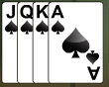Or 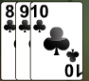

1. Make a duplicate set of minimum 3 sequential cards ( with or without joker)

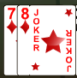

1. Make a set (sequential cards or same cards from different suits) of 3 and 4 cards.

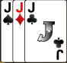 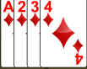

So, to achieve the above one has to set his cards in a way that he doesn’t confuse and discard the right cards.

**How to make sets?**

Two kinds of sets can be made:

1. Sequence 2. Same cards from different suits

Before sets are made the cards will look like this:

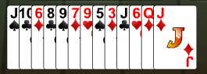

I believe by looking at the above 13 cards you cannot make it directly which sets can be made, or should one play this game or not.

Hence we sort them by suits and then in the order of the cards,

To make the sets you need to sort your cards so that you can check which sets can be formed from the cards presented to you:

<http://taashtime.com> gives you a button which makes it easy for you to sort your cards, by pressing **SORT** button!



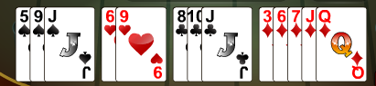

Now you can see that we can make sets of the following

1. Spades 9 and J can become a set if spade 10 comes us to us in further rounds
2. With Hearts 6 and 9 we may not be able to make a sequence set but this can be used for making a triplet or quadruplet set with Spade 9 or diamond 6
3. With Clubs 8 , 10 and J we can make a set if we get clubs 9
4. Diamond 3 cannot be used any set, Diamond 6,7 can be made a set if we get Diamond 5 or 8 and also Diamond J and Q can be made a set if we get Diamond 10 or K.

This kind of inferences will help us to proceed further in the game and make sets.

Once we are successful making sets after receiving and discarding the cards, before winning our cards will look like this

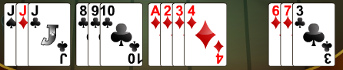

1. At the starting we have thought that if we get Spades 10 we could make the spade 9,10, J set but after discarding certain cards we are not having that in the final winning sets
2. But Spade J was used to make a triplet along with Diamond J and clubs J
3. All the hearts cards have been discarded as we thought making sets with Hearts 6 and 9 are difficult.
4. As we have received Clubs 9 we could make the clubs 8, 9, 10 sequence
5. While discarding we have received the full set of Diamond A, 2, 4 to support Diamond 3 and unlike as decided initially we have used Diamond 3 and could make a Duplicate sequence set.

Diamond 6 and 7 along with a joker has become our final set.