5 Numerical experiments
This section aims to validate the performance of GPR-KG proposed in the last section in addressing the biobjective stochastic discrete optimization problem with a probabilistic constraint. First, the GPR-KG algorithm is tested for three synthetic constrained biobjective stochastic discrete optimization problems, whose theoretical Pareto optimal solutions are known. Then, it is applied to address a real-field NSTPU problem, whose objectives and constraint are all evaluated by costly stochastic traffic simulation.

5.1 Test problems
By introducing stochastic noises and probabilistic constraint expressions and discretizing decision variables, the revised versions of ZDT1, ZDT2 and ZDT5 (Zitzler et al. 2000) are treated as the benchmark problems. Specifically, the white noises are added to each objective function and constraint function, respectively, and then bi-objectives and constraint are expressed by their expectation and probabilistic counterparts. The formulations of these three revised problems ZDT1, ZDT2 and ZDT5 are given as (22)-(24), respectively. Obviously, incorporating noises veils the true expected values of the bi-objectives as well as the probability of violating the constraint, which makes it challenging to solve these revised problems.

1) Revised ZDT1 (RZDT1):
minLx,ξ=Eξl1x,ξ,Eξl2x,ξs.t. Prξcx,ξ≤0≥1-ϵ (22)
where
$\begin{aligned}l_{1}\left(x,ξ\right)=\frac{x_{1}}{100}+ξ \\ l_{2}\left(x,ξ\right)=\left(1+\frac{9}{d-1}\sum_{t=2}^{d}{\frac{x_{t}}{100}}\right)∙\left(1-\sqrt{\frac{l_{1}\left(x,ξ\right)}{1+\frac{9}{d-1}\sum_{t=2}^{d}{\frac{x_{t}}{100}}}}\right)+ξ \\ c\left(x,ξ\right)=-{\left(\frac{x_{1}}{100}-0.5\right)}^{2}+0.04+ξ \end{aligned}$

2) Revised ZDT2 (RZDT2):
minLx,ξ=Eξl1x,ξ,Eξl2x,ξs.t. Prξcx,ξ≤0≥1-ϵ (23)
where
$\begin{aligned}l_{1}\left(x,ξ\right)=\frac{x_{1}}{100}+ξ \\ l_{2}\left(x,ξ\right)=\left[1+\frac{9}{d-1}\sum_{t=2}^{d}{\frac{x_{t}}{100}}\right]∙\left[1-{\left(\frac{l_{1}\left(x,ξ\right)}{1+\frac{9}{d-1}\sum_{t=2}^{d}{\frac{x_{t}}{100}}}\right)}^{2}\right]+ξ \\ c\left(x,ξ\right)=-{\left(\frac{x_{1}}{100}-0.5\right)}^{2}+0.04+ξ \end{aligned}$

3) Revised ZDT5 (RZDT5):
minLx,ξ=Eξl1x,ξ,Eξl2x,ξs.t. Prξcx,ξ≤0≥1-ϵ (24)
where
$\begin{aligned}l_{1}\left(x,ξ\right)=\frac{x_{1}}{30}+ξ \\ l_{2}\left(x,ξ\right)=\left(\sum_{t=2}^{d}{\frac{x_{t}}{5}+1}\right)∙\left(\frac{1}{x_{1}+1}\right)+ξ \\ c\left(x,ξ\right)=\frac{x_{1}}{30}-0.5+ξ \end{aligned}$
For all the three problems, the decision vector $x=(x_{1},x_{2},⋯,x_{d})∈Z^{d}$.
For RZDT1 and RZDT2,

To solve RZDT1, RZDT2 and RZDT5, the critical parameters of the GPR-KG algorithm are set as: the simulation budget N = 100, the number of pre-samples $N_{0}=11$, the weight for the initial variance estimate $s_{0}=0.5$, the number of random candidate samples $K_{1}=10$, and the number of candidate samples generated by solving the current posterior parametric belief model $K_{2}=90$. Moreover, three priori parametric belief models are built to estimate the underlying mean values of biobjectives and the constraint function of any decision x. Specifically, for each of the functions i∈{l1, l2, c}, we choose the parametric belief model to be encoded by a linear combination of 2×d basis functions: fj1ix=xj1,j=1,2,⋯d, fdix=xd, fd+j1ix=xj12,j=1,2,⋯d,⋯, f2dix=x1xd, i∈{l1, l2, c}. For each basis function, we divide its domain into two equal-sized partitions, and so there are a total of 2^{2d} = 4d combinations of the partitions indexed by $q\left(x\right)∈\{1,2,⋯,4^{d}\}$. We set the initial estimate of the variance of each partition combination qx∈{1,2,⋯,4d} as a common value $Λ_{q\left(x\right)}^{i,0}=0.01$,
$i∈\{l_{1}, l_{2}, c\}$.

Numerical results in Fig. 1 illustrate that the bi-objective values of most learned solutions lie on or close to the theoretical Pareto front (c.f., blue triangles), but those for a few other learned solutions (c.f., gray triangles) lie on the left boundary of the bi-objective domain, which seem to deviate from the theoretical Pareto front. This because the posterior parametric belief models can accurately approximate $l_{1}$ which is composed of the linear term related to $x_{1}$, and then guide more search on the left-side region (i.e., when $x_{1}→0$), where $l_{1}$ for RZDT1, RZDT2 and RZDT5 all are close to its lowest value 0. This indicates the good performance of GPR-KG in addressing the biobjective stochastic discrete optimization problem with a probabilistic constraint at the cost of limited computational resources. Specifically, in the iterative process, the biobjective points of iterative solutions usually scatter in the regions close to the theoretical Pareto front, and some of them fortunately locate on it, which helps the parametric belief models to learn the information about theoretical pareto front. However, there are also some biobjective points of iterative solutions that are distant from the theoretical pareto front or even infeasible (c.f., gray asterisks). This generally results from the following two causes. That is, the candidate solutions selected by the KG factors at each iterate might be from the set generated by sampling randomly (i.e., $S_{1}^{n}$ in section 4.3), and so may contain the dominated or infeasible solutions; the early posterior parametric belief models fitted with limited observations might be less accurate, which causes a high probability of not finding the biobjective points closed to the theoretical Pareto front and not complying with the probabilistic constraint.
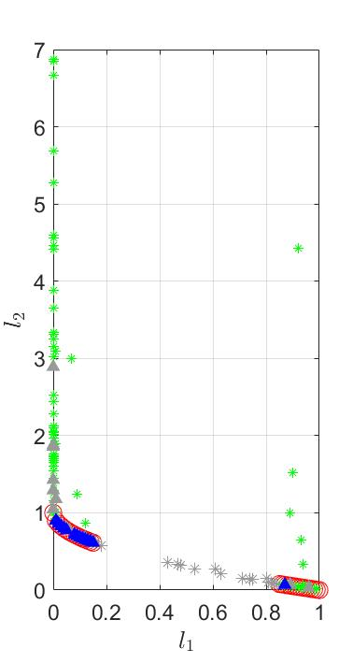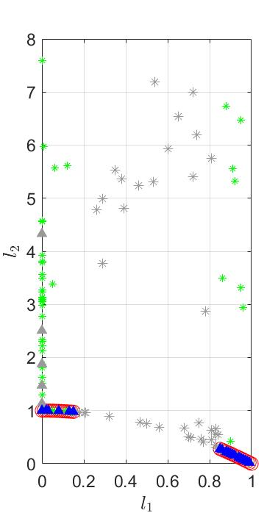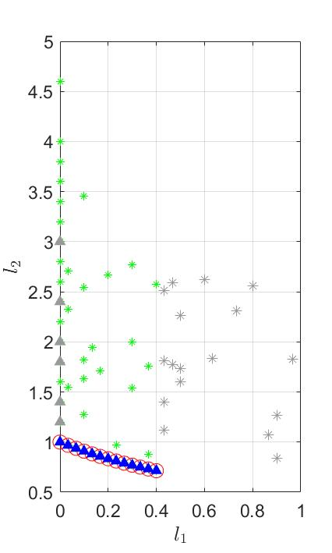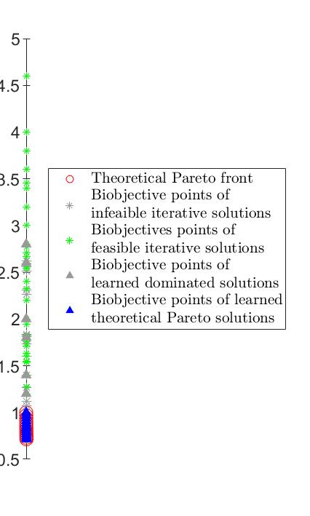
(a) (b) (c)
Fig. 1 Biobjective points of iterative solutions and finally searched Pareto optimal solutions by GPR-KG for (a) RZDT1, (b) RZDT2 and (c) RZDT5. Note: the iterative solutions represent the solutions selected from the set of candidate solutions (i.e., $S^{n}$ in section 4.3) by the corresponding biobjective KG factors. The learned solutions represent the finally optimized solutions generated with the posterior parametric belief models and the posterior variance estimations when GPR-KG terminates. The biobjective points of all solutions in this figure are evaluated by real (or nominal) objective and constraint functions without stochastic noises.

Meanwhile, a reliable performance indicator named inverted generational distance (IGD) (Zitzler et al. 2003) is introduced to quantify the closeness of the generated non-dominated front to a set of reference points and its diversity. It is formulated as $IGD=\sum_{p^{r}∈P}{\min_{p^{o}∈O}{{\left\|p^{r}-p^{o}\right\|}_{2}}}/|P|$, where $P$ is the set of reference points in the theoretical Pareto front, $O$ is the set of biobjective points of optimized (or iterative) solutions generated by GPR-KG and $|∙|$ denotes the cardinality of a set. Obviously, the smaller IGD means the better convergence and diversity of the optimized (or iterative) solutions. During the iteration process of GPR-KG, we obtain the iterative non-dominated solutions by the posterior parametric belief models and their posterior variance estimates at each iteration and then compute the corresponding IGD value. Moreover, to mitigate the impact of randomness, we carry out 10 independent runs of GPR-KG for RZDT1, RZDT2 and RZDT5, respectively, so as to calculate the corresponding average IGD values.

Numerical results in Fig. 2 show that the average IGD values decrease rapidly in the early few iterations, then the decline decelerates and finally reaches a very small level. This indicates the good convergence performance of the GPR-KG algorithm. Meanwhile, detailed results in Table 1 tell us that the learned Pareto optimal solutions by GPR-KG at the cost of 111 function evaluations cover most or almost all theoretical Pareto optimal solutions, and their final IGD values are 0.055, 0.022 and 0.005 for RZDT1, RZDT2 and RZDT5, respectively. These results further validate the good convergence, diversity and efficiency of GPR-KG in dealing with the biobjective stochastic discrete optimization problems with probabilistic constraints.
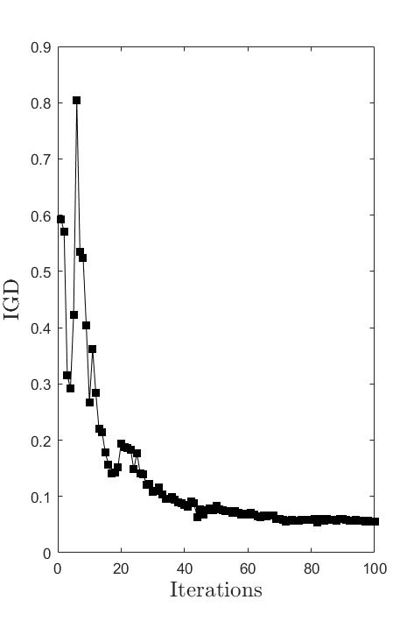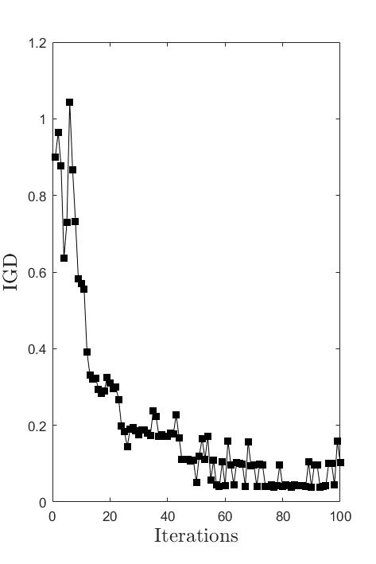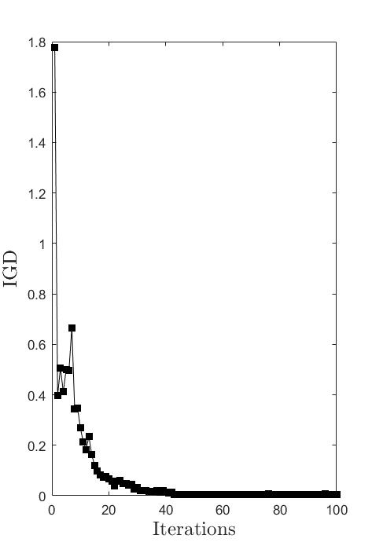
(a) (b) (c)
Fig. 2 Average IGD values over 10 independent runs of GPR-KG for solving (a) RZDT1, (b) RZDT2 and (c) RZDT5.

Table 1 Detailed average results over 10 independent runs of GPR-KG.
Test problem | No. of FEs. | No. of TPOS. | A. No. of LPOS. |  | A. IGD | A. Comp. time
RZDT1 | 111 | 32 | 18.5 |  | 0.055 | About 50 min
RZDT2 | 111 | 32 | 16.3 |  | 0.103 | About 50 min
RZDT5 | 111 | 12 | 11.1 |  | 0.005 | About 50 min
Note: No. of FEs. denotes the number of function evaluations for each run of GPR-KG, and No. of TPOS. is the number of theoretical Pareto optimal solutions. A. No. of LPOS., A. IGD and A. Comp. time represent the average number of learned Pareto optimal solutions, the average IGD value and the average running time over 10 independent runs of GPR-KG, respectively.

Moreover, we also use the iterative non-dominated solutions as the testing set to evaluate the estimation (prediction) errors of the current posterior parametric belief models with respect to biobjectives and probabilistic constraint during the iteration process. These errors are measured by Root Mean Square Errors (RMSEs) based on the estimated (predicted) and real (nominal) biobjective and constraint function values. Fig. 3 apparently shows that average RMSEs are relatively high in the early few iterations, and then decrease rapidly to reach a small and stable level. This implies the more and more accurate posterior parametric belief models and posterior variance estimates as the iteration goes on (i.e., the number of accumulative evaluated samples increases). Specifically, after 50 iterations, average RMSE of ${\overline{l}}_{1}$ reaches as small as about 0.021, 0.022 and 0.018 for RZDT1, RZDT2 and RZDT5, respectively; average RMSE of ${\overline{l}}_{2}$ reaches as small as about 0.227, 0.123 and 0.159 for RZDT1, RZDT2 and RZDT5, respectively; and average RMSE of $\tilde{c}$ reaches as small as about 0.009, 0.006 and 0.025 for RZDT1, RZDT2 and RZDT5, respectively. So, the fitted posterior parametric belief models after 50 iterations in fact are accurate enough and can well approximate the response surfaces of the two objectives and the probabilistic constraint.
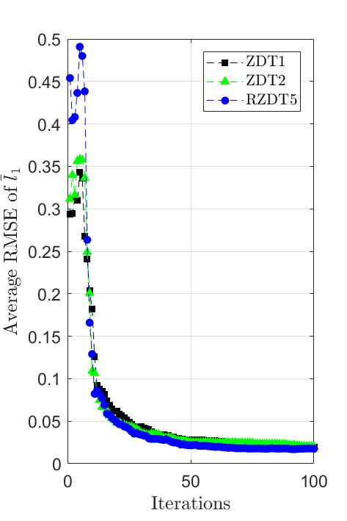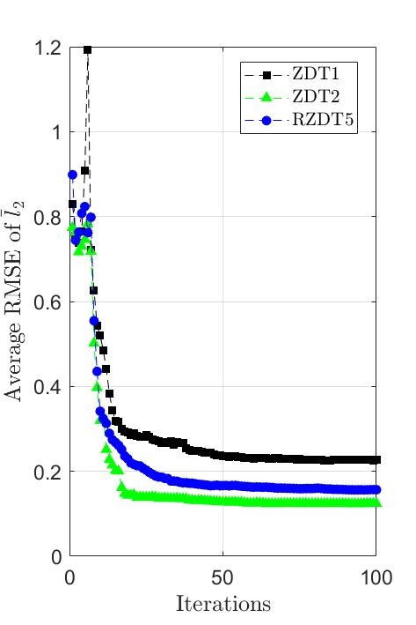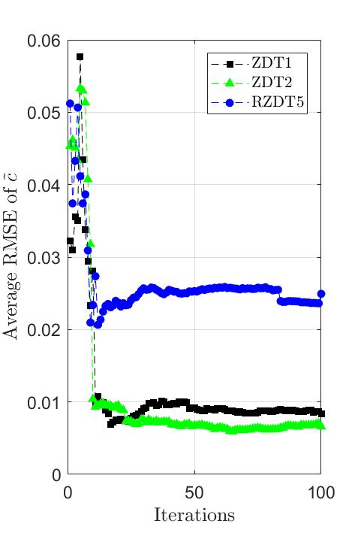
(a) (b) (c)
Fig. 3 Average estimation (prediction) errors of the current posterior parametric belief models with respect to (a) ${\overline{l}}_{1}$, (b) ${\overline{l}}_{2}$ and (c) $\tilde{c}$, over 10 independent runs of the GPR-KG algorithm for solving RZDT1, RZDT2 and RZDT5. Note: ${\overline{l}}_{1}$ and ${\overline{l}}_{2}$ denote the expectations of two objective values (i.e., $E_{ξ}(l_{1})$ and $E_{ξ}(l_{2})$), respectively, and $\tilde{c}$ represents the estimation of constraint value under the probability of $1-ε$ (i.e., $E_{ξ}\left(c\right)+Φ(1-ε)∙σ$), where $ε=0.05$, $σ=0.05$.

In addition, we evaluate each of the iterative non-dominated solutions by 100 times of stochastic constraint function (i.e., $c\left(x,ξ\right)$) and determine it as an infeasible solution if it violates the constraint (i.e., $c\left(x,ξ\right)>0$) more than five times. Numerical results in Fig. 4 illustrate that average number of infeasible solutions in the iterative non-dominated solutions is relatively high in the early few iterations, and then decreases rapidly to stabilize at zero. This validates the good ability of the GPR-KG algorithm in dealing with the probabilistic constraint.

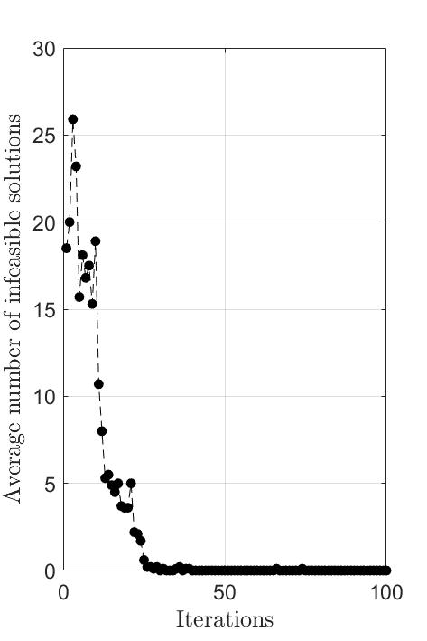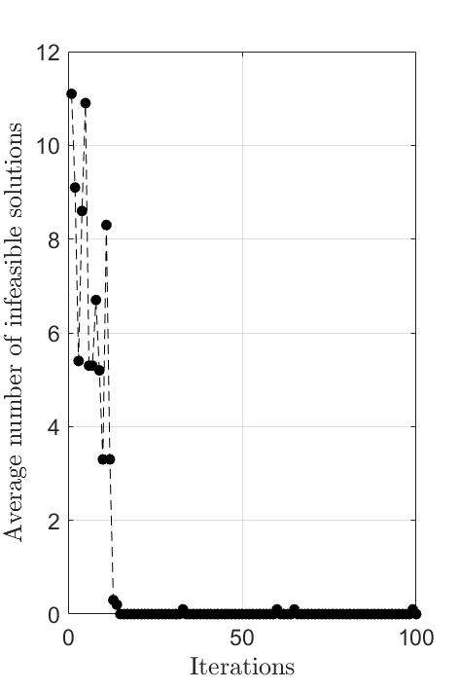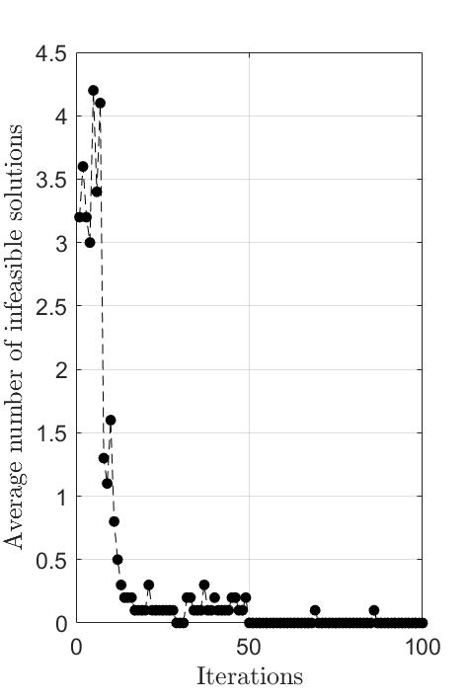
(e) (f) (g)
Fig. 4 Average number of infeasible solutions in the iterative non-dominated solutions over 10 independent runs of the GPR-KG algorithm for solving (a) RZDT1, (b) RZDT2 and (c) RZDT5.

Last but not least, we further carry out the sensitivity analyses of the performance of the GPR-KG algorithm with respect to three critical parameters, i.e., N, $Λ_{q\left(x\right)}^{i,0}$ and N₀. Λqxi,0Obviously, Fig. 5(a) shows the obvious decreasing trend of average IGD values as N increases. That is, the convergence and diversity performance of the GPR-KG algorithm would be improved by consuming more computation burden (i.e., more function evaluations). This is because the more accurate posterior parametric belief models fitted with more observations are conducive to searching more non-dominated solutions close to the theoretical Pareto optimal ones. Fig. 5(b) indicates the increasing trend of the average IGD values as $Λ_{q\left(x\right)}^{i,0}$ increases, which results from that the higher $Λ_{q\left(x\right)}^{i,0}$ would produce more conservative non-dominated solutions against the probabilistic constraint. Fig. 5(c) illustrates the average IGD values are rather insensitive to N₀, which means the fitting accuracies of the priori parametric belief models do not influence the convergence and diversity performance of the GPR-KG algorithm. Moreover, the sensitivity analyses with respect to N and $Λ_{q\left(x\right)}^{i,0}$ also explain why we set N and $Λ_{q\left(x\right)}^{i,0}$ as high as 100 and 0.01 respectively in aforementioned numerical experiments. That is, the performance of the GPR-KG algorithm under N=100 or $Λ_{q\left(x\right)}^{i,0}=0.01$ is satisfactory, and further increasing N or decreasing $Λ_{q\left(x\right)}^{i,0}$ would not help significantly improve the performance.

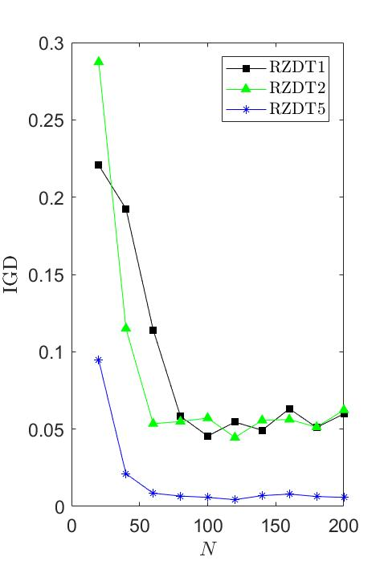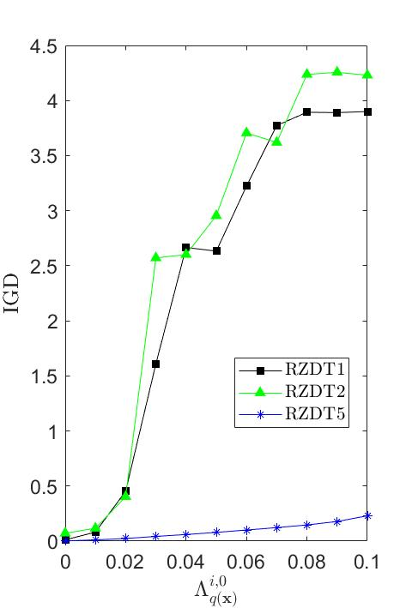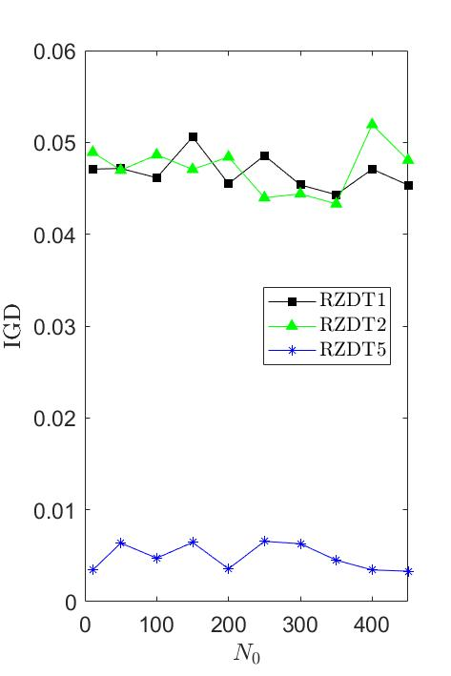
(a) (b) (c)
Fig. 5 Average IGD values over 10 independent runs of the GPR-KG algorithm for solving RZDT1, RZDT2 and RZDT5 under various values of (a) N, (b) $Λ_{q\left(x\right)}^{i,0}$, where $∈\{l_{1}, l_{2}, c\}$, and (c) N₀.

5.2 Network-wide signal timing problem
Signalized intersection plays an important role in the network-wide traffic efficiency, traffic equity and vehicular emissions. Network-wide signal timing optimization considering multi-criteria is also a hot and difficult topic to study. This application employs the microscopic traffic simulator VISSIM as an evaluation tool of network-wide signal timing plan, due to its flexibility in designing any type of traffic element, and capability of capturing the complicated relationship between the signal timing plan and multiple evaluation indices. Meanwhile, the mature COM interface in VISSIM also allows the inter-process communication and data exchange between VISSIM and other compatible computational software (e.g., MATLAB). So, we first construct the SO platform by integrating VISSIM with MATLAB through the COM interface. Then, an urban road network in Changsha, China is modelled by VISSIM as the experimental scenario, which consists of 15 signalized intersections, 5 non-signalized intersections, 29 entries, 24 exits and 31 road links (c.f., Fig. 6). The detailed calibration process and results about the traffic simulation model can refer to Zheng et al. (2019a, 2019b). In the SO platform, given a specific network-wide signal timing plan, the calibrated traffic simulator will output individual vehicular information after completing the traffic simulation run, which can be used to calculate three typical traffic evaluation indices D, A and E as defined in Appendix A.

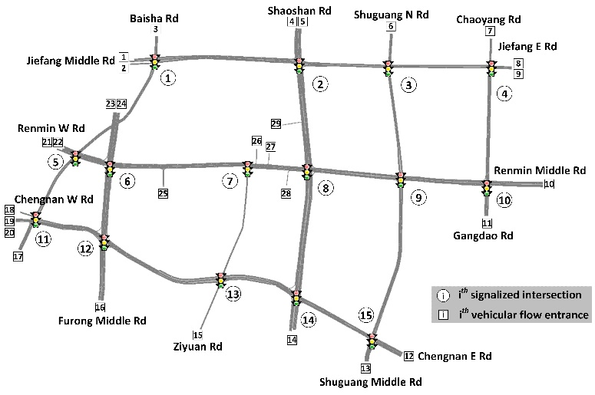
- (b)
Fig. 6 Study site, (a) a regional urban road network in Changsha, China, and (b) its VISSIM model.

For this NSTPU problem, the decision vector x consists of the signal timings of 47 signal phases in this regional urban road network. The perturbed network inflow vector is expressed by ${VI}_{1 ×29}∙ξ$, where VI_{1 ×29} is the calibrated network inflow vector of 29 entries in this network (Zheng et al., 2019a, 2019b) and can be treated as the nominal network inflow vector. $τ^{E}=0.9$ and $E=0.05$ are set for the probabilistic constraint. Several key parameters of the GPR-KG algorithm are set as: N=300, $N_{0}=100$, $s_{0}=0.5$, $K_{1}=10$, and $K_{2}=90$. Meanwhile, the same type of combination of the basis functions in section 5.1 is applied here. To reduce the computation burden, only the domains of some particular basis functions instead of all ones are divided into two equal partitions. These particular basis functions are the linear item ones which correspond to green timings of signal phases for five intersections numbered 2, 6, 8, 12 and 14 along two main roads (i.e., Shaoshan Rd and Furong Middle Rd), c.f., Fig. 6(b)). So, there are 2²⁰ combinations of these partitions with the combination index $q\left(x\right)∈\{1,2,⋯,2^{20}\}$. The initial estimate of the variance of each partition is set as $Λ_{q\left(x\right)}^{i,0}=0.03$, $i∈\{D, A, E\}$, $q\left(x\right)∈\left\{1,…,2^{20}\right\}$, which is determined by a small number of simulation evaluations.

During the numerical experiment, 400 simulation evaluations for pre-samples are used for initially fitting the parametric belief models with respect to biobjectives and probabilistic constraint, and 100 simulations are allocated to evaluate the infilled signal control plans in the latter iterations, and the rest of 150 simulations are used to re-evaluate the 100 infilled signal control plans and 50 final non-dominated signal control plans. It takes about 30 hours on an Intel Xeon 2.0 GHz to terminate the GPR-KG algorithm, and then the non-dominated solutions (that correspond to learned PF) obtained with the guide of final posterior parametric belief models and posterior variance estimates. Meanwhile, all iterative signal control plans also generate their own non-dominated solutions (that correspond to PF for iterative solutions). Then, above two types of non-dominated solutions result in the final ones that correspond to the final PF. Aforementioned numerical results in Fig. 7 show that the final non-dominated solutions significantly perform better than the iterative ones from three aspects of D, A and E. In particular, the E values of all non-dominated solutions are smaller than 0.9, which implies the satisfaction of the probalistic constraint, while those of the early iterative solutions cannot guarantee this aspect. In addition, the dispersive values of D, A and E of iterative signal control plans also indicates the extensive exploration capability of the GPR-KG algorithm in the domain space of three evaluation indices.

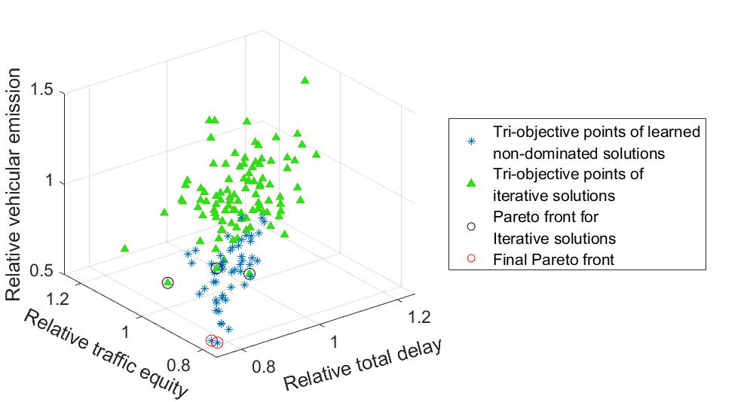
Fig. 7 D, E and A values of iterative and non-dominated signal control plans by GPR-KG. Note: the tri-objective points of all iterative and non-dominated solutions in this figure are (re)evaluated by simulation evaluations without the perturbation on the traffic volume (i.e., $ξ=1$).

Furthermore, we compare nine signal control plans by performing 100 independent simulation evaluations for each comparison solution so as to mitigate the influence of stochastic network inflows, that is, five non-dominated solutions $x_{o1}$ to $x_{o2}$ (that correspond to final PF), three non-dominated solutions $x_{c1}$ to $x_{c3}$ (that correspond to PF for iterative solutions) and the field-implemented signal control plan $x_{FSP}$. Numerical results in Fig. 8 show that various percentile values and fluctuation ranges of D, A and E values by 100 independent simulation evaluations for each non-dominated signal control plan are smaller than those for the field-implemented one. This in fact validates the effectiveness of GPR-KG in solving the NSTPU problem. Moreover, $x_{o1}$ to $x_{o3}$ outperform $x_{c1}$ to $x_{c3}$ in terms of D, A and E, which means the final posterior parametric belief models are accurate enough to generate the well-performed solutions. From Fig. 9, similar conclusions can also be found and only $x_{o1}$ to $x_{o3}$ are able to comply with the probabilistic constraint.

In addition, more detailed comparisons of eight non-dominated signal control plans are given in Table 3. Obviously, $x_{o1}$ to $x_{o3}$ improve $\overline{D}$, $\overline{A}$ and $\overline{E}$ by at most 13.9%, 15.3% and 22.8%, respectively, and $x_{c1}$ to $x_{c3}$ improve $\overline{D}$, $\overline{A}$ and $\overline{E}$ by at most 2.2%, 4.7% and 10.8%, respectively. At the same time, the D, A and E variances for $x_{o1}$ to $x_{o3}$ are smaller than those for $x_{c1}$ to $x_{c3}$. Particularly, the 95% quantities of the E values for $x_{o1}$ to $x_{o3}$ are all smaller than 0.9, while those for $x_{c1}$ to $x_{c3}$ are all higher than 0.9. These results in fact accord with those in Fig. 9(c). This means that the non-dominated solutions resulting from iterative solutions do not obey the probabilistic constraint. Fortunately, the non-dominated solutions resulting from the final posterior parametric belief models and posterior variance estimates can overcome the issue of violating the probabilistic constraint. This is because the final posterior parametric belief models and posterior variance estimates have more accurate estimation (or prediction) of the mean values of biobjectives and the probabilistic constraint than the intermediate parametric belief models and variance estimates used to determine the iterative solution. In conclusion, all above numerical results validate the good ability of GPR-KG in addressing the NSTPU problem.

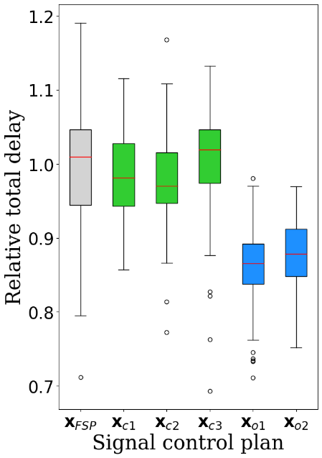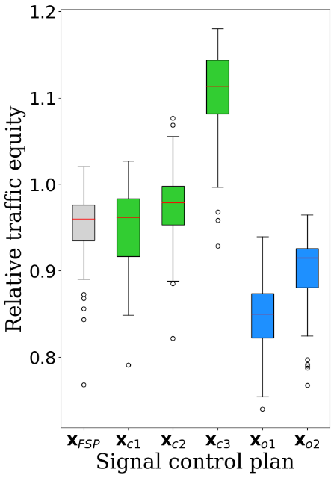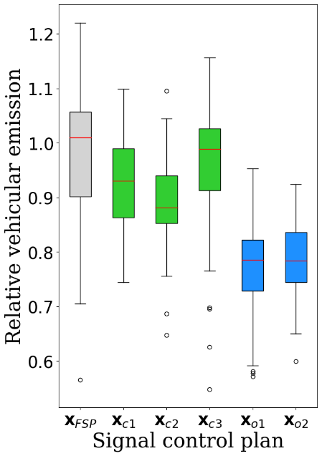
(a) (b) (c)
Fig. 8 Boxplots of (a) relative total delay, (b) relative traffic equity and (c) relative vehicular emission for nine comparison solutions.

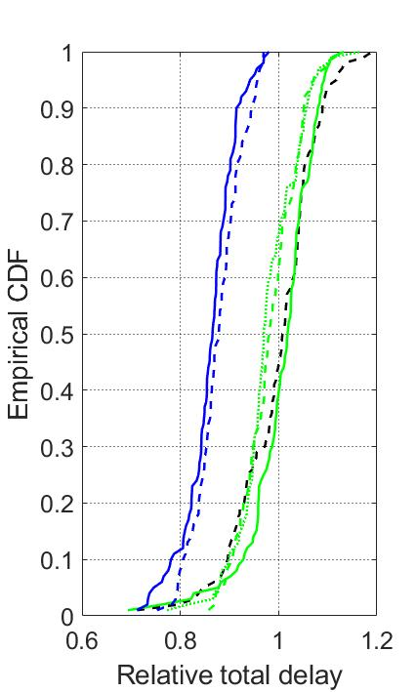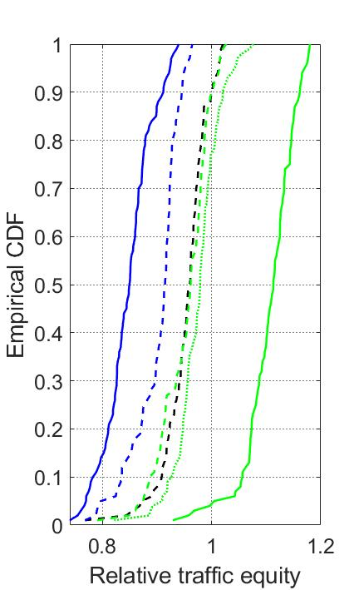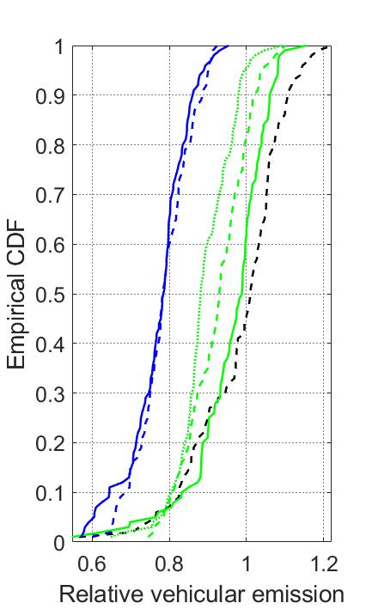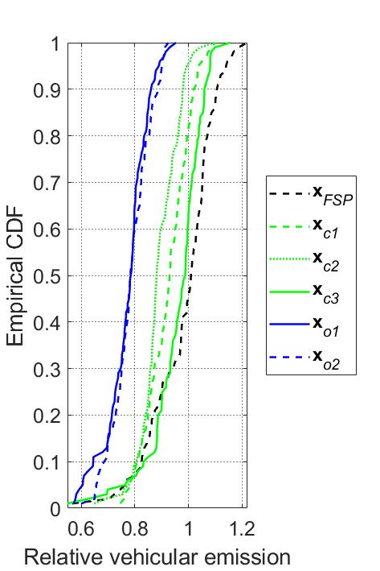
(a) (b) (c)
Fig. 9 Empirical CDFs of (a) relative total delay, (b) relative traffic equity and (c) relative vehicular emission for nine comparison solutions.

Table 3 Detailed comparison of eight non-dominated signal control plans.
Signal control plan | $$\overline{D}$$ | $$\overline{A}$$ | $$\overline{E}$$ | ($P_{\overline{D}}$, $P_{\overline{A}}$, $P_{\overline{E}}$) | (${Var}_{D}$, ${Var}_{A}$, ${Var}_{E}$) | $$E_{1-ε}$$
$$x_{c1}$$ | 0.983 | 0.953 | 0.925 | (1.7%↓, 4.7%↓, 7.5%↓) | (0.003,0.002, 0.006) | 1.037
$$x_{c2}$$ | 0.978 | 0.976 | 0.892 | (2.2%↓, 2.4%↓, 10.8%↓) | (0.004,0.002, 0.005) | 0.994
$$x_{c3}$$ | 1.006 | 1.108 | 0.961 | (0.6%↑, 10.8%↑, 3.9%↓) | (0.005,0.002, 0.010) | 1.081
$$x_{o1}$$ | 0.861 | 0.847 | 0.772 | (13.9%↓, 15.3%↓, 22.8%↓) | (0.002, 0.001, 0.006) | 0.889
$x_{o2}$ | 0.877 | 0.901 | 0.785 | (12.3%↓, 9.9%↓, 21.5%↓) | (0.002, 0.001, 0.005) | 0.898
 | D | A | E | PDPAPE | VarDVarAVarE | E1-ε
xc1
xc2
xc3
xo1
xo2
xo3
xo4
xo5
Note: $\overline{D}$, $\overline{A}$ and $\overline{E}$ denote the average D, A, and E values over 100 independent simulation evaluations, respectively, and ${Var}_{D}$, ${Var}_{A}$ and ${Var}_{E}$ represent the corresponding D, A, and E variances, respectively. Compared with the benchmark values (1,1,1) of the field-implemented signal control plan, $P_{\overline{D}}$, $P_{\overline{A}}$ and $P_{\overline{E}}$ represent the percentage changes of $\overline{D}$, $\overline{A}$ and $\overline{E}$, respectively, for a non-dominated signal control plan. $E_{1-ε}$ denotes $1-ε$ quantile of the E values over 100 independent simulation evaluations. ↓ is the improvement indicator for $\overline{D}$, $\overline{A}$ and $\overline{E}$.

6 Conclusion
This paper has proposed a SO approach for bi-objective stochastic optimization problems with probabilistic constraints and applied it to a nontrivial traffic network control problem which involves a very large number of feasible solutions. The challenges of these type of problems lie in effective learning of both the mean values of the two objectives as well as the quantile of the constraint function, particularly when the decision space is large. Therefore, we designed a flexible parametric GPR based posterior distribution over the feasible solutions and proposed an efficient approximate knowledge gradient sampling policy. The parametric belief model is general enough such that domain knowledge can be used to specified any feature vector associated with the solution. Moreover, we proposed an convenient iterative variance updating scheme aiming at fast learning of the variability distributions over the large solutions space under limited simulation budget. This variance updating scheme is based on grid divisions on the domain of the feature vector and deals with sampled and unsampled solutions separately such that the sampling policy has theoretical convergence guarantee.

Our experiments on a set of synthetic test problems validate the effectiveness of the proposed algorithm in finding the non-dominated feasible solutions. In all the three problems tested, the Pareto front found by our algorithm reasonably covers the theoretical one, though a higher initial variance estimate may lead to fewer solutions, mainly due to a more conservative posterior probabilistic constraint. The proposed algorithm is also successfully applied to a real-world traffic network signal timing problem which involves relative total delay and traffic equity as two stochastic objectives and a probabilistic constraint on the relative vehicular emission. Compared to field-implemented signal plan, any solution that is finally found by our algorithm can reduce at least 10% and 8% for the mean values of the two objectives, respectively. Unlike the field implemented signal plan, the solutions found by our algorithm all satisfy the probabilistic constraint, with the expected emission level cut by more than 19%. Therefore, the proposed SO approach is promising in solving probabilistically constrained bi-objective stochastic optimization problems. Although the simple quadratic model was shown effective in our experiment, one meaningful future exploration might be designing adaptive feature selection method that can tailor the belief model to different problem domains.

