1. Extract contents of platform.zip to some directory, suppose it will be E:\platform.
2. Go to platform directory.

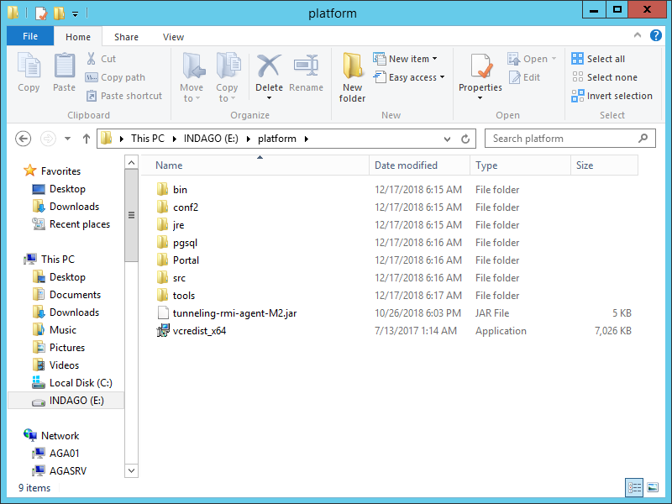

1. Run vcredist_x64.exe and follow instructions to install required components.
2. Go to tools\msys64 and double click msys2_shell.cmd. Wait until it says:

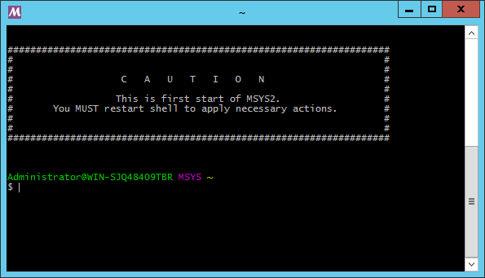

1. Once it appeared close the window.
2. Run msys2_shell.cmd again.
3. Type “cd E:/platform/bin” (use path from paragraph 1 with addition ‘/bin’ path component) and press Enter.
4. Type “./install.sh” and press Enter. Wait until the script has finished its work.

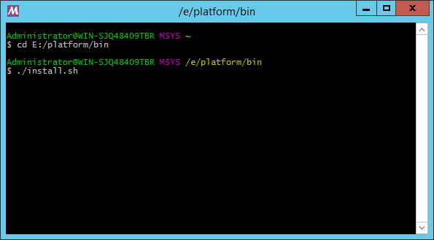

1. Type “./startAll.sh” and press Enter. Wait until the script has finished its work.

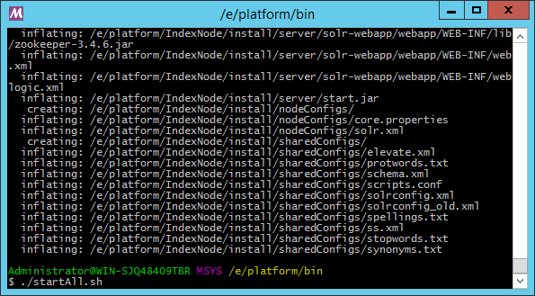

1. Open web browser. Go to [http://localhost:8090](http://localhost:8090/).
2. To login use following credentials:

* username: admin
* password: admin

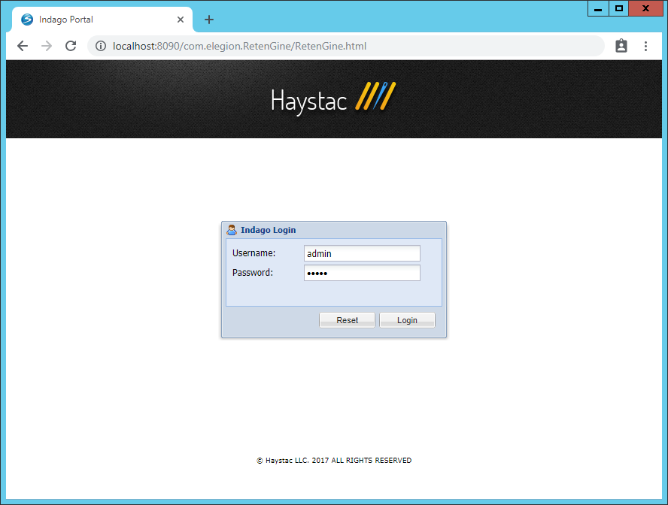

1. Go to Administration → Settings.
2. Select “Crawler Settings” in the left panel.
3. Press “Add” at the top left corner, choose “Crawl task”.
4. If data is available via SMB protocol then press “SMB Single IP task” and fill in required fields in the right panel. If data is available in the file system then press “Local File System” and fill in required fields in the right panel.

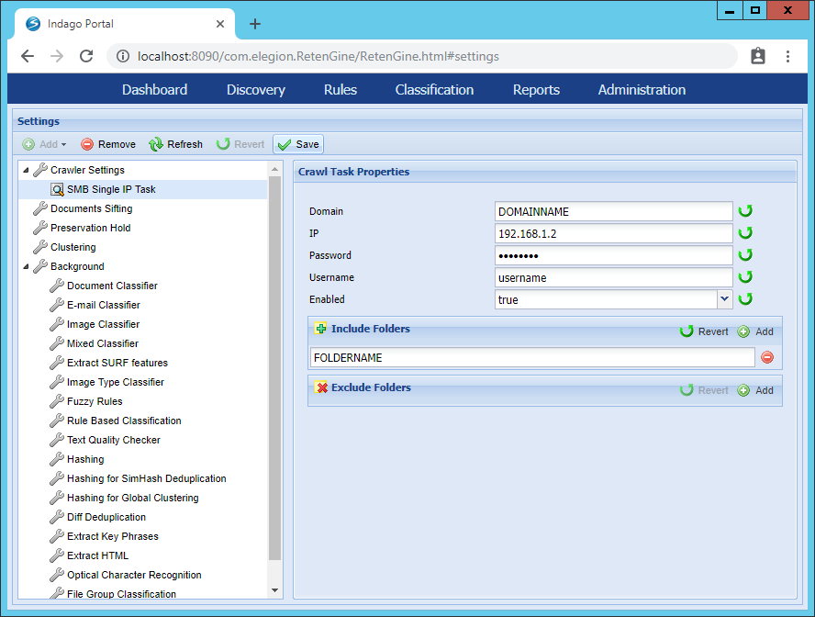

1. Under the “Background” menu item in the right pane you can turn on “Optical Character Recognition”, “Extract HTML”, “Hashing” or any other task by setting “Enabled” property to “true”.

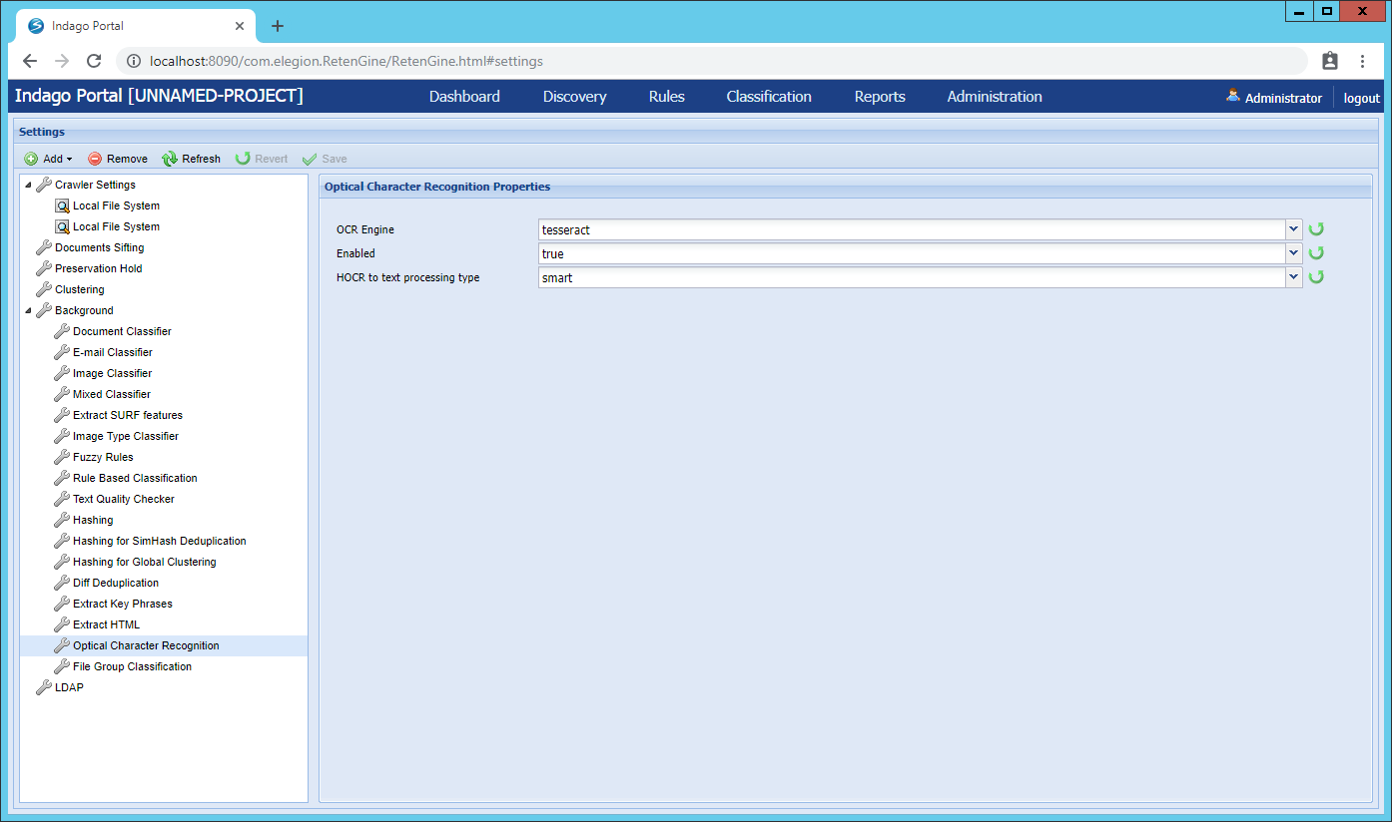

1. Go to “Administration → Crawler” and press “Run Crawler” at the top left corner.

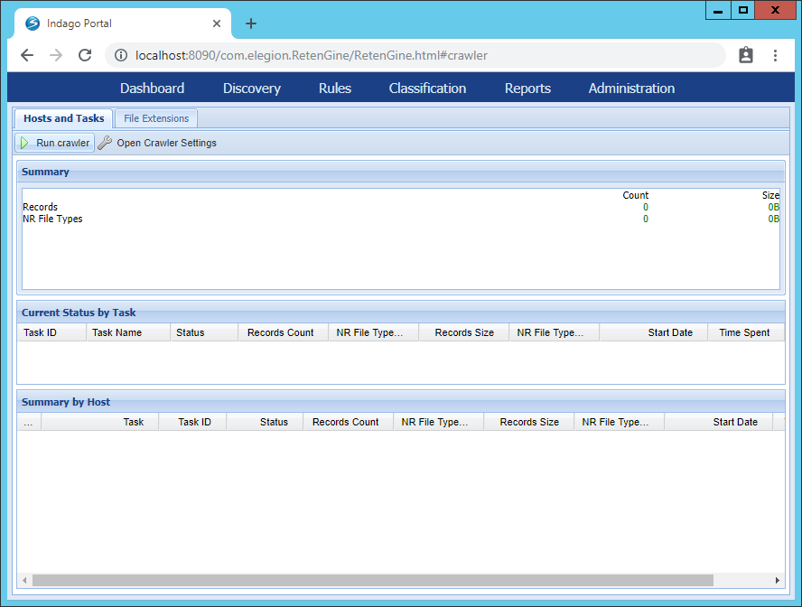

1. Wait until crawling procedure finished. It can be tracked on the “Administration → Crawler” screen and on the “Administration → Background Process Monitor” screen.

Settings adjustment:

Suppose the project is installed in the E:\platform directory.

To apply any changes from the list below, you should restart the server (if it is running). To do it:

1. Run “E:\platform\tools\msys64\msys2_shell.cmd” if it is not running yet.
2. Type “cd E:/platform/bin”.
3. Type “./stopAll.sh” and press Enter. Wait until the script has finished its work.
4. Type “./startAll.sh” and press Enter. Wait until the script has finished its work.

* To adjust CPU nodes count open file “E:\platform\bin\config-msys.sh” in any text editor. Modify the line which starts with “export CPU_NODES=” and place desired number of nodes right after the equal sign, for example: “export CPU_NODES=6”.

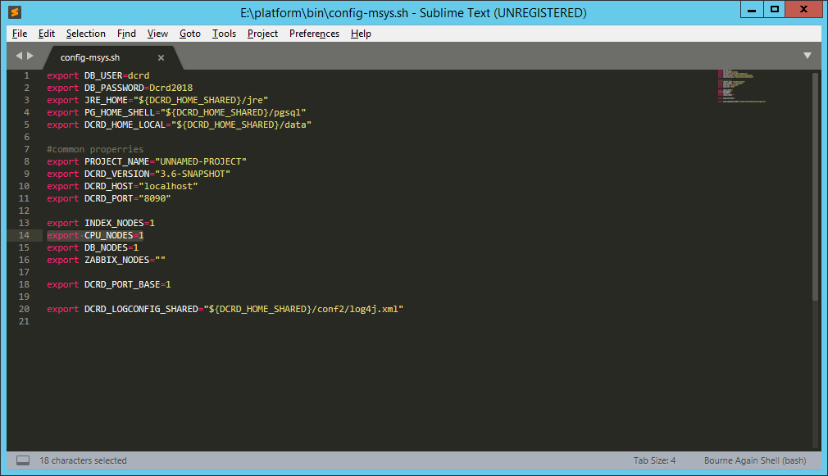

* To adjust the amount of memory allocated for each CPU node open file “E:\platform\bin\CpuNodes\1.sh” (where 1.sh corresponds to the first CPU node). Modify the line which starts “export CPUNODE_MEM=” and place desired value right after the equal sign, for example export CPUNODE_MEM="3G" which means allocate 3 gigabytes of memory to the first CPU node. To adjust memory amount of other nodes just modify file with appropriate name (2.sh for the second CPU node and so on).

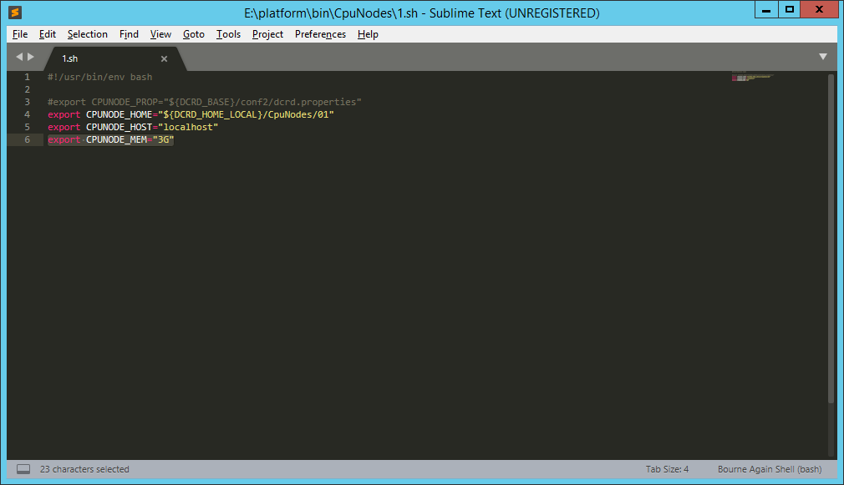

* To adjust application port open file “E:\platform\bin\config-msys.sh” in any text editor. Modify the line which starts with “export DCRD_PORT=” and place desired port number right after the equal sign in double quotes.

