|  |
| --- |
| CMPS411: Software Engineering Group Project – Milestone 2 |
| Due Date :2/5/2015 |
| Zainab Gharbi 201202667 Engy Soliman 201204833  Riyam Al-Dawood 201105618  Salwa Al Shahbl 20081145 |

Coordinator Login

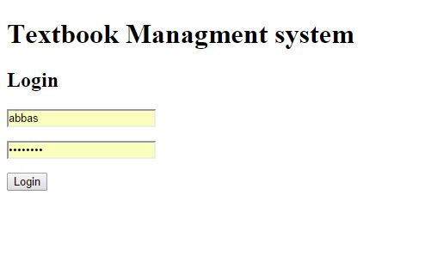

Add textbook use case

This is the main page for the textbooks

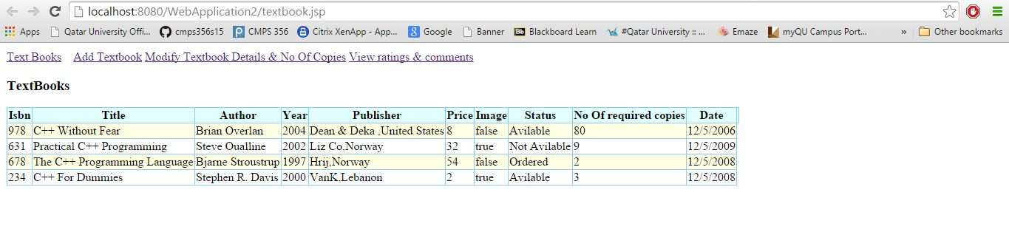

This is the form for adding a text book , after the user clicks submit

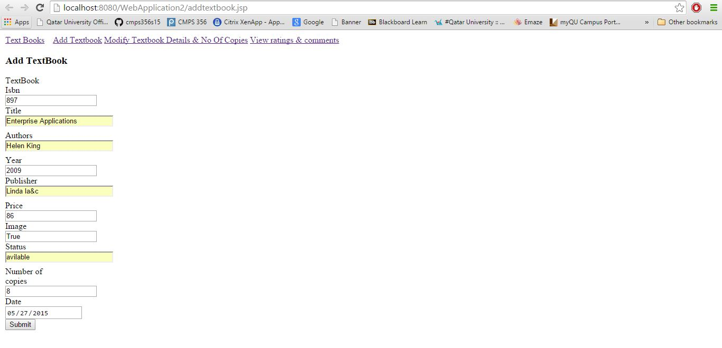

The new textbook is added to the textbook list

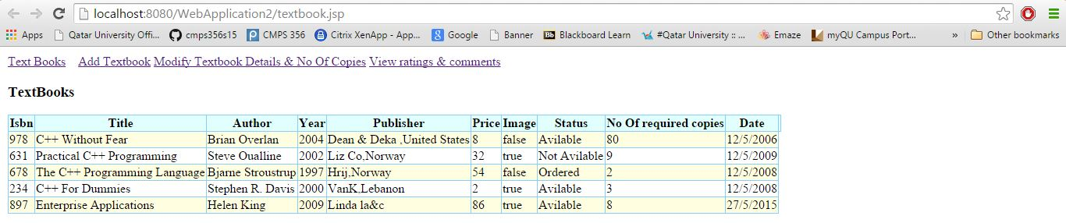

This is the use case for view ratings & comments

Coordinator types in the name of the book

Clicks on the button it will take him to amazon website with book name

Where he can be able to read all previous ratings and comments

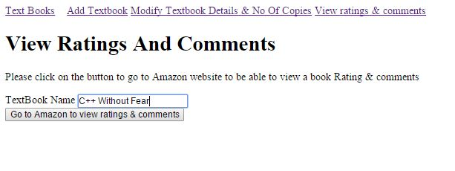

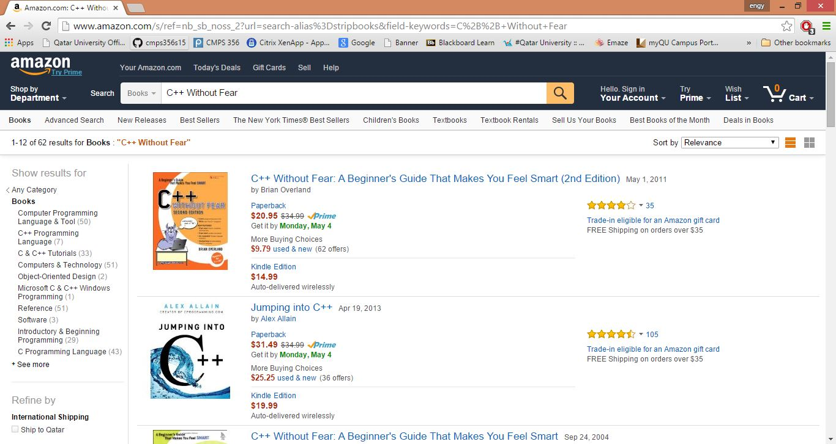

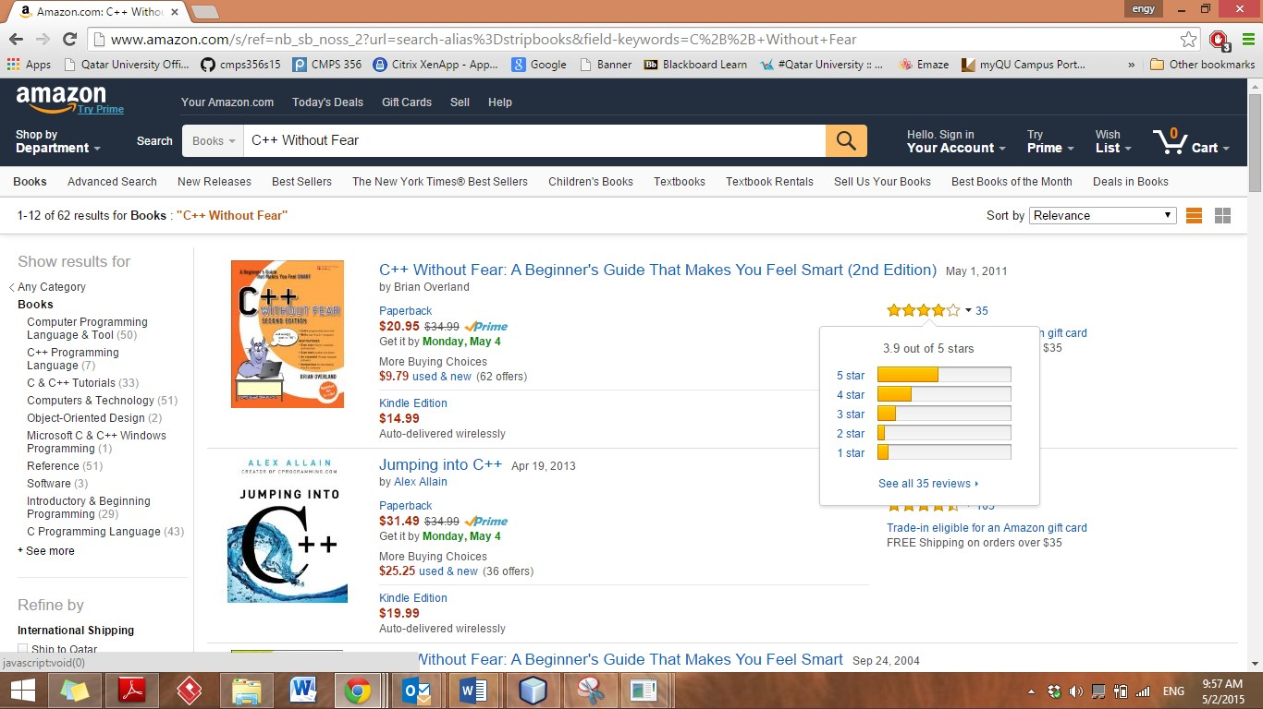

Modify number of copies

Coordinator searches for text book ISBN , 978 on the list has 80

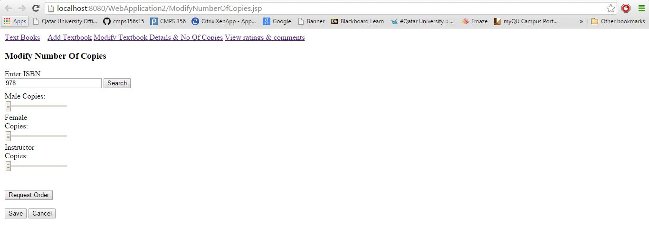

He moves the sliders to make the needed request of copies to submit an order

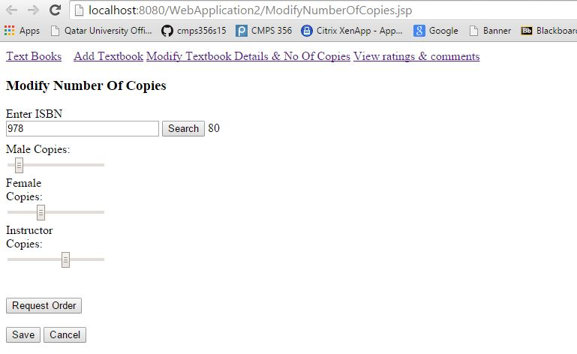

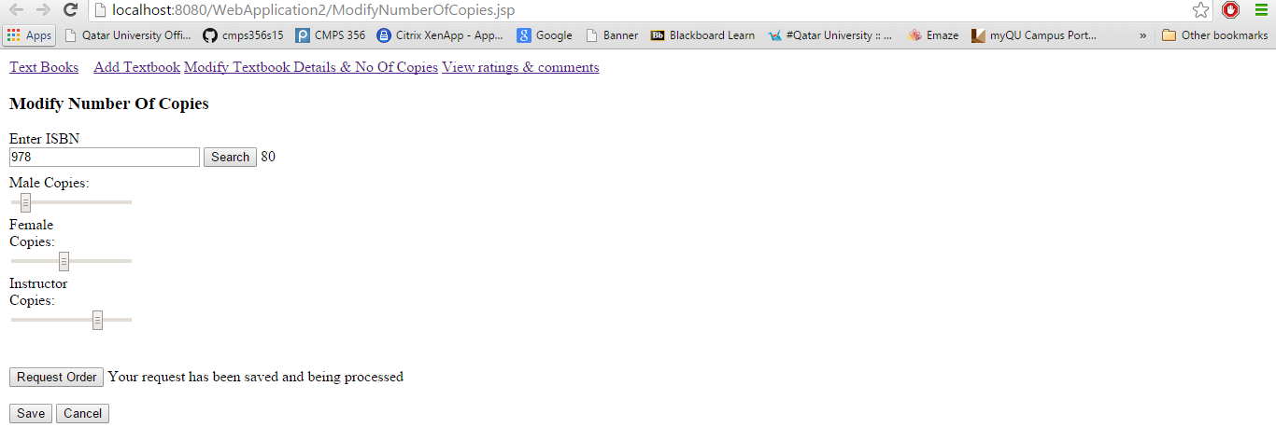

**Test -Textbook_Test-:**

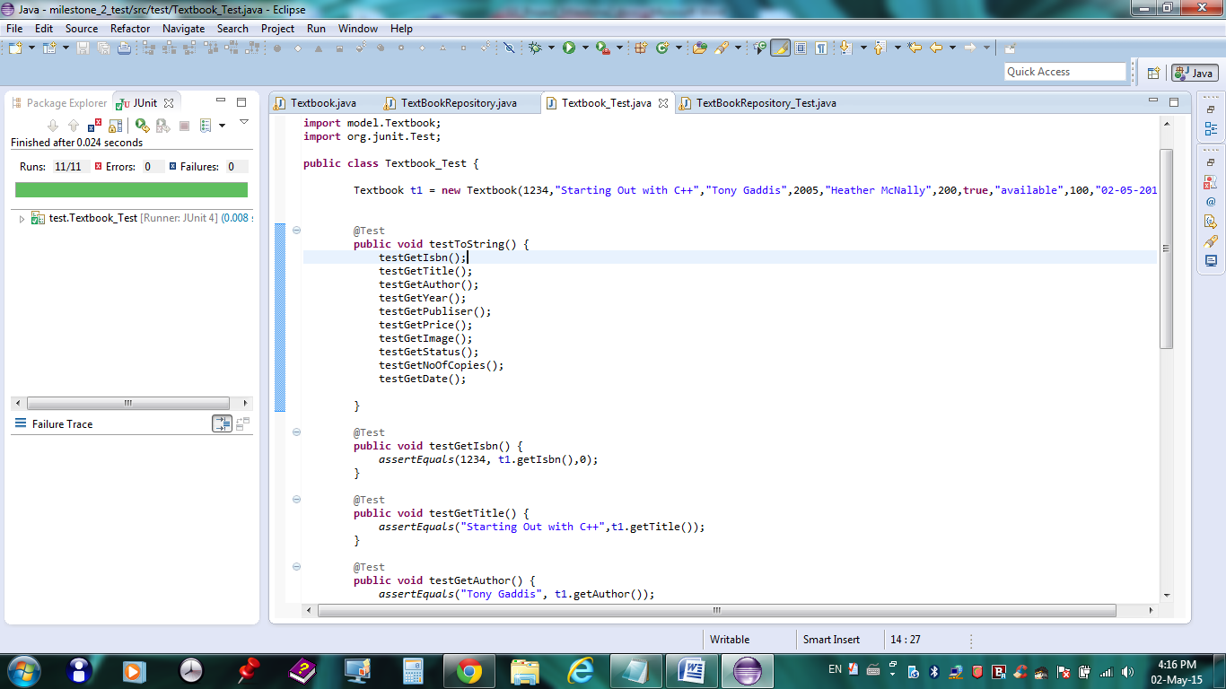

**Test -TextBookRepository_Test-:**

