**DynamoDB**

updating installed packages : sudo yum -y update

install python env. : sudo pip3 install boto3

attached local dynamodb docker: docker pull amazon/dynamodb-local

start local dynamodb : docker run -p 8000:8000 amazon/dynamodb-local

|  |
| --- |
| **Users** |
| **Id – S** |
| **AccountName – S** |
| **Email – S** |
| **FirstName – S** |
| **LastName – S** |
| **password** |
| **addresses** |
| **EIN** |

| **Access Pattern** | **Query** | **Entities Retrieved** |
| --- | --- | --- |
| Get requests per email | Get requests where "EMAIL" == EMAIL | User, Requests |
| Get requests per email and category | Get user where "email" == EMAIL and “cat” = CATEGORY | User, Requests |
| Get open requests per category | Find requests where " category " == CTEGORY and status = “OPEN” | Requests |
| Find request for a user | Find request where "email" == EMAIL | Requests, User |

**Tables:**

**Requests**

|  |  |  |  |  |  |  |
| --- | --- | --- | --- | --- | --- | --- |
| **PK** | **SK** |  | **GSI** |  |  |  |
| **email** | **Cat** | **Timestamp** | **Open** | **Price** | **request** | **Bid(json)** |
| [**eran@gmail.com**](mailto:eran@gmail.com) | **Flight** | **1.8.2021** | **yes** | **100** | **{tlv-bgk, persons:4, fromDate:15.8, toDate:20.8)** | **{“trip”:”tlv-bgk”, “persons”:”4”, “fromDate”:”15.8”, “toDate”:”20.8”, “price”:”100”)** |
| **moshe@gmail.com** | **Hotels** | **2.8.2021** | **yes** | **80** | **{country: Israel, town: Eilat, persons:2}** | **{“hotel”:”hilton”, “persons”:”2”, “fromDate”:”15.8”, “toDate”:”20.8”, “price”:”800”)** |

**For Each closed bid the open attribute is been deleted**

**Users/suppliers**

**Each user can make offer for other**

**EIN attribute assist distinguishes between users and business**

|  |  |  |  |  |  |  |  |
| --- | --- | --- | --- | --- | --- | --- | --- |
| **PK** |  |  |  |  |  |  |  |
| **Email(S)** | **First Name(S)** | **Last Name(S)** | **Timestamp(N)** | **Phone(S)** | **Password(S)** | **EIN (json)** | **Delivery Addresses(json)** |
| [**eran@gmail.com**](mailto:eran@gmail.com) | **Eran** | **Levi** | **1.8.2021** | **052-1234561** | **Eran123** |  | **{“country”:”Israel”, “town”: “tel-aviv”, “street”: “osishkin”, “no”:”15”}** |
| **moshe@gmail.com** | **Moshe** | **Dahan** | **1.8.2021** | **052-1234561** | **Moshe123** | **{**“12-3456789”: “best-flights”,  “categories”: [“flights”, “hotels”]  } | **{“country”:”Israel”, “town”: “tel-aviv”, “street”: “osishkin”, “no”:”15”}** |
| [**ben@gmail.com**](mailto:ben@gmail.com) | **Ben** | **Cohen** | **1.8.2021** | **052-1234563** | **Ben123** |  |  |
| **dan@gmail.com** | **Dan** | **Ron** | **2.8.2021** | **052-1234564** | **Dan123** | **{**“12-3456789”: “best-hotels”,  “categories”: [“zimmers”, “hotels”]  } | **{“country”:”Israel”, “town”: “jerusalem”, “street”: “sokolov”, “no”:”22”}** |

**Suppliers have additional attribute of EIN**

**Flights**

|  |  |  |  |  |  |  |  |  |  |
| --- | --- | --- | --- | --- | --- | --- | --- | --- | --- |
| **PK** |  |  |  | |  |  |  |  |  |
| **Trip(S)** | **TimeStamp(N** | **Min price (N)** | **Max Price(N)** | **Duration(N)** | | **Stops(N)** | **Trip(json)** |  |  |
| **TlV-BGK** | **1.8.2021** | **100** | **150** | **3600** | | **0** |  |  |  |
|  |  |  |  |  | |  |  |  |  |

tables items and attributes: <https://docs.aws.amazon.com/amazondynamodb/latest/developerguide/HowItWorks.CoreComponents.html#HowItWorks.CoreComponents.TablesItemsAttributes>

Primary Keys : <https://docs.aws.amazon.com/amazondynamodb/latest/developerguide/HowItWorks.CoreComponents.html#HowItWorks.CoreComponents.PrimaryKey>

Secondary Indexes: <https://docs.aws.amazon.com/amazondynamodb/latest/developerguide/HowItWorks.CoreComponents.html#HowItWorks.CoreComponents.SecondaryIndexes>

DynamoDB low level API : <https://docs.aws.amazon.com/amazondynamodb/latest/developerguide/Programming.LowLevelAPI.html>

AWS SDK’s : <https://docs.aws.amazon.com/amazondynamodb/latest/developerguide/GettingStarted.html>

DynamoDB Local: <https://docs.aws.amazon.com/amazondynamodb/latest/developerguide/DynamoDBLocal.html>

DynamoDB CLI Reference: <https://awscli.amazonaws.com/v2/documentation/api/latest/reference/dynamodb/index.html>

DynamoDB API Reference: <https://docs.aws.amazon.com/amazondynamodb/latest/APIReference/API_Operations_Amazon_DynamoDB.html>

Configuring Credentials: <https://docs.aws.amazon.com/amazondynamodb/latest/developerguide/SettingUp.DynamoWebService.html#SettingUp.DynamoWebService.ConfigureCredentials>

AWS Cloud 9 : <https://aws.amazon.com/cloud9/>

NOSQL Workbench for DynamoDB : <https://docs.aws.amazon.com/amazondynamodb/latest/developerguide/workbench.html>

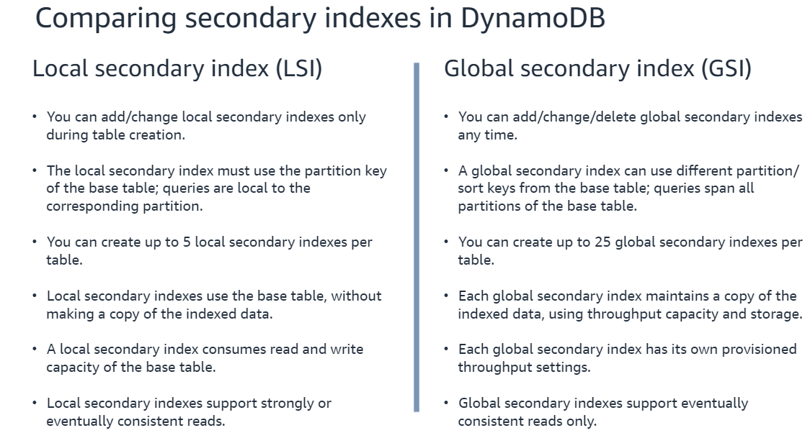

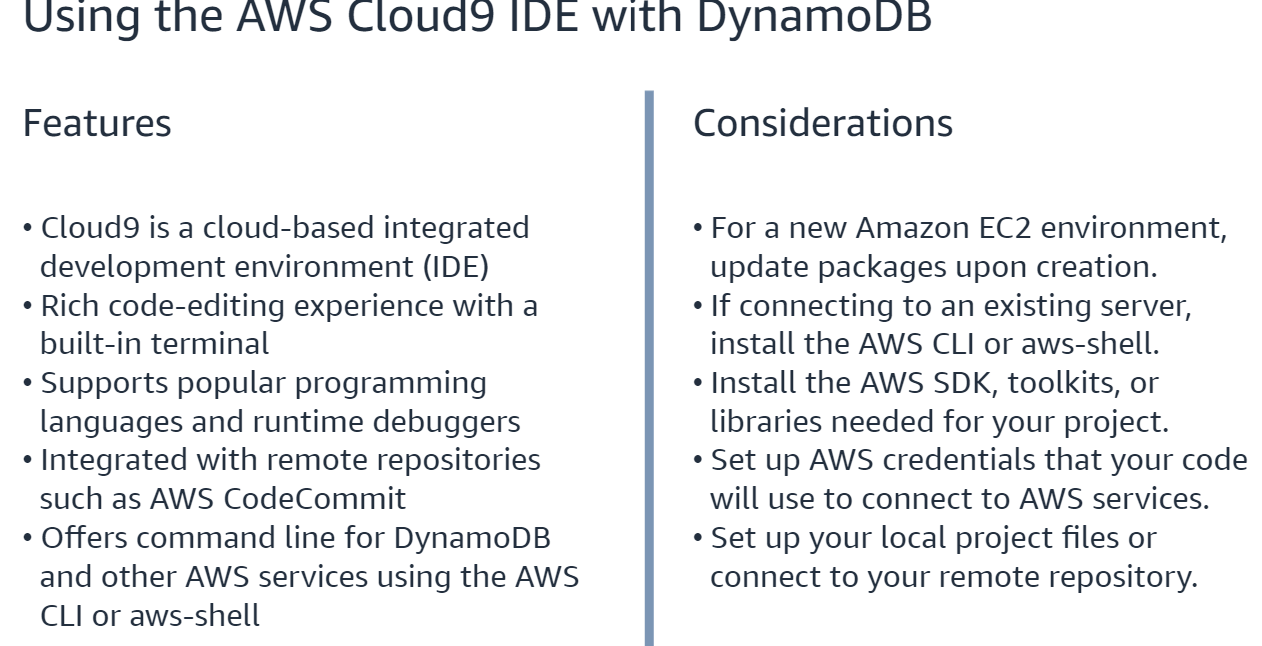

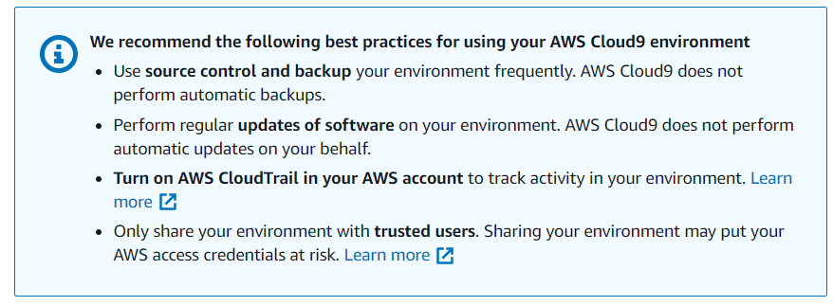

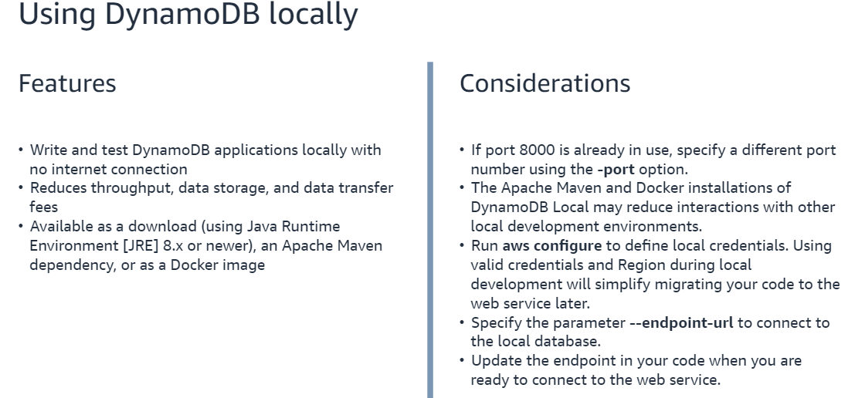

When updating was configure

