**Bids - Generators**

**Users**





* **Username (Bouzian674AlbisuGEN)**
* first name (**Bouzian**)
* random int between 123 and 999 (**674**)
* surname (**Albisu**)
* generator indication (**GEN**)
* **Entity** (**CUST#Bouzian674AlbisuGEN**)
* prefix (**CUST#**)
* Username(**Bouzian674AlbisuGEN**)
* **E-mail (Bouzian_Albisu@gmail.com)**
* first name (**Bouzian**)
* prefix (**_**) between first name and surname)
* surname (**Albisu**)
* pattern **(@gmail.com** \ @**yahoo.com**)

**DATES**

* **timestamp** (**2021-08-17T13:35:52.664372**)
* created record timestamp
* **create date (2021-04-13T11:55:52.608344)**
* 30-60 days ago
* **update date (2021-04-13T11:55:52.608344)**
* some records will have the value equal create date
* few records will have date few days after create date

**phone (718-820-5543)**

* random number

**Bids**



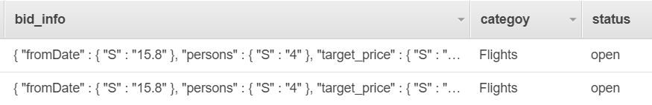

* **Username (Bouzian674AlbisuGEN)**
* Associated to the user
* **Entity (BID#01FDA6QYNQBSBQJ1J8GWXGJVHA)**
* prefix (**BID#**)
* ULID unique number

**DATES**

* **timestamp** (**2021-08-17T14:02:47.863156**)
* created record timestamp
* **create date (2021-04-19T08:09:52.661344)**
* 0-30 days ago (shell be after user been created in the system – related to user **update date**)
* **update date (2021-04-19T08:09:52.661344)**
* same as create date

**Offers**



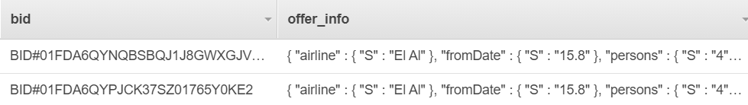

* **Username (Bouzian674AlbisuGEN)**
* Associated to the user
* **Entity (OFFER#01FDA74YZ2KMFEHJ0VHDN7EMVX)**
* prefix (**OFFER#**)
* ULID unique number
* **Bid (BID#01FDA6QYNQBSBQJ1J8GWXGJVHA)**
* related associated bid id

**DATES**

* **timestamp** (**2021-08-17T14:09:54.146441**)
* created record timestamp
* **create date (2021-04-21T05:17:52.713344)**
* 0-10 days ago (shell be after related bid been created in the system – related to user **bid** **update date**)
* **update date (2021-04-21T05:17:52.713344)**
* same as create date