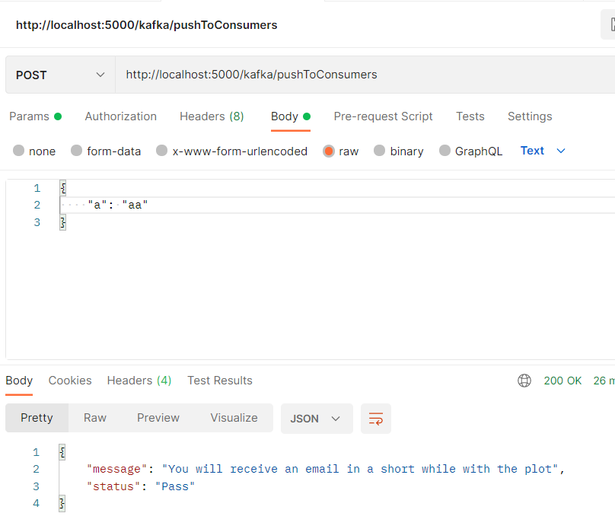

# producer.py

from flask import Flask, request, jsonify

import json

# from flask_cors import CORS

from kafka import KafkaConsumer, KafkaProducer

app = Flask(__name__)

TOPIC_NAME = "INFERENCE"

KAFKA_SERVER = "localhost:9092"

producer = KafkaProducer(

bootstrap_servers=KAFKA_SERVER,

api_version=(0, 11, 15)

)

@app.route('/kafka/pushToConsumers', methods=['POST'])

def kafkaProducer():

req = request.get_json(force=True)

print(req)

json_payload = json.dumps(req)

print(json_payload)

json_payload = str.encode(json_payload)

### push data into INFERENCE TOPIC

producer.send(TOPIC_NAME, json_payload)

producer.flush()

print("Sent to consumer")

return jsonify({

"message": "You will receive an email in a short while with the plot",

"status": "Pass"})

if __name__ == "__main__":

app.run(debug=True, port=5000)

# consumer.py

from kafka import KafkaConsumer, KafkaProducer

TOPIC_NAME = "INFERENCE"

KAFKA_SERVER = "localhost:9092"

consumer = KafkaConsumer(

TOPIC_NAME

)

for message in consumer:

print(str(message.value))