Ec2 - airflow

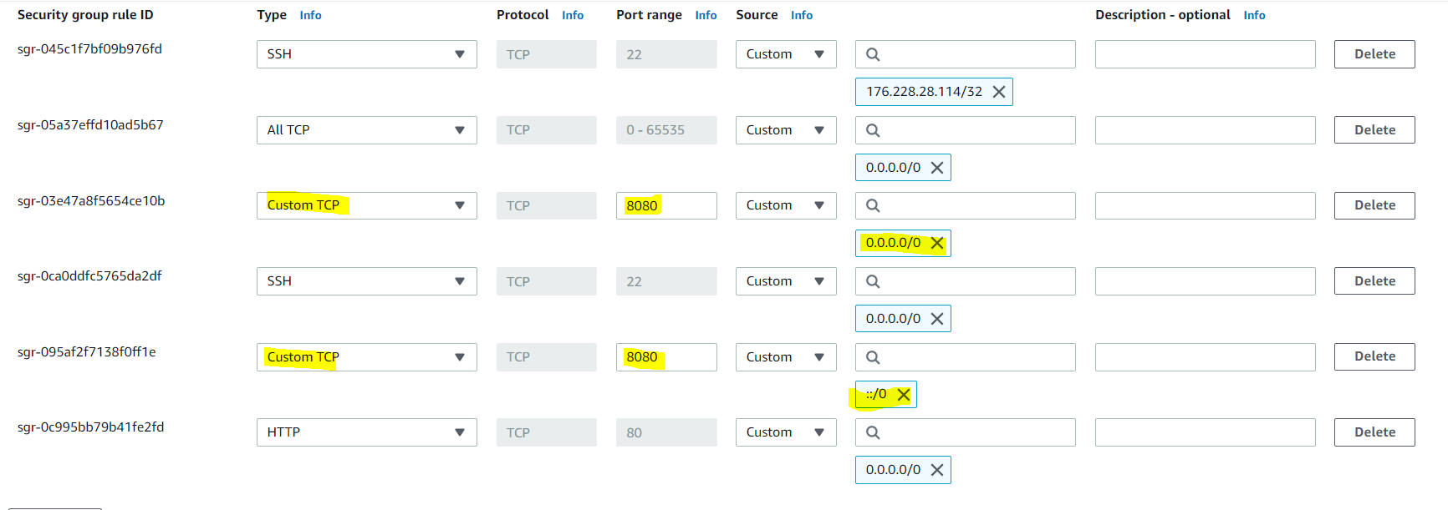

https://realpython.com/python-virtual-environments-a-primer/

1. pip3 install virtualenv
2. mkdir python-virtual-environments && cd python-virtual-environments
3. python3 -m venv env
4. cd ~/python-virtual-environments && source env/bin/activate
5. deactivate
6. python3 -m pip install --upgrade pip
7. python –version

install airflow on ec2

1. cd ~/python-virtual-environments && source env/bin/activate
2. sudo pip3 install SQLAlchemy==1.3.23
3. sudo pip3 install Flask-SQLAlchemy==2.4.4
4. sudo pip3 install apache-airflow==1.10.15
5. airflow initdb
6. export AIRFLOW_HOME=~/airflow
7. deactivate

first time I got error that’s why need to install SQLAlchemy and Flask-SQLAlch before installing apache-airflow==1.10.15

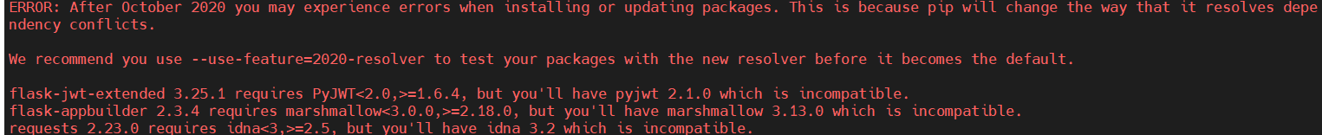

run airflow

cd aws

ssh -i "keyPair_ec2_tyche_pem.pem" [ec2-user@18.191.147.28](mailto:ec2-user@18.117.165.107)

airflow webserver -p 8080

<http://18.191.147.28:8080/admin/>

<https://newbedev.com/dag-not-visible-in-web-ui>

restart airflow webserver - airflow webserver -p 8080 -D

list dags: airflow list_dags

start scheduler (used when I didn’t see new dags in web-UI (airflow scheduler)

1. aws configure – apply es_credentials.csv
2. copy python script
3. add permission: chmod +rwx test_LoadKinesisUsers.py
4. pip3 install boto3
5. pip3 install python-dotenv
6. pip3 install python-dotenv

<https://docs.aws.amazon.com/cloud9/latest/user-guide/credentials.html>

<https://medium.com/@mahantya/access-your-aws-cloud9-ec2-instance-from-vs-code-over-ssh-ee1f5ea259ff>

https://stackoverflow.com/questions/53990203/ssh-into-aws-cloud9-environment

1. Launch cloud9
2. sudo cat **~/.ssh/authorized_keys**

**cert-authority ssh-rsa ** [5d553f63620f469f96b9913267c0a301@cloud9.amazon.com](mailto:5d553f63620f469f96b9913267c0a301@cloud9.amazon.com)

**cert-authority ssh-rsa  5d553f63620f469f96b9913267c0a301@cloud9.amazon.com**

ec2cloud9tyche

