Ec2 – airflow2.1.2

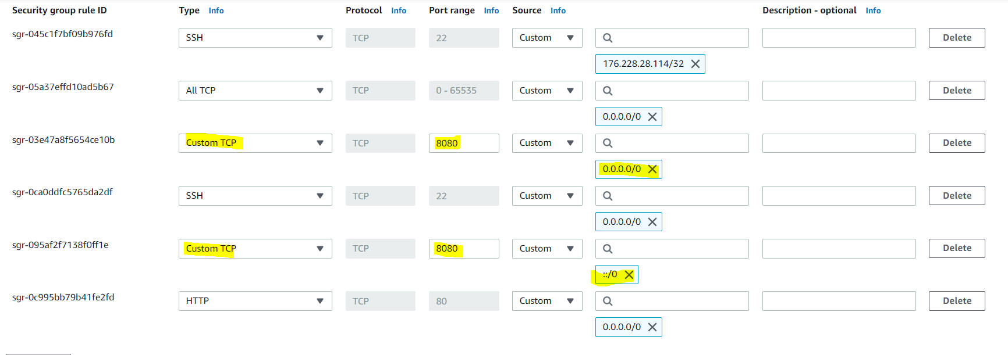

https://realpython.com/python-virtual-env-a-primer/

1. pip3 install virtualenv
2. mkdir python-virtual-env && cd python-virtual-env
3. python3 -m venv env
4. cd ~/python-virtual-env && source env/bin/activate
5. deactivate
6. python3 -m pip install --upgrade pip
7. python3 --version

install airflow on ec2

1. cd ~/python-virtual-env && source env/bin/activate

<https://airflow.apache.org/docs/apache-airflow/2.1.2/howto/set-up-database.html#setting-up-a-sqlite-database>

1. sudo yum -y install wget tar gzip gcc make expect
2. upgrade sqlite to be higher than 3.15

wget https://www.sqlite.org/src/tarball/sqlite.tar.gz

tar xzf sqlite.tar.gz

cd sqlite/

export CFLAGS="-DSQLITE_ENABLE_FTS3 \

-DSQLITE_ENABLE_FTS3_PARENTHESIS \

-DSQLITE_ENABLE_FTS4 \

-DSQLITE_ENABLE_FTS5 \

-DSQLITE_ENABLE_JSON1 \

-DSQLITE_ENABLE_LOAD_EXTENSION \

-DSQLITE_ENABLE_RTREE \

-DSQLITE_ENABLE_STAT4 \

-DSQLITE_ENABLE_UPDATE_DELETE_LIMIT \

-DSQLITE_SOUNDEX \

-DSQLITE_TEMP_STORE=3 \

-DSQLITE_USE_URI \

-O2 \

-fPIC"

export PREFIX="/usr/local"

LIBS="-lm" ./configure --disable-tcl --enable-shared --enable-tempstore=always --prefix="$PREFIX"

make

sudo make install

3. pip install 'apache-airflow==2.1.2' \

--constraint <https://raw.githubusercontent.com/apache/airflow/constraints-2.1.2/constraints-3.7.txt>

1. export AIRFLOW_HOME=.
2. airflow db init
3. create admin using:

FLASK_APP=airflow.www.app flask fab create-admin

1. export LD_LIBRARY_PATH=/usr/local/lib:$LD_LIBRARY_PATH
2. enter:

<http://3.139.96.180:8080/home>

1. aws configure – apply es_credentials.csv
2. copy python script
3. add permission: chmod +rwx test_LoadKinesisUsers.py
4. pip3 install boto3
5. pip3 install python-dotenv

Apply DAGS – need to edit

run airflow

cd aws

ssh -i "keyPair_ec2_tyche_pem.pem" [ec2-user@18.191.147.28](mailto:ec2-user@18.117.165.107)

airflow webserver -p 8080

<http://18.191.147.28:8080/admin/>

<https://newbedev.com/dag-not-visible-in-web-ui>

restart airflow webserver - airflow webserver -p 8080 -D

list dags: airflow list_dags

start scheduler (used when I didn’t see new dags in web-UI (airflow scheduler)

1. aws configure – apply es_credentials.csv
2. copy python script
3. add permission: chmod +rwx test_LoadKinesisUsers.py
4. pip3 install boto3
5. pip3 install python-dotenv