**Trip Sample: Badrinath - Gokarna**

<https://www.rome2rio.com/map/Badrinath/Gokarna>

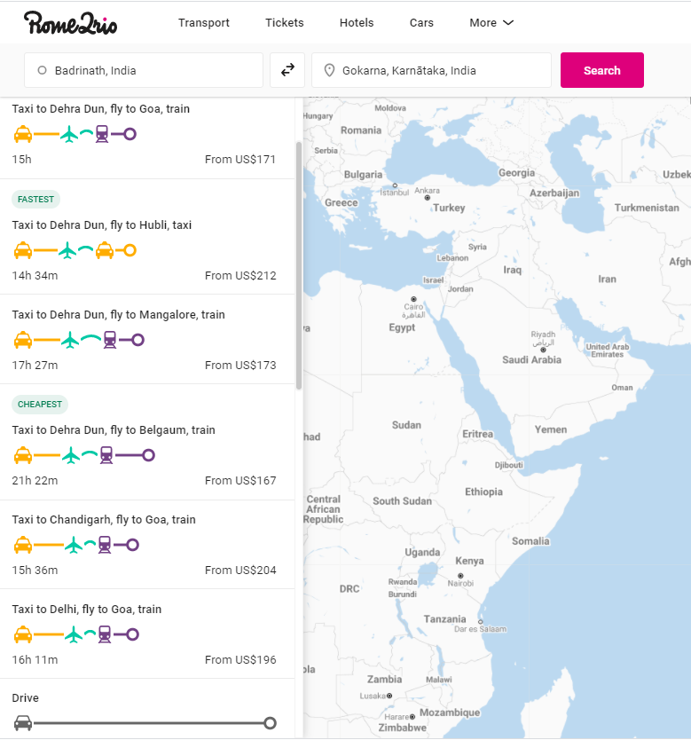

**Extracted Json – 7 trip options**

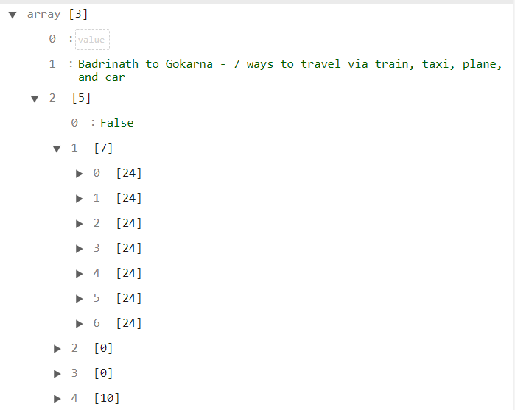

**Extracted Json – Option #1 for example**

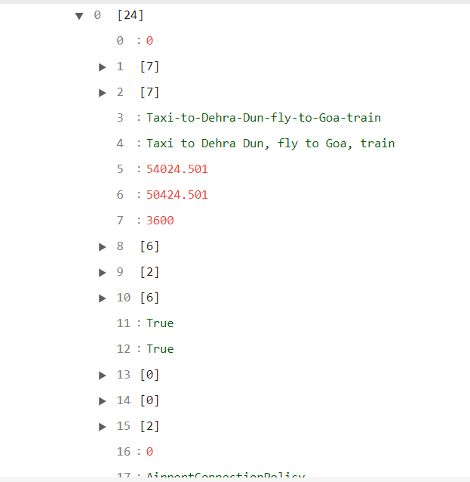

**Extracted Json – Option #1 Transits for example**

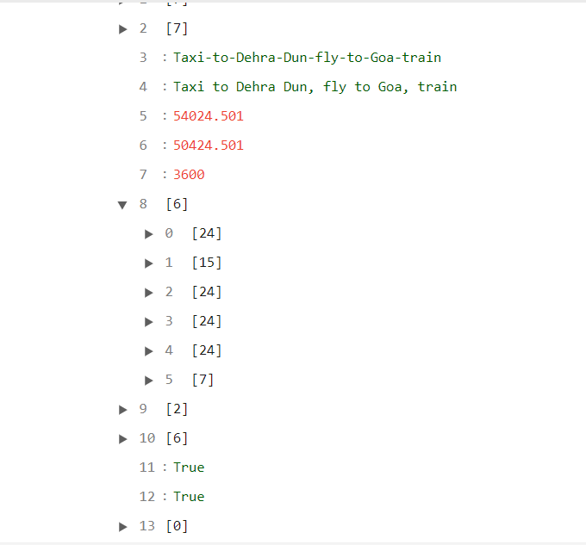

**Extracted and parsed Option and its related Transits – Option #1 for example**

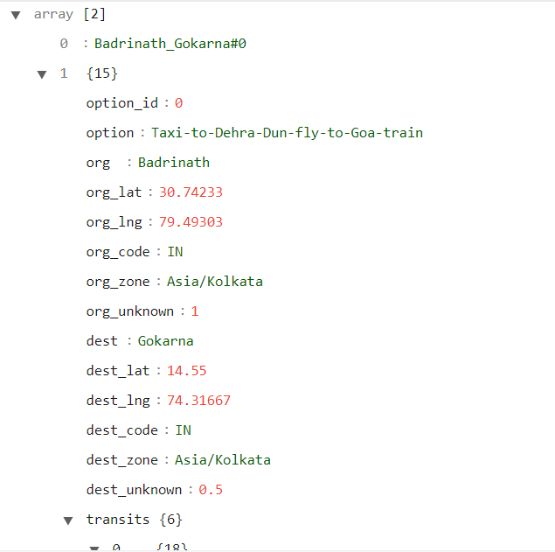

**Extracted and parsed Option and its related Transits – Option #1 Transits for example**

