1. Open your Command Line on Windows.
2. Create a new folder on Desktop called "DockerFiles".

1. Create a folder called YourFirstName_File inside the DockerFiles folder.

Note: No extension to be used.

1. Edit the file using VIM editor on Command Line.

1. Go to Insert mode and write the format for creating a new Docker image by using a set of instructions such as FROM, RUN, and CMD.
2. Create a new image by taking a base image as "ubuntu".
3. In the "MAINTAINER" section of the Docker file, write your first name, your last name, and your triOS College email ID.
4. During the container creation, write a message as follows:
5. "Your_Name-Hello world! Welcome to my Docker image!"

1. Save your work and exit the VIM editor.
2. View the contents of your Docker file by using a suitable command.

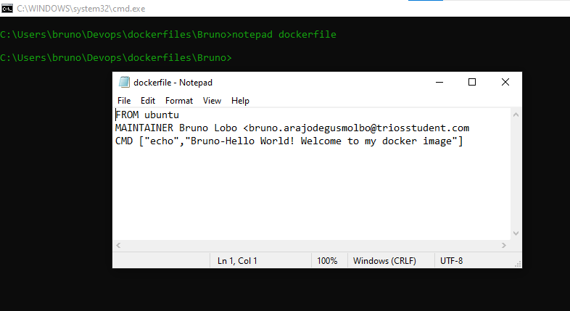

1. Take a screenshot and save it as "FirstName_1.jpeg."
2. Open your Docker file and check the contents you created.
3. Write a Docker command to build the image by giving the name for the image as your first name.

1. From the results, save the tag name and image ID.
2. List all the active Docker images.
3. Run the Docker image by using its ID to create the container.
4. Take a screenshot again of the results and save it as "FirstName_2.jpeg."

1. In the same folder DockerFiles, create one text file with the name "LastName.txt."
2. Write 'CSD113' and 'Computer Programming - triOS College' in this file. A screenshot of a computer program

   Description automatically generated

1. Push the Docker files to your Docker Hub repository.
2. Make the repository public and share the link for that repository by keeping it in the Word file.

docker pull esbrunol/new24:latest

<https://hub.docker.com/repository/docker/esbrunol/new24/tags>