Homework 1

Eric Sabelhaus

CMSC325

Professor: Michael Elms

I find both strategies to be similar, though the Random strategy is based off the randomness of the operating system on which it's running, while the Probability strategy expects a seed data of numbers produced by the Random strategy. I actually expected the probability strategy to be more random than the Random strategy considering it was just going off a lot of random numbers to being with. I expected at least a deviation away from near 50% probability of getting heads or tails. Now that I think about it, it's fairly reasonable that the probability of 1 or 0 would be about 50% on either side, so seeing 51% and 49% for both strategies makes pretty good sense actually. I suppose you will get a slight deviation on either side due to the system they're running on, but outside of that it should be at or near 50/50 split due to the nature of what the program is performing.

The runtime data from my application can be found in Random_data.txt and Probablistic_data.txt respectively within the application directory of zip I've submitted.

Instructions on how to run the application can be found in the README.md file within the application directory of the zip I've submitted.

Working JMonkey:

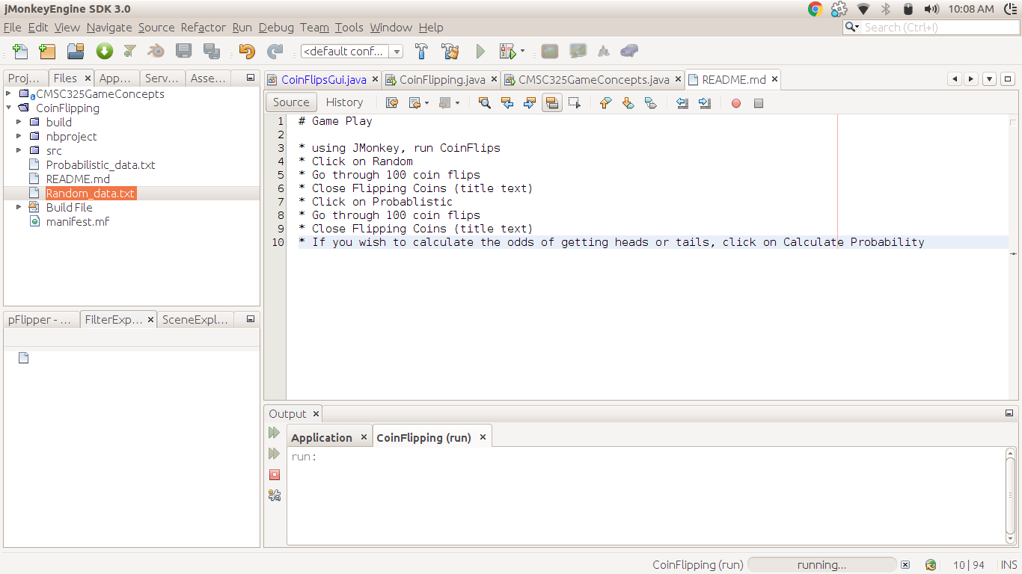

Application runthrough:

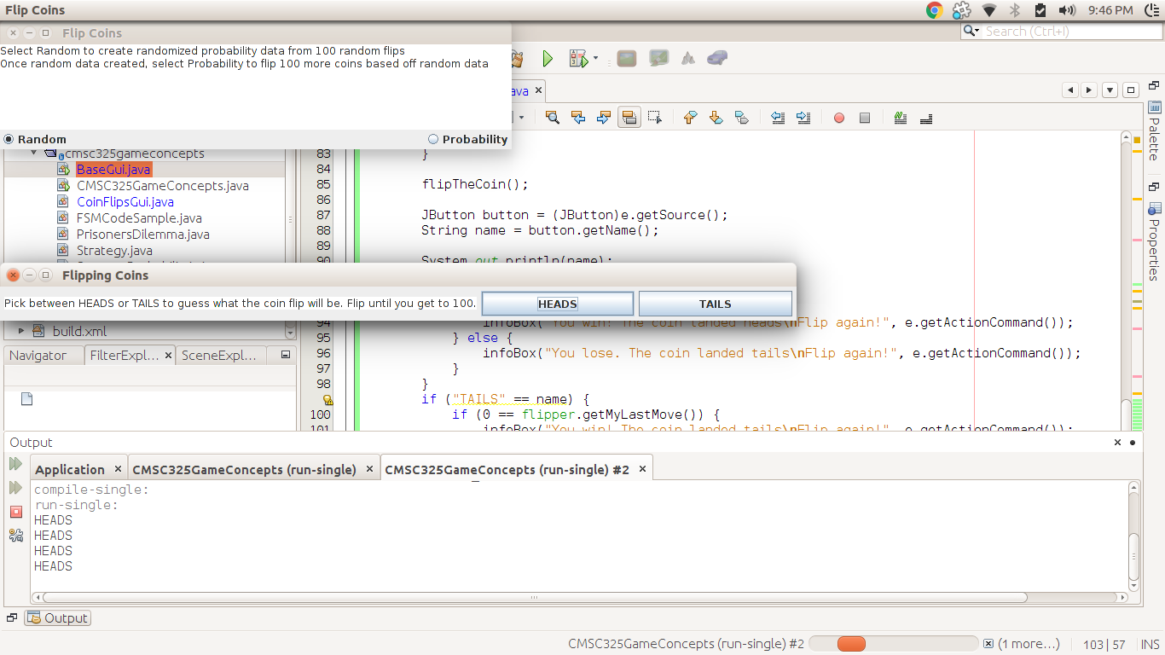

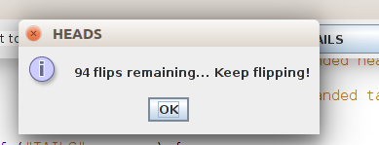

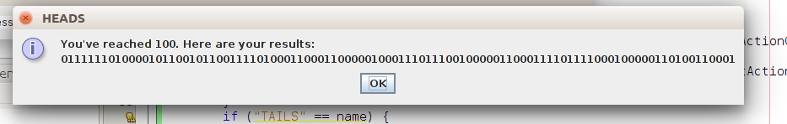

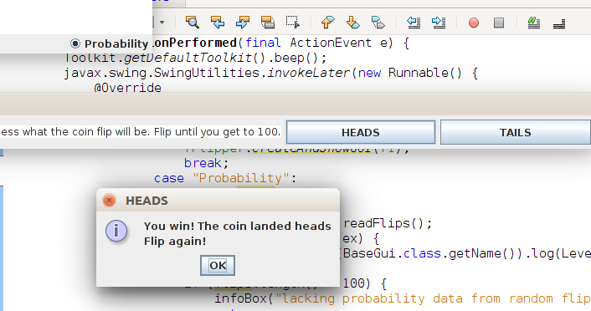

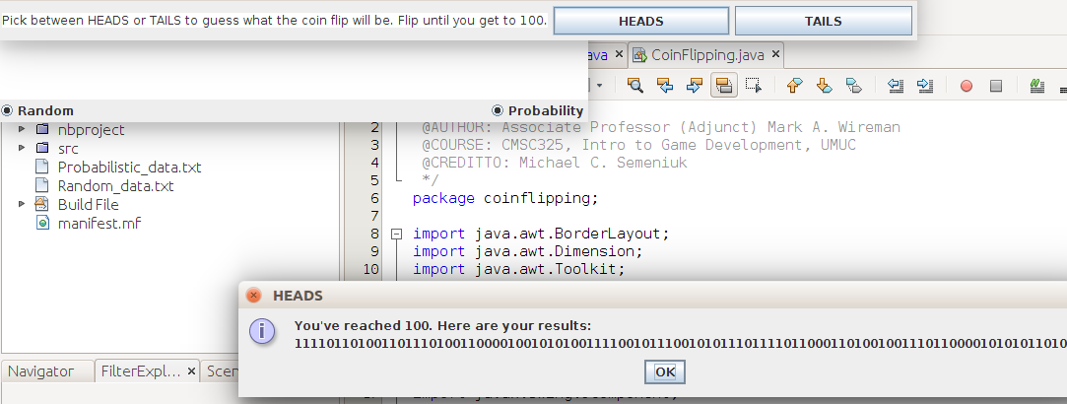

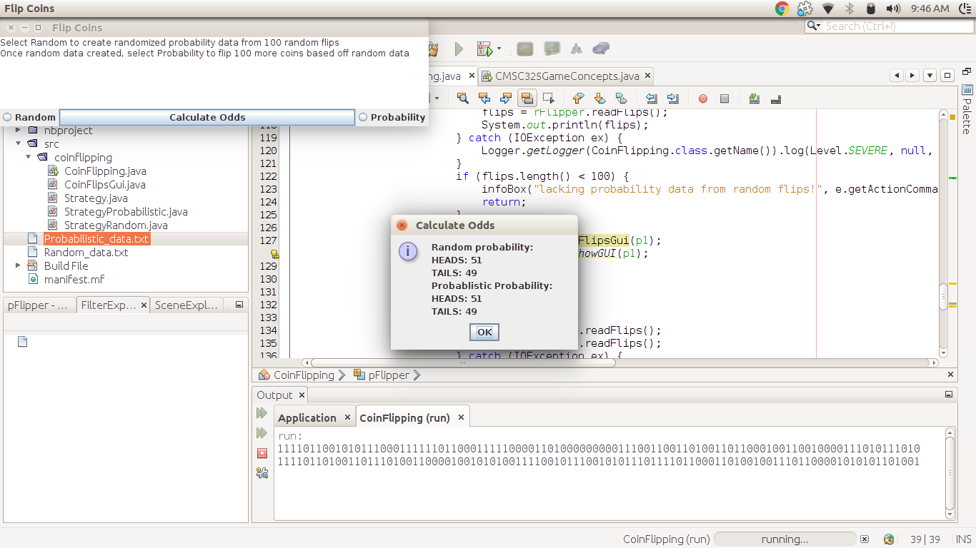

Also, provide an answer in the summary to the following questions:

1) Does either strategy produce a near 50% probability?

Yes, both produce about 49 or 51% probability

2) Which strategy produced more or less?

Since the seed data for Probability comes from the random probability, they end up producing around the same probability