**Primary Investigators**

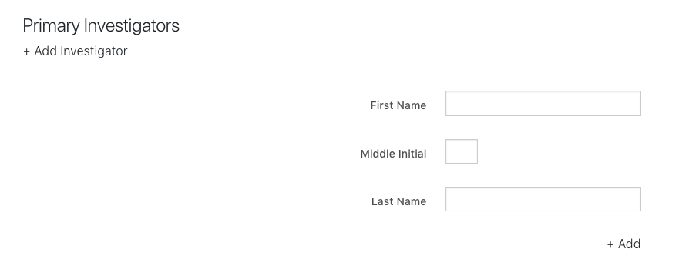

**First Name:** John

**Middle Initial:** (optional)

**Last Name:** Smith

**Assay Details**

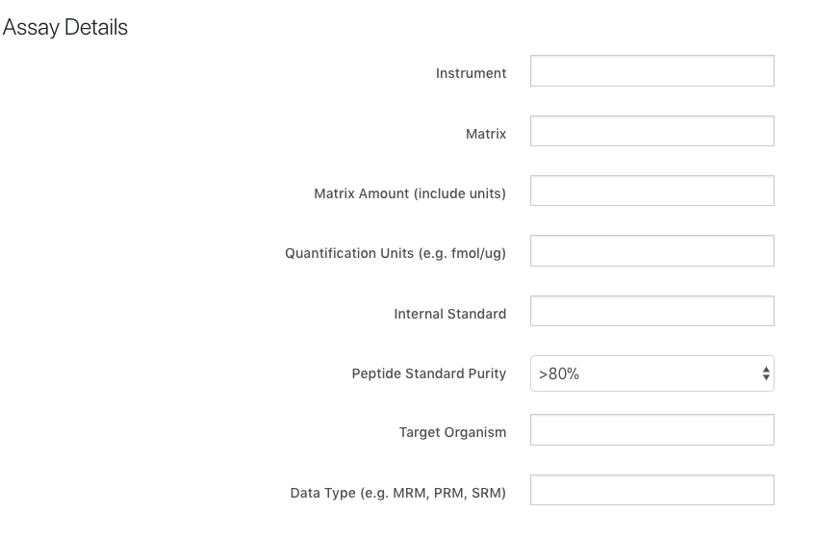

**Instrument:** 5500 QTRAP (ABSCIEX)

**Matrix:** cell line lysate pool

**Matrix Amount:** 1 ug

**Quantification Units:** fmol/ug

**Internal Standard:** peptide

**Peptide Standard Purity:** >80%

**Target Organism:** Homo Sapiens (Human)

**Data Type:** MRM

**Assay Parameters**

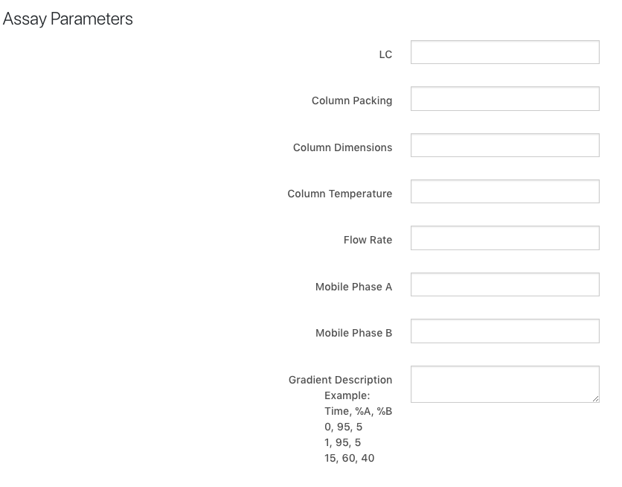

**LC:** nanoLC-Ultra 2D, cHiPLC-nanoflex (Eksigent)

**Column Packing:** ChromXP C18-CL, 3 um, 120A

**Column Dimensions:**150 x 0.075 mm

**Column Temperature:** 40C

**Flow Rate:** 500 nL / min

**Mobile Phase A:** 0.1% formic acid in water

**Mobile Phase B:** 0.1% formic acid in 90% acetonitrile

**Gradient Description:**

Time, %A, %B  
0, 95, 5  
1, 95, 5  
15, 60, 40

**Assay Type (enrichment)**

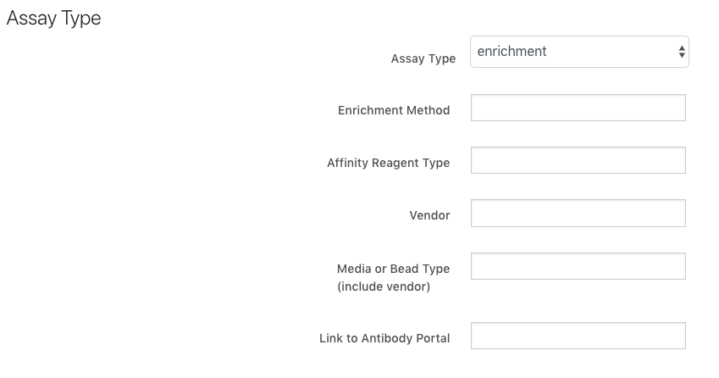

**Assay Type:** enrichment

**Enrichment Method:** Fe(III)-NTA

**Affinity Reagent Type:** hydrazide tip

**Vendor:** Qiagen/Agilent

**Media or Bead Type:** AssayMAP cartridge

**Assay Type (fractionation)**

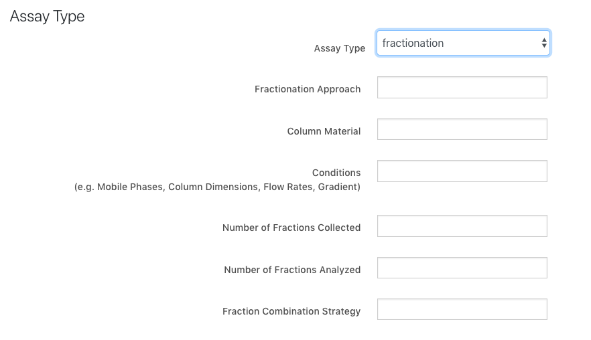

**Fractionation Approach:** high-pressure, high-resolution, high pH reverse phase frationation with online monitoring (PRISM)

**Column Material:** 3um C18 Jupiter 300 Å from Phenomenex

**Conditions:** Mobile Phase A: 10mM Ammonium formate in H2O, pH 9 and Mobile; Phase B: 10mM Ammonium formate in 90% ACN, pH 9; Column: 200um x 50cm; Flow rate: 2.2 uL/min; Gradient: 1-10% B in 2 min, 10-15% B in 15 min, 15-25% B in 35 min, 25-35% B in 25 min, 35-45% B i

**Number of Fractions Collected:** 1

**Number of Fractions Analyzed:** 96

**Fraction Combination Strategy:** none

**Upload SOP Files**

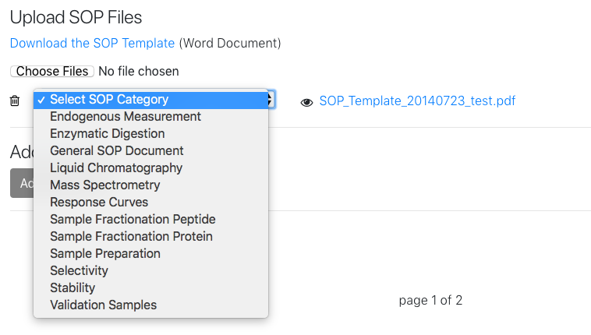

**SOP Files:** Liquid Chromatography

**Upload Publications**

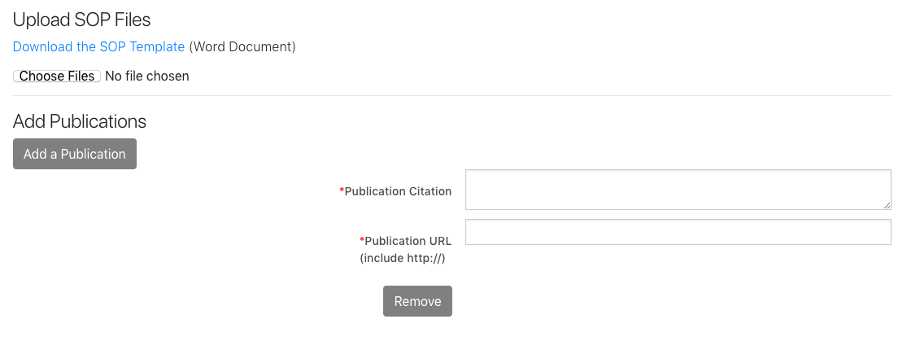

**Publication Citation:** <Publication Citation >

**Publication URL:** < Publication URL>