MealPlanner AI Recipe and Meal Planning Agent
Stage 1 Project Design Report
Suleyman Kavas | EECS3311 Software Design | Fall 2026 | Individual project
Proposed design | 2 October 2026

1 Project overview
My agent, "MealPlanner," will help a home cook decide what to buy and serve for the week and how much of each they'll need, making a trip to the grocery store easier. I propose a Java application with a desktop graphical interface and a command-line interface since these are things that I am already somewhat familiar with. The same Application Services, local data and AI Agent will be used for both interfaces.
The target customer population is cooking lovers who desire usable inspiration that they can follow at home, depending on their food likes/dislikes, ingredients they have, and the time they wish to invest in cooking. Searching for recipes individually can be time-consuming and inconsistent, and rewriting meal plans and then combining product quantities to purchase can be cumbersome.
The agent will load previously saved preferences, pantry foods and recipes, pick relevant foods and suggest meals based on the suggestion, and amend the meal based on the natural language meal query. Java components will validate constraints, scale ingredient quantities, combine shopping-list items and save accepted changes. One reason why an agent is well suited for this type of problem is that it can understand what a client wants, fetch context, select tools and make plans with multiple steps.

Project scope
The first version will only have one user locally, a specific set catalogue of ingredients, manually entered quantities of foods that are available to the user now, structured recipe entry or JSON import, and plans spanning one to seven days. Users will be able to review proposals through either interface before saving them. The ten features that will be implemented are specified in Section 5.
Report map
Section | Contents
2 | Scope, technology and data rules
3 | AI model and agent workflow
4 | Five design patterns and rationale
5 | Ten feature specifications, use cases and realization explanations
6 | UML class diagram views
7 | UML use-case diagram
8 | Sequence diagrams
9 | Feature-to-design traceability
10 | Validation plan, references and submission preparation

2 Scope and architecture

Technology choices
Proposed implementation employs Java 21, Swing (desktop GUI), a Java console CLI, JSON files (for local) and JUnit (for testing purposes). The choices of projects are not statements that the instructions provided for the project demand a specific language. An isolated provider adapter is used for API calls. The design does not depend on having a web server or mobile app.

Shared application structure
PlannerGUI and PlannerCLI convert user requests to PlannerFacade calls. The facade coordinates RecipeService, PlanService, ShoppingService and AgentCoordinator. The services handle business rules, while ConstraintValidator checks the supported constraints. The StateStore is an abstraction with state persistence that is implemented by the JsonStateStore. Here, Application startup builds and injects these dependencies and subsequently loads AppState.
API and file work are run separately from the Swing event-dispatch thread, and progress/changes are shown in the GUI. The CLI is a named interactive command session, where preview is saved on accept, and lost on reject (proposal). There are 2 modes of launching, CLI and GUI, and at any one time the process that launches it owns the data directory, while another one opening the directory is denied access due to the lock on the file.

Boundaries and data rules
- A seed catalogue of roughly 40 ingredients and 20 recipes provides enough data for demonstrations. Ingredients have stable IDs and one canonical unit: grams, millilitres or count.
- Recipes use positive BigDecimal quantities, unique ingredient IDs, 1 to 12 base servings, 1 to 240 preparation minutes and non-empty steps. Count quantities may be fractional. Calculations use DECIMAL128 precision; displays round to two decimal places without rewriting stored values. The recipe collection may contain structurally valid recipes that do not meet the current profile.
- Supported dietary filters are unrestricted, vegetarian and vegan, plus explicit excluded ingredient IDs. Eligibility is based on catalogue metadata. The app does not certify medical allergy safety or product-level religious compliance.
- A plan contains 1 to 7 days and at least one selected breakfast, lunch or dinner slot. Every requested slot occurs exactly once. PlanRequest fixes the date, days, slots, servings and noRepeat flag before model execution; the model cannot change these fields. MealPlan stores noRepeat so later revisions preserve it. Repetition is checked by source recipe ID.
- Shopping lists total the ingredients required. They do not deduct pantry quantities, estimate prices, order groceries or calculate nutrition. Recipe websites, arbitrary document imports and automatic unit conversions are outside this version.

Persistence and consistency
AppState contains the profile, pantry, recipes, plans and a revision counter. Changes are made to a copy and written to a temporary JSON file in the same directory before replacing the saved file atomically. If writing fails or atomic replacement is unsupported, the active state and original file remain unchanged. Invalid stored data produces an error instead of being replaced with empty data. Each meal entry stores its own recipe snapshot, so later recipe edits cannot change saved plans. Proposals record the state revision they were created from and must be regenerated if that revision changes. The facade processes changes one at a time and holds a lock from revision checking through saving.

3 AI model and agent capabilities
The proposed model is Google Gemini 3.5 Flash-Lite, with the model ID gemini-3.5-flash-lite. Google documents support for function calling and structured outputs [4]. These features allow the agent to request local tools and return recipe IDs and meal-plan entries in a format the application can process. API access and costs will be checked before implementation; the design does not assume free usage.
GeminiAdapter is an implementation of the application-owned interface LLMClient. It translates AgentContext to provider requests and responses from providers to AgentStep or AgentDraft objects. This API key is retrieved from an environment variable and never stored in source control. The model ID is programmable; provider changes are behind the adapter and are considered a design change.

Available agent tools
Tool name | Deterministic implementation and result
readProfile | Reads PreferenceProfile from the request snapshot.
readPantry | Reads ingredient IDs, quantities and units from the snapshot.
searchRecipes | RecipeService.search() returns eligible recipe records.
readPlan | Returns a saved MealPlan and recipe snapshots by ID.
listIngredients | Returns known IDs, units and dietary metadata.
checkPlan | PlanService.validate() checks a proposed plan and returns violations.

Bounded execution
AgentCoordinator.run() starts with a state snapshot and the task constraints. It calls LLMClient.nextStep(), receives a tool request, checks the tool name and argument schema, and passes the request to ToolRegistry.execute(). Tool results are added to the context for the next model step. The agent can search for alternatives and use validation feedback to revise its proposal.
This request allows for a maximum of 6 model calls: 5 nextStep(), 1 finish(). One call to the tool at each phase of the tool stage, with unsupported batches receiving a format error message. The tool loop gets terminated early with FinalReady. The last call is the call with a structured schema yet without tools. Context handles for tool calls, and results are preserved. Requests have an overall timeout of 90 seconds and 15 seconds per call to the provider. If there is an error or it's an invalid final draft, an explicit failure without saving occurs.
The facade and services independently validate the final IDs, quantities, meal slots and supported constraints. Recipe IDs must exist in the request snapshot. For AI recommendations and new meal selections, they must also come from candidates retrieved through the tools. Valid proposals are shown for review, and only PlannerFacade.accept() saves them. Recommendations do not change saved data. If a request is ambiguous or unsupported, the application explains the issue and asks the user to revise and resubmit it.

Memory and failure behaviour
Long-term memory is the saved profile, pantry, recipes and plans. Tool messages are short-term context for one request; a separate vector database is unnecessary. A timeout, authentication failure, malformed response or impossible constraint is reported explicitly. Deterministic features remain usable while the AI service is unavailable. Logging records task type, duration and success or failure without storing credentials or full request text.
4 Design patterns

Facade
Problem: the GUI and CLI must reveal the same workflows without having a problem with duplication. PlannerFacade is the facade; RecipeService, PlanService, ShoppingService, AgentCoordinator and StateStore are collaborating subsystems. The interfaces call focused facade methods such as createPlan(), scale() and shopping(). Without the facade, both interfaces would need to deal with validation, agent calls and persistence independently.

Adapter
Problem: provider request formats should not spread through application classes. LLMClient is the target interface, GeminiAdapter is the adapter, and the external Gemini API is the adapted service. nextStep() and finish() translate provider-specific tool and output structures into application DTOs. Without the adapter, changing model providers would affect the coordinator and callers. Tests can supply a fake LLMClient without network access.

Decorator
Problem: model-call logging should be reusable across multiple usages, without getting entangled in the planning or provider code. LoggingLLMClient implements LLMClient and wraps another LLMClient (typically GeminiAdapter) and delegates nextStep() and finish(), measures the elapsed time, logs sanitized outcomes and preserves both the return values and exceptions. Without such a pattern, the same logging code would have been replicated in all providers or callers. The wrapper can be omitted during tests without impacting clients.

Builder
Problem: a meal plan must be assembled from dates, meal slots, recipe snapshots and serving counts before it can be considered complete. MealPlanBuilder is the builder, MealPlan is the product and PlanService is the director. start() begins construction, addMeal() supplies entries, and build() returns a structurally complete plan. PlanService then validates profile constraints. Without a builder, controllers or parsing code would manipulate partially initialized plans directly. A separate abstract builder is unnecessary until multiple construction implementations are needed.

Prototype
Problem: revisions, substitutions and serving changes must preserve the source object. Recipe and MealPlan provide explicit deepCopy() prototype operations. RecipeService and PlanService are clients that copy a source and modify the independent result. MealPlan copies its entries and recipe snapshots; Recipe copies ingredient amounts and instruction lists. Accepted copies receive new IDs. Without deep copying, shared mutable lists could accidentally change the original meal plan or recipe. Copy tests will check this independence.
All five patterns are covered by the supplied creational or structural pattern slides [2, 3]. SOLID principles guide responsibilities and dependencies but are not counted as design patterns.

5.1 F01 Manage dietary preferences
Classification Deterministic feature
Input Diet (unrestricted, vegetarian or vegan), excluded ingredient IDs, default servings and maximum preparation time.
Output and purpose A saved preference profile or specific validation errors.
GUI access Preferences form with Save and field-level validation.
CLI example profile set --diet vegetarian --servings 2 --max-minutes 30 --exclude peanut

UC01 Manage dietary preferences
Primary actor: User. Goal: A saved preference profile or specific validation errors.
Preconditions The ingredient catalogue is loaded.
Trigger User saves the preferences form or runs profile set.
1. Enter or modify supported preferences.
2. Validate diet value, known ingredient IDs, servings from 1 to 12 and time from 1 to 240 minutes.
3. Copy the state, replace the profile, and save atomically.
4. Display the saved profile; assess future recommendations against it.
Alternative and exception flows Unknown ingredients, unsupported diet labels and out-of-range values are rejected. A write failure leaves the old profile intact. Existing recipes and plans are preserved; eligibility is rechecked when reused.
Postconditions The new profile is persisted and the state revision increases, or no state changes.

Feature realization
Both interfaces call PlannerFacade.updateProfile(). ConstraintValidator.profile() validates the fields. The facade updates a copy of the current AppState and saves it through StateStore before replacing the active state. PreferenceProfile is now the source of constraints for search and agent requests.
Classes PlannerGUI / PlannerCLI, PlannerFacade, ConstraintValidator, StateStore, PreferenceProfile, AppState
Key methods submit(), updateProfile(), profile(), deepCopy(), save(), display()
Traceability F01 / UC01 / SD01. Patterns: Facade.

5.2 F02 Manage pantry inventory
Classification Deterministic feature
Input A catalogue ingredient ID and quantity in its displayed canonical unit; Remove deletes an entry.
Output and purpose Updated pantry quantities available to recipe search and the agent.
GUI access Pantry table with ingredient selector, quantity editor and Remove action.
CLI example pantry set --ingredient rice --quantity 500

UC02 Manage pantry inventory
Primary actor: User. Goal: Updated pantry quantities available to recipe search and the agent.
Preconditions The catalogue is loaded; entries may initially be empty.
Trigger User adds, updates or removes a pantry entry.
1. Select a catalogue ingredient and enter a non-negative quantity.
2. Check the ingredient ID, quantity and associated canonical unit.
3. Update a copied pantry map and save the candidate state.
4. Display the current pantry and unit labels.
Alternative and exception flows Negative quantities, unknown IDs and malformed numbers are rejected. Zero is accepted and treated as unavailable. No automatic stock changes occur when a plan is created.
Postconditions The pantry map is saved, or the previous map remains unchanged.

Feature realization
PlannerFacade.updatePantry() performs field-level constraints by delegating to ConstraintValidator.pantry(), then applies the changes to a copy of AppState.pantry and persists it. Catalogue provides the unit, so that the same ingredient is not measured in different units. ToolRegistry can read the persisted pantry while issuing recommendations.
Classes PlannerGUI / PlannerCLI, PlannerFacade, ConstraintValidator, AppState, Ingredient, StateStore
Key methods submit(), updatePantry(), pantry(), deepCopy(), save(), display()
Traceability F02 / UC02 / SD01. Patterns: Facade.

5.3 F03 Create and import structured recipes
Classification Deterministic feature
Input Title, base servings, preparation minutes, canonical ingredient IDs with positive quantities, and non-empty instruction steps.
Output and purpose A validated recipe with a unique ID, or field and import errors.
GUI access Recipe form or Import JSON action, followed by preview and Save.
CLI example recipe import --file lentil-soup.json

UC03 Create and import structured recipes
Primary actor: User. Goal: A validated recipe with a unique ID, or field and import errors.
Preconditions The catalogue is loaded; import file is readable for the import route.
Trigger User submits a recipe form or imports a structured JSON recipe.
1. Read the form or a JSON file limited to 100 KB.
2. Parse the recipe and validate required fields, ingredient IDs, quantities and ranges.
3. Show the parsed recipe for review.
4. On Save, assign a new ID and persist the recipe in the local collection.
Alternative and exception flows Malformed JSON, missing fields and unsupported ingredients are rejected without partial import. Recipes conflicting with the current diet may be stored with a visible ineligible label, but are excluded from recommendations and plans.
Postconditions Acceptance adds one valid recipe; cancellation or failure changes nothing.

Feature realization
PlannerFacade.previewRecipe() uses the RecipeService.parse() method to attempt to parse normalized form data or a bounded JSON import. The ConstraintValidator.recipe() method distinguishes structural errors from those that arise from current-profile eligibility. A structurally valid recipe is submitted as an IMPORT_RECIPE Proposal, including any eligibility warnings. PlannerFacade.accept() revalidates structure and only stores the recipe after it has been accepted for review. Both search and planning require structural validity and current-profile eligibility.
Classes PlannerGUI / PlannerCLI, PlannerFacade, RecipeService, ConstraintValidator, Recipe, StateStore, Proposal
Key methods submit(), previewRecipe(), parse(), recipe(), validate(), accept(), save(), display()
Traceability F03 / UC03 / SD10 and SD08. Patterns: Facade.

5.4 F04 Search and filter recipes
Classification Deterministic feature
Input Optional title text, included ingredient IDs, maximum minutes and pantry-only flag.
Output and purpose Eligible matching recipes with servings and ingredient quantities; an empty result is allowed.
GUI access Recipe browser with title, ingredient, preparation-time and pantry-only filters.
CLI example recipe search --text soup --max-minutes 30 --pantry-only

UC04 Search and filter recipes
Primary actor: User. Goal: Eligible matching recipes with servings and ingredient quantities; an empty result is allowed.
Preconditions The profile and recipe collection are available.
Trigger User submits search filters.
1. Validate filter fields and read the current profile.
2. Match title and ingredient filters against stored recipes.
3. Exclude recipes that violate diet, exclusions or the chosen time limit.
4. For pantry-only search, require enough stock for each recipe at its base servings.
5. Display matching recipes without modifying storage.
Alternative and exception flows Invalid filters show field errors. No results shows an empty state and suggests changing filters; constraints are never silently relaxed.
Postconditions Matching recipes are displayed; saved state is unchanged.

Feature realization
PlannerFacade.search() delegates to RecipeService.search(state, filter) — which uses ConstraintValidator.recipe() for eligibility based on the user's profile and compares pantry quantities by canonical ID and unit. The same search service is exposed as an agent tool, to avoid reimplementing eligibility checks.
Classes PlannerGUI / PlannerCLI, PlannerFacade, RecipeService, ConstraintValidator, AppState
Key methods submit(), search(), recipe(), display()
Traceability F04 / UC04 / SD02. Patterns: Facade.

5.5 F05 Recommend recipes from preferences and pantry
Classification Hybrid feature
Input A request of up to 2,000 characters, saved preferences, pantry and recipe collection.
Output and purpose Up to five eligible stored recipe IDs with reasons and missing-ingredient information.
GUI access Recommend panel with a request box and ranked recipe cards.
CLI example agent recommend --request "Use my lentils and keep meals under 30 minutes"

UC05 Recommend recipes from preferences and pantry
Primary actor: User. Supporting actor: Gemini AI service. Goal: Up to five eligible stored recipe IDs with reasons and missing-ingredient information.
Preconditions A valid profile exists and at least one eligible stored recipe is available.
Trigger User requests recipe suggestions.
1. Create a snapshot of the current profile, pantry and recipes.
2. Run the bounded agent workflow to retrieve relevant data and search eligible recipes.
3. Ask the model to rank retrieved recipes and explain the choices.
4. Verify returned IDs and constraints; compute missing quantities deterministically.
5. Display suggestions with recipe details and reasons.
Alternative and exception flows An unavailable model, exhausted call budget, invalid recipe IDs or unsupported constraints produces an explicit failure or clarification request. No matching recipe is reported honestly.
Postconditions Recommendations are displayed without changing recipes, pantry or plans.

Feature realization
PlannerFacade.recommend() calls AgentCoordinator.run(). RecipeService.recommendations() checks that the returned recipe IDs are unique, were retrieved through the tools and meet the constraints. It then calculates missing ingredient quantities using each recipe’s base servings. ToolRegistry allows only approved read and validation operations. LoggingLLMClient records sanitized outcomes and the time taken by GeminiAdapter calls.
Classes PlannerFacade, AgentCoordinator, ToolRegistry, LLMClient, GeminiAdapter, LoggingLLMClient, RecipeService, ConstraintValidator
Key methods recommend(), run(), nextStep(), execute(), search(), finish(), recipe(), recommendations()
Traceability F05 / UC05 / SD03, SD09 and SD11. Patterns: Facade, Adapter, Decorator.

5.6 F06 Generate a meal plan
Classification Hybrid feature
Input Dates, requested slots, servings, preferences, pantry and eligible stored recipes.
Output and purpose A proposed plan covering every requested slot, with an explanation and validation result.
GUI access Plan form with start date, 1 to 7 days, meal slots, servings and a request box; preview before Accept.
CLI example agent plan --start 2026-10-05 --days 7 --slots dinner --servings 2 --no-repeat

UC06 Generate a meal plan
Primary actor: User. Supporting actor: Gemini AI service. Goal: A proposed plan covering every requested slot, with an explanation and validation result.
Preconditions A valid profile and sufficient eligible recipes exist; repetition is permitted unless explicitly forbidden.
Trigger User selects Generate Plan or runs agent plan.
1. Validate dates, day count, slot choices and servings.
2. Run the agent to retrieve constraints and eligible recipes.
3. Receive recipe IDs and servings for each requested slot.
4. Build recipe snapshots into a MealPlan and validate complete coverage and eligibility.
5. Show the proposed plan; save a new plan only after explicit acceptance.
Alternative and exception flows Missing or duplicate slots, unknown recipe IDs, forbidden ingredients or impossible constraints prevent saving. Pantry contents guide recipe selection but are not a hard stock limit. If there are too few recipes for a no-repeat request, the application explains the problem.
Postconditions A valid proposal is displayed; acceptance saves a new plan, while rejection changes nothing.

Feature realization
The PlanService.fromDraft(draft, state, request) method resolves the model-selected IDs and uses the original PlanRequest to direct the construction. The MealPlanBuilder creates the requested slots with deep-copied recipe snapshots, and it rejects changes to dates, slots or servings. The PlanService.validate() checks the complete coverage, dietary restrictions and noRepeat before the facade returns a versioned Proposal in a Result. The shared acceptance path persists the candidate state.
Classes PlannerFacade, AgentCoordinator, ToolRegistry, PlanService, MealPlanBuilder, MealPlan, Proposal, StateStore
Key methods createPlan(), run(), fromDraft(), start(), addMeal(), build(), validate(), accept(), save()
Traceability F06 / UC06 / SD03, SD04, SD08 and SD09. Patterns: Facade, Adapter, Decorator, Builder.

5.7 F07 Revise a plan through natural language
Classification Hybrid feature
Input A saved plan ID and a bounded natural-language revision request.
Output and purpose An independently copied revised plan with changed slots identified.
GUI access Open a saved plan, enter a revision request, and compare highlighted changes before Accept.
CLI example agent revise --plan P01 --request "Replace Tuesday dinner with a lentil dish"

UC07 Revise a plan through natural language
Primary actor: User. Supporting actor: Gemini AI service. Goal: An independently copied revised plan with changed slots identified.
Preconditions The plan exists and the current profile is valid.
Trigger User requests a change to a saved plan.
1. Load the plan snapshot, profile and eligible alternatives.
2. Let the agent identify replacement slots and recipe IDs.
3. Deep-copy the plan; apply specified replacements and preserve unaffected slots.
4. Validate the complete revised plan, including unchanged slots against current preferences.
5. Show differences and save as a new plan ID only after acceptance.
Alternative and exception flows Ambiguous dates or conflicting requests require clarification. Unknown slots, unavailable alternatives or a stale proposal are rejected. The original plan is never overwritten.
Postconditions An accepted revision is saved as a new plan; the source plan is unchanged.

Feature realization
PlanService.revise() makes a deep copy of MealPlan including its own entries and recipes. It is then rebuilt, using MealPlanBuilder, with only the requested changes to the slots, while retaining the dates and serving sizes, noRepeat and other entries not changed. The revised plan must fit the current preferences. Proposal.baseRevision prevents acceptance of any changes after a state transition takes place.
Classes PlannerFacade, AgentCoordinator, PlanService, MealPlan, MealPlanBuilder, Proposal, StateStore
Key methods revisePlan(), run(), revise(), deepCopy(), addMeal(), build(), validate(), accept()
Traceability F07 / UC07 / SD03, SD05, SD08 and SD09. Patterns: Facade, Adapter, Decorator, Prototype, Builder.

5.8 F08 Suggest and apply ingredient substitutions
Classification Hybrid feature
Input Recipe ID, ingredient ID and substitution request; catalogue metadata and preferences.
Output and purpose A proposed recipe variant with a replacement ingredient, quantity, revised instructions and explanation.
GUI access Select a recipe ingredient, describe the desired replacement, then review the resulting recipe variant.
CLI example agent substitute --recipe R01 --ingredient milk --request "Use a vegan alternative"

UC08 Suggest and apply ingredient substitutions
Primary actor: User. Supporting actor: Gemini AI service. Goal: A proposed recipe variant with a replacement ingredient, quantity, revised instructions and explanation.
Preconditions The recipe and selected ingredient exist; the catalogue contains a suitable possible replacement.
Trigger User requests an ingredient substitution.
1. Retrieve the source recipe, profile and permitted ingredient catalogue entries.
2. Ask the agent for a replacement ID, a positive quantity in its canonical unit, and affected instruction changes.
3. Deep-copy the recipe and apply the proposal.
4. Validate structure and all ingredient constraints, then show the full change.
5. On acceptance, save a new recipe ID; existing plans retain their snapshots.
Alternative and exception flows Unknown replacements, restricted ingredients and invalid quantities are rejected. If no supported replacement is available, report that limitation. Culinary suitability is a suggestion requiring user review, not a guaranteed equivalence.
Postconditions An accepted variant is saved separately; the source recipe and pantry are unchanged.

Feature realization
RecipeService.substitute() applies the structured agent draft to a copy created by Recipe.deepCopy(). ConstraintValidator.recipe() then checks the full variant. Different ingredients may use different units; the model proposes a quantity for the replacement rather than performing an unsupported mass-to-volume conversion.
Classes PlannerFacade, AgentCoordinator, RecipeService, Recipe, ConstraintValidator, Proposal, StateStore
Key methods substitute(), run(), deepCopy(), recipe(), accept(), save()
Traceability F08 / UC08 / SD03, SD06, SD08 and SD09. Patterns: Facade, Adapter, Decorator, Prototype.

5.9 F09 Adjust recipe serving quantities
Classification Deterministic feature
Input Recipe ID and target servings from 1 to 12.
Output and purpose A scaled recipe variant with quantities calculated from the original base servings.
GUI access Servings selector on a recipe with original and scaled quantities shown before Save Variant.
CLI example recipe scale --id R01 --servings 5

UC09 Adjust recipe serving quantities
Primary actor: User. Goal: A scaled recipe variant with quantities calculated from the original base servings.
Preconditions The source recipe has valid quantities and base servings greater than zero.
Trigger User requests a different serving count.
1. Validate the target serving count.
2. Deep-copy the source recipe.
3. Multiply each ingredient quantity by target servings divided by base servings using BigDecimal.
4. Update the serving count and display rounded quantities.
5. Save a new recipe ID only if accepted.
Alternative and exception flows Zero, negative, fractional or excessive serving counts are rejected. Fractional COUNT quantities are allowed (for example, half an onion). Preparation time and cooking instructions are retained with a note that cooking time may require judgement.
Postconditions An accepted scaled variant is saved; the source recipe remains unchanged.

Feature realization
RecipeService.scale() performs calculations without using an LLM, scaling from the chosen recipe base while preserving calculation precision up to presentation. Recipe.deepCopy() ensures that the source ingredient list cannot be edited. Similarly to manually entered recipes, structurally valid scaled recipes may be stored with an ineligible label, and thus excluded from current recommendations/plans.
Classes PlannerFacade, RecipeService, Recipe, ConstraintValidator, Proposal, StateStore
Key methods scale(), deepCopy(), recipe(), accept(), save()
Traceability F09 / UC09 / SD06 and SD08. Patterns: Facade, Prototype.

5.10 F10 Generate a consolidated shopping list
Classification Deterministic feature
Input A saved plan with recipe snapshots and per-meal serving counts.
Output and purpose One shopping-list line per canonical ingredient ID with the combined required quantity.
GUI access Shopping List action on a plan, showing ingredient totals with their units.
CLI example shopping generate --plan P01

UC10 Generate a consolidated shopping list
Primary actor: User. Goal: One shopping-list line per canonical ingredient ID with the combined required quantity.
Preconditions The saved plan exists and its snapshots contain structurally valid ingredients.
Trigger User requests a shopping list for a plan.
1. Read every meal entry and its recipe snapshot.
2. Scale each ingredient quantity by meal servings divided by recipe base servings.
3. Sum contributions by ingredient ID using the catalogue unit.
4. Round only the final display totals and show the source plan ID.
Alternative and exception flows A missing plan or corrupt snapshot produces an explicit error. Pantry stock is not deducted, so the list is labelled Total ingredients required. Distinct catalogue ingredients are never merged using fuzzy names.
Postconditions The list is displayed; recipes, plans and pantry remain unchanged.

Feature realization
ShoppingService.generate() iterates over MealPlan.meals and reads stored recipe snapshot of each and sums up quantities by ingredient ID. By using stable snapshots it becomes impossible for later changes of a recipe to stealthily change the shopping quantities of a generated plan. The units are taken from the catalogue.
Classes PlannerFacade, ShoppingService, MealPlan, MealEntry, Recipe, IngredientAmount, ShoppingList
Key methods shopping(), generate(), display()
Traceability F10 / UC10 / SD07. Patterns: Facade.

6 CD01 Class diagram view
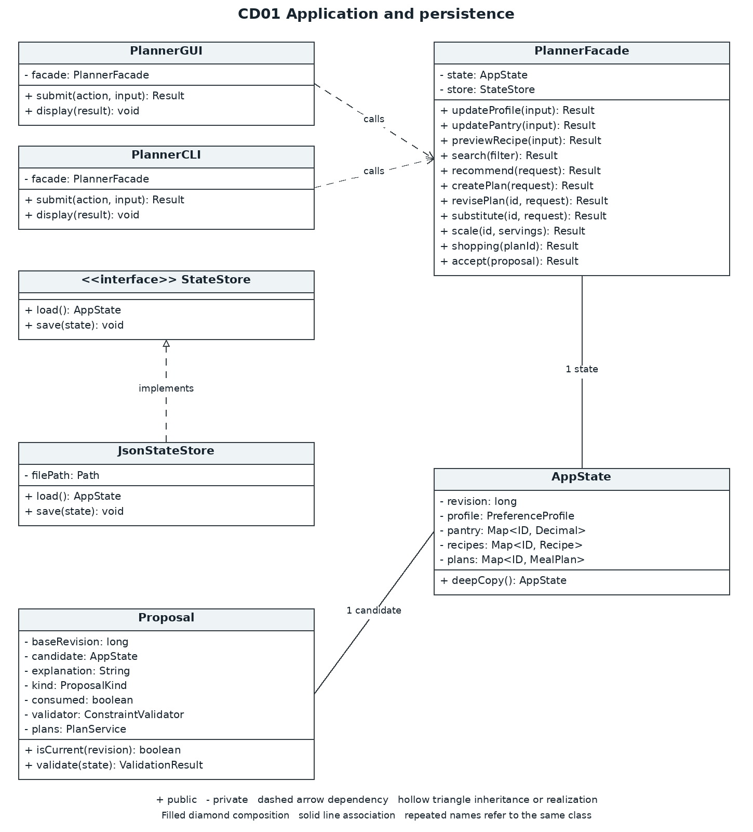
Both boundary classes share the same facade. JsonStateStore implements StateStore interface. PlannerFacade also depends on the services of CD03, AgentCoordinator in CD02 and ConstraintValidator. Proposal references a candidate state, and AppState owns its profile, recipes and plans. Dependencies between the class diagram views are listed in Section 6.5.

6 CD02 Class diagram view
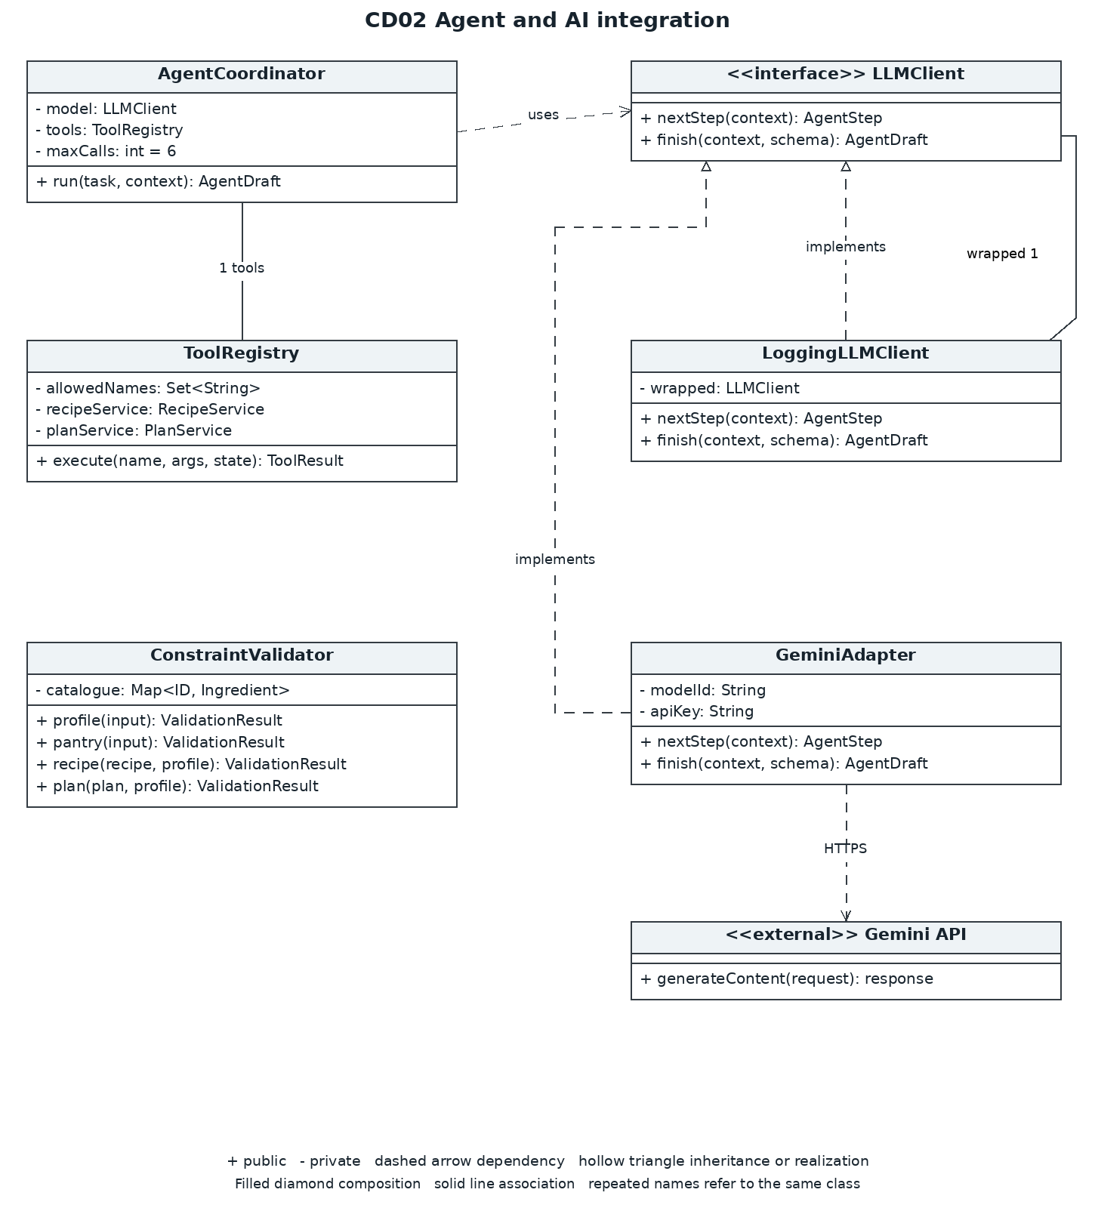
Both GeminiAdapter and LoggingLLMClient implement LLMClient. Each LoggingLLMClient instance wraps one LLMClient, normally a GeminiAdapter. The registry uses a read-only app state snapshot and the same domain services as the facade. The Gemini API is external to the system. Supporting data objects and dependencies between the diagram views are explained in Section 6.5.

6 CD03 Class diagram view
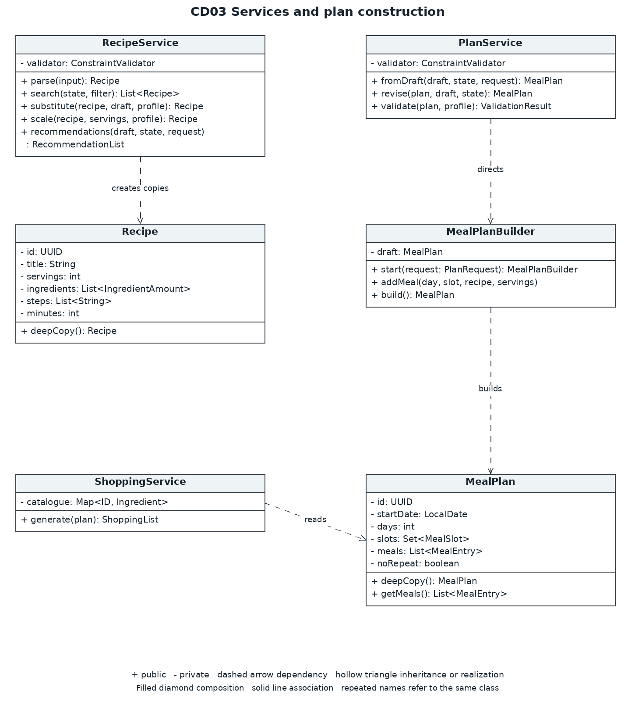
PlanService instructs MealPlanBuilder to create MealPlan. Recipe and MealPlan provide deepCopy() for Prototype. Services require ConstraintValidator. RecipeService search and validation are reused by the tool registry. Method parameters employ the DTO contracts to be described after CD04.

6 CD04 Class diagram view
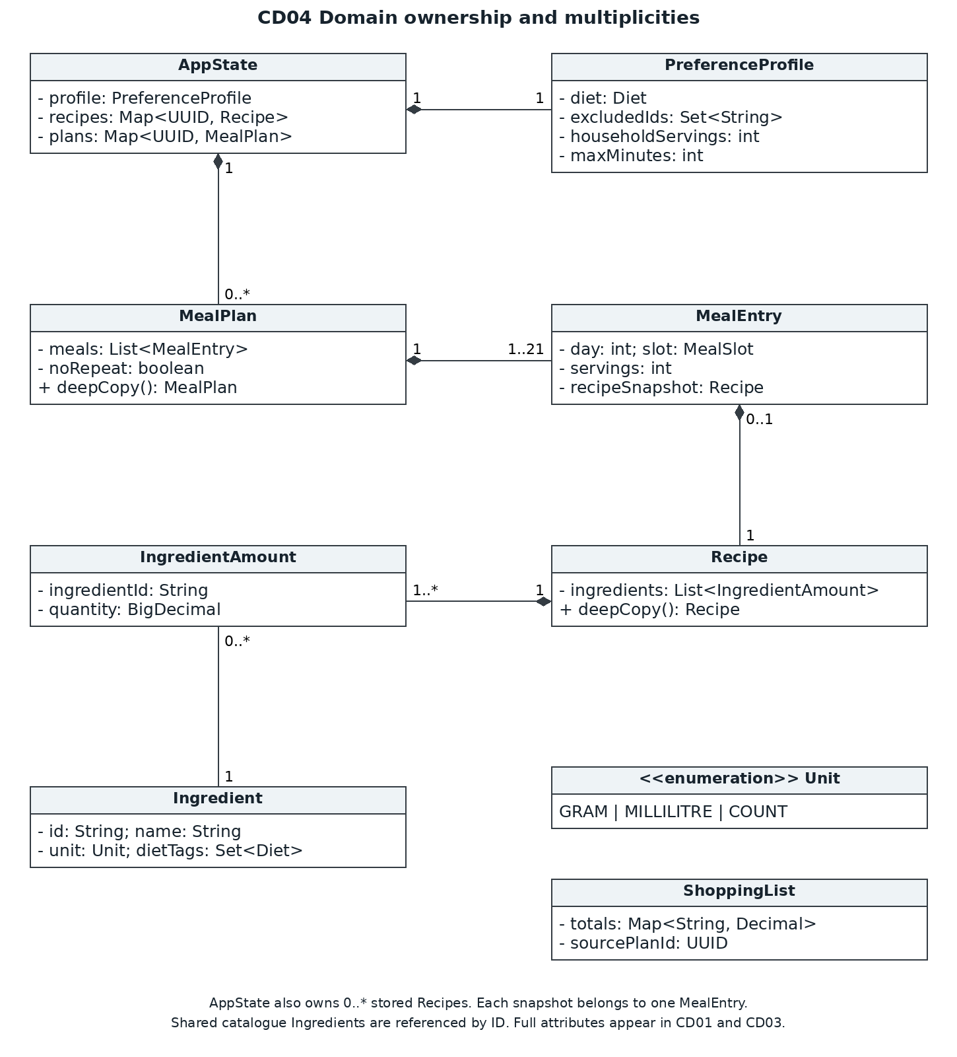
The composition links show the ownership of mutable children. MealEntry owns one recipe snapshot; the filled diamond at MealEntry signifies that snapshot ownership. IngredientAmount refers to a shared catalogue Ingredient. Ingredient.unit is one Unit value. AppState owns one profile and zero or more recipes and plans.

6.5 Class contracts and cross view relationships
CD01 to CD04 depict parts of the same class model. Minus signs indicate private fields and plus sign depict public methods. A dependency uses a dashed line with an open arrowhead. Interface realization uses a dashed line with a hollow triangle, and composition uses a solid line with a filled diamond at the owning class. Other relations are given below the diagram to avoid clutter.
Source | Relationship | Target
PlannerFacade | 1 reference each | AgentCoordinator, RecipeService, PlanService, ShoppingService, ConstraintValidator, StateStore
AgentCoordinator | 1 reference each | LLMClient, ToolRegistry
LoggingLLMClient | wraps 1 | LLMClient
ToolRegistry | uses 1 each | RecipeService, PlanService, ConstraintValidator
RecipeService and PlanService | use 1 each | ConstraintValidator
AppState | owns 1 | PreferenceProfile
AppState | owns 0..* each | Recipe, MealPlan
MealEntry | owns 1 snapshot | Recipe
IngredientAmount | references 1 | Ingredient
Ingredient | has 1 | Unit

Supporting value objects
IDs of recipes and plans are UUIDs; CLI examples, such as R01 and P01, are aliases for these UUIDs. An Ingredient ID is a stable string; decimal numbers are represented as BigDecimal. Diet is one of UNRESTRICTED, VEGETARIAN, and VEGAN; MealSlot is either BREAKFAST, LUNCH, or DINNER. AppState.pantry represents a map of ingredient IDs to amounts. Catalogue metadata is immutable after initial setup.
AgentContext contains task type, request text, the state snapshot, parsed constraints, permitted tool schemas and tool history. For substitutions it also includes the selected source recipe and ingredient ID. AgentStep is ToolCall(name, arguments) or FinalReady. ToolResult contains success, data and errors. AgentDraft contains structured recommendations, plan entries, slot replacements or a substitution. The coordinator attaches trusted retrieved IDs from ToolRegistry results, never from model claims. Schema validation does not replace domain validation.
The ValidationResult class differentiates between structuralErrors and eligibilityViolations. All public PlannerFacade operations return the Result type, which contains data representing its documented output or Proposal; failures contain user-facing errors. The proposal contains the candidate state, baseRevision, kind, explanation, and consumed status. Its validate(state) method uses injected PlanService to validate plans and a ConstraintValidator for recipes. IMPORT_RECIPE and SCALE_RECIPE need to be structurally valid; SUBSTITUTE_RECIPE also needs to be eligible. PLAN requires complete plan validation.

Key operation contracts
MealPlanBuilder.start(request: PlanRequest) records the requested date, days, slots, servings and noRepeat. addMeal(day, slot, recipe, servings) returns MealPlanBuilder, rejects duplicate or unrequested slots and deep-copies recipe snapshots. build() returns a plan only when every requested slot is present. PlanService.validate() also verifies dates, counts, quantities, eligibility and repetition. RecipeService.substitute(recipe, draft, profile) retains servings and changes only the selected ingredient and affected steps. Internal services return typed domain values or throw validation exceptions; StateStore.save() returns void or throws a storage exception. The facade translates exceptions into Result failures.

Tool and input contracts
ToolRegistry.execute() checks if the names and arguments passed in are valid before sending it off through dispatch. readProfile, readPantry, readPlan and listIngredients all return a read only snapshot of the data. searchRecipes then calls RecipeService.search(). checkPlan resolves a PlanDraft using PlanService.fromDraft() and then returns any validation violations. Tools should never be able to call accept() or StateStore.save().
PlanRequest contains startDate, days, slots, servings and noRepeat. SubstitutionRequest contains selectedIngredientId and requestText. PantryInput contains SET or REMOVE, ingredientId and optional quantity. SearchFilter contains text, ingredientIds, maxMinutes and pantryOnly. Filters may tighten, but never override, the saved maximum time. RecipeService.recommendations() calculates shortages at base servings. GUI and CLI expose recipe create, recipe import, pantry remove, proposal accept and proposal reject in addition to the examples in Section 5.

7 UML use case diagram
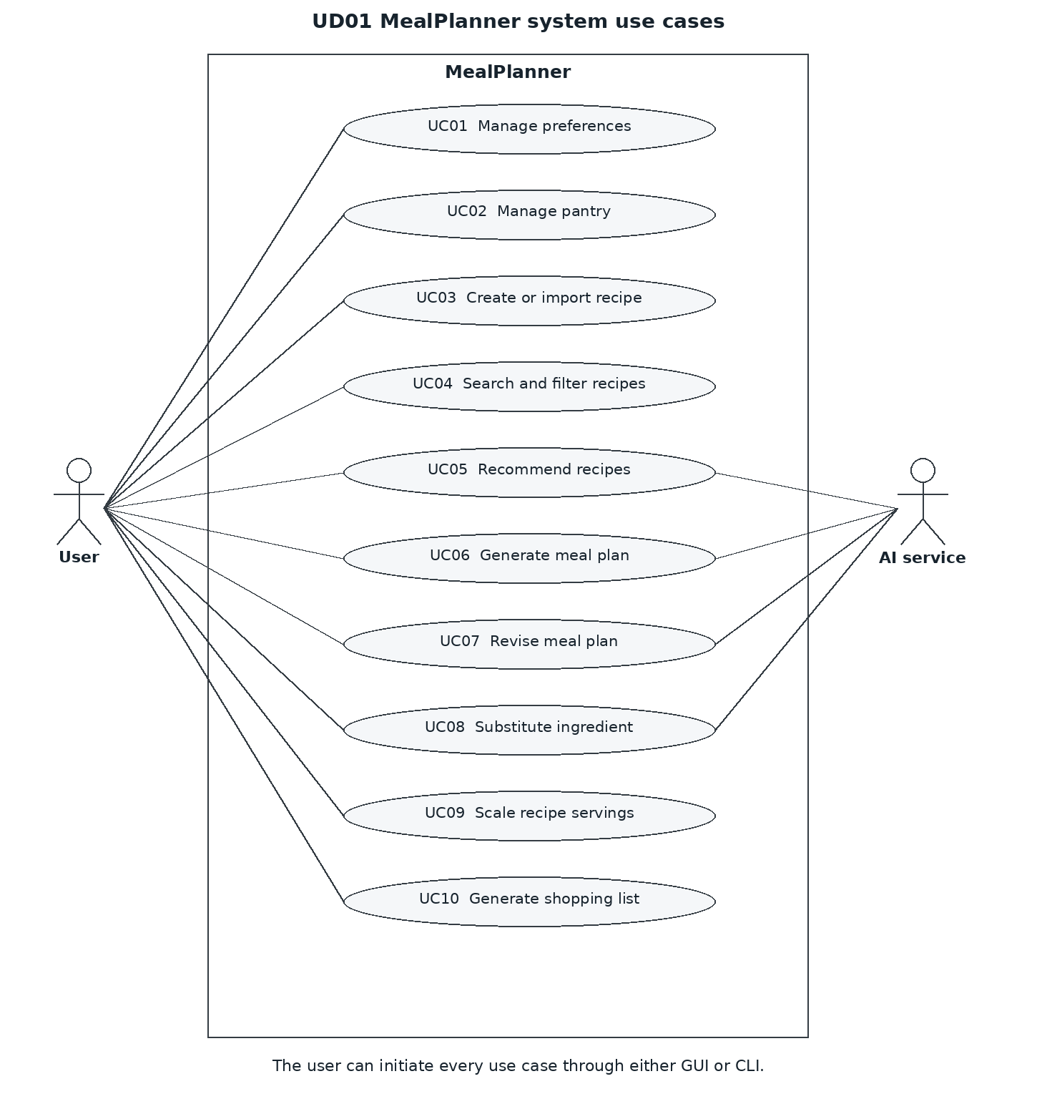
The main actor of the use case is the local user. In UC05 to UC08, the supporting AI serves as the second actor. The GUI and CLI are two ways for the same user to interact with the system; they are not separate actors. For each of the use cases, a detailed description, preconditions, success flows, exceptions, and postconditions, as well as links to the related features, are provided in Section 5.

8 SD01 Sequence diagram
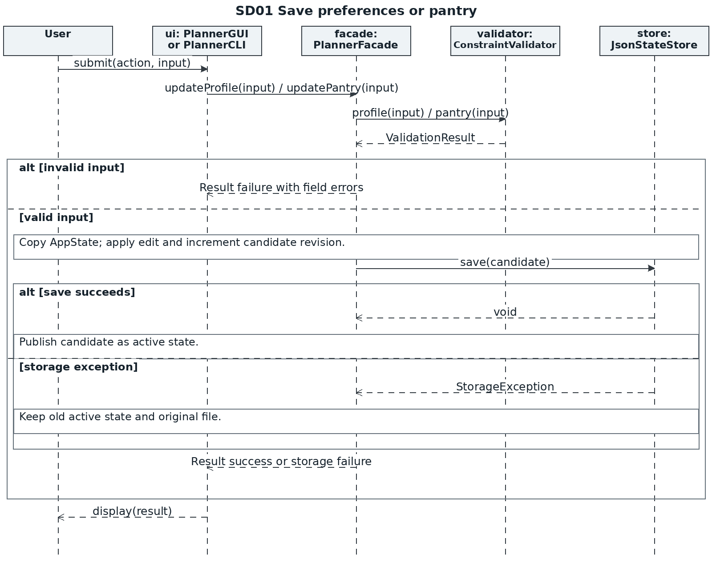
SD01 includes UC01 and UC02. SD10 specifically demonstrates recipe entry and import, with preview of the recipe prior to saving. Whereas in SD01, only selected profile or pantry operation is executed. Persistence exceptions result in Result failure, and have no effect on the active state.

8 SD02 Sequence diagram
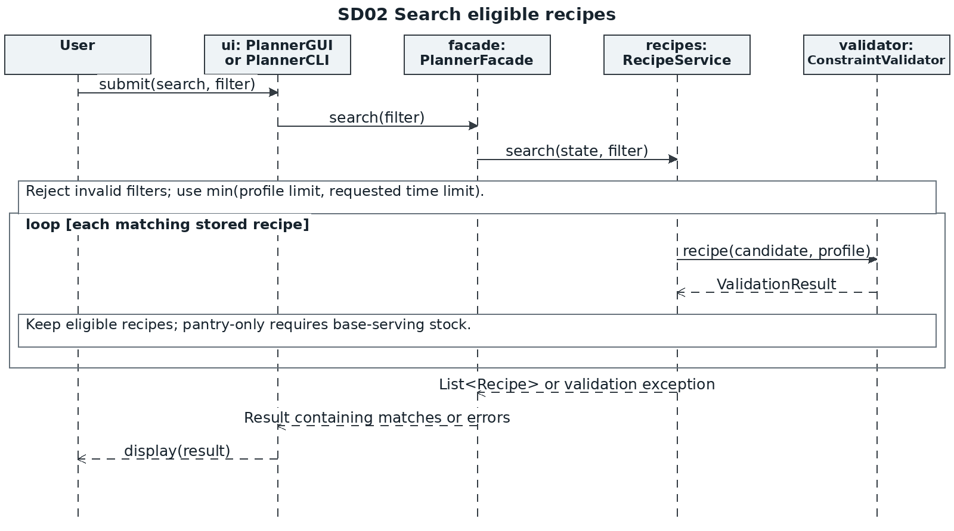
UC04 uses deterministic search. Current dietary restrictions apply even when the user omits search filters. Pantry-only comparison uses quantities, not just the presence of ingredient names.

8 SD03 Sequence diagram
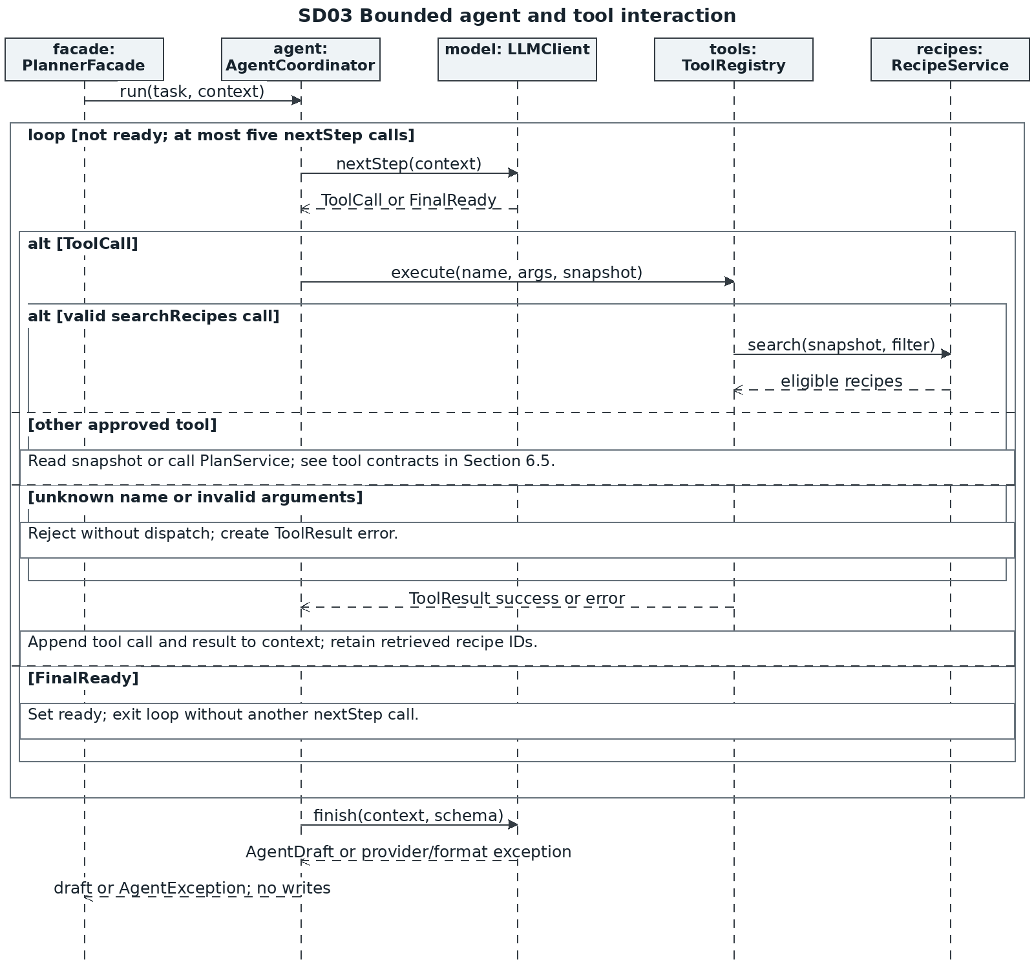
SD03 shows the shared agent workflow for UC05 through UC08. Its LLMClient object is normally a LoggingLLMClient that wraps GeminiAdapter. Both classes implement LLMClient. SD09 shows these provider calls in more detail. The searchRecipes branch utilizes the specific RecipeService invocation while other read operations delegate to the snapshot; checkPlan delegates to the PlanService as described in Section 6.5. The Provider or format exceptions cause the termination of the interaction resulting in the Result failure returned by the facade method.

8 SD04 Sequence diagram
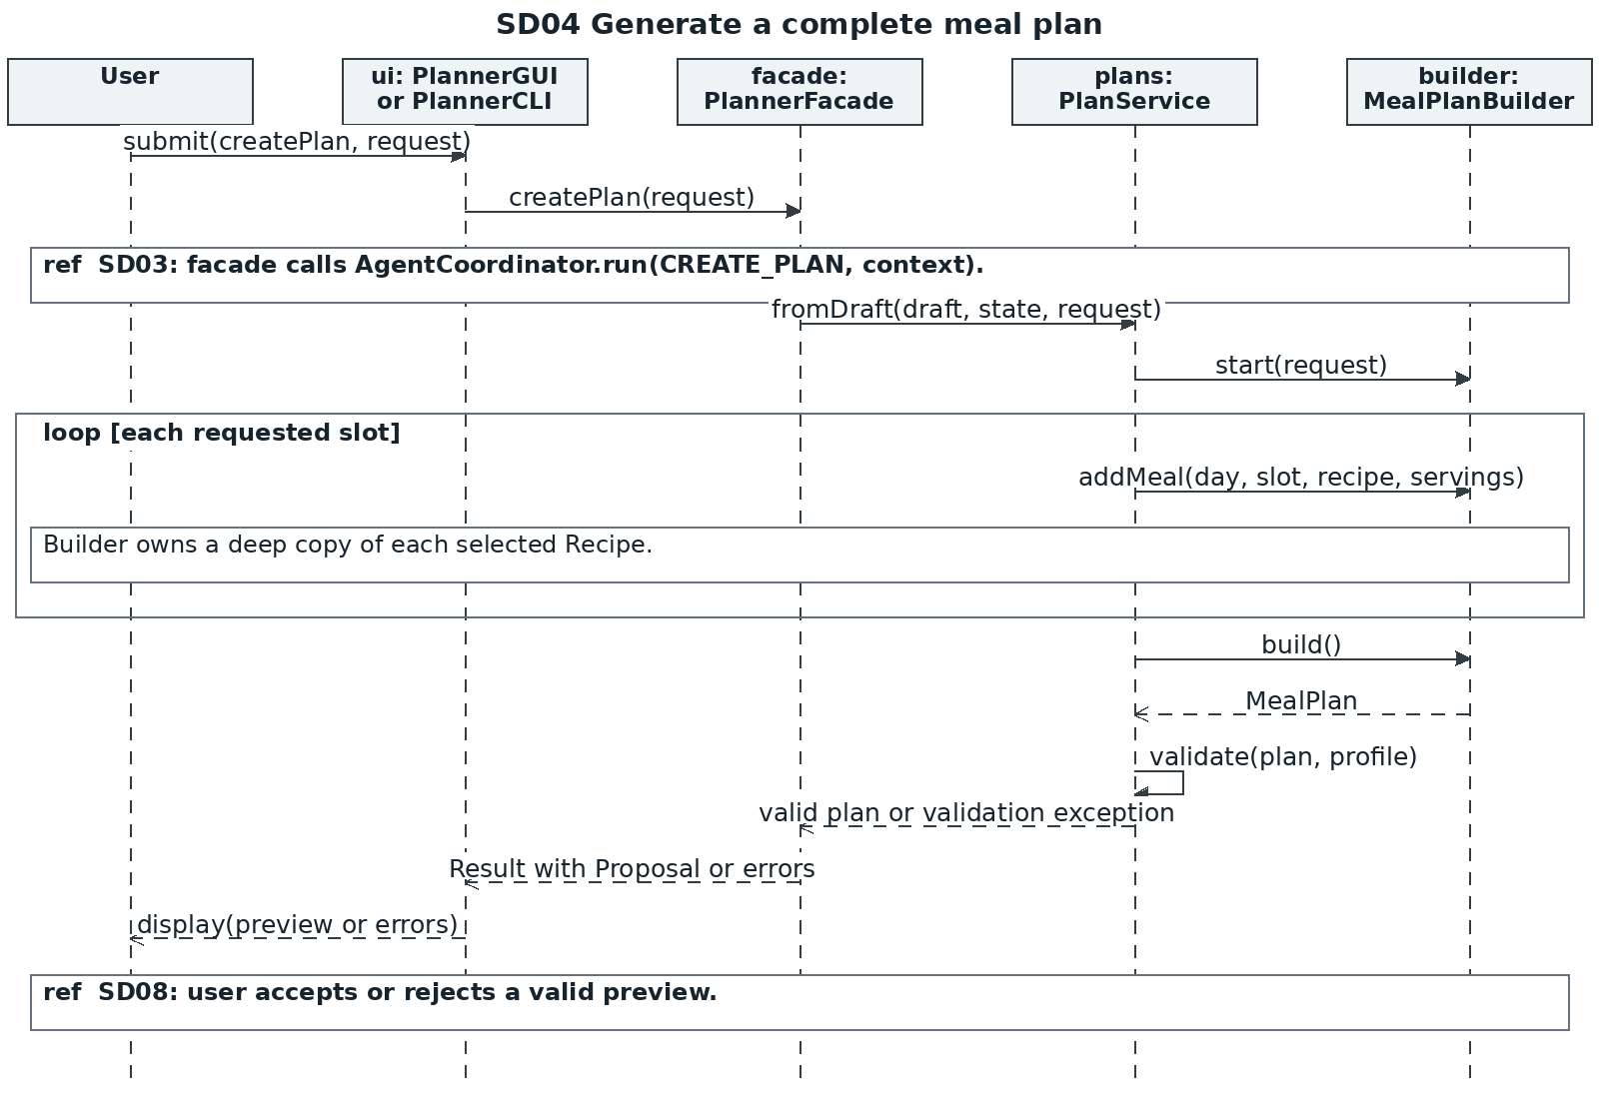
SD04 covers UC06 including explicit user and interface lifelines. PlanService.fromDraft() uses the original PlanRequest, resolves eligible recipe IDs and then directs the builder. SD11 covers UC05 recommendation validation, and deterministic shortage calculation separately. It returns errors instead of a preview for invalid drafts.
8 SD05 Sequence diagram
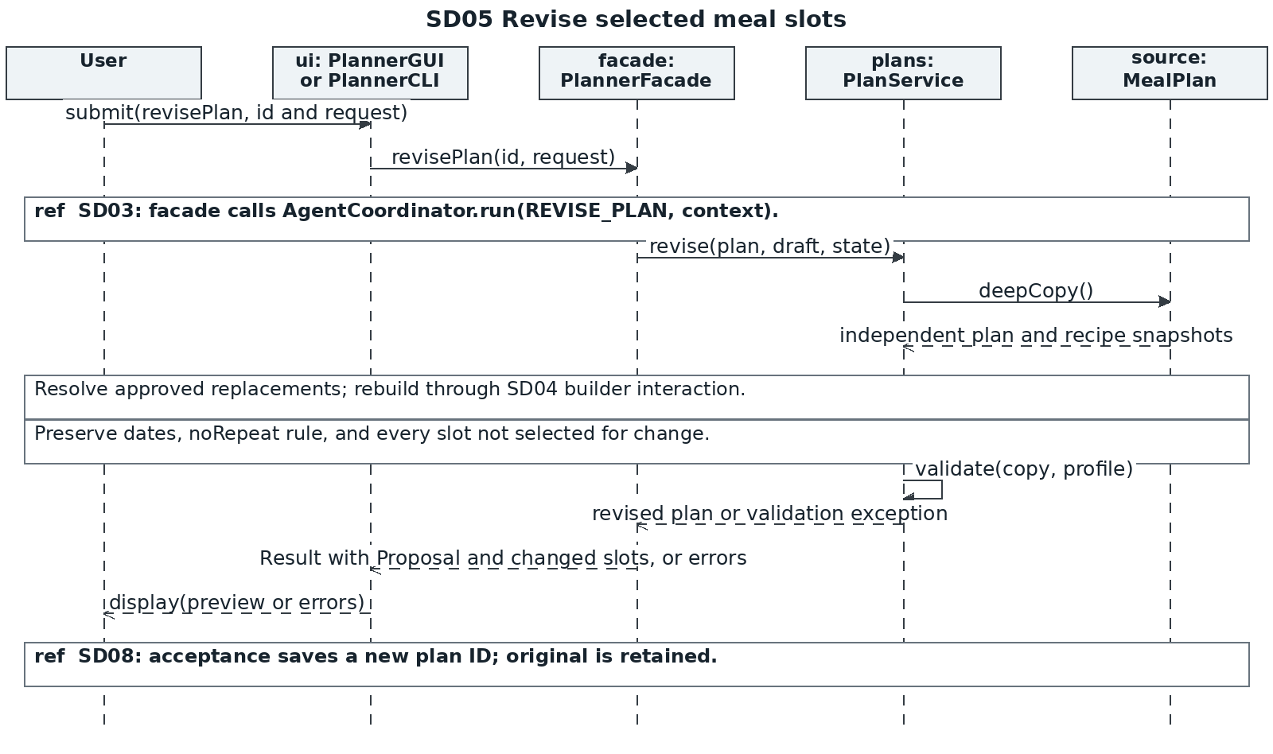
UC07 maintains the original plan by performing a deep copy. The method PlanService.revise() uses the same builder as shown in SD04 where only slots that have been explicitly specified are replaced. The reference to SD08 connects the preview to the acceptance and saving process. AI tool calls remain read-only; saving happens only after the user accepts the proposal.

8 SD06 Sequence diagram
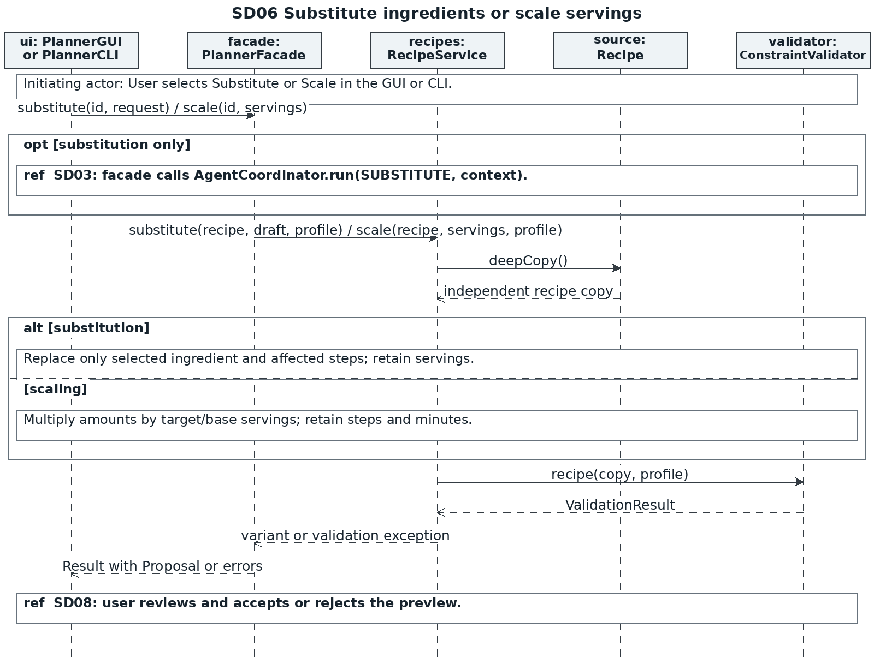
UC08 gets a substitute draft by means of SD03; UC09 skips the model. Both copy the recipe and invoke ConstraintValidator.recipe(). Substitution demands structural and eligibility qualification to pass. Scaling demands for structural validity and displays any eligibility warning. The source recipe is supplied in the substitution AgentContext even when it is currently ineligible.

8 SD07 Sequence diagram
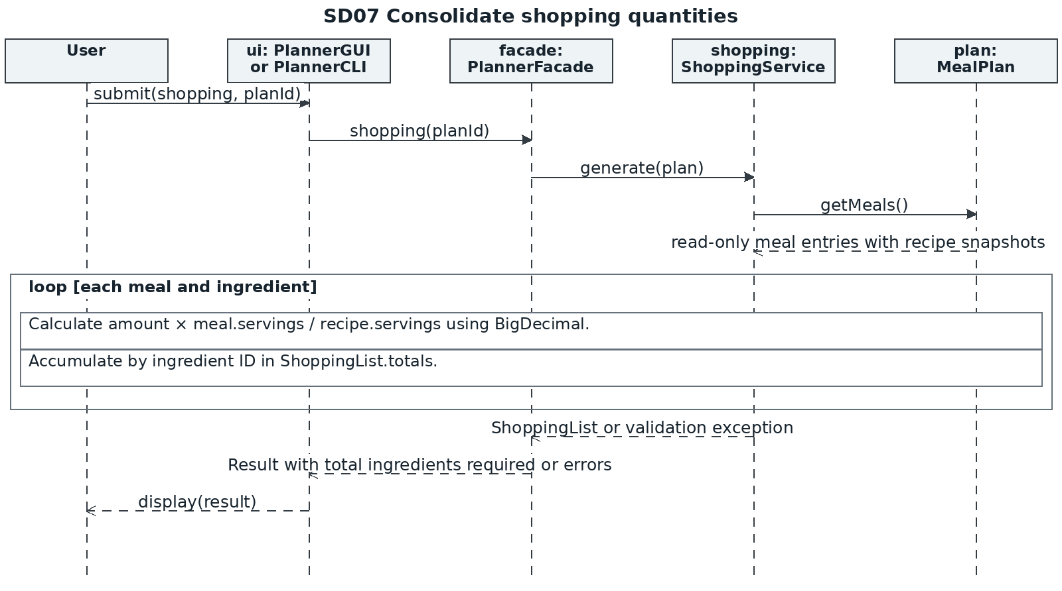
UC10 uses Java arithmetic for every total. MealPlan.getMeals() returns a read-only view of its entries; snapshot values are read through ordinary domain accessors. COUNT may be fractional. No pantry deduction or stock mutation occurs.

8 SD08 Sequence diagram
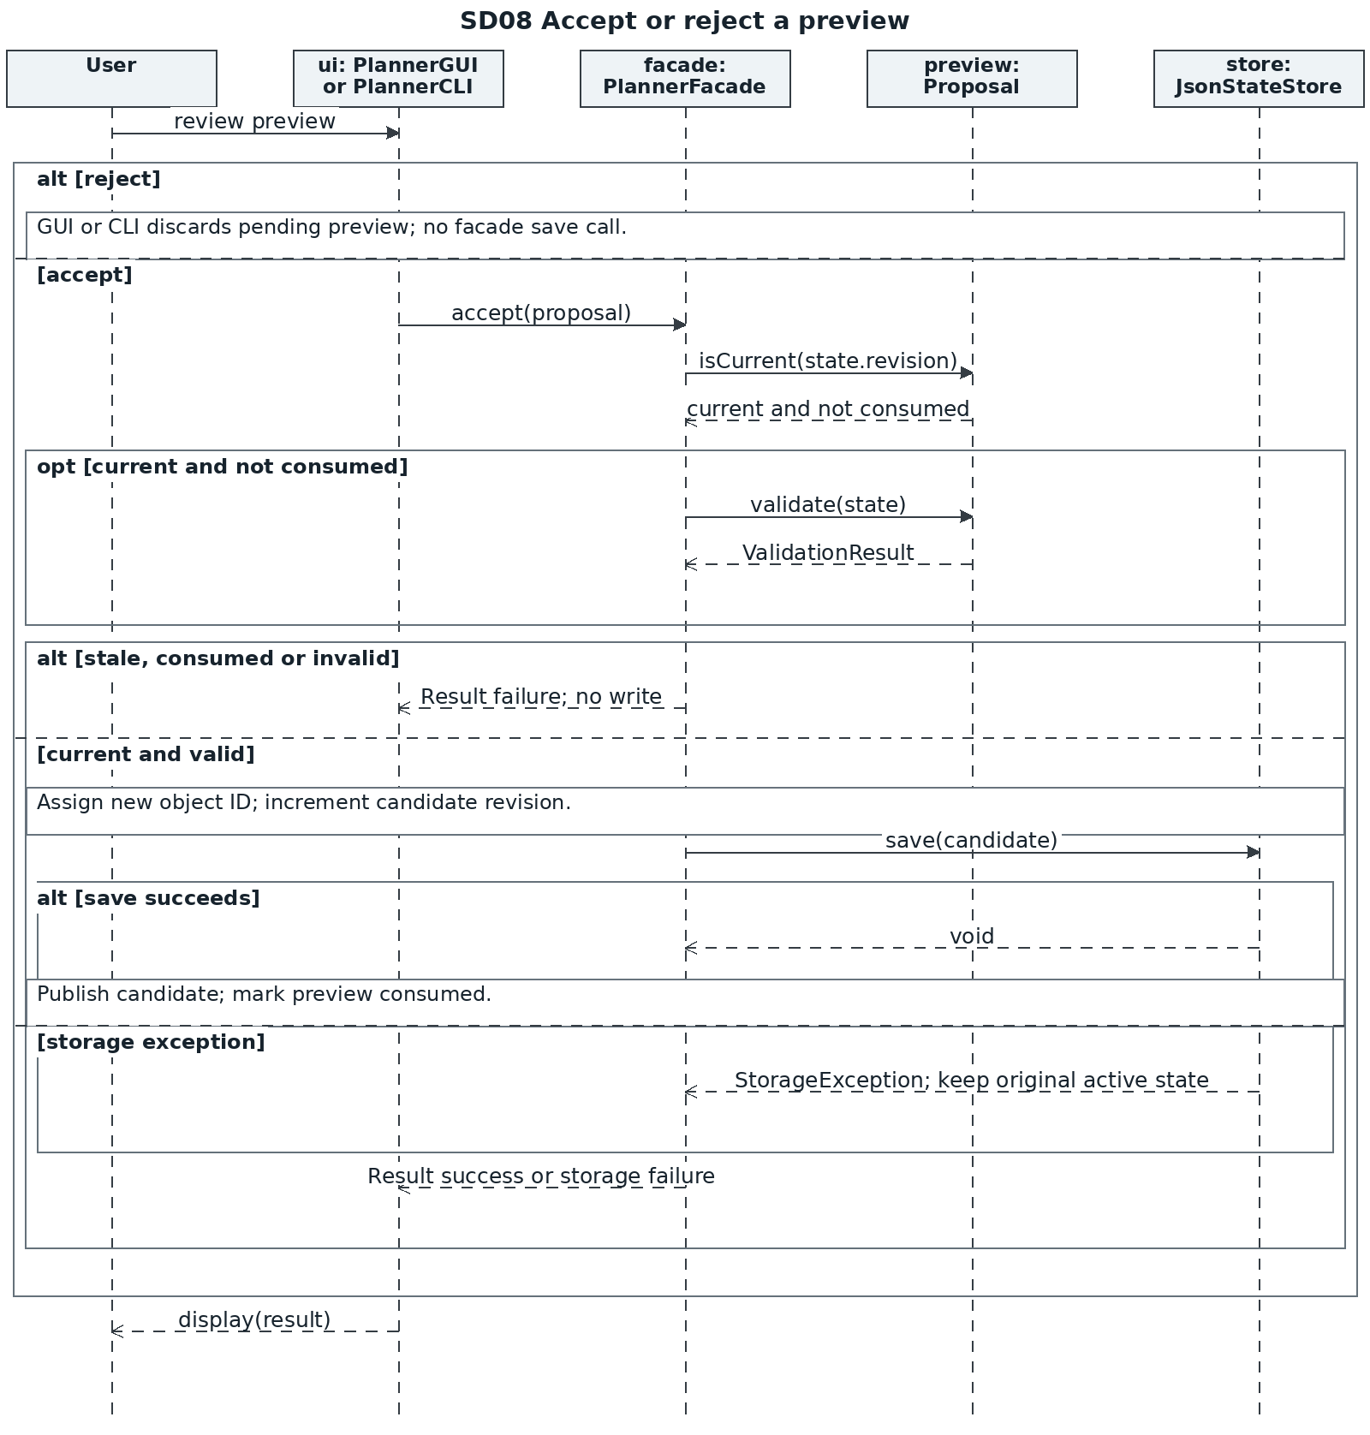
SD08 finishes UC03 and UC06 to UC09. Proposal.validate() delegates to the same validator and plan service that was used while previewing, which applies the ProposalKind rules. The facade holds on to the mutation lock from the revision check up until save and skips validation and saving for a stale or consumed proposal. A successful persistence will increment AppState.revision and consume the proposal, while a rejection or failure will make no persisted changes.

8 SD09 Sequence diagram
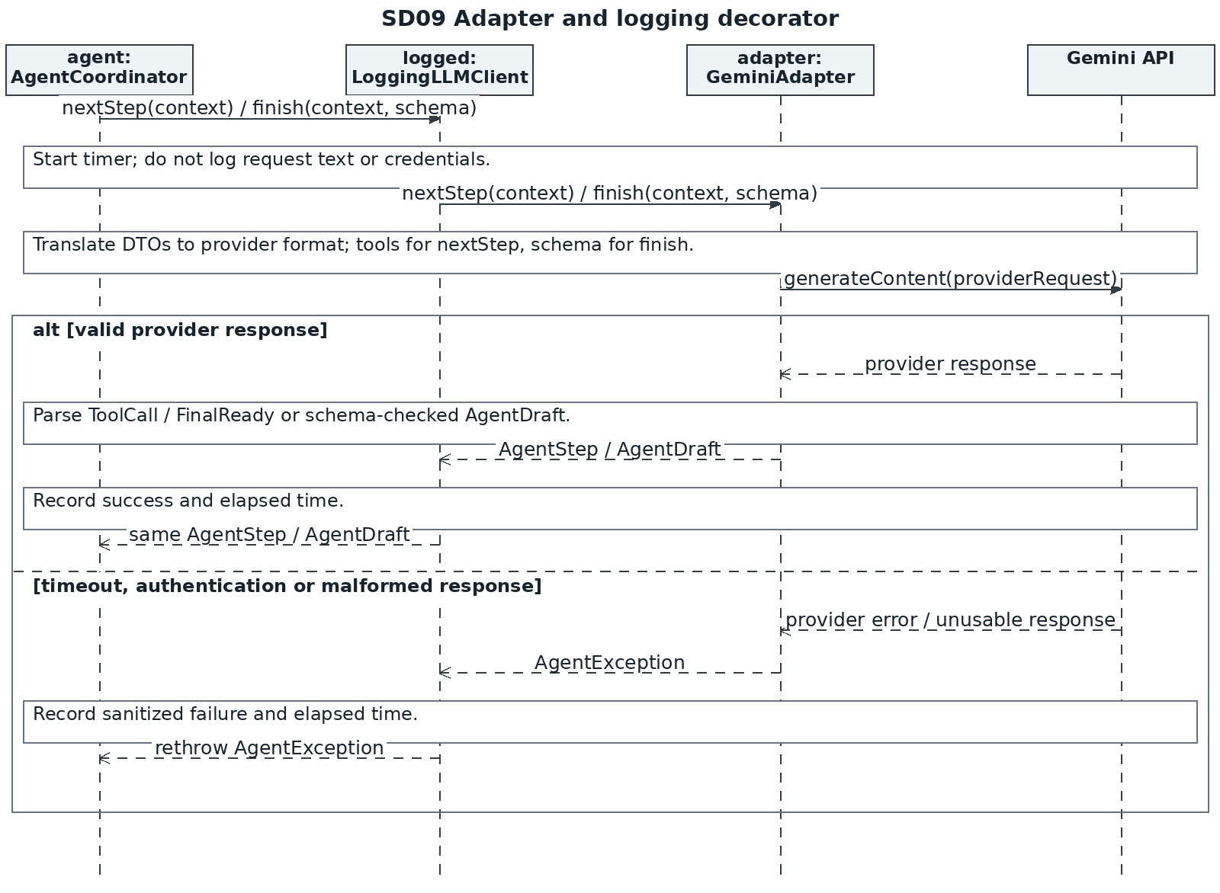
This expands every LLMClient call in SD03. The decorator delegates to the adapter and preserves its results or exceptions. The adapter alone knows the external provider request and response formats.

8 SD10 Sequence diagram
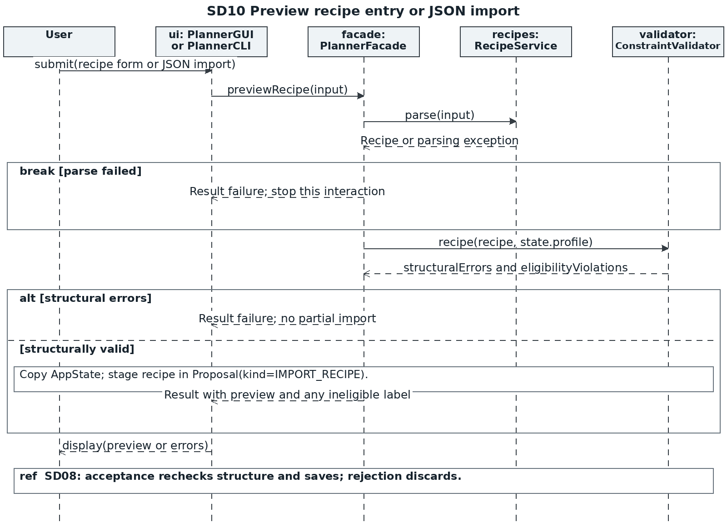
UC03 creates a preview before saving. Structural errors block import; dietary conflicts produce an ineligible label. Acceptance follows SD08 with IMPORT_RECIPE rules.

8 SD11 Sequence diagram
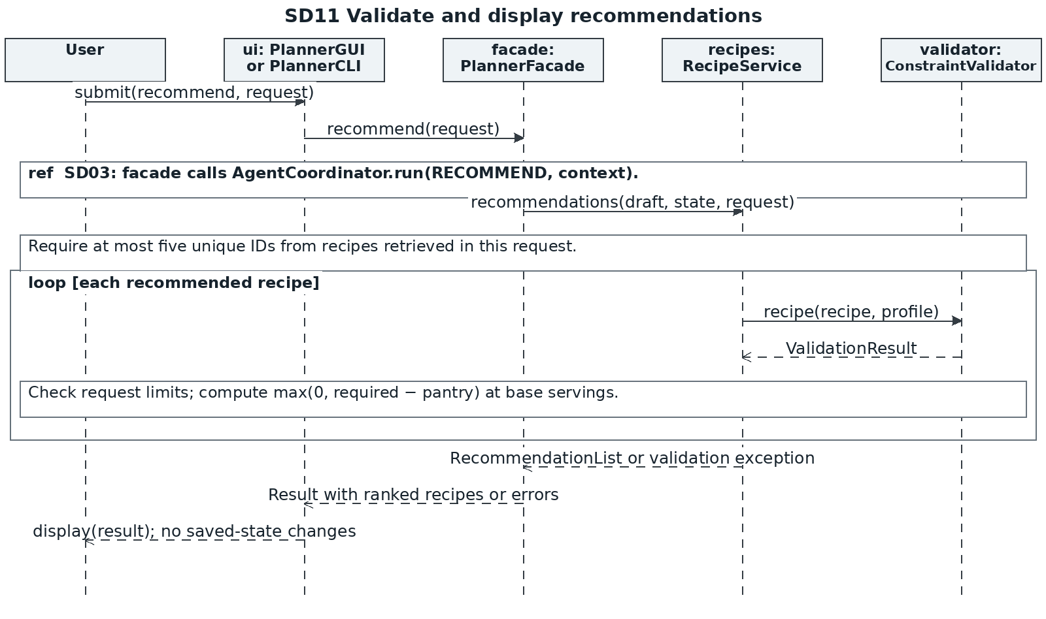
UC05 is read-only. Recommendations are checked against retrieved recipe IDs, the profile and supported request constraints. Java computes missing quantities; the model supplies ranking and explanations.

9.1 Traceability table
Feature and type | Use case and sequence | Classes | Key methods | Patterns
F01  Manage dietary preferences  Deterministic | UC01  SD01 | PlannerGUI / PlannerCLI, PlannerFacade, ConstraintValidator, StateStore, PreferenceProfile, AppState | submit(), updateProfile(), profile(), deepCopy(), save(), display() | Facade
F02  Manage pantry inventory  Deterministic | UC02  SD01 | PlannerGUI / PlannerCLI, PlannerFacade, ConstraintValidator, AppState, Ingredient, StateStore | submit(), updatePantry(), pantry(), deepCopy(), save(), display() | Facade
F03  Create and import structured recipes  Deterministic | UC03  SD10 and SD08 | PlannerGUI / PlannerCLI, PlannerFacade, RecipeService, ConstraintValidator, Recipe, StateStore, Proposal | submit(), previewRecipe(), parse(), recipe(), validate(), accept(), save(), display() | Facade
F04  Search and filter recipes  Deterministic | UC04  SD02 | PlannerGUI / PlannerCLI, PlannerFacade, RecipeService, ConstraintValidator, AppState | submit(), search(), recipe(), display() | Facade
F05  Recommend recipes from preferences and pantry  Hybrid | UC05  SD03, SD09 and SD11 | PlannerFacade, AgentCoordinator, ToolRegistry, LLMClient, GeminiAdapter, LoggingLLMClient, RecipeService, ConstraintValidator | recommend(), run(), nextStep(), execute(), search(), finish(), recipe(), recommendations() | Facade, Adapter, Decorator
Both interfaces use submit() and display() for every feature. AI features share ToolRegistry, LLMClient, GeminiAdapter and LoggingLLMClient through SD03 and SD09. Feature-specific responsibilities are explained in Section 5.

9.2 Traceability table
Feature and type | Use case and sequence | Classes | Key methods | Patterns
F06  Generate a meal plan  Hybrid | UC06  SD03, SD04, SD08 and SD09 | PlannerFacade, AgentCoordinator, ToolRegistry, PlanService, MealPlanBuilder, MealPlan, Proposal, StateStore | createPlan(), run(), fromDraft(), start(), addMeal(), build(), validate(), accept(), save() | Facade, Adapter, Decorator, Builder
F07  Revise a plan through natural language  Hybrid | UC07  SD03, SD05, SD08 and SD09 | PlannerFacade, AgentCoordinator, PlanService, MealPlan, MealPlanBuilder, Proposal, StateStore | revisePlan(), run(), revise(), deepCopy(), addMeal(), build(), validate(), accept() | Facade, Adapter, Decorator, Prototype, Builder
F08  Suggest and apply ingredient substitutions  Hybrid | UC08  SD03, SD06, SD08 and SD09 | PlannerFacade, AgentCoordinator, RecipeService, Recipe, ConstraintValidator, Proposal, StateStore | substitute(), run(), deepCopy(), recipe(), accept(), save() | Facade, Adapter, Decorator, Prototype
F09  Adjust recipe serving quantities  Deterministic | UC09  SD06 and SD08 | PlannerFacade, RecipeService, Recipe, ConstraintValidator, Proposal, StateStore | scale(), deepCopy(), recipe(), accept(), save() | Facade, Prototype
F10  Generate a consolidated shopping list  Deterministic | UC10  SD07 | PlannerFacade, ShoppingService, MealPlan, MealEntry, Recipe, IngredientAmount, ShoppingList | shopping(), generate(), display() | Facade
Both interfaces use submit() and display() for every feature. AI features share ToolRegistry, LLMClient, GeminiAdapter and LoggingLLMClient through SD03 and SD09. Feature-specific responsibilities are explained in Section 5.

10 Validation and project preparation

Design checks for later implementation
The first stage determines the design; therefore, the following tests are planned but not implemented. In the second stage, the target classes will be implemented, and all possible changes to the initial design will be documented. In the third stage, deterministic tests will be separated from the KUMA agent-behavior tests according to the project instructions [1].
Area | Planned verification
Arithmetic | Scale a 2-serving recipe with 200 g rice to 5 servings and obtain 500 g. Combine 300 g and 250 g rice as 550 g. Test fractional counts and zero-serving rejection.
Copies and persistence | Editing a copied ingredient list must not change its source. A failed save preserves the previous state. A stale or already accepted proposal must fail.
Constraints | Reject unknown IDs, excluded ingredients, duplicate meal slots, unsupported units and invalid quantities. Recheck eligibility after profile changes.
Agent behaviour | Use relevant retrieval tools, use tool results in the final proposal, follow requested slots and restrictions, handle empty searches, reject invalid calls, and terminate within the call budget.
Interface parity | Run equivalent GUI and CLI workflows against the same fixtures and compare domain outcomes. Use a fake LLMClient for deterministic tests.

Stage 1 submission preparation
The report and UML figures will be committed and pushed to a specific public GitHub repository that will be used for all three stages. I will submit the link to this repository via eClass and make sure that it is opened when I am not logged in. I will also check for any specific identifying information or other course-specific instructions before submission.

References
[1] EECS3311 Fall 2026. Course Project: Design, Build, and Test an AI Agent; and Course Project Stage-1 Instruction. Supplied course PDFs.
[2] Song Wang. EECS3311 Design Patterns: Creational Patterns. Supplied lecture slides. Builder and Prototype.
[3] Song Wang. EECS3311 Structural Patterns. Supplied lecture slides. Adapter, Facade and Decorator. UML and SOLID lecture slides also informed the design.
[4] Google AI for Developers. Gemini 3.5 Flash-Lite model documentation. https://ai.google.dev/gemini-api/docs/models/gemini-3.5-flash-lite. Accessed 2 October 2026. Model identifier, function calling and structured outputs.

