VMWare Software Installation:
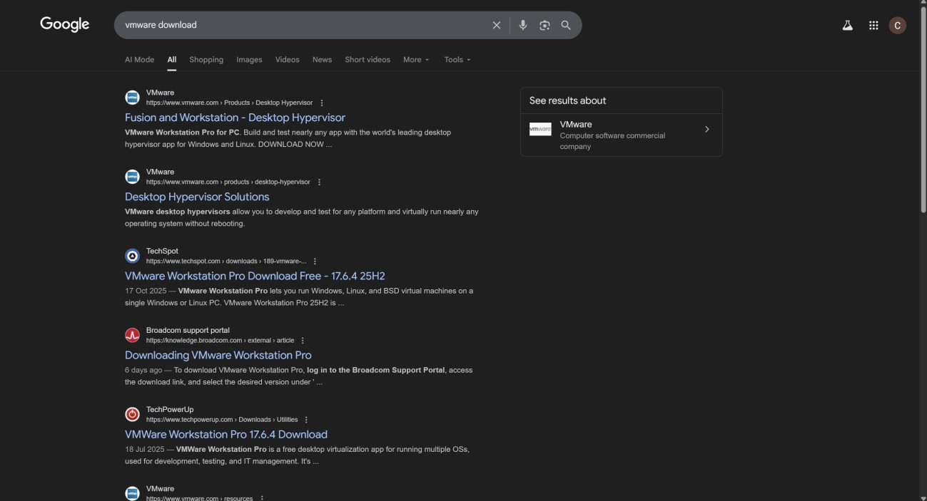
Open your browser, search for the VMware download as shown below, and click on the third link.
Click on the Workstation Windows 25H2.
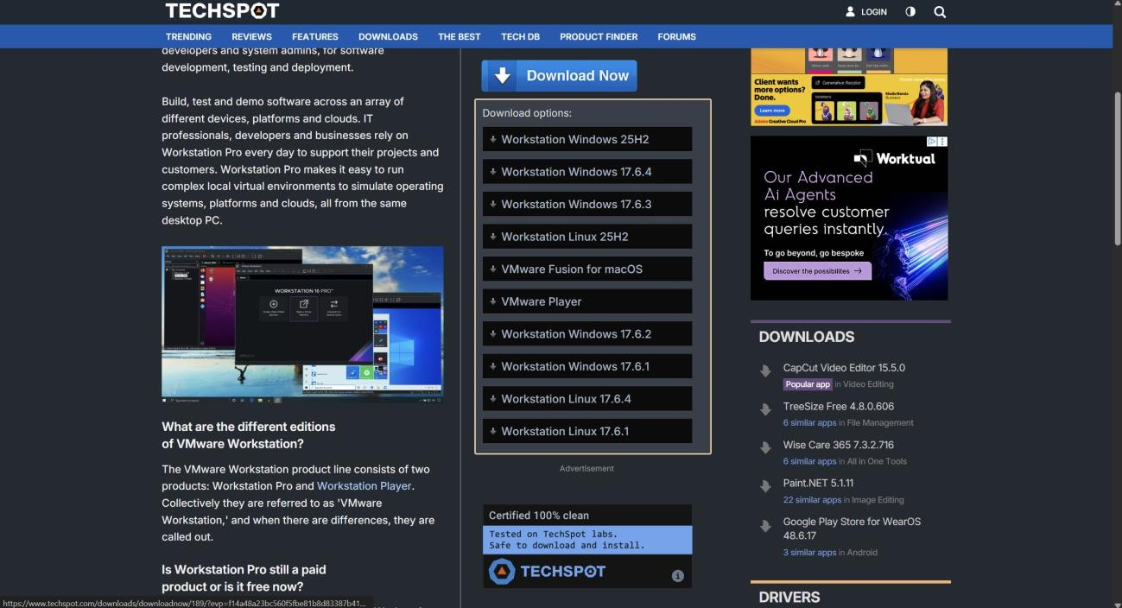
Press Ctrl + J to open the downloads section as shown below. Once it has downloaded, click on ‘VMware-Workstation-Full-25H2-24995812.exe’ and select Yes.
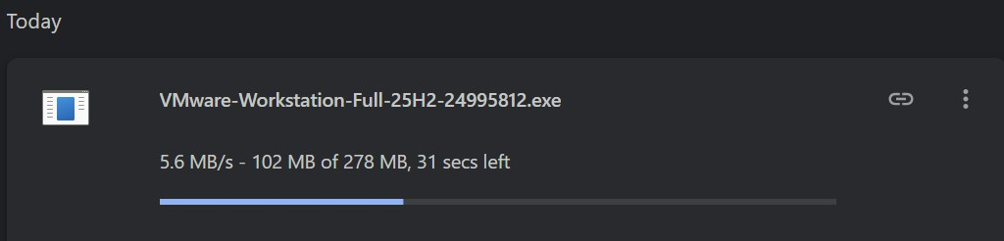

Click Next.
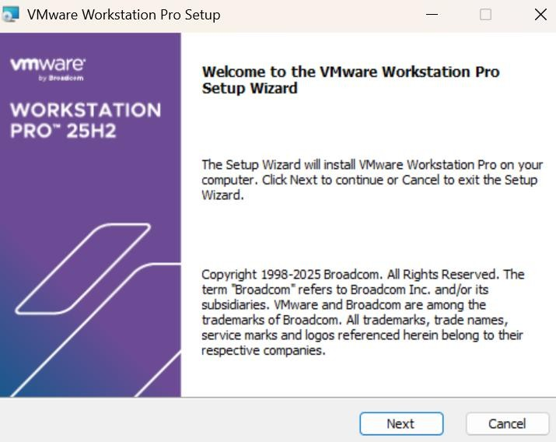

Click Next.
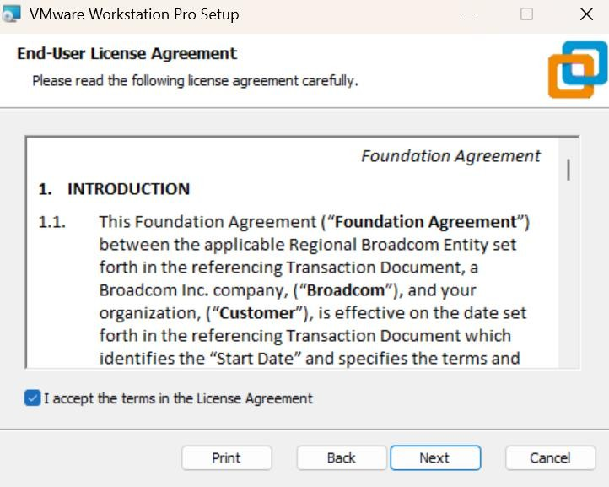
Click Next.

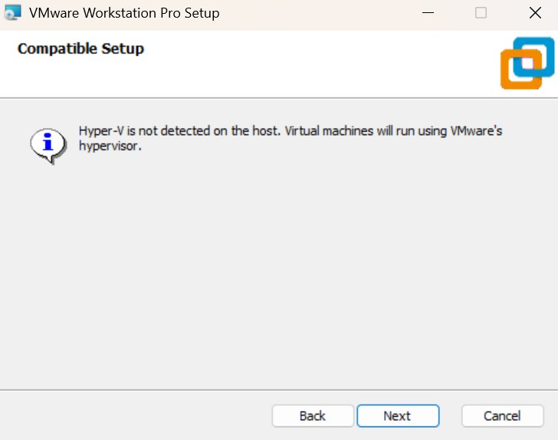
Click Next.
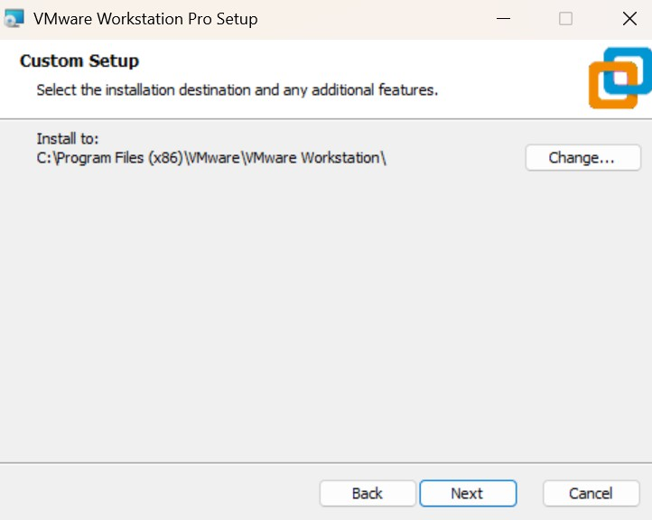
Click Next.
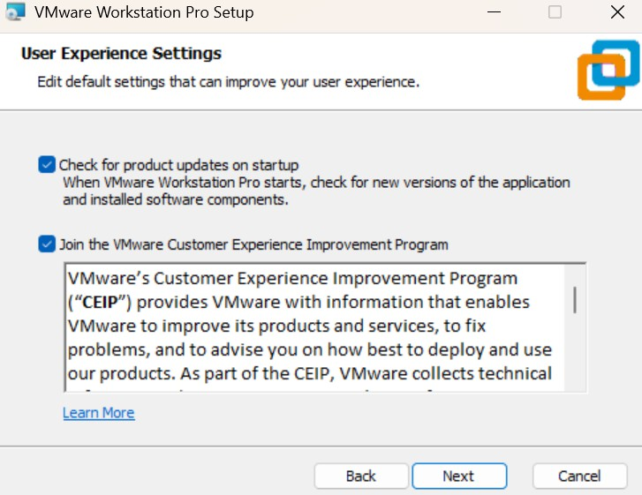

Click Next.
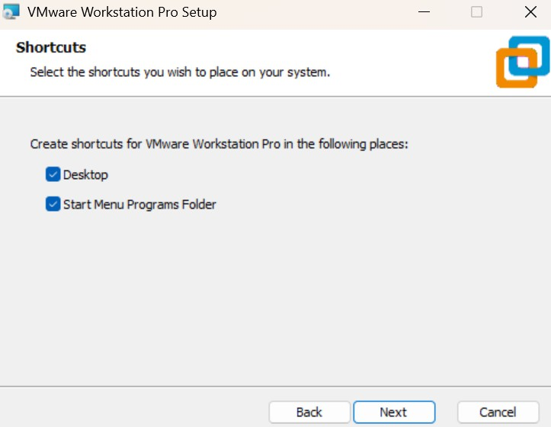
Click on Install as shown below.
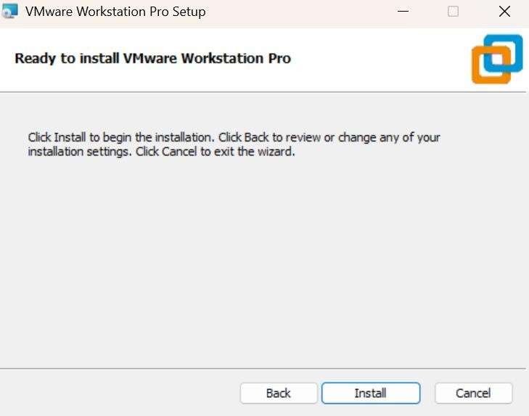
Now you can see that the software has started downloading, as shown below.
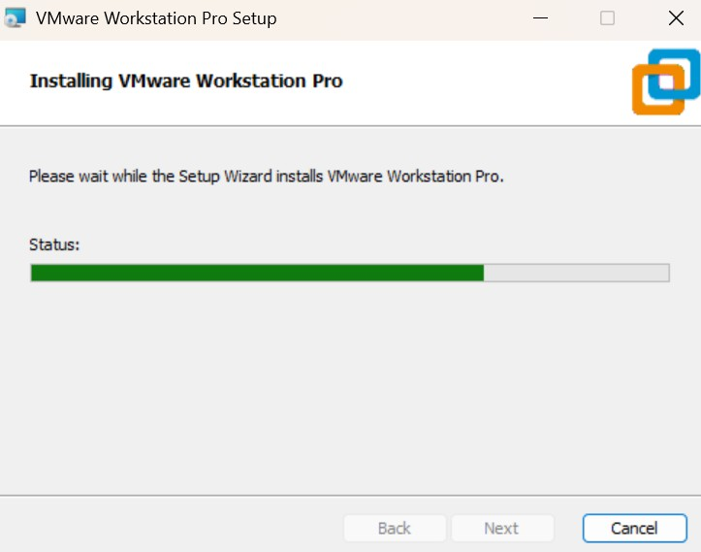

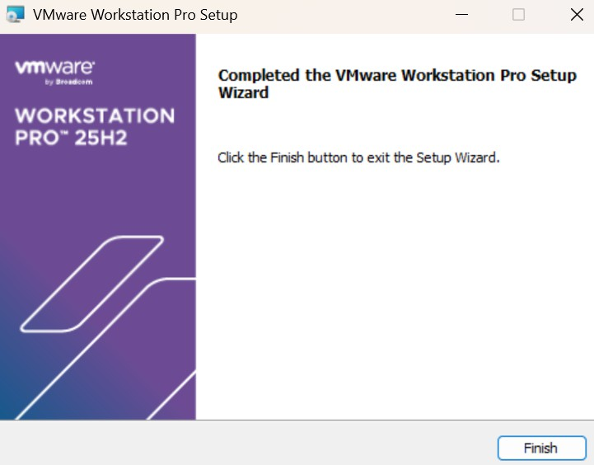
Click on the Finish button.

Open File Explorer. You will see the VMware software in the Downloads folder. Select the VMware software file and press Ctrl + X to cut it.
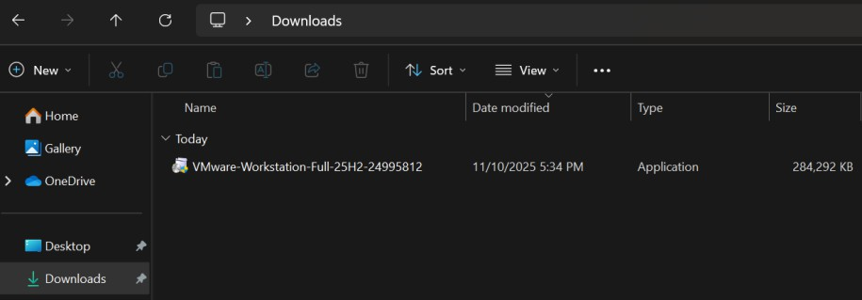
Click on the Documents folder > create a new folder and name it as VMWare > then go inside the VMWare folder. Inside the VMWare folder, create another folder named as ‘VMWare_Software.’ Go inside the VMWare_Software folder and press Ctrl + V to paste the software, as shown below.
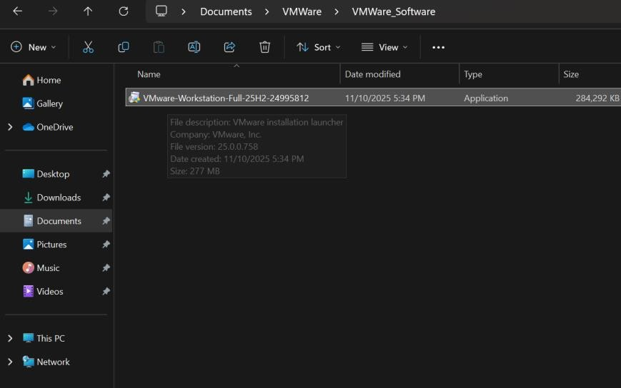

Kali Linux OS Installation:

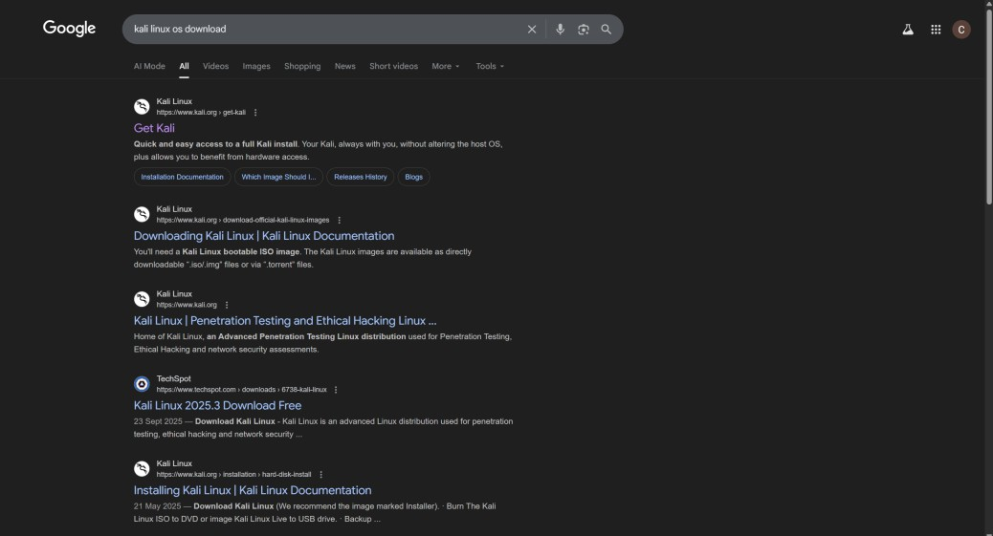
Open your browser, search for ‘Kali Linux OS download,’ and click on the first link as shown below.
Scroll down the website until you see the same interface. Once it appears, click on the first VMware download icon to start downloading the software.
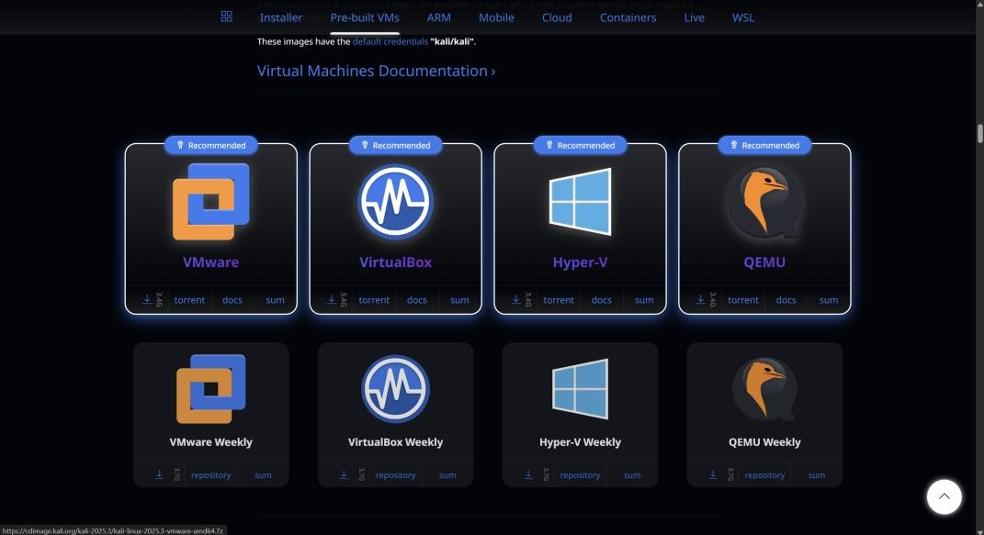
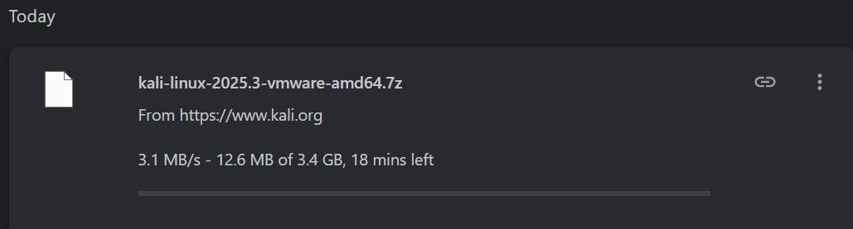
Press Ctrl + J on your keyboard to open the downloads section, as shown below.

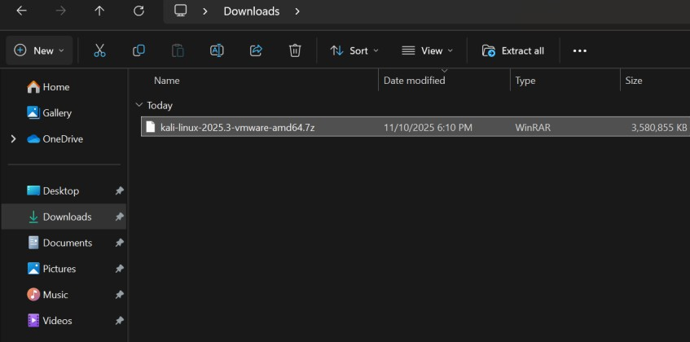
Open File Explorer, go to the Downloads folder, select the Kali Linux file, and press Ctrl + X on your keyboard to cut the file, as shown below.
Click on the Documents folder > then open the VMWare folder that we created earlier > Inside it, create a new folder and name it ‘Kali_Linux,’ and go inside the Kali_Linux folder and press Ctrl + V in your keyboard to paste the file as shown below.
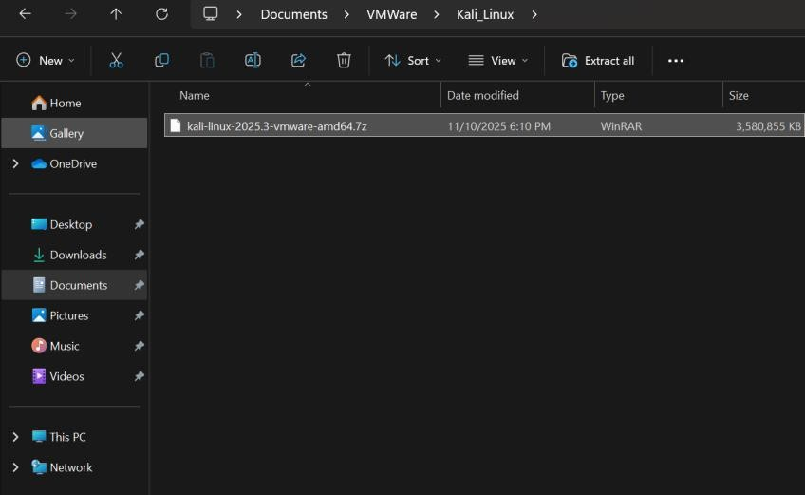

WinRAR Software Installation:
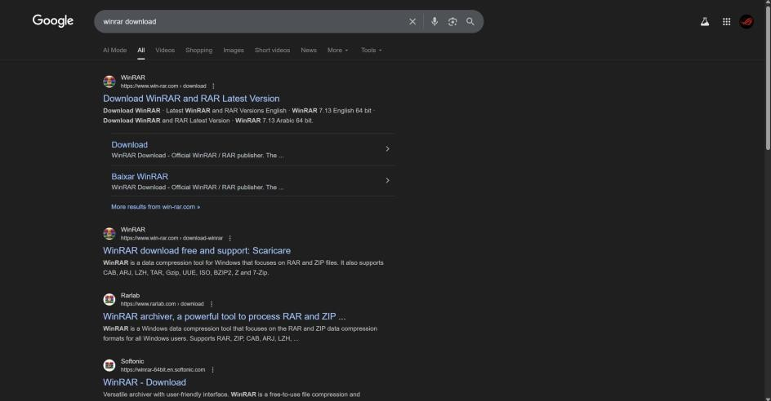
Open your browser, search for ‘WinRAR download,’ and click on the first link.

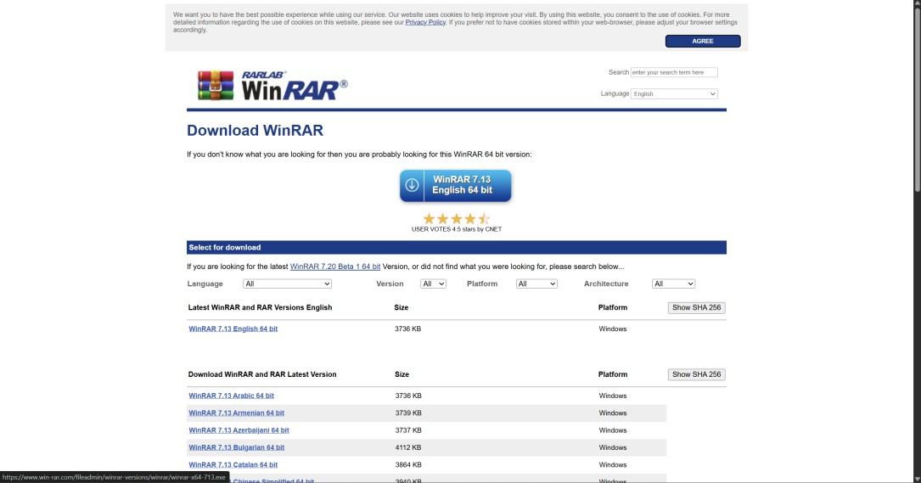
Click on the ‘WinRAR 7.13 English 64-bit’ button.
After you click on the WinRAR 7.13 button, the software will begin downloading. Next, press Ctrl + J on your keyboard to open the downloads section, then click on ‘Full download history.
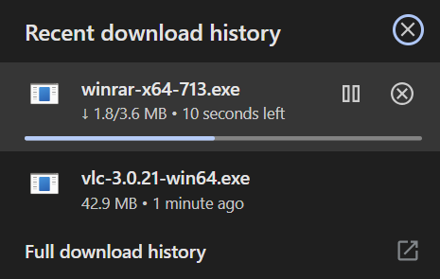
Click on ‘winrar-x64-713.exe.
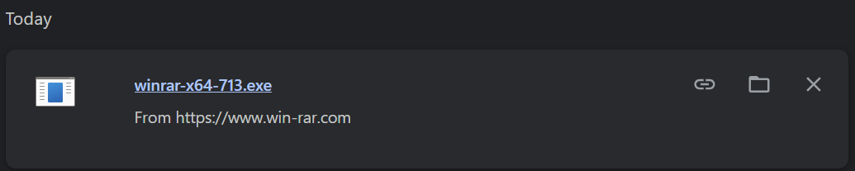

Click on Install.
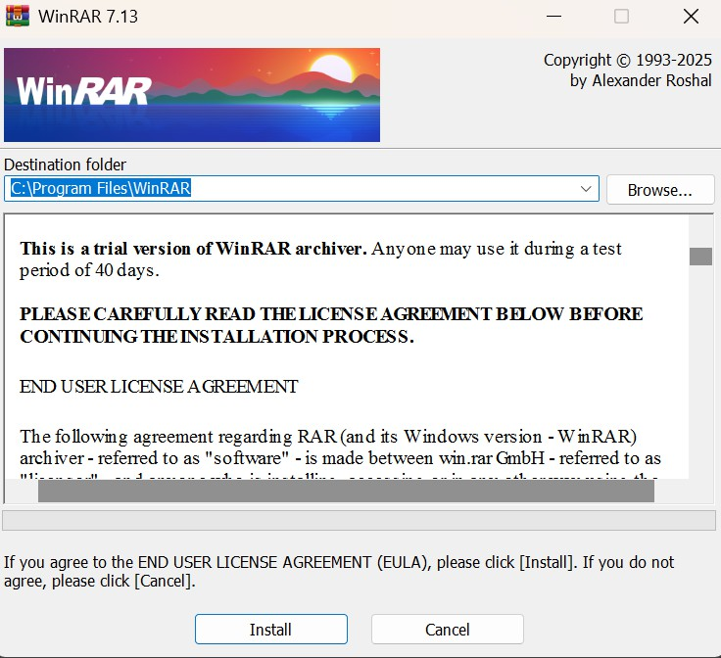
By default, the ISO and JAR checkboxes are unticked. Click on the checkboxes to select them. Before:
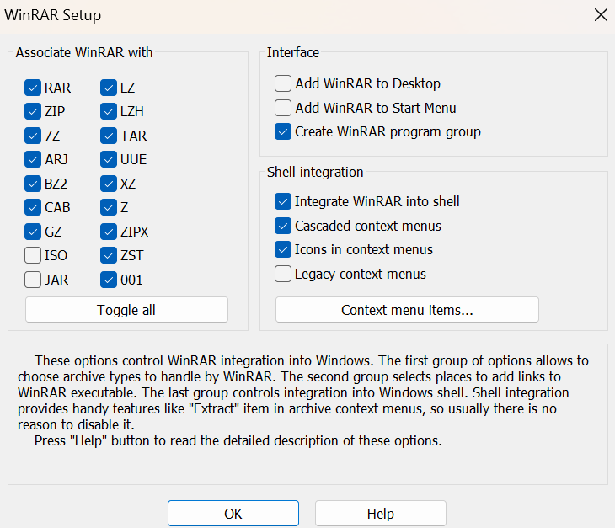
After:
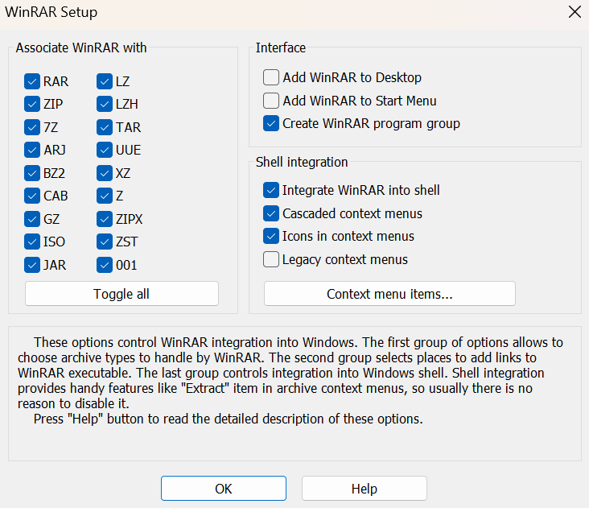

Click on Done.
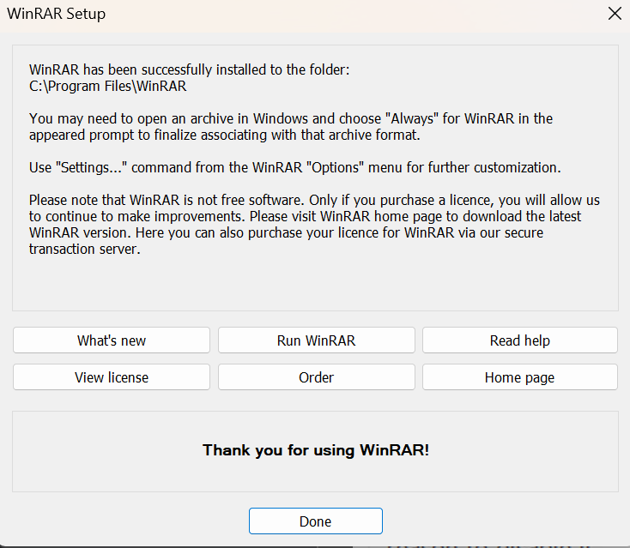
Now go back to the Documents folder. Right-click on the Kali Linux file, select WinRAR, and choose ‘Extract Here.
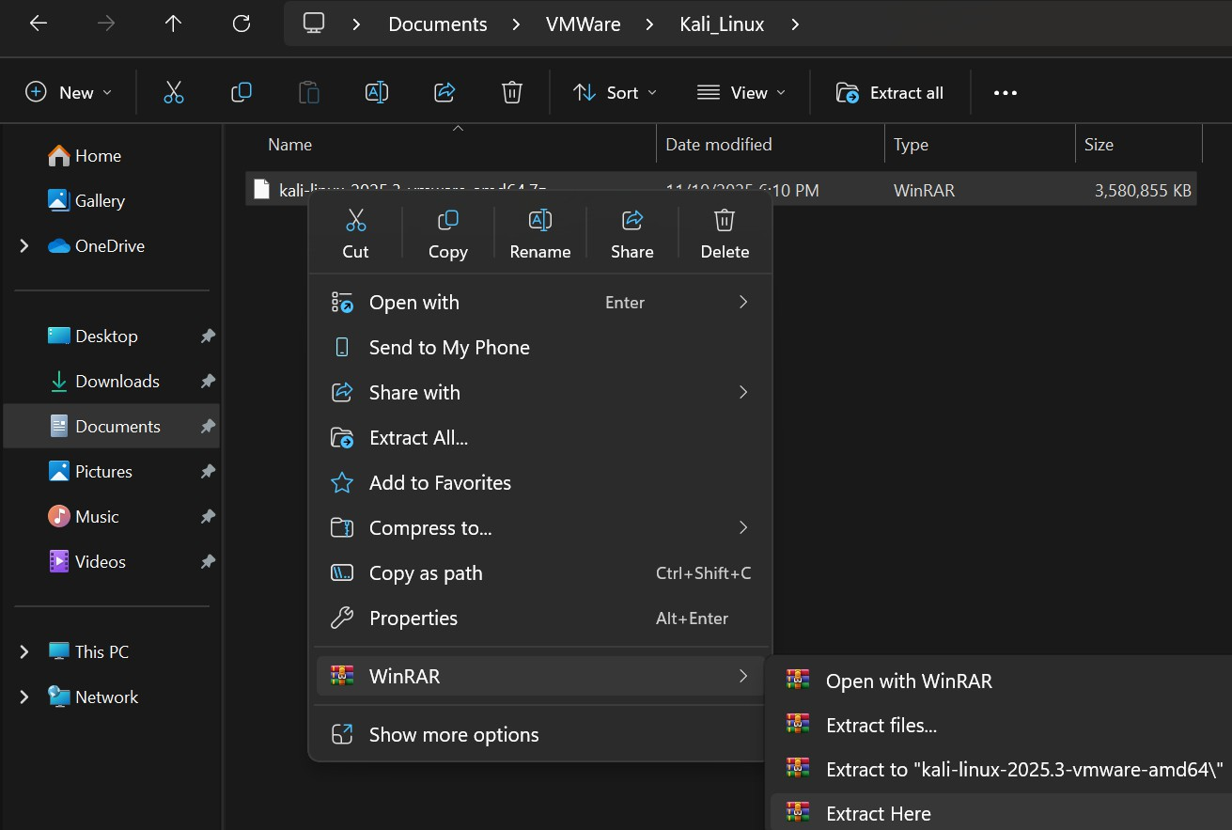

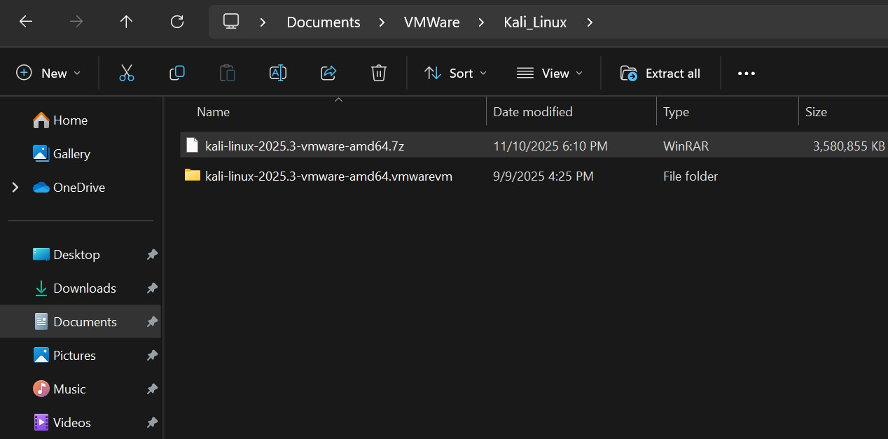
Once it has been extracted, you will see a new folder created. Open the newly extracted folder.
Click on View > Show > File name extensions, and then double-click the file that has the .vmx extension at the end.
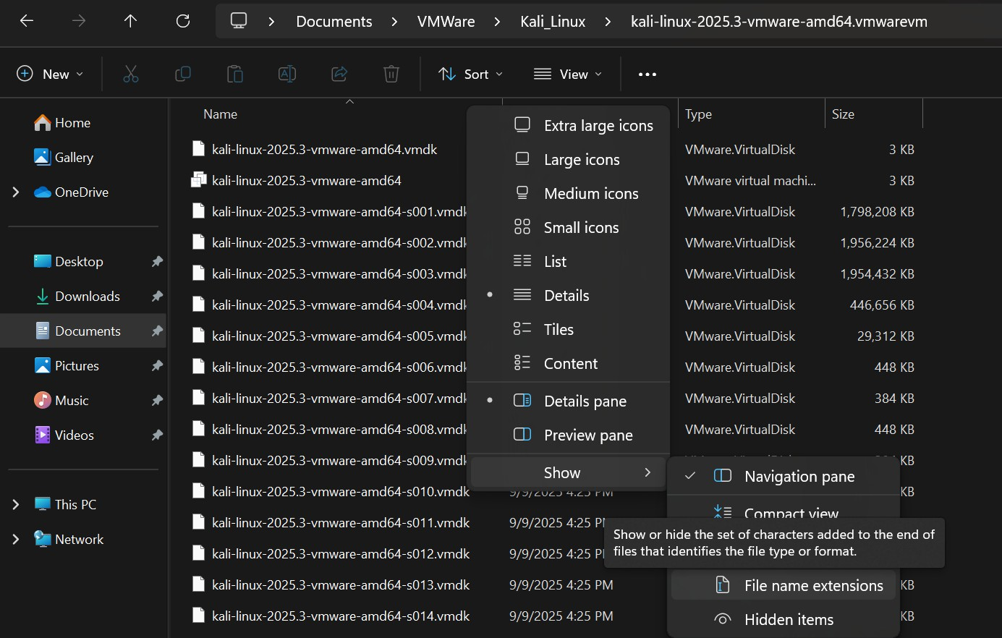
Click on VMware Workstation and select ‘Always.’

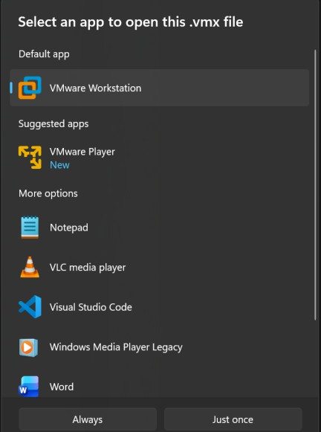
Start the OS:
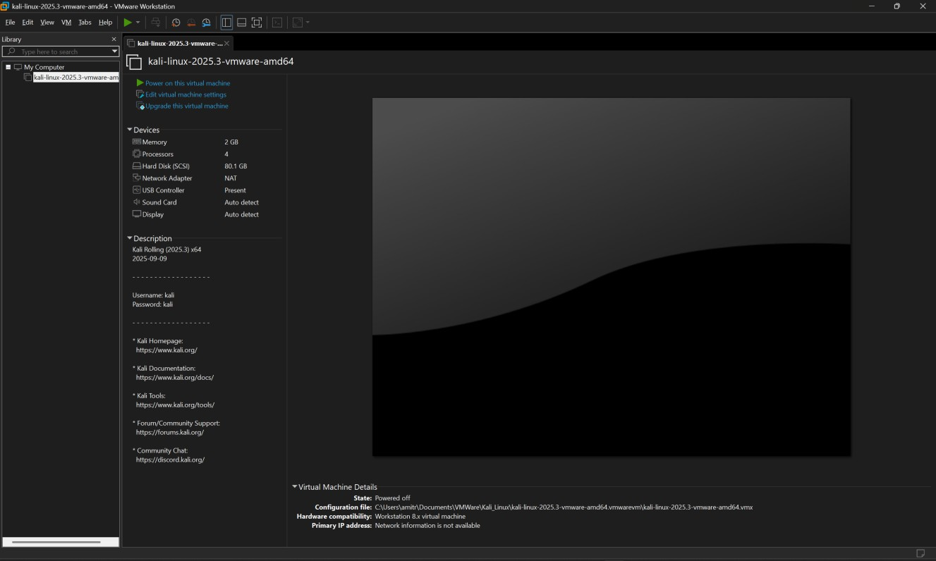
Click on the green button to start the OS.
Enter the credentials shown below: User ID: kali
Password: kali


Click on the Terminal icon.
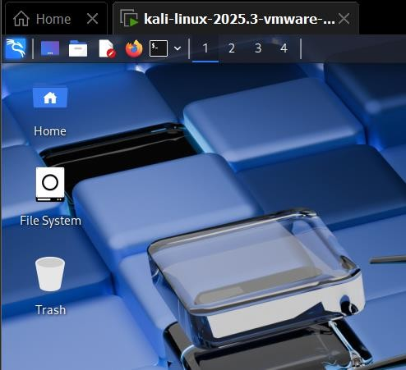
Alternatively, to open the Terminal, press Ctrl + Alt + T and enter the following command as shown below:

Command:
sudo passwd root kali
kali
kali

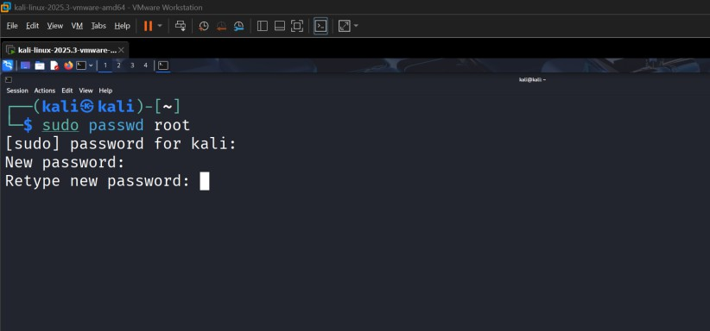
Click on the power-off icon.
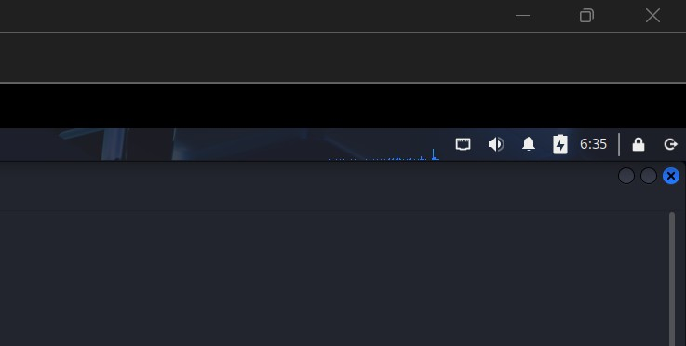
Click on the Shut Down option.
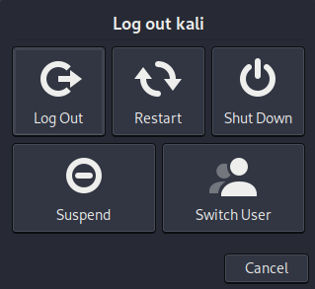

Enter the credentials as shown below: User ID: root
Password: kali

Open the Terminal.
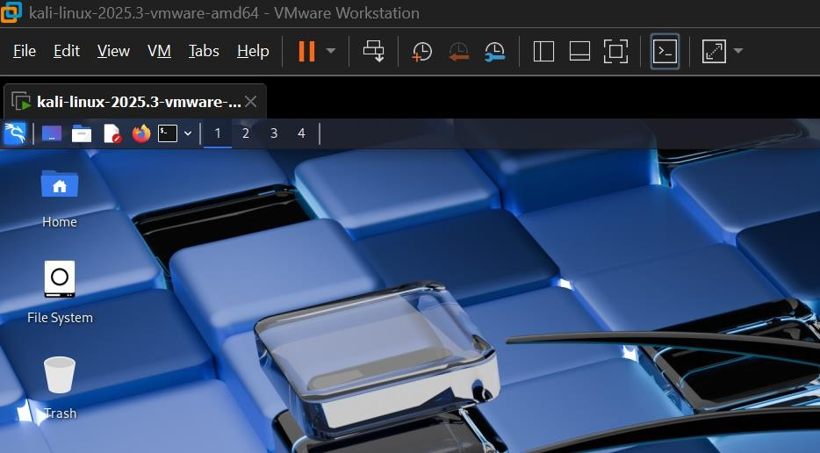

Enter the following command:
apt-get update

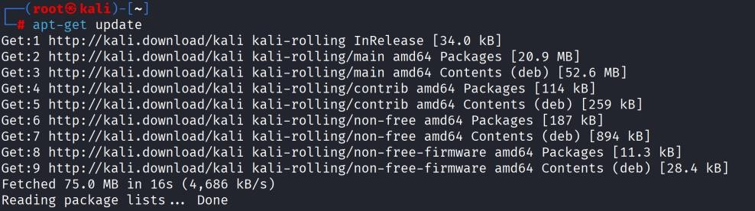

Enter the following command:
apt-get upgrade
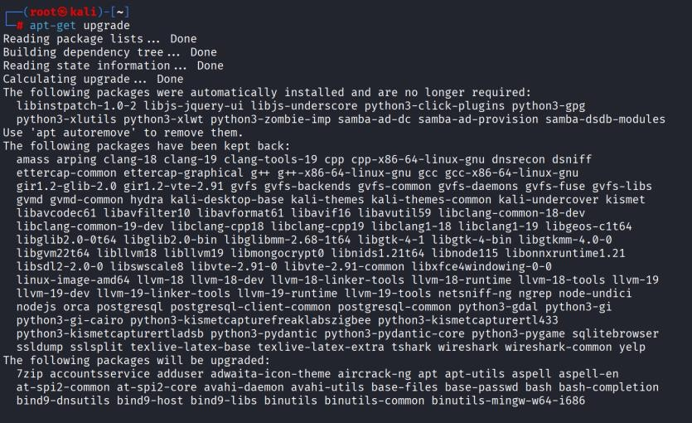
If it asks for a Yes or No option, type ‘y’ and press Enter, as shown below.
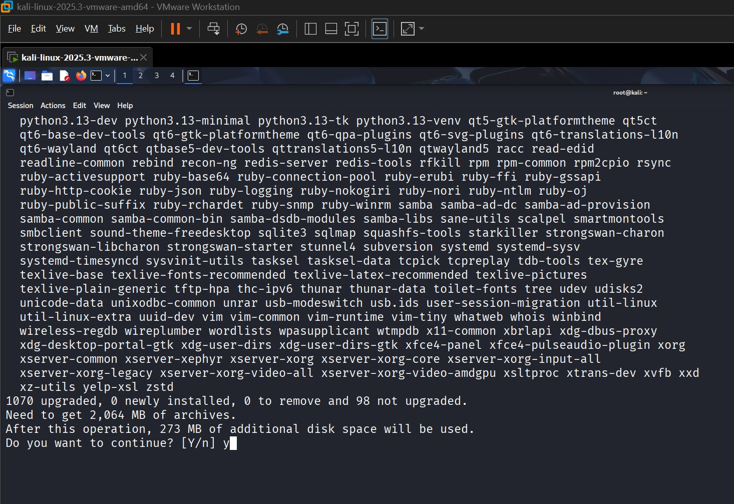

Power off the OS, then click on Edit virtual machine settings. Go to Network Adapter, change the setting from Bridged to NAT, and click OK.
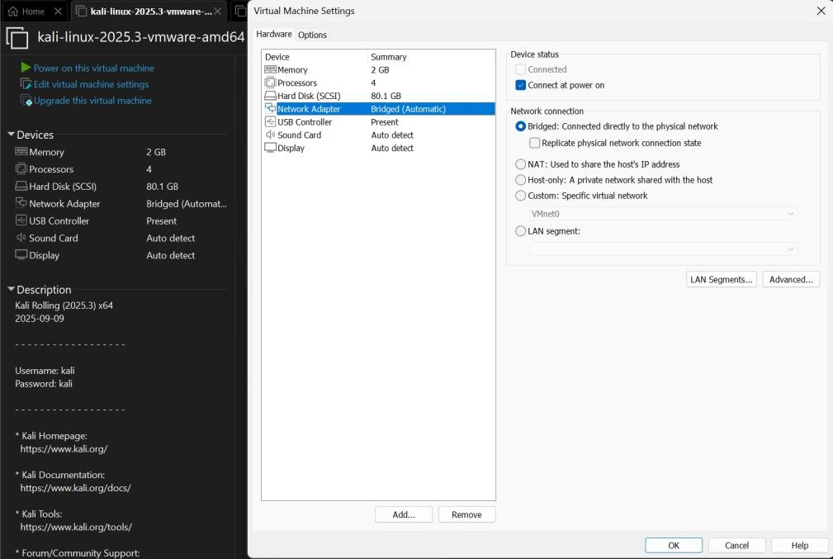
Before:

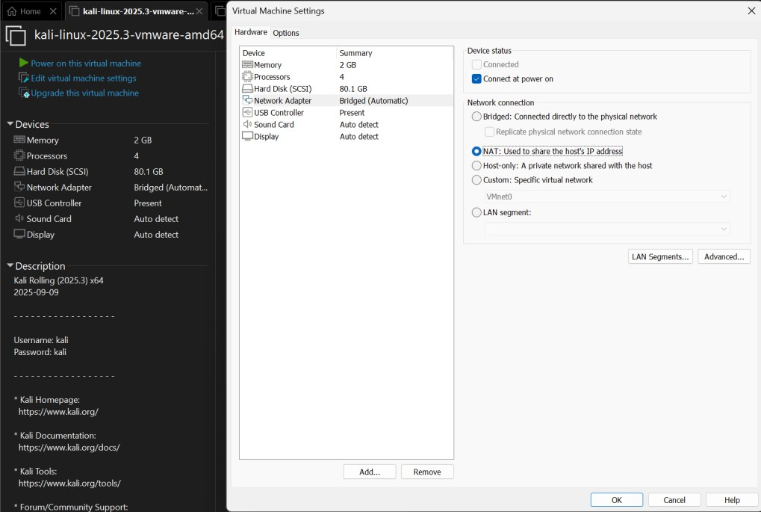
After:

Turn on your Kali Linux system, open the Terminal, and enter the following command: ifconfig
You should see an IP address displayed in the ‘inet’ section.

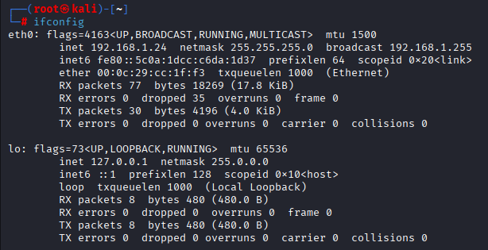
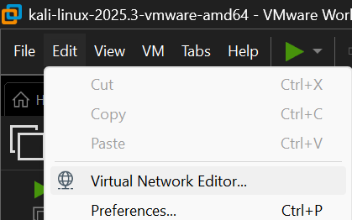
If you are not getting an IP address, kindly follow the steps below.
Click on Change Settings and then click Yes.
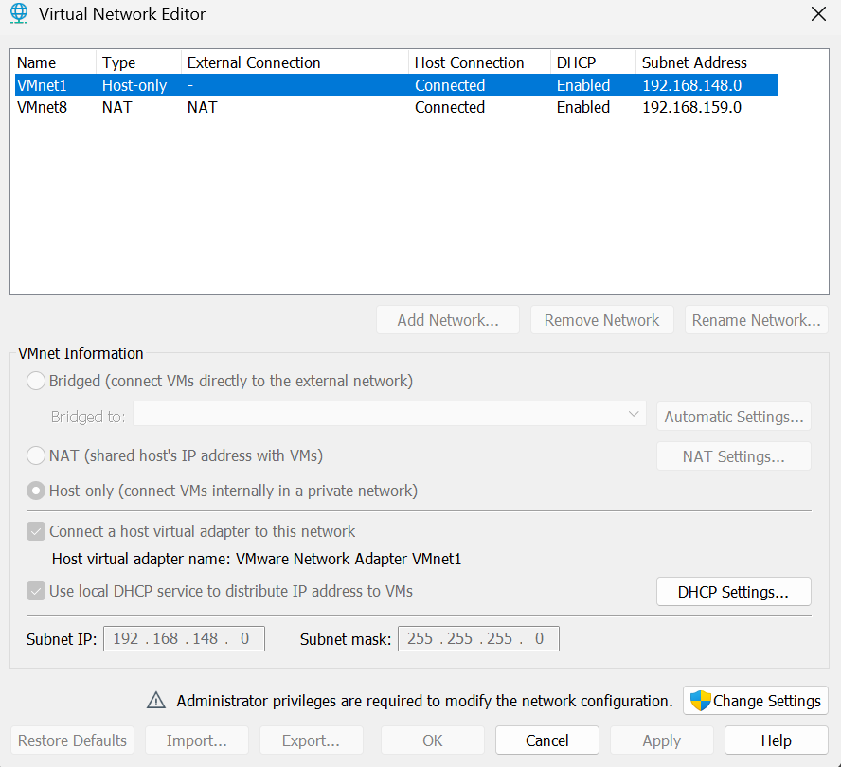

Now you will see the new adapter.

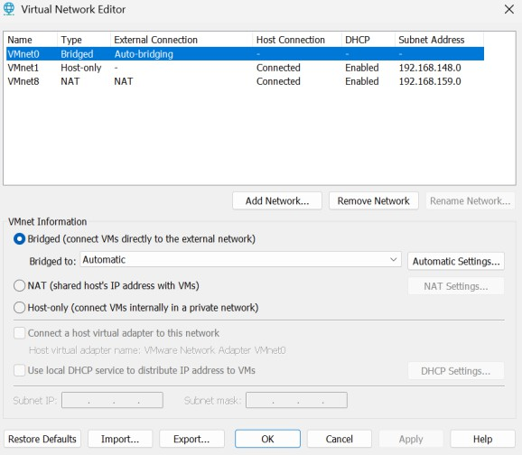

Select the Intel adapter, then click Apply and OK.
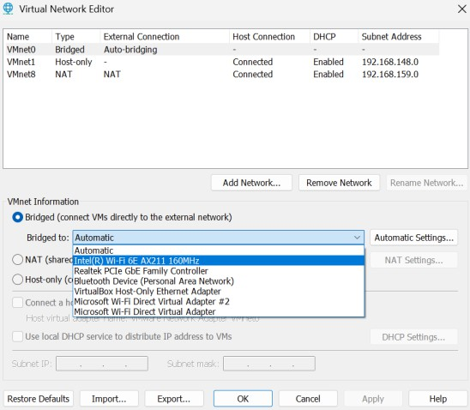
Restart the OS and open the Terminal.

Or

To open the terminal press Ctrl + Alt + T
Enter the command below:
ifconfig
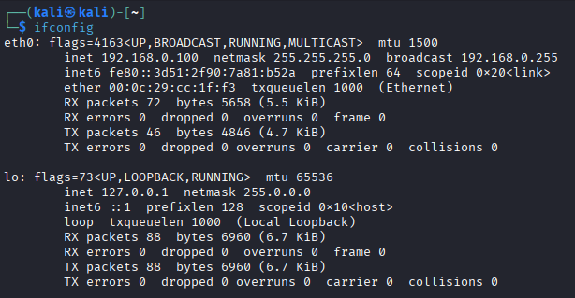
You should see an IP address in the ‘inet’ section. If you are getting the IP, it means everything is set. You can now power off the Kali O

Windows 10:
Click on the link below.
https://www.microsoft.com/en-us/software-download/windows10

Click Download Now button in the below image

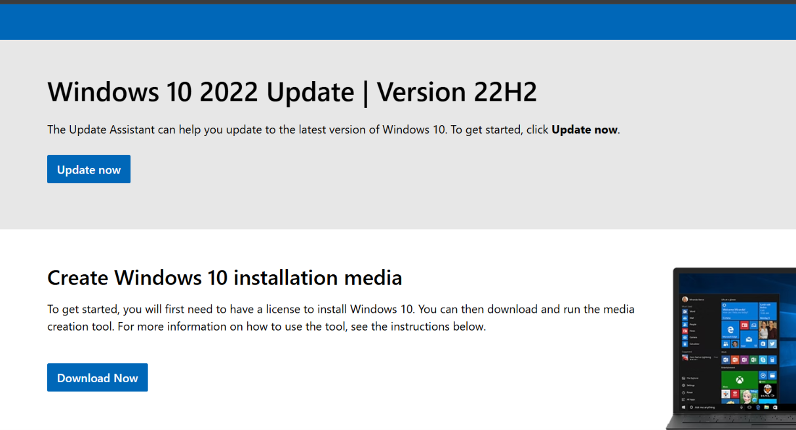

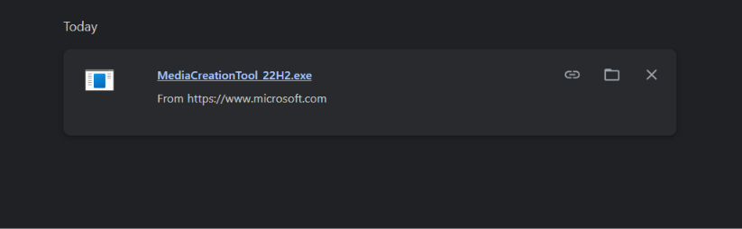
It will start downloading the file.

Run this file.
Accept the license
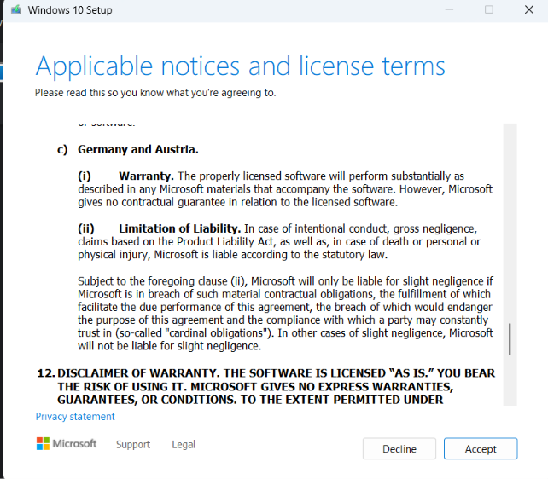

Choose second option and click next.
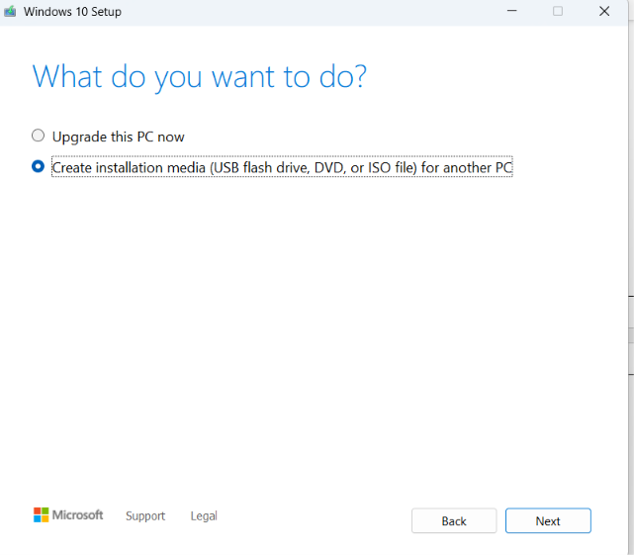

Click Next.
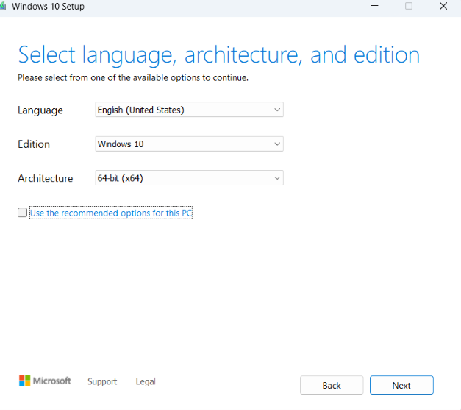
Choose second option “iso file” and click next.
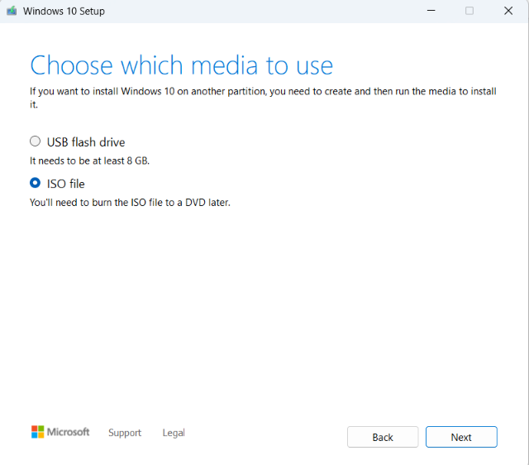

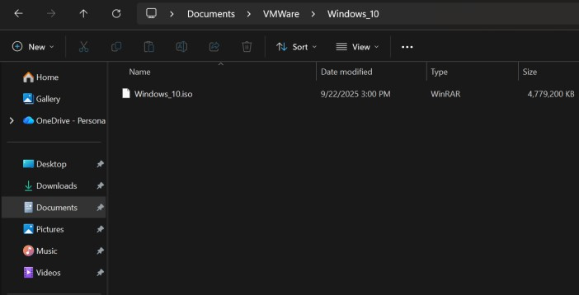
It will ask for the select the file path . Go to the Documents folder, open the VMWare folder, create a new folder named ‘Windows_10,’ and chose the folder and save then click next. It will downloading the iso file there.
Close and reopen VMware, go to the Home screen, and click on ‘Create a New Virtual Machine.’
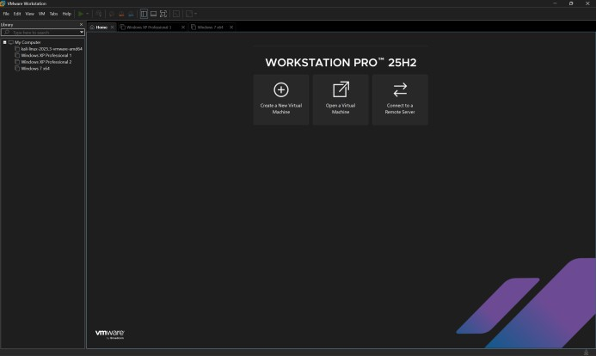
Select the second option and click Next.
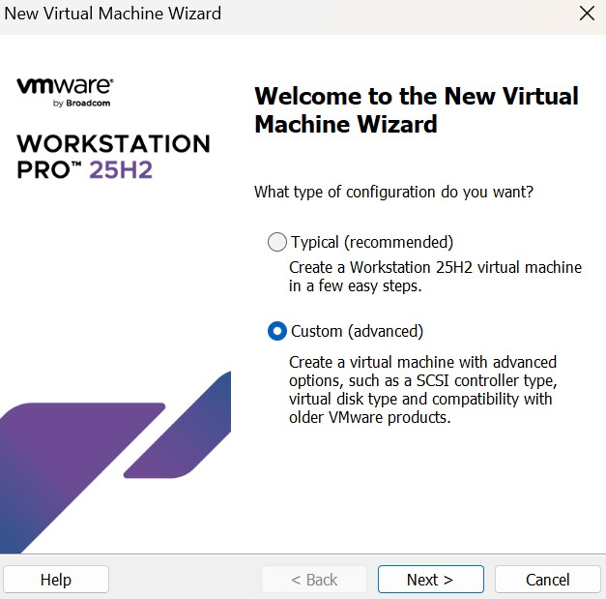

Click on Next.
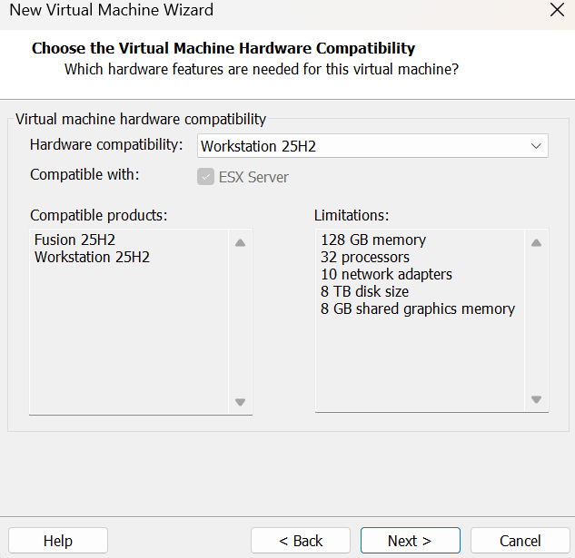
Select the second option and click the Browse button.
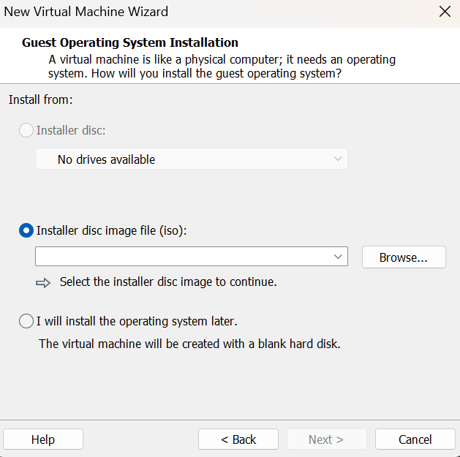

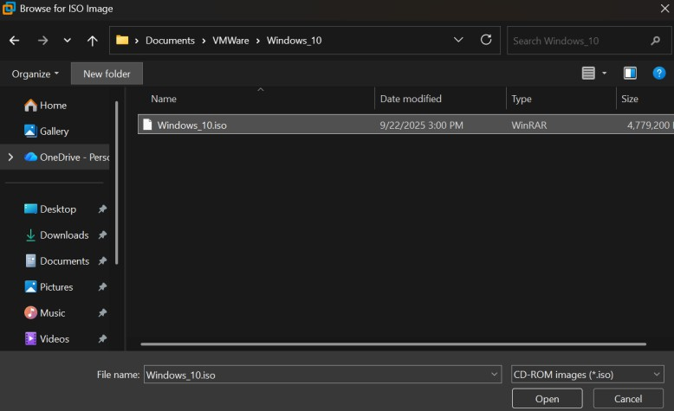
Go to Documents > VMWare > Windows_10, select the file, and click Open.

Click on Next.
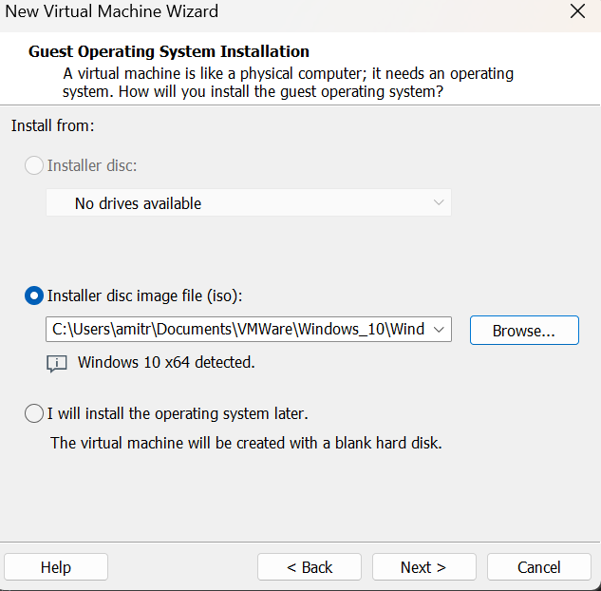

Click on Next.
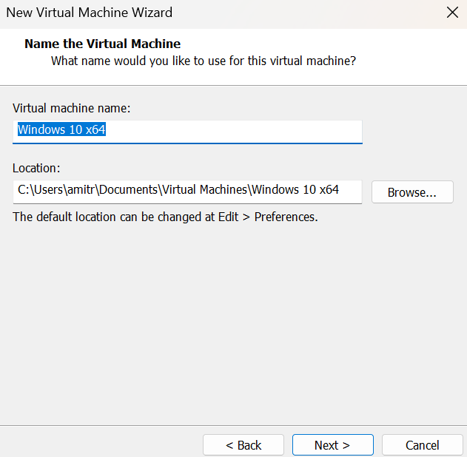
Click on Next.
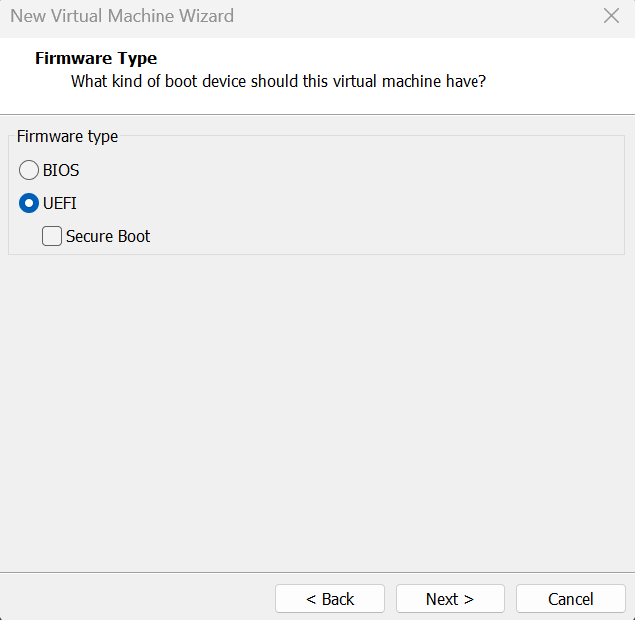

Set the processors to 2 and 1, as shown below, and click Next.
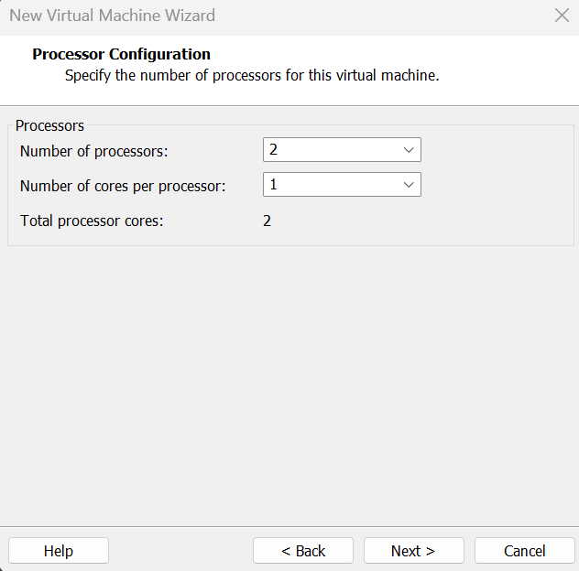

Change the memory from 2048 MB to 3000 MB, and click Next.
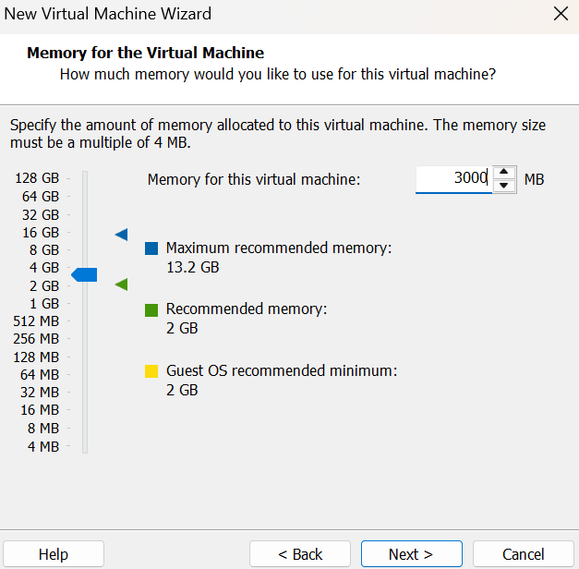
Select the first option and click Next.
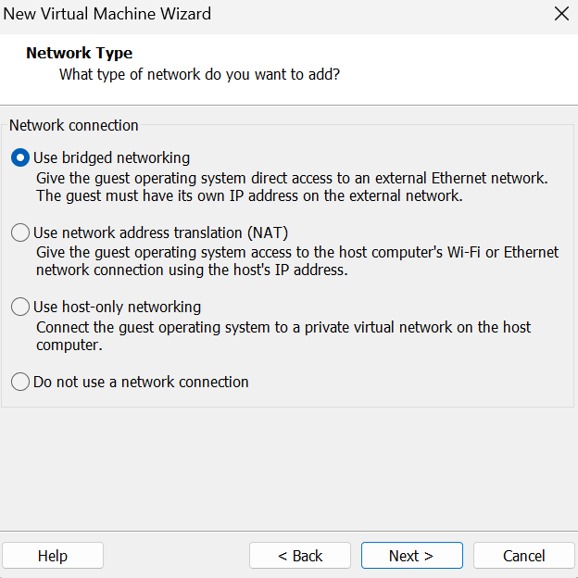

Click on Next.
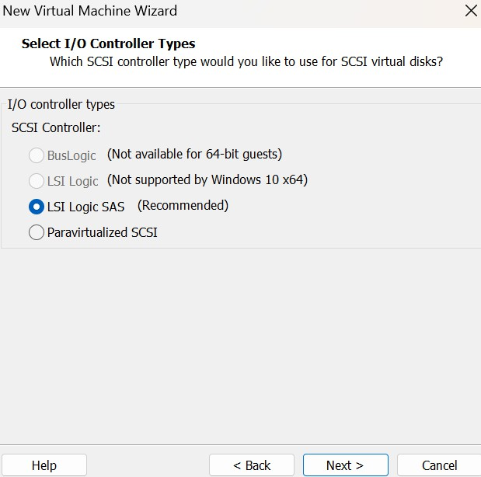
Click on the Next.
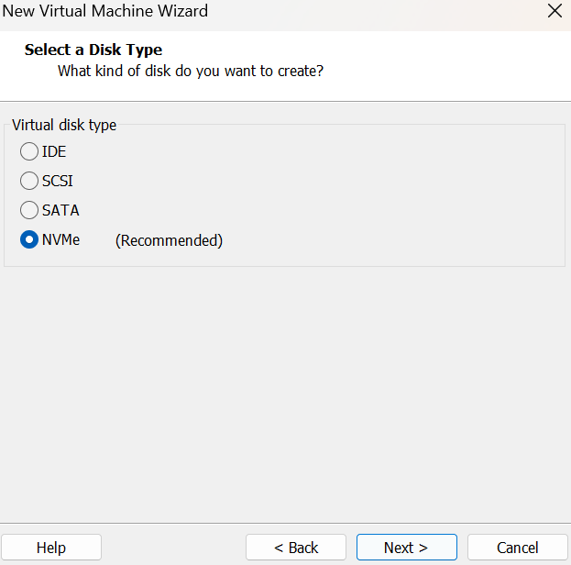

Click on Next.
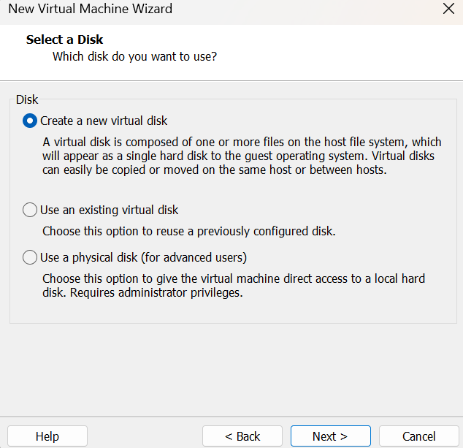

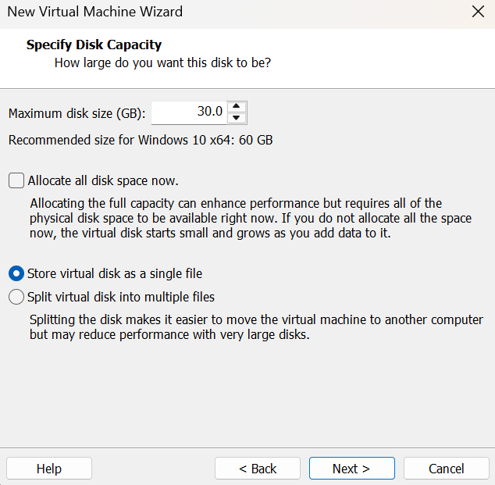
Assign the disk size to 30.0 GB, select the second option, and click Next.
Click on Next.
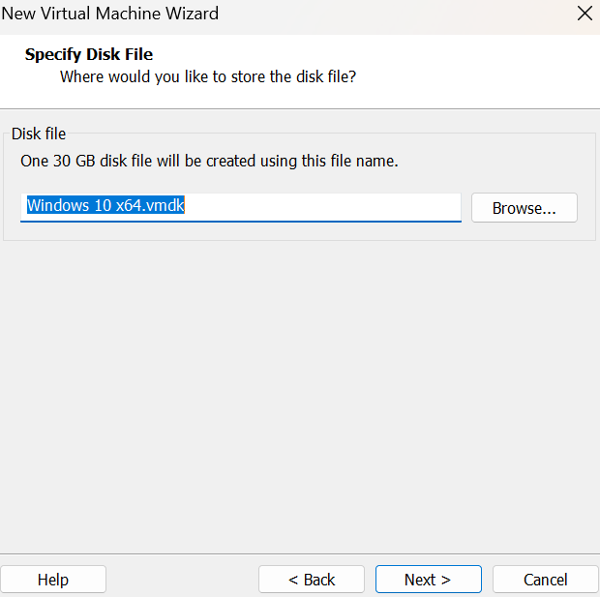
Click on Finish.
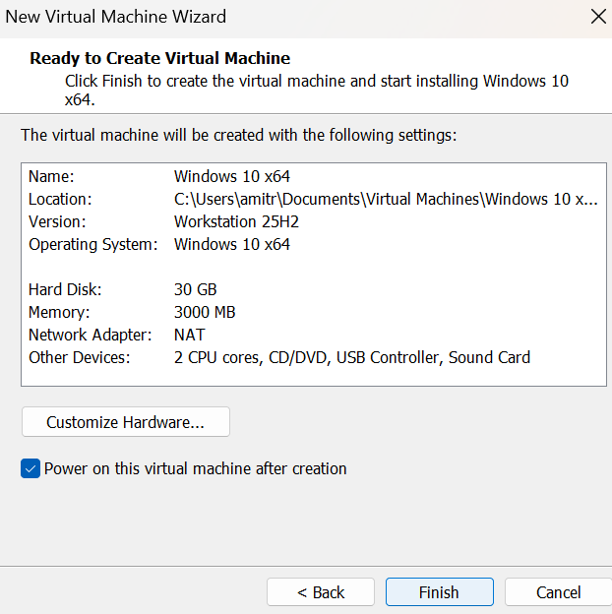

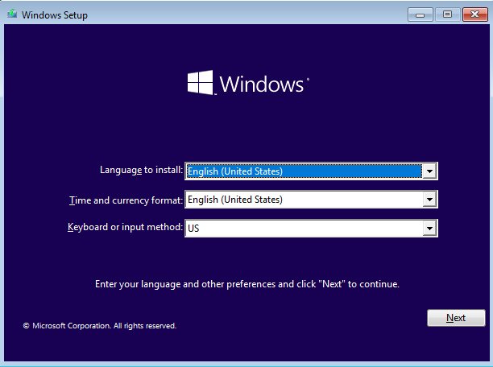
Assign the disk size to 30.0 GB, select the second option, and click Next.
Click on the Install Now button.
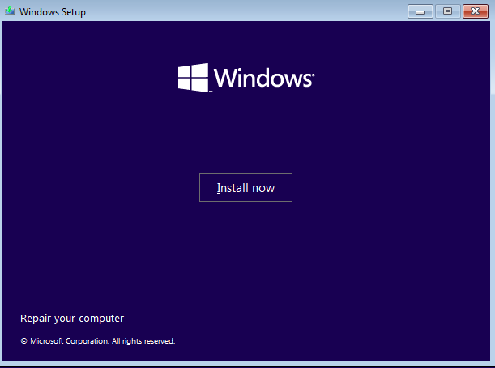
Click on the ‘I don’t have a product key’ option.
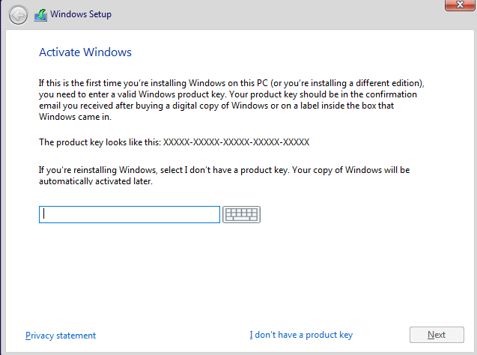

Select Windows 10 Pro and click Next.
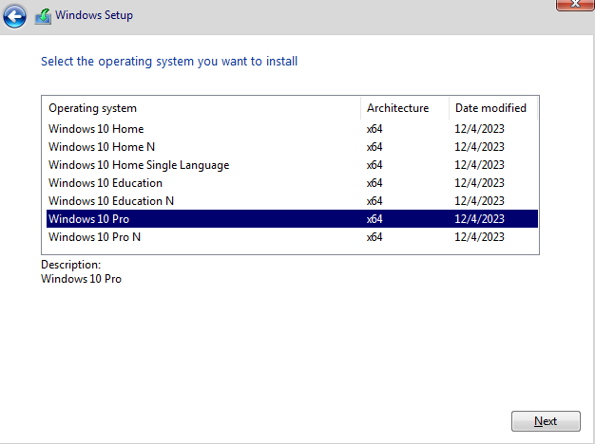
Check the box and click Next.
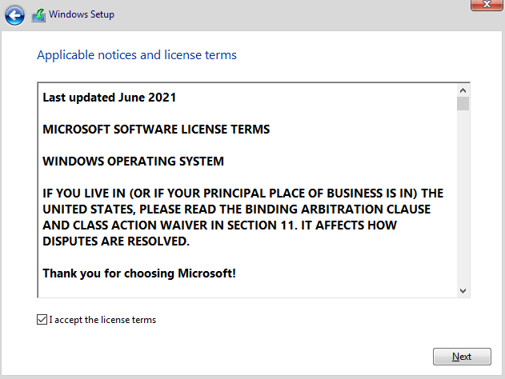
Click on the Custom option.
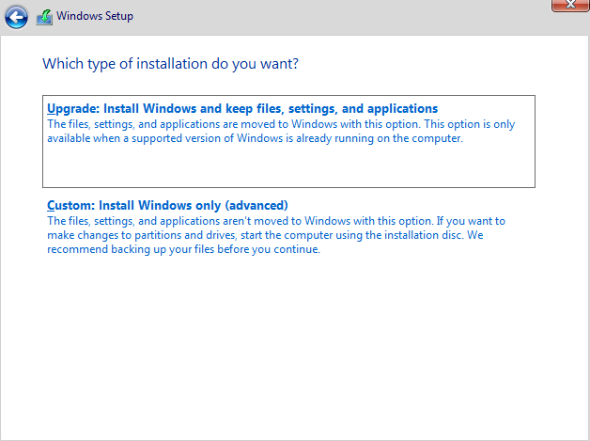

Click on Next.
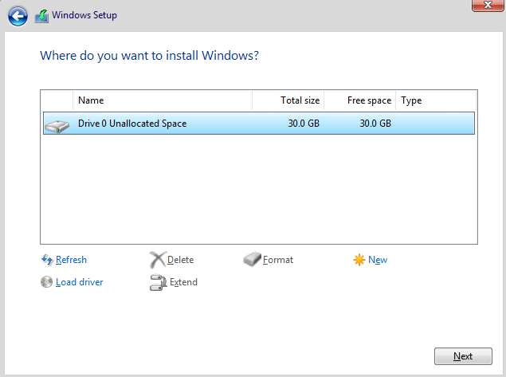
Wait for a few minutes.
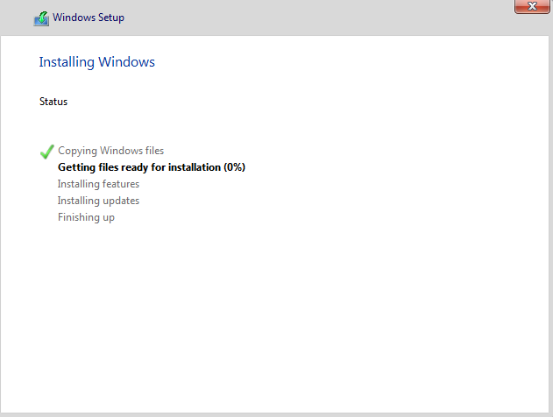
Click on Yes.
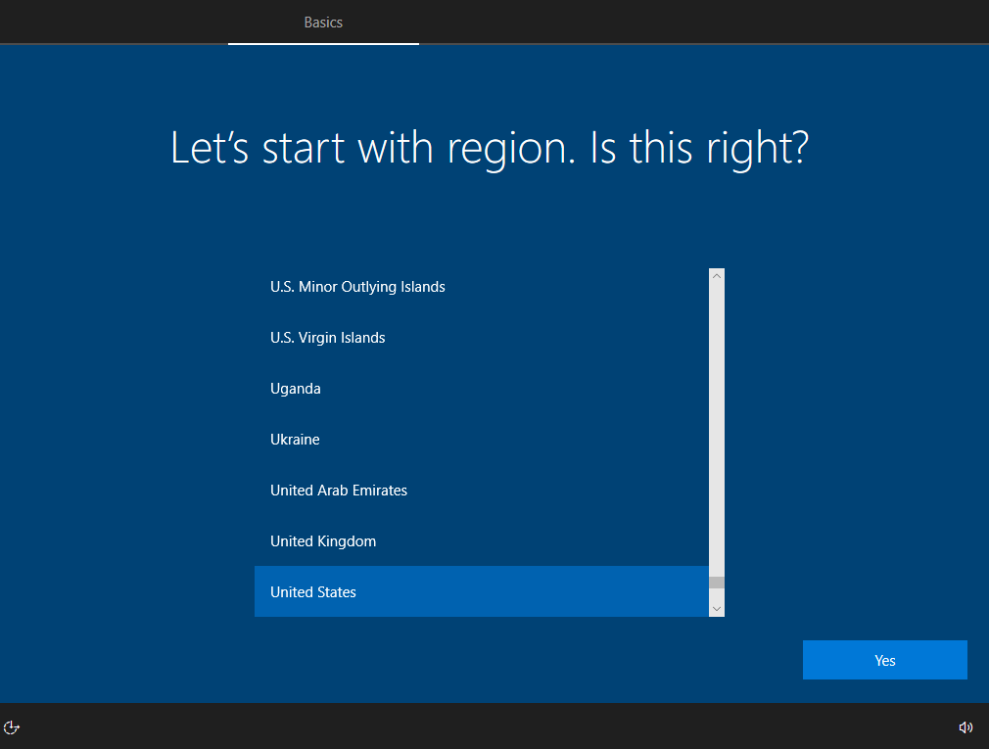

Click on Yes.
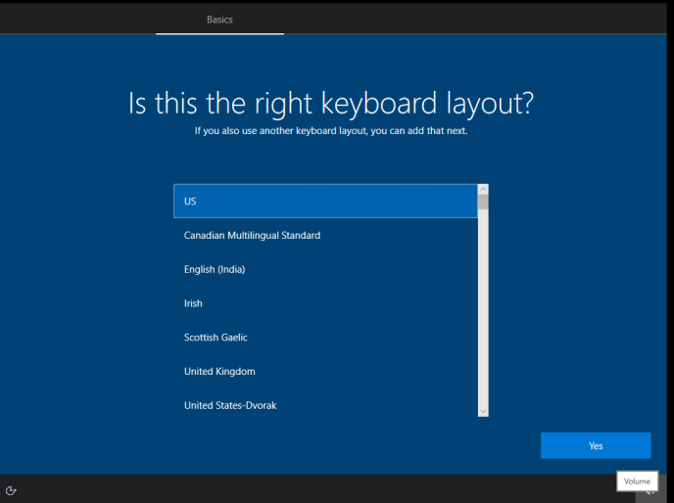
Click Skip.
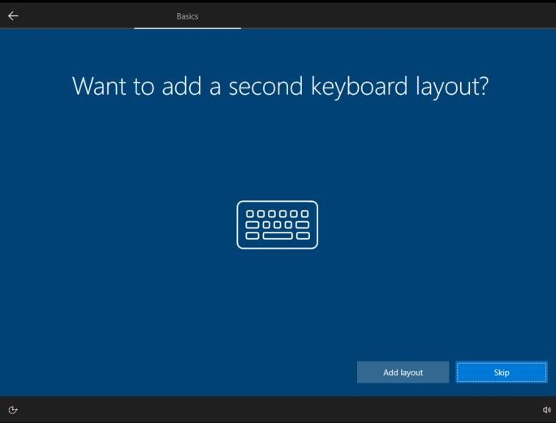
Select Personal Use and click Next.
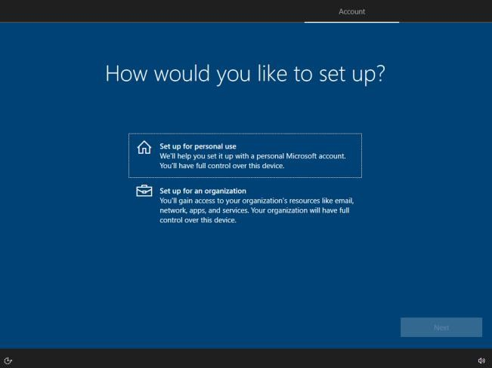
.

Click on Offline Account
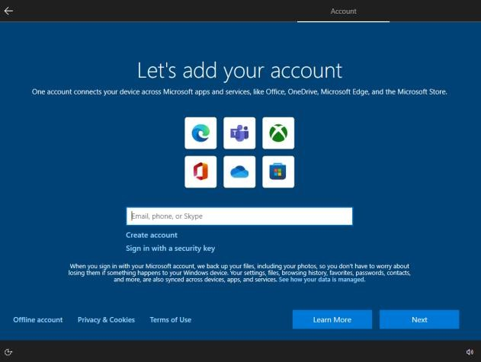
Click on Limited Experience.
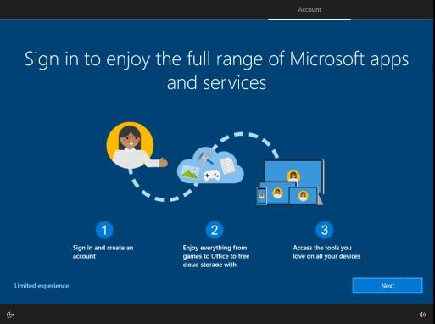
Enter the name as ‘Cybersecurity’ and click Next.
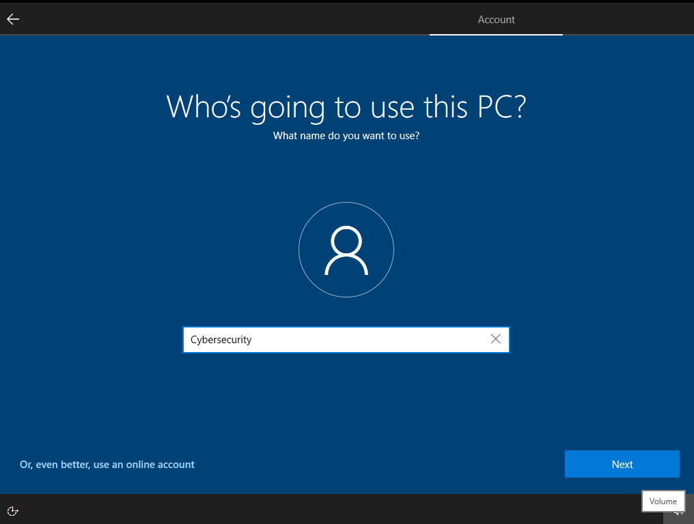

Enter the password you want to use and click Next.
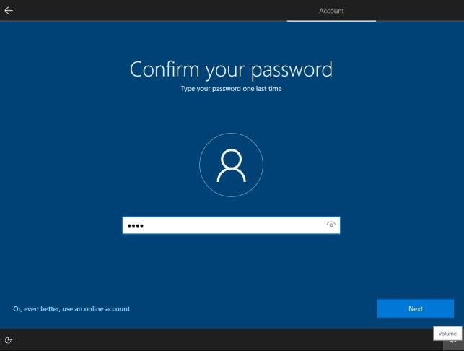
Select the questions as per your convenience and enter the answers. Make sure to remember the answers you provide, then click Next.
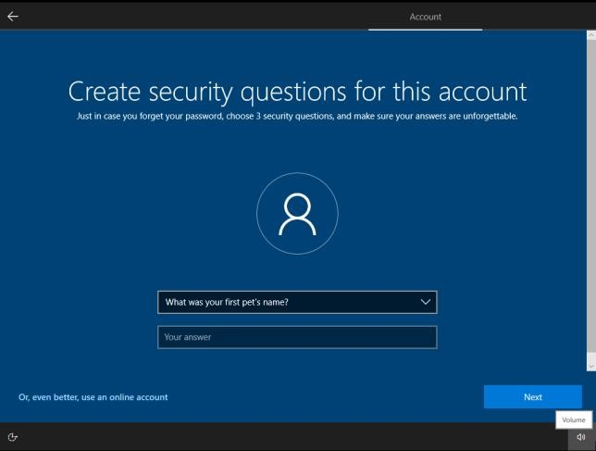
Click on Not now.
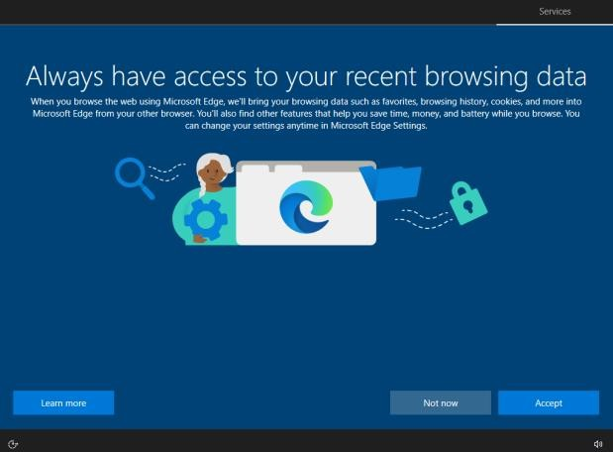

Disable all the options and click Accept. Before:
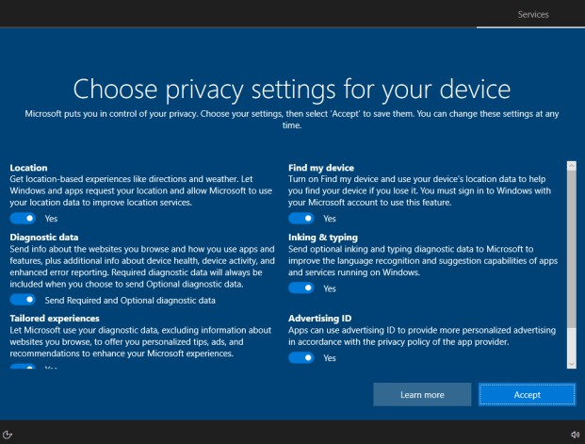
After:
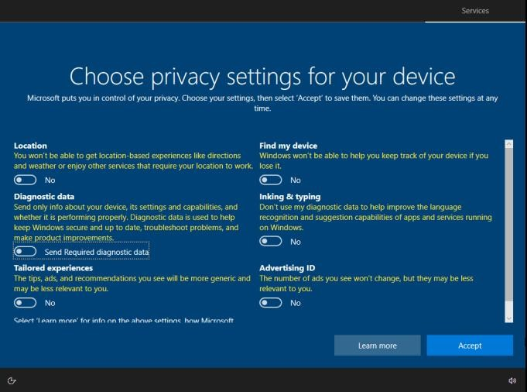
Click on Skip.
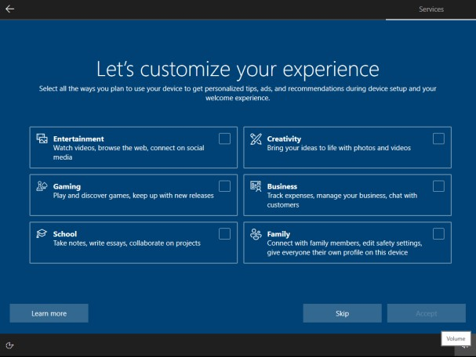

Click on Not now.
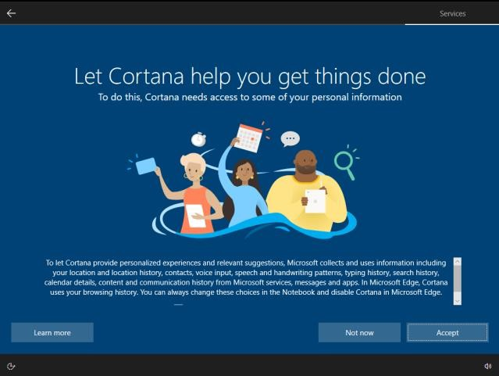
Now you are good to go.
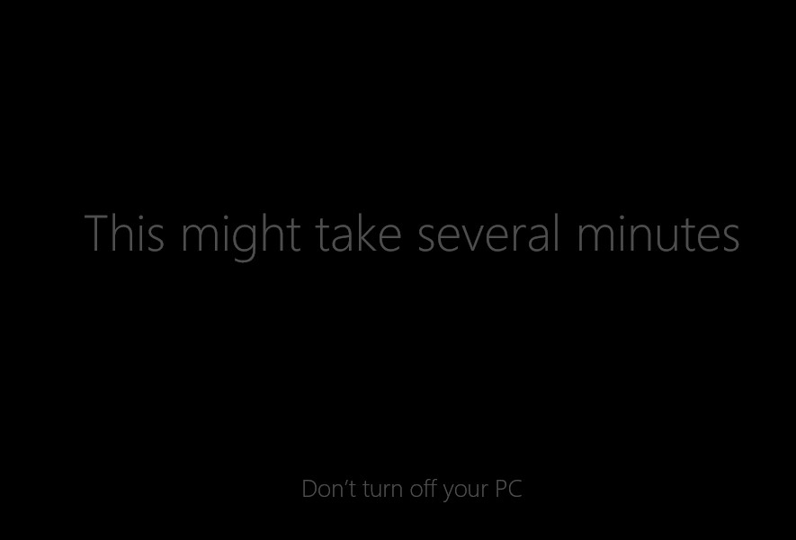
Click on Continue.
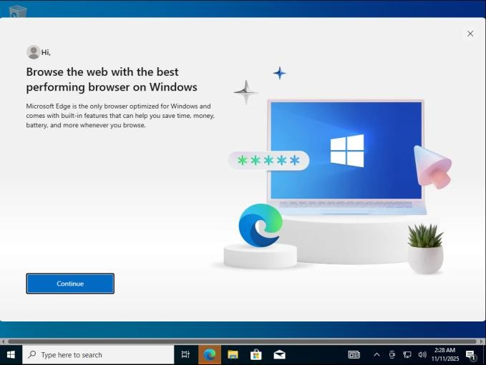

Click on ‘Start without your data.’
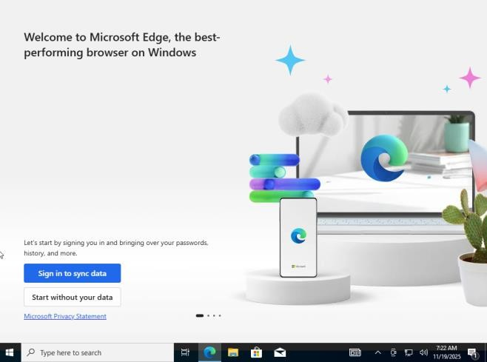
Click on Confirm and continue.
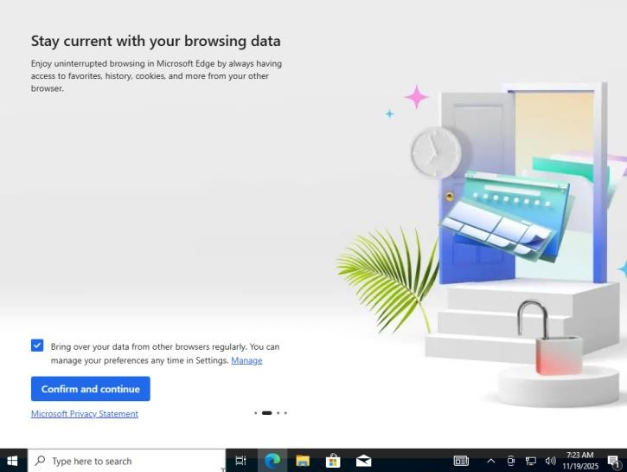
Click on Continue without Google data.
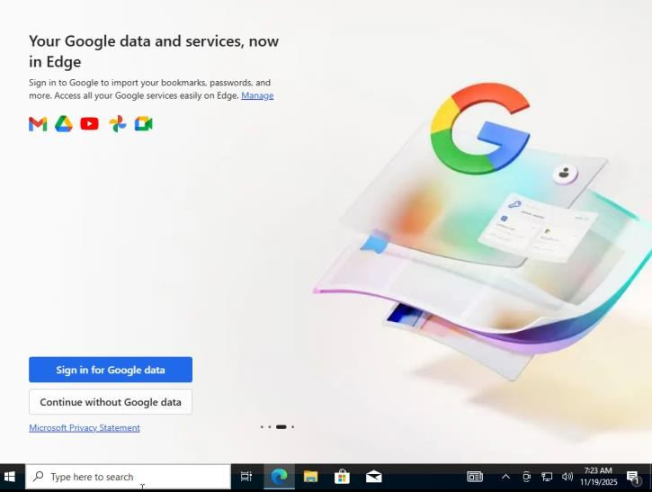

Click on Confirm and start browsing.
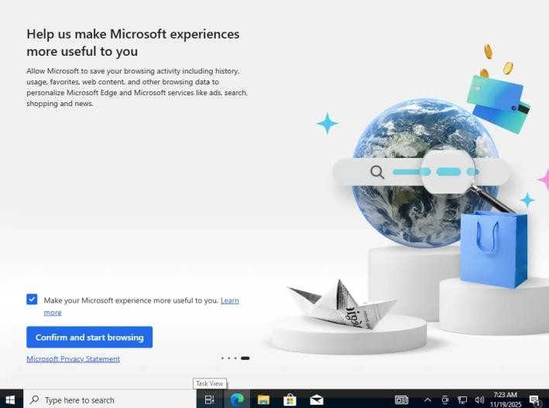
Click the X icon to close the browser.
Click on Yes.
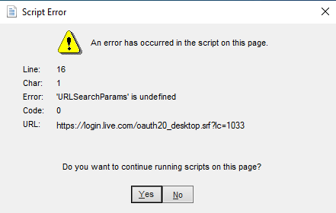
Click on Yes.
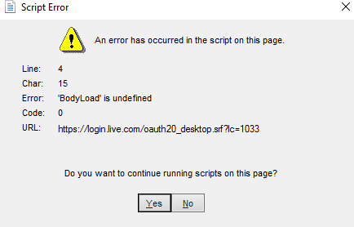

Now it has been successfully installed.
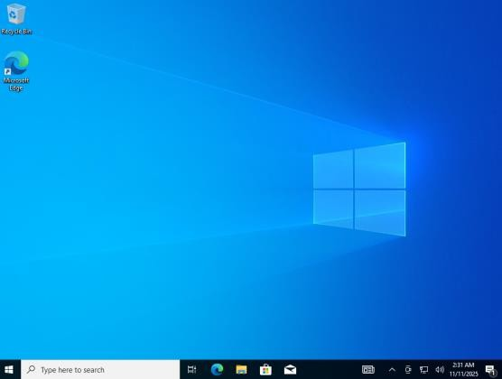
Click on VM > Install VMware Tools.
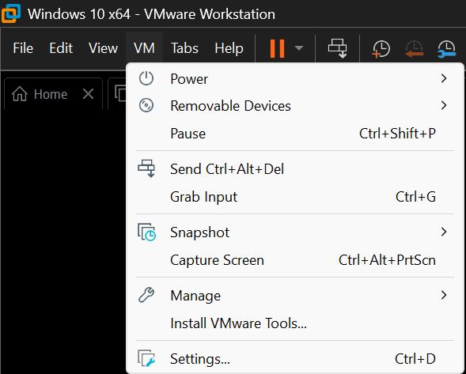
Open File Explorer, click on This PC, and then click on the DVD Drive.
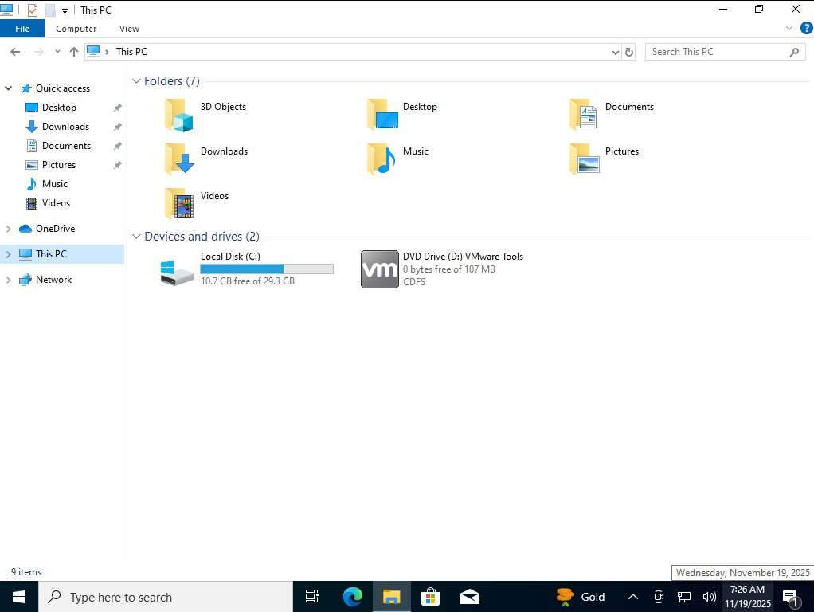

Click on Yes.
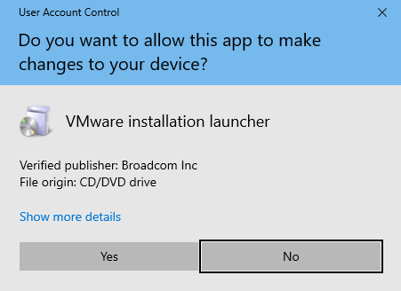
Click on Next.
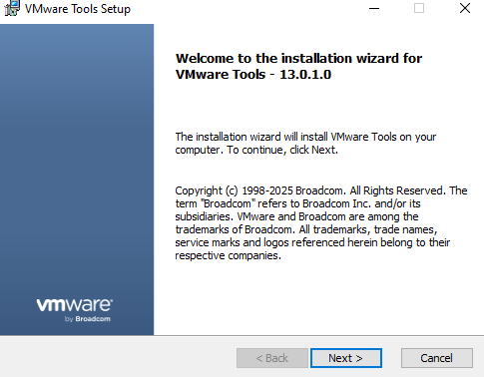
Click on Next.
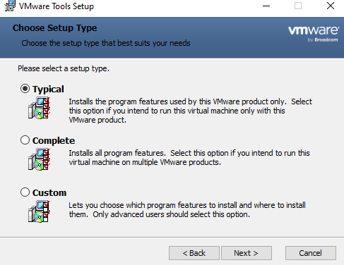

Click on Install.
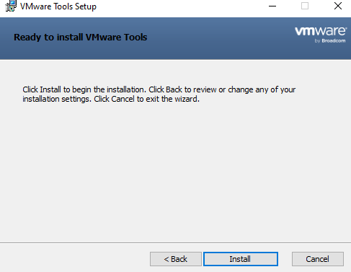
Click on Finish.
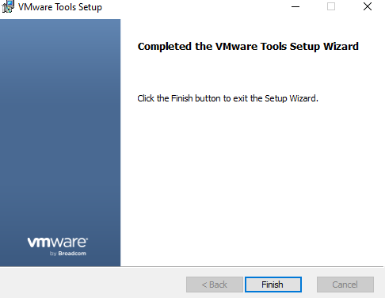
Click on Yes.
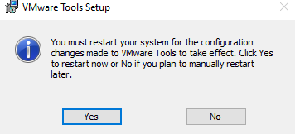
Once it has restarted, power off the OS & click on Edit virtual machine settings.
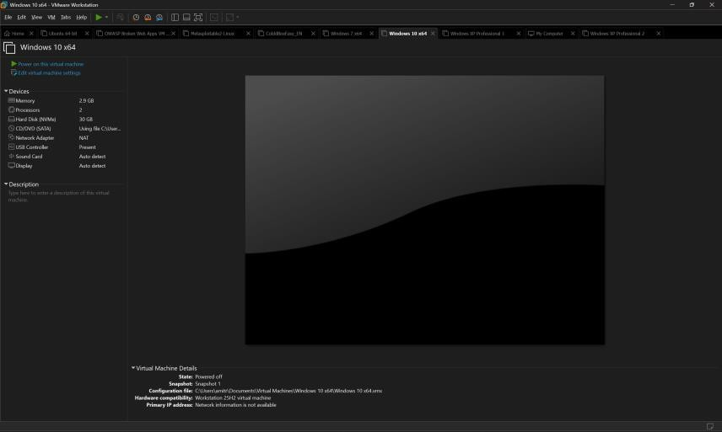

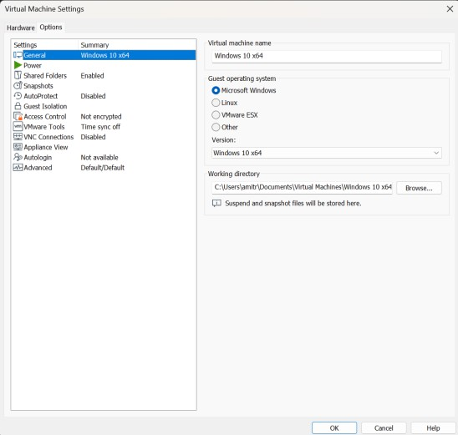
Click on Shared Folders and then click Browse

.
Enable the ‘Always enabled’ option and click the Add button.
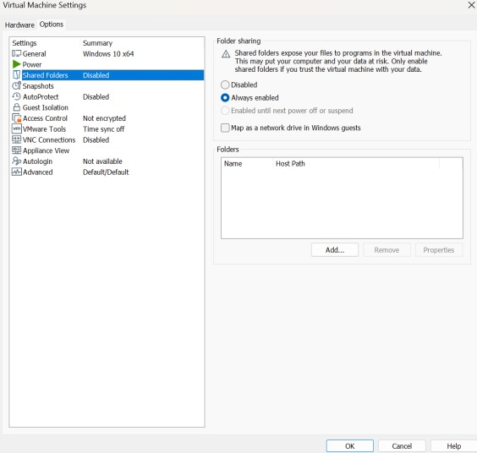
Click on Next.
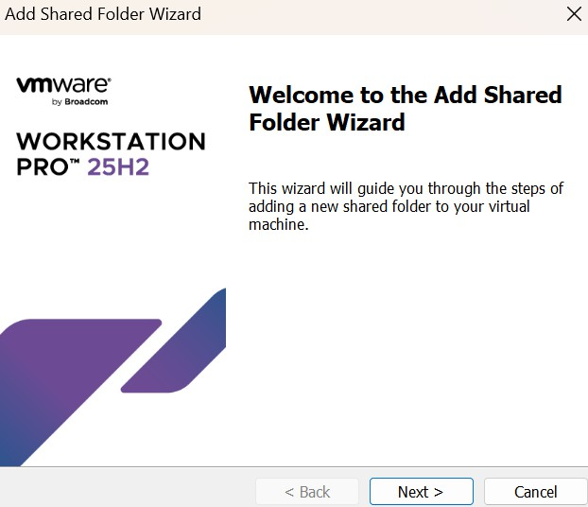

Click on Browse.
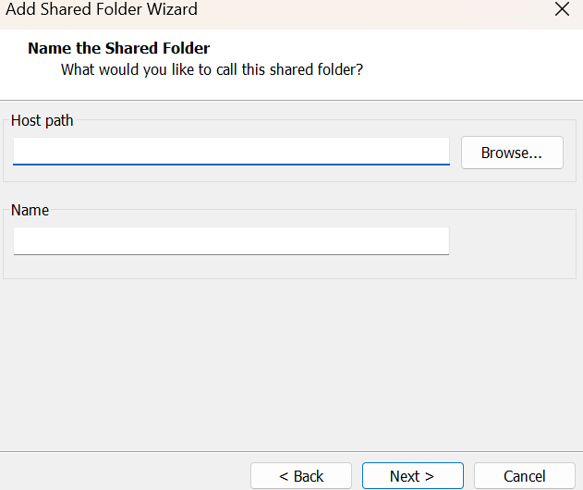
Go to Documents, click ‘Make New Folder,’ name the new folder ‘Virtualization_Share,’ and click OK.
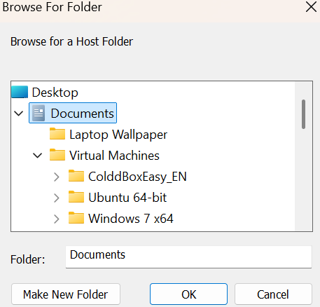
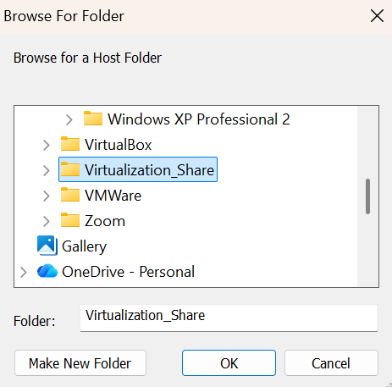
Select the ‘Virtualization_Share’ folder and click OK

.

Click on Next.
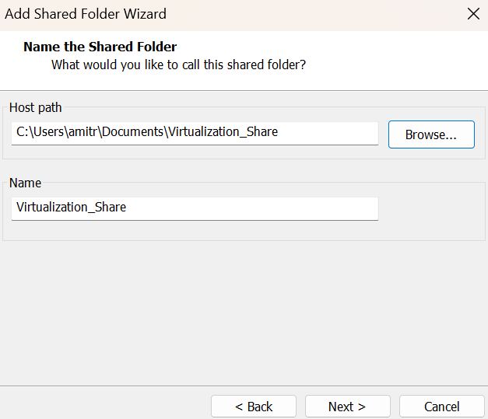
Click on Finish.
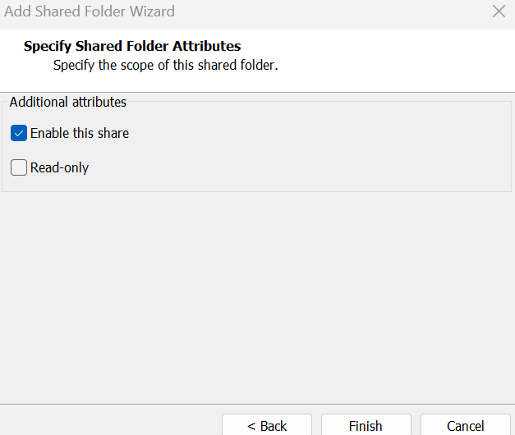
Click on OK
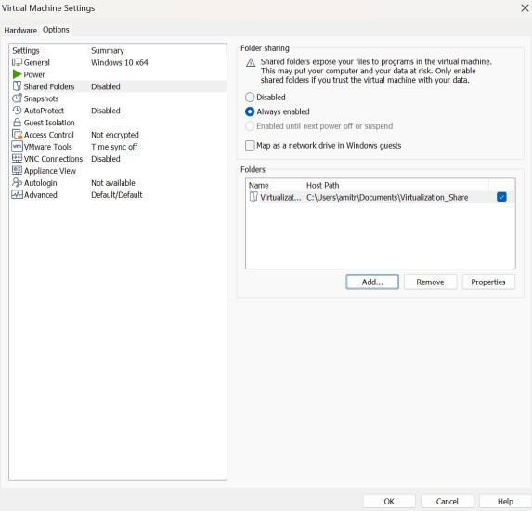

Click on Power on this virtual machine.
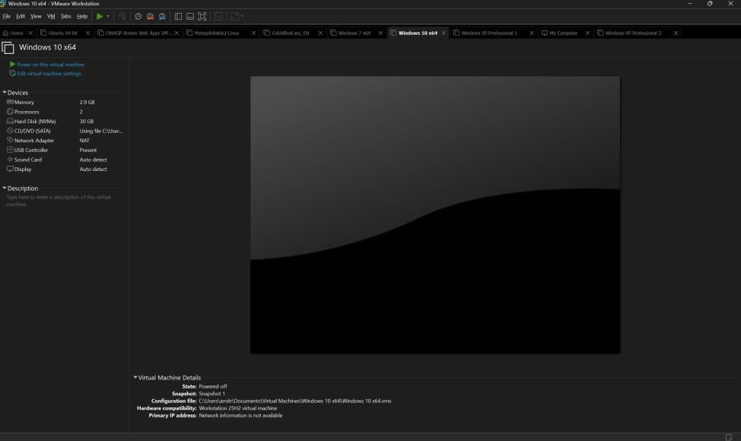
Press Win + R, then paste the following path:
\\vmware-host\Shared Folders
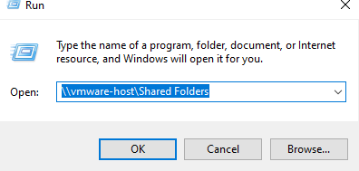
Now you can see that we are able to access the shared folders.
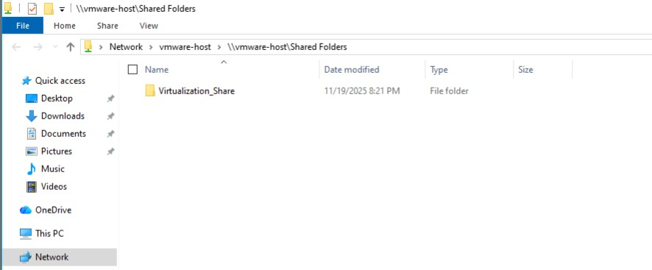

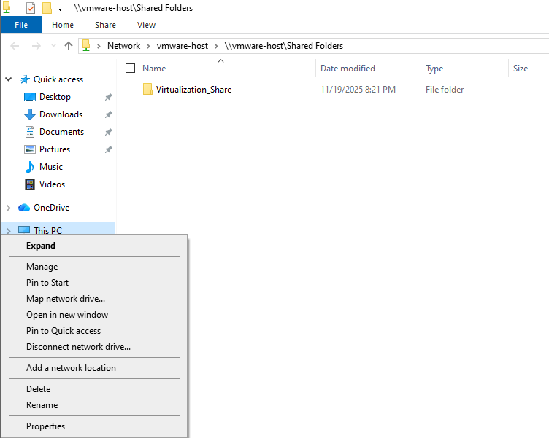
Right-click on This PC and click on ‘Map a network drive.

Click on Browse.
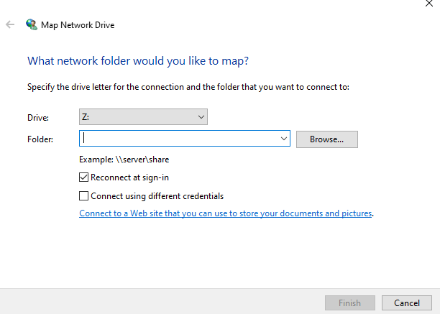

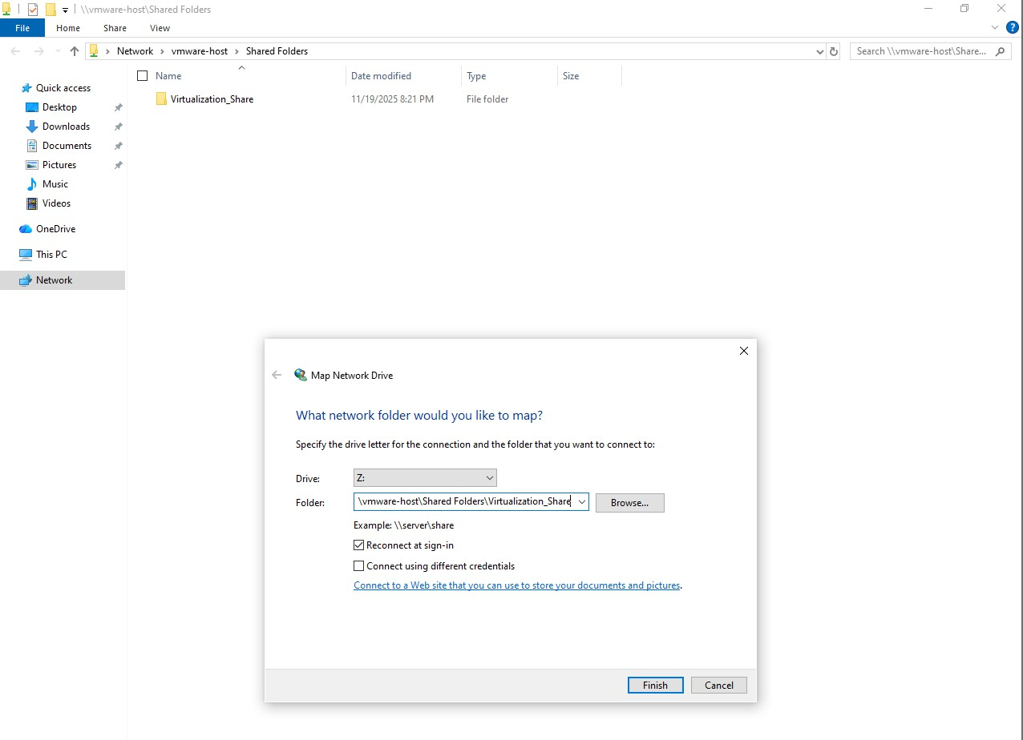
Then select the VM Share folder we created and click Finish.
Open File Explorer and click on This PC. Now you can see a new drive named ‘Virtualization_Share,’ as shown below.
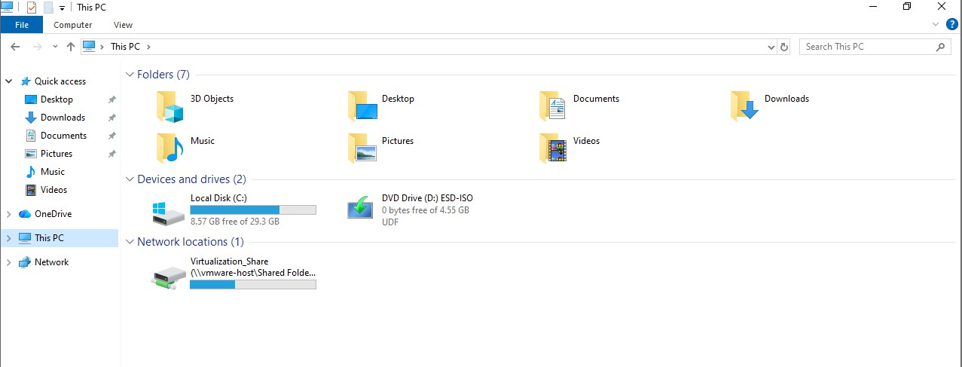

Windows 11 OS Installation:
Click on the link below:
https://www.microsoft.com/en-us/software-download/windows11

Scroll down the page, you will see this. Select the windows 11 (multi-edition ISO ) and click confirm
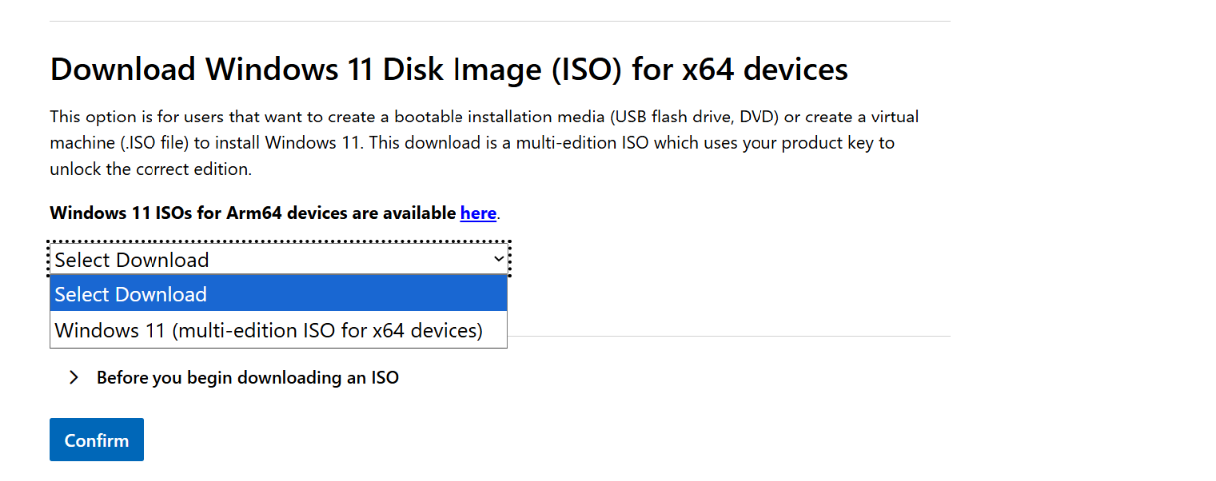
Select the language and click confirm
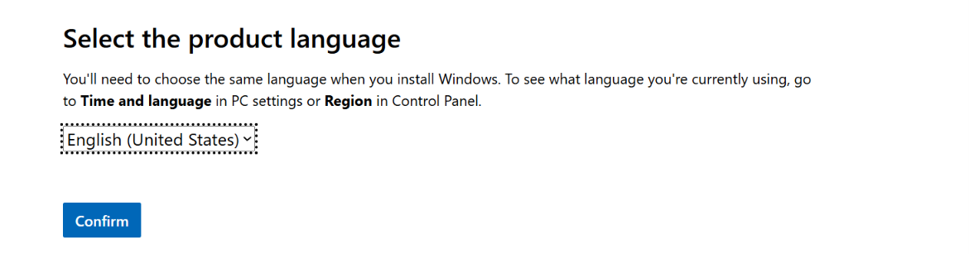
Then click on the download button.
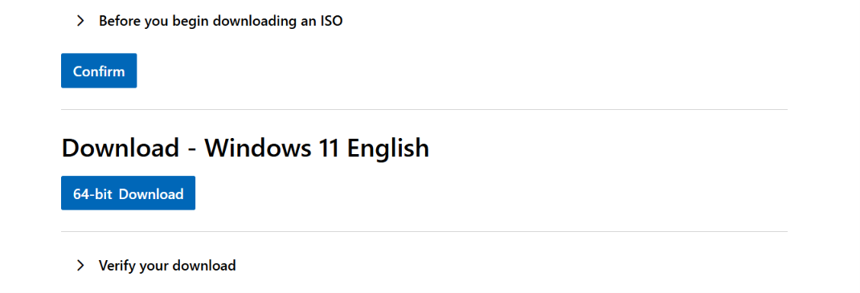

Once it has downloaded, open File Explorer and go to the Downloads folder. Select the file and press Ctrl
+ X to cut it.
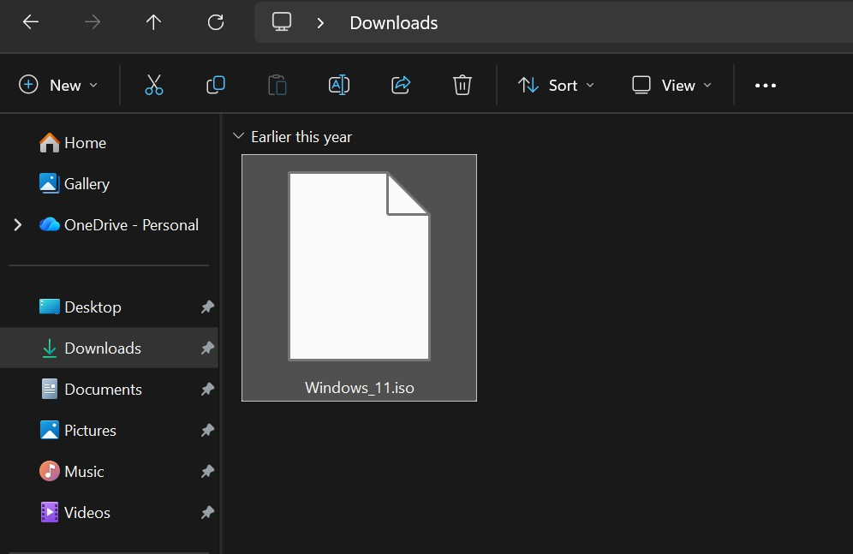
Click on the Documents folder, go to the VMWare folder, create a new folder named ‘Windows_11,’ go inside that folder, and press Ctrl + V to paste the file.
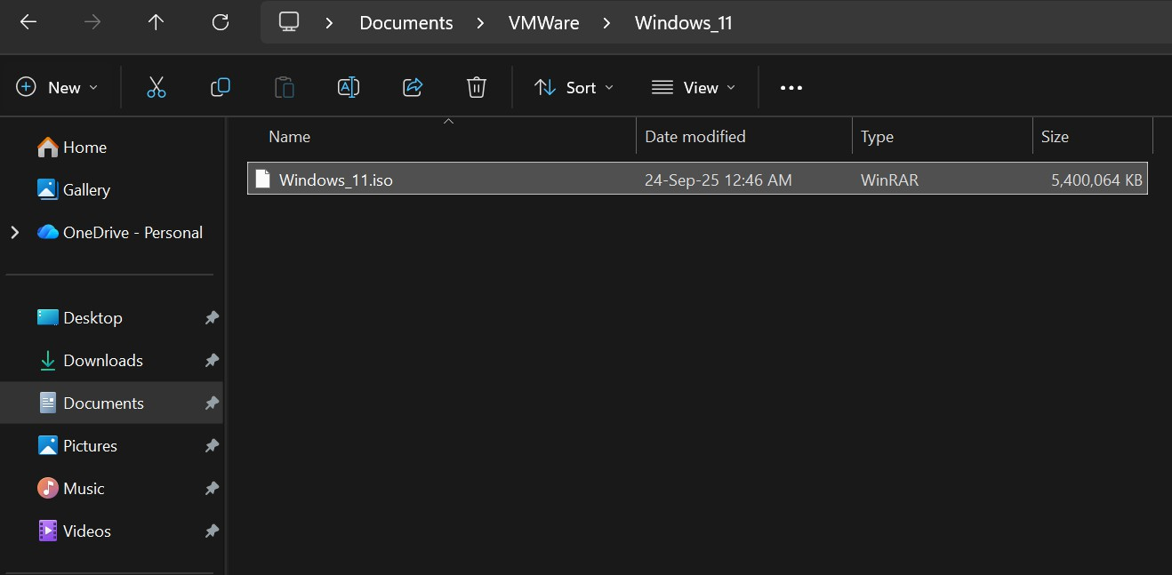

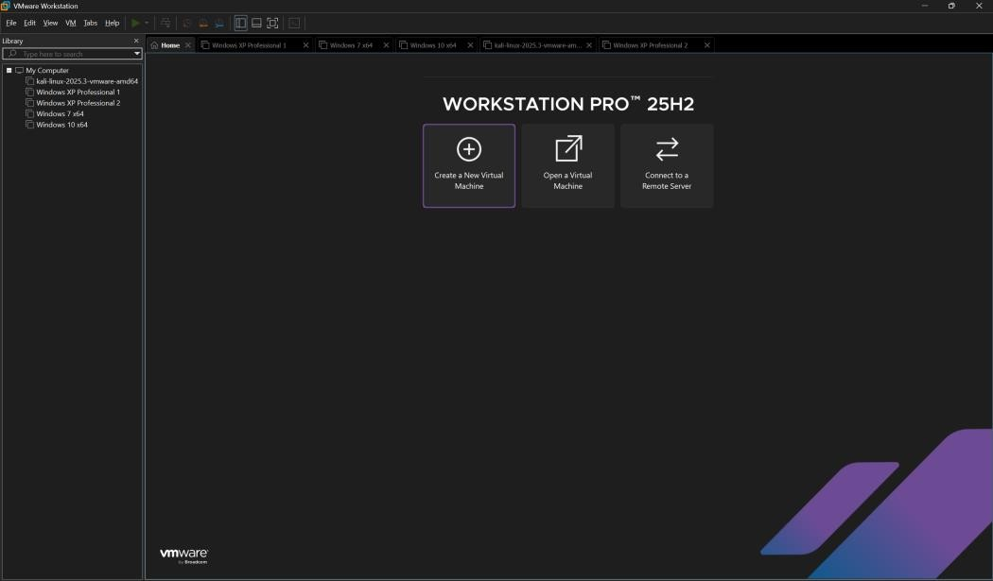
Open VMware and click on ‘Create a New Virtual Machine’.
Click on the 2nd option and click on Next.
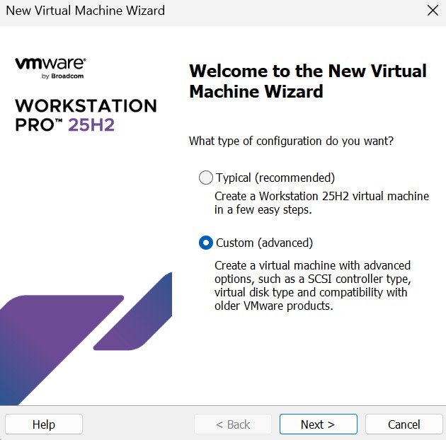

Click on Next.
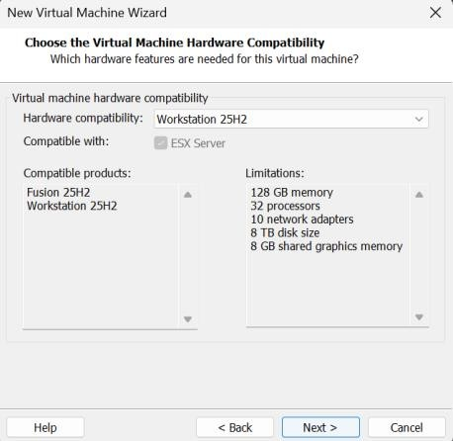
Click on the 2nd option and click on Browse.
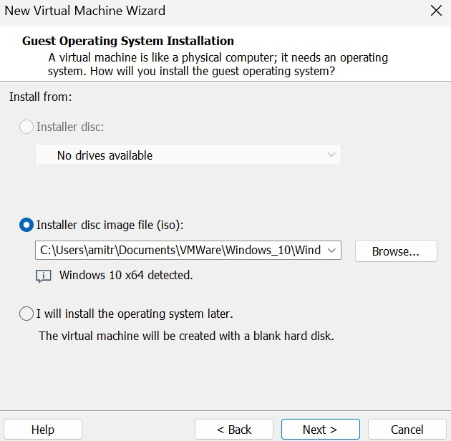
Go to Documents > VMWare > Windows_11 and select the file and click on Open.
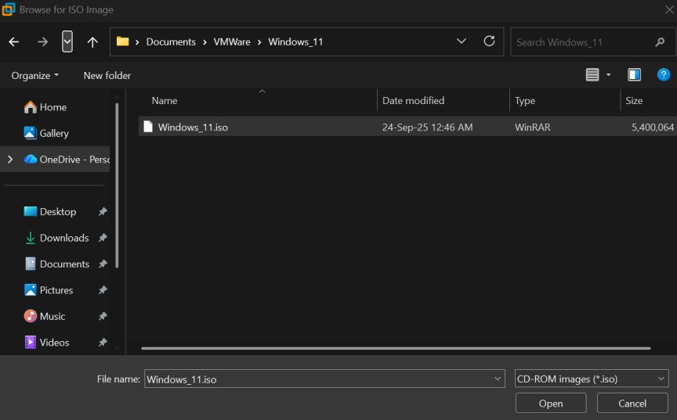

Click on Next.
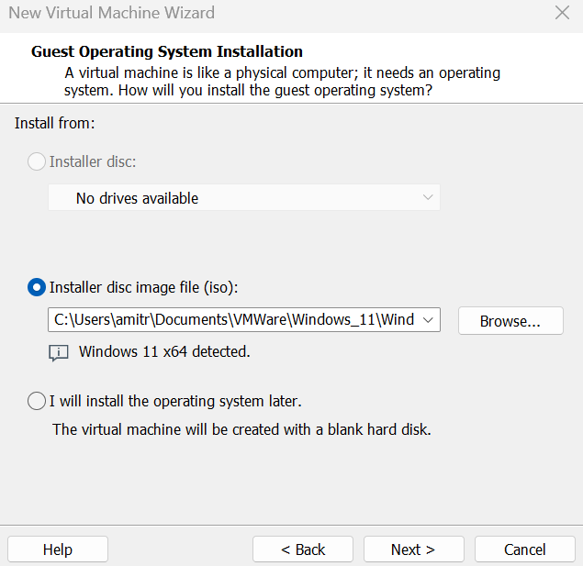

Click on Next.
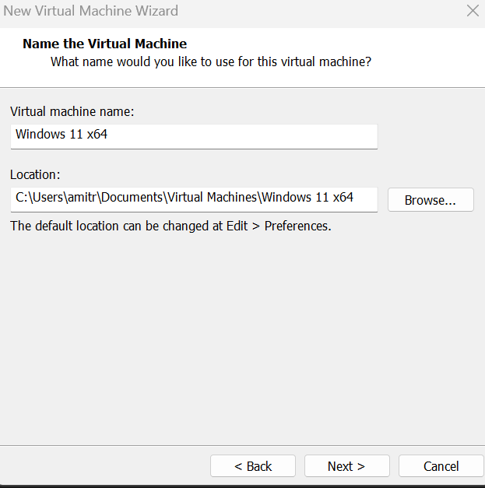

Enter the password as ‘12345678’ and click Next. If the checkbox is unticked on your system, make sure to select it.”
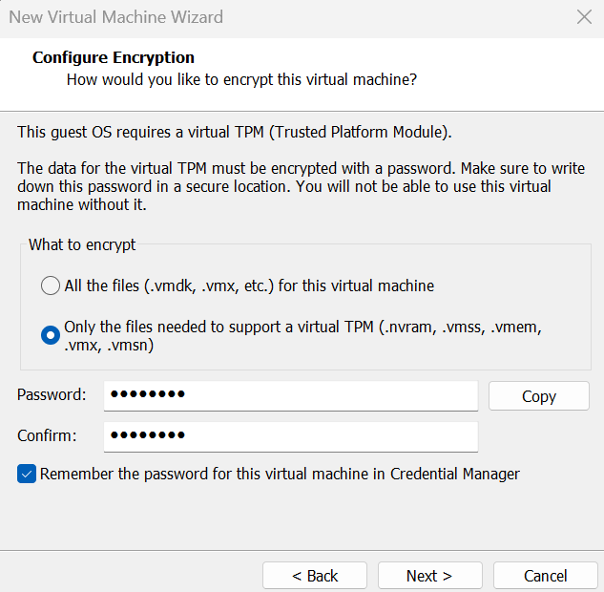

Click on Next.
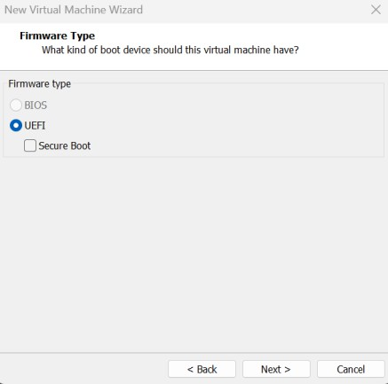
Assign the processors to 2 and 1, and click Next.
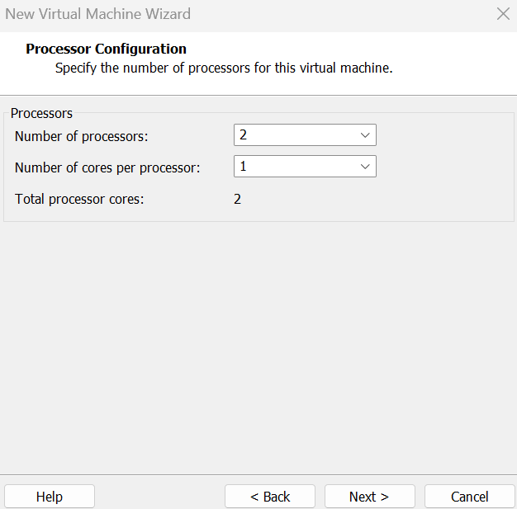
A Assign the base memory to 4000 MB and click Next
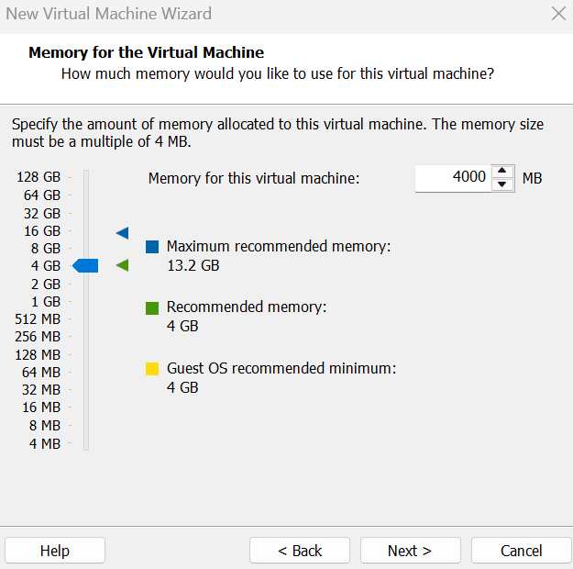

Select the first option and click Next.
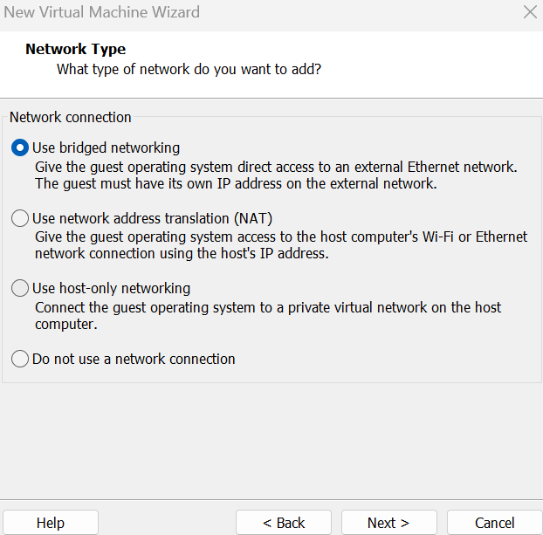
Click on Next.
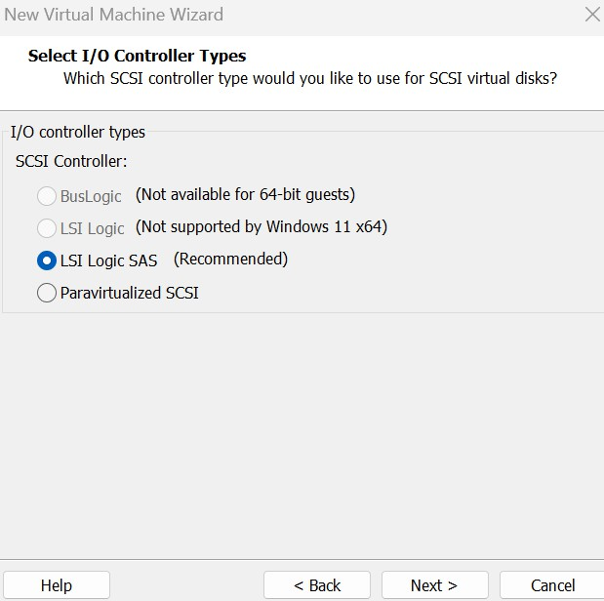
Click on Next.
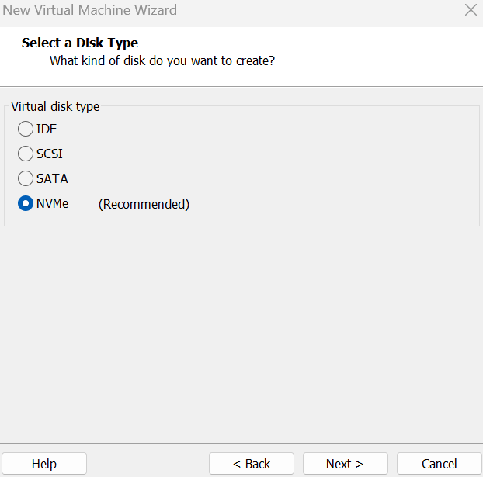

Click on Next.
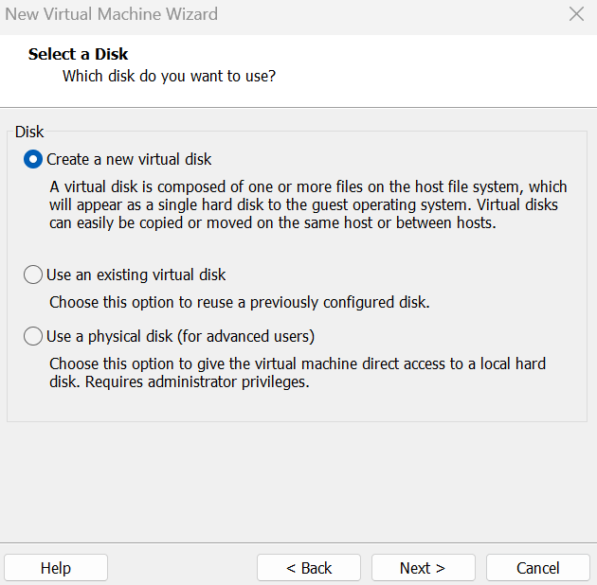
Assign the disk size to 32 GB, select the second option, and click Next.
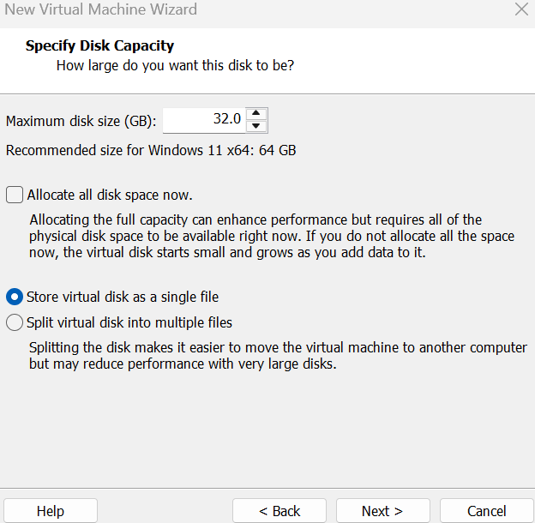

Click on Next.
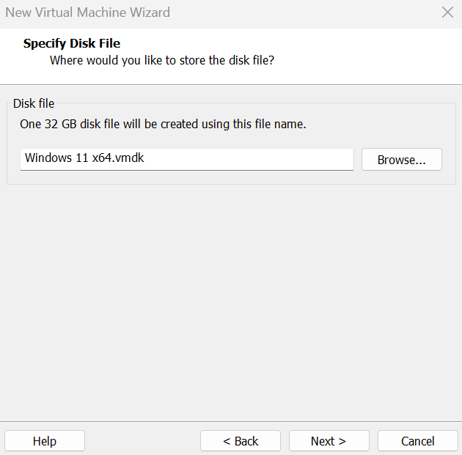

Click on Finish.
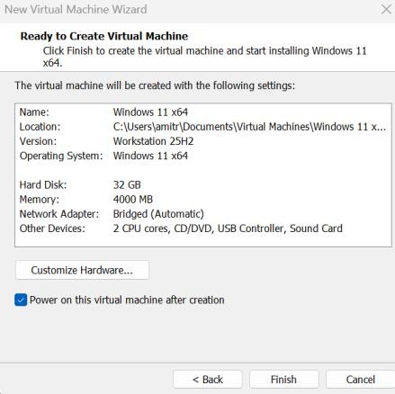
Click on Next.
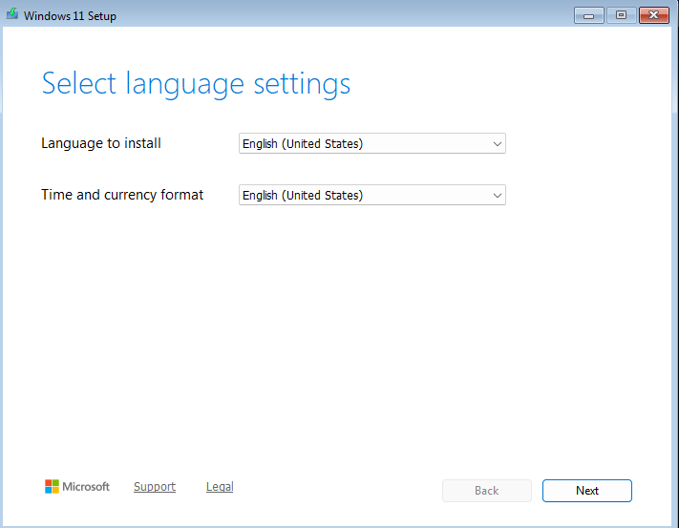
Click on Next.
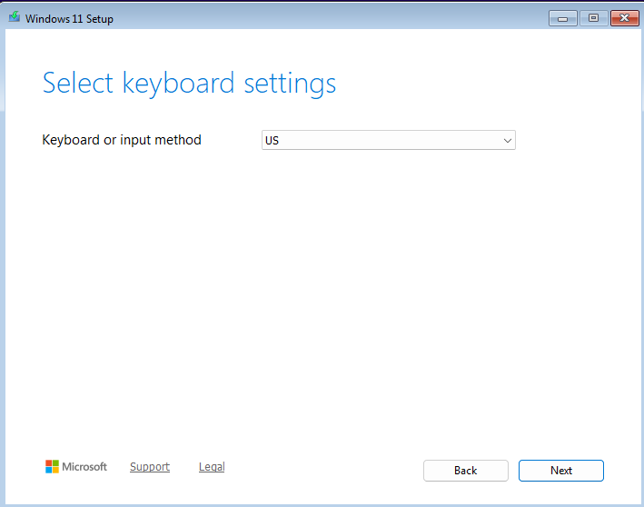

Click on the Next.
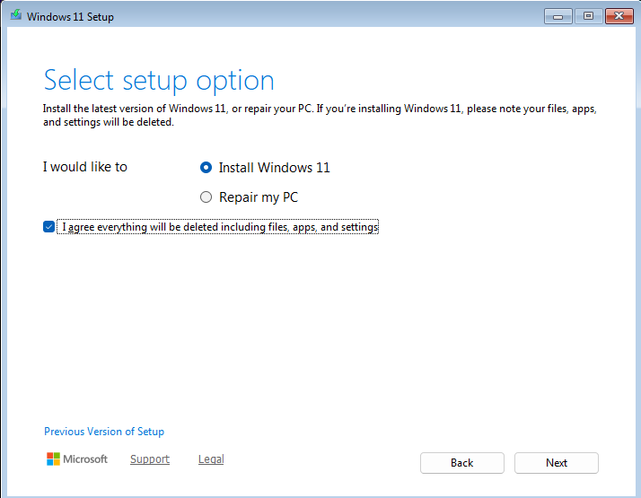

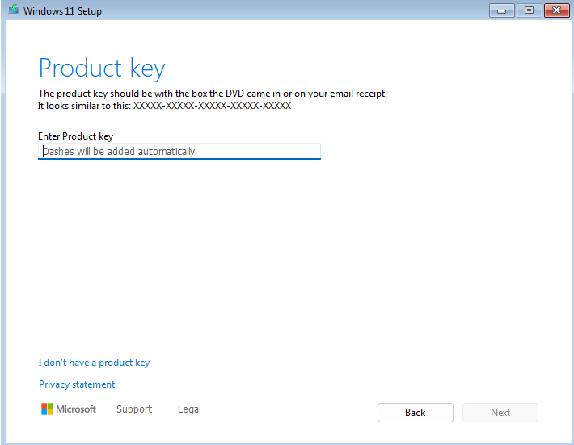
Click on ‘I don’t have a product key’ and then click Next.
Select Windows 11 Pro and click Next.
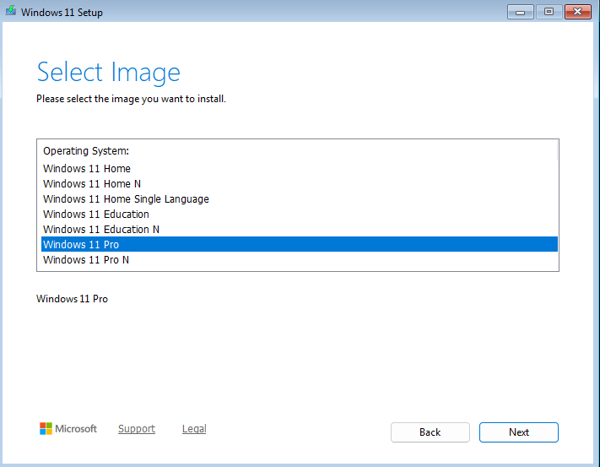

Click on Accept.
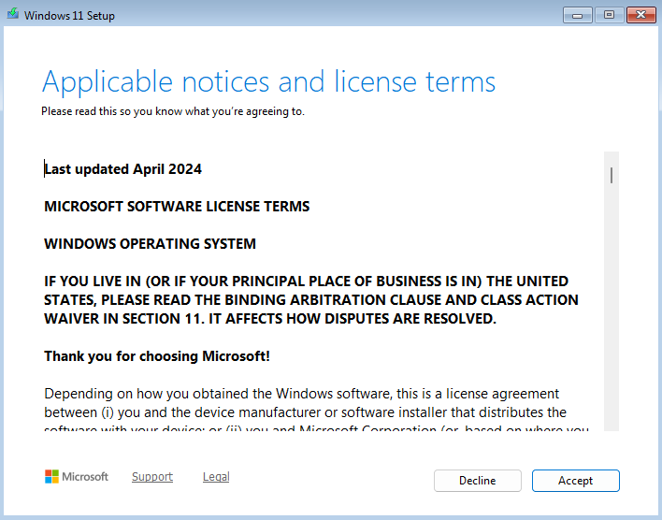
Click on Next.
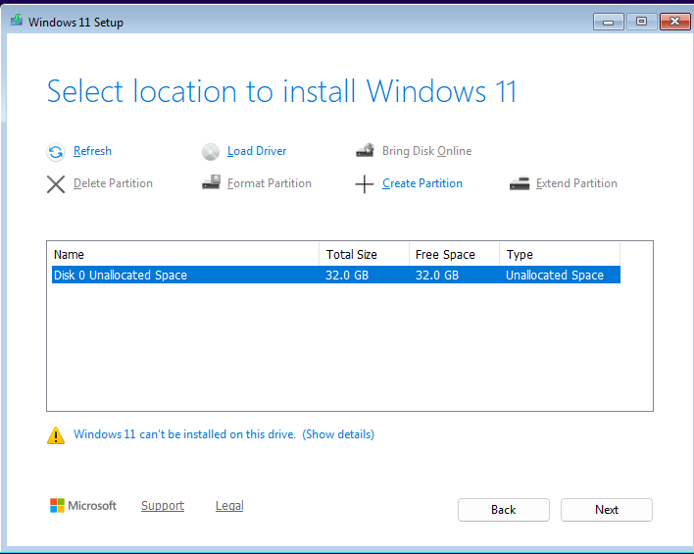
Click on Install.
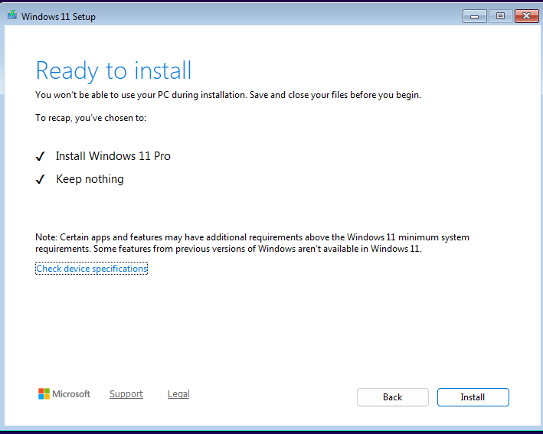

Click on Yes.

Click on Yes.
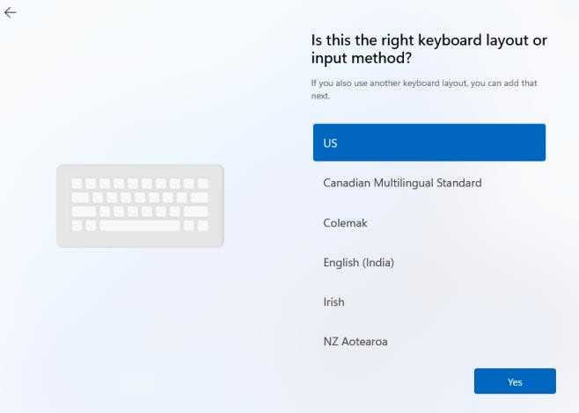
Click on Skip.
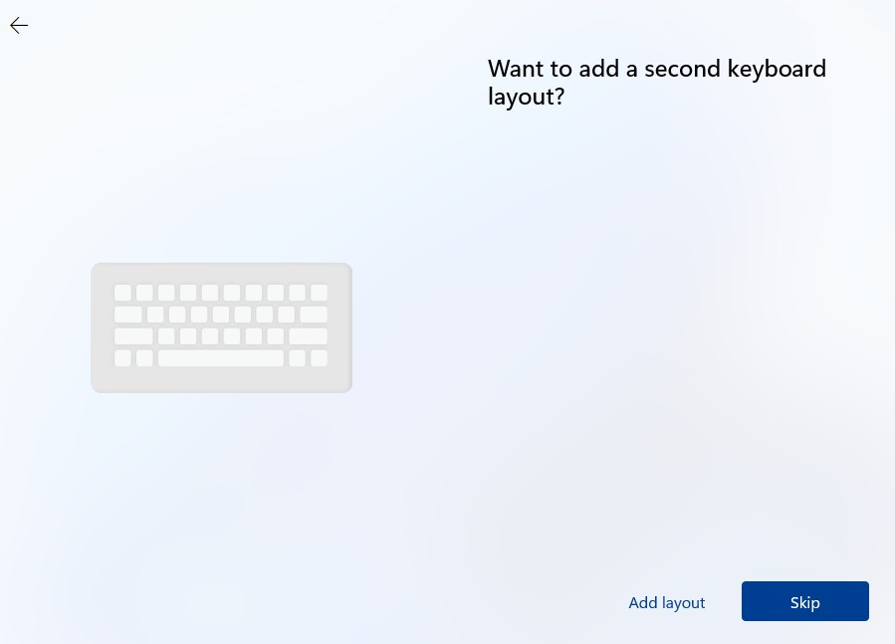

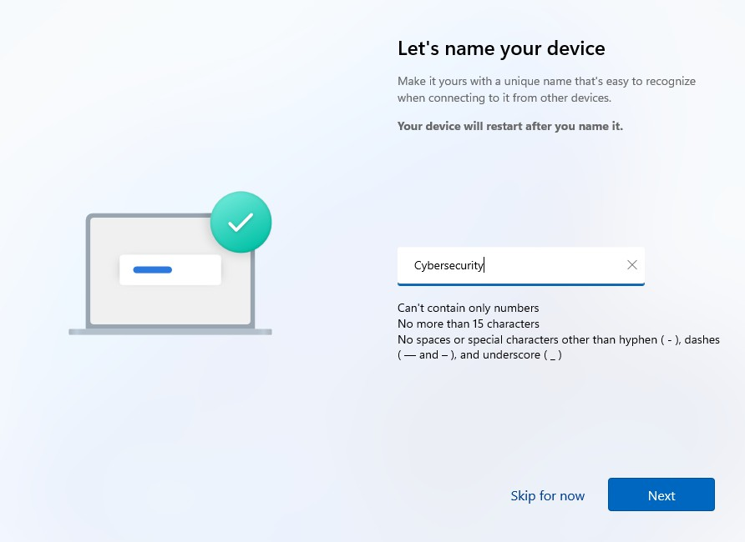
Enter the OS name as ‘Cybersecurity’ and click Next.
Select the second option and click Next.
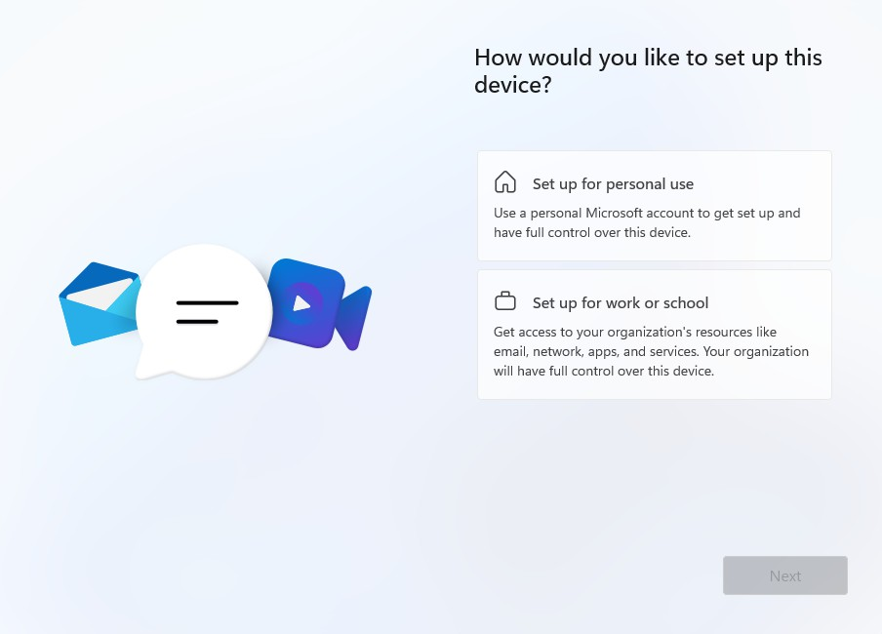
Click on Sign-in options.
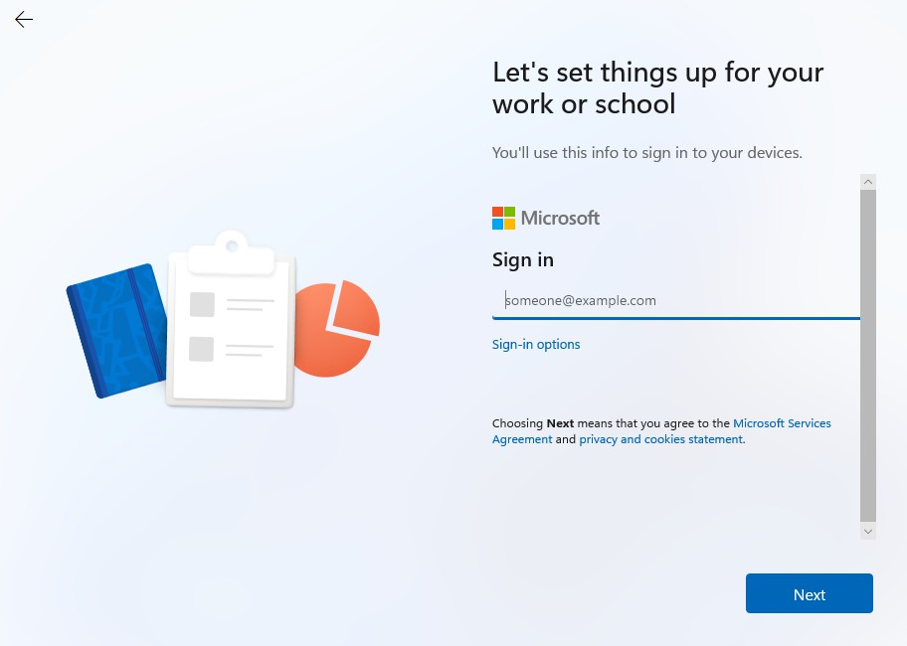

Click on ‘Domain join instead.
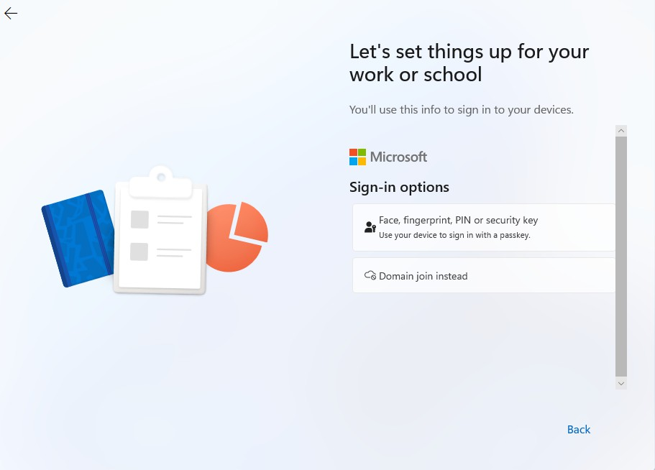

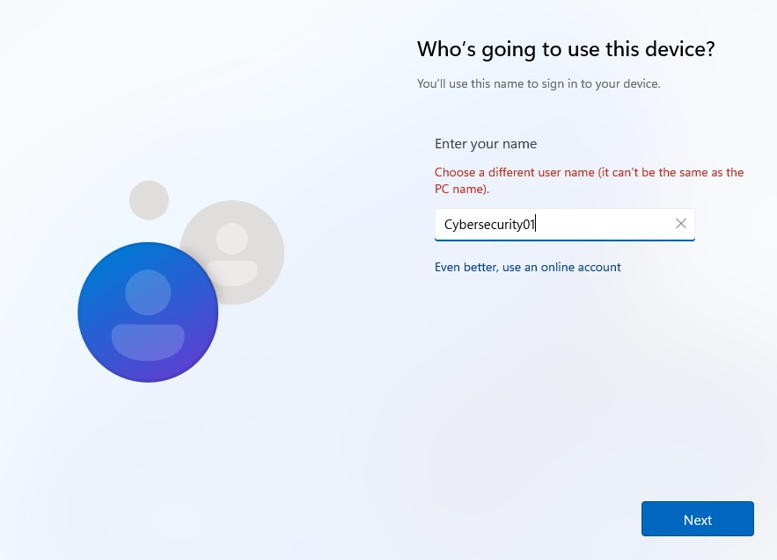
Enter the name as ‘Cybersecurity01’ and click Next.
Enter a password of your choice and make sure to note it down somewhere. Then click Next.
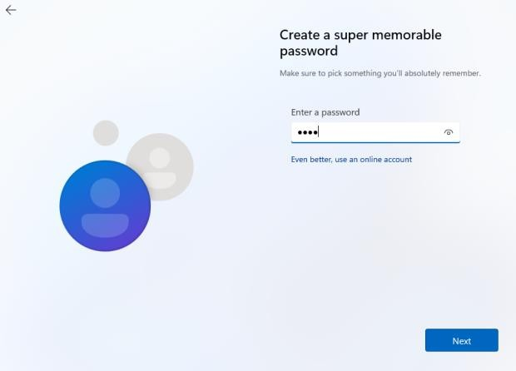

Select the security questions and enter any answers you prefer, but make sure to remember them. Then click Next.
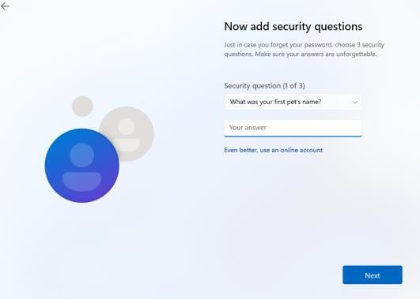
Disable all the options and click Next.
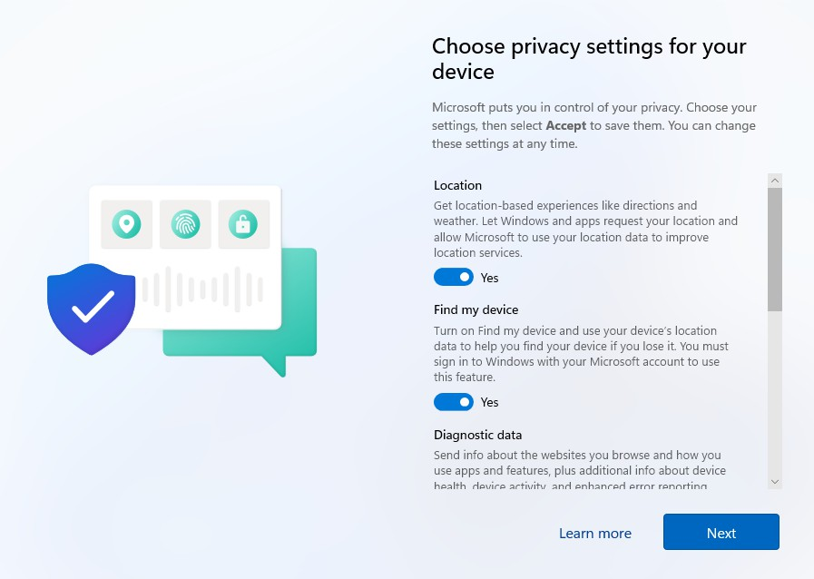

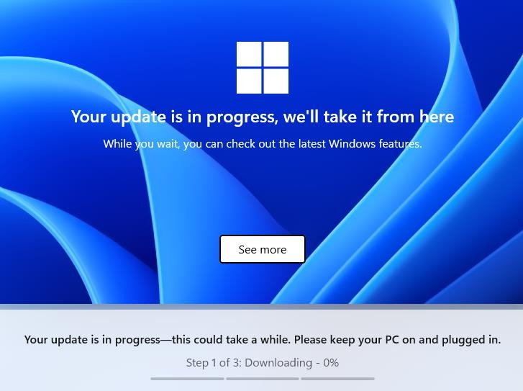
Wait for a few minutes while the OS files are downloaded to the system.

Now you are good to go.

Click on VM > Install VMware Tools.
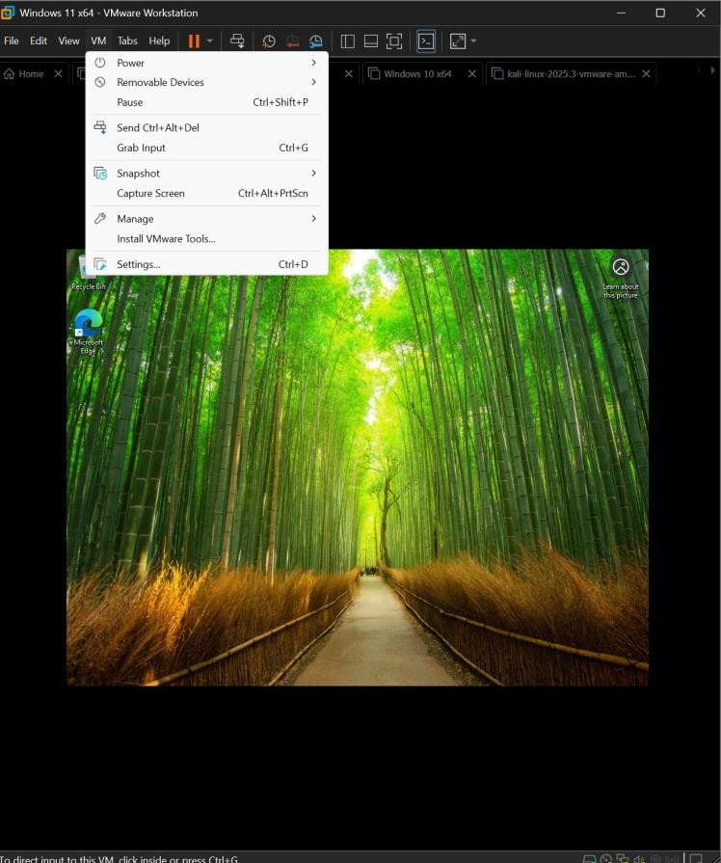

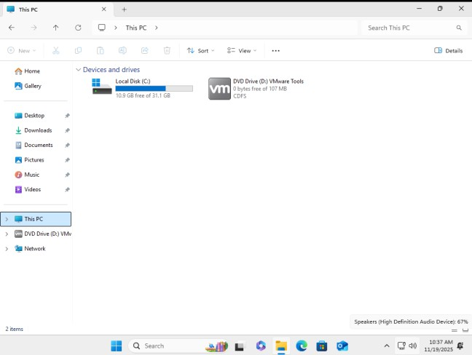
Open File Explorer, click on This PC, and then click on the DVD drive.
Click on Yes.
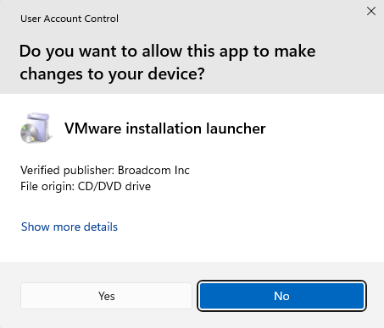
Click on Next.
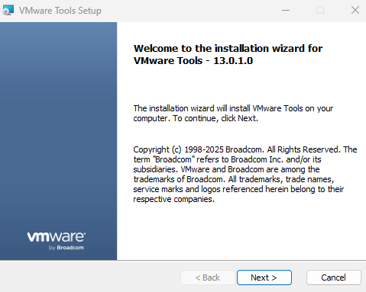

Select the first option and click Next.
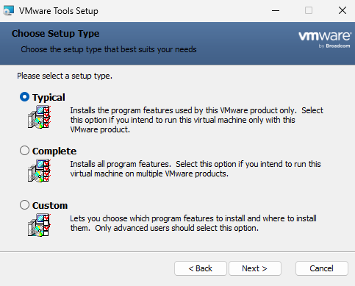
Click on Install.
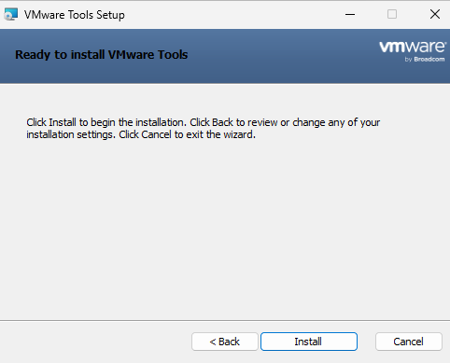
Click on Finish.
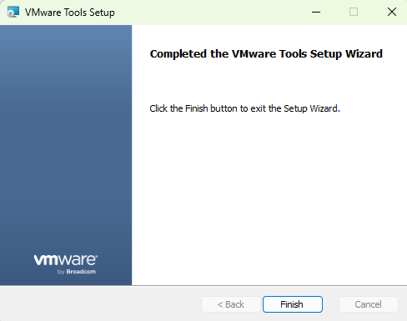
Click on Yes.
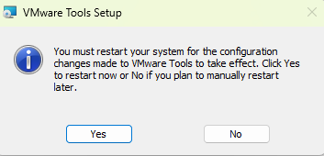
Ubuntu Sever Installation:
Ubuntu download Website link:
https://ubuntu.com/download/server

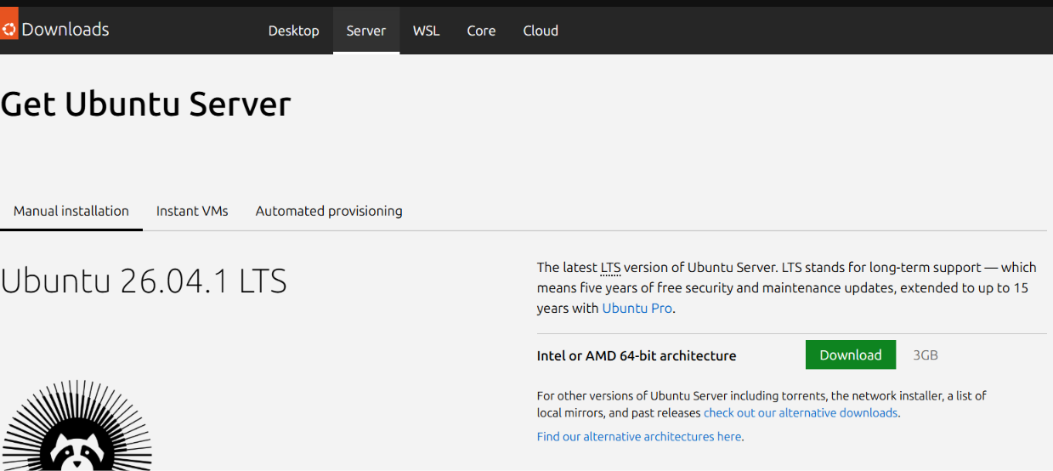
Click the download button

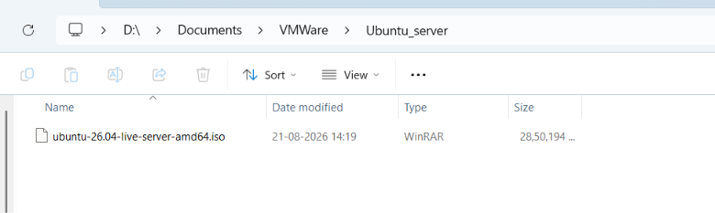
Create a folder name Ubuntu_server on /Document/VMWare folder and paste the downloaded iso file on there

Now open the VMware workstation and create a new virtual machine.
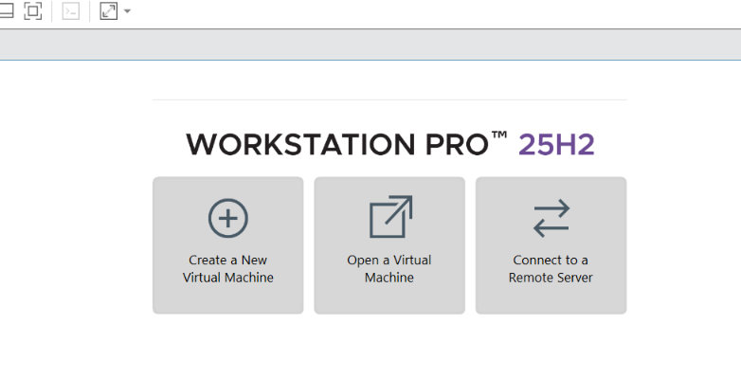

Click Custom option and click next.
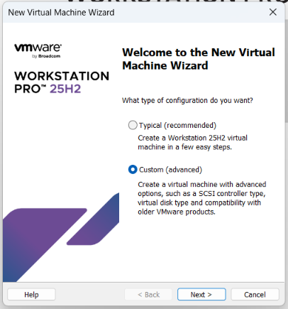

Click Next
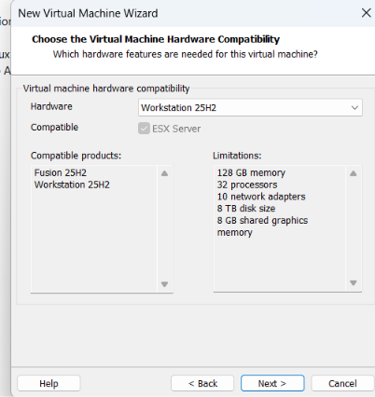

Chose 2nd option, click browse icon and select the iso file that you downloaded.
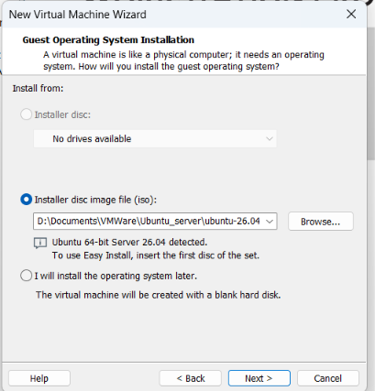
Name it as a Splunk server and click next
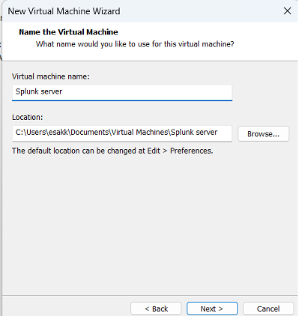
Give the number of processors as 2 for the both and click next
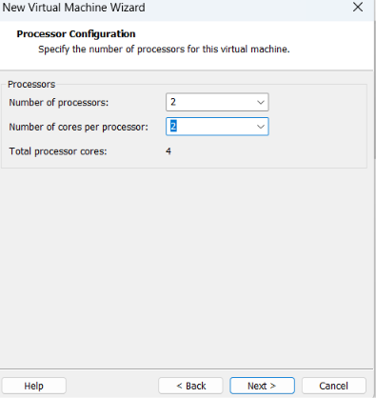
Give the 4 GB memory for this machine and click next
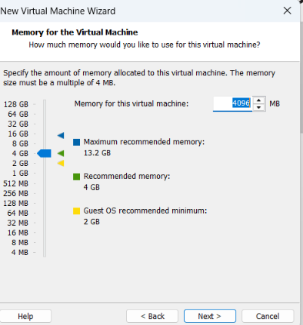
Use NAT network in the network type and click next
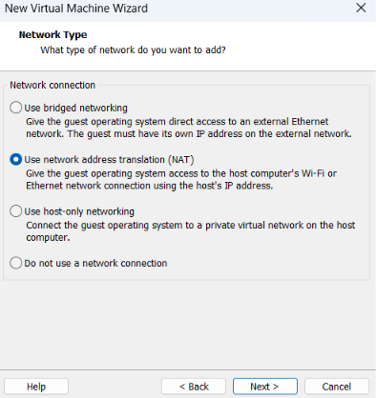
Click Next for the both
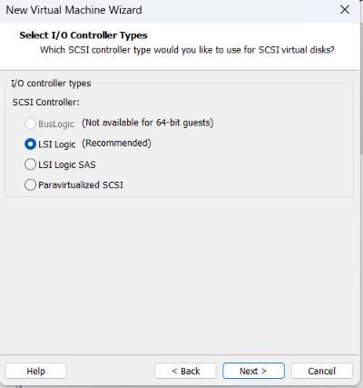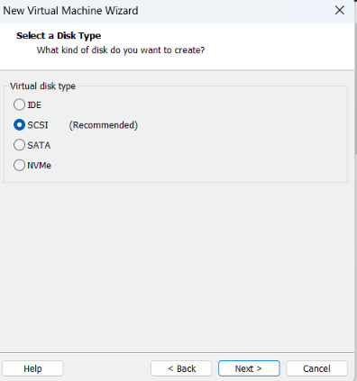

Select the first option and click next
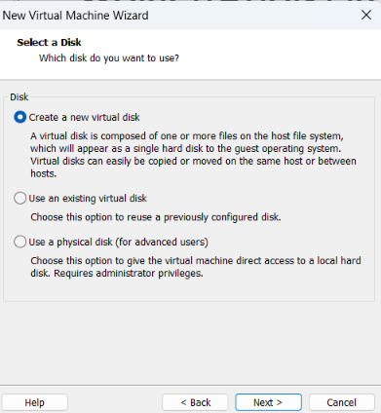

Give the 40 GB disk Capacity and choose store virtual disk as a single file and click next.
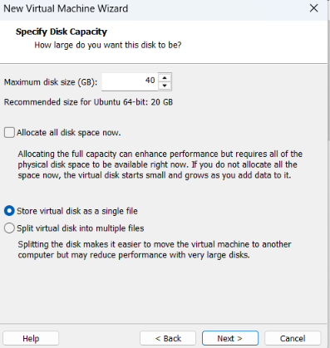

Click next and finish
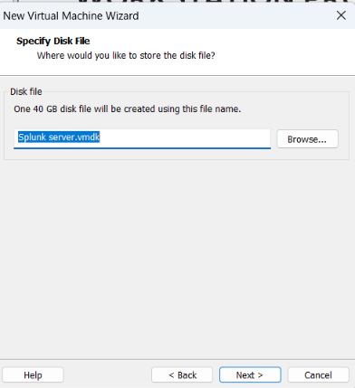

Click Enter
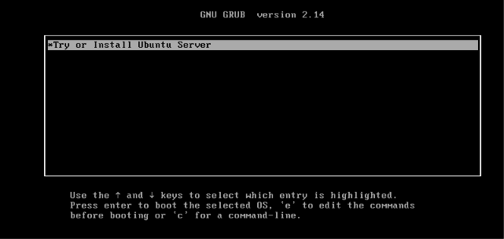
Choose English and click Enter
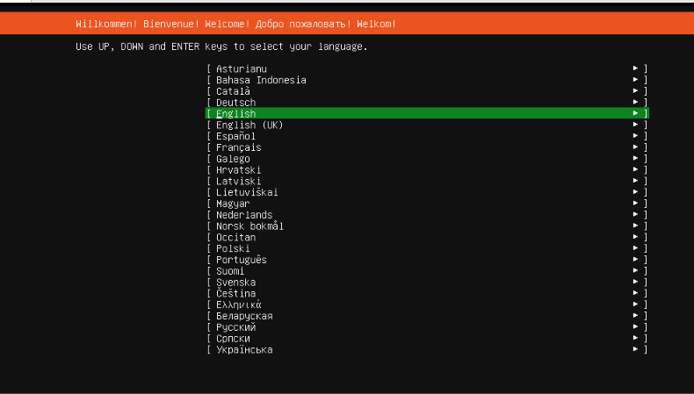
Chose continue without updating and enter and done
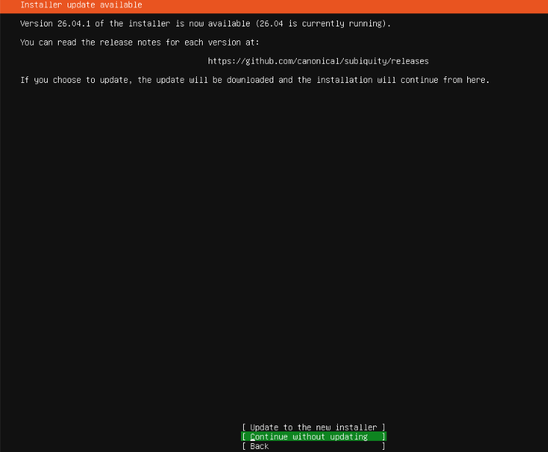
Select ubuntu server and click enter
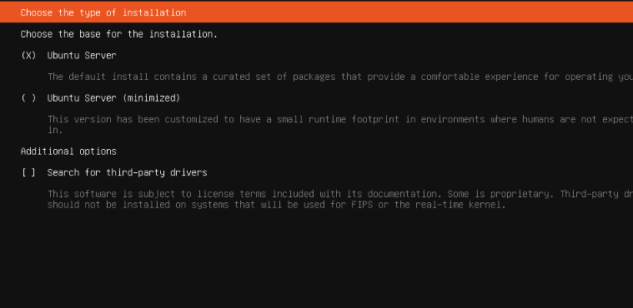
Click done for everything and click continue here
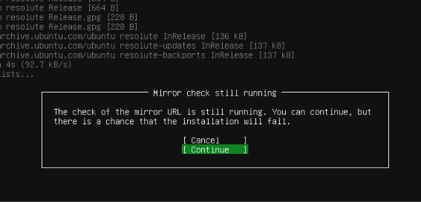

Choose use an entire disk and click enter
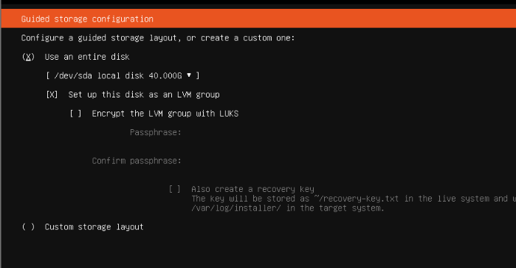

Select continue and enter
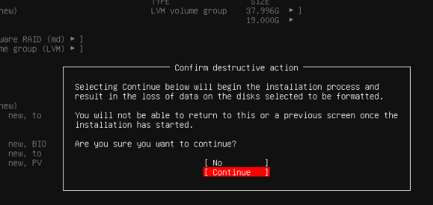
Give the name, username and password and click enter.
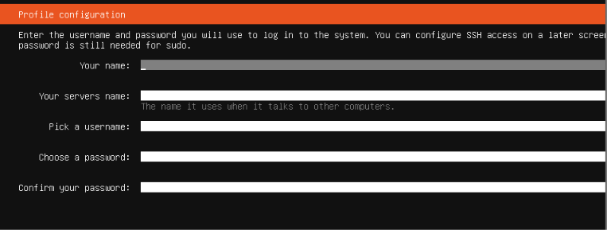
Select skip for now and hit enter
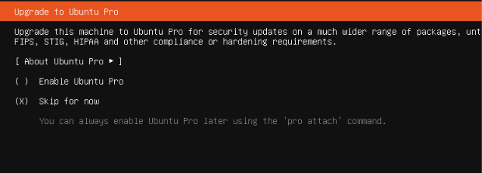
Select Install OpenSSH server and hit enter
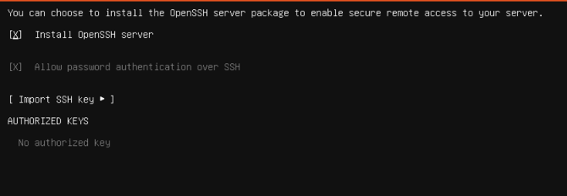

Click done and Wait to finish the installation
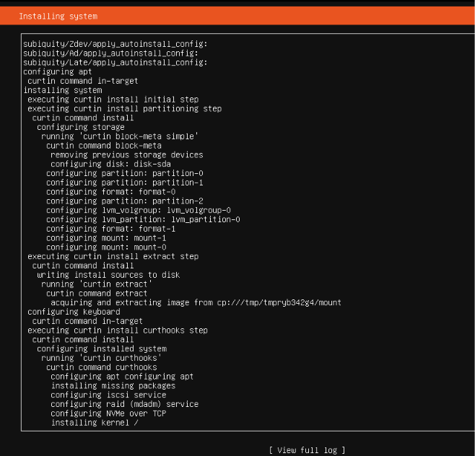
Click Reboot now after finishing installation.
Now you can access with you login credential .
